Raw files

Figure 1

Figure 1C western blot

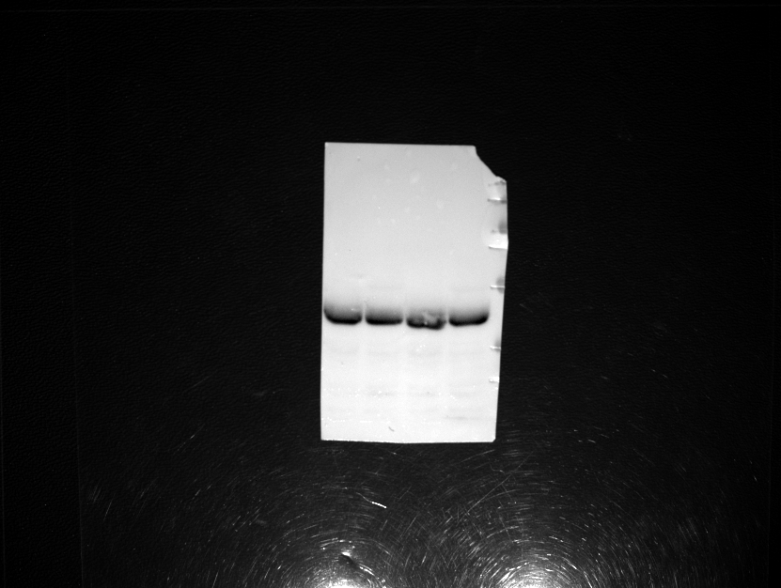
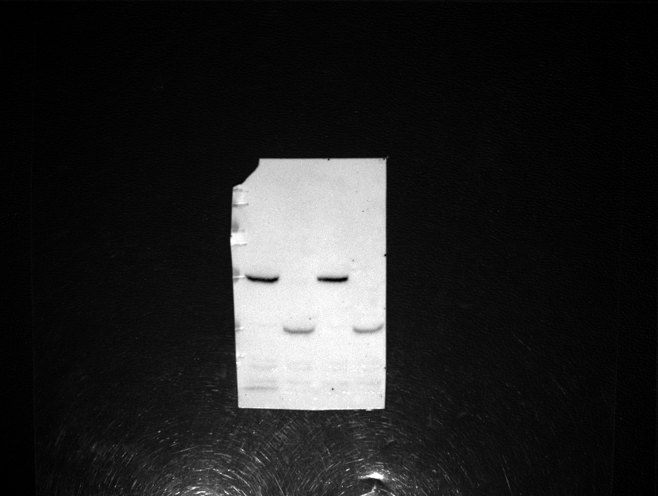
Duplicate 1
Duplicate 2
25kDa
35kDa
55kDa
70kDa
100kDa
130kDa
250kDa
Pgk1
25kDa
35kDa
55kDa
70kDa
100kDa
130kDa
250kDa
Duplicate 1
Duplicate 2
Fld1-mCherry
Fld1-ΔLR-mCherry

Figure 2

Figure 2G Electron microscopy raw images
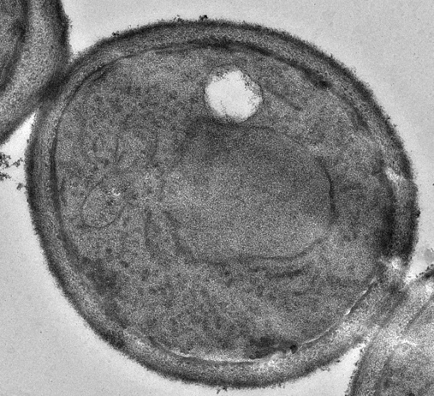
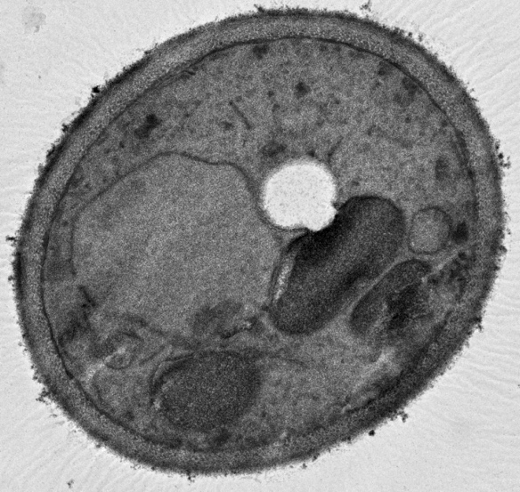
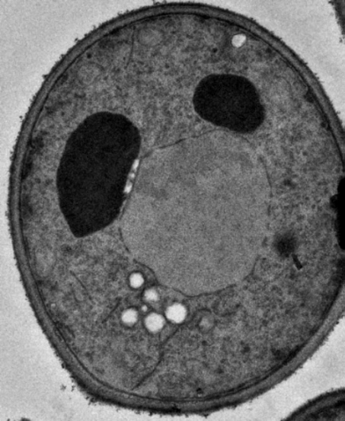
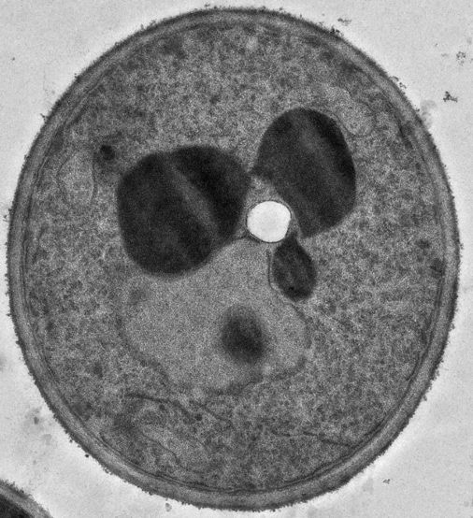
fld1Δ +pFld1-ΔLR
fld1Δ +pFld1
fld1Δ
WT
Figure 5

Figure 5G western blot

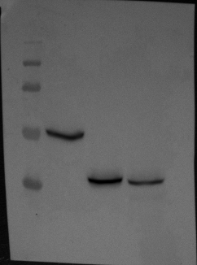
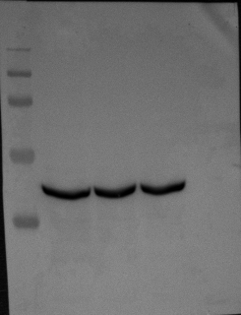
35kDa
55kDa
70kDa
100kDa
130kDa
Fld1-mCherry
Fld1-ΔLR-mCherry ^{P31G}
Pgk1
130kDa
100kDa
35kDa
55kDa
70kDa
Figure 6

Figure 6C western blot

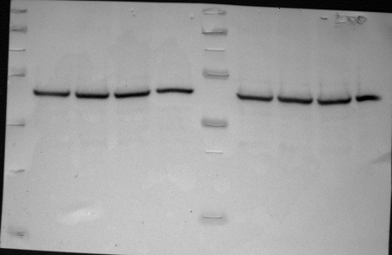
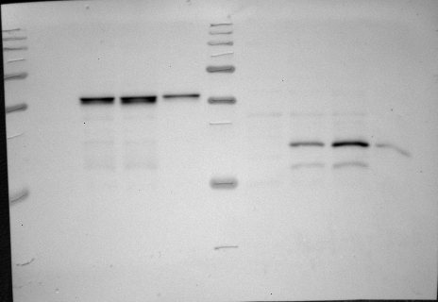
130kDa
10kDa
15kDa
25kDa
35kDa
55kDa
Fld1-ΔLR-HA
70kDa
100kDa
100kDa
70kDa
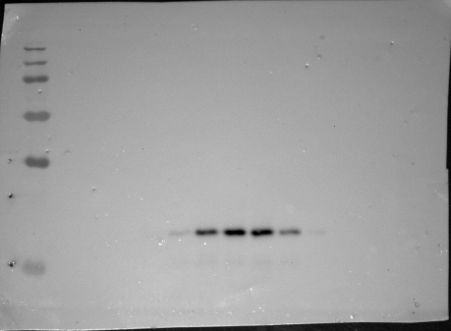
Fld1-ΔLR-HA
250kDa
130kDa
100kDa
55kDa
35kDa
25kDa
15kDa
Figure 6D western blot

Pgk1
55kDa
15kDa
25kDa
35kDa
Fld1-HA
Figure 8

Figure 8A and 8B TLC

Figure 8D TLC

are1Δ are2Δ fld1Δ
+ phSeipin

are1Δ are2Δ fld1Δ
+ phSeipin-ΔLR

STE standard

Tag standard

STE standard

Tag standard

are1Δ are2Δ fld1Δ
+ pFld1-ΔLR

are1Δ are2Δ fld1Δ
+ pFld1

are1Δ are2Δ fld1Δ

Figure S3

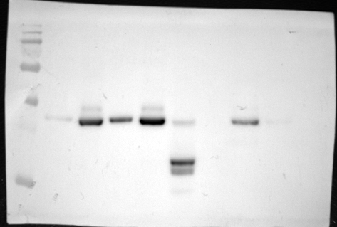
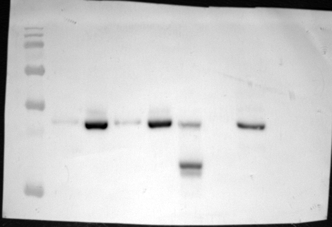
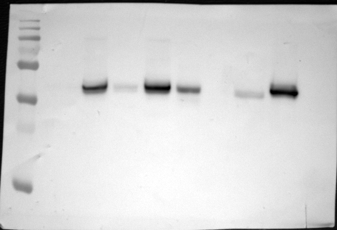
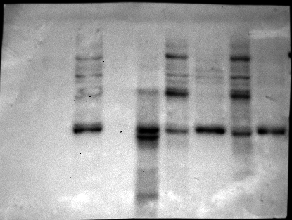
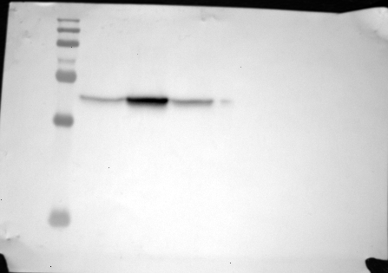
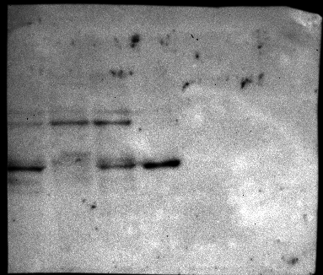
Figure S3D (homogenate)
Figure S3E (Salt detergent)

DPM-1

250kDa
130kDa
100kDa
55kDa
70kDa
35kDa
25kDa
15kDa
DPM-1

250kDa
130kDa
100kDa
70kDa
55kDa
15kDa
35kDa
25kDa
Fld1-ΔLR
-mCherry

250kDa
130kDa
70kDa
55kDa
100kDa
35kDa
25kDa
15kDa
Free/Cleaved GFP

GFP-Fld1-ΔLR

25kDa
35kDa
Fld1-ΔLR
-mCherry

250kDa
130kDa
100kDa
70kDa
55kDa
35kDa
25kDa
15kDa
25kDa
35kDa
Free/Cleaved GFP

GFP-Fld1-ΔLR

Figure S3F (Proteinase K)

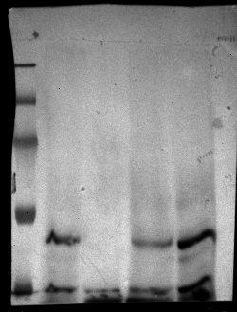
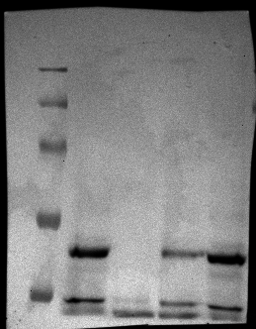
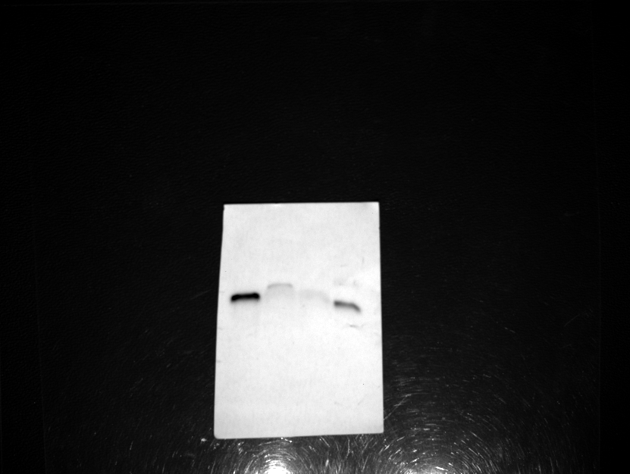
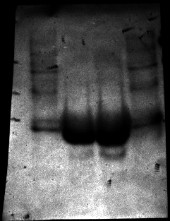
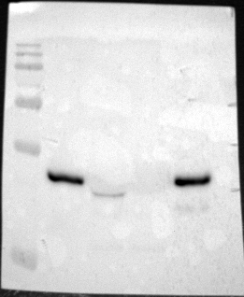
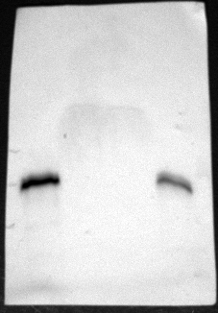
KAR2

KAR2

250kDa
130kDa
100kDa
70kDa
55kDa
55kDa
70kDa
100kDa
130kDa
250kDa
DPM-1

DPM-1

Fld1-ΔLR
-mCherry

Free/Cleaved GFP

GFP-Fld1-ΔLR

55kDa
25kDa
35kDa
250kDa
130kDa
100kDa
70kDa
55kDa
15kDa
35kDa
55kDa
35kDa
25kDa
15kDa
15kDa
55kDa
35kDa
25kDa
Figure S5A

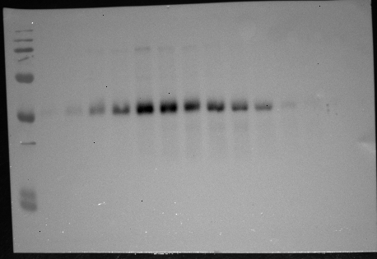
Fld1-HA
250kDa
130kDa
100kDa
70kDa
55kDa
15kDa
25kDa
35kDa
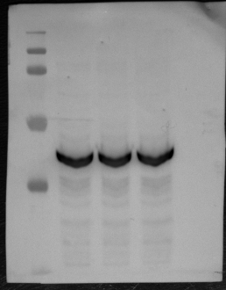
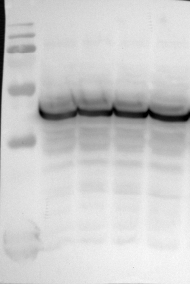
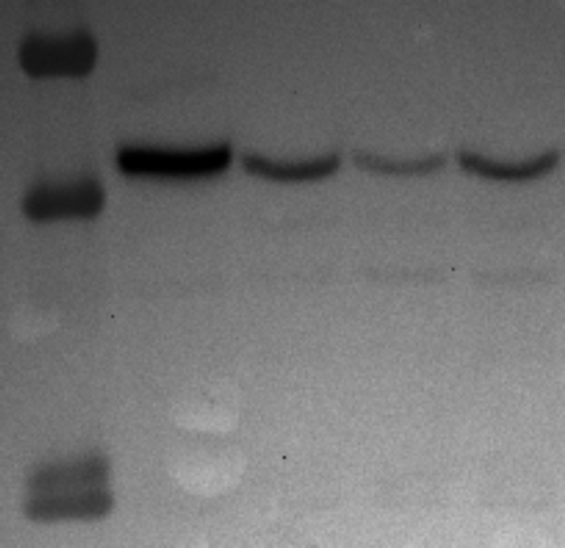
PGK1
250kDa
130kDa
100kDa
55kDa
35kDa
15kDa
Fld1-ΔLR + G235A L236A R237A Clone 2
Fld1-ΔLR + G235A L236A R237A Clone 1
Fld1-ΔLR + G235A L236A
25kDa
130kDa
100kDa
55kDa
70kDa
35kDa
15kDa
Fld1-ΔLR + single point mutants
PGK1
250kDa
130kDa
100kDa
70kDa
55kDa
15kDa
35kDa
15kDa
25kDa
55kDa
35kDa
Figure S6D

