Supplementary Information

Asymptomatic people with SARS-CoV-2 as unseen carriers of COVID-19: A systematic review and meta-analysis

Gopiram Syangtan¹, Shrijana Bista², Prabin Dawadi², Binod Rayamajhee^{3, 4}, Lok Bahadur Shrestha⁵, Reshma Tuladhar², Dev Raj Joshi^{2 *}
      - Shi-Gan International college of Science and Technology (SICOST), Tribhuvan University, Narayangopal Chowk, Nepal
- Central Department of Microbiology, Tribhuvan University, Kirtipur, Nepal
- School of Optometry and Vision Science (SOVS), Faculty of Science, Rupert Myers Building (North Wing), Level 3, Kensington NSW 2033, UNSW, Sydney, Australia
- Research Faculty, Department of Infectious Diseases and Immunology, Kathmandu Research Institute for Biological Sciences (KRIBS), Lalitpur, Nepal
- Department of Microbiology and Infectious Diseases, B. P. Koirala Institute of Health Sciences, Dharan, Nepal

*Correspondence: Dev Raj Joshi (dev.joshi@cdmi.tu.edu.np)

Supplementary information(SI) includes -
Number of Pages: 12
Number of Tables: 4
Number of Figures: 4

Table S1: PRISMA Checklist for meta-analysis of prevalence of COVID-19 Asymptomatic patients
S.N. | Section/Topic | Checklist item | Reported on page
TITLE
1 | - Title | Identify the report as a systematic review, meta-analysis, or both. | 1
ABSTRACT
2. | - Structured summary | Provide a structured summary including, as applicable: background; objectives; data sources; study eligibility criteria, participants, and interventions; study appraisal and synthesis methods; results; limitations; conclusions and implications of key findings. | 1-2 (Abstract)
INTRODUCTION
3. | - Rationale | Describe the rationale for the review in the context of what is already known. | 3 (Introduction, paragraph 4)
4. | - Objectives | Provide an explicit statement of questions being addressed with reference to participants, interventions, comparisons, outcomes, and study design (PICOS). | 3 (Introduction, paragraph 4)
METHODS
5. | - Protocol and registration | Indicate if a review protocol exists, if and where it can be accessed (e.g., Web address), and, if available, provide registration information including registration number. | 4 (Methods, paragraph 1)  Registration N/A
6. | - Eligibility criteria | Specify study characteristics (e.g., PICOS, length of follow-up) and report characteristics (e.g., years considered, language, publication status) used as criteria for eligibility, giving rationale. | 4 (Methods, paragraph 3)
7. | - Information sources | Describe all information sources (e.g., databases with dates of coverage, contact with study authors to identify additional studies) in the search and date last searched. | 4 (Methods, paragraph 1)
8. | - Search | Present full electronic search strategy for at least one database, including any limits used, such that it could be repeated. | 4 (Methods, paragraph 2)
9. | - Study selection | State the process for selecting studies (i.e., screening, eligibility, included in systematic review, and, if applicable, included in the meta-analysis). | 4-5 (Methods, paragraph 4) (Fig. 1)
10. | - Data collection process | Describe method of data extraction from reports (e.g., piloted forms, independently, in duplicate) and any processes for obtaining and confirming data from investigators. | 4 (Methods, paragraph 2)
11. | - Data items | List and define all variables for which data were sought (e.g., PICOS, funding sources) and any assumptions and simplifications made. | 5 (Methods, paragraph 5)
12. | - Risk of bias in individual studies | Describe methods used for assessing risk of bias of individual studies (including specification of whether this was done at the study or outcome level), and how this information is to be used in any data synthesis. | 5 (Methods, paragraph 7)  NOS Table S2 (SI file)
13. | - Summary measures | State the principal summary measures (e.g., risk ratio, difference in means). | 5 (Methods, paragraph 6)
14. | - Synthesis of results | Describe the methods of handling data and combining results of studies, if done, including measures of consistency (e.g., I²) for each meta-analysis. | 6 (Methods, paragraph 9)
15. | - Risk of bias across studies | Specify any assessment of risk of bias that may affect the cumulative evidence (e.g., publication bias, selective reporting within studies). | 5 (Methods, paragraph 8)
16. | - Additional analyses | Describe methods of additional analyses (e.g., sensitivity or subgroup analyses, meta-regression), if done, indicating which were pre-specified. | 6 (Methods, paragraph 10)
RESULTS
17. | - Study selection | Give numbers of studies screened, assessed for eligibility, and included in the review, with reasons for exclusions at each stage, ideally with a flow diagram. | 6 (Results, paragraph 1) (Fig. 1)
18. | - Study characteristics | For each study, present characteristics for which data were extracted (e.g., study size, PICOS, follow-up period) and provide the citations. | 7 (Results, paragraph, 2) (Table 1; SI, Table S3)
19. | - Risk of bias within studies | Present data on risk of bias of each study and, if available, any outcome level assessment (see item 12). | (SI, Table S2)
20. | - Results of individual studies | For all outcomes considered (benefits or harms), present, for each study: (a) simple summary data for each intervention group (b) effect estimates and confidence intervals, ideally with a forest plot. | 7 (Results, paragraph, 3 and 4) (Fig 2, Fig.3)
21. | - Synthesis of results | Present results of each meta-analysis done, including confidence intervals and measures of consistency. | 7-8 (Results, paragraph, 4, 5, 6, 7) (Fig. 3)
22. | - Risk of bias across studies | Present results of any assessment of risk of bias across studies (see Item 15). | 8 (Results, Paragraph 8) (SI, Fig S4, Table S4)
23. | - Additional analysis | Give results of additional analyses, if done (e.g., sensitivity or subgroup analyses, meta-regression [see Item 16]). | 7-8 (Results, paragraph, 5, 6 and 7) (Fig.3)
DISCUSSION
24. | - Summary of evidence | Summarize the main findings including the strength of evidence for each main outcome; consider their relevance to key groups (e.g., healthcare providers, users, and policy makers). | 8, 10-11 (Discussion, paragraph, 1, 5, 6 and 8)
25. | - Limitations | Discuss limitations at study and outcome level (e.g., risk of bias), and at review-level (e.g., incomplete retrieval of identified research, reporting bias). | 11 (Discussion, paragraph, 10)
26. | - Conclusions | Provide a general interpretation of the results in the context of other evidence, and implications for future research. | 11-12 (Conclusion, paragraph 1)
FUNDING
27. | - Funding | Describe sources of funding for the systematic review and other support (e.g., supply of data); role of funders for the systematic review. | N/A

Table S2: Newcastle-Ottawa Scale for quality assessment of included observational studies
S.N. | Study ID | Methodological quality (max 5 stars) | Comparability (max 2 stars) | Outcome measures and analysis (max 3 stars) | Total score
1. | Baggett et al. 2020 | **** | ** | ** | 8
2. | Dong et al. 2020 | **** | ** | *** | 9
3. | Hu et al. 2020 | *** | ** | *** | 8
4. | Kimball et al. 2020 | **** | ** | *** | 9
5. | Lu et al. 2020 | *** | ** | ** | 7
6. | Meng et al. 2020 | *** | ** | *** | 8
7. | Mizumoto et al. 2020 | **** | ** | *** | 9
8. | Nishiura et al. 2020 | **** | * | *** | 8
9. | Pan et al. 2020 | *** | ** | *** | 8
10. | Qiu et al. 2020 | ***** | * | *** | 9
11. | Song et al. 2020 | ** | ** | ** | 6
12. | Sutton et al. 2020 | **** | * | *** | 8
13. | Tao et al. 2020 | **** | ** | *** | 9
14. | Tian et al. 2020 | **** | ** | *** | 9
15. | Wang et al. 2020 | *** | ** | *** | 8
16. | Zhou et al. 2020 | *** | ** | *** | 8
*, One score

Table S3: Demographic and Clinical characteristics of COVID-19 patients from the studies included in the meta-analysis
S.N. | Study ID* | Gender |  | Age |  |  | Clinical observation
S.N. | Study ID* | Male | Female | Children ($≤$18 years) | Adult (19-50 years) | Elderly (≥51 years) | Symptomatic | Asymptomatic
1. | Baggett et al. (2020) [54] | 124 | 22 | 0 | 51 | 96 | 18 | 129
2. | Dong et al. (2020) [55] | 418 | 310 | 728 | 0 | 0 | 634 | 94
3. | Hu et al. (2020) [39] | 8 | 16 | 5 | 9 | 10 | 0 | 24
4. | Kimball et al. (2020) [52] | 7 | 16 | 0 | 23 | 0 | 10 | 13
5. | Lu et al. (2020) [56] | 104 | 67 | 171 | 0 | 0 | 132 | 39
6. | Meng et al. (2020) [53] | 26 | 32 | 0 | 48 | 10 | 0 | 58
7. | Mizumoto et al. (2020) [57] | 321 | 313 | 6 | 77 | 551 | 306 | 328
8. | Nishiura et al. (2020) [58] | - | - | - | - | - | 9 | 4
9. | Pan et al. (2020) [59] | 16 | 10 | - | - | - | 0 | 26
10. | Qiu et al. (2020) [60] | 23 | 13 | 36 | 0 | 0 | 26 | 10
11. | Song et al. (2020) [61] | - | - | - | - | - | 65 | 18
12. | Sutton et al. (2020) [62] | 0 | 33 | - | - | - | 4 | 29
13. | Tao et al. (2020) [38] | - | - | 7 | 97 | 63 | 147 | 20
14. | Tian et al. (2020) [63] | 127 | 135 | 11 | 203 | 48 | 249 | 13
15. | Wang et al. (2020) [64] | 22 | 33 | 15 | 18 | 22 | 0 | 55
16. | Zhou et al. (2020) [65] | - | - | - | - | - | 315 | 13
Total |  |  |  |  |  |  | 1915 | 873
*References for all included studies are listed in the ‘References’ of the manuscript.
Table S4. Begg’s and Egger’s test for assessment of public bias in the meta-analysis
Begg and Mazumdar rank Correlation
Kendall's S stistic (P-Q) | 30
Kendall's tau without continuity correction
Tau
Z-value for tau | 0.25
P-value (1-tailed) | 1.3507
P - value (2- tailed) | 0.0884
Kendall's tau with continuity correction
Tau | 0.2417
Z-value for tau | 1.3057
P-value (1-tailed) | 0.0958
P - value (2- tailed) | 0.1917
Egger's regression intercept
Intercept | 0.8079
Standard Error | 2.4575
95% lower limit (2- tailed) | -4.4529
95% upper limit (2- tailed) | 6.0787
t-value | 0.3736
df | 14
P - value (1-tailed) | 0.3736
P - value (2-tailed) | 0.7472

Figures

Fig. S1: Forest plot showing pooled prevalence of asymptomatic COVID-19 cases according to gender

Fig. S2:Forest plot showingpooled prevalence of asymptomatic COVID-19 cases according to age

Fig. S3: Forest plot showingprevalence of COVID-19 clinical outcome among patientsin included individual studies

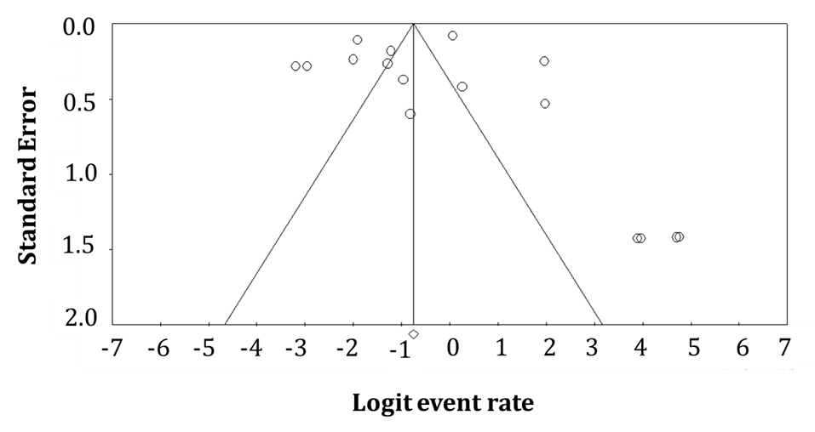
Fig. S4: Funnel plot for assessing publication bias in Meta-analysis for prevalence of asymptomatic COVID-19 cases.

