Appendix1

Figure 1. The number of newly infected people (per week)

Appendix 2
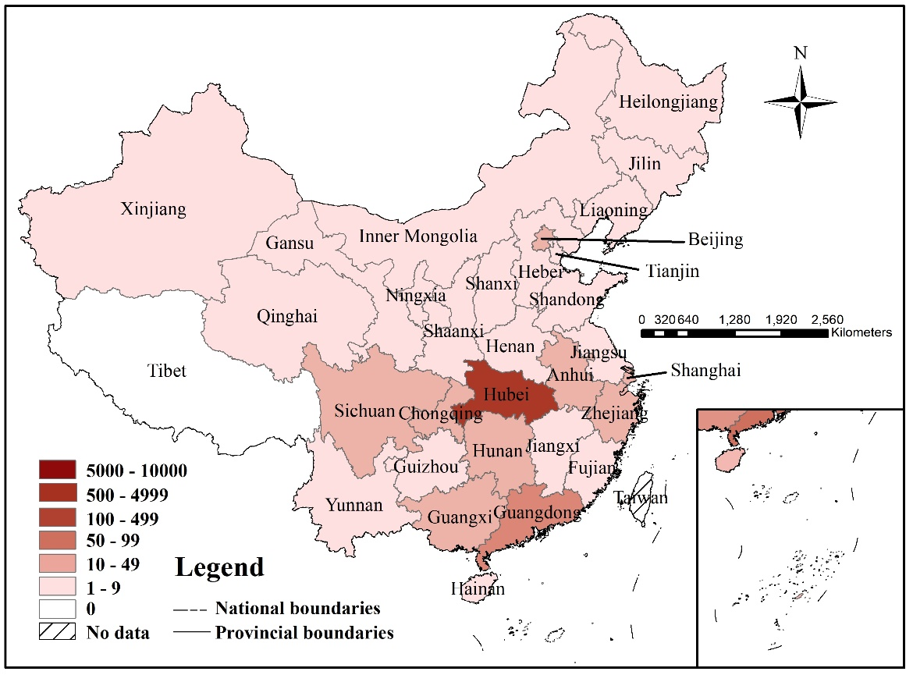
Figure 2. The number of infected people according to Chinese Province (as of 23 January 2020, before Chinese New Year)

Appendix 3
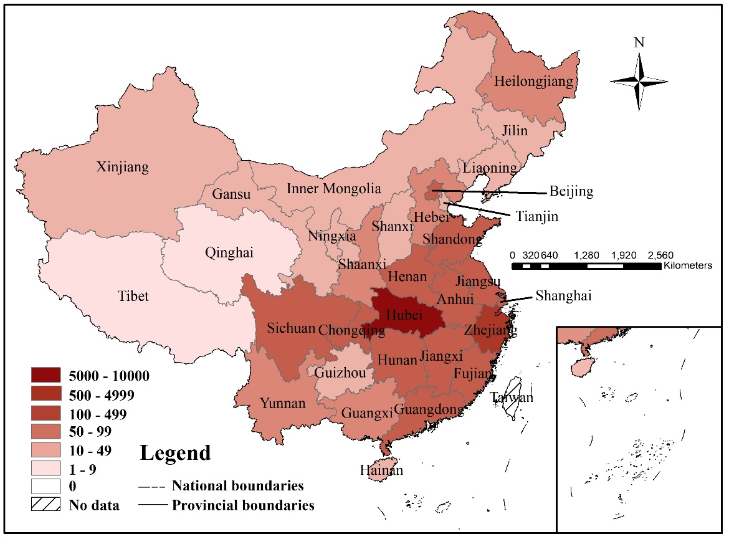
Figure 3. The number of infected people according to Chinese Province (as of 30 January 2020, after the Chinese New Year)

