Appendix

Figure 1. The number of newly infected people (per week)

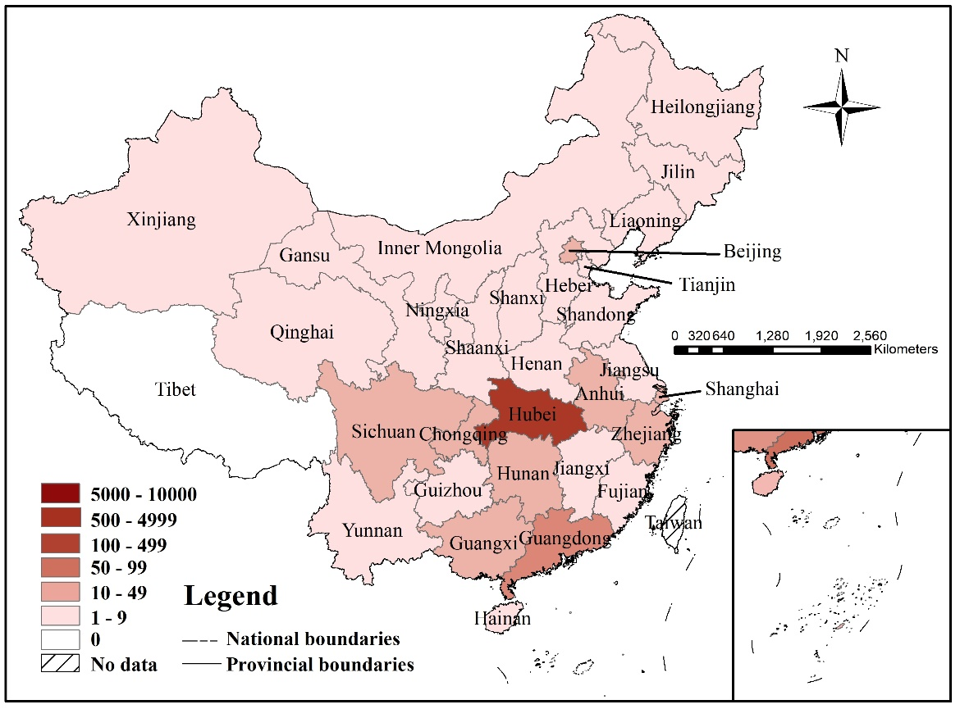
Figure 2. The number of infected people according to Chinese Province (as of 23 January 2020)
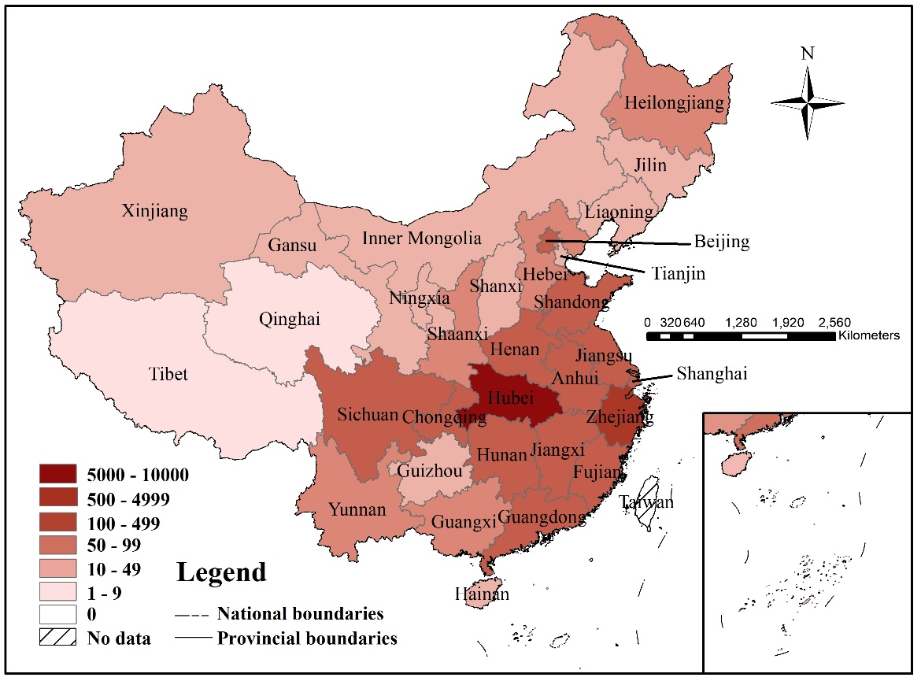
Figure 3. The number of infected people according to Chinese Province (as of 30 January 2020)

