Supplementary Material
Realization of 2D Multiferroic with Strong Magnetoelectric Coupling by Intercalation: A First-principles High-throughput Prediction
Ying Zhao ¹, Yanxia Wang ¹, Yue Yang ¹, Jijun Zhao ^{1, 2, 3}, Xue Jiang ^{1, 2, 3}*
¹Key Laboratory of Materials Modification by Laser, Ion and Electron Beams (Ministry of Education), Dalian University of Technology, Dalian 116024, China
² Guangdong Basic Research Center of Excellence for Structure and Fundamental Interactions of Matter, Guangdong Provincial Key Laboratory of Quantum Engineering and Quantum Materials, School of Physics, South China Normal University, Guangzhou 510006, China
³Guangdong-Hong Kong Joint Laboratory of Quantum Matter, Frontier Research Institute for Physics, South China Normal University, Guangzhou 510006, China

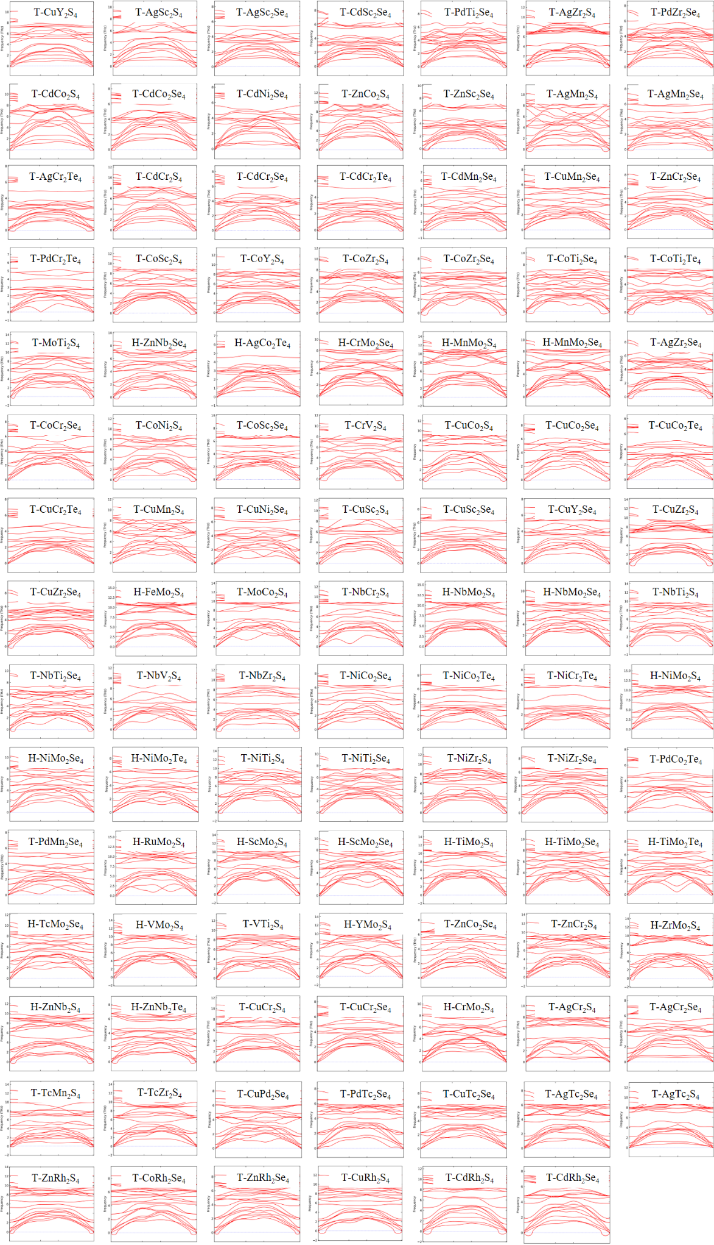
Supplementary Figure 1. Phonon dispersion for the 2D AM₂X₄ materials with dynamic stability.
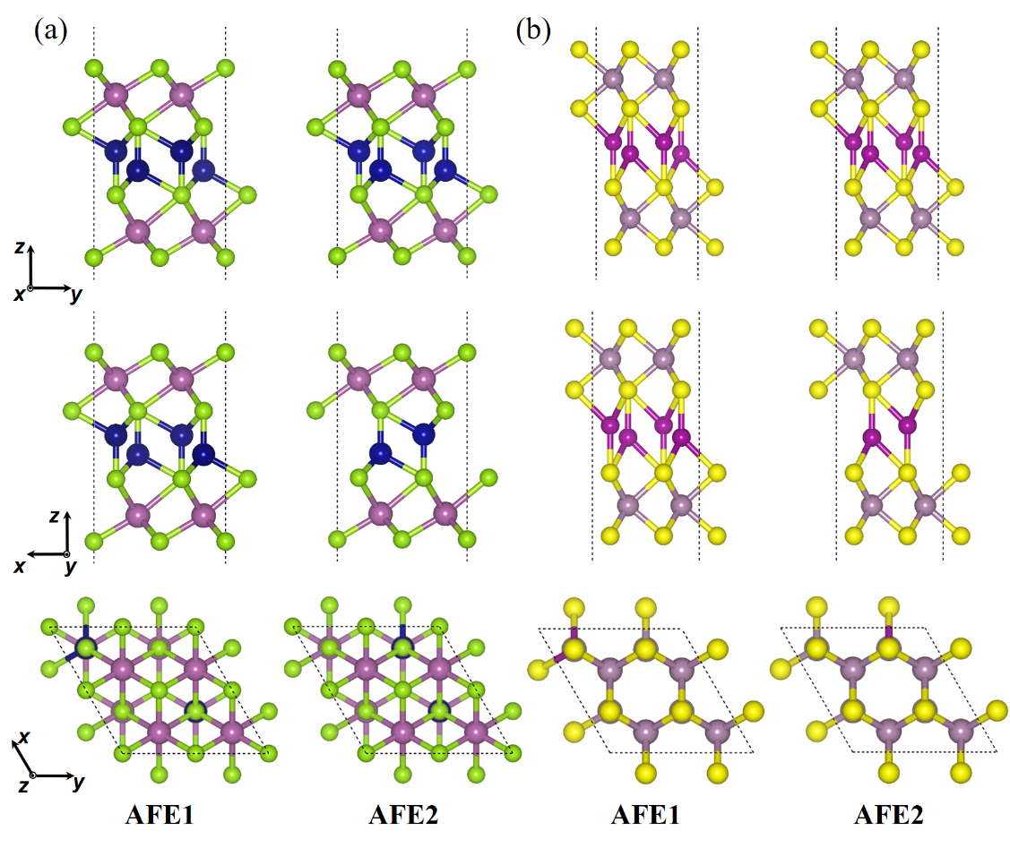
Supplementary Figure 2. Schematic diagrams of the AFE1 and AFE2 configures for the (a) T-AM₂X₄ and (b) H-AM₂X₄ materials.

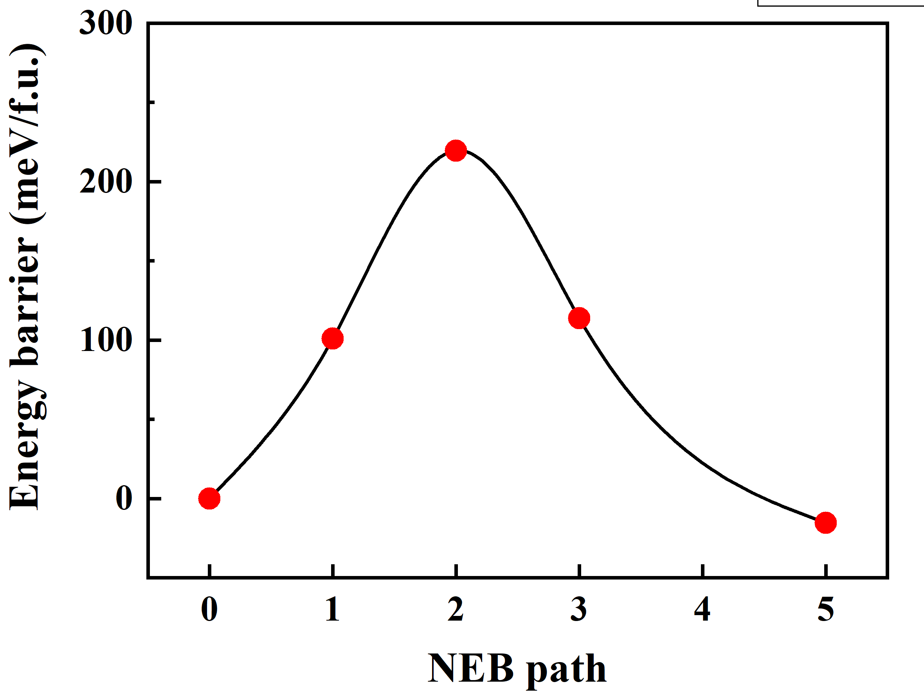
Supplementary Figure 3. The energy barrier of FE-AFE2 transition path in T-CoTi₂Te₄ monolayer.

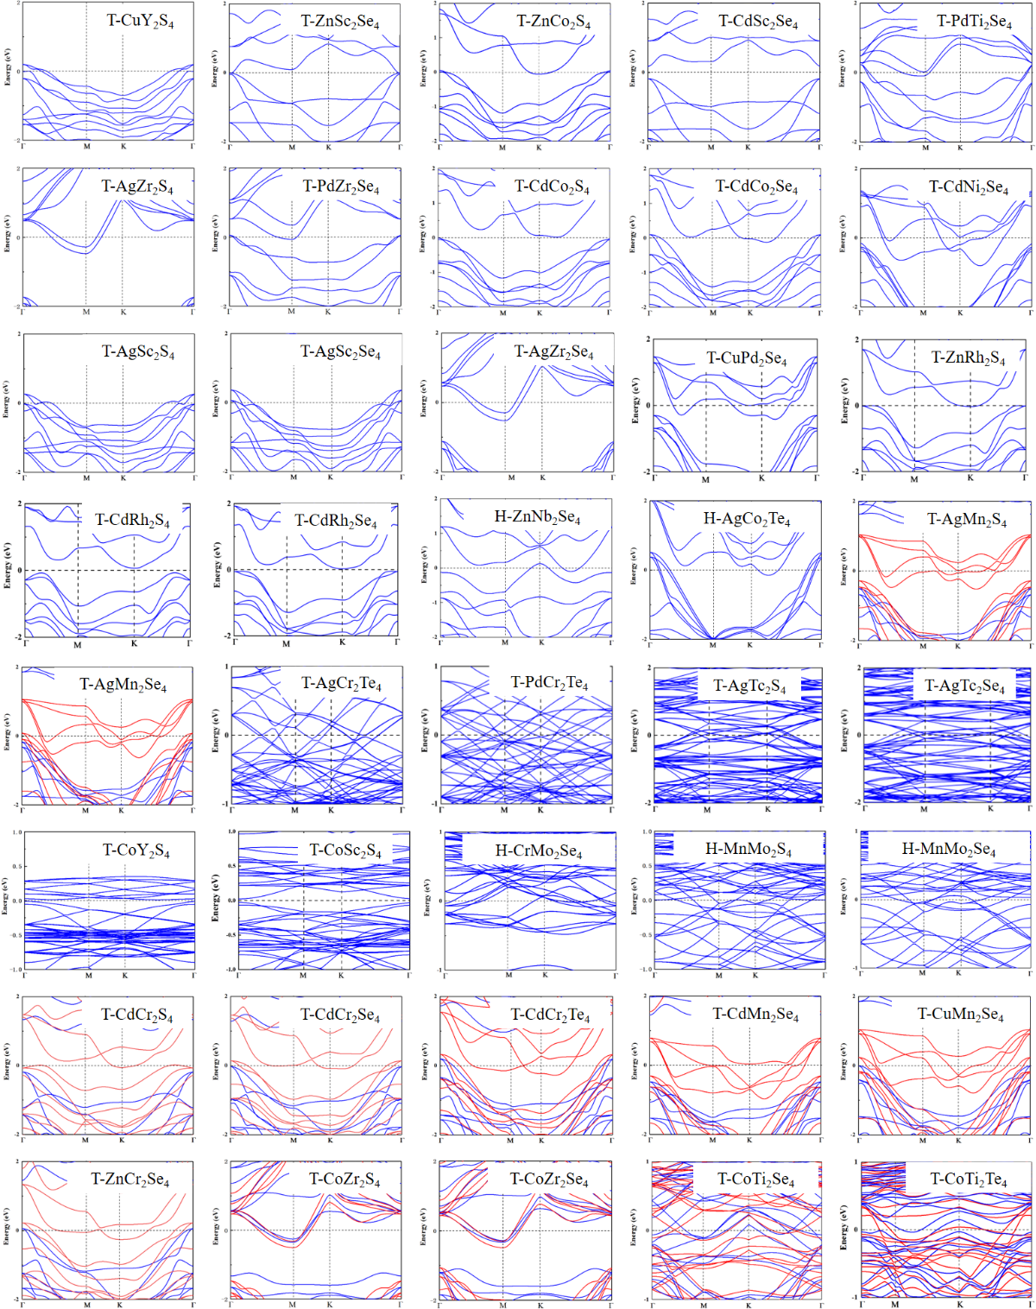
Supplementary Figure 4. The electronic band structures at the GGA+U level of 2D AM₂X₄. The red and blue indicate the spin majority and spin minority channels, respectively, and the Femi energy level is set to zero.

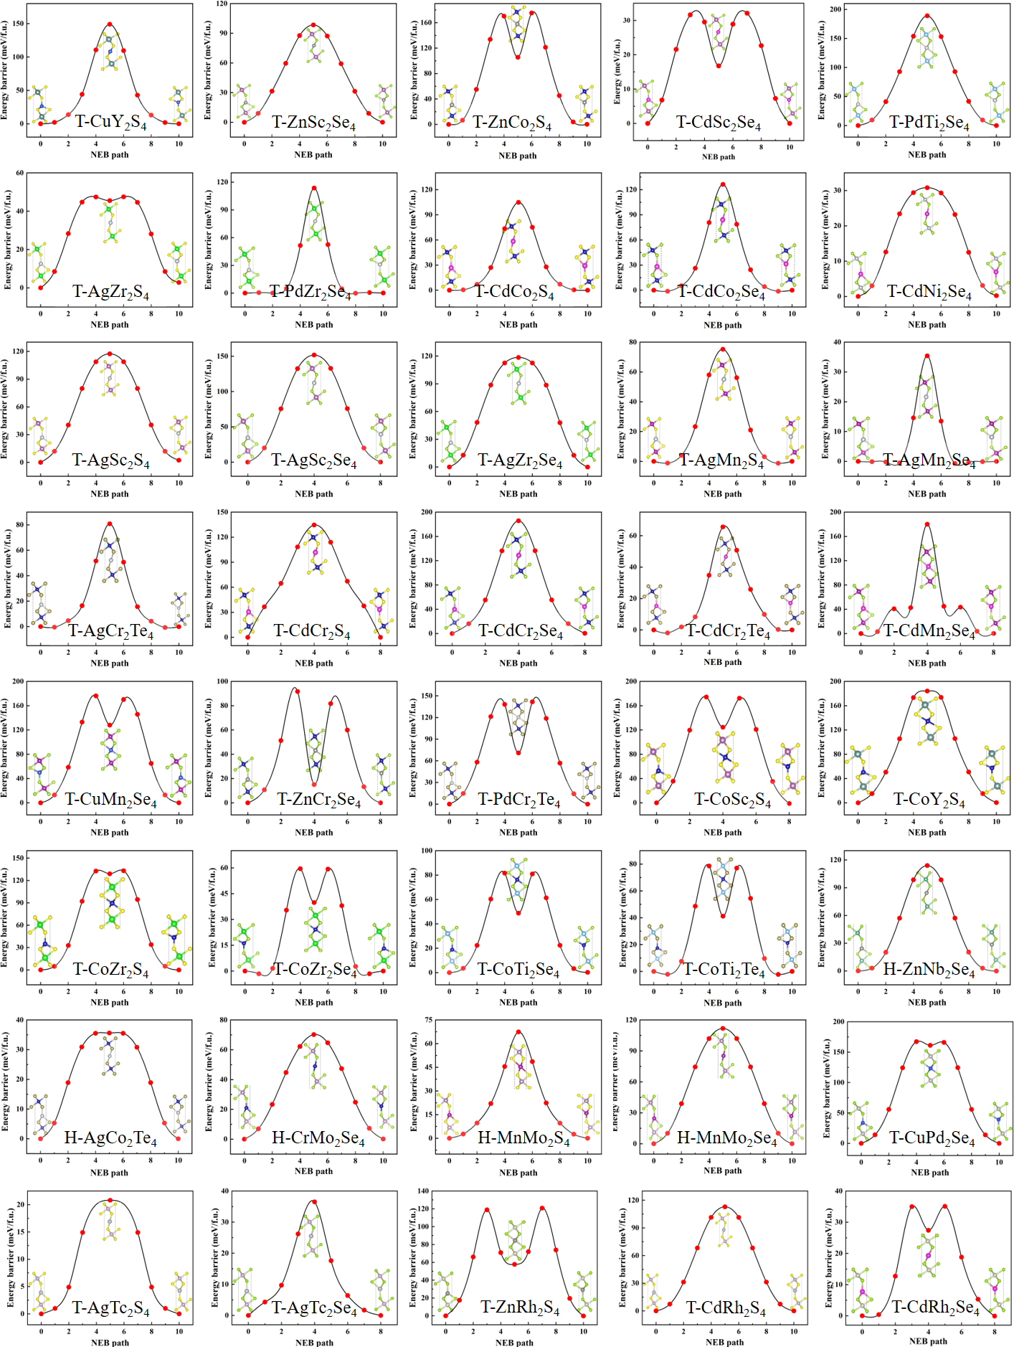
Supplementary Figure 5. The minimum energy path for transitions between FE states with opposite polarization in the AM₂X₄ monolayer. Insets show the crystal structures of the FE1, PE, and FE2 phases for the AM₂X₄ monolayer.

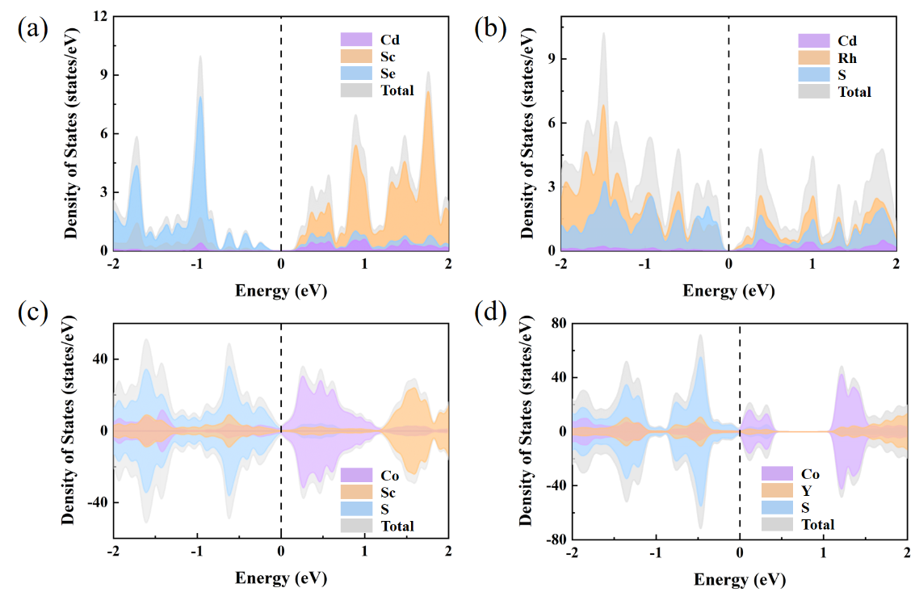
Supplementary Figure 6. The density of states (DOS) and projected density of states (PDOS) of the (a) T-CdSc₂Se₄, (b) CdRh₂S₄, (c) T-CoSc₂S₄ and (c) T-CoY₂S₄ with semiconductor behavior. The Fermi level is set as zero and marked by the black dotted line.

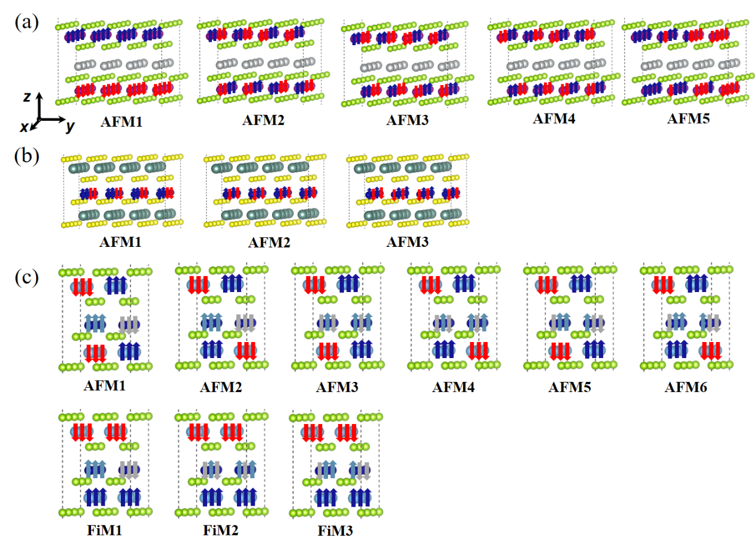
Supplementary Figure 7. Schematic diagrams of the AFM magnetic configures of (a) type-a and (b) type-b multiferroic materials. (c) are the different AFMs and FiMs configures for the type-c multiferroic materials. The spin orientations of the magnetic atoms are indicated by the arrows with different colors.

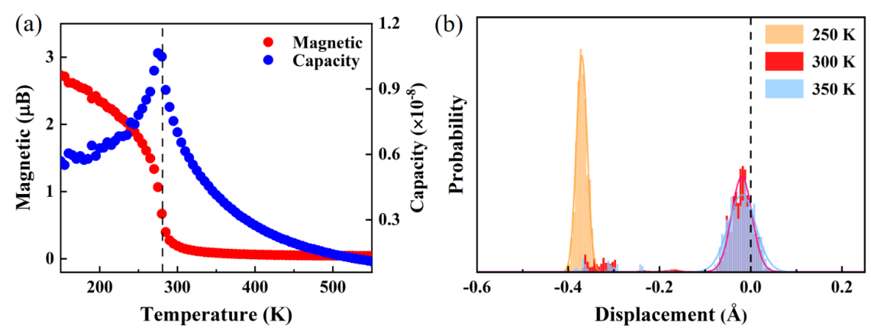
Supplementary Figure 8. (a) Net magnetic moment per magnetic atom and specific heat as a function of temperature using the Heisenberg model for 2D T-CdCr₂Te₄ from the Monte Carlo simulation. (b) Distributions of Cd displacements in the T-CdCr₂Te₄ monolayer along z-direction from the centrosymmetric position at T = 250 K (orange), 300 K (red) and 350 K (blue), respectively.

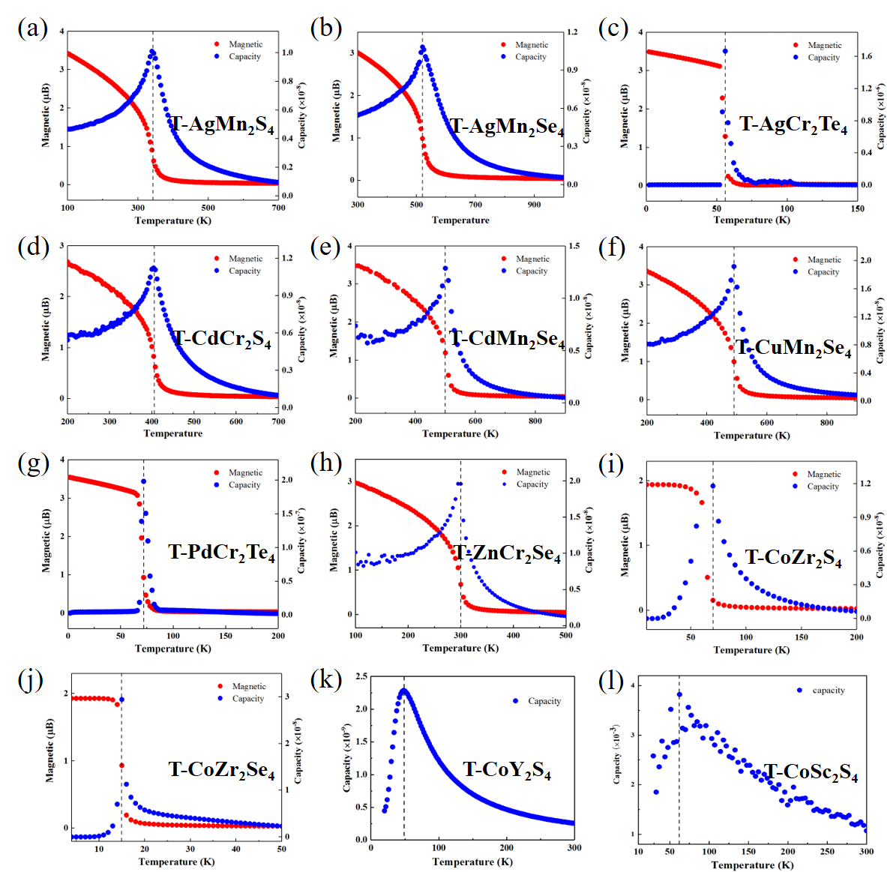
Supplementary Figure 9. Net magnetic moment per magnetic atom and speciﬁc heat as a function of temperature using the (a)-(i) Heisenberg model and (j)-(n) Ising model for 2D AM₂X₄ from the Monte Carlo simulated.

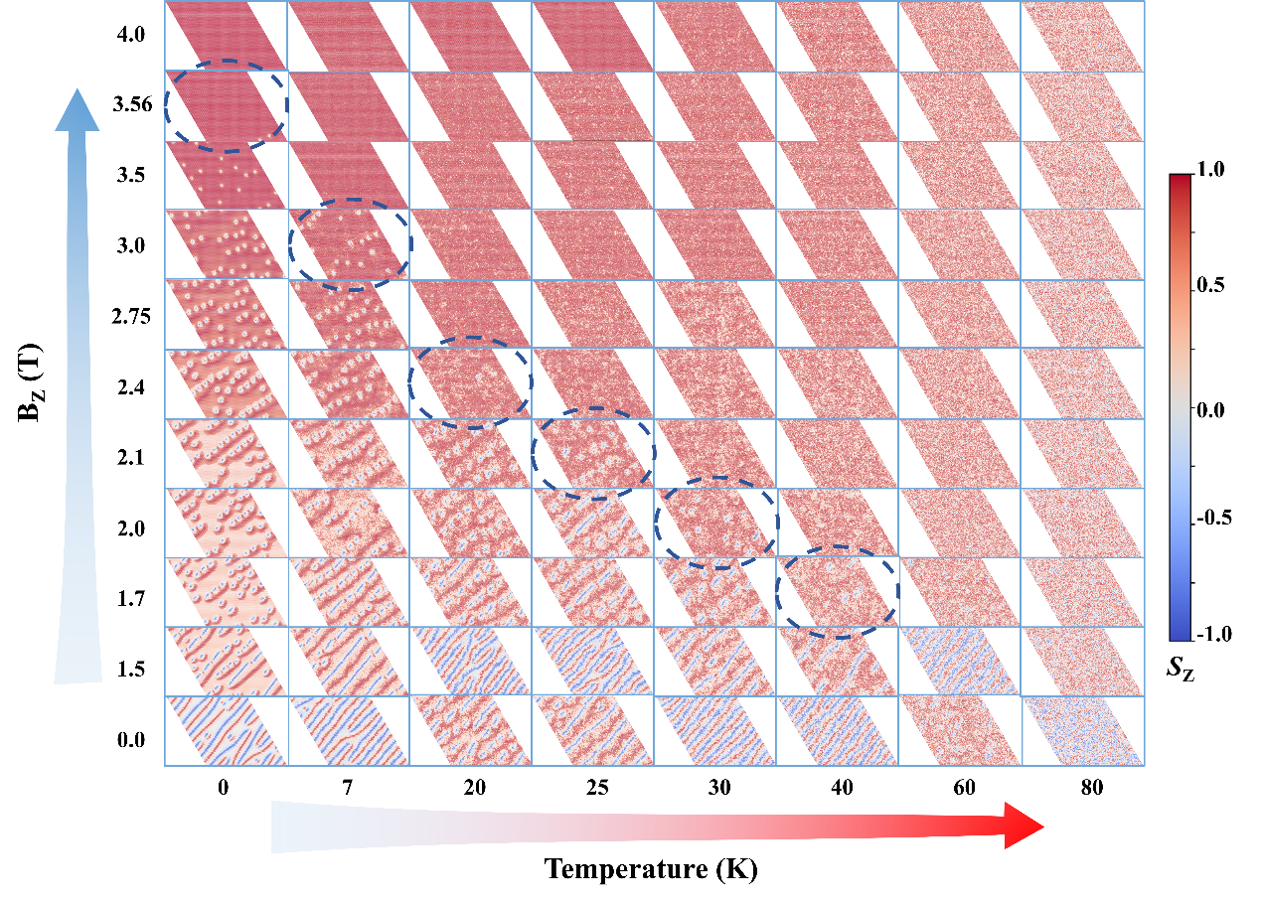
Supplementary Figure 10. The top views of different spin textures from MC simulations snapshots for neighbor Cr-Cr pairs of T-CdCr₂Te₄ bottom layers in FE2 state under increased temperatures and different external perpendicular magnetic field, where the blue dashed line encircles the critical magnetic field when skyrmions disappear at different temperatures.

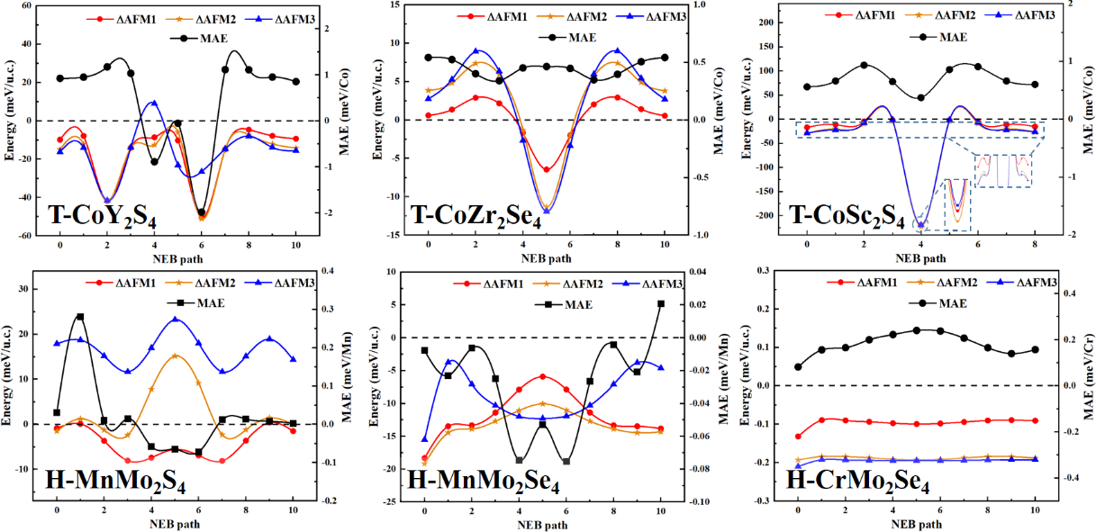
Supplementary Figure 11. Changes in magnetic ground state and MAE during FE inversion process for other type-b multiferroic materials. The red, orange, and blue lines represent the energy differences of AFM1, AFM2, and AFM3 compared to the FM state, respectively, while the black line represents the MAE corresponding to different transition states.

Supplementary Table 1. 960 different 2D AM₂X₄ structures were generated by replacing the intercalated A atoms and M atoms in the H phase and T phase MX₂ (H-MX₂ and T-MX₂) bilayer with 3d/4d transition metal elements. MX₂ with superscript [*] indicates that the corresponding thin layer or monolayer has been prepared in the experiment. The values in parentheses of A elements are the effective Hubbard parameter U_{eff} of the 3d/4d transition metal elements we used in calculation, the unit is eV.
Site | Elements
TM | Sc (3.3), Ti (2.3), V (2.72), Cr (2.82), Mn (3.06), Fe (3.29), Co (3.41), Ni (3.40), Cu (5.0), Zn (4.0),  Y (2.0), Zr (2.60), Nb (2.04), Mo (2.18), Tc (2.28), Ru (2.42), Rh (2.80), Pd (3.35), Ag (4.0), Cd (2.0)
T-MX₂ | ScS₂, ScSe₂, TiS₂*, TiSe₂*, VS₂*, VSe₂*, CrS₂*, CrSe₂*, MnS₂*, MnSe₂, FeS₂, FeSe₂, CoS₂*, CoSe₂*, NiS₂*, NiSe₂, CuS₂, CuSe₂, ZnS₂*, ZnSe₂*, YS₂, YSe₂, ZrS₂, ZrSe₂, NbS₂*, NbSe₂*, MoS₂*, MoSe₂, TcS₂, TcSe₂, RuS₂, RuSe₂, RhS₂, RhSe₂, PdS₂, PdSe₂, AgS₂, AgSe₂, TiTe₂*, VTe₂*, CrTe₂*, CoTe₂*
H-MX₂ | MoS₂*, MoSe₂*, MoTe₂*, NbS₂*, NbSe₂*, NbTe₂*

Supplementary note in Supplementary Table 1
Considering that 2H-TMD monolayers are easier to synthesize in experiments than 1T-TMD counterpart, and that the synthetic 2D TMDs containing S or Se element is more common than those with Te elements, the considered TMD host lattices are restricted in all H-MX₂ (X = S/Se), as well as experimentally prepared 2H-MTe₂ and 1T-MX₂ (X = S/Se/Te).¹⁻⁶

Supplementary Table 2. The heat of formation (E_{f}) of 100 dynamically stable structures, the unit is eV/atom.
Material | E_{f} | Material | E_{f} | Material | E_{f} | Material | E_{f}
T-ZnSc₂Se₄ | −1.32 | T-CoY₂S₄ | −1.49 | T-NbTi₂S₄ | −0.76 | H-YMo₂S₄ | −0.71
T-ZnCo₂S₄ | −0.40 | T-CoZr₂S₄ | −1.11 | T-NbTi₂Se₄ | −0.50 | T-ZnCo₂Se₄ | −0.01
T-PdTi₂Se₄ | −0.93 | T-CoZr₂Se₄ | −1.13 | T-NbV₂S₄ | −0.75 | T-ZnCr₂S₄ | −0.74
T-PdZr₂Se₄ | −1.61 | H-CrMo₂Se₄ | −0.58 | T-NbZr₂S₄ | −0.86 | H-ZrMo₂S₄ | −0.71
T-AgSc₂S₄ | −1.28 | H-MnMo₂S₄ | −0.87 | T-NiCo₂Te₄ | −0.08 | H-ZnNb₂S₄ | −0.96
T-AgSc₂Se₄ | −1.18 | H-MnMo₂Se₄ | −0.66 | T-NiCr₂Te₄ | −0.65 | H-ZnNb₂Te₄ | −0.26
T-AgZr₂S₄ | −1.18 | T-CoTi₂Se₄ | −0.94 | H-NiMo₂S₄ | −0.82 | T-CuCr₂S₄ | −0.76
T-AgZr₂Se₄ | −1.12 | T-CoTi₂Te₄ | −0.51 | H-NiMo₂Se₄ | −0.45 | T-CuCr₂Se₄ | −0.76
T-CdSc₂Se₄ | −1.28 | T-MoTi₂S₄ | −0.63 | H-NiMo₂Te₄ | −0.07 | H-CrMo₂S₄ | −0.75
T-CdCo₂S₄ | −0.64 | T-CoCr₂Se₄ | −0.50 | T-NiTi₂S₄ | −0.80 | T-AgCr₂S₄ | −0.70
T-CdCo₂Se₄ | −0.24 | T-CoSc₂Se₄ | −0.83 | T-NiTi₂Se₄ | −0.60 | T-AgCr₂Se₄ | −0.62
T-CdNi₂Se₄ | −0.22 | T-CrV₂S₄ | −0.95 | T-NiZr₂S₄ | −1.00 | T-CuPd₂Se₄ | −0.19
T-CuYS₄ | −1.36 | T-CuCo₂S₄ | −0.31 | T-NiZr₂Se₄ | −0.82 | T-PdTc₂Se₄ | −0.50
H-ZnNb₂Se₄ | −0.12 | T-CuCo₂T₄ | −0.05 | T-PdCo₂Te₄ | −0.13 | T-CuTc₂Se₄ | −0.51
H-AgCo₂Te₄ | −0.07 | T-CuCr₂Te₄ | −0.58 | T-PdMn₂Se₄ | −0.64 | T-AgTc₂Se₄ | −0.50
T-AgMn₂S₄ | −0.97 | T-CuMn₂S₄ | −0.72 | H-RuMo₂S₄ | −0.63 | T-AgTc₂S₄ | −0.60
T-AgMn₂Se₄ | −0.86 | T-CuSc₂S₄ | −0.92 | H-ScMo₂S₄ | −0.74 | T-ZnRh₂S₄ | −0.13
T-ZnCr₂Se₄ | −0.98 | T-CuSc₂Se₄ | −0.80 | H-ScMo₂Se₄ | −0.53 | T-CuRh₂S₄ | −0.01
T-CuMn₂Se₄ | −0.89 | T-CuY₂Se₄ | −1.18 | H-TiMo₂S₄ | −0.72 | T-CdRh₂S₄ | −0.04
T-CdMn₂Se₄ | −1.04 | T-CuZr₂S₄ | −0.97 | T-TcMn₂S₄ | −0.76 | T-CoRh₂Se₄ | −0.26
T-CdCr₂S₄ | −1.01 | T-CuZr₂Se₄ | −0.81 | T-TcZr₂S₄ | −0.92 | T-ZnRh₂Se₄ | −0.07
T-CdCr₂Se₄ | −0.92 | H-FeMo₂S₄ | −0.66 | H-TiMo₂Se₄ | −0.46 | T-CdRh₂Se₄ | −0.02
T-CdCr₂Te₄ | −0.60 | T-MoCo₂S₄ | −0.35 | H-TiMo₂Te₄ | −0.03 | T-CoNi₂S₄ | 0.06
T-AgCr₂Te₄ | −0.57 | T-NbCr₂S₄ | −0.67 | H-TcMo₂Se₄ | −0.34 | T-CuCo₂Se₄ | 0.09
T-PdCr₂Te₄ | −0.61 | H-NbMo₂S₄ | −0.64 | H-VMo₂S₄ | −0.75 | T-CuNi₂Se₄ | 0.14
T-CoSc₂S₄ | −1.41 | H-NbMo₂Se₄ | −0.36 | T-VTi₂S₄ | −0.98 | T-NiCo₂Se₄ | 0.07

Supplementary Table 3. Calculated total energy difference (eV/u.c.) of different AFE configures with respect to FE states in a 2 × 2 × 1 supercell for the structures with FE transition barrier below 200 meV/u.c..
Material | ΔAFE1  (eV/u.c.) | ΔAFE2  (eV/u.c.) | Material | ΔAFE1  (eV/u.c.) | ΔAFE2  (eV/u.c.)
T-ZnSc₂Se₄ | 0.77 | 0.08 | T-AgMn₂Se₄ | 1.31 | 0.66
T-ZnCo₂S₄ | 1.31 | 0.50 | T-ZnCr₂Se₄ | 0.98 | 0.43
T-PdTi₂Se₄ | 0.70 | 0.30 | T-CuMn₂Se₄ | 0.43 | 0.28
T-PdZr₂Se₄ | 0.20 | 0.06 | T-CdMn₂Se₄ | 1.63 | 0.86
T-AgSc₂S₄ | 1.04 | 0.46 | T-CdCr₂S₄ | 2.80 | 1.22
T-AgSc₂Se₄ | 0.71 | 0.30 | T-CdCr₂Se₄ | 1.88 | 0.84
T-AgZr₂S₄ | 1.34 | 0.61 | T-CdCr₂Te₄ | 9.00 | 0.42
T-AgZr₂Se₄ | 0.85 | 0.38 | T-AgCr₂Te₄ | 0.77 | 0.36
T-CdSc₂Se₄ | 1.42 | 0.46 | T-PdCr₂Te₄ | 0.22 | 0.09
T-CdCo₂S₄ | 4.17 | 1.92 | T-AgTc₂S₄ | 2.62 | 1.24
T-CdCo₂Se₄ | 2.52 | 1.15 | T-AgTc₂Se₄ | 1.58 | 0.75
T-CdNi₂Se₄ | 2.77 | 1.34 | T-CoSc₂S₄ | 0.67 | 0.26
T-CuY₂S₄ | 0.60 | 0.39 | T-CoY₂S₄ | 0.81 | 0.31
H-ZnNb₂Se₄ | 0.52 | 0.18 | T-CoZr₂S₄ | 0.31 | 0.16
H-AgCo₂Te₄ | 1.48 | 0.71 | T-CoZr₂Se₄ | 0.27 | 0.12
T-CuPd₂Se₄ | 0.30 | 0.20 | H-CrMo₂Se₄ | 2.52 | 1.79
T-ZnRh₂S₄ | 0.75 | 0.29 | H-MnMo₂S₄ | 2.88 | 1.36
T-CdRh₂S₄ | 2.93 | 1.33 | H-MnMo₂Se₄ | 2.40 | 1.17
T-CdRh₂Se₄ | 1.88 | 0.87 | T-CoTi₂Se₄ | 0.29 | 0.09
T-AgMn₂S₄ | 1.92 | 0.88 | T-CoTi₂Te₄ | 0.11 | −0.02

Supplementary Table 4. Calculated total energy difference (meV/u.c.) of different AFM with respect to FM configures in a 4 × 4 × 1 supercell for the type-a and type-b multiferroic materials.
Material | ΔAFM1  (meV/u.c.) | ΔAFM2  (meV/u.c.) | ΔAFM3  (meV/u.c.) | ΔAFM4  (meV/u.c.) | ΔAFM5  (meV/u.c.)
T-AgMn₂S₄ | 186.28 | 152.18 | 162.22 | 174.35 | 141.01
T-AgMn₂Se₄ | 59.48 | 187.97 | 191.57 | 206.48 | 175.50
T-ZnCr₂Se₄ | 2.34 | 125.31 | 123.14 | 138.89 | 96.90
T-CuMn₂Se₄ | 118.57 | 189.50 | 197.48 | 210.12 | 170.08
T-CdMn₂Se₄ | 0.43 | 2.94 | 3.00 | 3.27 | 2.53
T-CdCr₂S₄ | 3.00 | 135.80 | 135.65 | 153.63 | 115.22
T-CdCr₂Se₄ | 2.69 | 136.39 | 135.52 | 154.42 | 113.81
T-CdCr₂Te₄ | 3.04 | 119.12 | 118.24 | 137.65 | 96.07
T-AgCr₂Te₄ | −3.43 | 31.05 | 28.86 | 37.92 | 22.36
T-PdCr₂Te₄ | −11.68 | 59.41 | 60.73 | 72.92 | 42.31
T-AgTc₂S₄ | −11.63 | 82.45 | 88.91 | 155.11 | 69.95
T-AgTc₂Se₄ | −10.93 | 100.20 | 122.10 | 161.99 | 85.79
T-CoSc₂S₄ | −17.16 | −29.15 | −29.01 | − | −
T-CoY₂S₄ | -9.83 | −14.87 | −16.18 | − | −
T-CoZr₂S₄ | 2.92 | 7.31 | 6.40 | − | −
T-CoZr₂Se₄ | 0.61 | 3.85 | 2.75 | − | −
H-CrMo₂Se₄ | −132.01 | −195.63 | −211.21 | − | −
H-MnMo₂S₄ | −0.86 | -1.50 | 17.88 | − | −
H-MnMo₂Se₄ | −18.71 | −19.87 | −108.36 | − | −

Supplementary Table 5. The nearest-, second- and third- neighbor magnetic exchange coupling parameters (meV) in the intralayer (J₁^{intra}, J₂^{intra}, J₃^{intra}), and the nearest-, second neighbor couplings in the interlayer (J₁^{inter}, J₂^{inter}) of the type-a multiferroic materials. The nearest-, second- and third- neighbor magnetic exchange coupling parameters (meV) in the intralayer (J₁^{intra}, J₂^{intra}, J₃^{intra}) of the type-b multiferroic materials.
Material | J₁^{intra} (meV) | J₂^{intra} (meV) | J₃^{intra} (meV) | J₁^{inter} (meV) | J₂^{inter} (meV)
T-AgMn₂S₄ | 0.71 | −0.36 | 0.23 | −0.31 | 2.25
T-AgMn₂Se₄ | 1.27 | 0.23 | 0.13 | −0.11 | 0.73
T-ZnCr₂Se₄ | 0.95 | −0.28 | 0.79 | 0.09 | −0.06
T-CuMn₂Se₄ | 0.76 | −0.26 | −0.24 | 0.65 | 1.45
T-CdMn₂Se₄ | 0.96 | −0.11 | −0.10 | 0.58 | 0.35
T-CdCr₂S₄ | 1.68 | 0.04 | 0.25 | 0.01 | 0.04
T-CdCr₂Se₄ | 1.55 | −0.002 | 0.25 | 0.04 | 0.001
T-CdCr₂Te₄ | 1.36 | −0.10 | 0.18 | 0.03 | 0.005
T-AgCr₂Te₄ | 0.65 | −0.0002 | −0.16 | 0.09 | −0.14
T-PdCr₂Te₄ | 0.75 | −0.30 | 0.33 | −0.05 | −0.10
T-AgTc₂S₄ | 12.45 | 0.70 | −7.93 | −0.55 | 0.22
T-AgTc₂Se₄ | 6.98 | −1.16 | −2.03 | −1.75 | 1.46
T-CoSc₂S₄ | −1.15 | −0.12 | −0.05 | − | −
T-CoY₂S₄ | −0.59 | −0.05 | −0.09 | − | −
T-CoZr₂S₄ | 0.48 | 0.01 | −0.06 | − | −
T-CoZr₂Se₄ | 0.27 | −0.02 | −0.08 | − | −
H-CrMo₂Se₄ | −2.77 | −0.29 | −0.39 | − | −
H-MnMo₂S₄ | −0.09 | −0.17 | −0.03 | − | −
H-MnMo₂Se₄ | 0.28 | −0.30 | 0.15 | − | −

Supplementary Table 6. The calculated total energy difference (meV/u.c.) between different FiMs and AFMs relative to FM states in a 2 × 3 × 1 supercell for the type-c multiferroic materials.
 | T-CoTi₂Se₄ | T-CoTi₂Te₄
ΔFiM1 (meV/u.c.) | −27.24 | −2.38
ΔFiM2 (meV/u.c.) | −24.97 | −14.43
ΔFiM3 (meV/u.c.) | −25.21 | −15.74
ΔAFM1 (meV/u.c.) | 41.69 | 73.88
ΔAFM2 (meV/u.c.) | 77.33 | 115.65
ΔAFM3 (meV/u.c.) | 34.70 | 24.15
ΔAFM4 (meV/u.c.) | 41.41 | 32.92
ΔAFM5 (meV/u.c.) | 40.01 | 31.48
ΔAFM6 (meV/u.c.) | 32.89 | 28.14

Supplementary References
1 Zhang, Z. et al. Recent progress in the controlled synthesis of 2D metallic transition metal dichalcogenides. Nanotechnology 30, 182002, (2019).
2 Wang, K. et al. Few-layer NbTe₂ nanosheets as substrates for surface-enhanced Raman scattering analysis. ACS Appl. Nano Mater. 3, 11363-11371 (2020).
3 Wang, P. et al. Emerging Phases of Layered Metal Chalcogenides. Small 18, e2105215, (2022).
4 Ge, Y. et al. Two-dimensional nanomaterials with unconventional phases. Chem 6, 1237-1253 (2020).
5 Coleman, J. N. et al. Two-dimensional nanosheets produced by liquid exfoliation of layered materials. Science 331, 568-571, (2011).
6 Raza, A. et al. Advances in liquid‐phase and intercalation exfoliations of transition metal dichalcogenides to produce 2D framework. Adv. Mater. Interfaces 8, 2002205 (2021).

* Corresponding Authors. Email: jiangx@dlut.edu.cn (Xue Jiang)

