Image 1. Histopathological features of the wound sections from Sham, Dxp, and SM groups on the 5th, 10th, and 15th days. H-E staining (×200) shows epithelization and inflammation whereas MT (×40) staining shows collagenization of the wounds of the tissues.
Image 2. Immunohistochemical staining (×200) of the E-Cadherin, Occludin, N-Cadherin, Vimentin, FGF1, MMP-9, Claudin-1, VEGF-A, NfκB, and TNFα proteins from Sham, Dxp, and SM groups on the 5th, 10th, and 15th days.
Image 1.
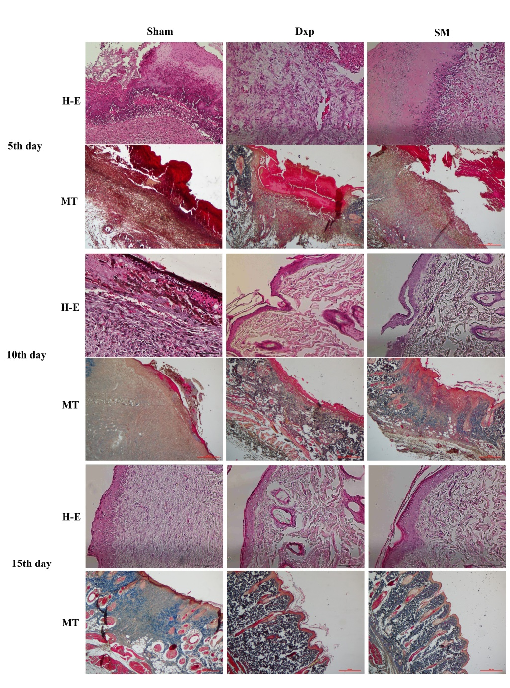
Image 2.
