SUPPLEMENTAL MATERIAL
Supplemental Figure 1.
A. Standardized pictograms designed for this proof-of-concept study.
B. Simulation of the pictograms for different skin colors
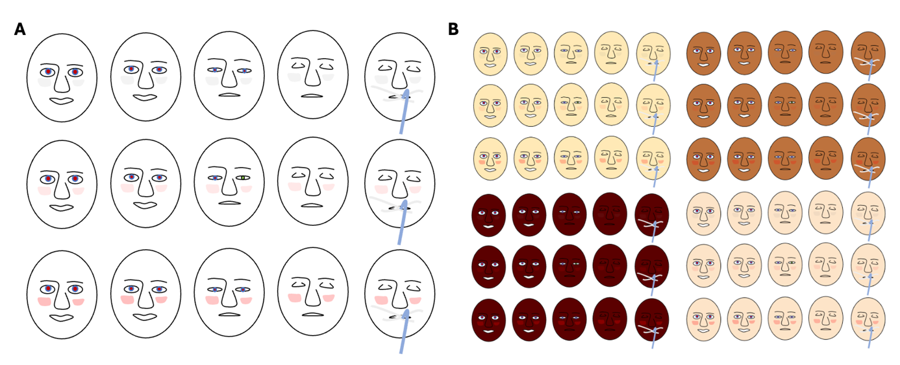

Supplemental Figure 2. Flowchart of study inclusion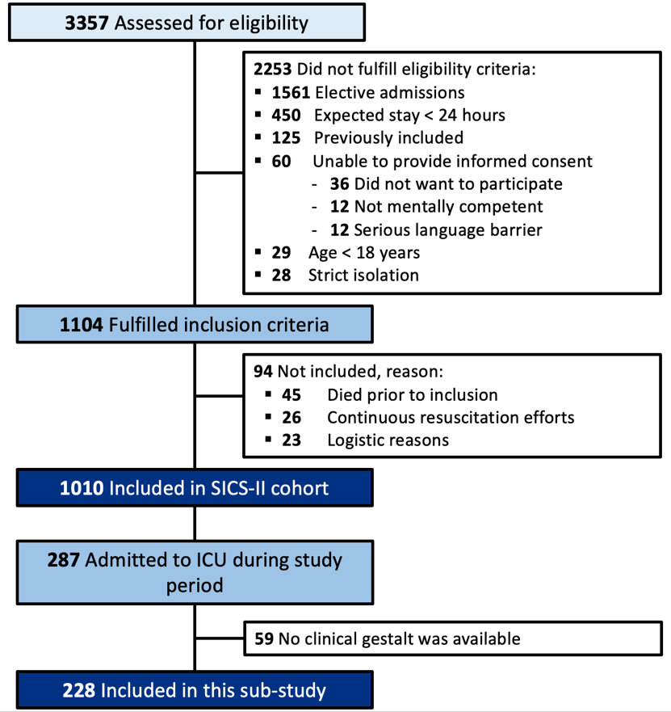
Supplemental Figure 3. Interaction between the two traits of gestalt eye opening and facial color
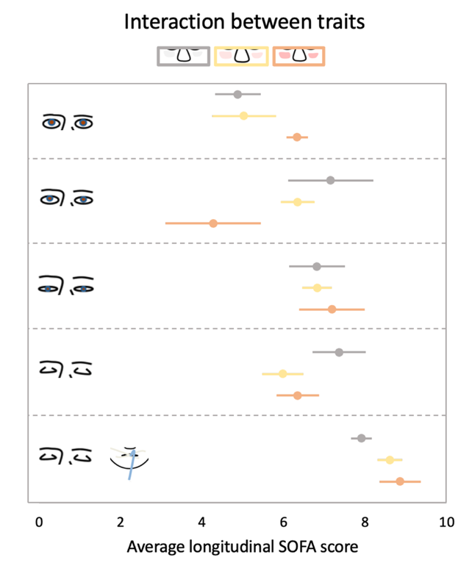
SOFA: Sequential Organ Failure Assessment; bars indicate standard error of the mean.

Supplemental Table 1. The SOFA score*
 | 1 | 2 | 3 | 4
Respiration  PaO2/FiO2 (mmHg) | ≤400 | ≤300 | ≤200ª | ≤100ª
Coagulation  Platelets (x10⁹ /l) | ≤150 | ≤100 | ≤50 | ≤20
Liver  Bilirubin (μmol/l) | 20-32 | 33-101 | 102-204 | >204
Cardiovascular  Hypotension^{b} | MAP <70 mmHg | Dopamine ≤5 or dobutamine (any dose) | Dopamine >5 or epinephrine ≤0.1 or norepinephrine ≤0.1 | Dopamine >15 or epinephrine >0.1 or norepinephrine >0.1
CNS  Glasgow Coma Scale | 13-14 | 10-12 | 6-9 | <6
Renal  Creatinine (μmol/l) or Urine output (ml/day) | 110-170 | 171-299 | 300-440 or  urine output <500 | >440 or  urine output <200
a: with respiratory support; b: adrenergic agents administered for at least one hour (doses given are in µg/kg × min).
Abbreviations: MAP: mean arterial pressure; CNS: central nervous system; SOFA: Sequential Organ Failure Assessment
*After completing the data, every patient had a SOFA score for each day at the ICU, resulting in 852 serial SOFA scores. On day one of admission, all patients had a SOFA score; on day two, 214 (94%) patients had a SOFA score, and on day three, 139 (61%) patients, and on day four, 96 (42%) patients had a SOFA score. On day five, 72 (32%) patients, day six, 58 (25%), and day seven, 45 (20%) patients had a SOFA score.

Reference
Vincent JL, Moreno R, Takala J, et al.: The SOFA (Sepsis-related Organ Failure Assessment) score to describe organ dysfunction/failure. On behalf of the Working Group on Sepsis-Related Problems of the European Society of Intensive Care Medicine. Intensive Care Med 1996; 22:707–10

