Supporting information
for
Synergistic oxidation and adsorption of As(III) in water using biochar-mediated Fe(II)/nano-CaO₂ system
Silu Lv ^{b}, Kaixia Zuo ^{b}, Mingyue Hu ^{b}, Xuewen Xie ^{b}, Min Liao ^{b}, Jie Li ^{b}, Yanhua Xie ^{a,b} ∗

ª State Key Laboratory of Geohazard Prevention and Geoenvironment Protection, Chengdu University of Technology, Chengdu 610059 China
^{b} College of Ecology and Environment, Chengdu University of Technology Chengdu 610059, China

Number of equations: 6
Number of figures: 6
Number of tables: 1

Figure list：
Fig. S1. Fe(II)/Fe(III) concentration in (a) nano-CaO₂ and (b) nano-CaO₂/RBC system.
Fig. S2. pH potential maps of As(III) and As(V).
Fig. S3. Orbital spectra of Fe 2p after reaction.
Fig. S4. O 1s orbital spectra of nano-CaO₂/RBC composite before (a) and after (b) reaction.
Fig. S5. (a) Influence of initial As(III) concentration on As(T) removal by nano-CaO₂/RBC system and changes in As(III) concentration during reactions of (b) 5 mg L⁻¹, (c) 10 mg L⁻¹, (d) 20 mg L⁻¹, (e) 30 mg L⁻¹, and (f) 40 mg L⁻¹.
Fig. S6. Adsorption isothermal models by Fe(II)/nano-CaO₂/RBC system at different initial As(III) concentrations：(a) Langmuir and (b) Freundlich.
Table S1. Isotherm modeling parameters for adsorption of As(III) at different temperatures.

Chemical reagents
The chemicals used in this research were of reagent grade, including sodium arsenite (Na₃AsO₃), hydrogen peroxide (H₂O₂, 30 wt%), polyethylene glycol (PEG200), ammonia (NH₃·H₂O, 25~28 wt%), hydrochloric acid (HCl, 37 wt%), nitric acid (HNO₃), sodium chloride (NaCl), sodium hydroxide (NaOH), sodium sulfate (Na₂SO₄), sulfuric acid (H₂SO₄, 98 wt%), sodium carbonate(Na₂CO₃), sodium metasilicate nonahydrate (Na₂SiO₃·9H₂O), copper chloride dihydrate (CuCl₂·2H₂O), zinc Chloride (ZnCl₂), cadmium chloride pentahydrate (CdCl₂·2.5H₂O), magnesium chloride hexahydrate (MgCl₂·6H₂O), potassium dichromate (K₂Cr₂O₇), lead nitrate (Pb(NO₃)₂), tert-butyl alcohol(C₄H₁₀O), 1,4-benzoquinone (C₆H₄O₂), potassium bromide (KBr), ferrous sulfate heptahydrate (FeSO₄·7H₂O). All the chemical agents were of analytical grade and without further purification. The stock solution of 10-mg L⁻¹ As(III) was prepared by using Na₃AsO₃. All the chemical agents were of analytical grade and without further purification.

The preparation of nano-CaO₂/RBC material
The preparation method of nano-CaO₂/RBC was based on our previous study with some modifications ^{[1]}(Li et al., 2020). Firstly, rice husk was prepared by the pyrolysis method under an air atmosphere at 500 °C for 2 h. The obtained biochar was then ground into 80 meshes (0.18 mm) for later use.
Secondly, 8mL NH₃⋅H₂O and 7.5mL PEG 200 were put into 20 mL Ca²⁺ solution at a concentration of 0.9 mol L⁻¹. After stirring at 180 rpm for 10 min, 6 mL of H₂O₂ solution was added into the mixture dropwise, and the nano-CaO₂ particles formed according to the reaction in Eq. (1):
(1)
Lastly, 2 g RBC was added to the nano-CaO₂ solution. After magnetically stirring for 2 h, the solid powder (nano-CaO₂/RBC) was collected by centrifuging the suspension at 5000 rpm for 5 min. The prepared nano-CaO₂/RBC particles were sufficiently rinsed and dried before use.

Molybdenum blue spectrophotometry
The basic principle of molybdenum blue spectrophotometry is that As(V) interacts with ammonium molybdate to form an arsenomolybdate complex. It is reduced to molybdenum blue in water by adding a reducing agent and the color is developed in a high temperature water bath. However, under the same conditions, As(III) does not react and does not show color, the absorbance of the reaction solution is proportional to the concentration of As(V). The operation is as follows: absorb a certain amount of filtrate in a stoppered colorimeter tube, add concentrated hydrochloric acid, colorant (10% ascorbic acid, 3% ammonium molybdate, 0.56% antimony potassium tartrate, 13.98% H₂SO₄ solution according to the volume ratio of 2: 2:1:5 mixed homogeneously) (colorant is now ready for use). Then add ultrapure water to the scale, fully shaken well and then left to stand for 30 minutes, through the spectrophotometer at a wavelength of 880 nm. The absorbance of blue antimony-arsenic-molybdate complex was measured by spectrophotometer at a wavelength of 880 nm with deionized water as blank.

Kinetic models
In this study, adsorption kinetics experiments of As(T) by Fe(II)/nano-CaO₂/RBC Fenton-like system were carried out. Chemical reaction kinetics was mainly used to characterize the chemical reaction rate ^{[2]}(Hu et al., 2015), and quasi-primary kinetics, quasi-secondary kinetics, and Elovich models were used to analyze the removal process for different As(III) concentrations. The quasi-primary kinetic model, quasi-secondary kinetic model, and Elovich model ^{[3]}(Wu et al., 2009) can be represented by Eqs. (2), (3), and (4), respectively:
(2)
(3)
(4)
where Q_{e} (mg L⁻¹) and Q_{t} (mg L⁻¹) are the amounts of As(T) removed at reaction equilibrium and time t, respectively; t (min) is the contact time; k₁ (min⁻¹) and k₂ (g mg⁻¹ min⁻¹) are the quasi-primary and quasi-secondary rate constants for As(T) removal, respectively. αE(g mg⁻¹ min⁻¹) is the initial adsorption efficiency; βE (g mg⁻¹) is the desorption constant related to the degree of surface coverage and activation energy for chemisorption.

Adsorption isotherm
As(III) contaminated solutions with concentrations of 10, 30, 50, 70, 100, 150, and 200 mg L⁻¹ were configured by adding 0.20 g L⁻¹ FeSO₄·7H₂O to the serum vials and 0.25g L⁻¹ nano-CaO₂/RBC composite, respectively. The temperature of the three sets of reaction water bath shaking was controlled to be 298 K, 308 K, and 318 K, respectively, at 200 rpm, and after shaking for 4 h.
The Langmuir isotherm assumes that the surface of the adsorbent is homogeneous and that the adsorption sites have equal adsorption affinities, which is suitable for fitting homogeneous or monolayer adsorption phenomena ^{[4]}(Zhu et al., 2017). Whereas the Freundlich isotherm describes a multilayer adsorption process that occurs on an inhomogeneous surface of the adsorbent, which is suitable for fitting non-homogeneous or multilayer adsorption phenomena ^{[5]}(Zhou et al., 2020).
The Langmuir Eqs. (5) is expressed as follows:
(5)
where Q_{e} is the equilibrium adsorption amount (mg g⁻¹); C_{e} is the equilibrium concentration (mg L⁻¹); Q_{m} is the theoretical maximum adsorption amount (mg g⁻¹); and K₁ is the adsorption equilibrium constant (L mg⁻¹), which is related to the affinity of the binding site.
The Freundlich Eqs. (6) was expressed as follows:
(6)
where K_{f} is the Freundlich constant and n is the heterogeneity factor.

Fe(II)/Fe(III) conversion
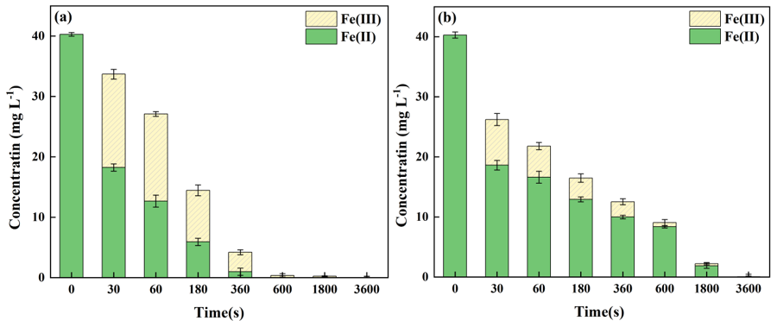
Fig. S1. Fe(II)/Fe(III) concentration in (a) nano-CaO₂ and (b) nano-CaO₂/RBC system.
Figure S1 demonstrates the variation of Fe(II)/Fe(III) concentration during the As(III) removal process in both nano-CaO₂ Fenton-like and nano-CaO₂/RBC Fenton-like systems. As can be seen in Fig. S1(a), in the nano-CaO₂ Fenton-like system, the concentration of Fe(II) in the solutin decreased fastly, and the ratio of Fe(II)/Fe(III) degreased gradually, which was attributed to the fast oxidation of Fe(II) to Fe(III). Besides, all of the Fe(II) and Fe(III) ions almost disappeared at 600 s due to the formation of iron hydroxides under alkaline environment after the reaction.
From Fig. S1(b), in the nano-CaO₂/RBC Fenton-like system, the solution concentration of Fe(II) gradually decreased, and some Fe(II) ions were still detceted at 1800 s. Besides, compared to the Fe(II)/nano-CaO₂ Fenton-like, the Fe(II)/nano-CaO₂/RBC Fenton-like system had a higher Fe(II)/Fe(III) ratio during the reaction process, indicating that the existence of RBC could promote the conversion of Fe(III) to Fe(II) and maintain a relatively high Fe(II) content in the solution. The relatively longer and higher Fe(II) content in the solution was facilitated the oxidation of As(III). However, almost no free iron ions existed in the final solution at 3600 s, which was owing to the precipitation and aggregation of Fe(III) or Fe(II). As the iron oxides or hydroxides have high affinity for As (V), the oxidized As (V) could be captured efficiently during the iron precipitation and transfrom into the insoluble complexes ^{[6-8]}(Ding et al., 2018; Dong et al., 2011; Wang et al., 2003).
Based on the above, it was shown that the presence of RBC has a positive contribution in the reaction. (i) Due to its excellent dispersive and catalytic properties, RBC had a good buffering capacity for solution pH. This scattering effect alleviated the release rate of H₂O₂ from nano-CaO₂ dissolution and reduced the disproportionation of H₂O₂, which significantly improved the utilized efficiency of nano-CaO₂ ^{[9]}(Wang et al., 2017). (ii) Due to the excellent electrical conductivity and abundant redox-active groups of RBC, the close contact between nano-CaO₂ and RBC could improve the electron transfer rate in the reaction system^{[10]}(Xie et al., 2023). (iii) The presence of PFRs in RBC accelerated the Fe(III)/Fe(II) conversion, increasing the Fe(II) content and persistence, which enhanced the oxidation and adsorption capabilities of the Fenton-like reaction ^{[11]}(Zhang et al., 2022).

pH potential maps of As(III) and As(V)
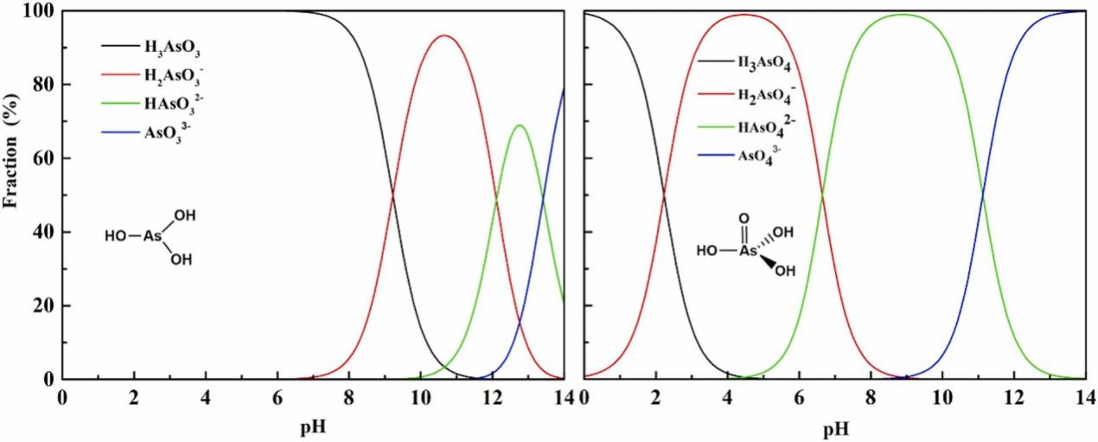
Fig. S2. pH potential maps of As(III) and As(V).
Figure S2 shows the species distribution of As(III) and As(V) in relation to pH. The inorganic arsenic compounds in water mainly existed in two forms, nonionic trivalent arsenite and ionic pentavalent arsenate, under different environmental conditions. For As(III), its main existence form is H₃AsO₃ in acidic environment, and the reaction activity is low in this existence form. As the pH increased to 7, H₂AsO₃⁻ began to appear accompanied by a decrease in H₃AsO₃. When the pH is 10, As(III) exists almost as H₂AsO₃⁻. When the pH was raised further, HAsO₃²⁻ and AsO₃³⁻ began to appear, accompanied by a gradual decrease to complete disappearance of H₂AsO₃⁻. For As(V), it exists mainly in the form of H₃AsO₄ and additionally in the form of H₂AsO₄⁻ at pH<2, which is not favorable for the removal reaction ^{[12]}(Zheng et al., 2020). Along with the increase of pH, H₂AsO₄⁻ begins to increase and reaches the maximum at pH=4.5. As the pH continued to increase, H₂AsO₄⁻ begins to decrease while HAsO₄²⁻ begins to appear, and at pH=9, As(V) is almost exclusively in the form of HAsO₄²⁻. And then with further increase in pH, AsO₄³⁻ gradually increases and the content of HAsO₄²⁻ decreases to disappeared.
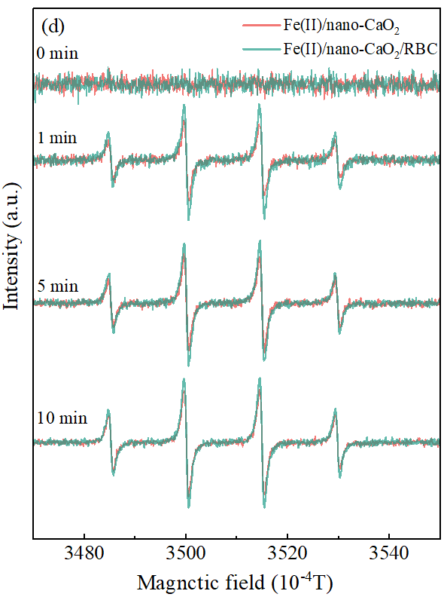
Fig. S3. EPR characterization results of ·OH in the reactions of the Fe(II)/nano-CaO2 and Fe(II)/nano-CaO2/RBC system.
Figure S3 shows the EPR characterization results of the Fe(II)/nano-CaO₂ and Fe(II)/nano-CaO₂/RBC systems. From the EPR spectrograms, four characteristic peaks of the adduct DMMPO-•OH with an intensity ratio of 1:2:2:1 were identified in both reaction systems (Lu et al., 2020). However, in contrast with the Fe(II)/nano-CaO₂ system, the signal intensity of DMPO-•OH in the Fe(II)/nano-CaO₂/RBC system was stronger. This further indicated that the existence of RBC increased the production of •OH in the Fe(II)/nano-CaO₂/RBC system (Zhang et al., 2022).

XPS of Fe 2p
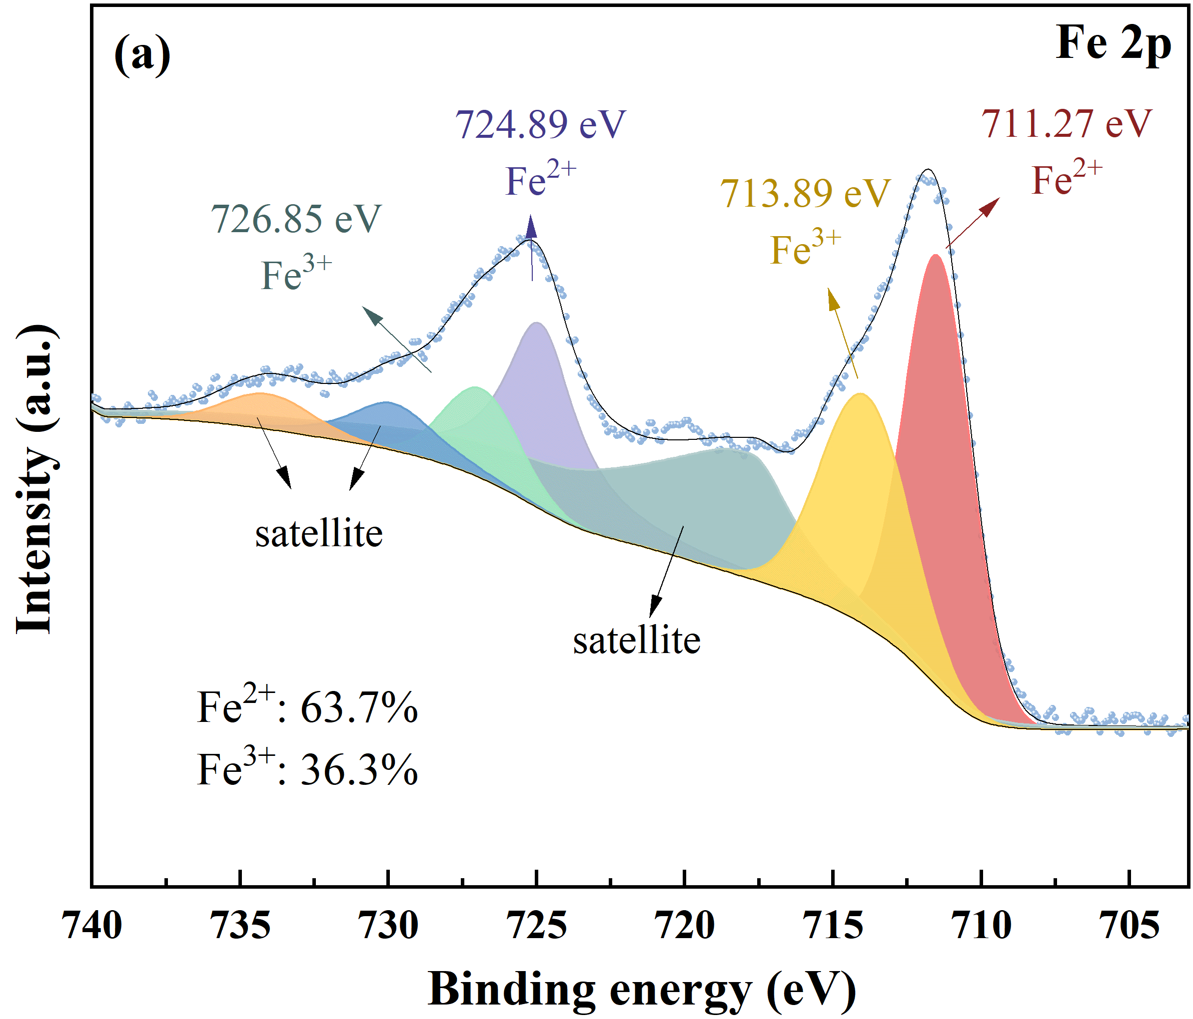
Fig. S4. Orbital spectra of Fe 2p after reaction.
Figure S4 presents the spectrum of the Fe 2p orbital of the composites after the reaction. The deconvoluted high-resolution spectra of Fe 2p indicated the existence of Fe(II) and Fe(III) in the post-reaction products, which could be classified into seven peaks. The orbitals with binding energies of 711.27 eV and 724.89 eV were attributed to Fe(II) (Bhuyan et al., 2023; Xue et al., 2021). The peaks of 713.89 eV and 726.85 eV corresponded to Fe(III) (Jia et al., 2007). The binding energies of 717.77 eV, 729.85 eV, and 734.06 eV were attributed to satellite peaks (Bhuyan et al., 2023). In addition, it can also be seen that Fe(II) and Fe(III) constituted 63.7% and 36.3% of the post-reaction products, respectively. Since the key step of the reaction was to control the continuous Fe(III)/Fe(II) conversion, the higher the Fe(III)/Fe(II) conversion ratio in the post-reaction products, the more favorable it was for As(III) oxidation and removal (Hou et al., 2022).
Effect of initial As(III) concentration on As(T) removal effect
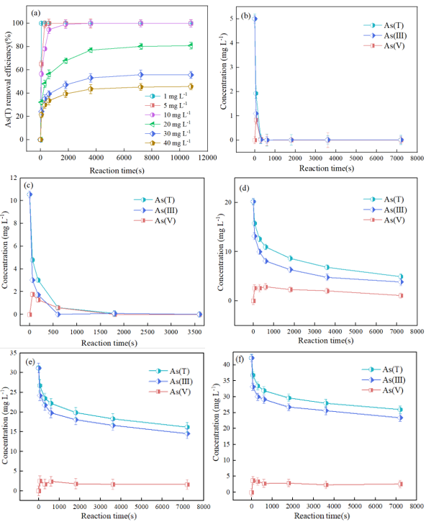
Fig. S5. (a) Influence of initial As(III) concentration on As(T) removal by nano-CaO₂/RBC system and changes in As(III) concentration during reactions of (b) 5 mg L⁻¹, (c) 10 mg L⁻¹, (d) 20 mg L⁻¹, (e) 30 mg L⁻¹, and (f) 40 mg L⁻¹.
Figure S5 shows the effect of the Fe(II)/nano-CaO₂/RBC Fenton-like system on As(T) removal at different initial As(III) concentrations. When the initial As(III) concentrations were 1, 5, and 10 mg L⁻¹, the removal efficiencies were all above 99%. However, when the As(III) concentration was gradually increased from 20 mg L⁻¹ to 40 mg L⁻¹, the As(T) removal efficiency decreased from 80.8% to 45.6%. Figs. S8(b)-(f) show the changes in the concentration of different valence arsenic remaining in the solution with time after reaction with different initial As(III) concentrations. As can be seen from the figures, the reaction process under each initial As(III) concentration showed a trend of As(V) concentration increasing and then decreasing. This was mainly due to the oxidation efficiency of As(III) in the composite system at the early stage of the reaction was faster than the adsorption efficiency of As(V), and the oxidation product As(V) in the solution was increased. In addition, when the initial concentration of As(III) exceeded 20 mg L⁻¹, a higher concentration of As(III) existed in the solution after the reaction, which was mainly due to the fact that a certain amount of nano-CaO₂ and Fe(II) could not oxidize and adsorb the high-concentration As(III) completely. Therefore, the high concentration As(III) solution can be treated by increasing the dosage of the composite materials nano-CaO₂/RBC and Fe(Ⅱ) to achieve a high As(T) removal efficiency.

Adsorption isotherm analysis
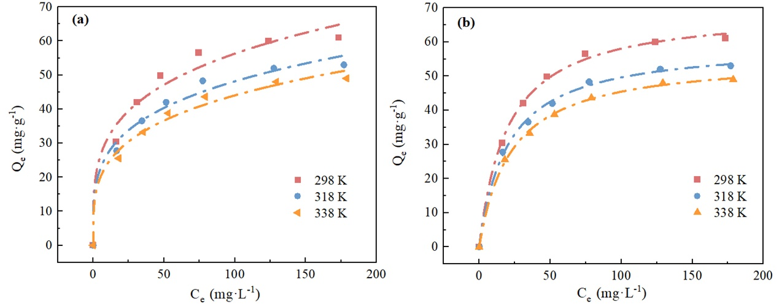
Fig. S6. Adsorption isothermal models by Fe(II)/nano-CaO₂/RBC system at different initial As(III) concentrations：(a) Langmuir and (b) Freundlich.
The removal capacity of Fe(II)/nano-CaO₂/RBC Fenton-like system for As(III) was elaborated by Langmuir and Freundlich model fitting as shown in Fig. S6. The adsorption equilibrium capacity of the composite system increased with the initial concentration of As(III), and the growth rate of the adsorption isothermal curve was gradually slowed down as shown by the slope of the curve. When the temperature increased from 298 K to 338 K, the adsorption capacity of the composite system on As(T) slightly decreased, which is consistent with the previous results of the investigation of the effect of reaction temperature on its removal effect.
Table S1 shows the correlation parameters of Langmuir and Freundlich adsorption isotherm nonlinear fits of the composite system to the As adsorption process. Comparison of the correlation coefficients R² shows that the Freundlich model fits the experimental efficiency better compared to the Langmuir model, indicating that the adsorption process is non-homogeneous ^{[13]}(Chin et al., 2022). The reason for the relatively poor fit of the Langmuir equation to the experimental efficiency may be that the Langmuir model assumes that the adsorption and desorption efficiencies of the reaction are equal and does not take into account the possible oxidation of the soluble products on the surface of the adsorbent ^{[14]}(Li et al., 2013). The removal of As(III), although ultimately dependent on adsorption, also involves redox processes on the surface of the nano-CaO₂/RBC. Moreover, in the Freundlich model, the parameters 1/n were 0.255, 0.280, and 0.341 (1/n<0.5) at three temperatures, which indicated the inhomogeneity of the adsorbent's surface. The composite system has a larger adsorption binding force for arsenic, which can be used to remove As(III) ions from the solution more easily ^{[15]}(Ren et al., 2011).

Table S1. Isotherm modeling parameters for adsorption of As(III) at different temperatures.
Temperature（K） | Langmuir
Temperature（K） | Q_{m}  （mg·g⁻¹） | K_{l}  （L·mg⁻¹） | R²
298 | 69.597±5.245 | 19.952±3.098 | 0.975
318 | 59.591±3.511 | 20.162±1.387 | 0.984
338 | 55.539±2.318 | 22.276±1.141 | 0.986
Temperature（K） | Freundlich
Temperature（K） | K_{f}  （mg^{(1−n)}·L^{n}/g） | n | R²
298 | 17.338±0.527 | 3.911±0.032 | 0.995
318 | 14.864±0.216 | 3.564±0.005 | 0.998
338 | 12.968±0.093 | 2.925±0.002 | 0.998

Reference
Chin J, Heng Z, Teoh H, et al. Recent development of magnetic biochar crosslinked chitosan on heavy metal removal from wastewater–modification, application and mechanism[J]. Chemosphere, 2022, 291: 133035.
Ding W, Xu J, Chen T, et al. Co-oxidation of As(III) and Fe(II) by oxygen through complexation between As(III) and Fe(II)/Fe(III) species[J]. Water Res, 2018, 143: 599-607.
Dong H, Guan X, Wang D, et al. A novel application of H₂O₂-Fe(II) process for arsenate removal from synthetic acid mine drainage (AMD) water[J]. Chemosphere, 2011, 85(7): 1115-21.
Hou J, Tan X, Xiang Y, et al. Insights into the underlying effect of Fe vacancy defects on the adsorption affinity of goethite for arsenic immobilization[J]. Environmental Pollution, 2022, 314: 120268.
Hu Q, Chen N, Feng C, et al. Nitrate adsorption from aqueous solution using granular chitosan-Fe³⁺ complex[J]. Applied surface science, 2015, 347: 1-9.
Jia Y, Xu L, Wang X, et al. Infrared spectroscopic and X-ray diffraction characterization of the nature of adsorbed arsenate on ferrihydrite[J]. Geochimica et Cosmochimica Acta, 2007, 71(7): 1643-1654.
Li T, Liu Y, Peng Q, et al. Removal of lead (II) from aqueous solution with ethylenediamine-modified yeast biomass coated with magnetic chitosan microparticles: Kinetic and equilibrium modeling[J]. Chemical Engineering Journal, 2013, 214: 189-197.
Li X, Xie Y, Jiang F, et al. Enhanced phosphate removal from aqueous solution using resourceable nano-CaO2/BC composite: Behaviors and mechanisms[J]. Science of The Total Environment, 2020, 709.
Manjuri Bhuyan P, Borah S, Kumar Bhuyan B, et al. Fe₃S₄/biochar catalysed heterogeneous Fenton oxidation of organic contaminants: Hydrogen peroxide activation and biochar enhanced reduction of Fe(III) to Fe(II)[J]. Separation and Purification Technology, 2023, 312.
Ren Z, Zhang G, Chen J P. Adsorptive removal of arsenic from water by an iron–zirconium binary oxide adsorbent[J]. Journal of colloid and interface science, 2011, 358(1): 230-237.
Wang H, Zhao Y, Su Y, et al. Fenton-like degradation of 2,4-dichlorophenol using calcium peroxide particles: performance and mechanisms[J]. RSC Advances, 2017, 7(8): 4563-4571.
Wang J, Bejan D, Bunce N. Removal of arsenic from synthetic acid mine drainage by electrochemical pH adjustment and coprecipitation with iron hydroxide[J]. Environmental science & technology, 2003, 37(19): 4500-4506.
Wu F, Tseng R, Juang R. Characteristics of Elovich equation used for the analysis of adsorption kinetics in dye-chitosan systems[J]. Chemical Engineering Journal, 2009, 150(2-3): 366-373.
Xie Y, Xiong R, Li J, et al. Insight into n-CaO₂/SBC/Fe(II) Fenton-like system for glyphosate degradation: pH change, iron conversion, and mechanism[J]. J Environ Manage, 2023, 333: 117428.
Xue L, Hao L, Ding H, et al. Complete and rapid degradation of glyphosate with Fe₃Ce₁O_{x} catalyst for peroxymonosulfate activation at room temperature[J]. Environmental Research, 2021, 201: 111618.
Zheng Q, Hou J, Hartley W, et al. As(III) adsorption on Fe-Mn binary oxides: Are Fe and Mn oxides synergistic or antagonistic for arsenic removal?[J]. Chemical Engineering Journal, 2020, 389.
Zhang S, Wei Y, Metz J, et al. Persistent free radicals in biochar enhance superoxide-mediated Fe (III)/Fe (II) cycling and the efficacy of CaO₂ Fenton-like treatment[J]. Journal of Hazardous Materials, 2022, 421: 126805.

