Supplementary Information for
Establishing C-C electro-coupling mechanism via big data analyses of reaction networks
Haobo Li ^{1, 3}, Xinyu Li ^{2, 3}, Pengtang Wang ^{1, 3}, Zhen Zhang ², Kenneth Davey ¹, Javen Qinfeng Shi ², and Shi-Zhang Qiao ^{1, *}
¹ School of Chemical Engineering, The University of Adelaide, Adelaide, SA 5005, Australia
² Australian Institute for Machine Learning, The University of Adelaide, Adelaide, SA 5000, Australia
³ These authors contributed equally: Haobo Li, Xinyu Li, Pengtang Wang

* Correspondence to E-mail: s.qiao@adelaide.edu.au

Supplementary Figures
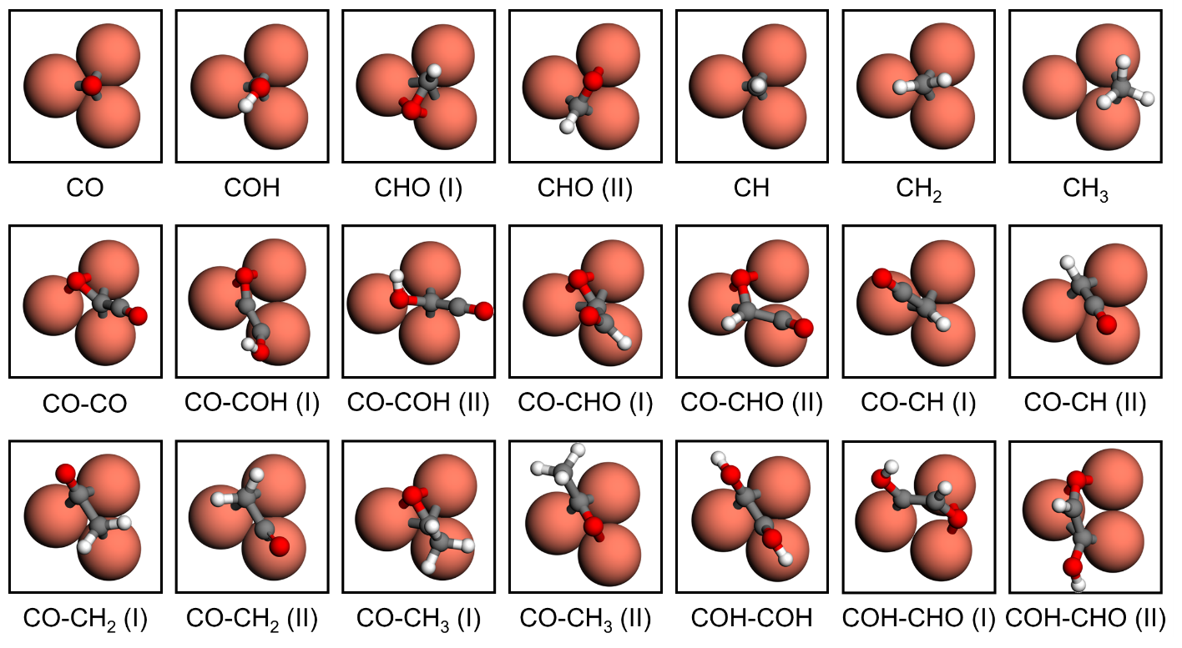
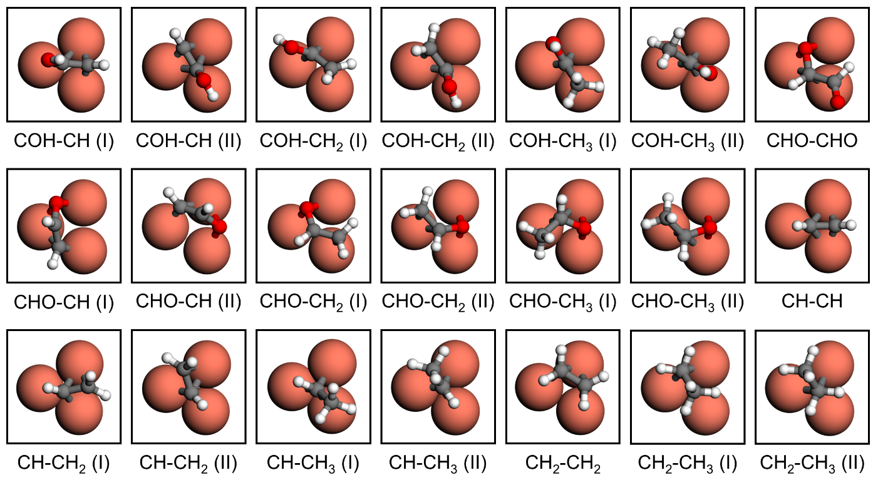
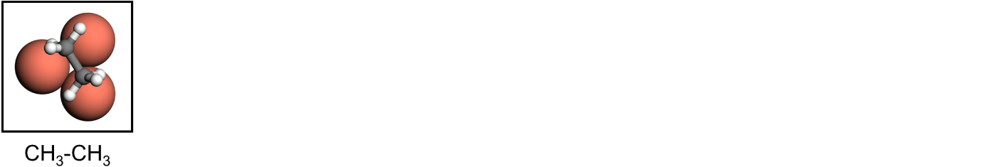
Supplementary Figure 1 | Initial adsorption configurations for generating C-C coupling big database. Tri-atomic metal active sites are composed of ABCu with 27 metal replacements available for A and B atoms. Metals, large spheres; C, grey-color small spheres; O, red small spheres; H, white small spheres.
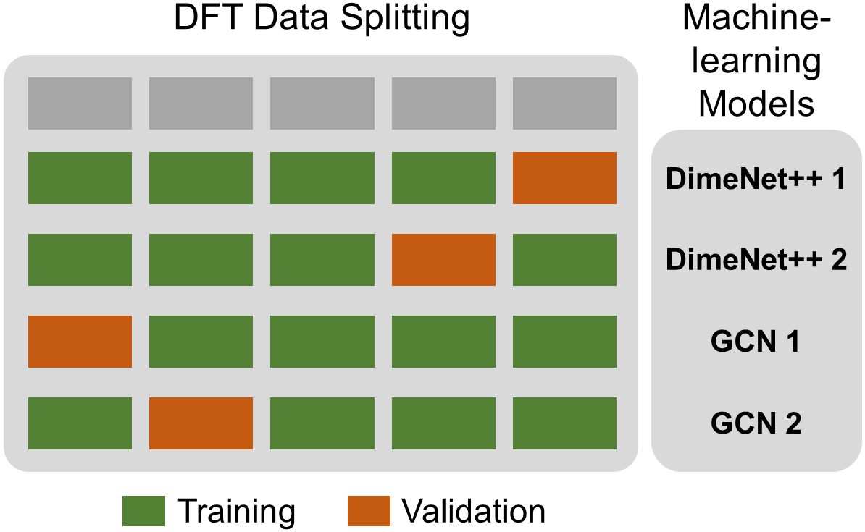
Supplementary Figure 2 | 2D-3D ensemble machine-learning (ML). Schematic for establishing 2D-3D ensemble for DimeNet++ algorithm and GCN algorithm.

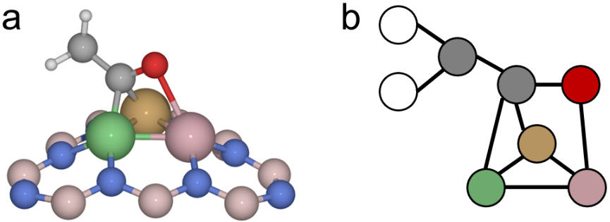
Supplementary Figure 3 | Identification of adsorption configurations. Adsorption graph and neighbor information for coordination atom fingerprint in graphical neural network (GNN) model: An example of CO-CH₂ coupling on tri-atomic active site. Metals, green-color, yellow and pink spheres; C, grey spheres; O, red spheres; H, white spheres. Substrate atoms are neglected for coordination atom fingerprint.

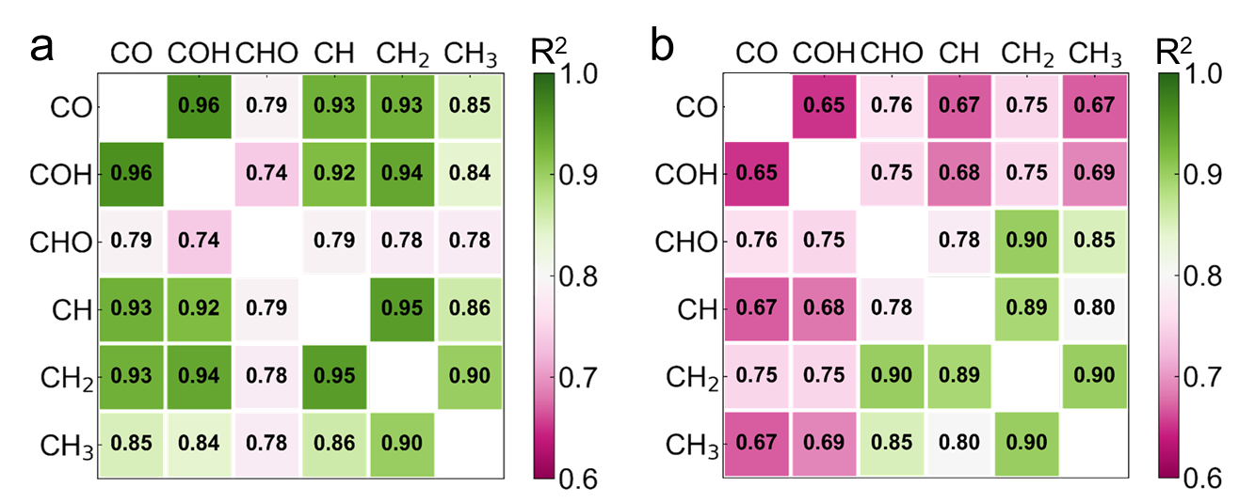
Supplementary Figure 4 | Linear relationship coefficient. (a) R² coefficient for linear correlation between adsorption energies for C-C coupling precursors across ABCu big database, and (b) Across pure metal surfaces e.g. the intersection of CO (horizontal/vertical axis) and CH₃ (vertical/horizontal axis) signifies correlation between E_{ad}(CO) vs E_{ad}(CH₃).

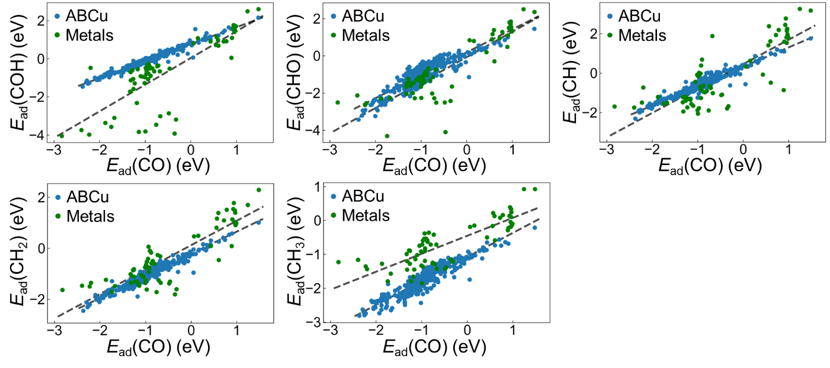
Supplementary Figure 5 | Comparison of linear scaling-relationships. Adsorption energy (E_{ad}) scaling-relationship between CO and the 5 other C-C coupling precursors, (CO, COH, CHO, CH, CH₂ and CH₃) across the ABCu active sites (blue-color) and metal surfaces (green).
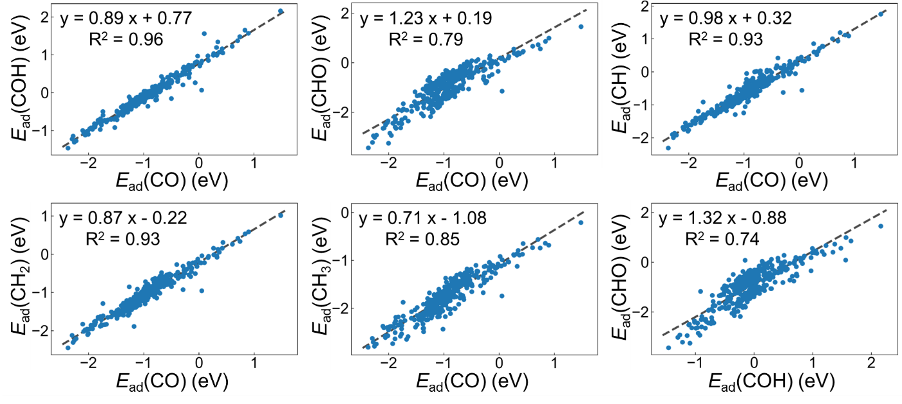
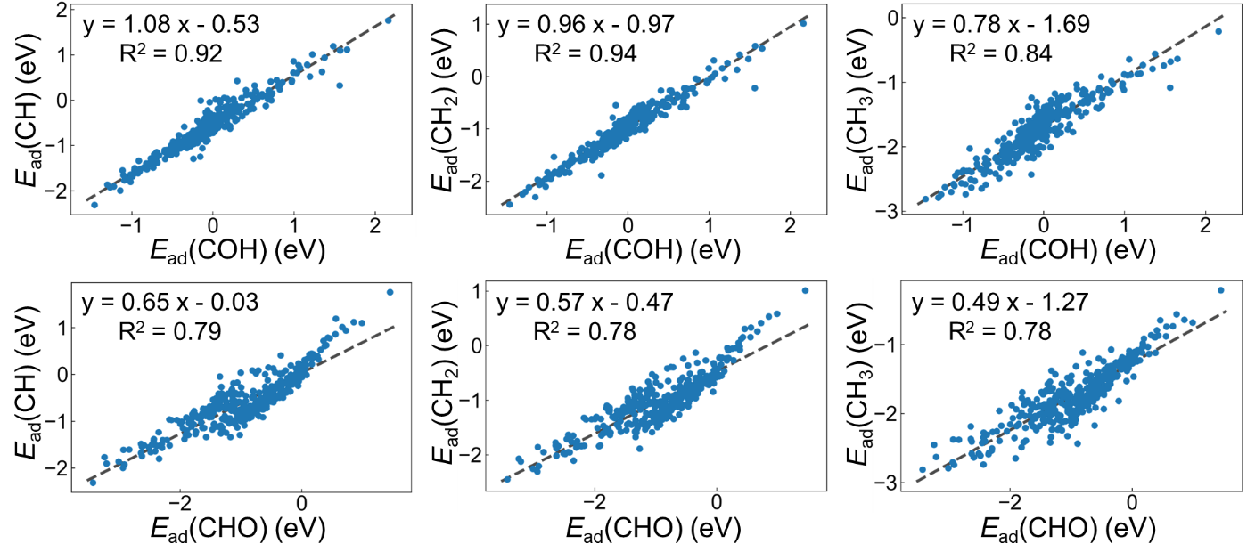
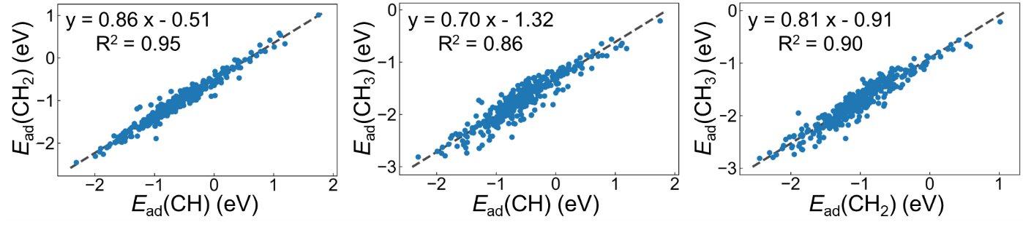
Supplementary Figure 6 | Linear scaling-relationships for precursors. Adsorption energy (E_{ad}) scaling-relationship between 6 C-C coupling precursors (CO, COH, CHO, CH, CH₂, CH₃) across the entire database. Linear fit is shown as black dashed-line.

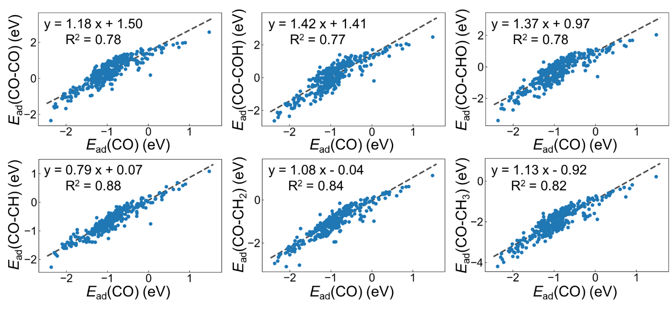
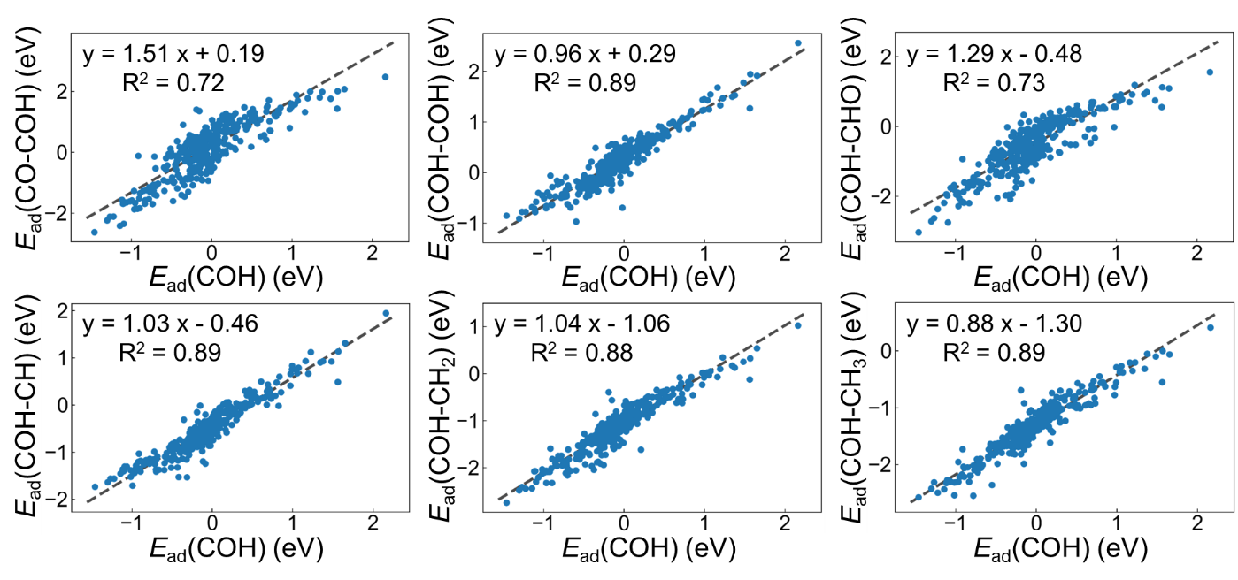
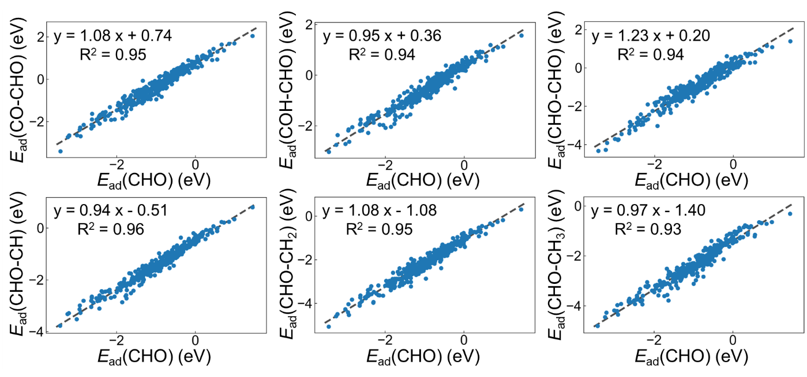
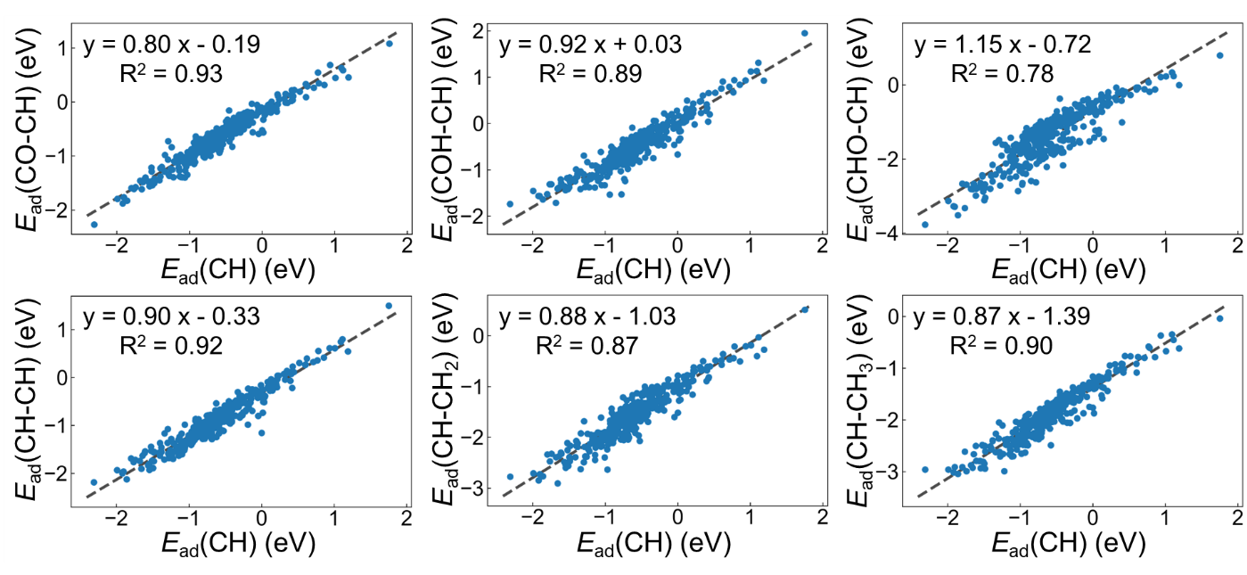
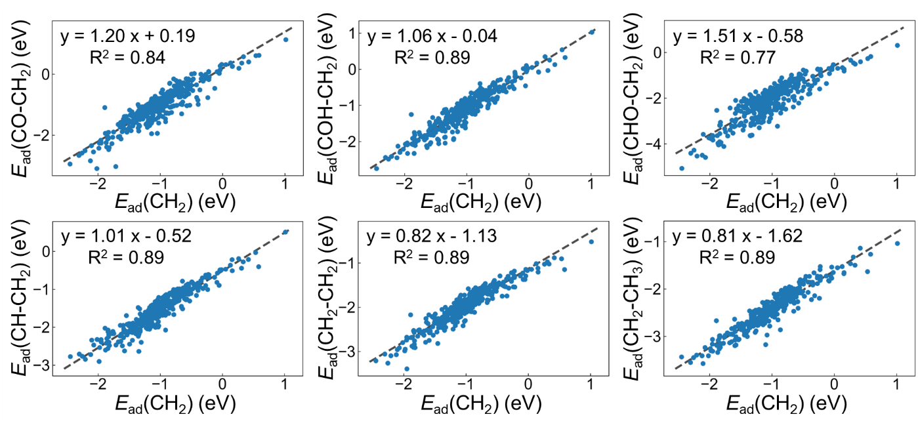
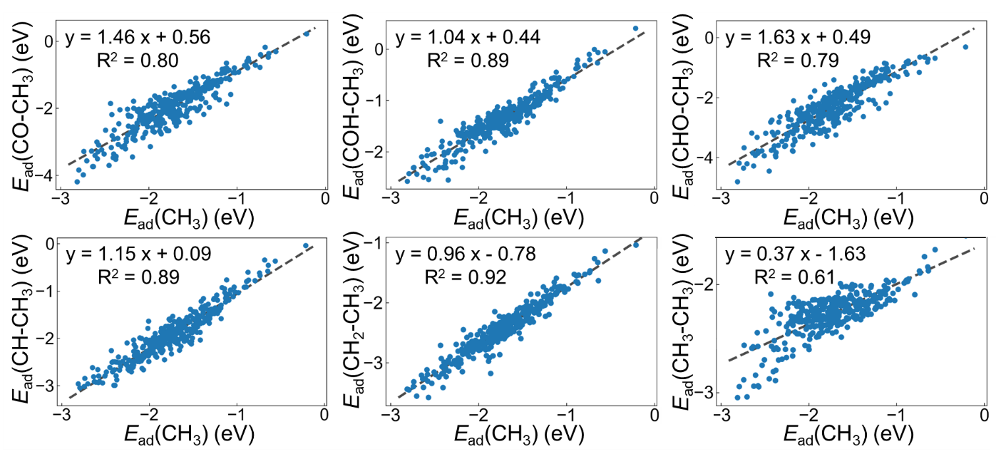
Supplementary Figure 7 | Linear scaling-relationships for C-C coupling. Adsorption energy (E_{ad}) scaling-relationship between C-C precursors and C₂ products following coupling. Linear fit is shown by the black dashed-line. Supplement to Figure 3.
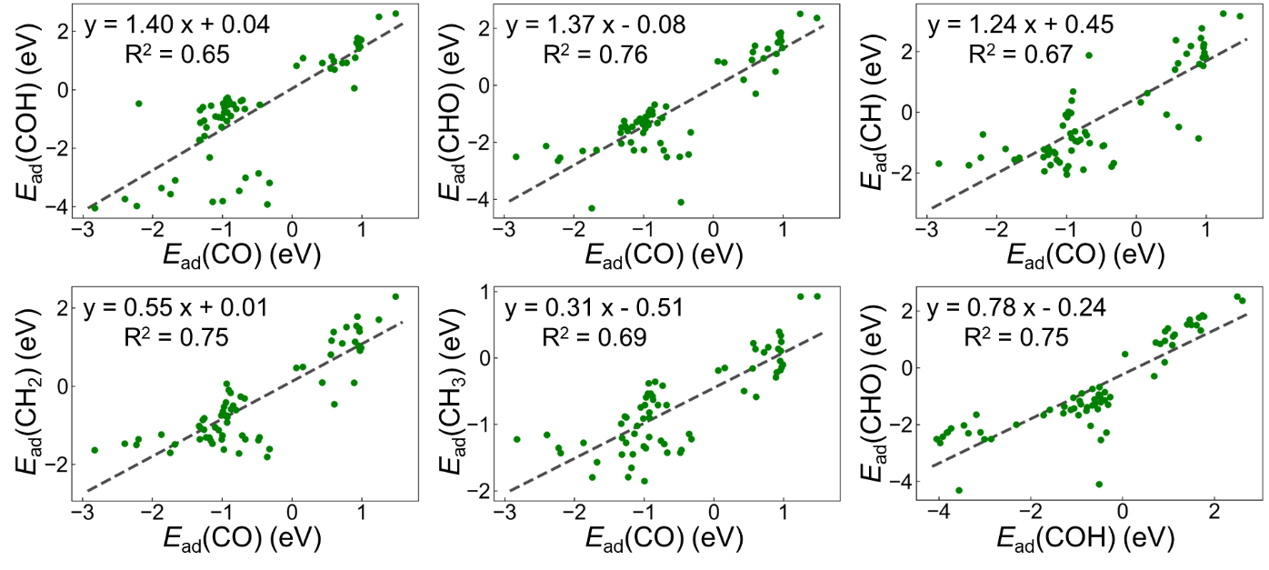
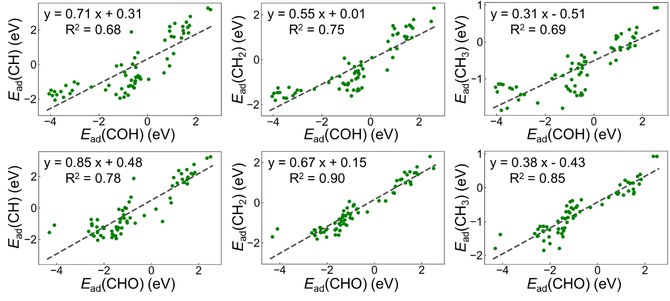
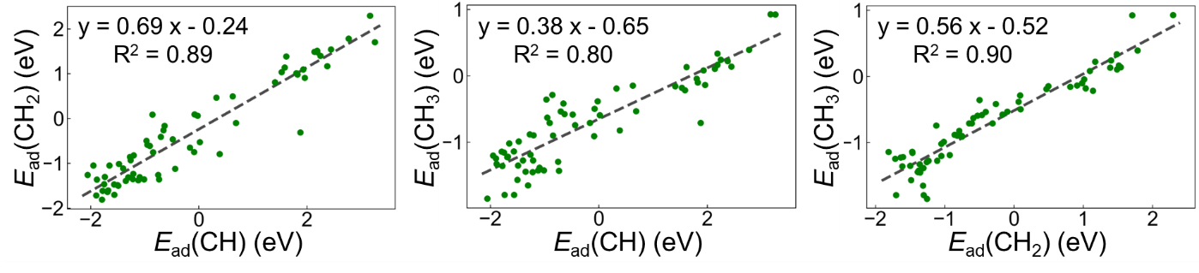
Supplementary Figure 8 | Linear scaling-relationships on metals. Adsorption energy (E_{ad}) scaling-relationships between 6 C-C coupling precursors (CO, COH, CHO, CH, CH₂, CH₃) across the fcc(111) and fcc(100) surfaces of 33 metals (Sc, Ti, V, Cr, Fe, Co, Ni, Cu, Zn, Y, Mo, Ru, Pd, Ag, Cd, Hf, Ta, W, Re, Os, Ir, Pt, Au, Hg, Te, Pb, Zr, Nb, Tc, Rh, Al, Sn, In, Tl). Linear fit is shown by the black dashed-line.

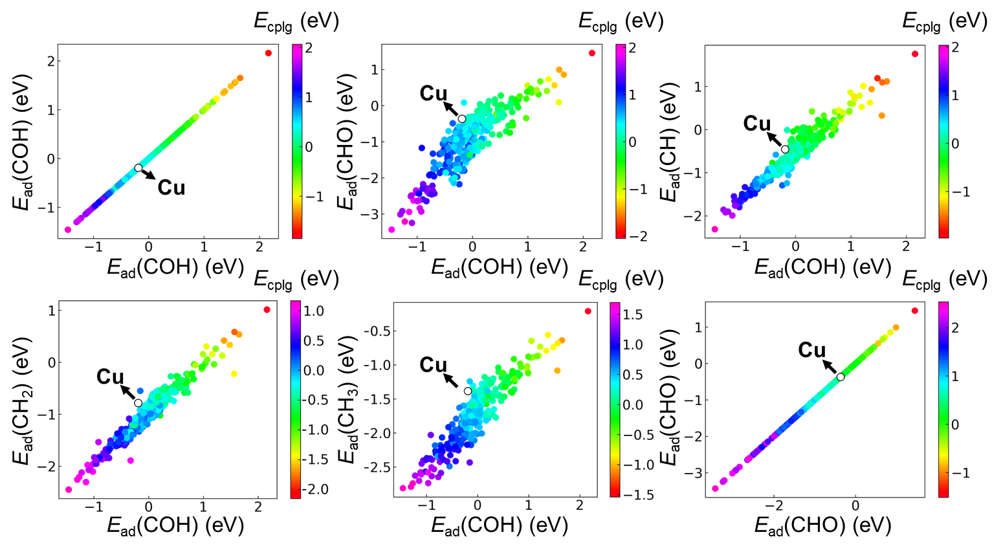
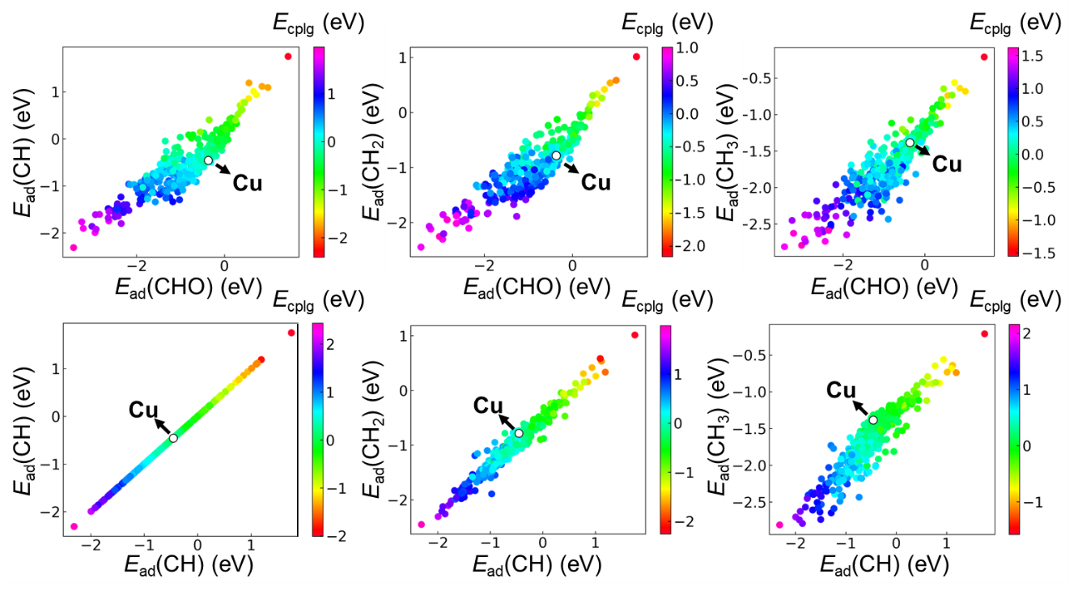
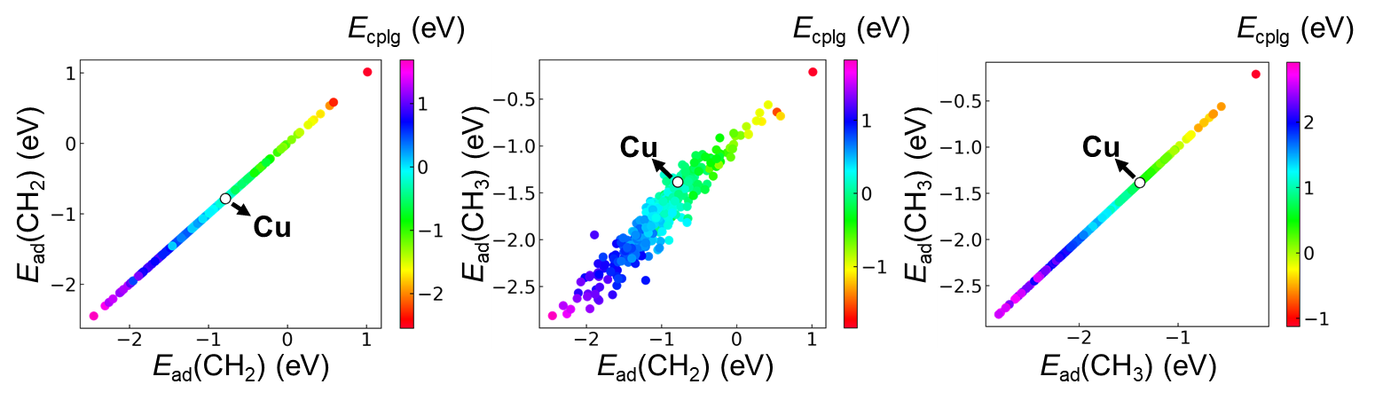
Supplementary Figure 9 | Adsorption energy vs coupling energy. Relation between adsorption energy (E_{ad}) of CO (horizontal axis), E_{ad} for coupling precursors (vertical axis), and coupling energy (E_{cplg}) for CO with these precursors (presented by color) across the entire database. Arrow indicates position of pure Cu site (where A and B in ABCu are equal to Cu). Supplement to Figure 4.
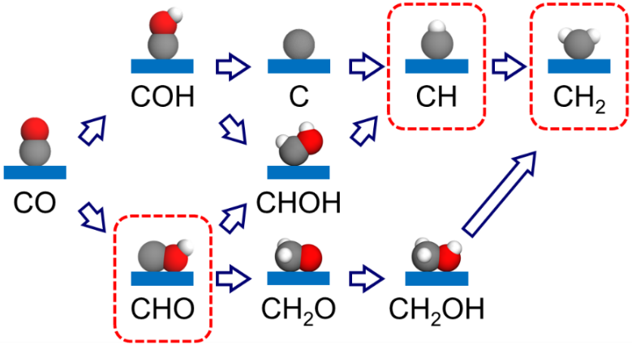
Supplementary Figure 10 | Reaction network. Reaction network illustrating formation of CHO, CH and CH₂ precursors starting from CO that is necessary for coupling of CHO-CH and CHO-CH₂ reactions.

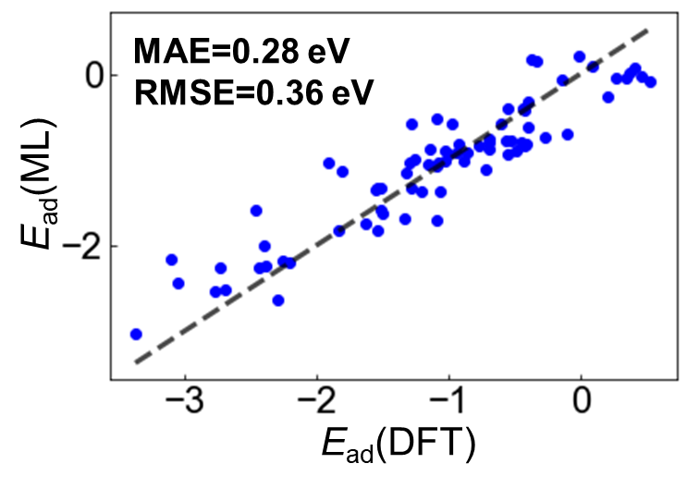
Supplementary Figure 11 | Accuracy of ML results. A comparison between DFT computed adsorption energy (E_{ad}(DFT)) for the most stable adsorption configuration and ML result (E_{ad}(ML)) across the 11 screened sites. The adsorption species include CO, COH, CHO, CH, CH₂, CHO-CH and CHO-CH₂. The black dashed-line represents where E_{ad}(DFT) is equal to E_{ad}(ML).

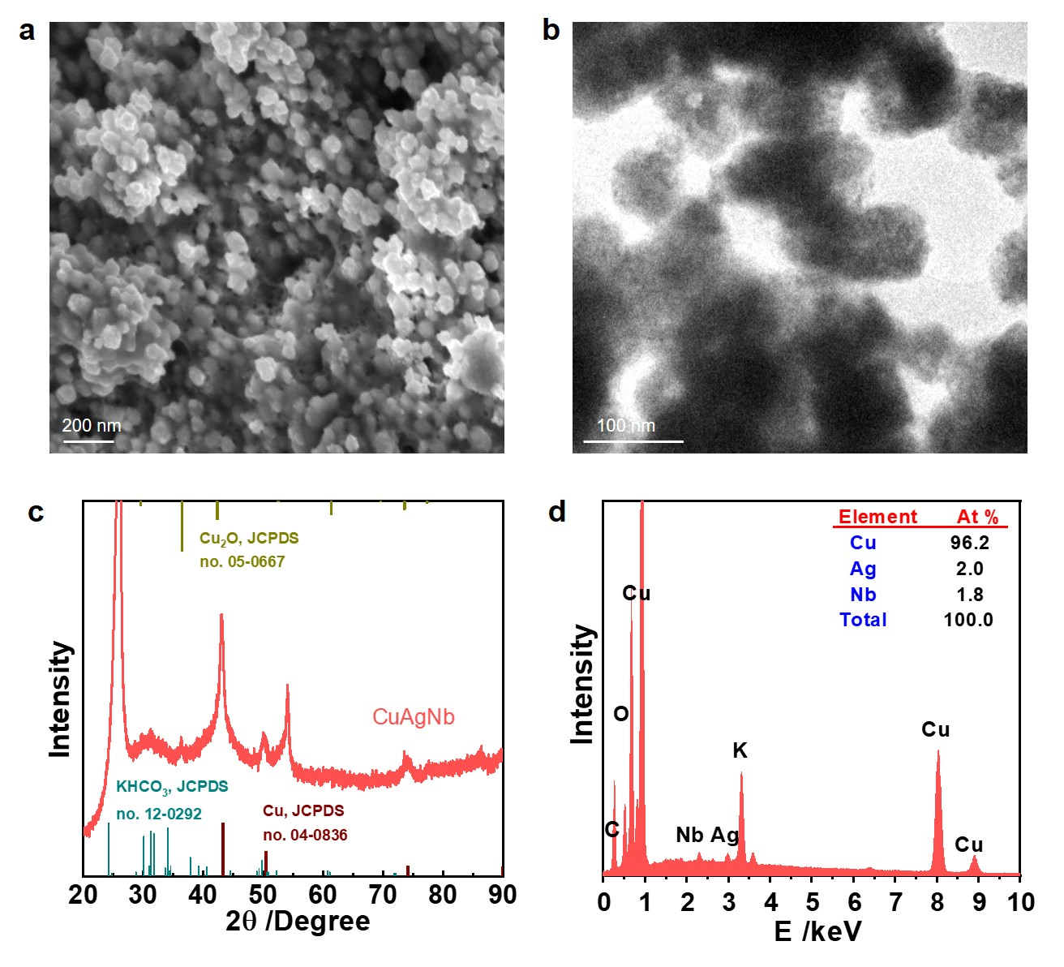
Supplementary Figure 12 | Structural characterization of CuAgNb catalysts. (a) Scanning electron microscopy (SEM), (b) TEM and (c) XRD, images. (d) EDS patterns for CuAgNb catalyst.
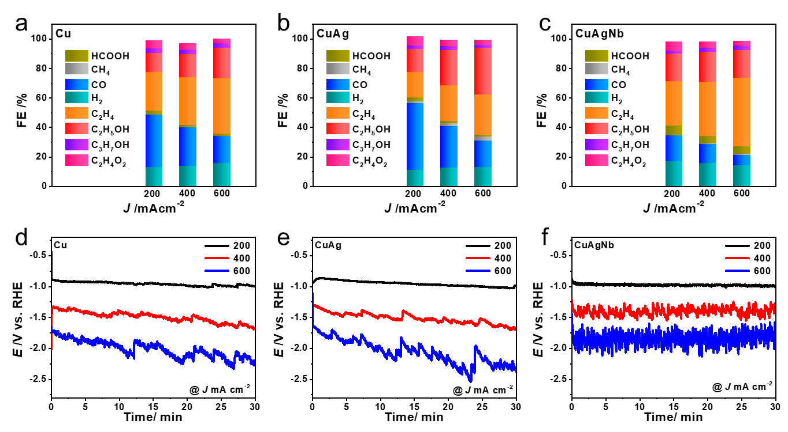
Supplementary Figure 13 | Electrochemical experimental performance. (a, b, c) Product FEs and (d, e, f) Chronoamperometry curves for (a, d) Cu, (b, e) CuAg and (c, f) CuAgNb catalysts during CO₂RR at applied current. Supplement to Fig. 6d.
Supplementary Methods
Computational model
Three atoms on a substrate are assumed as the active sites for C-C coupling. The active sites, referred to as ABCu (A, B = transition metals), retain one Cu atom whilst the other two atoms are replaceable by 27 different metals. To reduce computations, the tri-atomic structure is supported on a two-dimensional (2D) hexagonal boron nitride (h-BN) material. In this configuration, three B atoms and one N atom are removed from the h-BN lattice to create a hole, allowing the ABCu cluster to be well-embedded within the N atom framework (see Supplementary Fig. 1). A periodic unit-cell of size (4 x 4) is used for the h-BN material to ensure a distance of > 8 Å between the adsorbed species. Additionally, a vacuum layer of 20 Å is introduced to obviate periodic interactions in the direction perpendicular to the 2D plane.
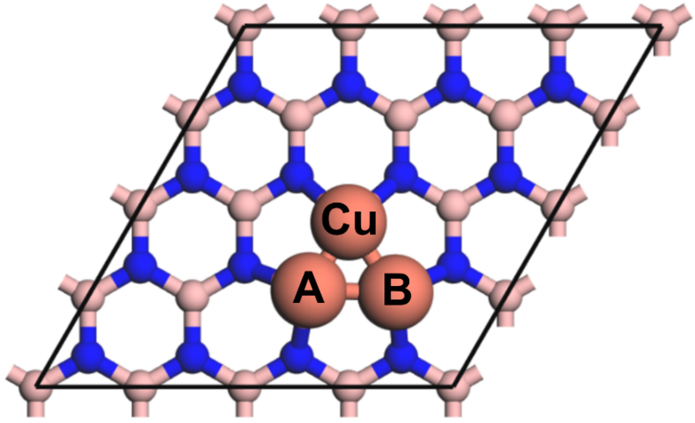
Supplementary Figure 14 | Top view (plan) of atomic structure for DFT computation. The highlighted ABCu tri-atomic structure is the catalytic active site for adsorption energy computation. Metals, large spheres; B, pink-color small spheres; N, blue-red small spheres.
Graphical neural network (GNN)
To predict adsorption energy via a graphical neural network (GNN), each adsorption system is represented as a graph with atoms as nodes and bonds as edges. As shown in Supplementary Fig. 3, the graphs are constructed based on the connectivity of atoms and relevant features are assigned to each node. A GNN architecture is designed, incorporating graphical convolutional layers, or attention mechanisms to capture spatial relationships and interactions. Training data is prepared by splitting into training- and confirmation-sets, ensuring a range in adsorption energy. Model evaluation is performed using the confirmation-set, assessing metrics including, mean absolute error (MAE), or root mean absolute error (RMSE). Once ‘trained’ the GNN is used to predict the adsorption energy for new systems, this is accomplished by converting the new systems into graph representations and processing them through the model’s message passing and graph pooling operations. Refinement and fine-tuning of the model is carried out based on evaluation results, or incorporating additional features.
2D-3D ensemble ML
Supplementary Figure 2 demonstrates the ensemble of two distinct ML models to create a 2D-3D ensemble. The entire data is randomly divided into five (5) parts. Each of the two ML methods performs two training and confirmation operations. In each operation, the method selects a different part as the confirmation-set and uses the remaining parts as the training-set. This process is repeated four (4) times, resulting in a total of four training and confirmation operations. By conducting these operations, the two ML methods are trained and confirmed on different subsets of the data. The ensemble method is constructed via combining predictions, or decisions, from the two individual methods, leveraging the knowledge and insights gained from the multiple training and confirmation iterations.

Supplementary Tests
Tests on Effects of Electrochemical Conditions
Temperature
The effect of temperature was considered in form of vibrational frequency correction (F_{vib}), computed from:
F_{vib} = ZPE + ʃ C_{p}dT + TS (1)
where ZPE is zero-point energy, ʃ C_{p}dT enthalpic temperature correction and TS entropic correction. For the process of Precursor1 and Precursor2 coupling into Product, the difference (Δ_{vib}) following adding F_{vib} is:
Δ_{vib} = F_{vib}(Product) - [F_{vib}(Precursor1) + F_{vib}(Precursor2)] (2)
In this work the temperature was set to T = 298 K to simulate room temperature (RT). As shown in Supplementary Table S1, Δ_{vib} for CO coupling with CO, CH and CH₃ are all < 0.1 eV. This evidences that the influence of temperature is ‘cancelled out’ (rendered void) before and following the coupling reaction, making it negligible and therefore to be disregarded.
Aqueous electrolyte
The effect of aqueous electrolyte was considered in form of solvation energy correction (G_{sol}), that is computed implicitly using the VASPsol package. Similar to vibrational frequency correction, the difference (Δ_{sol}) following adding G_{sol} is:
Δ_{sol} = G_{sol}(Product) - [G_{sol}(Precursor1) + G_{sol}(Precursor2)] (3)
As shown in Supplementary Table S1, Δ_{sol} for CO coupling with CO, CH and CH₃ are all < 0.15 eV. This evidences that the influence of solvent is rendered void before and following the coupling reaction, making it negligible and, therefore to be disregarded.

Supplementary Table 1 | Vibrational frequency and solvation corrections. Contribution of vibrational frequency and solvation corrections to adsorption energy before and following C-C coupling. (Unit: eV).
Coupling | Before |  | Following | Δ_{vib} | Δ_{sol}
CO + CO | 0.14 | 0.11 | 0.27 | 0.02 | -0.06
CO + CH | 0.08 | 0.34 | 0.46 | 0.04 | -0.06
CO + CH₃ | 0.14 | 0.91 | 1.13 | 0.08 | -0.13

Working potential
The reducing working potential condition for C-C coupling was simulated by adding electrons to the system. As shown in Supplementary Figure 14, based on the established linear relation, the number of added electrons to the system can be determined. On examining the electronic state of the computational model used, it was found that unlike pristine and defect states of h-BN, the Cu₃@h-BN system exhibited no distinct band gap at the Fermi level (Supplementary Figure 15). This characteristic confirms that the Cu₃@h-BN model is more akin to a metallic state, and as a result, the non-conductive nature of h-BN substrate does not significantly impact the simulation of working potential. Supplementary Table S2 shows that for CO coupling with CO or CH, the influence of working potential on the coupling energy (Δ_{pot}) is not significant, < 0.05 eV, whilst for CO coupling with the larger precursor CH₃, the influence of working potential is greater, up to 0.3 eV under U = -1.2 V. Given the high computational cost and the fact that the actual working potential is (generally) not too high, the influence of working potential was ignored.

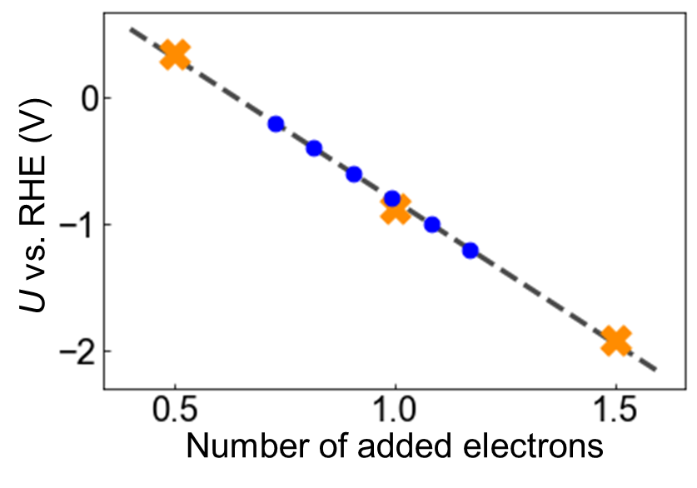
Supplementary Figure 15 | Linear relation between electron number and working potential. 0.5, 1.0 and 1.5 electrons (orange-color symbols) are added in the system to establish a linear relation with electrochemical working potential. The computation is conducted for applied potentials of -0.2, -0.4, -0.6, -0.8, -1.0 and -1.2 V (blue-color symbols), within this interval. The horizontal axis represents the corresponding number of electrons to be added to the system at each applied potential.

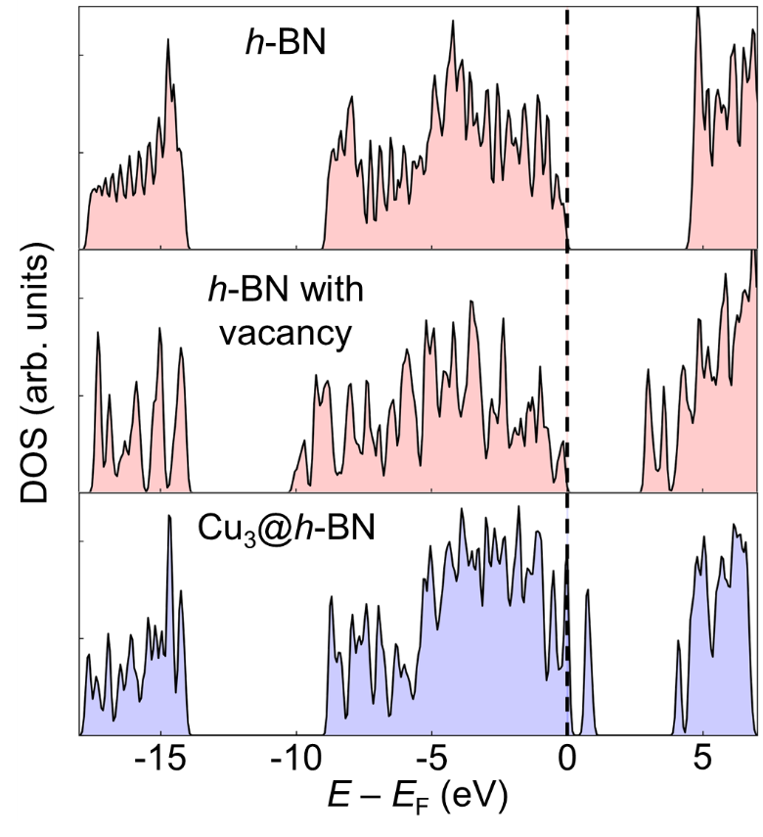
Supplementary Figure 16 | Electronic density of states (DOS). DOS for the computational model, Cu₃@h-BN, in comparison with pristine h-BN and h-BN with vacancy.

Supplementary Table 2 | Potential-dependent effect on C-C coupling. Contribution of working potential to coupling energy.
U / V | Δ_{pot} / eV
 | CO + CO | CO + CH | CO + CH₃
-0.2 | 0.0208 | -0.0098 | -0.1167
-0.4 | 0.0153 | -0.0087 | -0.1633
-0.6 | 0.0033 | -0.0100 | -0.2072
-0.8 | 0.0180 | -0.0129 | -0.2445
-1.0 | 0.0314 | -0.0147 | -0.2784
-1.2 | 0.0272 | -0.0161 | -0.3091

Supplementary References S. Hamilton, W. L. Representation learning. Synthesis Lectures on Artificial Intelligence and Machine Learning Morgan & Claypool Publishers (2020).
S. Mathew, K., Sundararaman, R., Letchworth-Weaver, K., Arias, T. A. & Hennig, R. G. Implicit solvation model for density-functional study of nanocrystal surfaces and reaction pathways. J. Chem. Phys. 140, 084106 (2014).
S. Kim, K., Shi, J. & Liu, Y. Substantial impact of charge on electrochemical reactions of two dimensional materials. J. Am. Chem. Soc. 140, 9127-9131 (2018).

