Mortality:

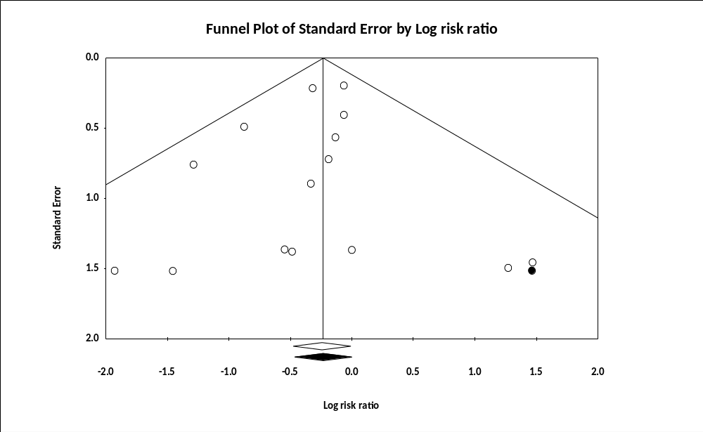
Figure S1: funnel plot of mortality (egger test P= 0.48)

Rehospitalization:
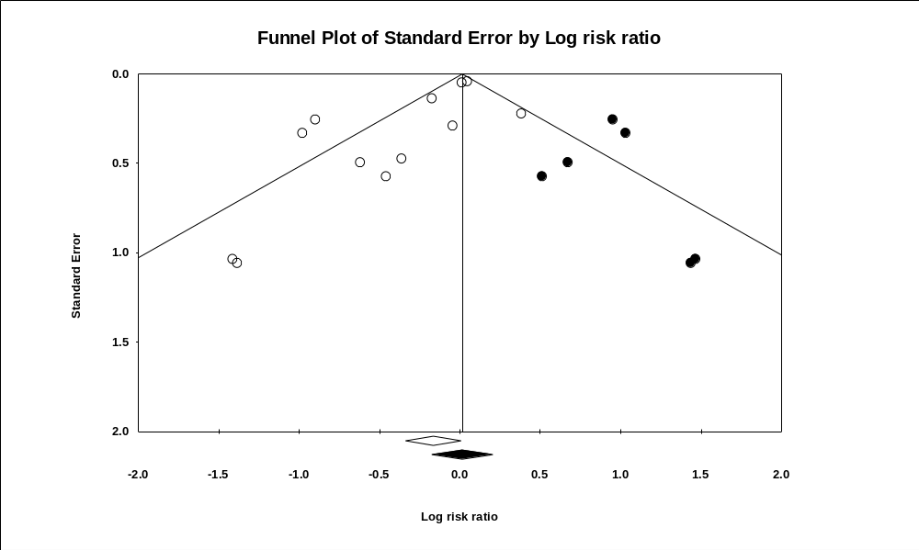
Figure S2: Funnel plot of rehospitalization (egger’s test P=0.01)

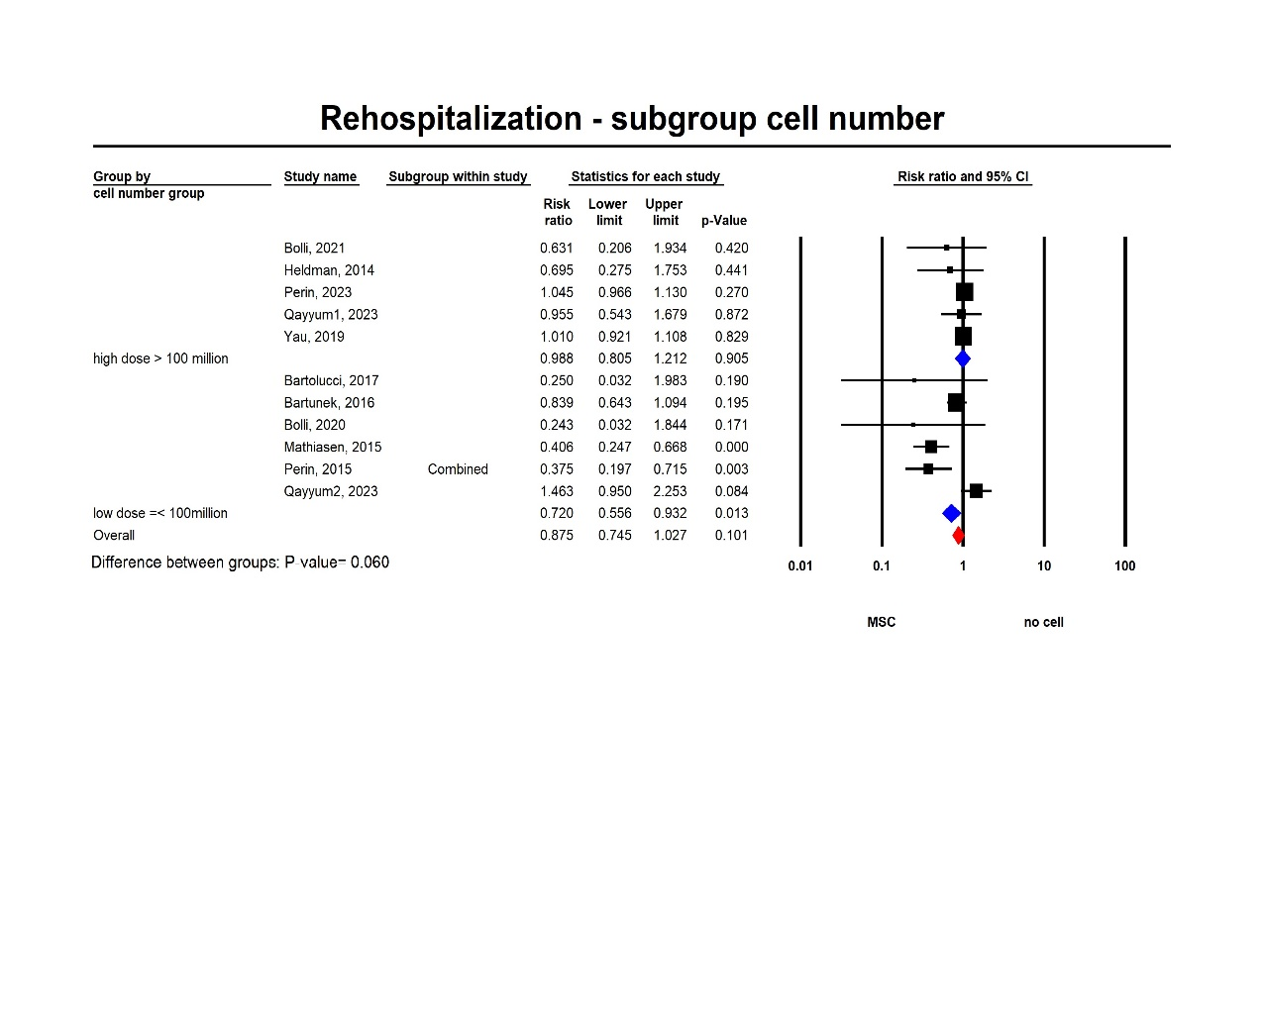
Figure S3: rehospitalization sub-group analysis of cell number

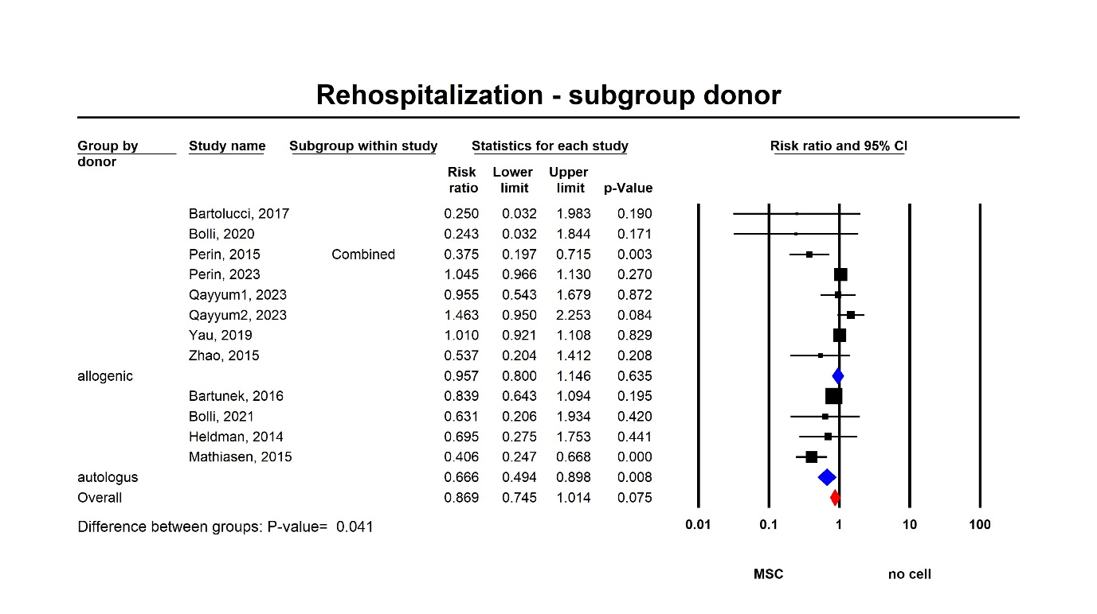
Figure S4: rehospitalization subgroup analysis of donor

Covariate | Coefficient | Standard Error | 95% Lower | 95% Upper | Z-value | 2-sided P-value
Intercept | -0.7925 | 0.3513 | -1.481 | -0.1041 | -2.26 | 0.0241
Cell number Mean | 0.00000001 | 0 | 0 | 0 | 2.07 | 0.0386
R² analog = 0.27

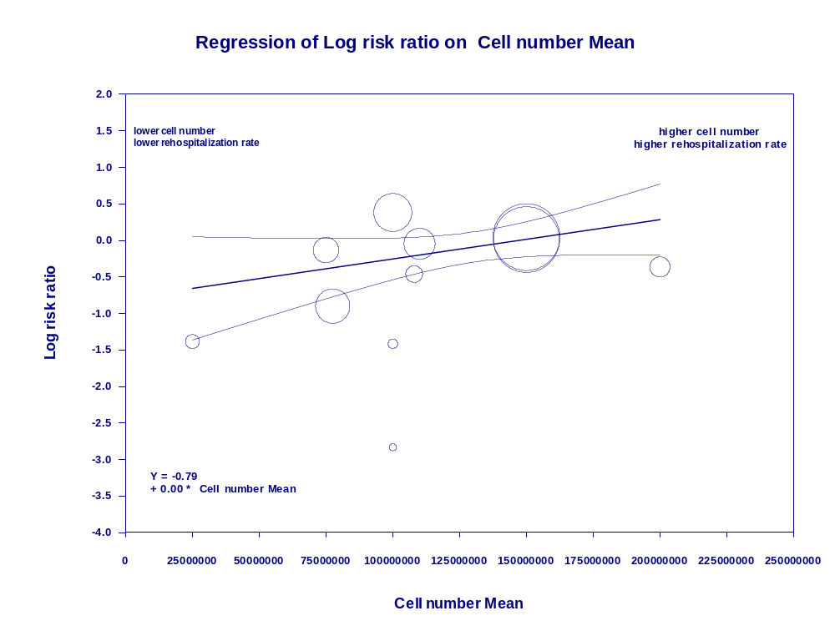
Figure S5: meta-regression investigating the effect of cell number on rehospitalization

HF worsening:
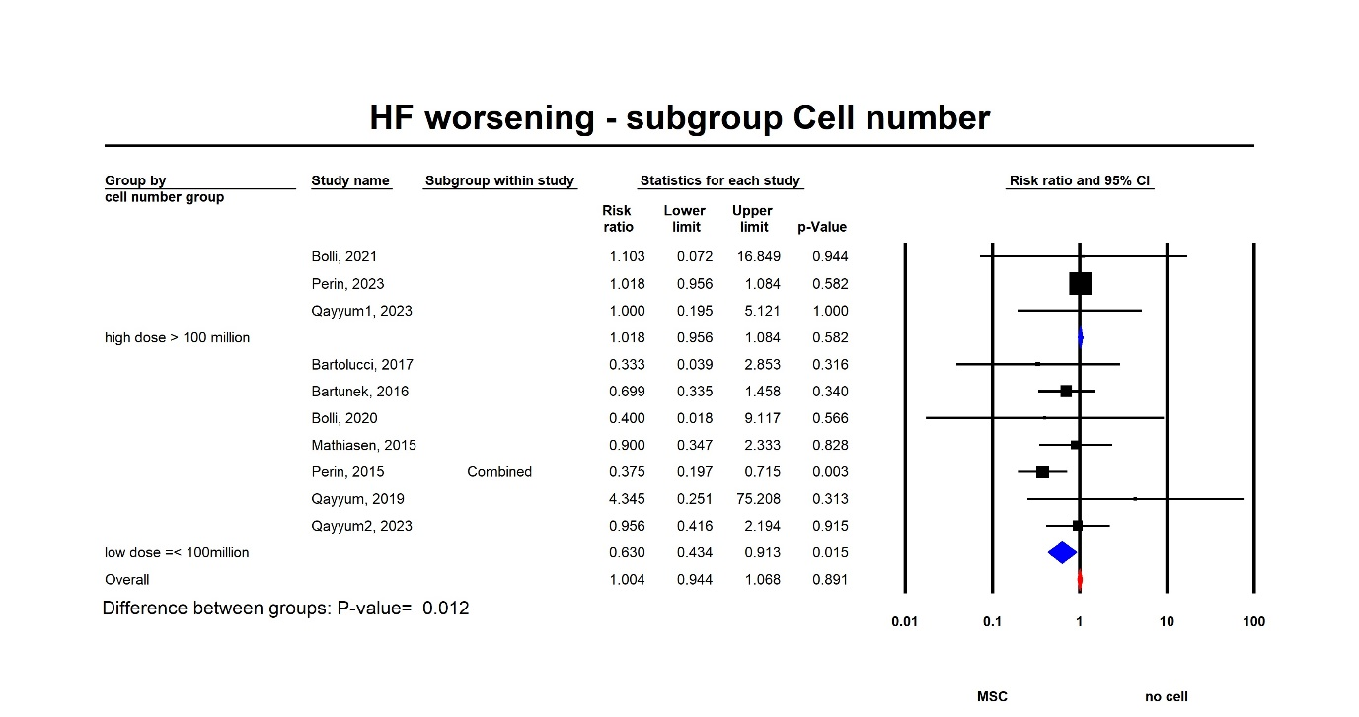
Figure S6: HF worsening subgroup analysis of cell number groups

LVEF:

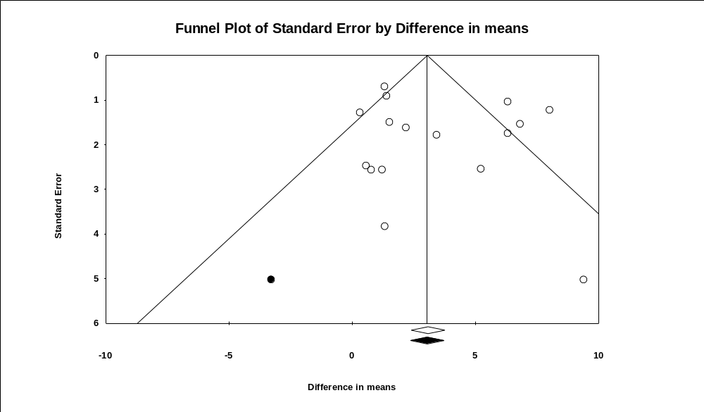
Figure S7: Funnel plot of LVEF (egger’s test P=0.5)
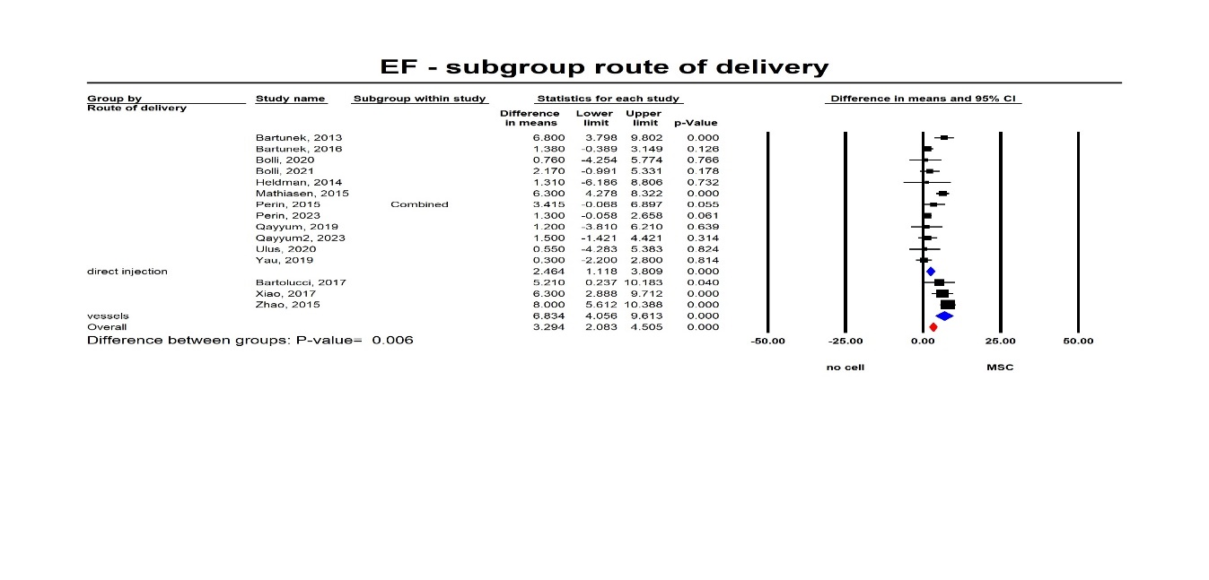
Figure S8: LVEF subgroup analysis of route of delivery

Covariate | Coefficient | Standard Error | 95% Lower | 95% Upper | Z-value | 2-sided P-value
Intercept | 20.87343244 | 9.819343921 | 1.627872007 | 40.11899288 | 2.13 | 0.0335
age mean | -0.29105369 | 0.162972051 | -0.61047304 | 0.028365662 | -1.79 | 0.0741
R² analog = 0.11

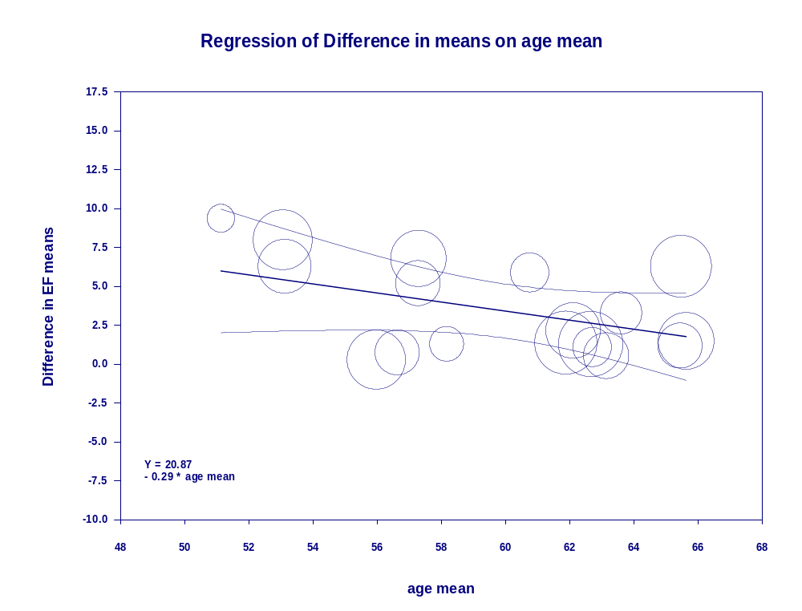
Figure S9: meta-regression investigating the effect of age on LVEF

Covariate | Coefficient | Standard Error | 95% Lower | 95% Upper | Z-value | 2-sided P-value
Intercept | 1.849557327 | 0.976315311 | -0.06398552 | 3.763100174 | 1.89 | 0.0582
Cell number Mean | 0.000000006 | 0.000000004 | -1E-09 | 0.000000013 | 1.81 | 0.0705
R² analog = 0.21

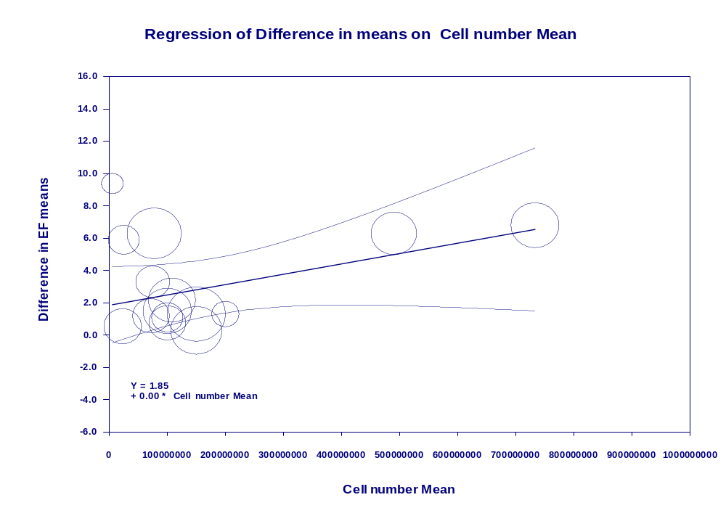
Figure S10: meta-regression investigating the effect of cell number on LVEF

LVESV:

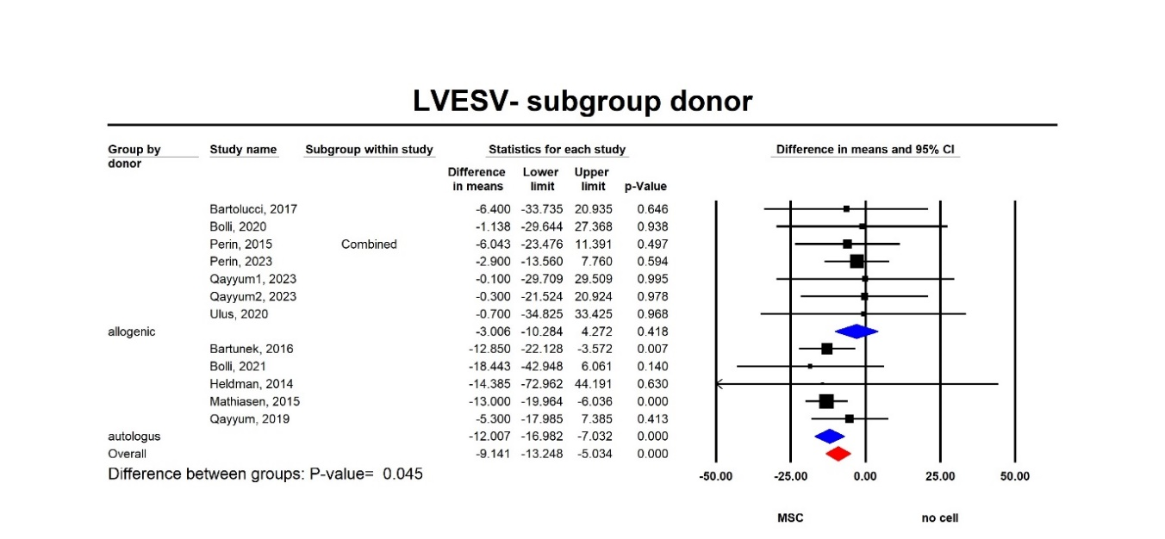
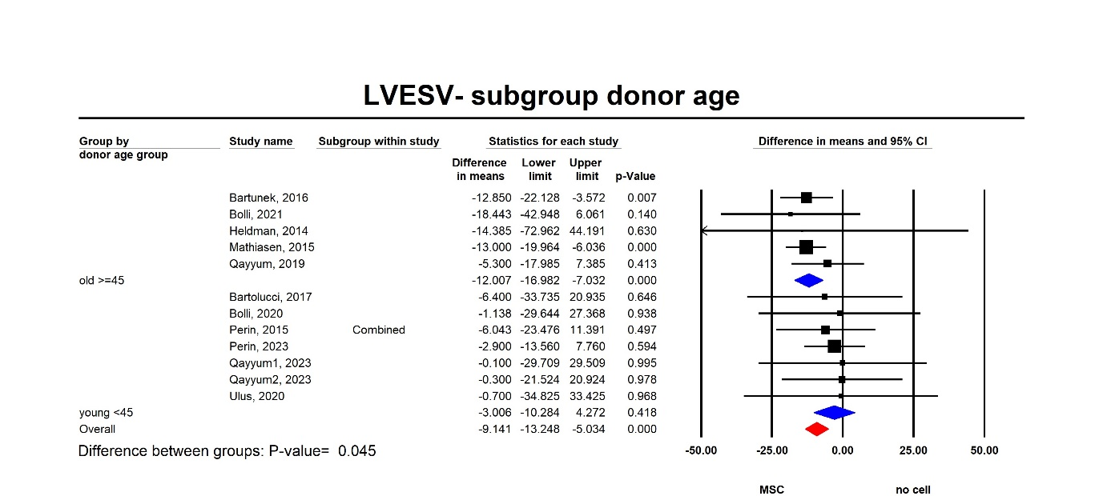
Figure S11: LVESV subgroup analysis of donor
Figure S12: LVESV subgroup analysis of donor age

NYHA:

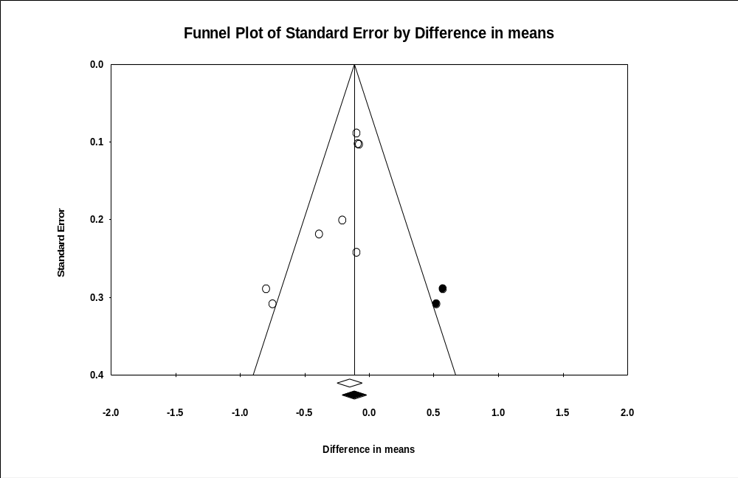
Figure S13: Funnel plot of NYHA

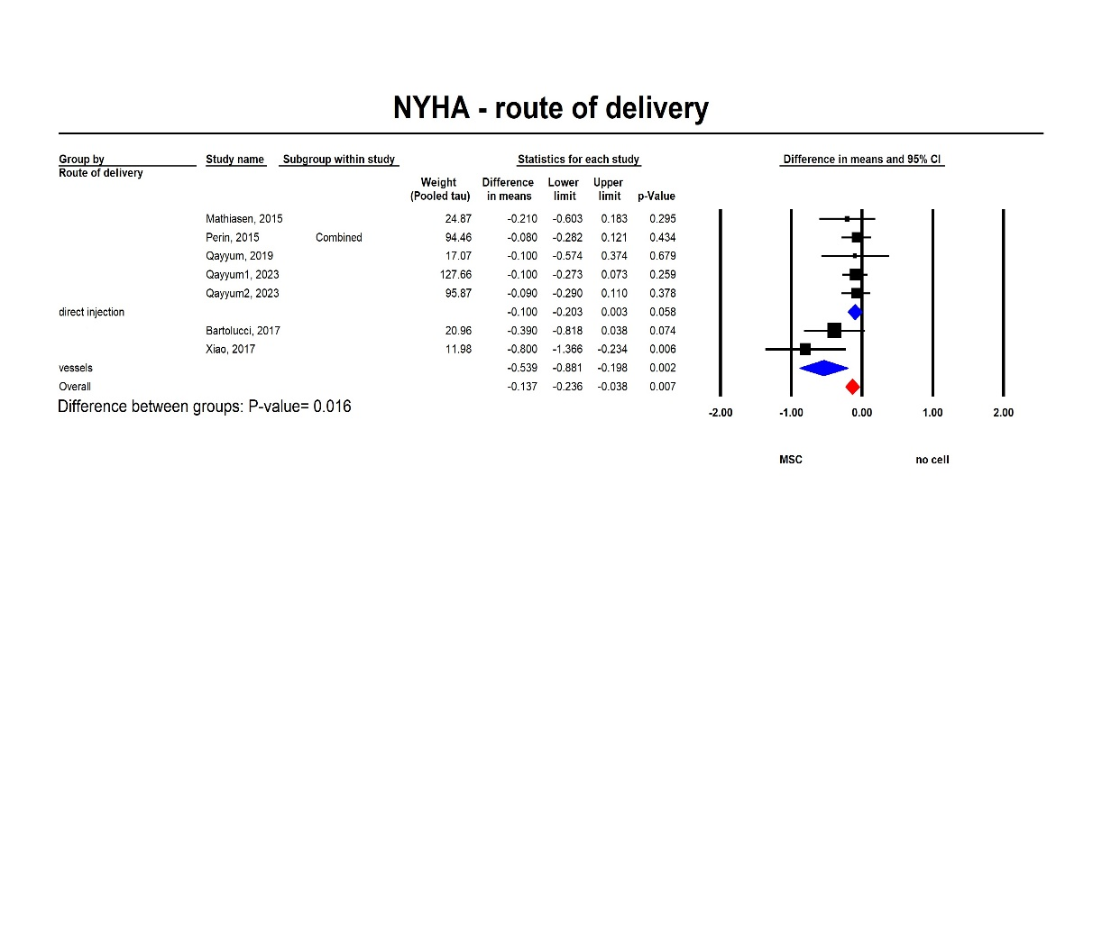
Figure S14: NYHA subgroup analysis of route of delivery
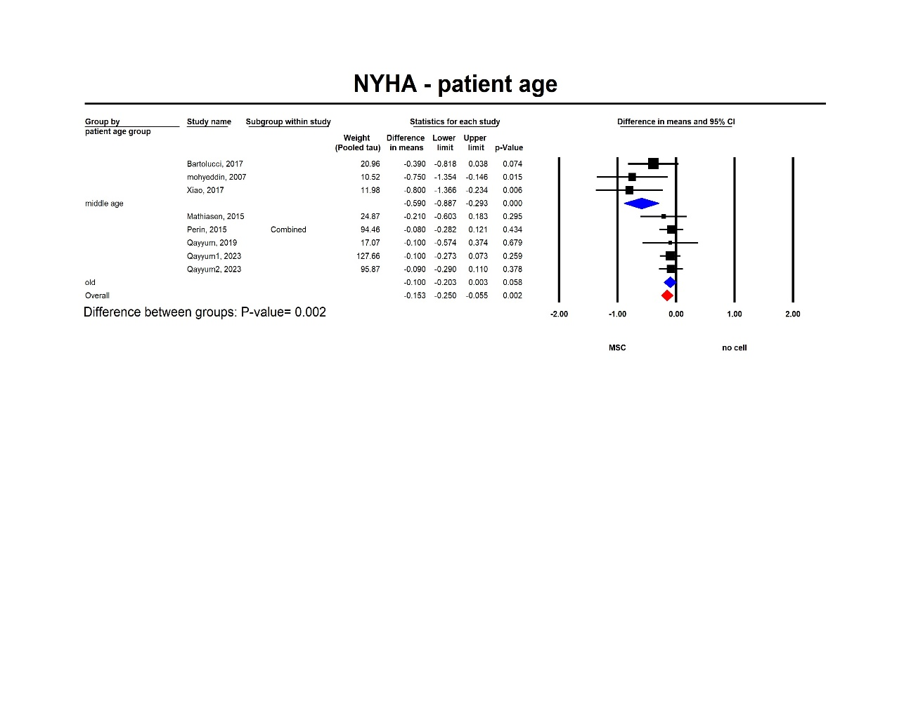
Figure S15: NYHA subgroup analysis of patient's age
Covariate NYHA | Coefficient | Standard Error | 95% Lower | 95% Upper | Z-value | 2-sided P-value
Intercept | -2.5156 | 0.8372 | -4.1564 | -0.8747 | -3 | 0.0027
age mean | 0.0369 | 0.013 | 0.0113 | 0.0625 | 2.83 | 0.0047
R² analog = 1.00

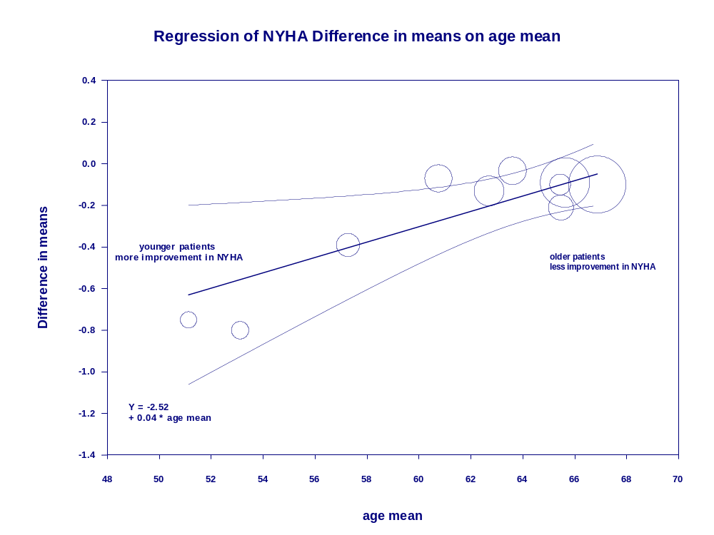
Figure S16: meta-regression investigating the effect of patient's age on NYHA

Covariate NYHA | Coefficient | Standard Error | 95% Lower | 95% Upper | Z-value | 2-sided P-value
Intercept | -2.1279 | 0.974 | -4.037 | -0.2188 | -2.18 | 0.0289
gender | 0.0229 | 0.0113 | 0.0008 | 0.0451 | 2.03 | 0.0423
R² analog = 1.00

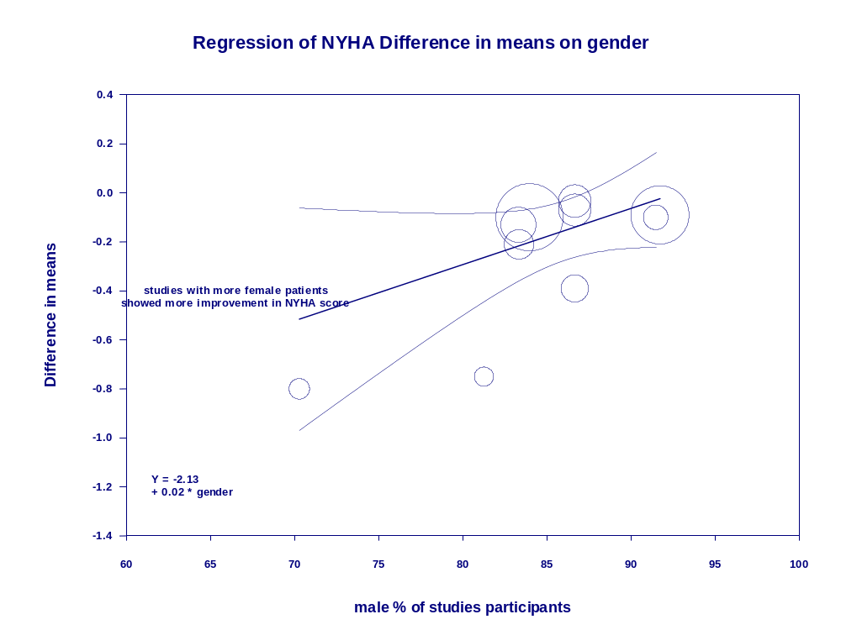
Figure S17: meta-regression investigating the effect of gender on NYHA

6MWT:

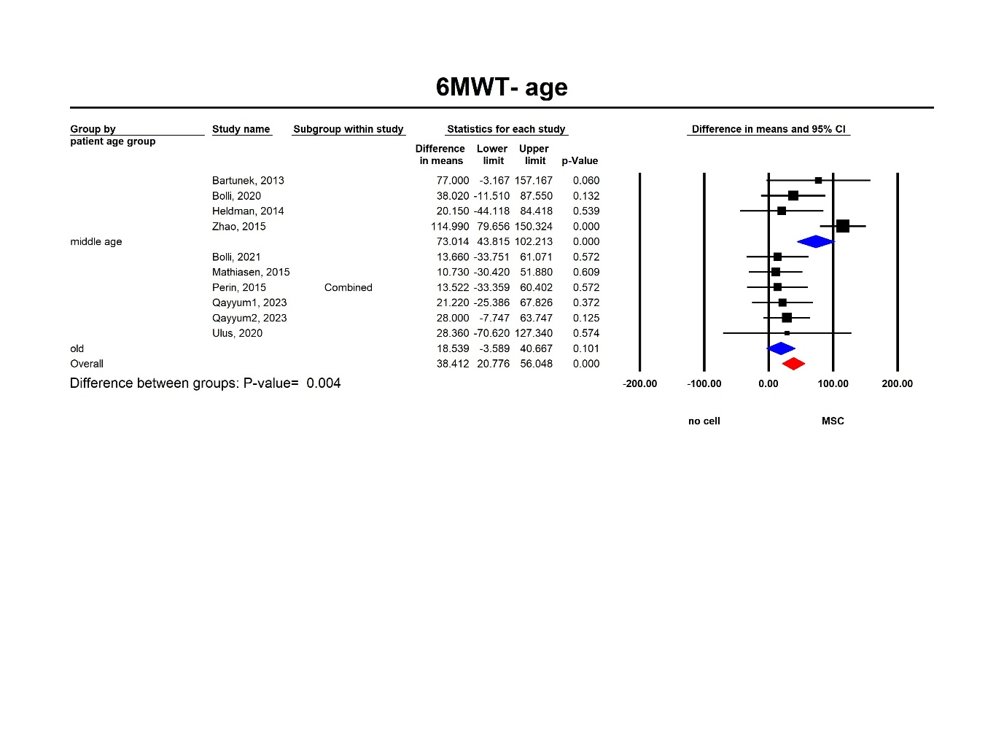
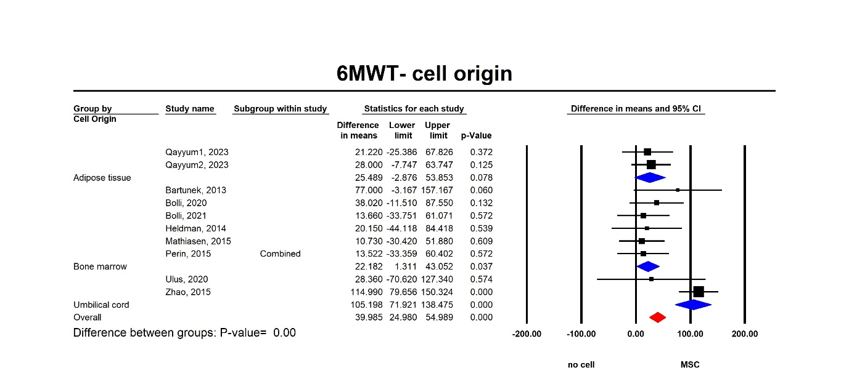
Figure S18: 6MWT subgroup analysis of patient's age
Figure S19: 6MWT subgroup analysis of cell origin

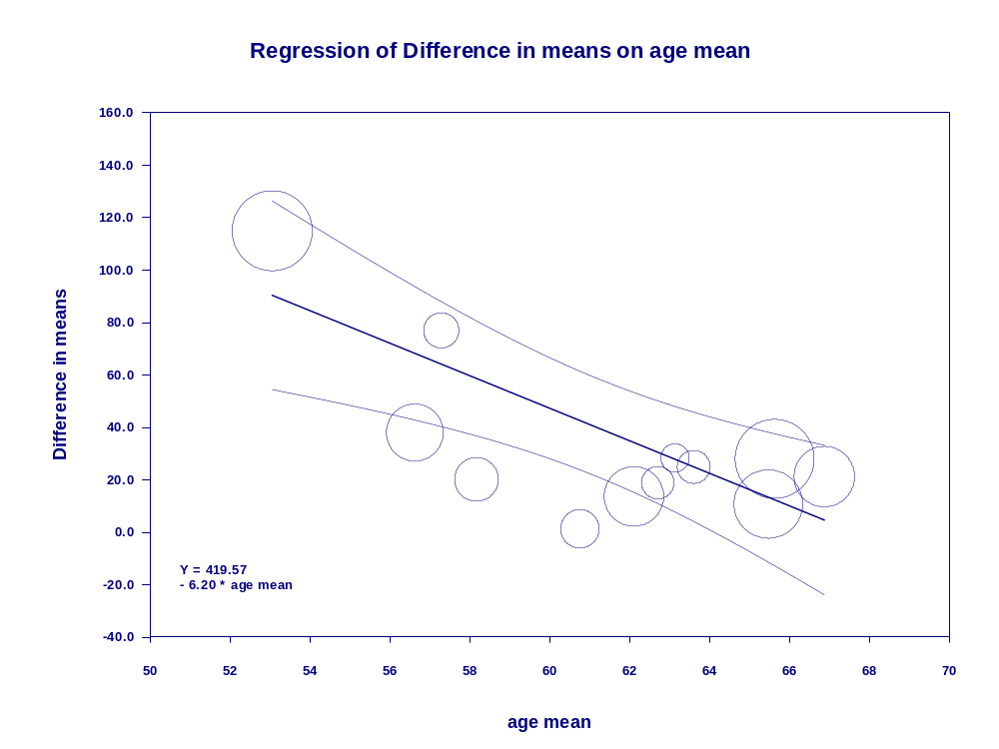
Figure S20: meta-regression investigating the effect of age on 6MWT

Covariate | Coefficient | Standard Error | 95% Lower | 95% Upper | Z-value | 2-sided P-value
Intercept | 419.5741 | 94.8245 | 233.7215 | 605.4266 | 4.42 | 0
age mean | -6.2048 | 1.545 | -9.2329 | -3.1768 | -4.02 | 0.0001
R² analog = 1.00

Covariate 6MWT | Coefficient | Standard Error | 95% Lower | 95% Upper | Z-value | 2-sided P-value
Intercept | 83.2654 | 20.1488 | 43.7745 | 122.7563 | 4.13 | 0
donor age | -1.1129 | 0.4391 | -1.9735 | -0.2523 | -2.53 | 0.0113
R² analog = 0.82

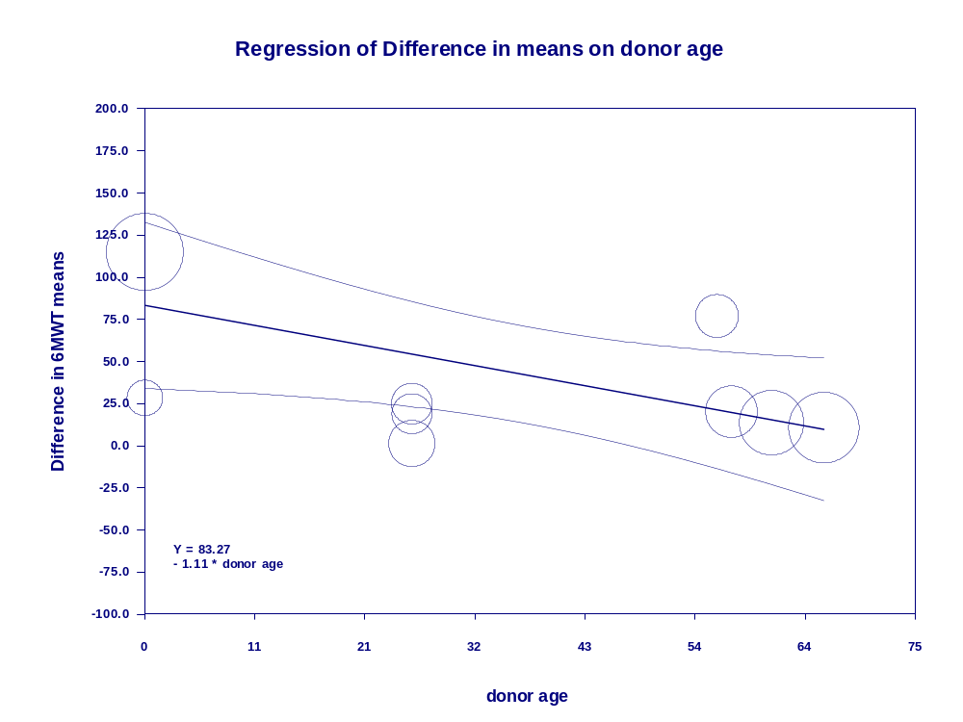
Figure S21: meta-regression investigating the effect of donor age on 6MWT

Covariate 6MWT | Coefficient | Standard Error | 95% Lower | 95% Upper | Z-value | 2-sided P-value
Intercept | 79.3308 | 24.0642 | 32.1659 | 126.4958 | 3.3 | 0.001
ischemic cause % | -0.5567 | 0.287 | -1.1191 | 0.0057 | -1.94 | 0.0524
R² analog = 0.57

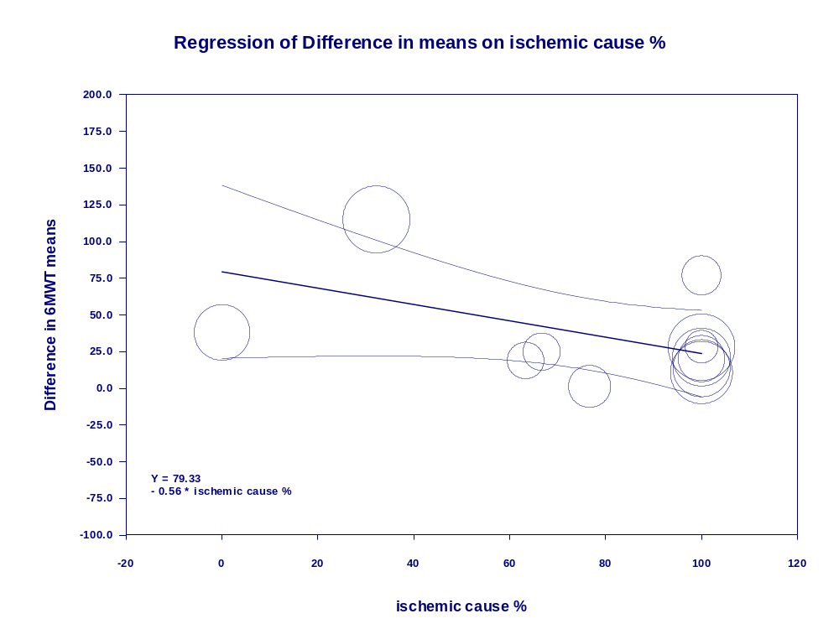
Figure S22: meta-regression investigating the effect of ischemic cause on 6MWT

Sensitivity Analysis:
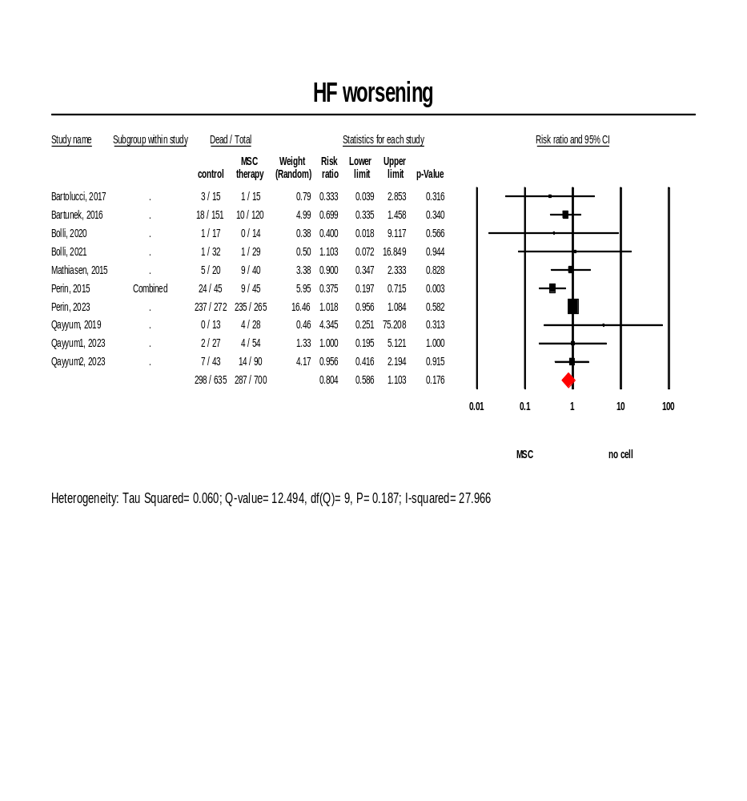
Figure S23: Forest plot of the comparison between the changes in treatment and control groups regarding heart failure worsening
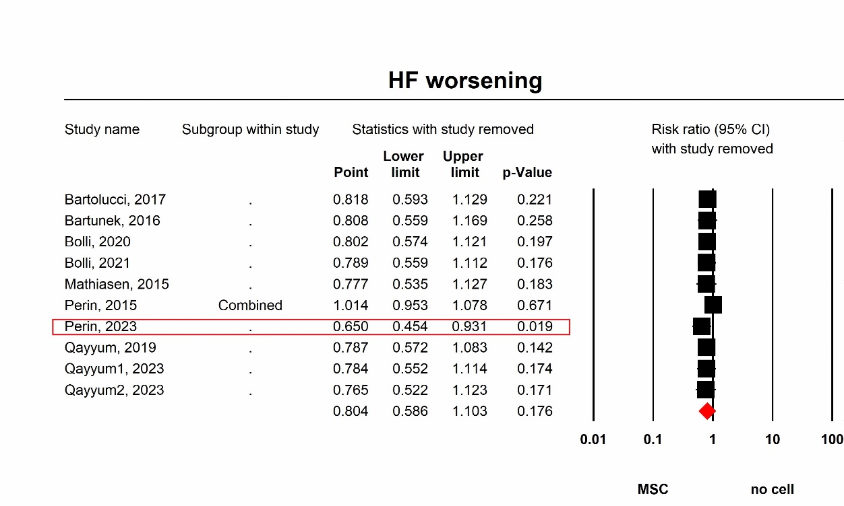
Figure S24: one study removed test for heart failure worsening outcome.

Table S1: Summary of subgroup analysis. auto= autologous, allo= allogenic, BM= bone marrow, UC= umbilical cord, AT= adipose tissue, IH= ischemic heart failure, nIH =non- ischemic heart failure, #: insignificant, _: not enough study to perform analysis
subgroup analysis of outcomes | Death | rehospitalization | HF worsening | MACE | EF | LVESV | LVEDV | Quality of life | 6MWT | BNP | NYHA | scar mass
Donor (allo vs. auto) | # | autologous | # | # | # | autologous | autologous | _ | # | _ | #: in favor of autologous | _
cell origin (BM vs. UC vs AT) | # | _ | _ | _ | # | # | _ | _ | UC | _ | # | _
cell number (<=10^8 vs. >10^8 ) | # | #: in favor of <=10^8 | <=10^8 | # | # | # | # | _ | # | _ | # | _
delivery (vessels vs. direct injection) | # | _ | _ | _ | vessels | _ | # | _ | _ | _ | vessels | _
donor age ( >=45 vs <45) | # | # | # | # | # | >=45 | # | _ | # | _ | # | _
CHF cause (IH vs. nIH or both) | # | # | # | # | # | # | # | _ | # | _ | # | _
patient's age (<60 vs. >=60) | # | # | # | # | # | # | # | _ | <60 | _ | <60 | _

Meta-regression of outcomes | Death | rehospitalization | HF worsening | MACE | EF | LVESV | LVEDV | Quality of life | 6MWT | BNP | NYHA | scar mass
10^7 mean cell number | # | 0.1 | # | # | # (+0.06) | # | # | _ | # | _ | # | _
donor mean age | # | # | # | # | # | # | # | _ | -1.11 | _ | # | _
number of injection sites | # | # | # | # | # | # | # | _ | # | _ | # | _
% ischemic | # | # | # | # | # | # | # | _ | # (-0.55) | _ | # | _
% male gender | # | # | # | # | # | # | # | _ | # | _ | 0.02 | _
mean age | # | # | # | # | # (-0.29) | # | # | _ | -6.2 | _ | 0.03 | _
baseline EF | # | # | # | # | # | # | # | _ | # | _ | # | _
baseline NYHA | # | # | # | # | # | # | # | _ | # | _ | # | _
follow up | # | # | # | # | # | # | # | _ | # | _ | # | _
egger test | 0.48 | 0.01 | 0.2 | 0.76 | 0.5 | 0.14 | 0.9 | 0.16 | 0.56 | 0.94 | 0.01 | 0.16
Table S2: Summary of meta-regression; #: insignificant, _: insufficient study to perform analysis.

