Supplementary Figures for

The loss of OPA1 accelerates intervertebral disc degeneration and osteoarthritis in aged mice

Vedavathi Madhu¹, Miriam Hernandaz-Meadows¹, Ashley Coleman¹, Kimheak Sao¹, Kameron Inguito¹, Owen Haslam¹, Paige K Boneski¹, Hiromi Sesaki², John A Collins¹, Makarand V. Risbud^{1*}

¹Department of Orthopaedic Surgery, Thomas Jefferson University, Philadelphia, PA.
²Department of Cell Biology, Johns Hopkins University, Baltimore, MD.

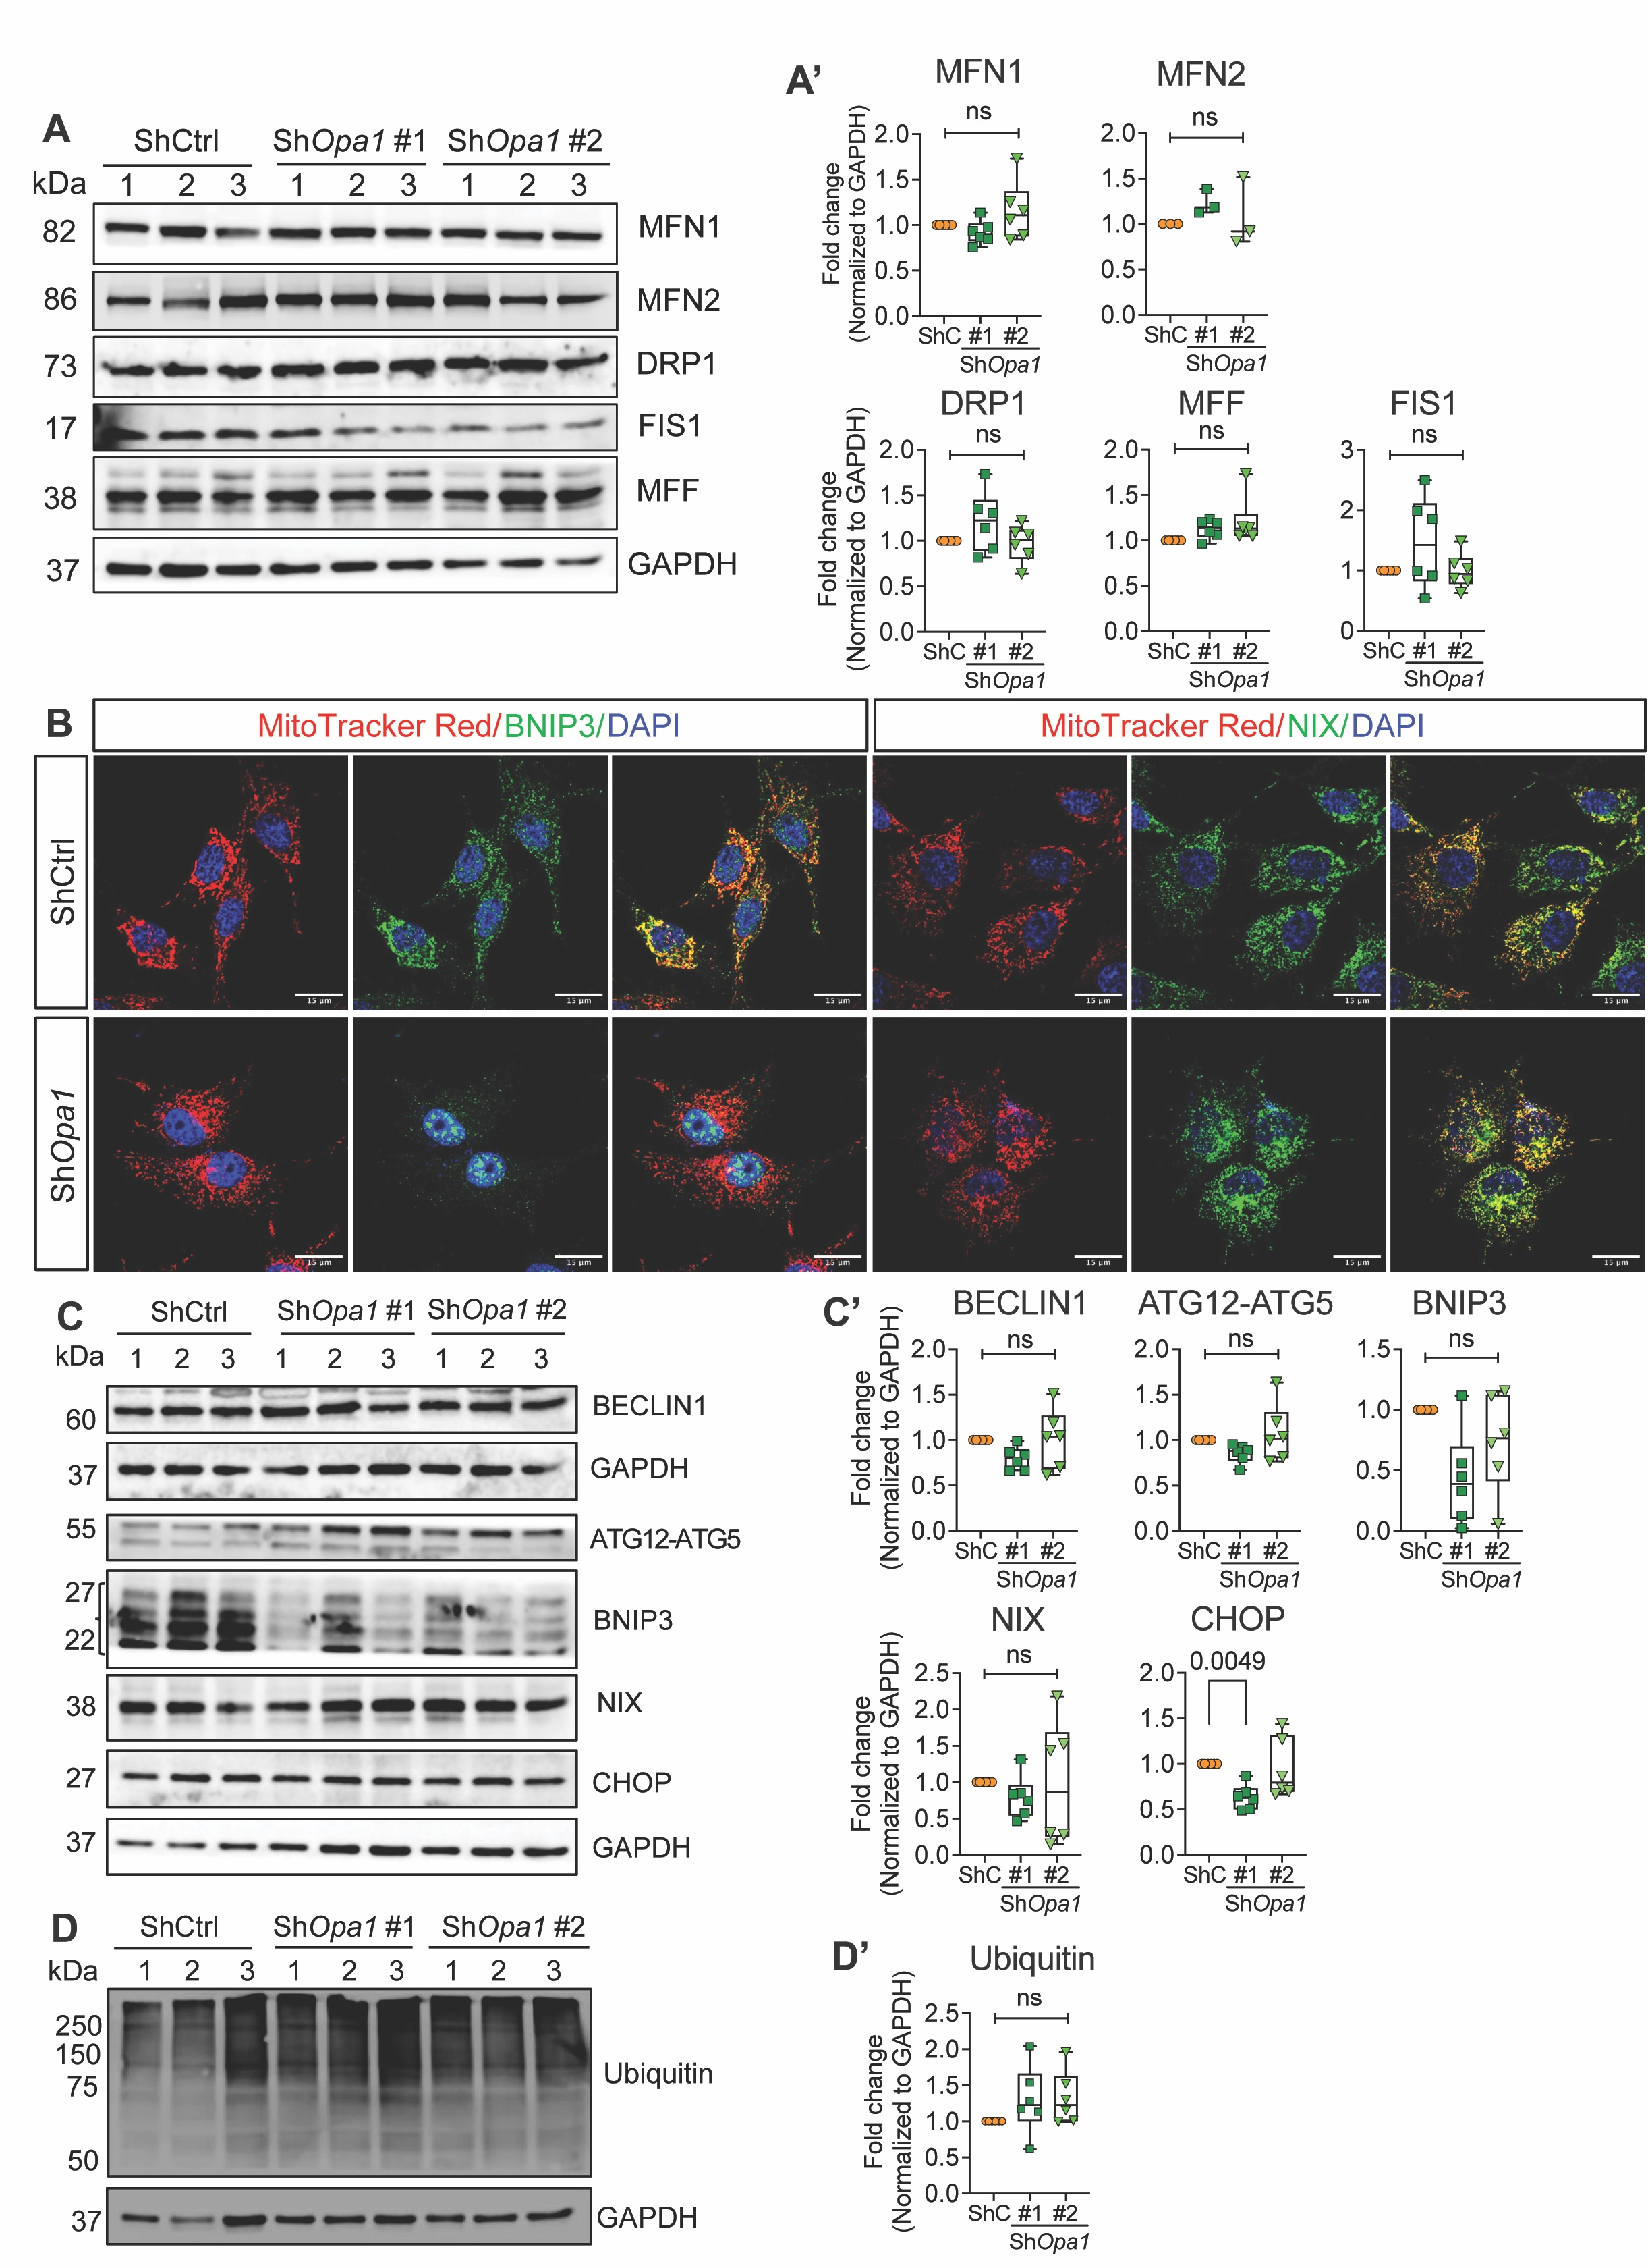

Figure. S1. OPA1 knockdown does not alter OMM fusion, fission, and mitophagy related proteins in NP cells. (A, A’) Western blot analysis and corresponding densitometric quantification of fusion proteins MFN1, MFN2 and fission proteins DRP1, MFF, FIS1 in NP cells lentivirally transduced with ShCtrl, and ShOpa1 #1 and ShOpa1#2. (B) Immunofluorescence staining for BNIP3 and NIX in ShCtrl and ShOpa1#1 NP cells. Scale bar = 15 μm. (C, C’) Western blot analysis and corresponding densitometric quantification of autophagy markers BECLIN1, ATG12-ATG5, mitophagy markers BNIP3, NIX, and apoptosis marker CHOP. (D, D’) Western blot analysis and densitometric quantification of Ubiquitin in NP cells lentivirally transduced with ShCtrl, ShOpa1#1, and ShOpa1#2. Data represents 6 independent experiments and presented as Box and Whiskers plots showing all data points with median and interquartile range and maximum and minimum values. Statistical significance was determined using one-way ANOVA with Sidak’s multiple comparisons test

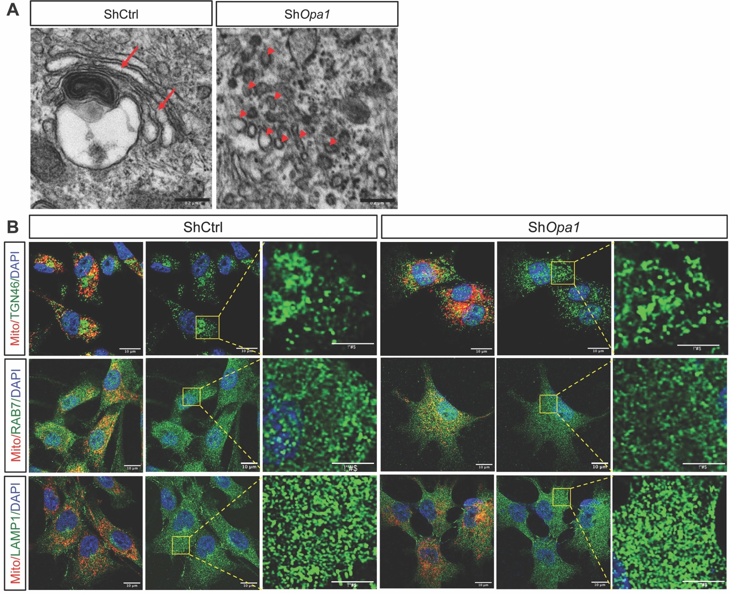

Figure. S2. Effect of OPA-1 deficiency in NP cells on cis-Golgi, trans-Golgi, late endosome and lysosomal morphology. (A) A representative TEM image of ShCtrl and ShOpa1 cells showing fragmented cis-Golgi compared in ShOpa1 cells. Scale bar: 200 nm (B) Immunofluorescence staining of ShCtrl and ShOpa1 NP cells for Trans-Golgi marker TGN46, late endosome marker RAB7 and lysosome marker LAMP1. There are no distinctive morphological changes in either of these organelles between the two groups. Scale bar: 15 μm

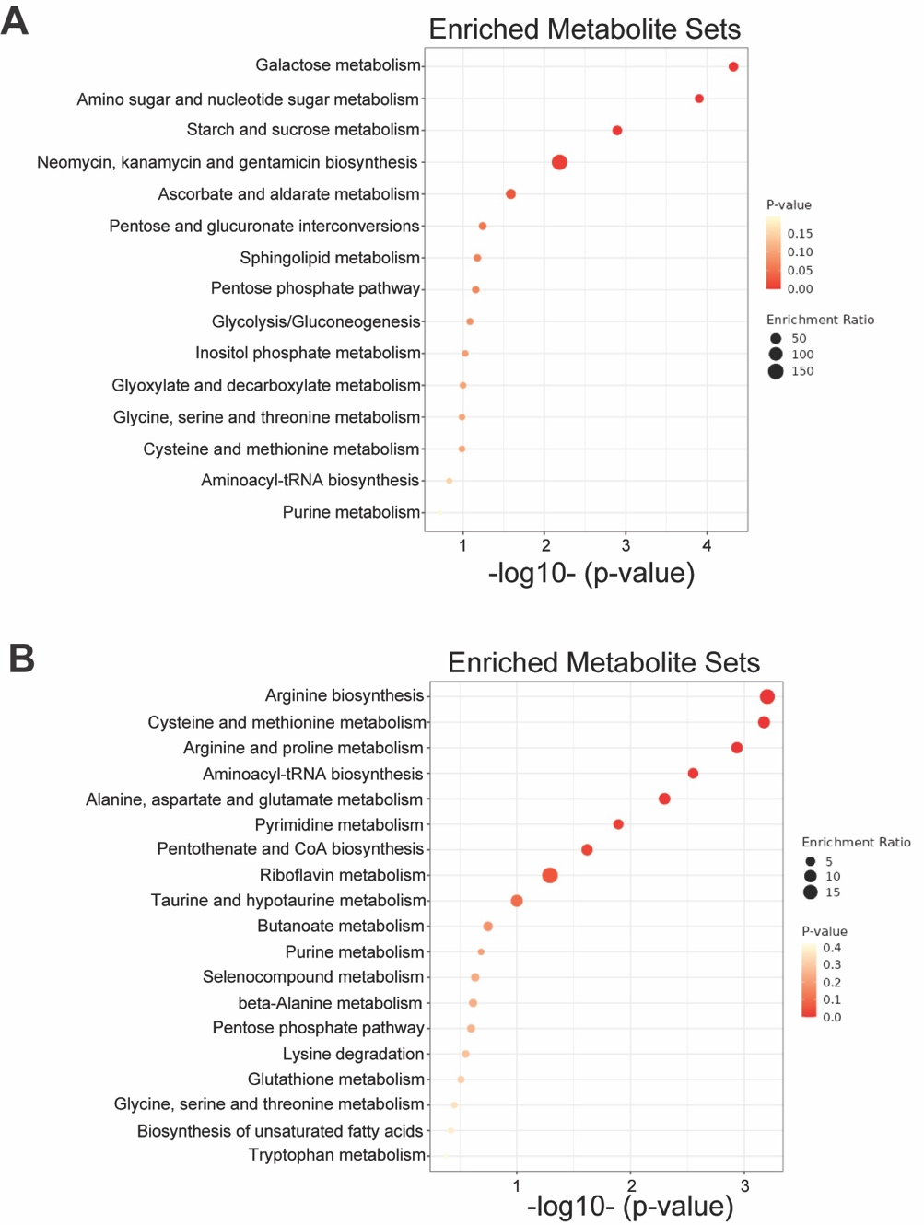

Figure. S3. Metabolic pathway analysis (MetPA) of (A) upregulated and (B) downregulated metabolites (FDR < 0.05) from ShOpa1 vs ShCtrl transduced cells.

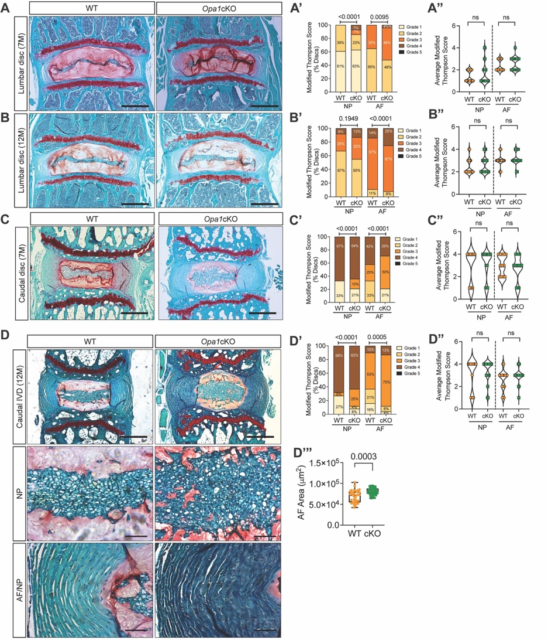

Figure. S4. IVD degeneration phenotype in Opa1cKO mice is age-dependent (A-B) Representative images of Safranin O/Fast Green/hematoxylin staining of (A) 7-month-old and (B) 12-month-old WT and Opa1cKO lumbar discs showing disc morphology and overall proteoglycan content in the intervertebral disc, scale bar = 500 μm. (A’ A’, B’ B”) Modified Thompson Scoring (A’, B’) grade distributions and (A”, B”) average scores from NP and AF compartments of 7-month-old and 12-month-old WT and Opa1cKO lumbar discs. n = 7-month-old: 6-7 mice/genotype; 4/5 lumbar disc/animal, 25-34 discs/genotype; 12-month-old: 9-10 mice/genotype; 4 lumbar disc/animal, 36-40 discs/genotype. (C) Representative Safranin O/Fast Green/Hematoxylin staining images of 7-month-old WT and Opa1cKO caudal discs, scale bar = 500 μm. (C’, C”) Modified Thompson Scoring grade distributions and average scores of NP and AF compartments of 7-month-old WT and Opa1cKO caudal discs. (D) Representative Safranin O/Fast Green staining images of 12-month-old WT and Opa1cKO caudal discs; scale bar = top row – 500 μm, bottom rows - 100 μm. (D’, D”) Modified Thompson Scoring grade distributions and average scores of NP and AF compartments of 12-month-old WT and Opa1cKO caudal discs. (D”’) Quantification of AF hyperplasia in WT and Opa1cKO caudal discs. N = 7-month-old: 6-7 mice/genotype; 2 caudal disc/animal, 12-14 discs/genotype; 12-month-old: 9-10 mice/genotype; 2/3 caudal disc/animal, 19-24 discs/genotype. Significance was determined using a chi-square test (A’, B; C’, D’) and data represented as Violin plots or Box and Whisker plot showing all data points with median and interquartile range and maximum and minimum values. Statistical significance was determined using t-test or Mann Whitney test, as appropriate.

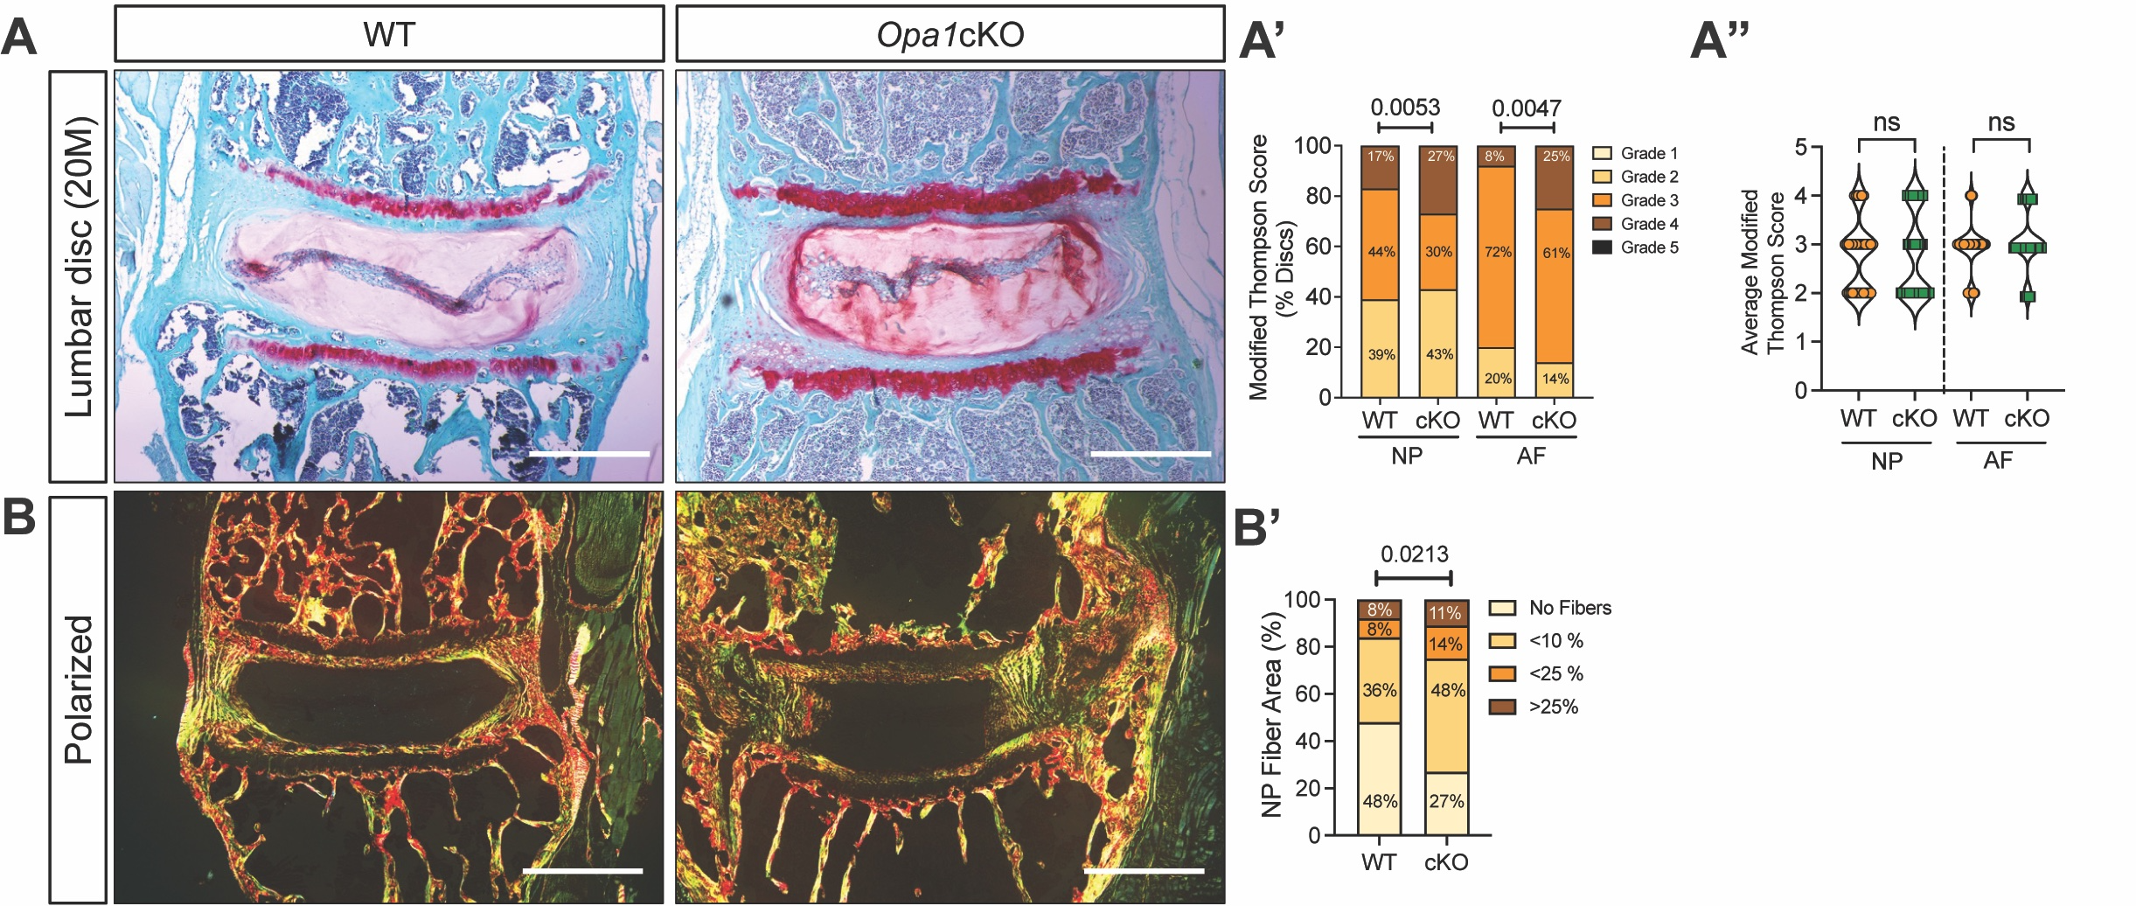

Figure. S5. Opa1cKO mice show mild degenerative changes in lumbar discs at 20-months.
(A) Representative Safranin O/Fast Green/Hematoxylin staining images of 20-month-old WT and Opa1cKO lumbar discs, scale bar = 500 μm. (A’, A”) Modified Thompson Scoring (A’) grade distributions and (A”) average scores of NP and AF compartments of 20-month-old WT and Opa1cKO lumbar discs. (B) Representative picrosirius red stained polarized light images and (B’) quantification of 20-month-old lumbar discs showing the presence of collagen fibers in the NP compartment. n = 9-11 mice/genotype; 4 lumbar disc/animal, 36-44 discs/genotype. Significance for A” and B’ was determined using a chi-square test. Significance for A” was determined using an unpaired t-test or Mann-Whitney test, as appropriate. Quantitative data in A” is represented as a Violin plot showing all data points with median and interquartile range and maximum and minimum values.

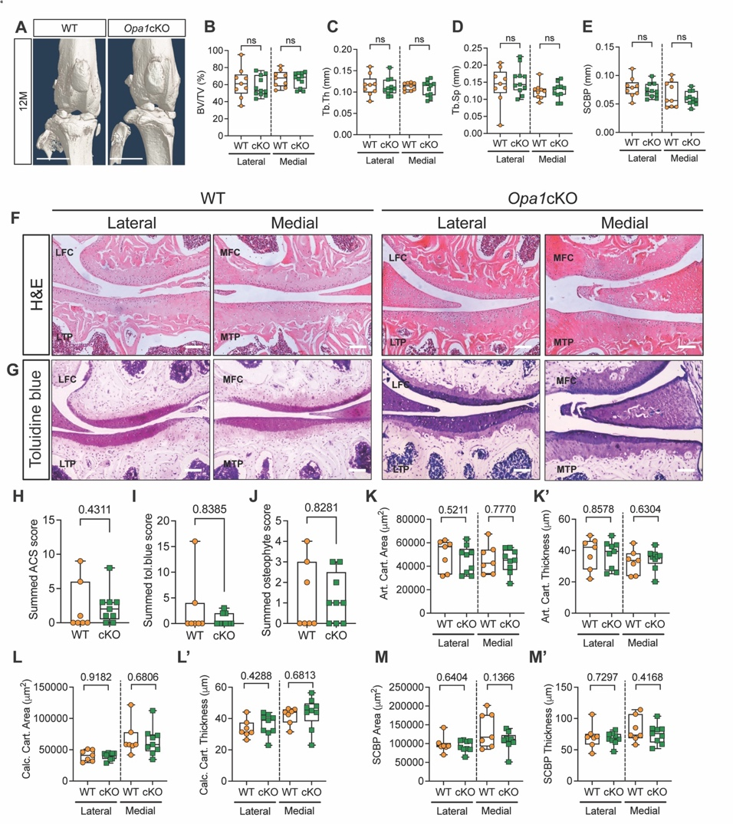

Figure. S6. Opa1cKO mice did not show altered cartilage morphology at 12-months. WT and Opa1cKO mice were aged to 12 months and OA severity was analyzed by microCT and histological analysis. (A) The representative 3D reconstruction of the knee joint of 12-month-old WT and Opa1cKO mice. Scale bar: 500 μm. (B-E) Quantitative microCT analyses of tibial subchondral bone parameters on the lateral and medial tibial plateaus of 12-month-old WT and Opa1cKO mice (B) subchondral bone volume fraction (BV/TV), (C) trabecular thickness (Tb.Th), (D) trabecular separation (Tb.Sp), (E) subchondral bone plate thickness (SCBP.Th). (F-G) Representative images of H&E and toluidine blue stained midcoronal sections showing the lateral and medial tibial plateaus and femoral condyles from WT and Opa1cKO mice. (H-J) Summed (MTP, MFC, LTP, LFC) scores for (H) Articular Cartilage structure (ACS), (I) toluidine blue and (J) osteophyte in 12-month-old mice. LFC = lateral femoral condyle, LTP = lateral tibial plateau, MFC = medial femoral condyle, MTP = medial tibial plateau. (K, K’) Histomorphometric analyses of lateral and medial compartments performed on midcoronal sections of 12-month-old WT and Opa1cKO mouse limbs to compute (K) articular cartilage (Art. cart) area, (K’) articular cartilage (Art. cart) thickness, (L) calcified cartilage (Calc. cart) area and (L’) calcified cartilage (Calc. cart) thickness, (M) subchondral bone plate (SCBP) area and (M’) subchondral bone plate (SCBP) thickness. n = 7 WT (4F, 3M), 9 Opa1cKO (4F, 5M). Quantitative data represented as Box and Whiskers plots showing all data points with median and interquartile range and maximum and minimum values. Significance was determined using an unpaired t-test or Mann-Whitney test, as appropriate

