Supplementary Table 1. Top 20 performing female gametophytes based on HST and progeny’s biomass; AQ – Arroyo Quemado, CI – Catalina Island, CP – Camp Pendleton.

Female Gametophyte | Population | HST | Sporophyte's Biomass | Genotyped | Rank
CP.46.F.A1 | CP | -0.087 | 467.80 | No | 1
CP.04.F.A3 | CP | -0.054 | 403.75 | Yes | 2
CP.70.F.D3 | CP | -0.047 | 378.75 | Yes | 3
AQ.59A.F.C1 | AQ | -0.069 | 352.67 | Yes | 4
AQ.62.F.A5 | AQ | -0.029 | 328.75 | Yes | 5
CI.17.F.C3 | CI | -0.104 | 344.80 | Yes | 6
AQ.28.F.A5 | AQ | -0.106 | 310.67 | Yes | 7
CP.45.F.D4 | CP | -0.080 | 300.25 | No | 8
CI.43.F.D3 | CI | -0.065 | 282.00 | Yes | 9
CP.73.F.B2 | CP | -0.172 | 300.00 | Yes | 10
CP.01.F.D3 | CP | -0.057 | 270.00 | Yes | 11
CP.67.F.C4 | CP | -0.062 | 266.25 | Yes | 12
CI.36.F.B4 | CI | 0.031 | 245.00 | Yes | 13
CP.05.F.D2 | CP | -0.116 | 259.00 | Yes | 14
CI.22.F.D2 | CI | -0.130 | 262.00 | Yes | 15
CI.01.F.A4 | CI | -0.032 | 241.67 | Yes | 16
CP.41.F.D1 | CP | -0.015 | 234.40 | Yes | 17
AQ.21.F.C1 | AQ | -0.315 | 328.40 | Yes | 18
CP.66.F.B1 | CP | -0.074 | 230.40 | Yes | 19
CI.58.F.C2 | CI | -0.394 | 386.75 | Yes | 20

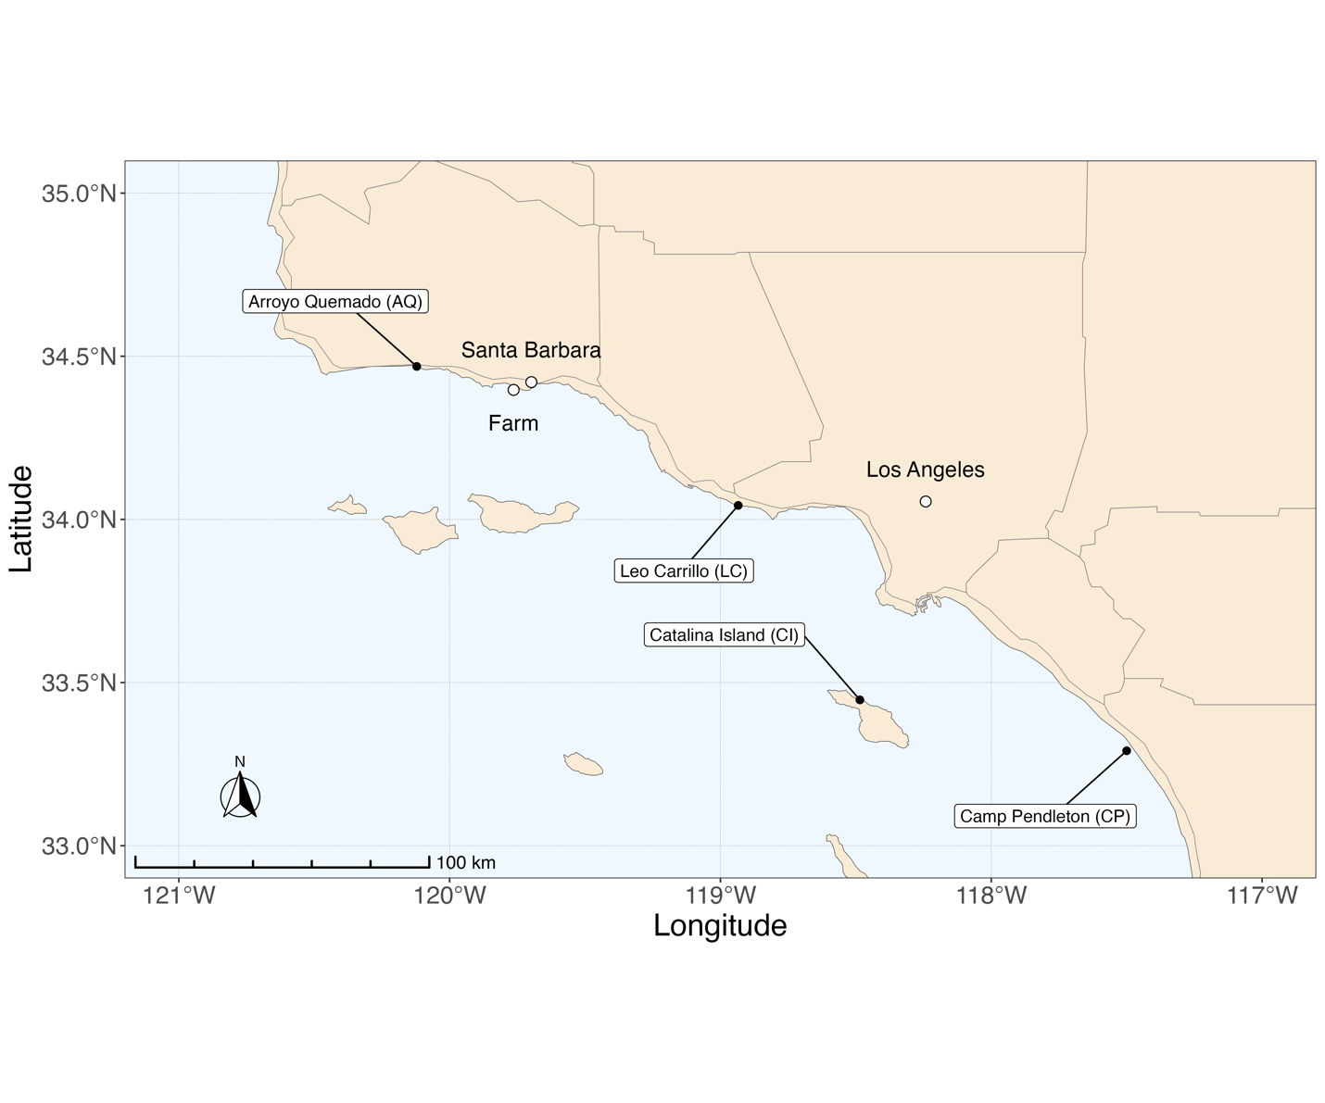
Supplementary Figure 1. Map of M. pyrifera sampling locations across the Southern California Bight and the farm location.

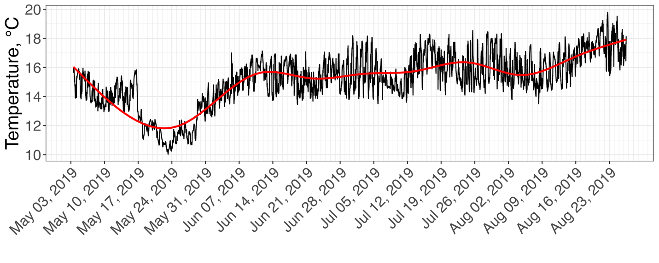
Supplementary Figure 2. Averaged temperature pattern on the farm between 05/03/2019 and 08/27/19; the red line is a smooth approximation representing the temperature trend.

