Supplementary information for
Scalable two-step annealing method for preparing ultra-high-density single-atom catalyst libraries
Xiao Hai^{1,10}, Shibo Xi^{2,10}, Sharon Mitchell^{3,10}, Karim Harrath^{4,5,10}, Haomin Xu¹, Dario Faust Akl³, Debin Kong⁶, Jing Li¹, Zejun Li¹, Tao Sun¹, Huimin Yang¹, Yige Cui¹, Chenliang Su⁷, Xiaoxu Zhao^{8*}, Jun Li^{4,5*}, Javier Pérez-Ramírez^{3*} and Jiong Lu^{1,9*}
¹Department of Chemistry, National University of Singapore, 3 Science Drive 3, Singapore 117543, Singapore.
²Institute of Chemical and Engineering Sciences, Agency for Science, Technology and Research, Singapore 627833, Singapore.
³Institute for Chemical and Bioengineering, Department of Chemistry and Applied Biosciences, ETH Zurich, Zurich, Switzerland.
⁴Department of Chemistry, Southern University of Science and Technology, Shenzhen 518055, China.
⁵Department of Chemistry and Key Laboratory of Organic Optoelectronics & Molecular Engineering of the Ministry of Education, Tsinghua University, Beijing 100084, China.
⁶CAS Key Laboratory of Nanosystem and Hierarchical Fabrication, CAS Center for Excellence in Nanoscience, National Center for Nanoscience and Technology, Beijing 100190, China.
⁷SZU-NUS Collaborative Center and International Collaborative Laboratory of 2D Materials for Optoelectronic Science & Technology of Ministry of Education, Engineering Technology Research Center for 2D Materials Information Functional Devices and Systems of Guangdong Province, Institute of Microscale Optoelectronics, Shenzhen University, Shenzhen 518060, China.
⁸School of Materials Science and Engineering, Nanyang Technological University, Singapore 639798, Singapore.
⁹Centre for Advanced 2D Materials and Graphene Research Centre, National University of Singapore, Singapore 117546, Singapore.
¹⁰These authors contributed equally: Xiao Hai, Shibo Xi, Sharon Mitchell, Karim Harrath.
*E-mails: xiaoxu.zhao@ntu.edu.sg; junli@tsinghua.edu.cn; jpr@chem.ethz.ch; chmluj@nus.edu.sg

Table of Contents
Supplementary Figures 1-16
Supplementary Tables 1-2

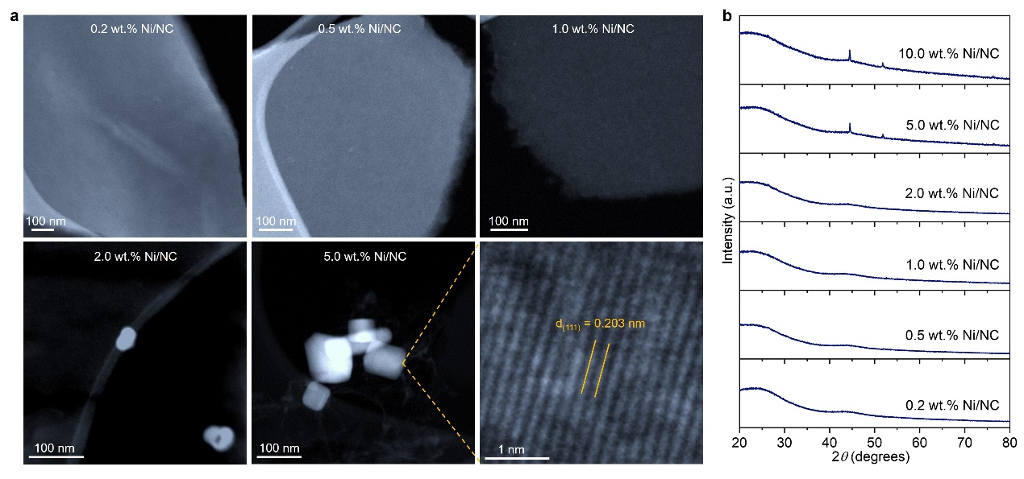
Supplementary Fig. 1 |Catalyst synthesis via one-step annealing. a, b, TEM images (a) and XRD patterns (b) of Ni/NC catalysts with different metal loadings prepared by impregnation of NiCl₂ followed by conventional one-step annealing. The formation of large Ni nanoparticles is readily detected at a metal loading of 2 wt.%, and the particle size gradually increases with higher Ni content. Reflections corresponding to the metallic phase are evident in samples containing 5 and 10 wt.% Ni. The absence of reflections in 2 wt.% Ni/NC suggests that the metal loading is below the detection limit.

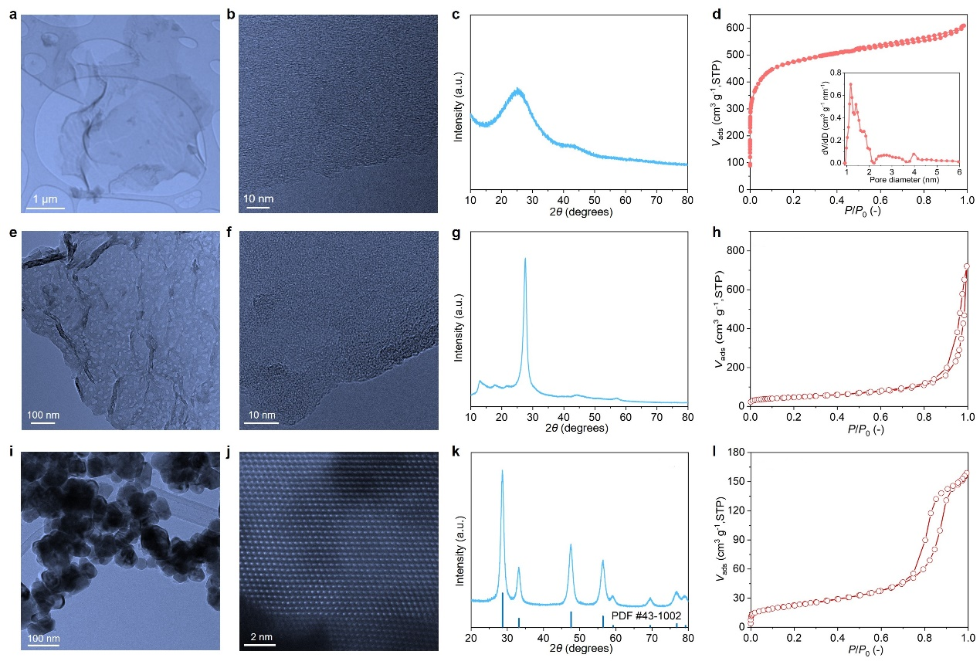
Supplementary Fig. 2 | Characterization of catalyst carriers. Representative TEM images of as-synthesized NC (a), PCN (e) and CeO₂ (i). High-resolution TEM images of NC (b), PCN (f) and CeO₂ (j). XRD patterns of NC (c), PCN (g) and CeO₂ (k). N₂ isotherms of NC (d), PCN (h) and CeO₂ (l) derived a total surface area of 1724, 172 and 82 m² g⁻¹, respectively.

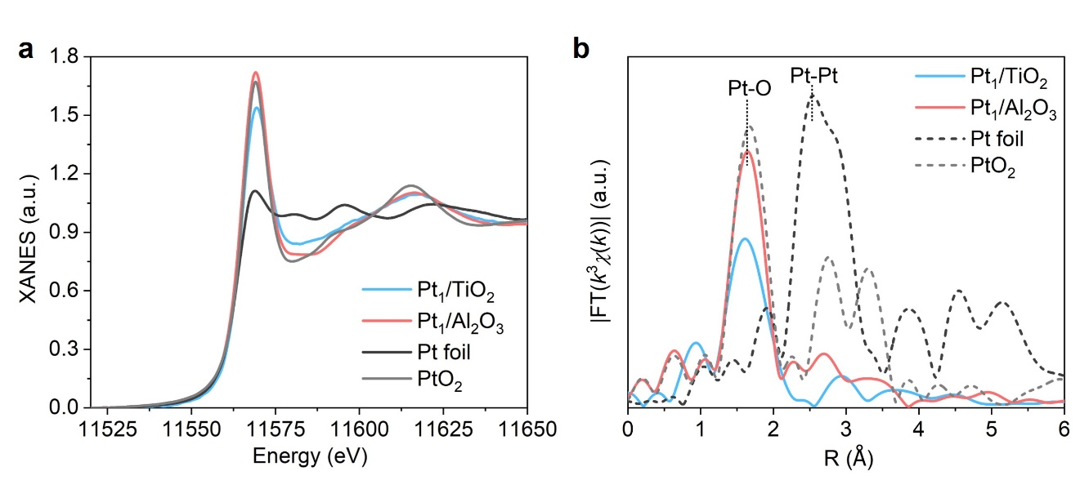
Supplementary Fig. 3 | XANES and EXAFS characterization of Pt₁/TiO₂ and Pt₁/Al₂O₃ UHD-SACs. The Pt L₃-edge a, XANES and b, Fourier transformed EXAFS spectra of Pt₁/TiO₂ and Pt₁/Al₂O₃ are compared with Pt references (Pt foil and PtO₂). The intensities of the white line of Pt₁/TiO₂ and Pt₁/Al₂O₃ are close to PtO₂, suggesting that the Pt atoms are positively charged. Besides, the Fourier transformed EXAFS magnitude of Pt₁/TiO₂ and Pt₁/Al₂O₃ are characterized by only one significant peak around 1.63Å that is close to the location of the Pt-O peak in the PtO₂ reference and thus can be ascribed to Pt-O bonding. The absence of a Pt-Pt peak confirms the Pt species are atomically dispersed on TiO₂ and Al₂O₃. The Pt contents are 8.3 wt.% and 6.8 wt.% for TiO₂ and Al₂O₃, respectively.

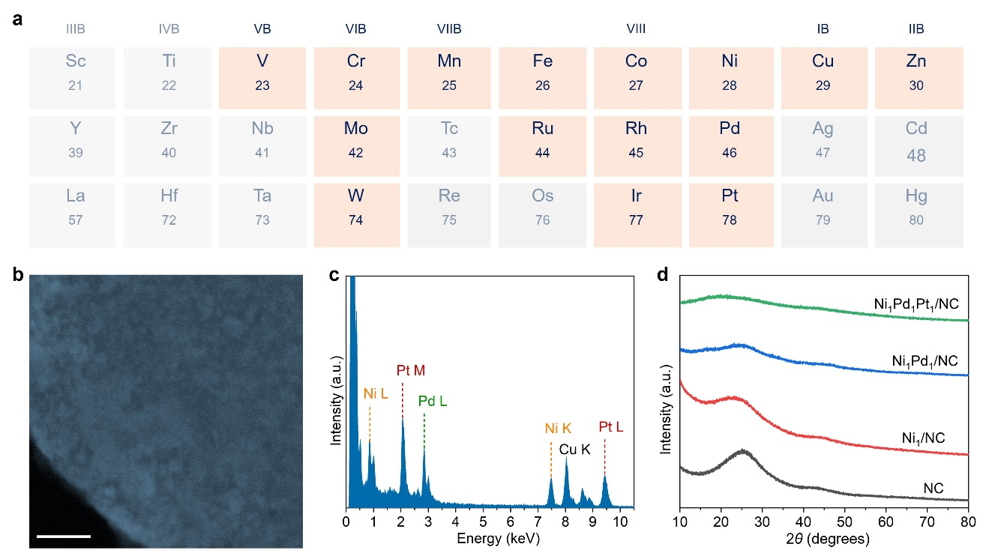
Supplementary Fig. 4 | Multimetallic UHD-SACs. a, Periodic table showing the accessible metals for multimetallic UHD-SACs shaded orange. STEM image (b), the corresponding EDX spectra (c) of Ni, Pd and Pt in Ni₁Pd₁Pt₁/NC. Scale bars: 100 nm. d, XRD patterns of Ni₁Pd₁/NC and Ni₁Pd₁Pt₁/NC only show the broad reflection at 20-30° and 40-50° 2θ belonging to amorphous carbon, no metal-related peaks can be observed. The Ni and Pd loadings are measured to be 4.2 and 8.6 wt.%, respectively, for Ni₁Pd₁/NC sample. The Ni, Pd and Pt loadings for Ni₁Pd₁Pt₁/NC sample were determined as 2.3, 5.1 and 9.8 wt.%, respectively.

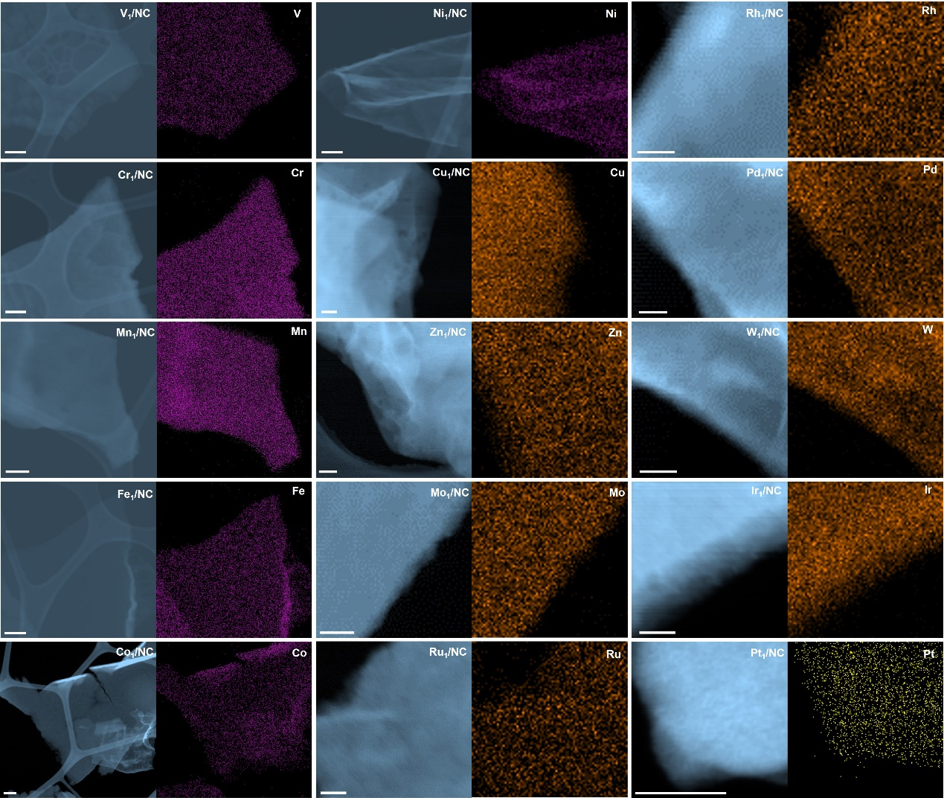
Supplementary Fig. 5 | Elemental mapping of UHD-SACs of various metals on NC. STEM image and corresponding EDS maps of various metals on NC, evidencing the uniform dispersion of metals over the NC support. Scale bars: 100 nm.
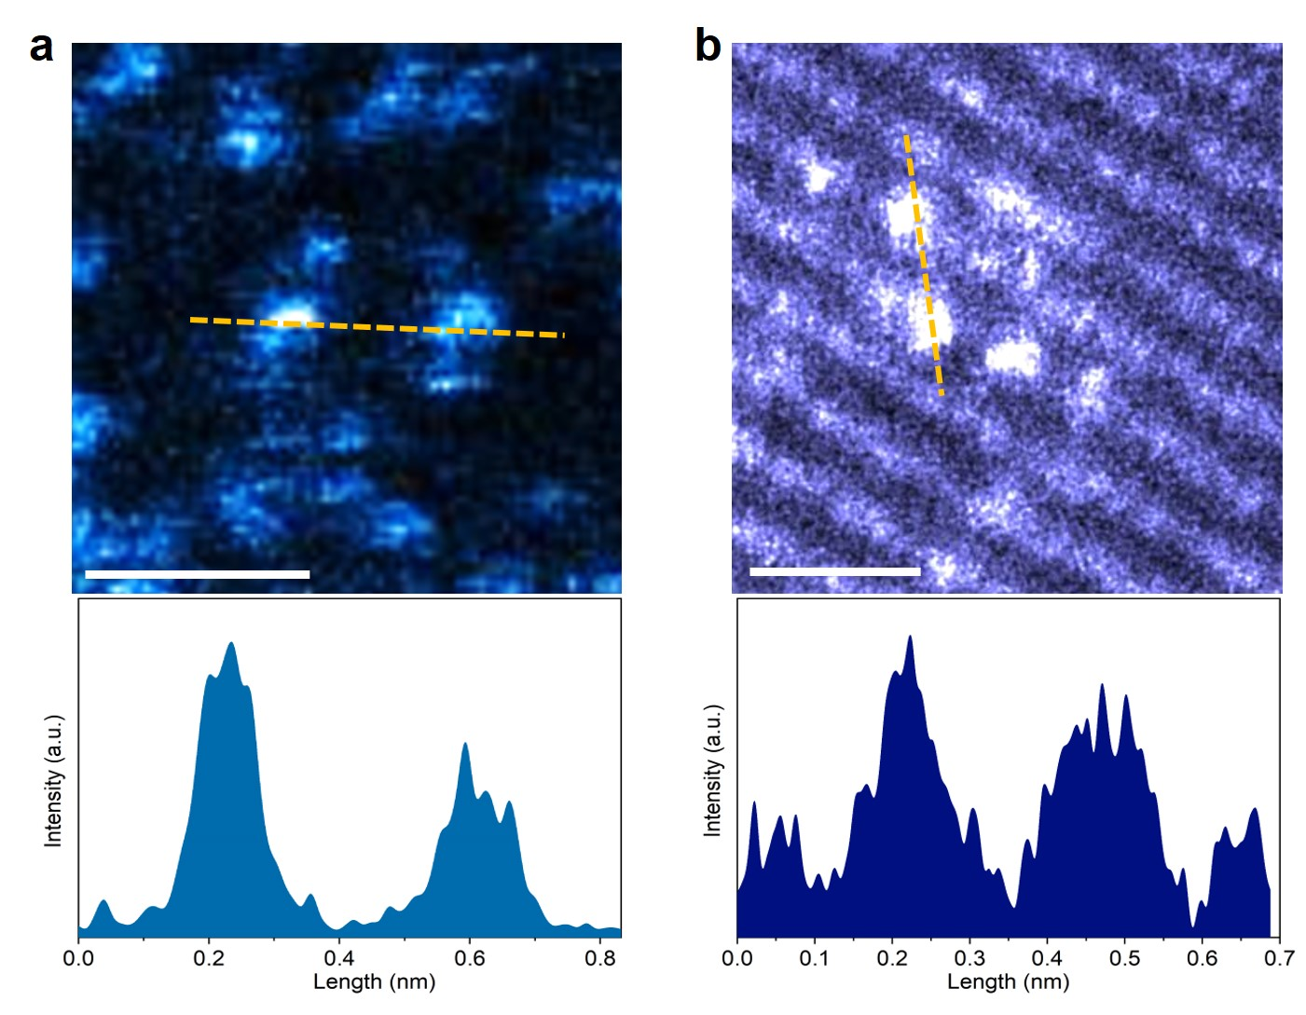
Supplementary Fig. 6 | STEM analysis of Pt₁/PCN and Pt₁/CeO₂. Enlarged areas of the ADF-STEM images of Pt₁/PCN (a) and Pt₁/CeO₂ (b) line profiles showing the corresponding size of bright dots of approximately 0.2 nm, which coincides well with the atomic size of Pt. Scale bars: 0.5 nm. c, STEM image and corresponding EDS maps of Pt₁/CeO₂, evidencing the uniform dispersion of O, Ce and Pt over the support.

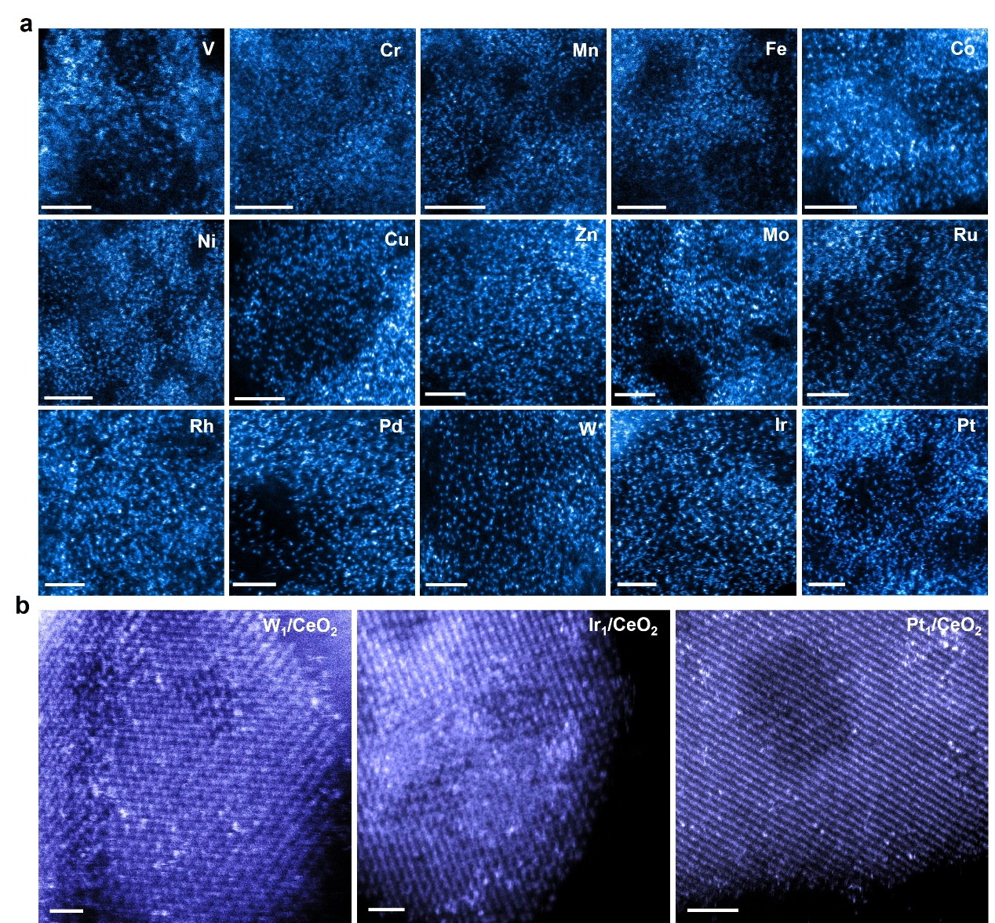
Supplementary Fig. 7 | Visualization of UHD-SACs. Atomic-resolution ADF-STEM images of a, various metals on PCN support, b, W, Ir and Pt on CeO₂. Scale bars: 1 nm.

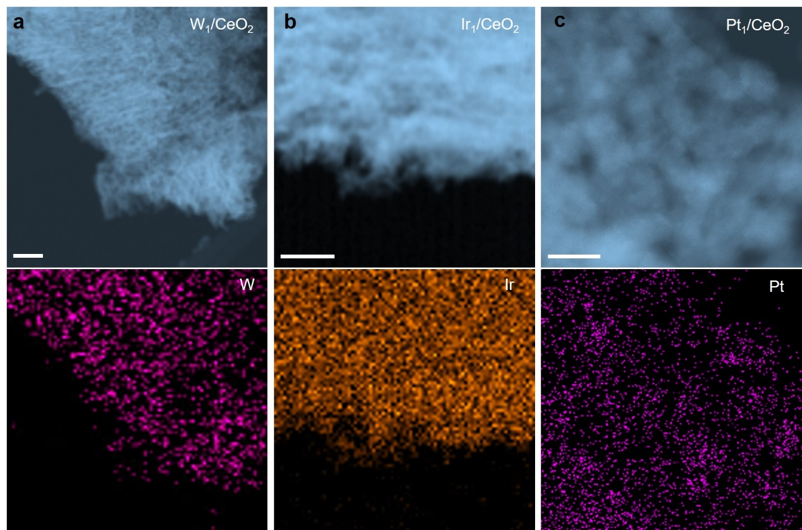
Supplementary Fig. 8 | Elemental mapping of UHD-SACs of W, Ir and Pt on CeO₂. STEM image and corresponding EDS maps of W, Ir and Pt on CeO₂, evidencing the uniform dispersion of W, Ir and Pt over the support. Scale bars: a, b, 100 nm; c, 10 nm.

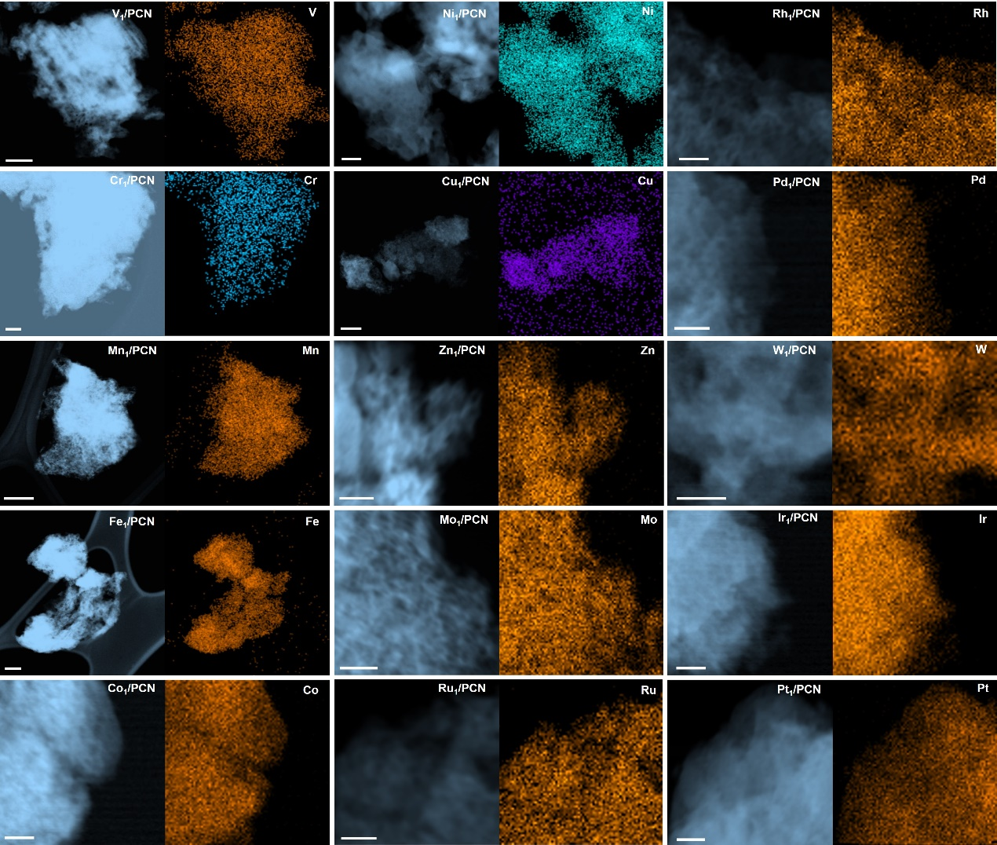
Supplementary Fig. 9 | Elemental mapping of UHD-SACs of various metals on PCN. STEM image and corresponding EDS maps of various metals on PCN, evidencing the uniform dispersion of metals over the support. Scale bars: 100 nm.

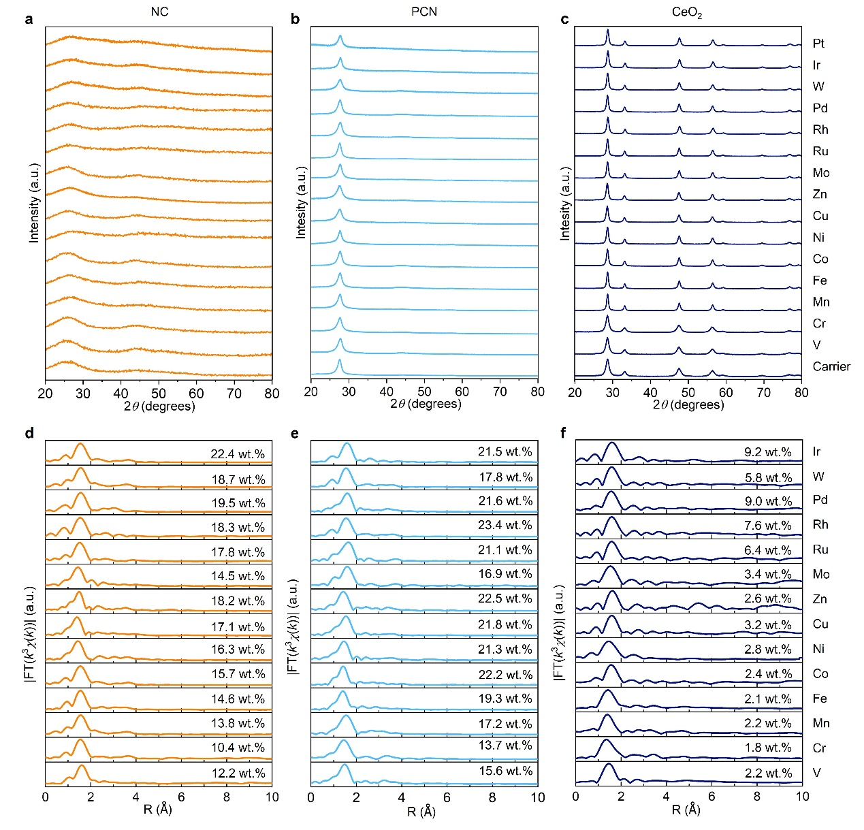
Supplementary Fig. 10 | X-ray diffraction and absroption spectroscopy of UHD-SACs of various metals on different carriers. XRD patterns of UHD-SACs of various metals on a, NC, b, PCN and c, CeO₂. The XRD patterns of all single-atom catalysts only exhibit reflections from the supports, no metal-related signatures can be observed. Fourier transformed EXAFS spectra of UHD-SACs of various metals on NC (d), PCN (e) and CeO₂ (f). The Fourier transformed EXAFS spectra of all single-atom catalysts show the main peak below 2 Å, which can be ascribed to the metal-N/O bonding. No metal-metal bond is detected in any of the samples, confirming the metals are atomically dispersed on the supports.

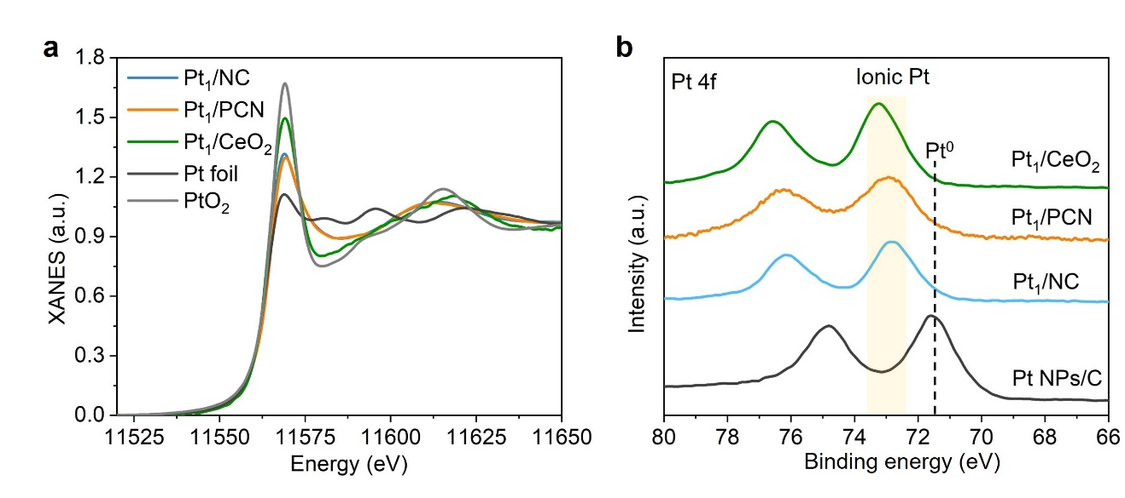
Supplementary Fig. 11 | Spectroscopy characterization of Pt UHD-SACs. a, Pt L₃-edge XANES spectra of Pt₁/NC, Pt₁/PCN and Pt₁/CeO₂. b, Pt 4f XPS spectra of Pt₁/NC, Pt₁/PCN and Pt₁/CeO₂.

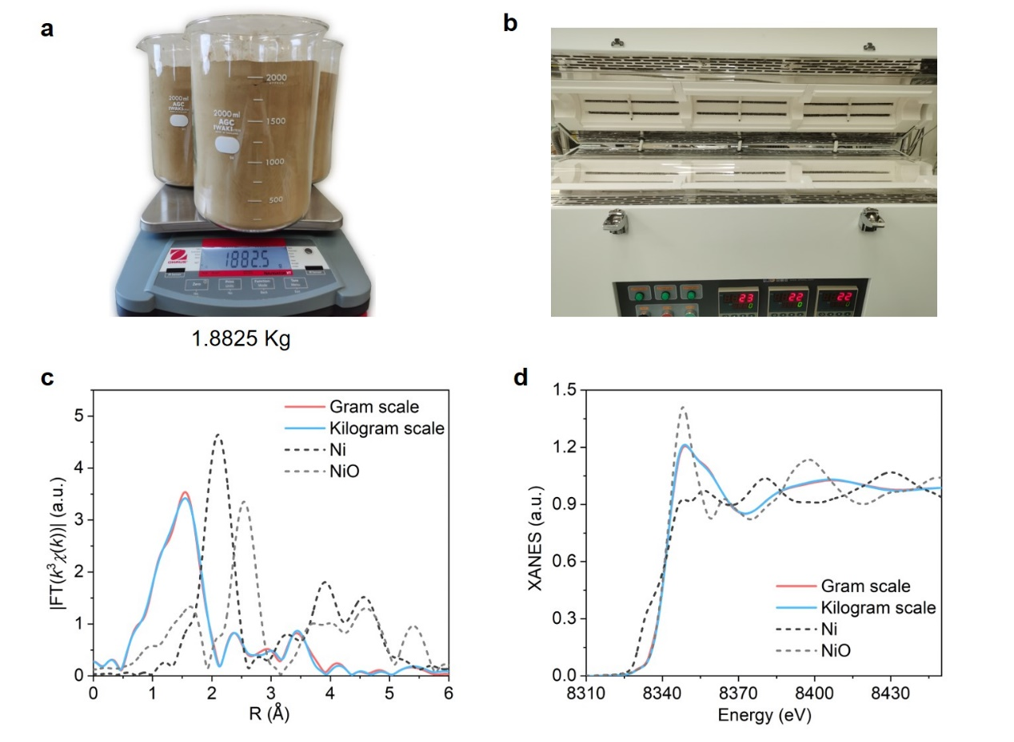
Supplementary Fig. 12 | Production at kilogram scale. Photos of a, UHD Ni₁/PCN catalyst synthesized in kilogram scale and b, the corresponding tubular furnace used for the synthesis (80 × 1400 mm tube size). Ni K-edge c, Fourier transformed EXAFS spectra and d, XANES spectra of UHD Ni₁/PCN synthesized at gram and kilogram scales, respectively. The Ni loadings are measured to be 21.3 wt.% and 20.8 wt. % for gram and kilogram scales, respectively.

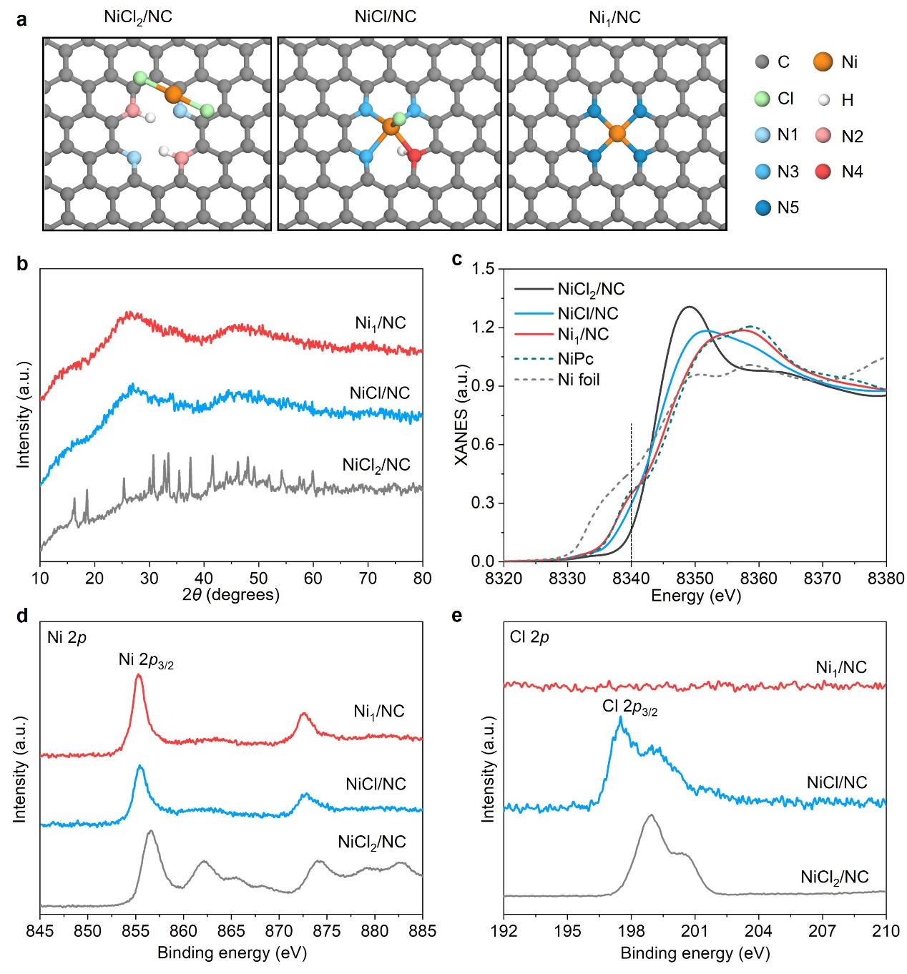
Supplementary Fig. 13 | Structural characterization of NiCl₂/NC, NiCl/NC and Ni₁/NC. a, Atomic structural representations of NiCl₂/NC, NiCl/NC and Ni₁/NC. b, XRD patterns showing the disappearance of reflections arising from NiCl₂ after the low-temperature annealing process, indicating that most of the metal precursor reacted with the NC support. c, The Ni K-edge XANES spectra of NiCl₂/NC, NiCl/NC and Ni₁/NC are compared with NiPc reference. d, e, XPS spectra of Ni 2p (d) and Cl 2p (e) of NiCl₂/NC, NiCl/NC and Ni₁/NC.
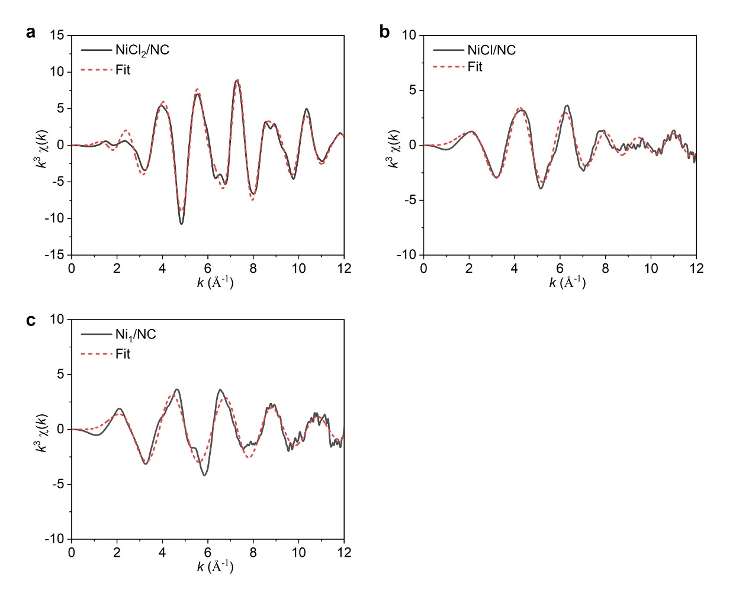
Supplementary Fig. 14 | EXAFS fits of NiCl₂/NC, NiCl/NC and Ni₁/NC in K plot. EXAFS fits for NiCl₂/NC, NiCl/NC and Ni₁/NC evidence a close match between measured and calculated spectra. The fitted parameters are reported in Supplementary Table 1.

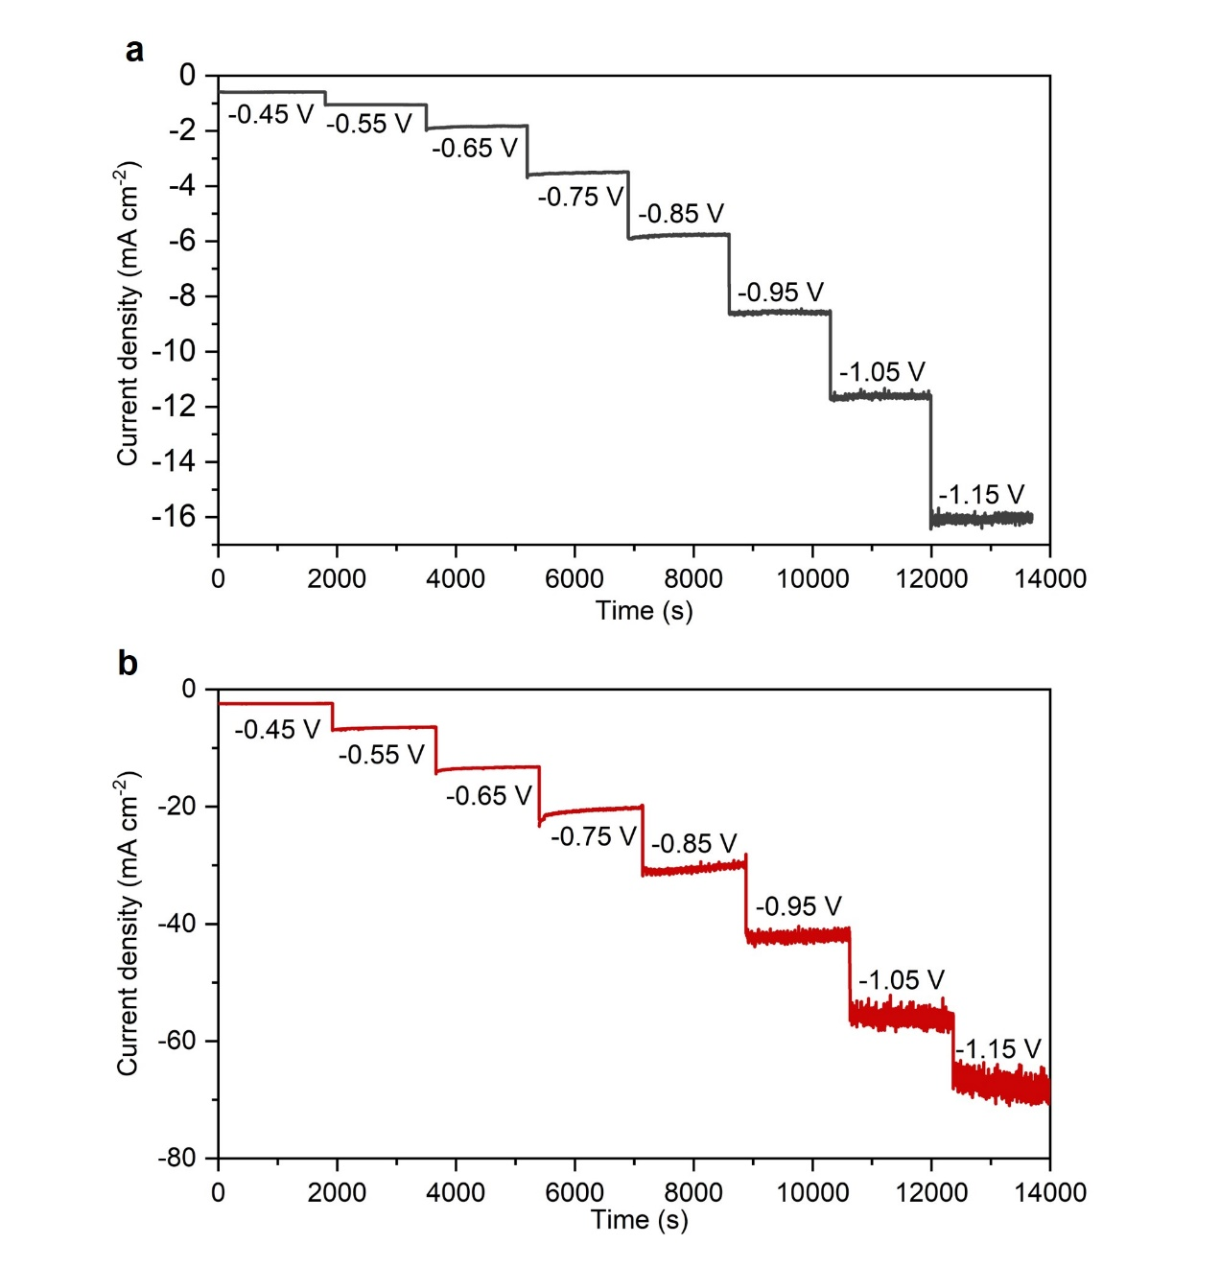
Supplementary Fig. 15 | Additional electrocatalytic data. Chronoamperometric curve of 1.6 wt.% Ni₁/NC (a) and 16.3 wt.% Ni₁/NC (b) electrodes under bias from -0.45 V to -1.15 V versus RHE in 0.5 M CO₂-saturated KHCO₃ aqueous solution.

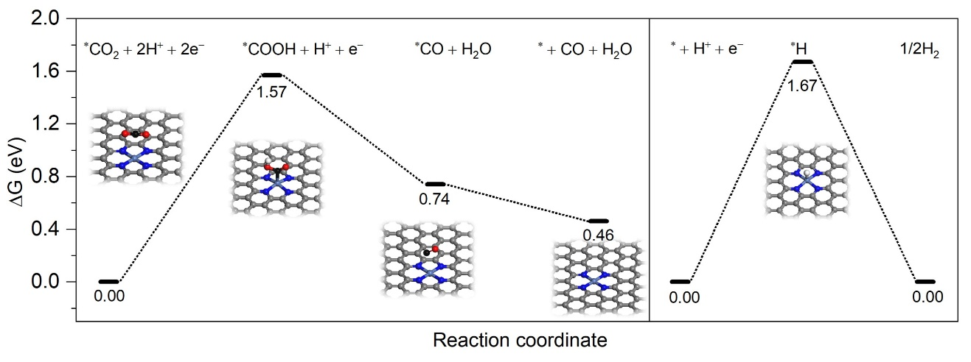
Supplementary Fig. 16 | DFT calculations. DFT calculated binding energy of intermediates on catalysts for CO₂ reduction reaction and HER. A key issue for the electrocatalytic CO₂RR to CO is the rate of the competing hydrogen evolution reaction (HER), where H⁺ does not attach to the CO₂ but adsorbs on the catalytic site and then forms an H₂ molecule. Thus, the decisive factor in the selective reduction of CO₂ is the competition between the free energies of *COOH (G_{*COOH}) and *H (G_{*H}) intermediates on each reaction. Our calculations show that G_{*COOH} (1.57 eV) is lower than G_{*H} (1.67 eV). As a result, CO₂RR has lower activation energy than HER, consistent with the high CO₂RR performance observed experimentally.

Supplementary Table 1 | Optimization of T₁ in the synthesis of Ni₁/NC using distinct Ni precursors.
Ni precursors | T₁ (°C)ª | T₂ (°C) | Ni content (wt. %)
Ni₂(CH₃COO)₂·4H₂O | 100 | 550 | 4.2
NiSO₄·7H₂O | 300 | 550 | 14.4
NiCl₂·6H₂O | 100 | 550 | 3.6
NiCl₂·6H₂O | 200 | 550 | 9.2
NiCl₂·6H₂O | 300 | 550 | 16.3
ª T₁ is selected to be close to the temperature of decomposition of the Ni precursor. If T₁ is selected to be higher than the temperature of decomposition then nanoparticle formation is typically observed. If T₁ is much lower than the decomposition temperature then this leads to lower metal contents in the resulting SACs.

Supplementary Table 2 | Results of EXAFS fits of NiCl₂/NC, NiCl/NC and Ni₁/NC.
Sample | Shell | N | R (Å) | σ² (10⁻³Å²) | R factor
NiCl₂/NC | Ni-Cl | 6 | 2.39 | 0.0076 | 0.003
NiCl₂/NC | Ni-Ni | 6 | 3.49 | 0.0145 | 0.003
NiCl/NC | Ni-N | 4.8 | 1.97 | 0.0111 | 0.003
NiCl/NC | Ni-Cl | 0.9 | 2.26 | 0.0032 | 0.003
Ni₁/NC | Ni-N | 4.6 | 1.89 | 0.0066 | 0.013
N, coordination number; R, distance between absorber and backscatter atoms; σ², Debye-Waller factor to account for both thermal and structural disorders; R factor indicates the goodness of the fit. The fitted coordination environment of NiCl₂/NC, NiCl/NC and Ni₁/NC coincides well with the proposed initial, intermediate and final structures. For the initial NiCl₂/NC, Ni is coordinated to 6 Cl. For the intermediate NiCl/NC, Ni is coordinated to 4 N and 1 Cl. For the final Ni₁/NC, Ni is coordinated to 4 N.

