Additional file 9: Supplementary information
Bathymetric data
(a) Biomphalaria sp.
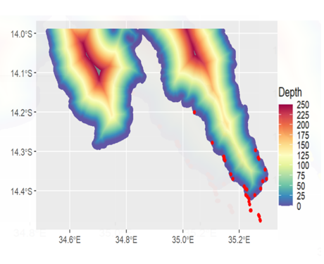
(b) Bulinus spp. 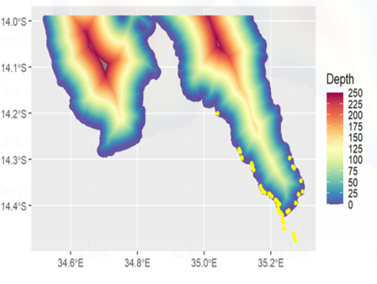

Figure S1: Bathymetric water depth (m) data for the shoreline with observe snails plotted a Biomphalaria sp. b) Bulinus spp.
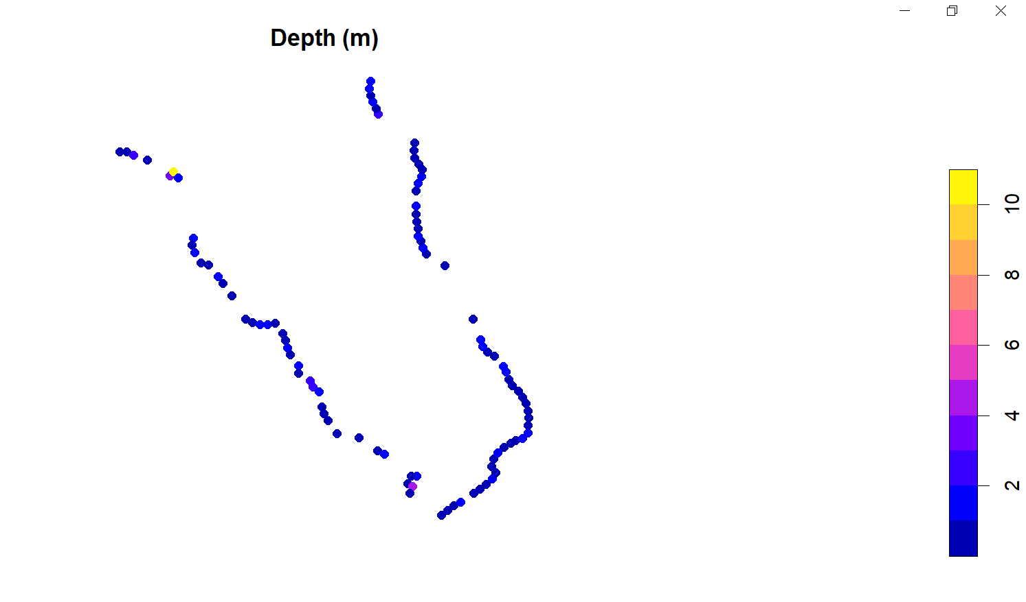
Figure S2: 2D plot of depth (m) extracted for the prediction points with 100km buffer.
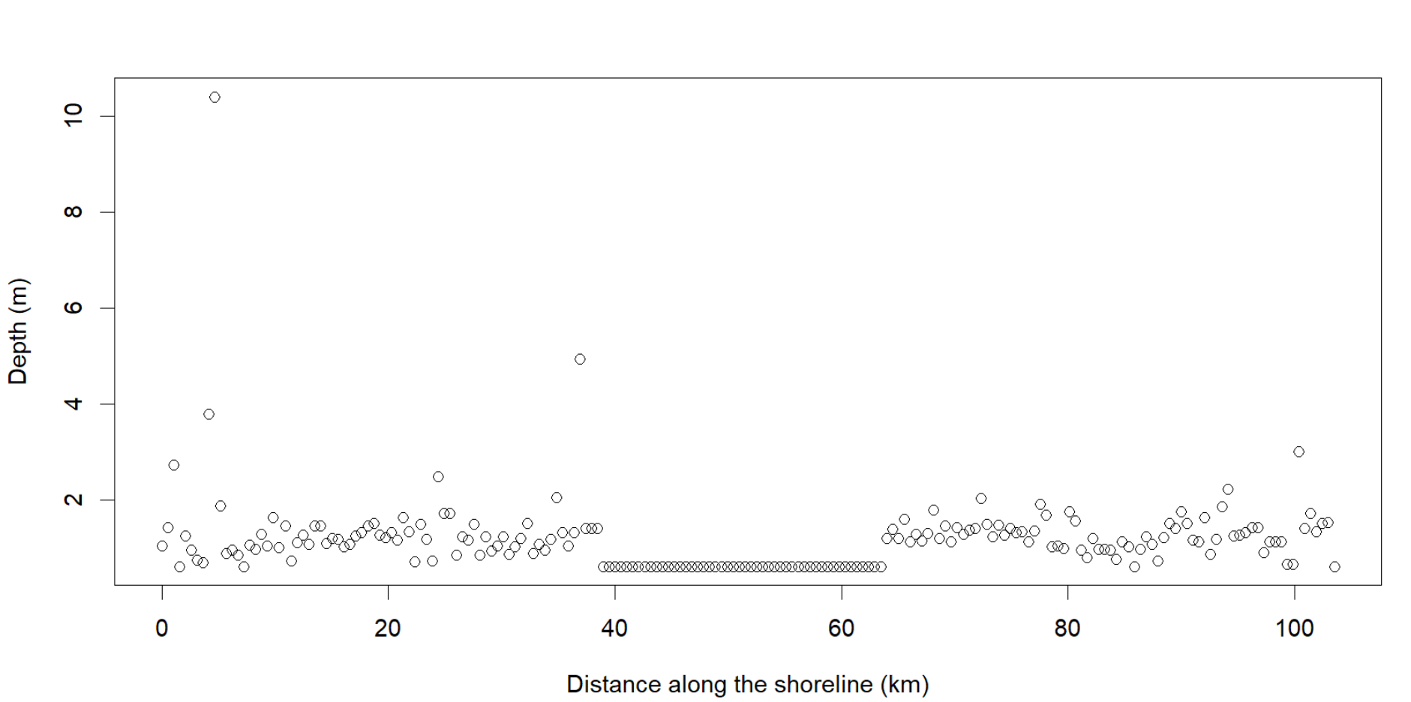
Figure S3: Depth (m) against distance along (km) the shoreline with 100km buffer and fill in NAs for the shoreline.

