Additional file 3: Supplementary information
1D extracted environmental data
Figure S1: Scatterplot of environmental data versus distance along (km) for prediction points
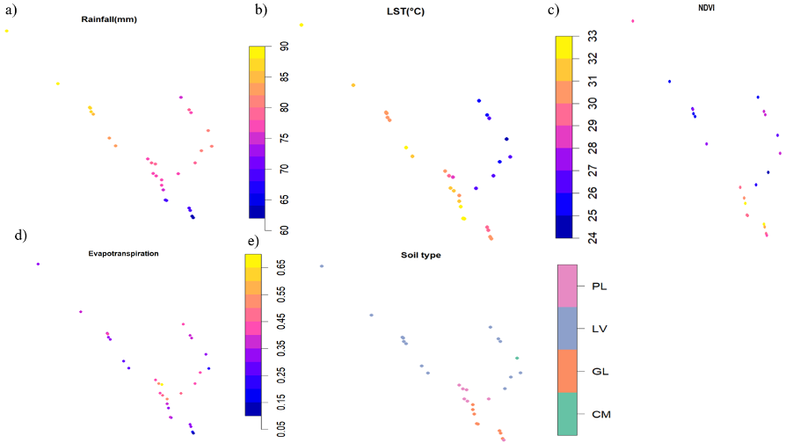
Figure S2: Biomphalaria sp. observed sample points extracted environmental data a) Rainfall (mm) b) LST ($℃)$ c) NDVI (index) ) Evapotranspiration (index) e) Soil type

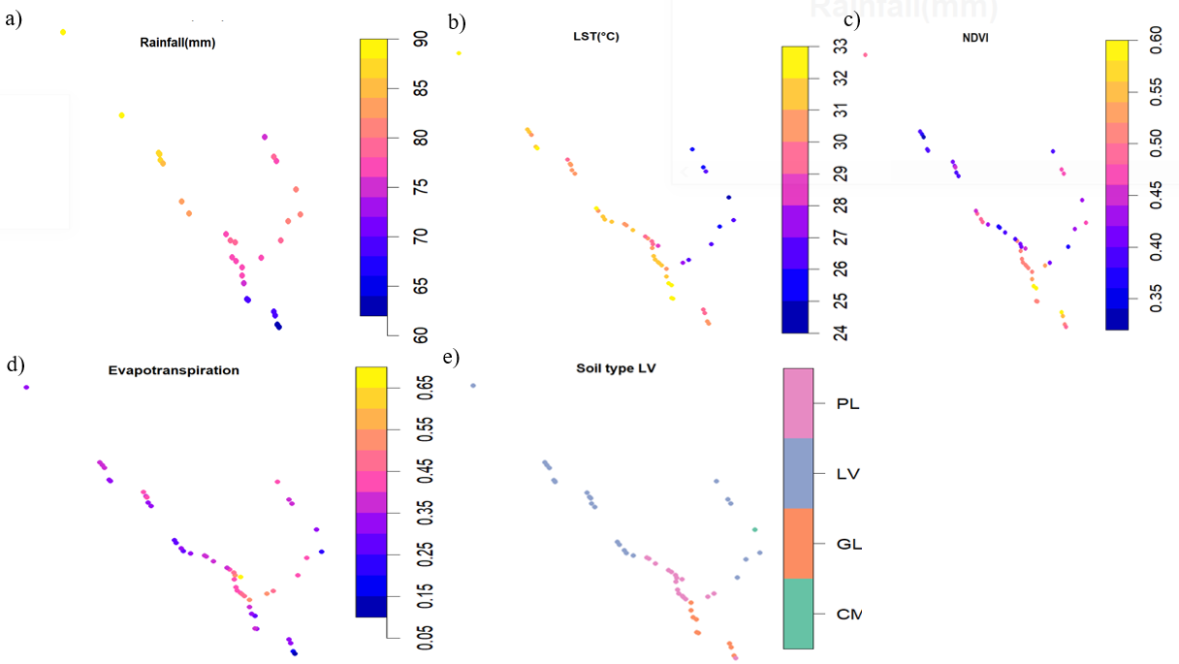
Figure S3: Bulinus spp. observed sample points extracted environmental data. a) Rainfall (mm) b) LST ($℃)$ c) NDVI (index) ) Evapotranspiration (index) e) Soil type

