Additional file 8: Supplementary information
1D result
(a) Biomphalaria sp.
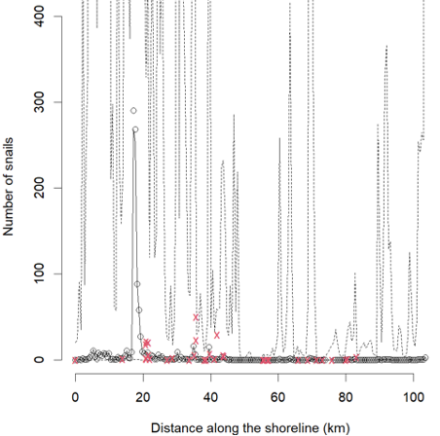
(b) Bulinus spp.
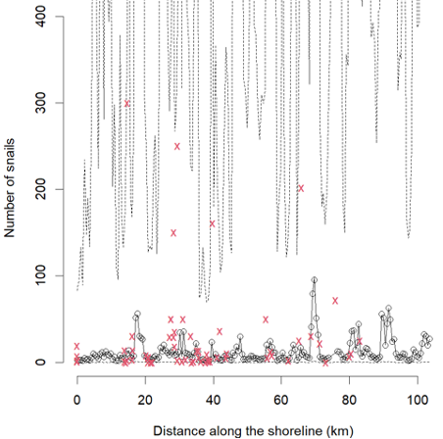
Figure S1: 1D mean GP prediction (Exponential covariance function) of number of snails $log⁡(\hat{μ_{i}})$ against distance along the shoreline (km) a) Biomphalaria sp. b) Bulinus spp. Red crosses: observed number of snails at sampling locations along the shoreline. Black faded lines: SD of GP values.

