Table 1: 1st Five rows of Test Dataset
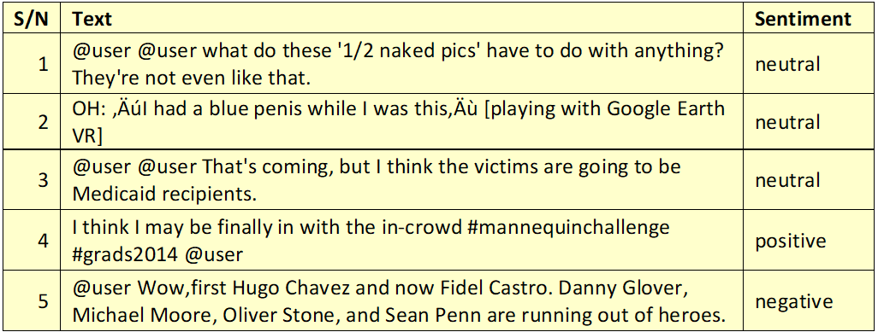
Table 2: Twitter Search Query and Component Definition (Source: (Twitter, Inc., 2023))
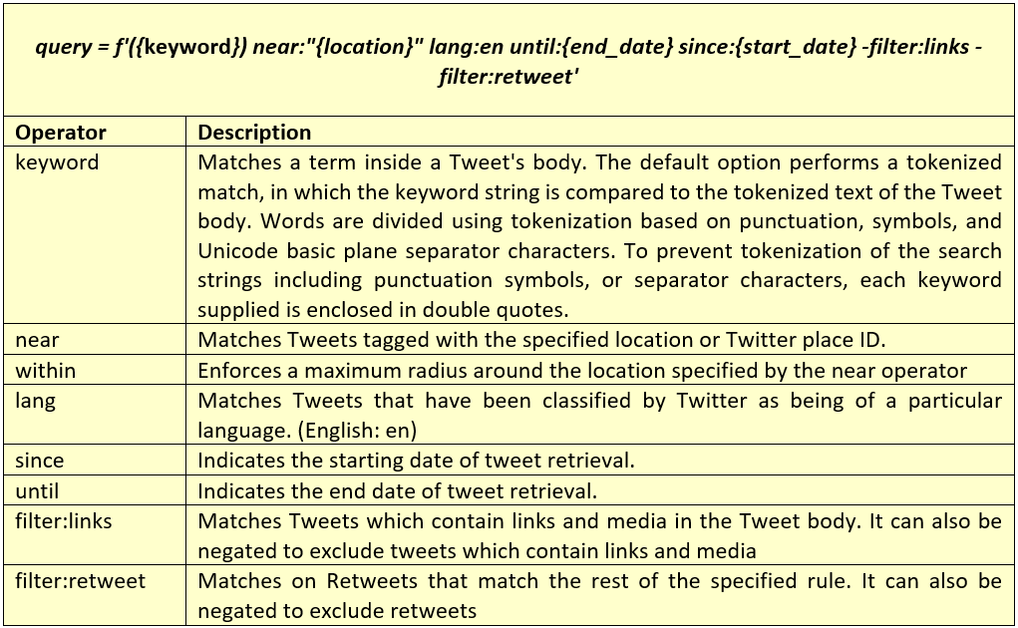
Table 3: Twitter API Access Levels (Source: (Twitter , 2023))
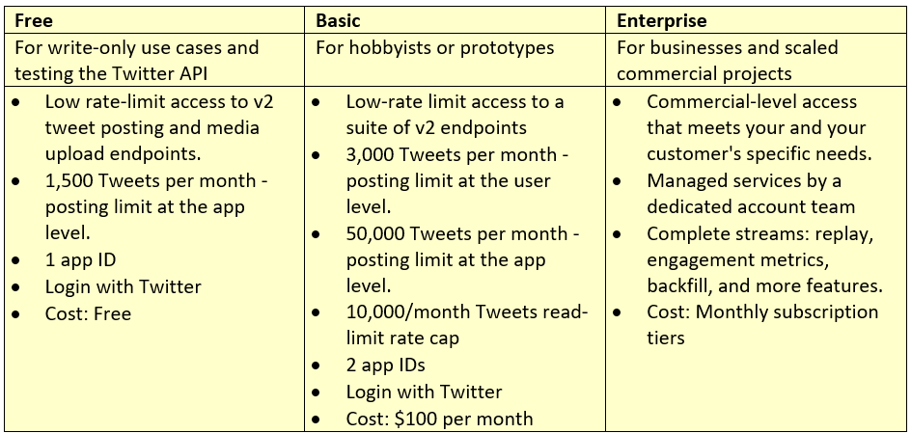
Table 4: Removal of newlines and lowercasing of all letters.
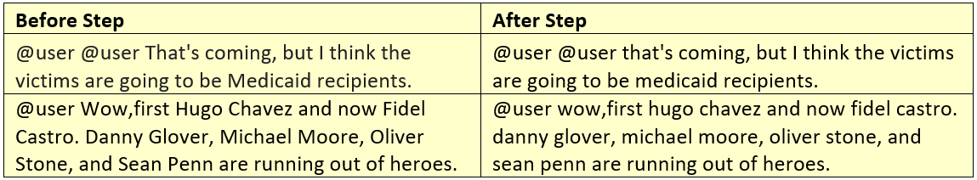
Table 5: Removal of user handles from tweets
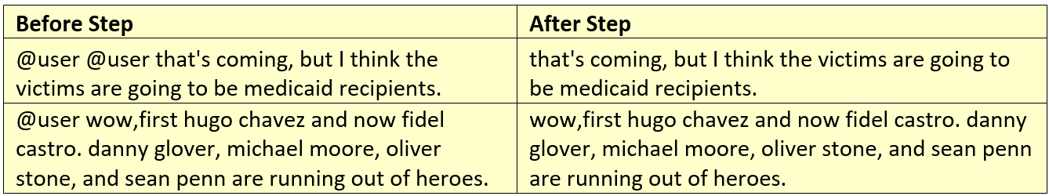
Table 6: Expansion of contractions
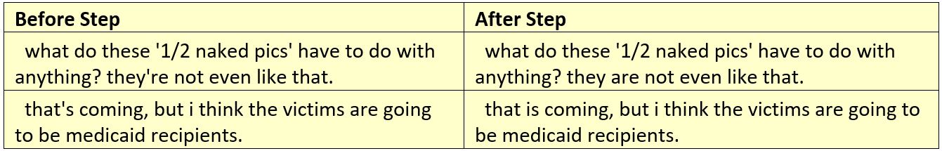
Table 7: Removal of Punctuations
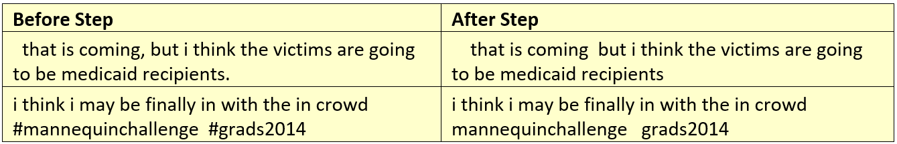
Table 8: Removal of Consecutive Characters
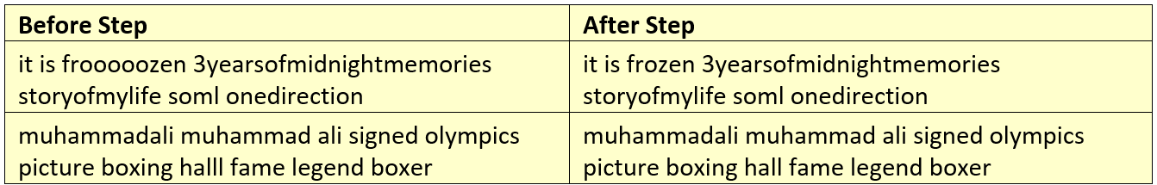
Table 9: Removal of Extra Spaces
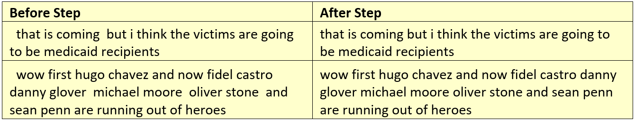
Table 10: Removal of Stop Words
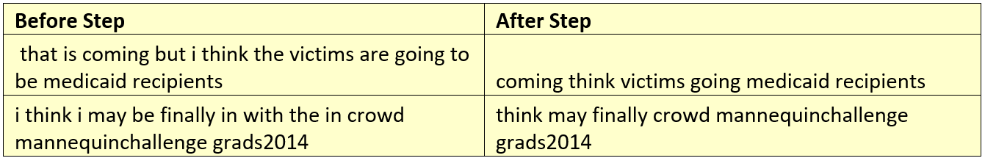
Table 11: Comparison of Raw and Cleaned text
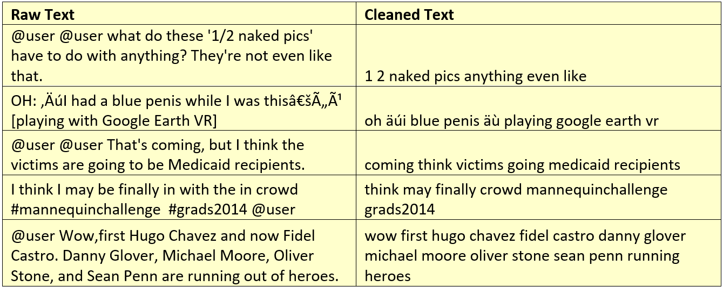
Table 13: Vader & TweetNLP Metrics Comparison
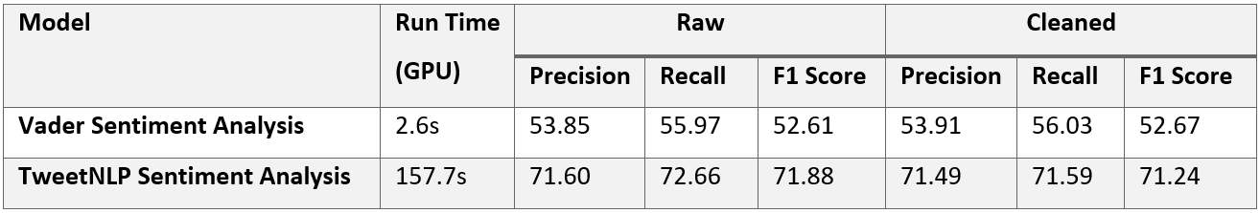

Table 14: 1st five rows of TweetNLP Sentiment Result
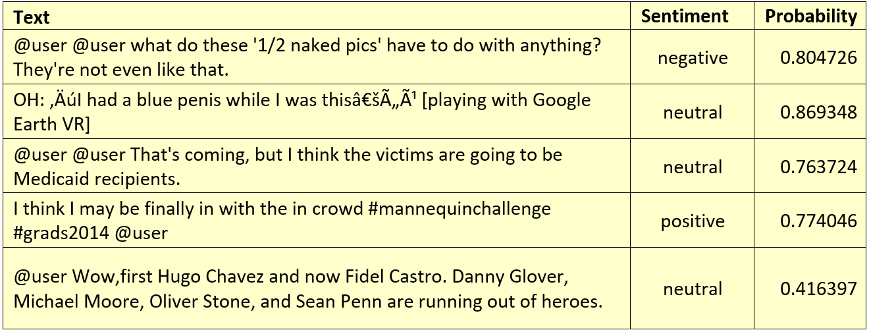

Table 15: Sample of Tweets with Low Classification Probability
