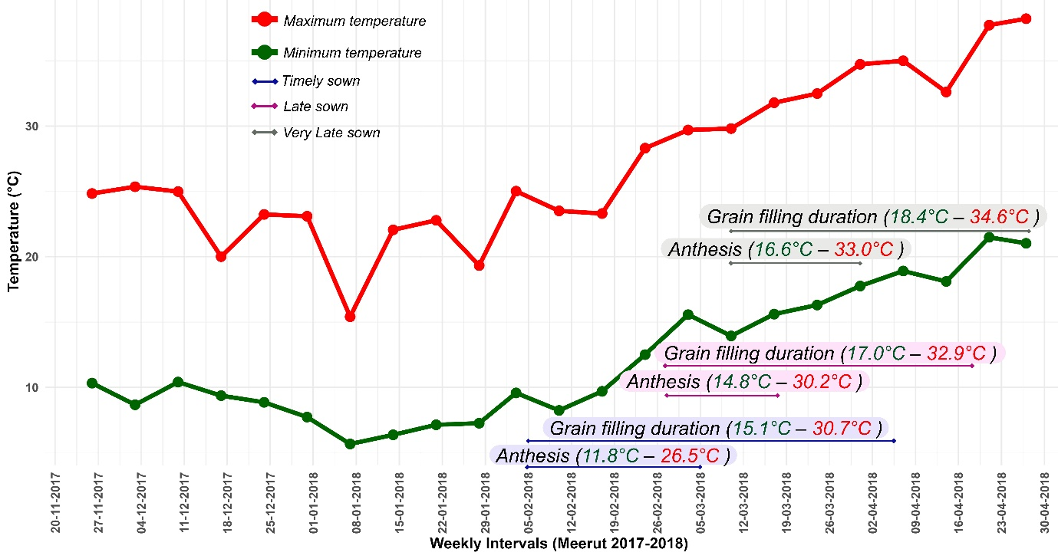
(a)

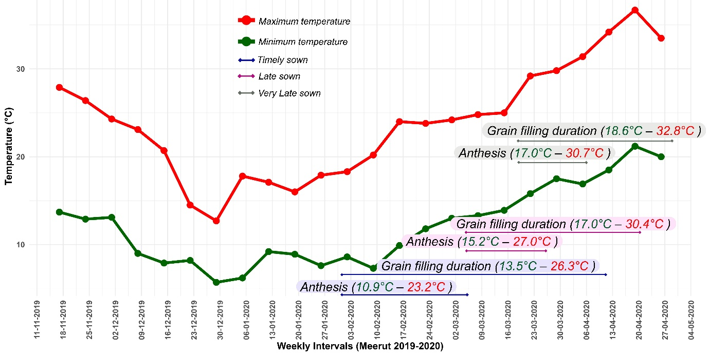
(b)
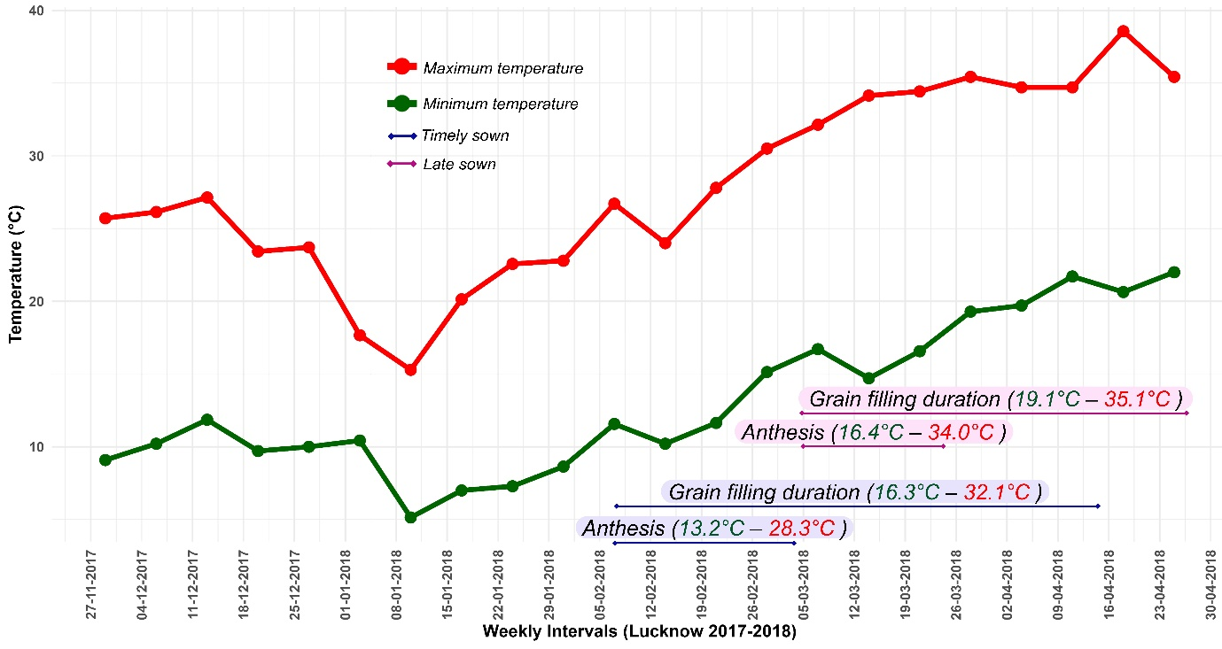
(c)

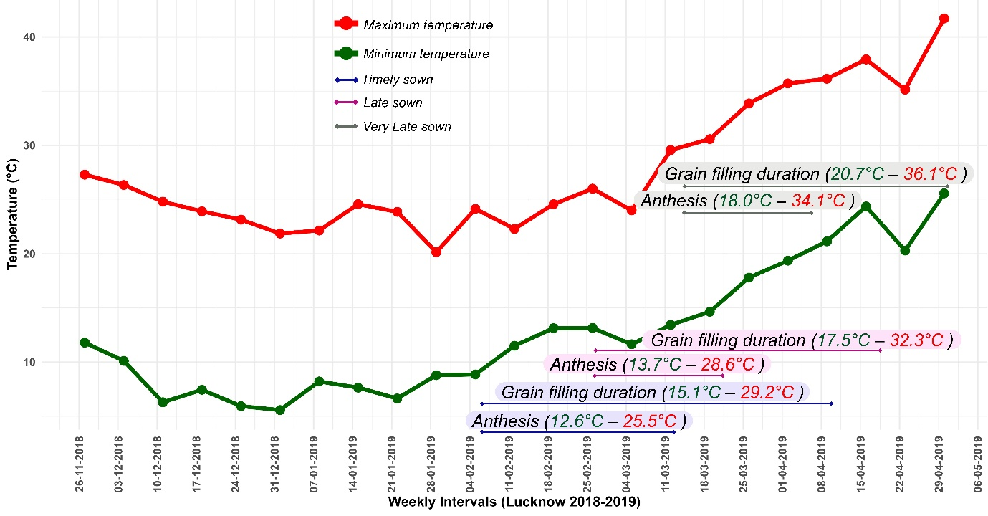
(d)

Figure S1. Weekly mean temperature fluctuations in the experimental fields at Meerut 2017-18 (a), Meerut 2019-20 (b), Lucknow 2017-18 (c), and Lucknow 2018-19 (d) under timely (TS), late (LS), and very late sown (VLS) environments. The durations anthesis and grain filling phases, which are heat sensitive, are shown with two-headed arrows.

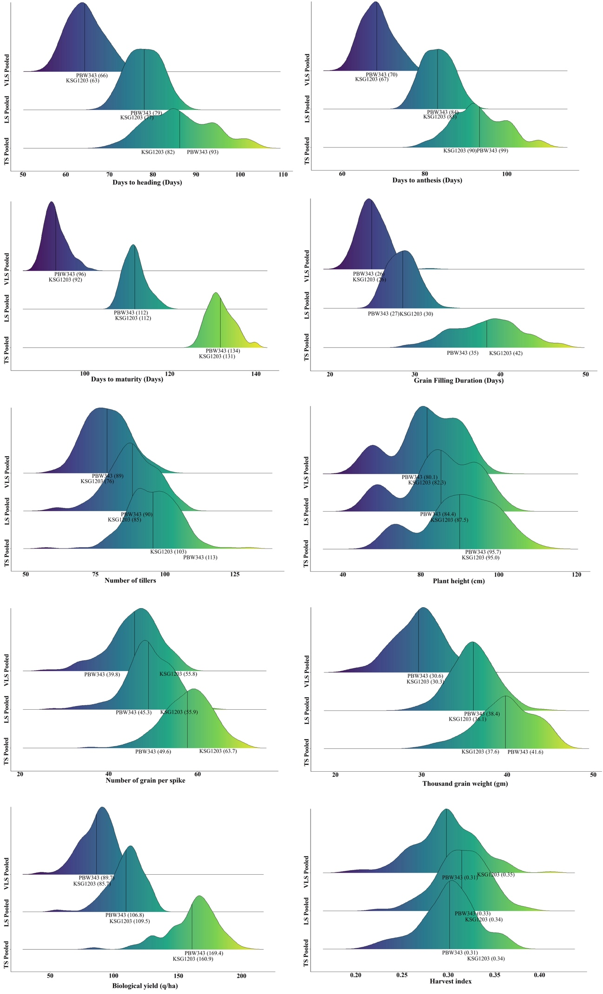
Figure S2. Ridge plots showing distribution of ten (10) agronomic traits in the doubled-haploid mapping population evaluated under timely sown (TS), late sown (LS) and very late sown (VLS) environments. Refer Table S4 for descriptive statistics for these traits.

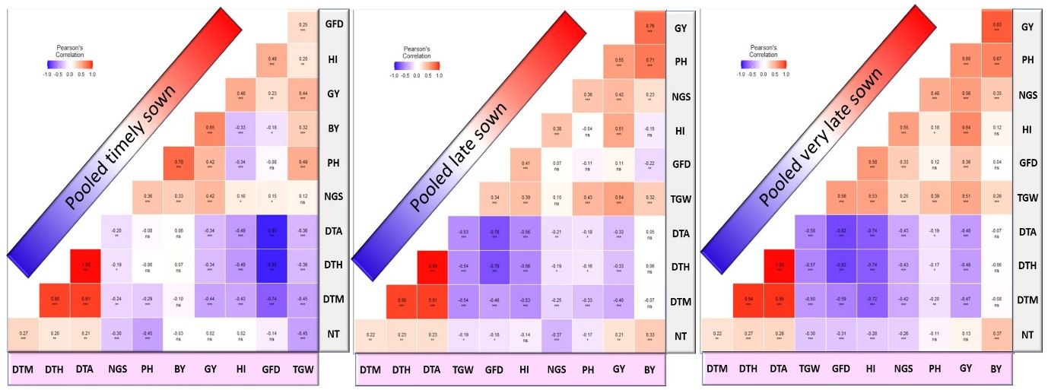
Figure S3. Correlation among eleven heat stress related traits in each of the timely sown, late sown and very late sown environments calculated using the pooled BLUE values across the three years and the two locations.

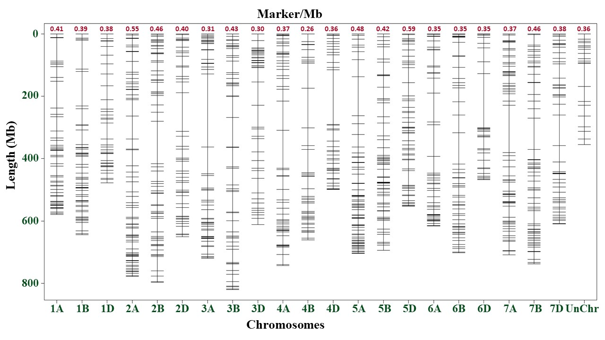
Figure S4. Distribution of SNP markers on the physical map used for mapping QTLs.

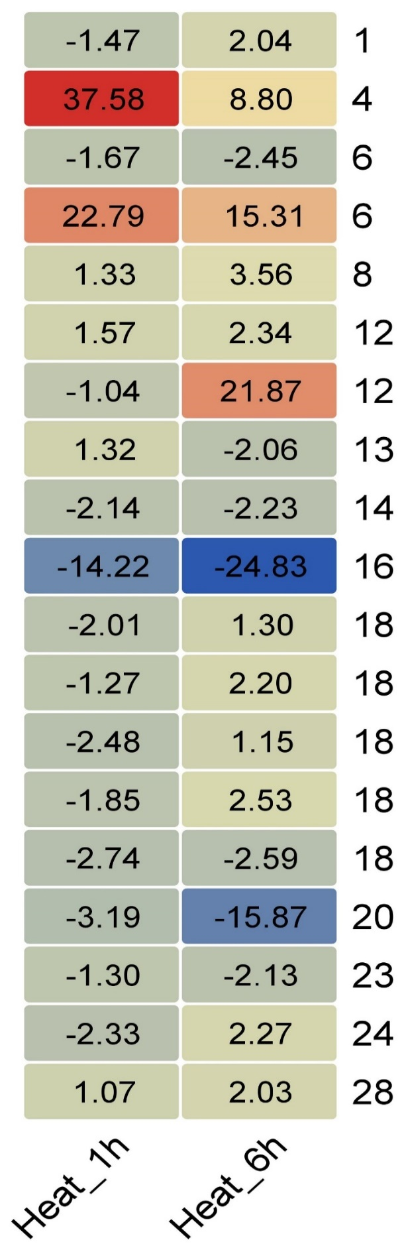
(a)
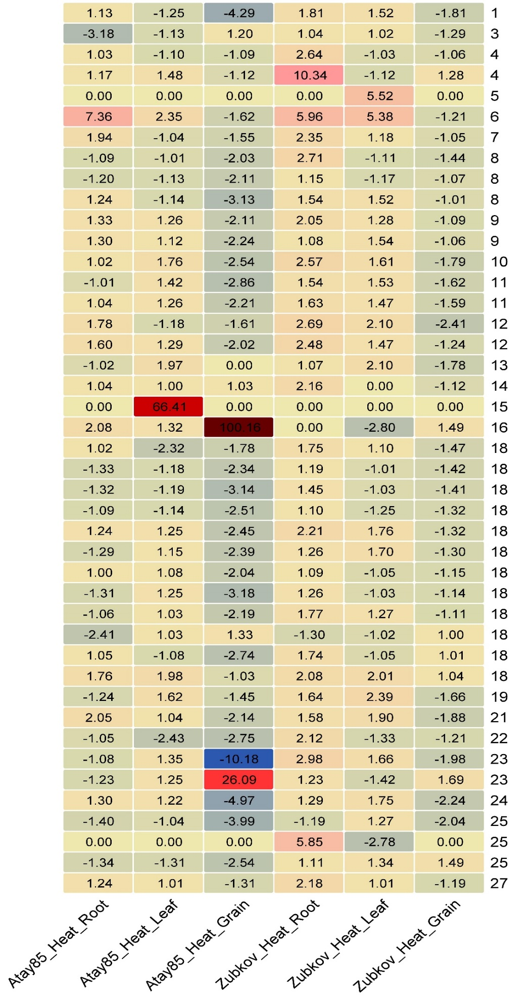
(b)
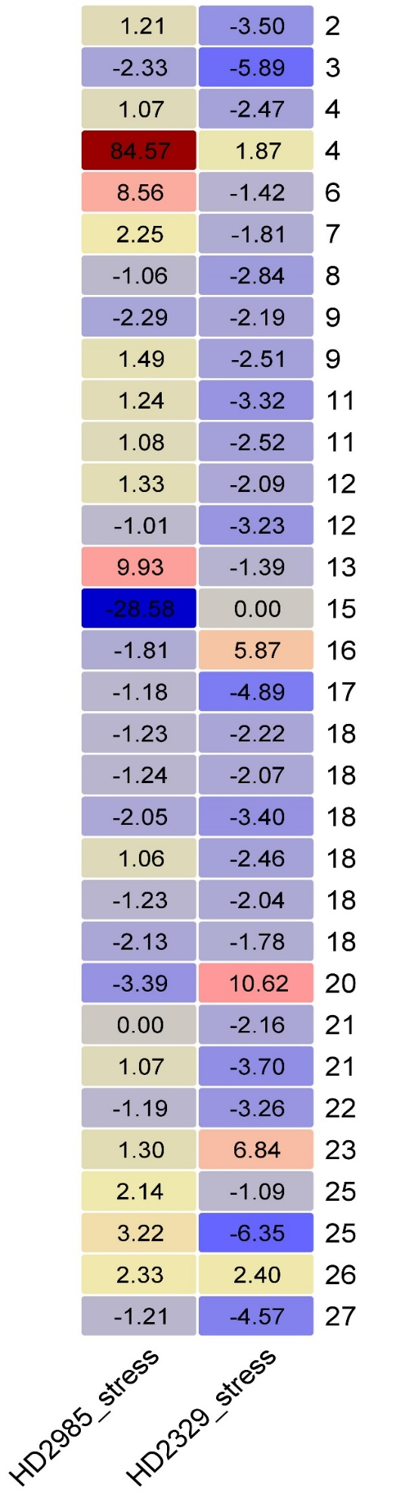
(c)
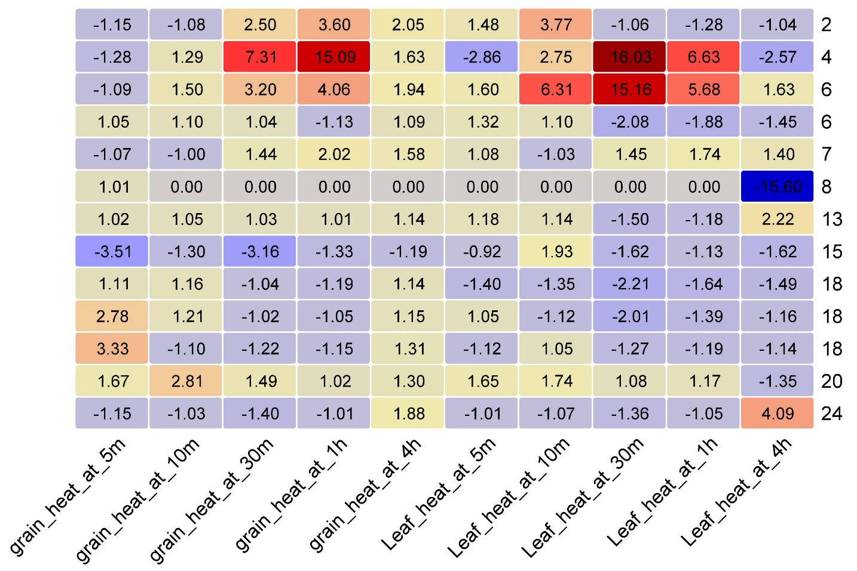
(d)
Fig. S5. Heat maps representing differential expression of candidate genes underlying QTLs from drought and heat stress data set (a), stress treatment (drought, heat and drought+heat) leaf, root and grain tissues data set (b), tolerant and sensitive wheat cultivar under heat stress data set (c), and heat stress-responsive transcriptomes data set (d).

