Annexes
Annex 1. Patient Survey via phone or electronically
(Shown in the original Spanish version)
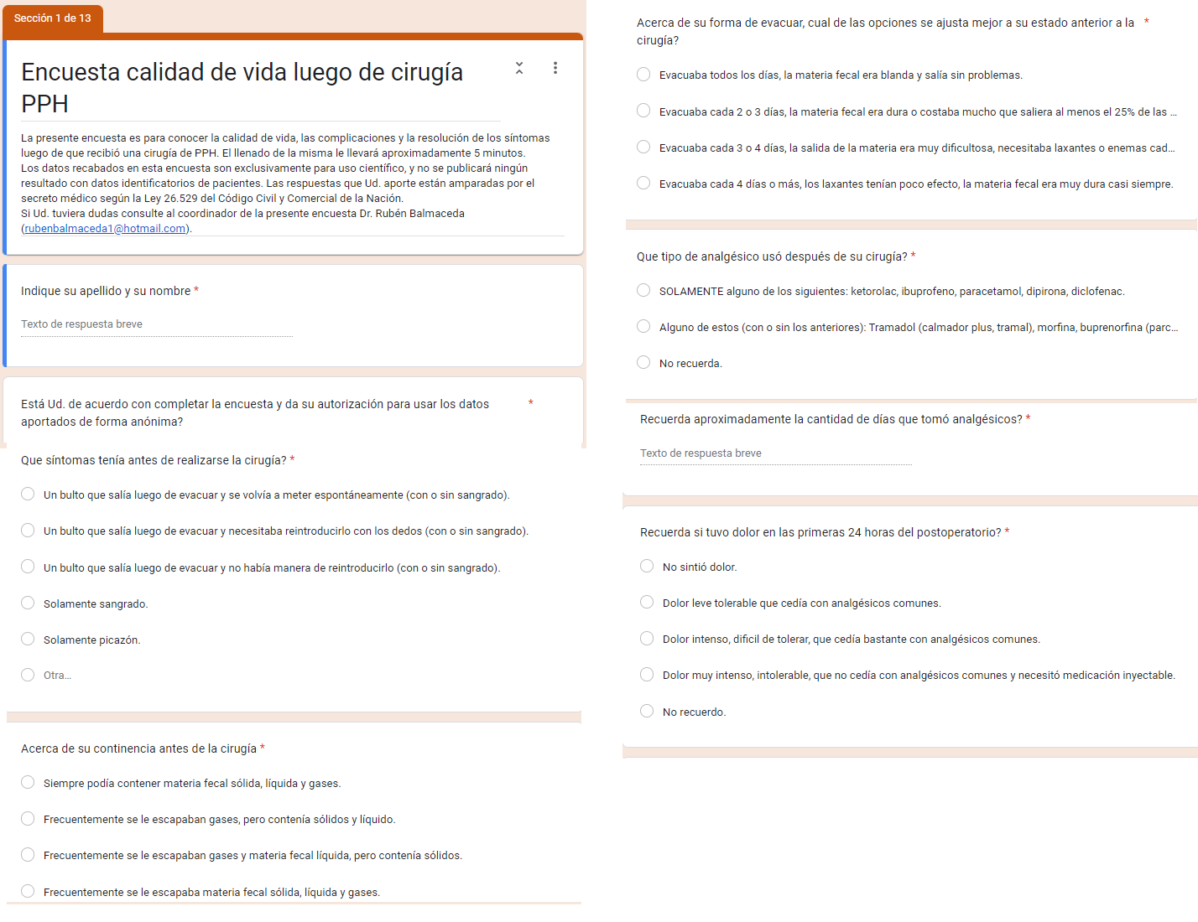
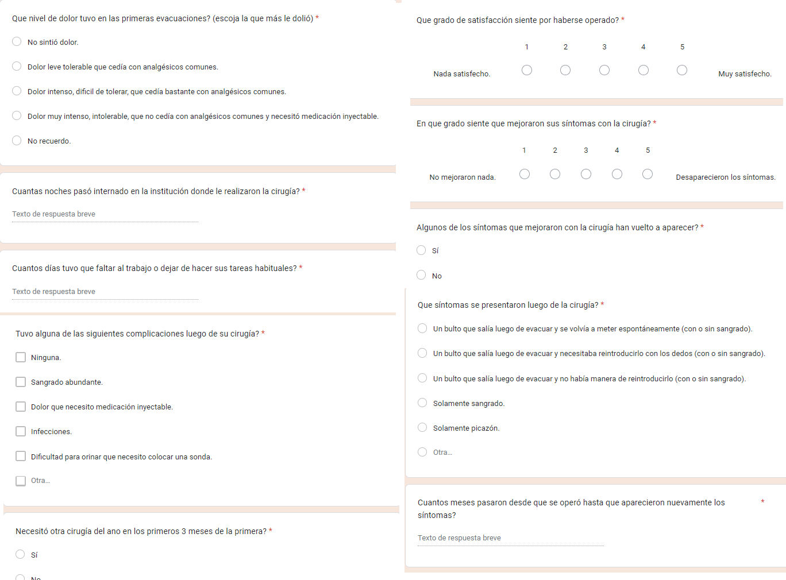

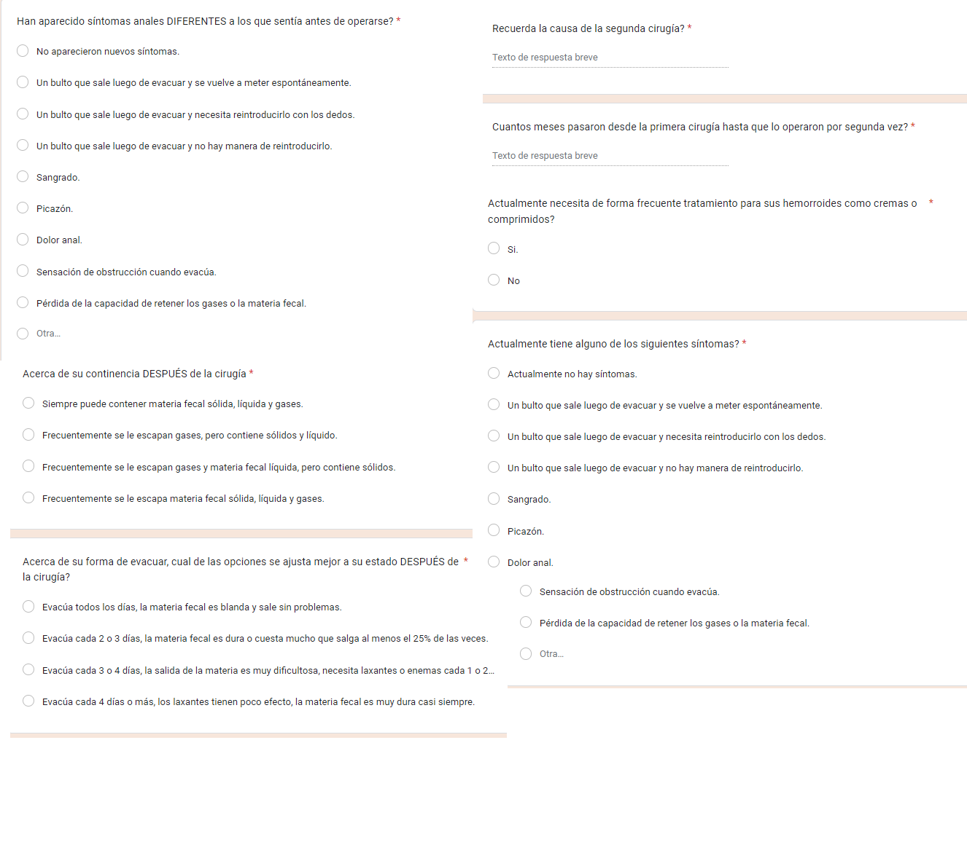

Annex 2. Classification and scoring systems used
Goligher Scale [11]
Grade I | No prolapse. Hemorrhoids only visible on anoscopy.
Grade II | Prolapse that reduces spontaneously.
Grade III | Prolapse requiring manual reduction .
Grade IV | Prolapse which cannot be reduced or that upon reduction re-prolapses spontaneously
Continence score
Grade | Description | Approximate correspondence with the ICCFS [12]
0 | Normal continence | 0
1 | Gas incontinence | 4
2 | Fluid fecal incontinence | 8
3 | Solid fecal incontinence | >12
Constipation scale
Grade | Description | Approximate correspondence with WCS[13]
0 | No constipation. | 0
1 | Mild constipation | 5
2 | Moderate constipation | 10
3 | Severe constipation | >20

ICCFS: Incontinence Cleveland Clinic Florida Scale – Wexner. WCS: Wexner Constipation Scale

