Appendix 1: Search strategies
Medine (PubMed)
((“Spinal Cord Injuries”[mh] or “Quadriplegia”[mh] or “Hemiplegia”[mh] or Spinal Cord Injuries[tiab] or Spinal Cord Trauma[tiab] or Spinal Cord Traumas[tiab] or Spinal Cord Injury[tiab] or Spinal Cord Transection[tiab] or Spinal Cord Transections[tiab] or Spinal Cord Laceration[tiab] or Spinal Cord Lacerations[tiab] or Spinal Cord Contusion[tiab] or Spinal Cord Contusions[tiab] or Spinal Cord Compromised[tiab] or spinal cord lesion[tiab] or Quadriplegia[tiab] or paraplegia[tiab] or tetraplegia[tiab] or spinal cord rupture[tiab] or cervical spinal cord injury[tiab] or Quadriplegias[tiab] or Tetraplegia[tiab] or Tetraplegias[tiab] or Spastic Quadriplegia[tiab] or Spastic Quadriplegias[tiab] or Spastic Tetraplegia[tiab] or Spastic Tetraplegias[tiab] or Quadriparesis[tiab] or Quadripareses[tiab] or Flaccid Quadriplegia[tiab] or Flaccid Quadriplegias[tiab] or Flaccid Tetraplegia[tiab] or Flaccid Tetraplegias[tiab] or Hemiplegias[tiab] or Transient Hemiplegia[tiab] or Transient Hemiplegias[tiab] or Monoplegia[tiab] or Monoplegias[tiab] or Post-Ictal Hemiplegia[tiab] or Post-Ictal Hemiplegias[tiab] or Crossed Hemiplegia[tiab] or Crossed Hemiplegias[tiab] or Flaccid Hemiplegia[tiab] or Flaccid Hemiplegias[tiab] or Infantile Hemiplegia[tiab] or Infantile Hemiplegias[tiab] or Spastic Hemiplegia[tiab] or Spastic Hemiplegias[tiab] or Contusion [tiab] or Transection[tiab] or Hemisection[tiab] or Compression[tiab]) AND ("Sirolimus"[mh] OR "Rapamune"[tiab] OR "Rapamycin"[tiab]))
Embase
#1 'spinal cord injury'/exp OR 'spinal cord injury' OR 'spinal cord contusion'/exp OR 'spinal cord contusion' OR 'spinal cord hemisection'/exp OR 'spinal cord hemisection' OR 'spinal cord transsection'/exp OR 'spinal cord transsection' OR 'cervical spine injury'/exp OR 'cervical spine injury' OR 'spinal compression':ab,ti OR 'spinal cord trauma':ab,ti OR 'trauma, spinal cord':ab,ti OR 'injured spinal cord':ab,ti OR 'spinal cord injured':ab,ti OR 'spinal cord injuries':ab,ti OR 'nerve transection'/exp OR 'nerve transection' OR 'quadriplegia'/exp OR 'quadriplegia' OR 'hemiplegia'/exp OR 'hemiplegia' OR 'paralysis'/exp OR 'paralysis'
#2 'sirolimus'/exp OR sirolimus OR 'rapamune'/exp OR rapamune OR 'Rapamycin'/exp OR Rapamycin
#1 AND #2
Scopus
#1 TITLE-ABS-KEY ( “Spinal Cord Injury” OR “Quadriplegia” OR “Hemiplegia” OR “Spinal Cord Trauma” OR “Spinal Cord Traumas” OR “Spinal Cord Transection” OR “Spinal Cord Transections” OR “Spinal Cord Laceration” OR “Spinal Cord Lacerations” OR “Spinal Cord Contusion” OR “Spinal Cord Contusions” OR “Spinal Cord Compromised” OR “spinal cord lesion” OR “paraplegia” OR “tetraplegia” OR “spinal cord rupture” OR “cervical spinal cord injury” OR “Quadriplegias” OR “Tetraplegia” OR “Tetraplegias” OR “Spastic Quadriplegia” OR “Spastic Quadriplegias” OR “Spastic Tetraplegia” OR “Spastic Tetraplegias” OR “Quadriparesis” OR “Quadripareses” OR “Flaccid Quadriplegia” OR “Flaccid Quadriplegias” OR “Flaccid Tetraplegia” OR “Flaccid Tetraplegias” OR “Hemiplegias” OR “Transient Hemiplegia” OR “Transient Hemiplegias” OR “Monoplegia” OR “Monoplegias” OR “Post-Ictal Hemiplegia” OR “Post-Ictal Hemiplegias” OR “Crossed Hemiplegia” OR “Crossed Hemiplegias” OR “Flaccid Hemiplegia” OR “Flaccid Hemiplegias” OR “Infantile Hemiplegia” OR “Infantile Hemiplegias” OR “Spastic Hemiplegia” OR “Spastic Hemiplegias” OR “Contusion “ OR “Transection” OR “Hemisection” OR “Compression”)
#2 TITLE-ABS-KEY( "Sirolimus" OR "Rapamune" OR "Rapamycin")
#1 AND #2
Web of Science
#1 TS= ( “Spinal Cord Injury” OR “Quadriplegia” OR “Hemiplegia” OR “Spinal Cord Trauma” OR “Spinal Cord Traumas” OR “Spinal Cord Transection” OR “Spinal Cord Transections” OR “Spinal Cord Laceration” OR “Spinal Cord Lacerations” OR “Spinal Cord Contusion” OR “Spinal Cord Contusions” OR “Spinal Cord Compromised” OR “spinal cord lesion” OR “paraplegia” OR “tetraplegia” OR “spinal cord rupture” OR “cervical spinal cord injury” OR “Quadriplegias” OR “Tetraplegia” OR “Tetraplegias” OR “Spastic Quadriplegia” OR “Spastic Quadriplegias” OR “Spastic Tetraplegia” OR “Spastic Tetraplegias” OR “Quadriparesis” OR “Quadripareses” OR “Flaccid Quadriplegia” OR “Flaccid Quadriplegias” OR “Flaccid Tetraplegia” OR “Flaccid Tetraplegias” OR “Hemiplegias” OR “Transient Hemiplegia” OR “Transient Hemiplegias” OR “Monoplegia” OR “Monoplegias” OR “Post-Ictal Hemiplegia” OR “Post-Ictal Hemiplegias” OR “Crossed Hemiplegia” OR “Crossed Hemiplegias” OR “Flaccid Hemiplegia” OR “Flaccid Hemiplegias” OR “Infantile Hemiplegia” OR “Infantile Hemiplegias” OR “Spastic Hemiplegia” OR “Spastic Hemiplegias” OR “Contusion “ OR “Transection” OR “Hemisection” OR “Compression”)
#2 TS= ( "Sirolimus" OR "Rapamune" OR "Rapamycin")
#1 AND #2

Appendix 2: Risk of bias assessment of the included studies according to the SYRCLE’s risk of bias assessment tool
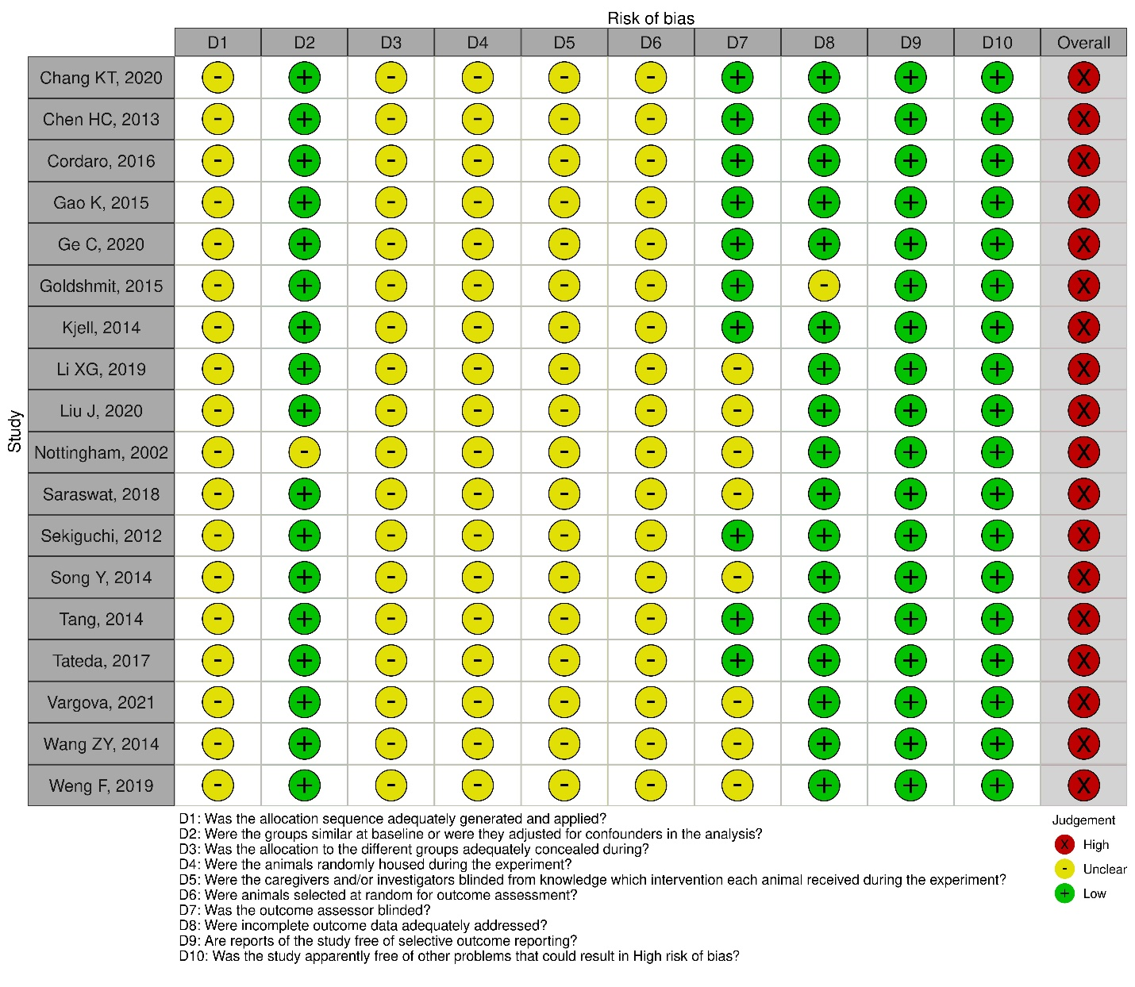
Appendix 3: Funnel plots for the assessment of publication bias

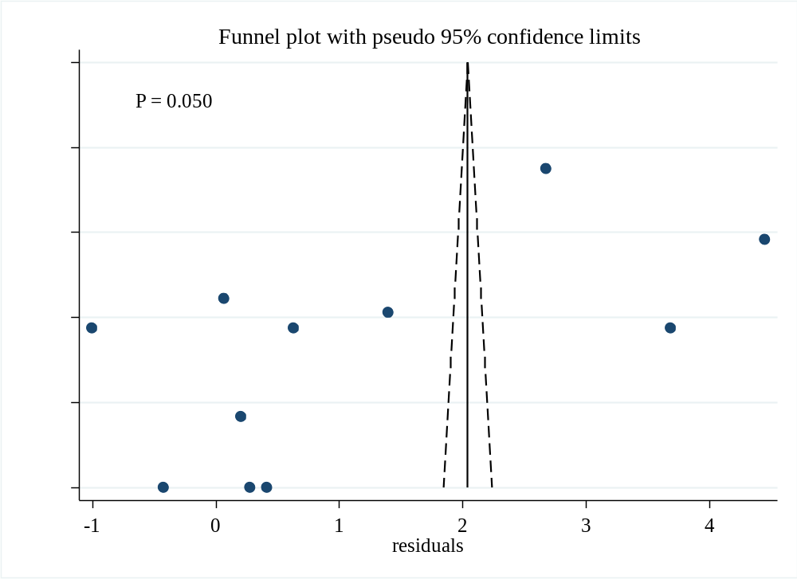
Fig 6 Funnel plot for the assessment of publication bias in studies evaluating the short-term effects of rapamycin treatment on locomotion recovery after spinal cord injury

Fig 7 Funnel plots for the assessment of publication bias in studies evaluating the long-term effects of rapamycin treatment from 1 to 6 weeks post-injury on locomotion recovery after spinal cord injury
Fig 8 Funnel plots for the assessment of publication bias in studies evaluating the effects of rapamycin treatment on (A) TUNEL-positive cells, (B) Bax, (C) Bcl-2, (D) Caspase-3, (E) Beclin-1, (F) LC3-II, (G) TNF-α, (H) GFAP, (I) alpha-motor neurons, and (J) p-P70S6K after spinal cord injury

