SUPPLEMENTARY

Supplementary Table 1. Comparison of baseline characteristics between the stringent ML defined cohort (cutoff=0.99) and the two criteria based cohorts.

 | Predicted Case based on machine learning (cutoff=0.99) | 1987 Criteria Based Cases | 2010 Criteria Based Case
N☨ | 303 | 386 | 457
Proportion Women | 0.65 | 0.63 | 0.66
Proportion anti-CCP2 Positive | 0.58 | 0.49* | 0.49*
Proportion RF positive | 0.62 | 0.58 | 0.59
Median DAS44 at Baseline | 2.8 | 2.9 | 2.9
Median BMI | 26.0 | 25.6 | 25.6
Median BSE | 28 | 28 | 26
Median CRP | 9.7 | 10.5 | 9.0
Median Age at Inclusion | 57.6 | 58.7 | 57.2
Median Symptom Duration at Diagnosis (days) | 89.0 | 89.5 | 91.0
Median Number of Swollen Joints | 5 | 6 | 5
P-values were calculated with the Pearson Chi-Squared for proportions, Mann-Whitney U for medians: * p<0.05; ** p<0.01, *** p<0.001; ☨ Not statistically tested;

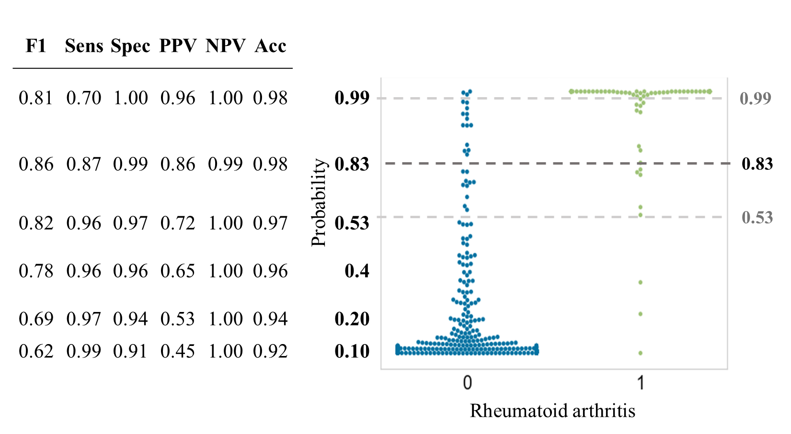
Supplementary figure 1 Swarm plot SVM depicting the support vector machine–derived probability of being either non-rheumatoid arthritis (blue) or rheumatoid arthritis (green) in the model development set. The dotted lines display the optimal cutoffs: 0.99 (PPV>0.95), 0.83 (Sens>0.85; PPV>0.95) and 0.53 (Sens>0.95). Sens: sensitivity, Spec: specificity; PPV: positive predictive value; NPV: negative predictive value; Acc: accuracy; F1: F1 score. This figure is adapted from “Machine Learning Electronic Health Record Identification of Patients with Rheumatoid Arthritis: Algorithm Pipeline Development and Validation Study” by T.D. Maarseveen et al, 2020, JMIR.

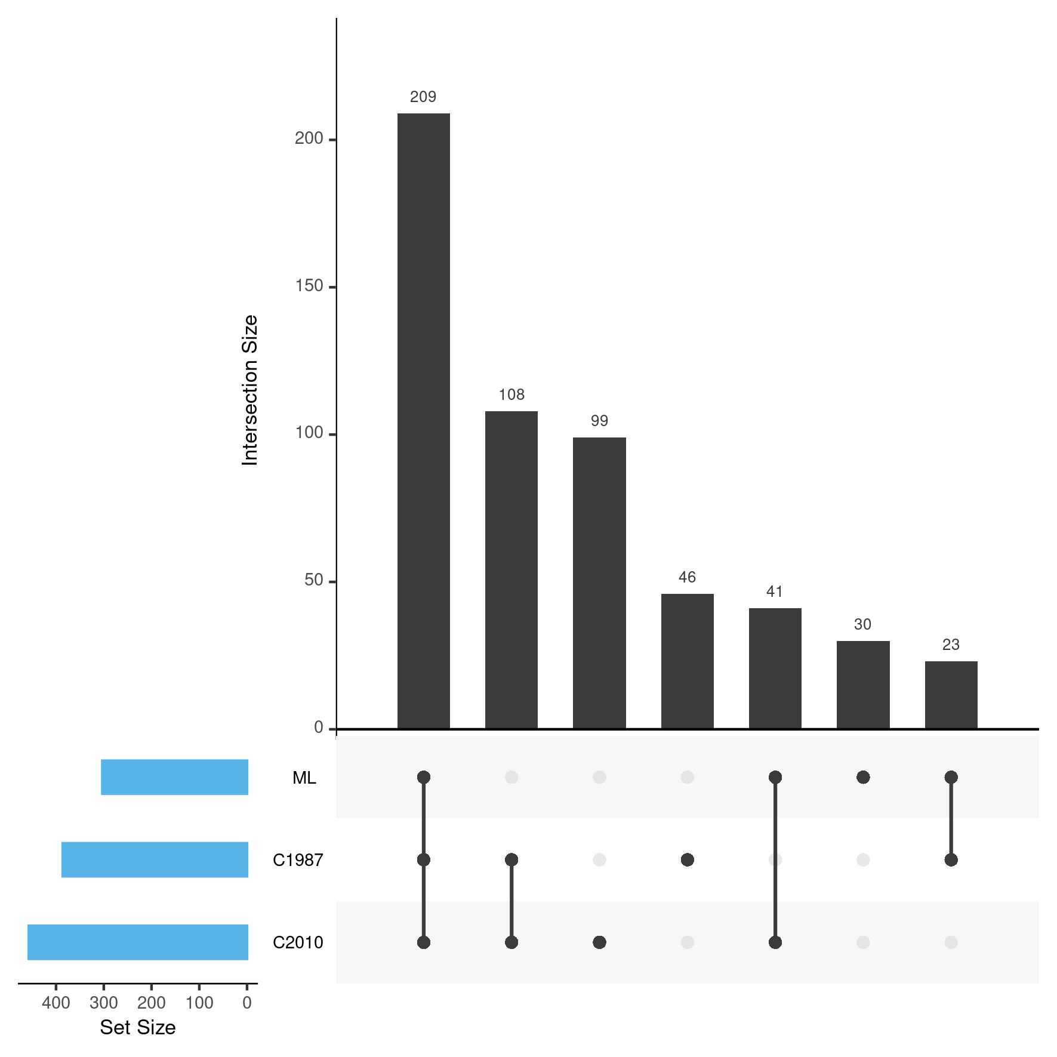
Supplementary figure 2 Upset plot visualizing the intersections of the ML defined cohort with the stringent cutoff (0.99) and the 2 criteria based gold standards, with a bar chart depicting the total cohort size in the bottom-left. Where C1987 = 1987 criteria based cases; ML= Machine learning based cases; C2010 = 2010 criteria based cases. N = 556 unique cases out of 1,212 records.
Supplementary Table 2. Comparison of baseline characteristics between the lenient ML defined cohort (cutoff=0.99) and the two criteria based cohorts.
 | Predicted Case based on machine learning (cutoff=0.53) | 1987 Criteria Based Cases | 2010 Criteria Based Case
N☨ | 465 | 386 | 457
Proportion Women | 0.64 | 0.63 | 0.66
Proportion anti-CCP2 Positive | 0.47 | 0.49 | 0.49
Proportion RF positive | 0.53 | 0.58 | 0.59
Median DAS44 at Baseline | 2.7 | 2.9 | 2.9*
Median BMI | 25.8 | 25.6 | 25.6
Median BSE | 25 | 28 | 26
Median CRP | 9.1 | 10.5 | 9.0
Median Age at Inclusion | 57.8 | 58.7 | 57.2
Median Symptom Duration at Diagnosis (days) | 87 | 89.5 | 91.0
Median Number of Swollen Joints | 5 | 6* | 5
P-values were calculated with the Pearson Chi-Squared for proportions, Mann-Whitney U for medians: * p<0.05; ** p<0.01, *** p<0.001; ☨ Not statistically tested;

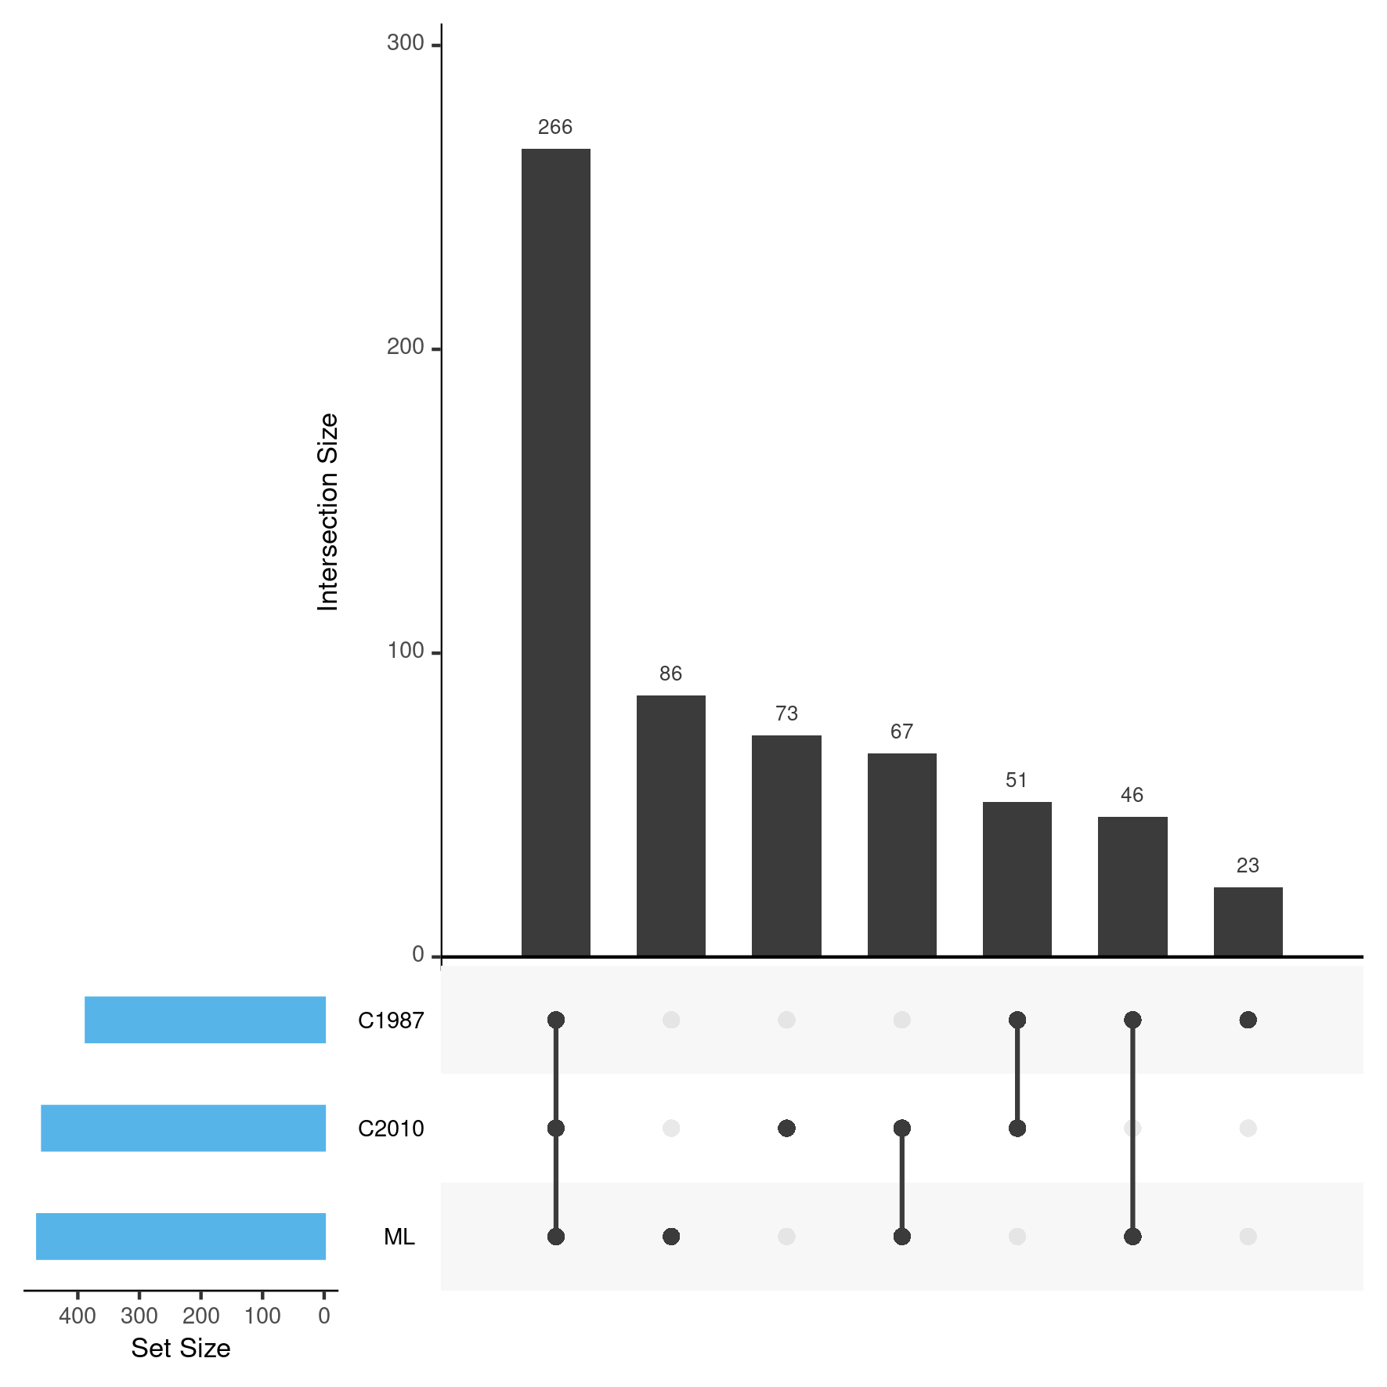
Supplementary figure 3 Upset plot visualizing the intersections of the ML defined cohort with the lenient cutoff (0.53) and the 2 criteria based gold standards, with a bar chart depicting the total cohort size in the bottom-left. Where C1987 = 1987 criteria based cases; ML= Machine learning based cases; C2010 = 2010 criteria based cases. N = 612 unique cases out of 1,212 records.

