Effect of nickel acetyl acetonate as lubricant additive in base oils with different molecular structure on in-situ formation and tribomechanism of carbon-based tribofilms of steel-steel sliding pair

Fig. S1 Friction coefficients under lubrication of four kinds of base oils alone and base oils with Ni-RF additive: (a) DIOS, DIOS + 1.8% RF1151, DIOS + 2% Ni-RF; (b) AN-5, AN-5 + 1.8% RF1151, AN-5 +2% Ni-RF; (c) PAO6, PAO6 + 1.8% RF1151, PAO6 + 2% Ni-RF; (d) 150N, 150N + 1.8% RF1151, 150N + 2% Ni-RF (four-ball machine; 196 N, 1800 rev/min, 54 °C, 60 min).
Fig. S2 3D contours of wear scars on lower steel balls lubricated by various base oils containing 1.8% RF1151 (sliding condition the same as that of Fig. S1).
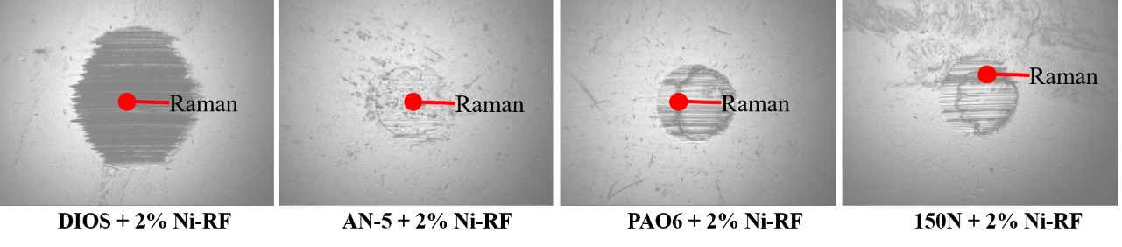
Figure. S3 Optical photographs of wear scars showing the specific regions for Raman characterization (sliding condition the same as that of Fig. S1).

Fig. S4 Raman spectra of wear scars of lower steel balls lubricated by four kinds of base oils alone (sliding condition the same as that of Fig. S1).

