Supplementary information

S1.1 Soil source, and manure antibiotics
The red soil (R) originated from the Red Soil Ecological Experimental Station of the Chinese Academy of Sciences in Yingtan, China. The black soil (B) was sourced from agricultural land in Changchun, China. Red soil and black soil were classified as Ultisol and Mollisol [1]. Pig manure from a medium-intensive farm in Yingtan, China, underwent a 2-month composting process. The soil and manure were dried naturally and ground through a 0.85-mm sieve. The physicochemical attributes are detailed in Table S1. Black soil and red soil were amended with 4% manure [2]. The moisture content of the manure-amended soil was then adjusted to 28% [3]. Pre-cultivation was conducted in a temperature-controlled incubator at 25°C under light-shielded conditions for two weeks, with moisture replenishment occurring every two days. A stock solution of normal sulfadiazine (¹²C-SDZ) with a concentration of 200 mg/l in methanol was prepared. This stock solution was mixed with the pre-cultured soil to create 20 mg/l of SDZ-contaminated soil. The same procedure was followed to prepare ¹³C-labeled sulfadiazine (¹³C-SDZ) contaminated soil.

S1.2 Preparation of biochar-based biofilm (BB)
Bamboo biochar was procured from Shanghai Nono Charcoal Co. After grinding and sieving, biochar particles ranging from 0.06 to 0.085 mm were carefully selected, followed by washing, drying, and autoclaving, and subsequently used as a bacterial biofilm carrier. The sulfadiazine-degrading bacterium, Arthrobacter spp. D₂ was obtained from the laboratory of Professor Tong Zhang at the University of Hong Kong [4]. Cultivation of the bacterium was carried out using Luria-Bertani medium under conditions of 37°C and 180 rpm. After activation, the bacteria were expanded for 24 hours, washed twice with sterilized phosphate buffer (PBS), resuspended in a mineral salt medium, and adjusted to an optical density of 1 at 600 nm (OD₆₀₀). The carrier biofilm culture system was established by incorporating 8 ml of bacterial broth (OD₆₀₀ = 1), 36 ml of Luria-Bertani medium, and 4 g of biochar in a total volume of 40 ml. After biofilm isolation, it underwent two rounds of PBS washing, followed by freeze-drying under vacuum conditions at -80°C, and was promptly used for the experiment. The quantification of microorganisms within the biofilm was determined through precise weighing.

S1.3 The detection of ¹³C-SDZ and δ¹³C, and ¹³CO₂
Soil samples and gas samples were collected on days 0, 7, 14, and 21. Subsequently BB were isolated from the soil samples in the BB-added treatments, ¹²C-SDZ and ¹³C-SDZ extraction and concentration detection were performed separately for the soil and the biofilm (Thermo Scientific DELTA V Advantage IRMS). To ascertain the potential conversion of ¹³C-SDZ by soil SDZ-degrading bacteria, we assessed the concentration of SDZ in soil and δ¹³C and concentration of ¹³CO₂ produced through soil respiration at various incubation durations. The headspace of microcosms was analyzed for CO₂ concentration (Agilent 7890B Gas Chromatograph) as well as the abundance of ¹³CO₂ (Thermo Scientific 253 Plus 10 kV IRMS). After each headspace sampling, fresh air was introduced into the bottles to maintain oxygen levels.

S1.4 The extraction of antibiotics
The soil sample is freeze-dried and ground through 0.25 mm sieves. The soil was thoroughly mixed. The prepared soil or manure samples (1.5 g) and 2.0 ml of 150 mg/l of Na₂EDTA solution were placed in 50 ml polypropylene centrifuge tubes with two ceramic homogenizers, and mixed by vortexing for 1 min. 5 ml of acetonitrile and methanol mixtures with volume ratios of 65/35 were added to the centrifuge tubes. After shaking for 1 min, anhydrous Na₂SO₄ (2.0 g) and NaCl (0.5 g) were added into the centrifuge tubes, and vortexed with the soil samples for 1.5 min. All the samples were centrifuged at 6000 rpm for 10 min, and 1.3 ml of the supernatants were collected in 2 ml polypropylene centrifuge tubes to which the d-SPE sorbents consisting of C18 (12.5 mg), PSA (12.5 mg), and Na₂SO₄ (225 mg) were added. The samples were mixed vigorously for 1 min, centrifuged at 10000 rpm for 5 min, and then 1.0 ml of the supernatants were transferred to clean brown glass vials for LC-MS/MS analysis.
The extraction of antibiotics from the biochar-based biofilm (BB) was performed similarly to the soil samples. The procedure was as follows: The BAB samples (150 mg) and 0.8 ml of 150 mg/l of Na₂EDTA solution were placed in 15 ml polypropylene centrifuge tubes with two ceramic homogenizers, and mixed by vortexing for 1 min. 2 ml of acetonitrile and methanol mixtures with volume ratios of 65/35 were added to the centrifuge tubes. After shaking for 1 min, anhydrous Na₂SO₄ (1.0 g) and NaCl (0.25 g) were added into the centrifuge tubes, and vortexed with the soil samples for 1.5 min. All the samples were centrifuged at 10000 rpm for 10 min, and 1.3 ml of the supernatants were collected in 2 ml polypropylene centrifuge tubes to which the d-SPE sorbents consisting of C18 (12.5 mg), PSA (12.5 mg), and Na₂SO₄ (225 mg) were added. The samples were mixed vigorously for 1 min, centrifuged at 10000 rpm for 5 min, and then 1.0 ml of the supernatants were transferred to clean brown glass vials for LC-MS/MS analysis.

S1.5 Detection of soil pH and elemental composition
Soil pH was assessed using a pH meter (Mettler Toledo FE28-CN) with a prepared suspension containing a soil-to-water ratio of 1:2.5. The elemental composition of C, H, N, and S was determined using an Elementar Vario EL Cube elemental analyzer (Elementar Analysensysteme GmbH, Germany).

S1.6 DNA extraction
DNA was extracted from soil samples using the FastDNA Spin Kit following the manufacturer’s protocol (MP Biomedicals, CA, USA). For extracting the DNA from SDZ-degrading bacterium, Arthrobacter spp. D2, the OMEGA Bacterial DNA Kit D3350 was used. The extracted DNA was quantified using the Qubit® 3.0 Fluorometer (Thermo Fisher Scientific Inc., USA) [5] and stored at -80°C.

S1.7 Quantitative PCR of individual layers from ultracentrifugation
The 16S rRNA gene copy number within each DNA stratum was quantified by quantitative polymerase chain reaction (qPCR) on a qTower 3G Real-Time PCR System (ZX 2018, Analytik Jena AG Germany) using TB green probe (TB Green® Premix Ex TaqTM), forward primer 515F (5'-GTGCCAGCMGCCGCGG-3'), and reverse primer 907R (5'-CCGTCAATTCMTTTRAGTTT-3'). Additional qPCR conditions are listed in Tables S7 and S8. The heavy and light DNA layers of each sample were separately combined and stored at -80°C.

S1.8 Calculation
The relative abundance of ¹³C in soil and CO₂ was quantified using Δδ¹³C (‰), which is determined by subtracting the δ¹³C (‰) value of the labeled treatment samples from the corresponding non-labeled treatment (natural level). The formula for calculating Δδ¹³C (‰) is shown in Eq. (S1).
Δδ¹³C (‰) = δ¹³C_{labeled treatment} - δ¹³C_{non-labeled treatment} (S1)

The δ¹³C (‰) was converted to ¹³C atom-% according to Eq. (S2). The CO₂, efflux from ¹³C-SDZ soil was partitioned into ¹³C-SDZ and soil-derived components using a two-pool isotope-mixing mo del Eq. (S3) [6]. Calculation of mineralized ¹³C-SDZ in soil via ¹³CO₂ is shown in Eq. (S4)
$atom\%^{13}C_{SDZ}=\frac{100×R_{standard}×({δ^{13}C}/{1000}+1)}{1+R_{standard}×({δ^{13}C}/{1000}+1)}$ (S2)
${CO}_{2 SDZ−derived}={CO}_{2 total} × \frac{atom\%^{13}CO_{2 toral}−atom\%^{13}CO_{2 soil}}{atom\%^{13}CO_{2 SDZ}−atom\%^{13}CO_{2 soil}}$ (S3)
${Mineralized }^{13}C_{6}−SDZ={CO}_{2 SDZ−derived}×\frac{6×m_{C}×{m_{13}}_{C_{6}−SDZ}}{m_{CO_{2}}}$ (S4)

where CO_{2 13C-SDZ-derived}, CO_{2 soil}, and CO_{2 total} refer to the ¹³C-SDZ-derived CO₂-C, soil-derived CO₂-C, and total CO₂-C from ¹³C-SDZ soil, respectively. Atom% ¹³CO_{2 SDZ-derived}, atom% ¹³CO_{2 soil}, and atom% ¹³CO_{2 total} are the ¹³C atom-% values of the CO₂, derived from ¹³C-SDZ, non-labeled soil, and ¹³C-SDZ soil, respectively. Where δ¹³C represents the soil sample or CO₂ sample. R_{standard}, 0.0111802, m_{C}, m_{13C6-SDZ}, m_{CO2}, represented atomic mass of C, ¹³C₆-SDZ, and CO₂.

The relative gene copy number of ARG was calculated using Eq. (S5) [7] with a threshold cycle detection limit of 30 (Ct). The relative abundance of ARGs was normalized to the relative gene copy number (GCN) of 16S rRNA by Eq. (S6). according to a previou s report [2].
$\text{Relative GCN = }{\text{10}}^{\frac{\text{30-Ct}}{\text{3.3333}}}$ (S5)
$\text{RA}\text{ARG}\text{ (\%) =}\frac{\text{relative GCN}}{{\text{relative GCN}}_{\text{16S }\text{rRNA}}}\text{ × 100}$ (S6)
The relative abundance of “VFs” and “pathogenic bacteria” was calculated with “reads number” from metagenomic sequencing and the relative GCN of 16S rRNA (Eq. (S1)) for each sample by Eq. (S3) and Eq. (S4).
$\text{normalized RA }\text{VFs}\text{ (\%) =}\frac{\text{reads number }\text{(VFs)}}{\text{relative GCN }\text{(16S rRNA)}}$ (S7)
$\text{normalized RA}\text{ pathogenic bacteria}\text{ (\%) =}\frac{\text{reads number }\text{(}\text{pathogenic bacteria}\text{)}}{\text{relative GCN }\text{(16S rRNA)}}$ (S8)
Accumulation factors (AFs), the ratio of the relative abundance of pathogenic bacteria (reads number/16S rRNA copies) in the same treatment between labeled SDZ and non-labeled SDZ treatments was used to describe whether the pathogenic bacteria were accumulated in SDZ-degrading bacteria. AFs were calculated by Eq. (5).
$\text{AFs =}\frac{\text{RA}\text{(13C_SDZ)}}{\text{RA}\text{(12C_SDZ)}}$ (S9)
An AFs value greater than 1 indicates a higher relative abundance of the pathogenic bacteria in SDZ-degrading bacteria, while a ratio less than 1 indicates a lower relative abundance of the pathogen in SDZ-degrading bacteria compared to non-SDZ-degrading bacteria.
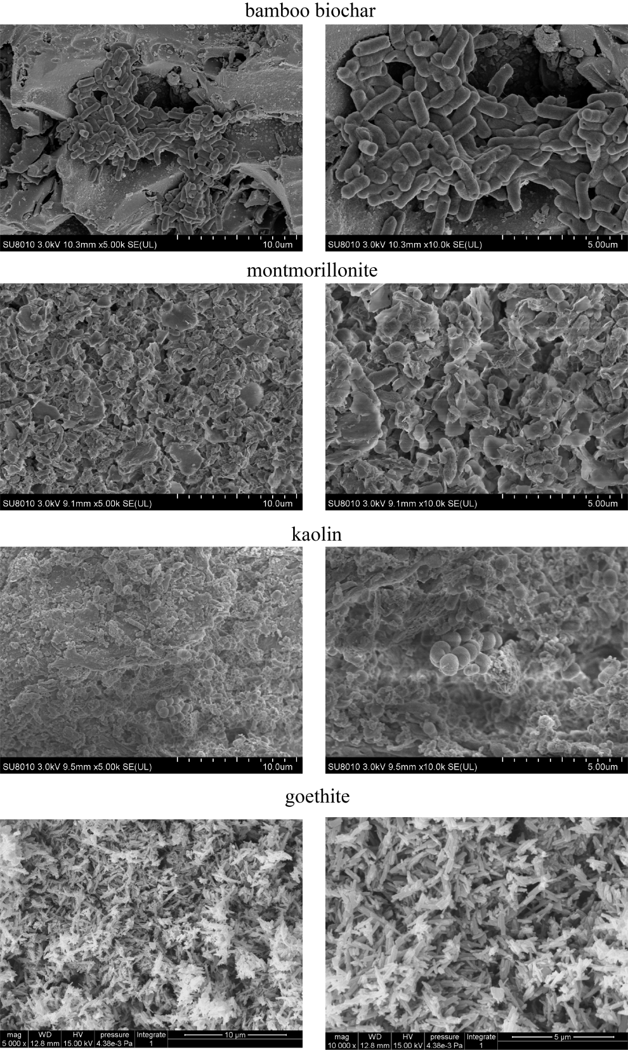

Figure S1. Morphology of bacterial biofilms on different carriers as given by bioscanning electron microscope (BSEM).
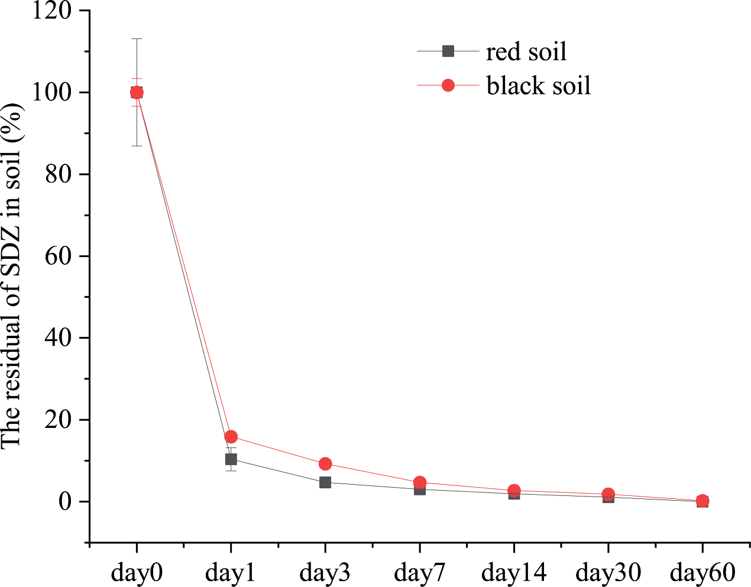
Figure S2. Degradation of sulfadiazine (SDZ) in red and black soils at different incubation times.

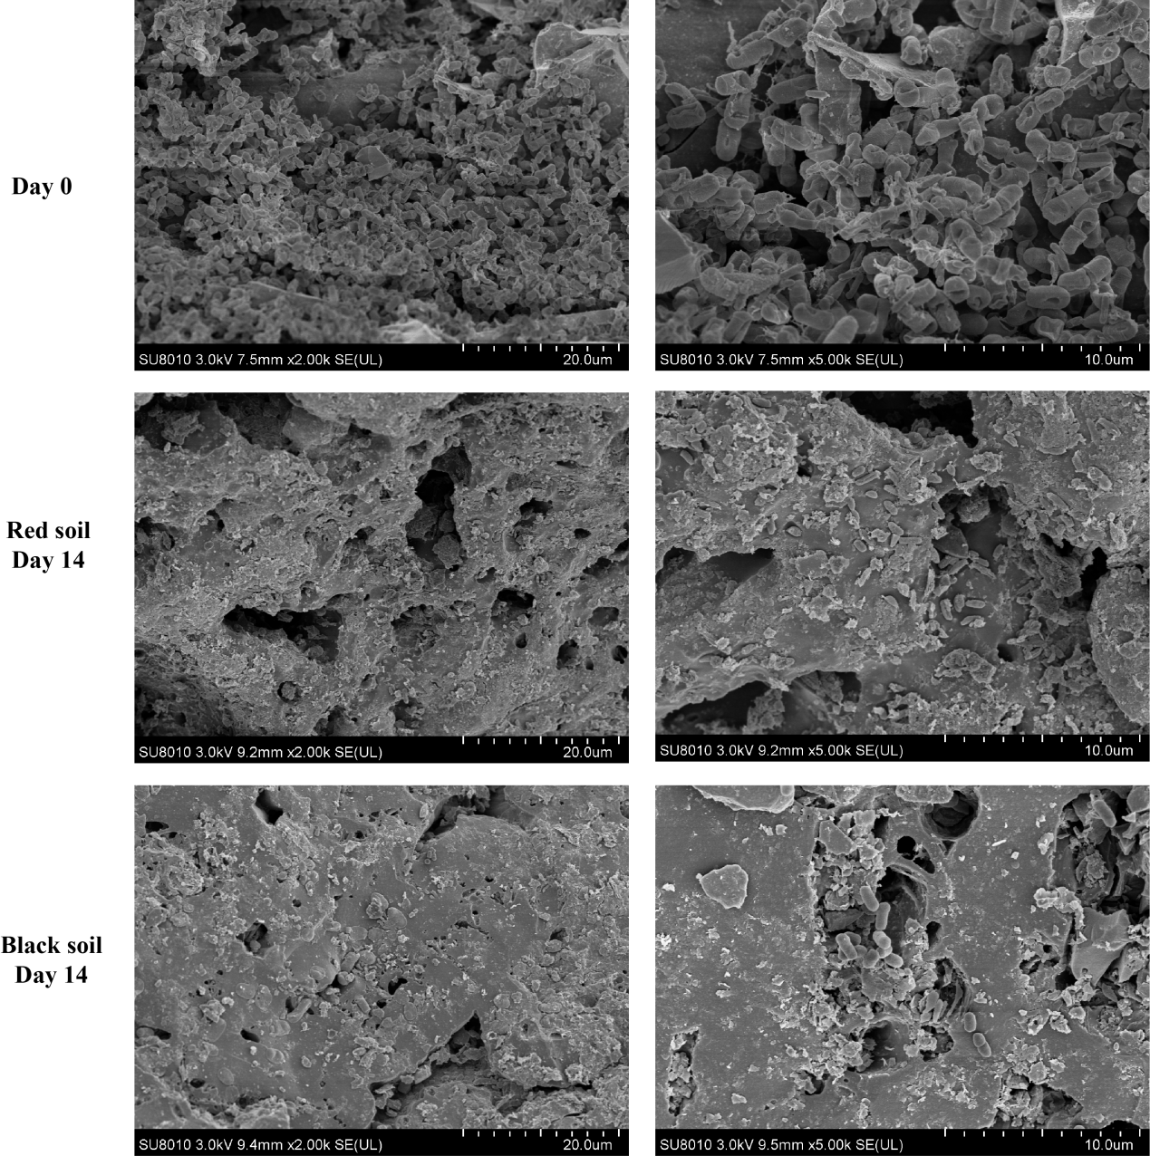

Figure S3. Morphology of D₂ bacterial biofilms on biochar carriers (Day 0) and BB isolated from black and red soils after 14 days of incubation by BSEM.
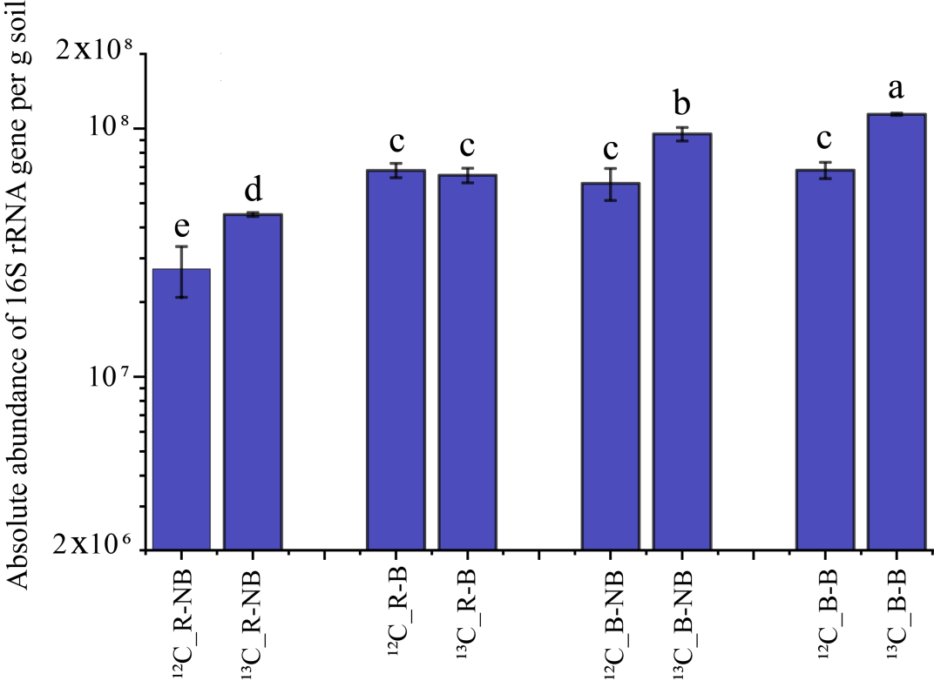

Figure S4. Absolute abundance of 16S rRNA gene per g soil. R, red soil, B, black soil, NB, treatment without biochar biofilm addition, B, treatment with biochar biofilm addition, ¹²C, no ¹³C-labeled SDZ treatment, ¹³C, ¹³C-labeled SDZ treatment. Different letters indicate significant differences between treatments (p<0.05).
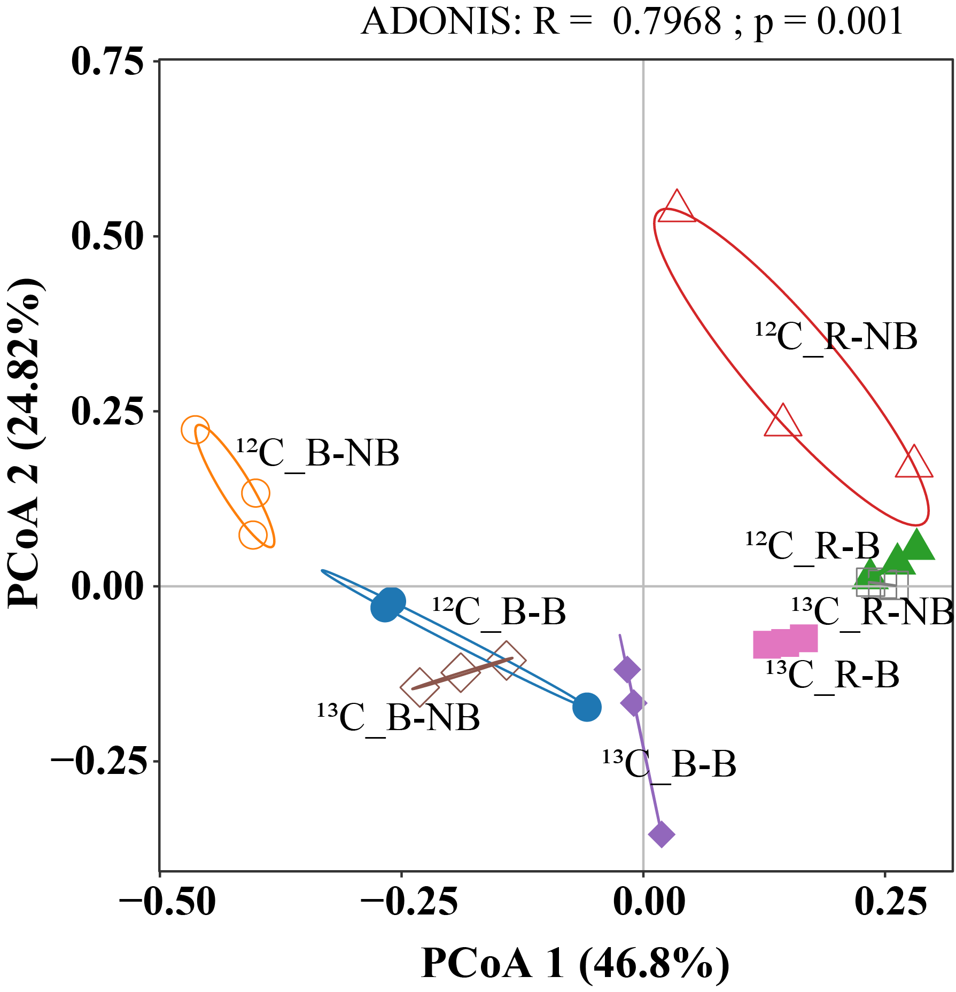

Figure S5. Principal coordinate analysis (PCoA) of all ARGs and MGEs detected in the heavy layers of ¹²C-SDZ treatments and ¹³C-SDZ treatments, based on relative abundance. Sample codes are the same as in Figure S4.
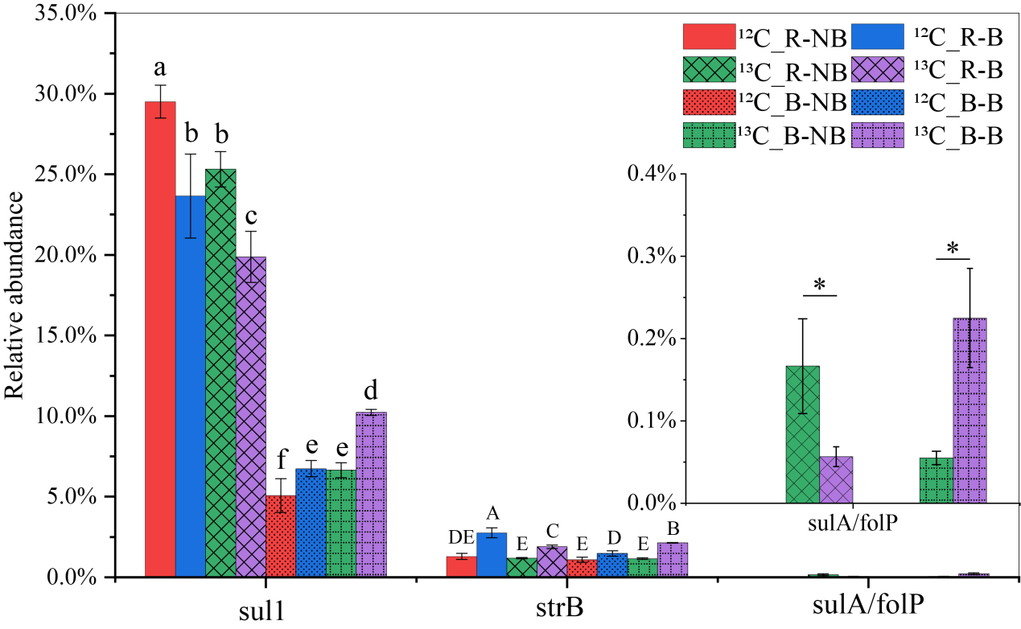
Figure S6. Relative abundance of sulfonamide resistance genes. Genes sul2, sul3, and folA were not detected in all samples and are not shown here. Different letters and “*” represent different significant differences (p<0.05). Sample codes are the same as in Figure S4.
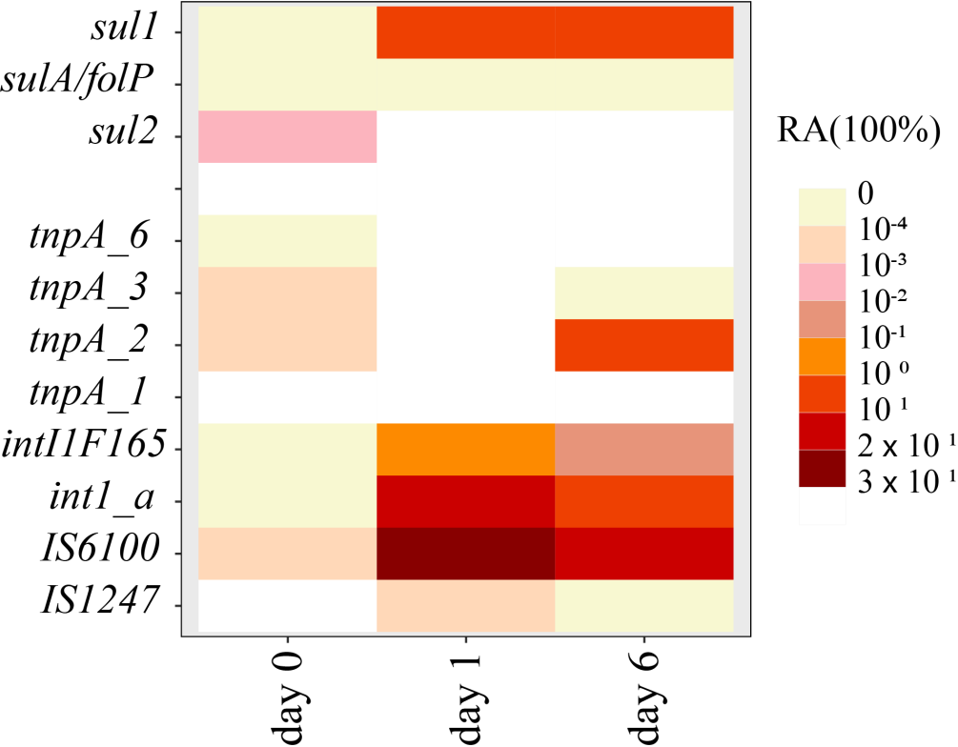
Figure S7. Relative abundance of sulfonamide resistance genes and MGEs detected in D₂ bacteria under incubation conditions with SDZ as the sole carbon source.
Figure S8. PCoA of microorganisms in the heavy layers of ¹²C-SDZ treatments and ¹³C-SDZ treatments according to the relative abundance of bacteria species of. Sample codes are the same as in Figure S4.
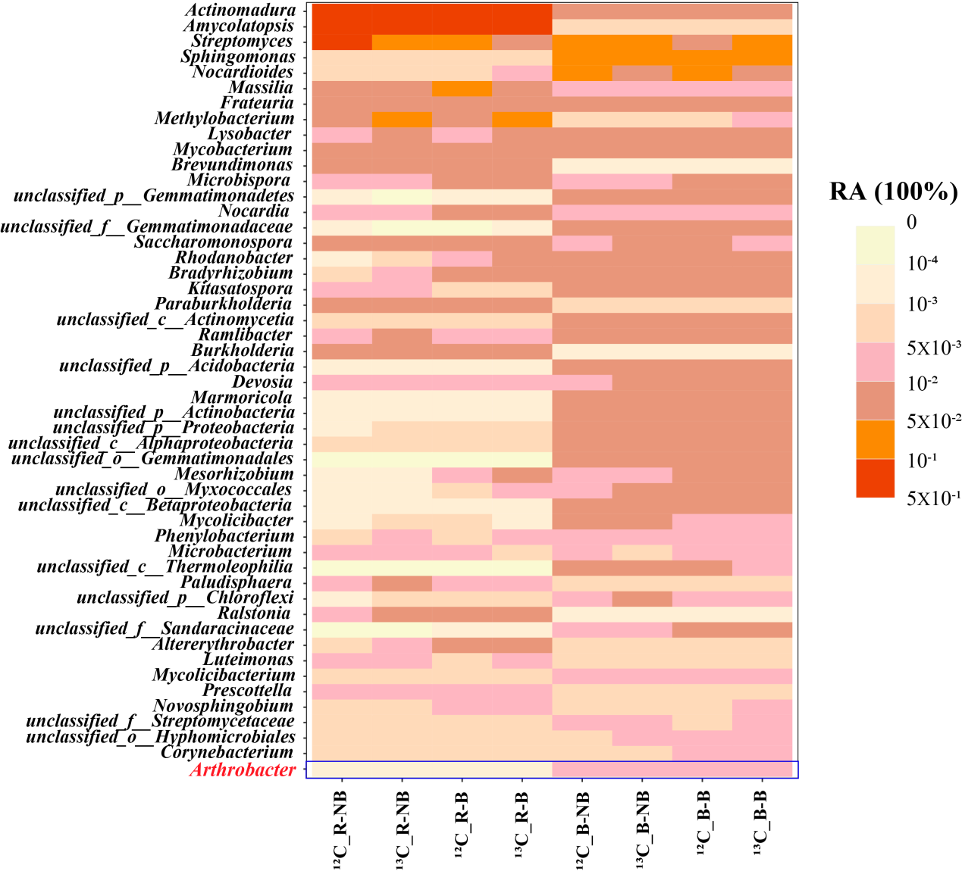
Figure S9. Relative abundance of the top 50 bacterial genera. Arthrobacter is the 50th abundant bacterial genera. Sample codes are the same as in Figure S4.

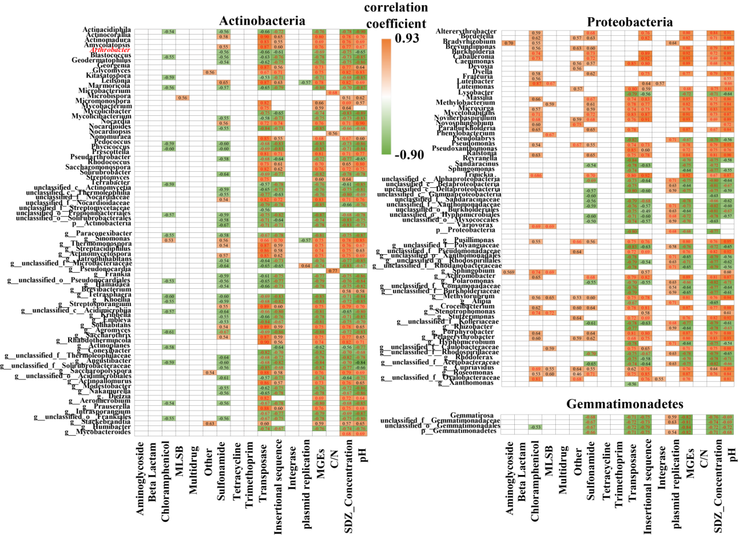
Figure S10. Relative abundance of bacteria in the top 200 bacterial genera significantly correlated with each of the resistance classes ARGs (including MGEs), and environmental factors and their corresponding correlation coefficients (p<0.05). The metagenomic sequencing results from all samples revealed a total of 5816 bacterial genera, with the cumulative abundance of the top 200 bacterial genera (representing 3.44% of the total bacterial genera) comprising 49.6% to 50.7% of the overall microbial community's relative abundance. By concentrating on these top 200 bacterial genera based on their relative abundances, the correlation between ARGs and environmental factors was investigated. Coefficients marked in red represent highly significant correlations p<0.01. The phylum proteobacteria, phylum actinobacteria, and phylum Gemmatimonadetes, the three phyla (Proteobacteria, Actinobacteria, and Gemmatimonadetes) had the most significant correlations with ARGs, MGEs, and environmental factors in the redundancy analysis (Figure S10). Among the SDZ-degrading bacteria in the phylum of Actinobacteria, including Actinocorallia, Amycolatopsis, Leifsonia, Nocardia, Sinomonas, Thermomonospora, Actinomycetospora, Streptosporangium, Solihabitans, and Saccharothrix showed the positive correlations (ρ> 0.5, p < 0.05) with sulfonamide resistance genes and MGEs. Sample codes are the same as in Figure S4.

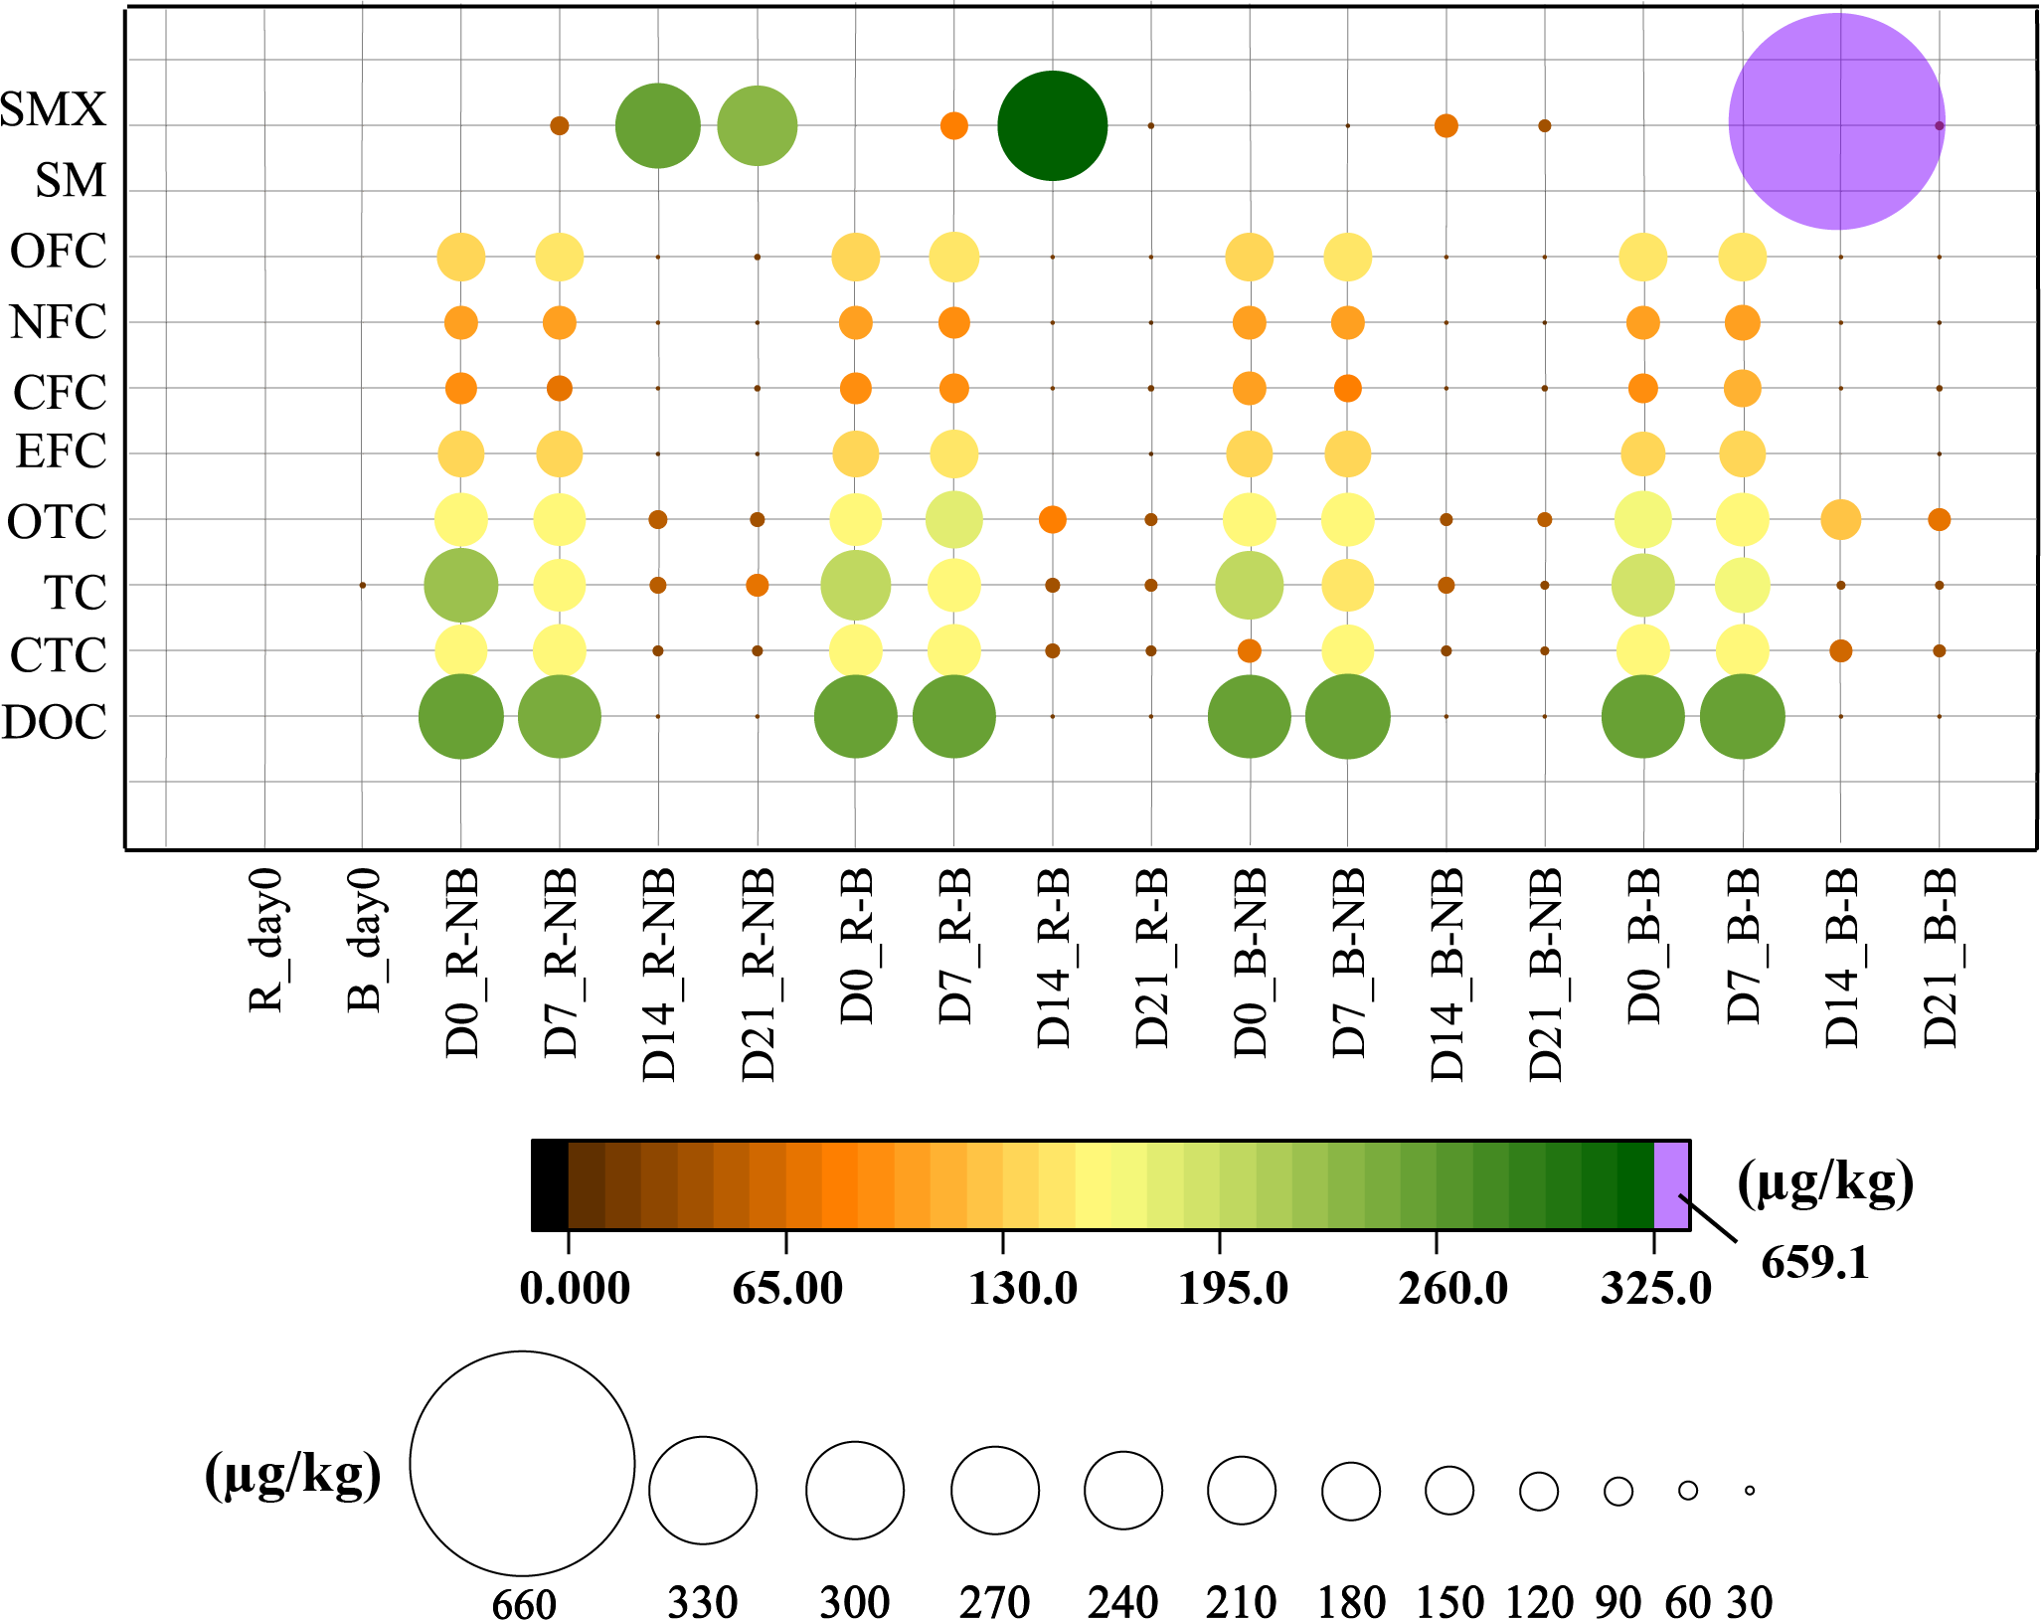
Figure S11. The concentration of other ten antibiotics in soil samples of different sampling times. SMX, sulfamethoxazole; SM, sulfamethoxine; OFC, ofloxacin; NFC, norfloxacin; CFC, ciprofloxacin; EFC, enrofloxacin; OTC, oxytetracycline; TC, tetracycline; CTC, chlortetracycline; DOC, doxycycline. Sample codes are the same as in Figure S4.
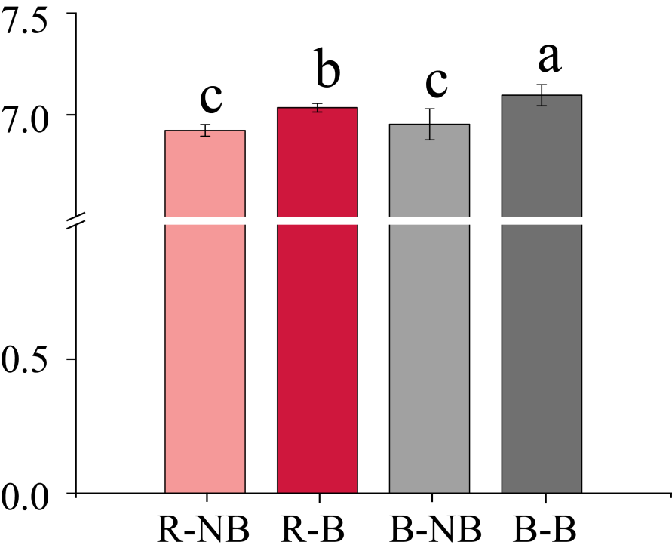
Figure S12. Soil pH in different treatments. Different letters represent different significant differences (p<0.05). Sample codes are the same as in Figure S4.
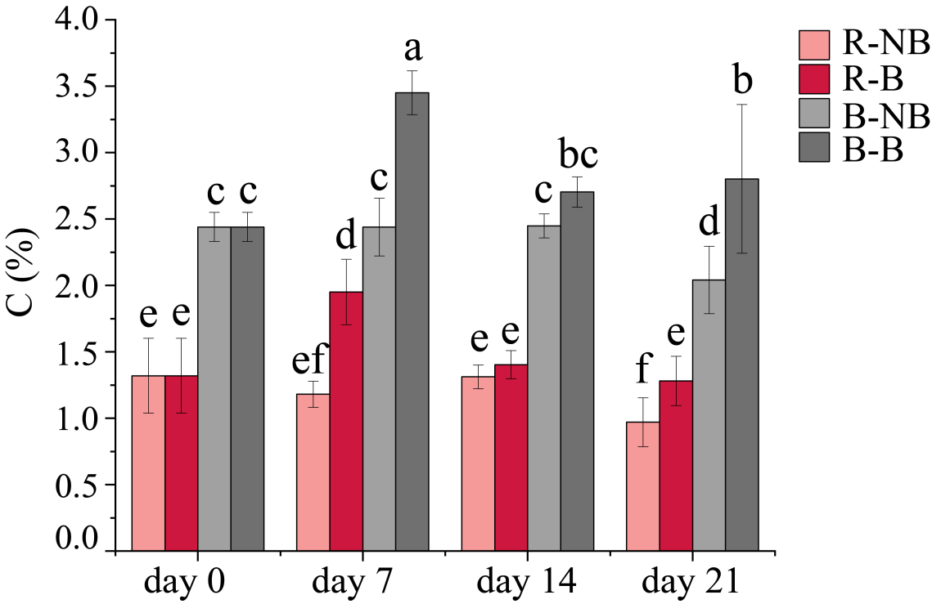
Figure S13. Carbon content in soil from different treatments. Different letters represent different significant differences (p<0.05). Sample codes are the same as in Figure S4.

Table S1 Physical and chemical properties of soil and manure

 | pH | SOM | TN | TP | TK | AN | AP | AK | DOC | CEC | Particle Size Composition（%）
 | pH | g/kg | g/kg | g/kg | g/kg | mg/kg | mg/kg | mg/kg | mg/kg | cmol/kg | 2-0.05mm | 0.05-0.002mm | <0.002mm
red soil | 5.4±0.04 | 4.7±0.13 | 0.65±0.06 | 0.2±0.02 | 6.8±3.0 | 141.5±2.6 | 1.4±0.47 | 87.5±14.8 | 84.4±5.08 | 13.6±1.0 | 21.8±0.18 | 33.8±0.3 | 44.4±0.1
black soil | 6.7±0.07 | 21.8±0.45 | 1.5±0.02 | 0.51±0.11 | 17.3±3.5 | 211.3±2.6 | 40.4±0.65 | 280±0.0 | 161.7±6.4 | 25±0.86 | 24.2±1.3 | 42.1±1.3 | 33.7±0.05
manure | 7.04±0.07 |  | 31.6±0.48 | 19.9±5.3 | 10.4±0.94

Table S2 Physicochemical properties of bamboo biochar

 | pH | CEC | Ash | C | H | N | O | S
 | pH | cmol/kg | g/kg | % | % | % | % | %
biochar | 10.2 ± 0.02 | 25.9 ± 2.8 | 49.8 ± 10.7 | 64.4 ± 11.7 | 2.2 ± 0.51 | 1.1 ± 1.3 | 15.6 ±2.2 | 0.16 ± 0.07

Table S3 Percent recoveries of sulfonamide in different types of samples

Sample | Recovery % | RSD %
red soil | 97.6 | 0.4
black soil | 83.7 | 3.1
manure | 78.5 | 2.2
biochar biofilm | 76 | 2.7

RSD: relative standard deviation

Table S4 The HPLC-MS/MS conditions for 11 antibiotics

Name | Q1 m/z | Q3 m/z | Dwell time (ms) | Q1 Pre-bias (V) | CE (V) | Q3 Pre-bias (V)
Sulfadiazine (SDZ) | 251 | 156 | 15 | -30 | -15 | -29
Sulfadiazine (SDZ) | 251 | 92.1 | 15 | -30 | -25 | -17
¹³C-Sulfadiazine  (¹³C-SDZ) | 257 | 162 | 15 | -30 | -15 | -29
¹³C-Sulfadiazine  (¹³C-SDZ) | 257 | 98.1 | 15 | -30 | -25 | -17
Sulfamethoxazole (SMX) | 254 | 156 | 15 | -30 | -16 | -29
Sulfamethoxazole (SMX) | 254 | 92 | 15 | -30 | -28 | -17
Sulfamethoxine (SM) | 281 | 156.1 | 15 | -30 | -17 | -29
Sulfamethoxine (SM) | 281 | 108.1 | 15 | -30 | -26 | -21
Ofloxacin  (OFC) | 362 | 318.2 | 15 | -30 | -18 | -24
Ofloxacin  (OFC) | 362 | 261.1 | 15 | -30 | -28 | -19
Norfloxacin  (NFC) | 320 | 302.1 | 15 | -16 | -20 | -23
Norfloxacin  (NFC) | 320 | 231.1 | 15 | -16 | -46 | -28
Ciprofloxacin  (CFC) | 332 | 314.1 | 15 | -13 | -16 | -24
Ciprofloxacin  (CFC) | 332 | 231 | 15 | -13 | -44 | -18
Enrofloxacin  (EFC) | 360 | 342.2 | 15 | -29 | -20 | -26
Enrofloxacin  (EFC) | 360 | 316.2 | 15 | -29 | -20 | -24
Oxytetracycline (OTC) | 461 | 426 | 15 | -14 | -18 | -23
Oxytetracycline (OTC) | 461 | 443.1 | 15 | -14 | -14 | -24
Tetracycline  (TC) | 445 | 410.2 | 15 | -11 | -22 | -30
Tetracycline  (TC) | 445 | 427 | 15 | -11 | -16 | -23
Chlortetracycline (CTC) | 479 | 444.1 | 17 | -12 | -24 | -23
Chlortetracycline (CTC) | 479 | 154.1 | 17 | -12 | -28 | -12
Doxycycline  (DOC) | 445 | 428.2 | 15 | -11 | -16 | -23
Doxycycline  (DOC) | 445 | 154.1 | 15 | -11 | -34 | -17

Table S5 the concentration of 11 antibiotics in blank soils

Concentration (µg/kg) | Red soil | Black soil
Sulfadiazine (SDZ) | NA | NA
Sulfamethoxazole (SMX) | NA | NA
Sulfamethoxine (SM) | NA | NA
Ofloxacin (OFC) | NA | 0.89±0.117
Norfloxacin (NFC) | 0.235 | 1.44
Ciprofloxacin (CFC) | 0.149±0.0416 | 0.762±0.287
Enrofloxacin (EFC) | 0.0487±0.011 | 0.799±0.081
Oxytetracycline (OTC) | 0.258±0.172 | 0.528±0.161
Tetracycline (TC) | NA | 0.149±0.040
Chlortetracycline (CTC) | 5.34±5.31 | 1.514±0.512
Doxycycline (DOC) | 2.31±0.945 | 2.15±0.216

Table S6 BET Surface Area (m²/g)

 | red soil | black soil | bamboo biochar | biochar biofilm
BET (m²/g) | 30.9 | 5.11 | 502.7 | 195.7

Table S7 The reaction system of qPCR

Step | Temperature°C | Time | Number of cycles
Pre-denaturation | 95 | 30 s | 1
Denaturation | 95 | 10 s | 40
Annealing | 55 | 30 s | 40
Extension | 72 | 30 s | 40
Storing temperature | 4 | ∞ | 1

Table S8 The reaction cycle parameters of qPCR

Reagent | Volume
TB Green | 10 µl
10 uM upstream primer | 0.5 µl
10 uM downstream primer | 0.5 µl
DNA template | 1.0 µl
PCR-H₂O | 8µl

Table S9 List of primers used in this study
Gene Name | Mechanism | Classification | Forward Primer | Reverse Primer
16S old 1 | 16S rRNA | 16S rRNA | GGGTTGCGCTCGTTGC | ATGGYTGTCGTCAGCTCGTG
16S new 2 | 16S rRNA | 16S rRNA | CCTACGGGAGGCAGCAG | ATTACCGCGGCTGCTGGC
aacA/aphD | deactivate | Aminoglycoside | AGAGCCTTGGGAAGATGAAGTTT | TTGATCCATACCATAGACTATCTCATCA
aac (6')-II | deactivate | Aminoglycoside | CGACCCGACTCCGAACAA | GCACGAATCCTGCCTTCTCA
aphA3 | deactivate | Aminoglycoside | AAAAGCCCGAAGAGGAACTTG | CATCTTTCACAAAGATGTTGCTGTCT
sat4 | deactivate | Aminoglycoside | GAATGGGCAAAGCATAAAAACTTG | CCGATTTTGAAACCACAATTATGATA
aac (6')-Ib | deactivate | Aminoglycoside | CGTCGCCGAGCAACTTG | CGGTACCTTGCCTCTCAAACC
aadA2 | deactivate | Aminoglycoside | ACGGCTCCGCAGTGGAT | GGCCACAGTAACCAACAAATCA
aadA5 | deactivate | Aminoglycoside | ATCACGATCTTGCGATTTTGCT | CTGCGGATGGGCCTAGAAG
aadD | deactivate | Aminoglycoside | CCGACAACATTTCTACCATCCTT | ACCGAAGCGCTCGTCGTATA
aphA1 | deactivate | Aminoglycoside | TGAACAAGTCTGGAAAGAAATGCA | CCTATTAATTTCCCCTCGTCAAAAA
aadE | deactivate | Aminoglycoside | TACCTTATTGCCCTTGGAAGAGTTA | GGAACTATGTCCCTTTTAATTCTACAATCT
Aac6-Aph2 |  | Aminoglycoside | CCAAGAGCAATAAGGGCATACCAA | GCCACACTATCATAACCACTACCG
aadA6 | deactivate | Aminoglycoside | CCATCGAGCGTCATCTGGAA | CCCGTCTGGCCGGATAAC
aadA16 | deactivate | Aminoglycoside | ACGGTGGCCTGAAGCC | GAATTGCAGTTCCCGTCTGG
aadA17 | deactivate | Aminoglycoside | TGTACGGCTCCGCAGTG | CACGGAATGATGTCGTCGTG
aadB | deactivate | Aminoglycoside | CCTGCTTGGTGGGCAGAC | CGGCACGCAAGACCTCAA
ant (6)-ia | deactivate | Aminoglycoside | TCGCCATGAGCTGCTGA | CCTATCATACTCCGGATAGGCATA
aph (3'')-ia | deactivate | Aminoglycoside | TAACAGCGATCGCGTATTTCG | TCCGACTCGTCCAACATCAATA
aph3-III |  | Aminoglycoside | CAGAAGGCAATGTCATACCACTTG | GACAGCCGCTTAGCCGAA
aac (3)-Xa | deactivate | Aminoglycoside | GCAAGCGGTTCGTGACGTA | TCAGGTGCTCCTCGATCCAG
catB3 | deactivate | Amphenicol | GCACTCGATGCCTTCCAAAA | AGAGCCGATCCAAACGTCAT
cmlA1 | efflux | Amphenicol | TAGGAAGCATCGGAACGTTGAT | CAGACCGAGCACGACTGTTG
cmx(A) | efflux | Amphenicol | GCGATCGCCATCCTCTGT | TCGACACGGAGCCTTGGT
floR | efflux | Amphenicol | AACCCGCCCTCTGGATCA | GCCGTCGAGAAGAAGACGAA
blaPSE | deactivate | Beta Lactam | TTGTGACCTATTCCCCTGTAATAGAA | TGCGAAGCACGCATCATC
cphA | deactivate | Beta Lactam | GCGAGCTGCACAAGCTGAT | CGGCCCAGTCGCTCTTC
blaOXY-1 | deactivate | Beta Lactam | AAAGGTGACCGCATTCGC | CCAGCGTCAGCTTGCG
blaCARB |  | Beta Lactam | TGATTTGAGGGATACGACAACTCC | CTGTAATACTCCGAGCACCAA
qepA1_A2 | efflux | Fluoroquinolone | GGGCATCGCGCTGTTC | GCGCATCGGTGAAGCC
QnrB4 | protection | Fluoroquinolone | TCACCACCCGCACCTG | GGATATCTAAATCGCCCAGTTCC
qnrD | protection | fluoroquinolone | CGCTGGAATGGCACTGTGA | GCTCTCCATCCAACTTCACTCC
oprD | efflux | MDR | ATGAAGTGGAGCGCCATTG | GGCCACGGCGAACTGA
mepA | efflux | MDR | ATCGGTCGCTCTTCGTTCAC | ATAAATAGGATCGAGCTGCTGGAT
merA-marko | unknown | MDR | GTGCCGTCCAAGATCATG | GGTGGAAGTCCAGTAGGGTGA
mdtH | efflux | MDR | ATGCTGGCTGTACAAGTGATG | CACTCCAGCGGGCGATA
mdtG | efflux | MDR | TTCCAGCCGGTCAGCAA | GACATCTCCCGCGAGTTCG
qacF/H |  | MDR | CTGAAGTCTAGCCATGGATTCACTAG | CAAGCAATAGCTGCCACAAGC
mdtA | efflux | MDR | ACAAGCCCAGGGCCAAC | CCTTAATGGTGCCTTCGGTTTC
copA |  | MDR | TGCACCTGACVGGSCAYAT | GVACTTCRCGGAACATRCC
tcrB |  | MDR | GTGCCGGAACTCAAGTAGCA | GCACCGACTGCTGGACTTAA
ermT | protection | MLSB | GTTCACTAGCACTATTTTTAATGACAGAAGT | GAAGGGTGTCTTTTTAATACAATTAACGA
ermX | protection | MLSB | GCTCAGTGGTCCCCATGGT | ATCCCCCCGTCAACGTTT
ermY | protection | MLSB | TTGTCTTTGAAAGTGAAGCAACAGT | TAACGCTAGAGAACGATTTGTATTGAG
cfr | protection | MLSB | GCAAAATTCAGAGCAAGTTACGAA | AAAATGACTCCCAACCTGCTTTAT
erm(B) | protection | MLSB | GAACACTAGGGTTGTTCTTGCA | CTGGAACATCTGTGGTATGGC
erm(Q) | protection | MLSB | TGAAAGCCATGCGTCTGAC | TTCAGCTGGCAGCTTAAGC
lnuB | deactivate | MLSB | GGATCGTTTACCAAAGGAGAAGG | AGCATAGCCTTCGTATCAGGAA
mphA | deactivate | MLSB | TCAGCGGGATGATCGACTG | GAGGGCGTAGAGGGCGTA
erm (35) | protection | MLSB | CCTTCAGTCAGAACCGGCAA | GCTGATTTGACAGTTGGTGGTG
erm (42) | protection | MLSB | TGTTGAGATTGGGCCTGGA | CTAAGGGTGGGTTCTCACTATCTA
erm(F) | protection | MLSB | TCTGATGCCCGAAATGTTCAAG | TGAAGGACAATTGAACCTCCCA
lnu(F) | deactivate | MLSB | ATACCGGTCATTTCCACTTGGC | GCATCAGGCTGATGAGGTTCAA
dfrA1 | protection | other | GGAATGGCCCTGATATTCCA | AGTCTTGCGTCCAACCAACAG
dfrA12 | protection | other | CCTCTACCGAACCGTCACACA | GCGACAGCGTTGAAACAACTAC
catB2 | deactivate | Phenicol | GCTACTATTCCGGCTATTACCATG | GGGCTCCTCGTTCATGTAGA
catQ | deactivate | Phenicol | AGGTGCACTTACAGTATGACTGC | AACGTGGGAAGTTCTCGTCATAC
TrbC |  | plasmid | CGGYATWCCGSCSACRCTGCG | GCCACCTGYSBGCAGTCMCC
strB | protection | Sulfonamide | GCTCGGTCGTGAGAACAATCT | CAATTTCGGTCGCCTGGTAGT
sul1 NEW | protection | Sulfonamide | GCCGATGAGATCAGACGTATTG | CGCATAGCGCTGGGTTTC
tetG_F | efflux | tetracycline | TCGCGTTCCTGCTTGCC | CCGCGAGCGACAAACCA
tetR | efflux,protection | tetracycline | CCGTCAATGCGCTGATGAC | GCCAATCCATCGACAATCACC
tet (32) | protection | Tetracycline | CCATTACTTCGGACAACGGTAGA | CAATCTCTGTGAGGGCATTTAACA
tetA | efflux | Tetracycline | CTCACCAGCCTGACCTCGAT | CACGTTGTTATAGAAGCCGCATAG
tetW | protection | Tetracycline | ATGAACATTCCCACCGTTATCTTT | ATATCGGCGGAGAGCTTATCC
tetO | protection | Tetracycline | CAACATTAACGGAAAGTTTATTGTATACCA | TTGACGCTCCAAATTCATTGTATC
tetL | efflux | Tetracycline | ATGGTTGTAGTTGCGCGCTATAT | ATCGCTGGACCGACTCCTT
tetX | deactivate | Tetracycline | AAATTTGTTACCGACACGGAAGTT | CATAGCTGAAAAAATCCAGGACAGTT
tetT | protection | Tetracycline | CCATATAGAGGTTCCACCAAATCC | TGACCCTATTGGTAGTGGTTCTATTG
tetPA | efflux | Tetracycline | GGAAACCTTAGTTCAGTGACTTGG | CCCATTTAACCACGCACTGAA
tetM | protection | Tetracycline | GGAGCGATTACAGAATTAGGAAGC | TCCATATGTCCTGGCGTGTC
tet44 | protection | Tetracycline | CTCATGTAGATGCAGGAAAGACG | GTAACTGCTGCCTGAATTGTGA
tnpA_1 | MGE | Transposase | GCCGCACTGTCGATTTTTATC | GCGGGATCTGCCACTTCTT
tnpA_2 | MGE | Transposase | CCGATCACGGAAAGCTCAAG | GGCTCGCATGACTTCGAATC
tnpA_3 | MGE | Transposase | GGGCGGGTCGATTGAAA | GTGGGCGGGATCTGCTT
tnpA_5 | MGE | Transposase | GAAACCGATGCTACAATATCCAATTT | CAGCACCGTTTGCAGTGTAAG
tnpA_6 | MGE | Transposase | TGCAGATGGTTTAACCTTGGATATTT | TCGGTTCATCAAACTGCTTCAC
dfrA14 | MGE | trimethoprim | CGGATCATGTCATTGTTTCAGG | ATGTTAGAGGCGAAGTCTTGG
dfrA17 | MGE | trimethoprim | CGGGAACGGCCCTGATATTCC | CGTGTTGCGACCGCATACTTTC
dfrA21 | MGE | trimethoprim | TTGTTTCAACGCTGTCGCA | GGTTTCGGTTGAGACAAGCTC
dfrG | MGE | trimethoprim | TCAATCGGAAGAGCCTTACCTGA | TGGGCAAATACCTCATTCCATTCC
IncP_oriT | MGE | plasmid incompatibility | CAGCCTCGCAGAGCAGGAT | CAGCCGGGCAGGATAGGTGAAGT
pBS228-IncP-1α | MGE | plasmid replication | CAATCCATCGACAATCAC | GACAATCAGCTACTTCAC
ISSm2-Xanthob | MGE | Insertional sequence | TGGATCGACCGGTTCCAT | GCTGACCGAGCTGTCCATGT
IS26 | MGE | Insertional sequence | ATGGATGAAACCTACGTGAAGGTC | CGGTACTTAATCTGTCGGTGTTCA
IS256 | MGE | Insertional sequence | CTTGCGCATCATTGGATGATGG | AAGAACGGCTCCAATTAAGCGA
IS1247 | MGE | Insertional sequence | CGGCCGTCACTGACCAA | TCGGCAGGTTGGTGACG
int1-a-marko | MGE | Integrase | CGAAGTCGAGGCATTTCTGTC | GCCTTCCAGAAAACCGAGGA
intl2 | MGE | Integrase | TGCTTTTCCCACCCTTACC | GACGGCTACCCTCTGTTATCTC
intI1F165_clinical | MGE | Integrase | CGAACGAGTGGCGGAGGGTG | TACCCGAGAGCTTGGCACCCA
intl3 | MGE | Integrase | CAGGTGCTGGGCATGGA | CCTGGGCAGCATCACCA
vanB | protection | Vancomycin | TTGTCGGCGAAGTGGATCA | AGCCTTTTTCCGGCTCGTT
vanHB | protection | Vancomycin | GAGGTTTCCGAGGCGACAA | CTCTCGGCGGCAGTCGTAT
vanA | protection | Vancomycin | GGGCTGTGAGGTCGGTTG | TTCAGTACAATGCGGCCGTTA

Table S10 The maximum relative abundance of 16S rRNA and its corresponding buoyant density in different treatments. Sample codes are the same as in Figure S3

$RA (\%)=\frac{16S rRNA absolute abundance of heavy or light layer}{total 16S rRNA absolute abundance of all layers}$×100%

TRTs | R-NB |  | R-B |  | B-NB |  | B-B
layers | light (¹²C) | heavy (¹³C) | light (¹²C) | heavy (¹³C) | light (¹²C) | heavy (¹³C) | light (¹²C) | heavy (¹³C)
BD (g/ml) | 1.708 | 1.717 | 1.717 | 1.722 | 1.715 | 1.719, 1.724 | 1.708 | 1.712, 1.718
RA (%) | 44.8 | 35.2 | 58.0 | 73.4 | 57.5 | 36.4, 34.1 | 49.5 | 24.4, 32.2

Table S11 Consistency analysis for different phyla of SDZ-degrading bacteria and antibiotic resistome based on NMDS results of the relative abundance of ARGs and species (M²: Procrustes sum of squares, permutations=999). Sample codes are the same as in Figure S1.
Phylum | relative abundance | M² | p value
Actinobacteria | 56.61% | 0.075 | 0.002
Proteobacteria | 34.62% | 0.7205 | 0.321
Gemmatimonadetes | 2.99% | 0.7205 | 0.321
Planctomycetota | 1.92% | 0.1486 | 0.002
Chloroflexi | 1.27% | 0.3161 | 0.008
Acidobacteria | 1.10% | 0.1628 | 0.005
Verrucomicrobia | 0.44% | 0.1115 | 0.001
Firmicutes | 0.44% | 0.6032 | 0.099
Bacteroidota | 0.15% | 0.081 | 0.002

Reference:

- Staff SS. Keys to Soil Taxonomy (eighth ed.). United States Department of Agriculture: Washington, DC, USA. 1998; p. 326.
- Mei Z, Xiang L, Wang F, Xu M, Fu Y, Wang Z, et al. Bioaccumulation of manure-borne antibiotic resistance genes in carrot and its exposure assessment. Environ Int. 2021; 157:106830. https://doi.org/https://doi.org/10.1016/j.envint.2021.106830
- Xu M, Stedtfeld RD, Wang F, Hashsham SA, Song Y, Chuang Y, et al. Composting increased persistence of manure-borne antibiotic resistance genes in soils with different fertilization history. Sci Total Environ. 2019; 689:1172-80. https://doi.org/https://doi.org/10.1016/j.scitotenv.2019.06.376
- Deng Y, Mao YP, Li B, Yang C, Zhang T. Aerobic Degradation of Sulfadiazine by Arthrobacter spp.: Kinetics, Pathways, and Genomic Characterization. Environ Sci Technol. 2016; 50 (17):9566-75. https://doi.org/10.1021/acs.est.6b02231
- Wang F, Xu M, Stedtfeld RD, Sheng H, Fan J, Liu M, et al. Long-Term Effect of Different Fertilization and Cropping Systems on the Soil Antibiotic Resistome. Environ Sci Technol. 2018; 52 (22):13037-46. https://doi.org/10.1021/acs.est.8b04330
- Wu L, Xu H, Xiao Q, Huang Y, Suleman MM, Zhu P, et al. Soil carbon balance by priming differs with single versus repeated addition of glucose and soil fertility level. Soil Biol Biochem. 2020; 148:107913. https://doi.org/https://doi.org/10.1016/j.soilbio.2020.107913
Looft T, Johnson TA, Allen HK, Bayles DO, Alt DP, Stedtfeld RD, et al. In-feed antibiotic effects on the swine intestinal microbiome. Proc Natl Acad Sci U S A. 2012; 109 (5):1691-6. https://doi.org/https://doi.org/10.1073/pnas.1120238109

