Table 1. Active binding sites predicted in SIX13, Fosp9 and FocTR4 using CASTp and Prankweb server

Protein name | Sequence | Binding Sites | Location of Binding Sites
Secreted in Xylem 13 (SIX13) | >tr|A0A0S3CV99|A0A0S3CV99_FUSOX Secreted in xylem 13 OS=Fusarium oxysporum OX=5507 GN=SIX13 PE=4 SV=1  MTRFHLILLPLLFSWFSYCLGELEVSDLSDQPPSVENTYRDQAFNEEELLKVVDELSVEL  TNHTERALVSEAALQRRQDDEHPNGPCPRGGSLYVDSDEDRSCNAKWGIQTDNDVRTFGS  TGSVCAGTFRRITCACCYTMHPITDNNAKKLTEILIATKKVVKEYCTPKRWLPSTGKGKN  AKFHTWAYNYSTGQLTKLKWMYLKLDGQYAKSASGISEWGLTYSVNEHNAIELCGYPSDD  MQRNSIDAELQWEVTVQ | A100, A104, A117, A118, A119, A120, A121, A135, A136, A137, A138, A82, A84, A85, A86, A87, A88, A89, A90, A94, A96 | 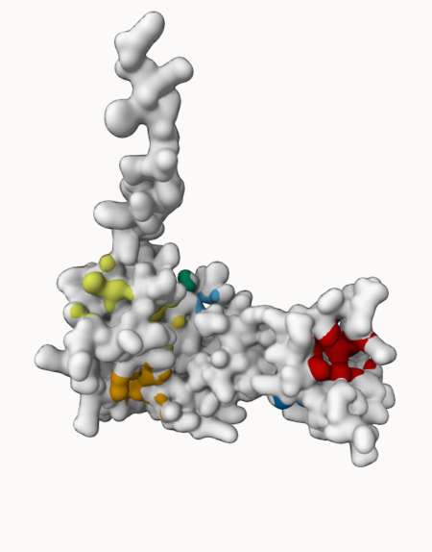
Fosp9 | >XP_031059907.1 uncharacterized protein FOIG_10132 [Fusarium odoratissimum NRRL 54006]  MLAQTIFSILAIATTGLAAPVEPRSNDHFTPSEIHTYNINNGAIYDTDEGRVTKAPTNGGNDITTLLTFKYPEAARGKQC  QFAFYLAPGENVIGSKKLDLYSSLAPAPGPRAGWGPGNQRNVHLGRMDVKVGGFATWEATYGPYMTQKTDCKKPGTVEGL  ELVGVYDLDAIYWNPAKSGPRIVIS | A30, A31, A34, A47, A48, A49, A50, A65, A67, A85, A173, A175, A176, A177, A178, A179, A180, A181 | 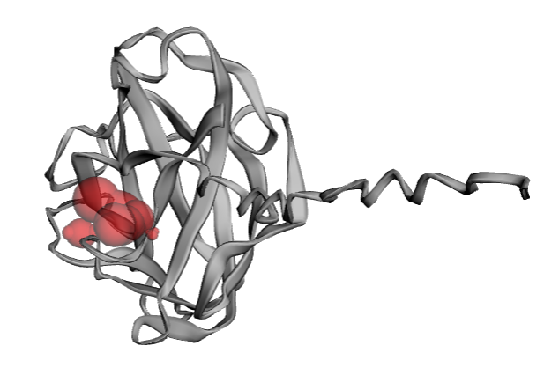
FocTR4 | >tr|A0A5C6SWE8|A0A5C6SWE8_FUSOX Cupin type-1 domain-containing protein OS=Fusarium oxysporum f. sp. cubense OX=61366 GN=FocTR4_00015351 PE=4 SV=1  MVHRNTFFKALAASLSVAPGSALPAPQMGDYGENKGPVGGVKPPTPTVTSTSGSLYGDSS  LLGGNAPLPDPDQDSAIVKDPKHVNGQAADPKLGLYLDFDGVDVPQPIRGELGATDPGPR  TYDYEKLNPDLFAPPGTDAGDVPNAMWPLGLSHNRLGSEAGAGWARQQNQDVLPAATDMA  GVDMRLAPNAYRELHWHTANEWALVTKGCLRVAAVNDEGKSFVDDLCEGDVWFFPAGIPH  SLQAFDKGVEFLLVFDQGTFSEDETFLVSELFLRNPVSVLAKNFETETTAFDNIPKDELY  IFNGTPAPKDIEKQNVTGSAGALTGNGSYTYHWSQQKPHTVPGGSVKIIDPTTFPIAKGF  SAALVVVQPGALREIHWHTTSDEWSYFLQGSGRITVFKAASSARTFDFTAGGVGYIPAAN  SHYVENTGTEDLIFLEVLQAPKFSDVSVAQWLALTPKQIVKDHLKVSDKFLDSLPKEKAF  IKTGNVNMTAIVDEP | A_204, A_205, A_206, A_228, A_229, A_333, A_334, A_338, A_345, A_347, A_364, A_366, A_388, A_433 | 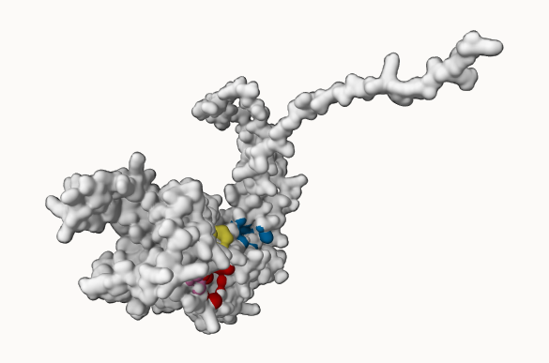

Name | Molecular formula | Molecular weight | Structure
Cordycepin | C₁₀H₁₃N₅O₃ | 251.24 g/mol | 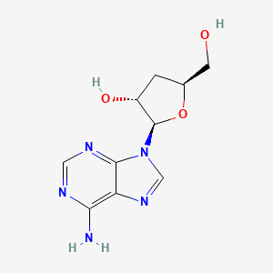
Prothioconazole | C₁₄H₁₅C_{l2}N₃OS | 344.3 g/mol | 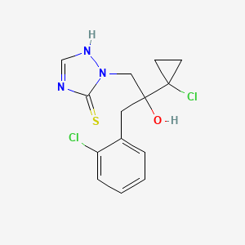
Tebuconazole | C₁₆H₂₂ClN₃O | 307.82 g/mol | 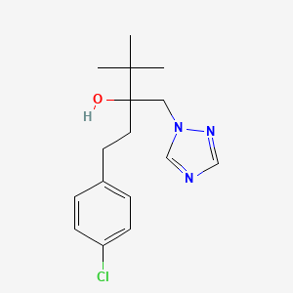
Table. 2. Structure of ligands retrieved using PubChem database

