Supporting information

Article title: Soil water regime and nutrient availability modulate fine root distribution and biomass allocation in Amazon forests with shallow water tables.

Authors: Edher Checa-Cordoba, Erick J. L. Esteban, Thaise Emilio, Demetrius Martins, Juliana Schietti, José P. V. Pinto, Javier Tomasella and Flávia R. C. Costa

The following Supporting Information is available for this article:
Figure S1. Temporal fluctuation of the water table depth for Amazonian terra-firme forests with shallow water tables.
Figure S2. Relationships between fine-root biomass distribution and rooting depth or estimated total fine-root biomass on Amazonian terra-firme forests with shallow water tables.
Figure S3. Significant effects retained in the final piecewise Structural Equation modeling (pSEM) using soil available phosphorus as a proxy for soil fertility.
Figure S4. Results of piecewise SEM modeling using soil available nitrogen and the sum of exchangeable cations content as proxies for soil fertility.
Figure S5. Soil bulk density, MCWD and WT regime index for Amazonian terra-firme forests with shallow water tables.
Table S1. Summary of piecewise structural equation model (pSEM) results when using soil nitrogen (N) as a proxy for soil fertility.
Table S2. Summary of piecewise structural equation model (pSEM) results when using the sum of exchangeable cations content as a proxy for soil fertility.
Table S3. Summary of piecewise structural equation model (pSEM) results when using soil available phosphorus (P) as a proxy for soil fertility and considering the interaction effect between WT regime and soil P.

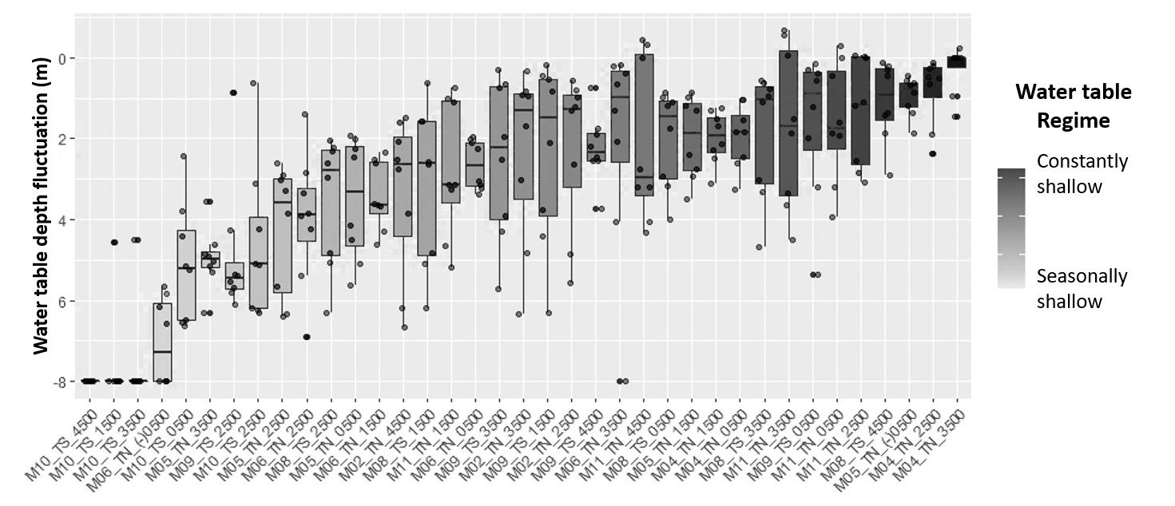
Fig. S1. Temporal fluctuation of the water table depth for Amazonian terra-firme forests with shallow water tables. High variability in WT depth, both spatially (between plots) and temporally (within each plot) was observed, with a general mean (±SD) WT depth of 3.1 ± 2.4 m across the region, and fluctuations of 3.8 ± 1.7 m and up to 5 m within some plots. Each box plot represents the temporal WT fluctuation in each of the 37 study 1-ha plots during the monitoring period, measured with 7m deep piezometers. Overall, the WT is within 7 m of soil depth, ranging from areas where the WT regime is seasonally shallow (fluctuating between 4-7m, light gray boxes) to areas where it is constantly shallow (WT within the first meters of soil depth, dark gray boxes).

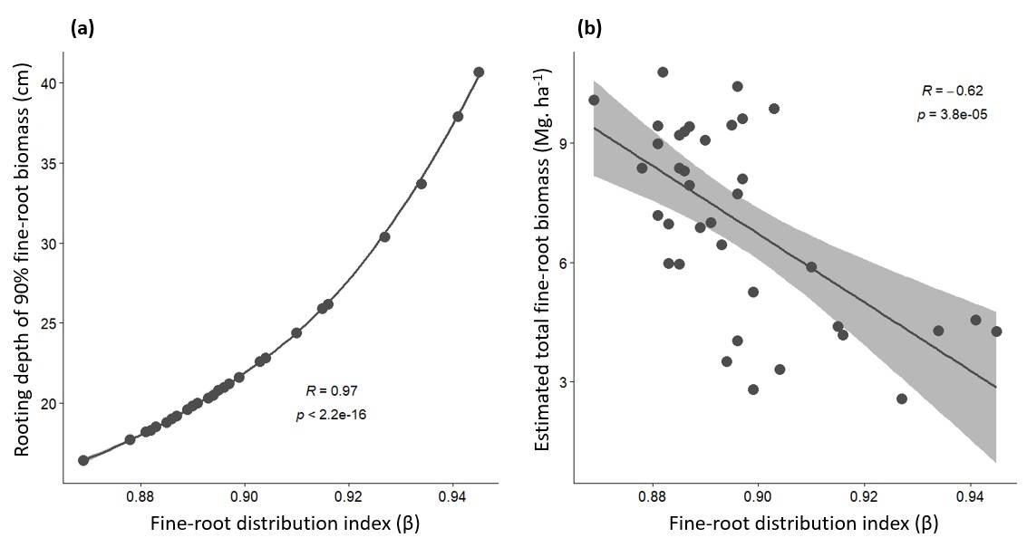

Fig. S2. Relationships between the fine-root biomass distribution with rooting depth or estimated total fine-root biomass in Amazonian terra-firme forests with shallow water tables. Plots show significant correlation effects between the index of fine-root biomass vertical distribution (β) and: (a) the soil depth (m) at which 90% of this biomass is accumulated, and (b) the total fine-root biomass stock (Mg.ha⁻¹).

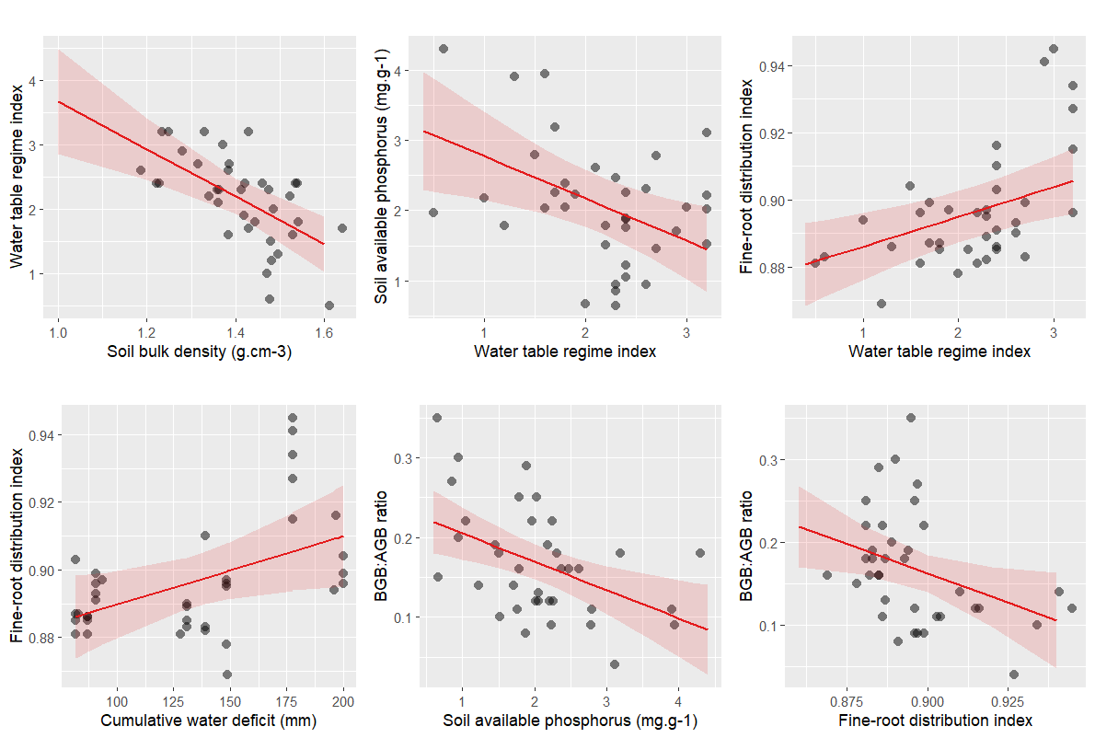

Fig. S3. Significant effects retained in the final piecewise Structural Equation modeling (pSEM) using soil available phosphorus as a proxy for soil fertility. Plots show the partial effects derived from the Structural Equation Modeling to investigate the combined effects of climate (cumulative water deficit), soil physical constraints (soil bulk density), soil fertility (available phosphorus) and water table regime on fine-root biomass distribution and biomass allocation to below- and aboveground components (BGB:AGB ratio) along Amazonian terra-firme forests with shallow water tables.

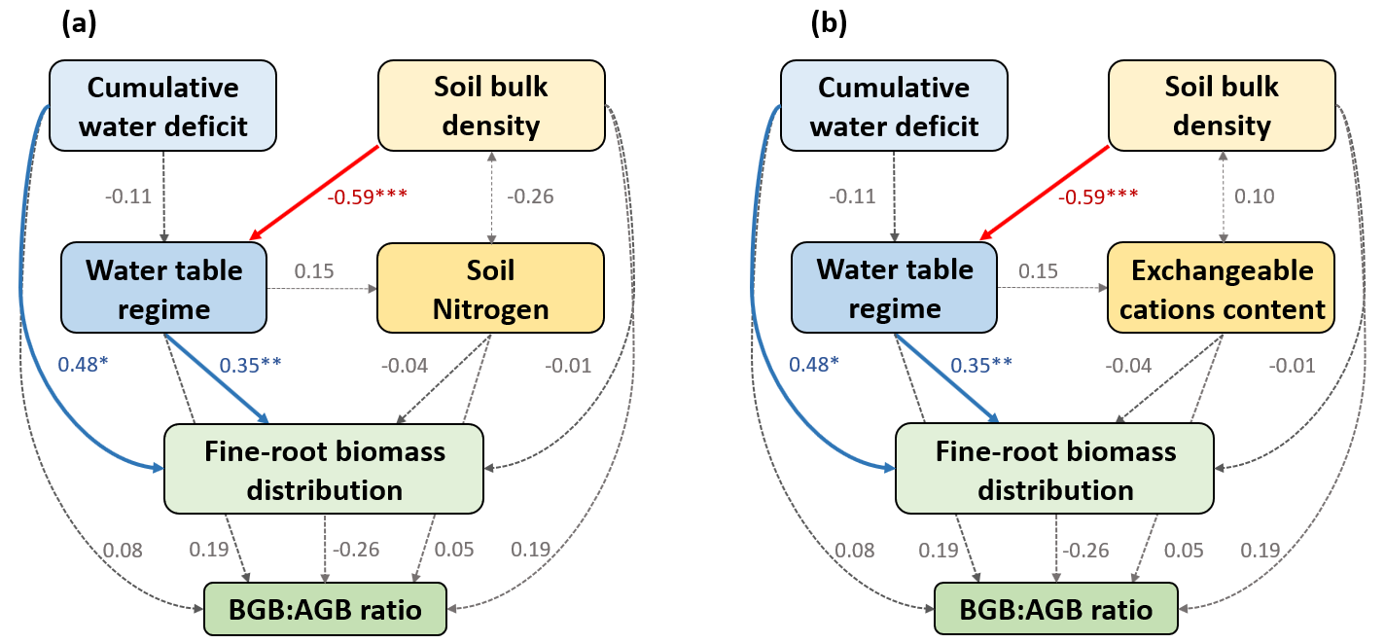

Fig. S4. Results of piecewise SEM modeling using soil available nitrogen and the sum of exchangeable cations content as proxies for soil fertility. Both pSEMs were fit to test: (i) the effect of cumulative water deficit and soil density on water table regime; (ii) the influence of water table regime on soil fertility; (iii) their combined effects on vertical fine-root biomass distribution and, (iv) the interplay of these factors in shaping biomass allocation to below- and aboveground components (BGB:AGB ratio) across Amazonian terra-firme forests characterized by predominantly shallow water table levels. Blue and red arrows denote significant positive and negative relationships, respectively. Dashed gray arrows represent paths included in the general conceptual model that were not retained as significant effects in the final model. Numbers are the standardized coefficients of determination for each predictor. (*) p<0.01, (**) p<0.005, (***) p <0.001.

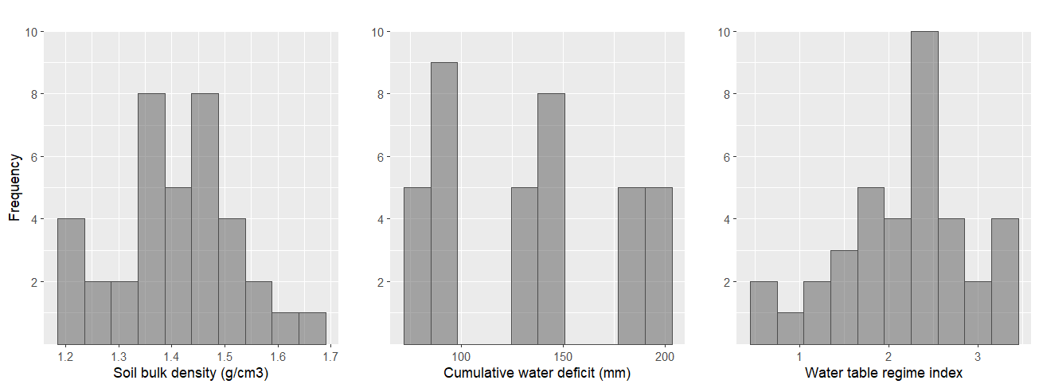
Fig. S5. Soil bulk density, MCWD and WT regime index for Amazonian terra-firme forests with shallow water tables. Frequency histograms for values of soil bulk density (g.cm⁻³), climate-related water deficit (MCWD, mm), and temporal behavior of the water table (WT regime index) across the 37 1-ha study plots. Soil bulk density ranges from low values (1.2 g.cm⁻³) to the highest value of 1.7 g.cm⁻³, with most plots having soil densities between 1.4-1.6 g.cm⁻³. MCWD varies from values <100 mm, meaning low levels of climate-related water deficit, up to a cumulative of 200 mm water deficit, indicating areas exposed to moderate dry periods. The WT regime index varied across plots from low values (0.5) representing areas where the WT remains constantly very shallow along the year, up to higher values (3.2) indicating more seasonally shallow WT levels.

Table S1. Summary of piecewise structural equation model (pSEM) results when using soil nitrogen (N) as a proxy for soil fertility. In the table, Std. est denotes the standardized estimation values for each predictor; P is the probability p-value, with values in bold indicating significant effects; R²_{m} is the fixed-effects coefficient of determination, representing the proportion of the variance for a response variable explained by all fixed effects included in the model; R²_{c} is the conditional-effect coefficient of determination, representing the proportion of the variance explained by the random effects included in the model. Model fit statistics Fisher’s C, AIC (Akaike information criteria) and P (p-value) are also shown.

Path | Response | Std. est | P | R²_{m} | R²_{c}
Predictor
Cumulative water deficit | WT regime | -0.11 | 0.616
Soil bulk density | WT regime | -0.59 | <0.001 | 0.35 | 0.54
WT regime | Soil N | 0.15 | 0.406 | 0.02 | 0.07
Cumulative water deficit | Fine-root distribution | 0.48 | 0.038
Soil bulk density | Fine-root distribution | -0.01 | 0.929
WT regime | Fine-root distribution | 0.35 | 0.003
Soil N | Fine-root distribution | -0.04 | 0.696 | 0.41 | 0.75
Cumulative water deficit | BGB:AGB ratio | 0.08 | 0.792
Soil bulk density | BGB:AGB ratio | 0.19 | 0.459
WT regime | BGB:AGB ratio | 0.19 | 0.453
Soil N | BGB:AGB ratio | 0.05 | 0.758
Fine-root distribution | BGB:AGB ratio | -0.26 | 0.348 | 0.05 | 0.35
Correlation
Soil bulk density | Soil N | -0.26 | 0.06
Fisher’s C |  | 3.99
AIC |  | -363.71
P |  | 0.996

Table S2. Summary of piecewise structural equation model (pSEM) results when using the sum of exchangeable cations content (SEC) as a proxy for soil fertility. In the table, Std. est denotes the standardized estimation values for each predictor; P is the probability p-value, with values in bold indicating significant effects; R²_{m} is the fixed-effects coefficient of determination, representing the proportion of the variance for a response variable explained by all fixed effects included in the model; R²_{c} is the conditional-effect coefficient of determination, representing the proportion of the variance explained by the random effects included in the model. Model fit statistics Fisher’s C, AIC (Akaike information criteria) and P (p-value) are also shown.

Path | Response | Std. est | P | R²_{m} | R²_{c}
Predictor
Cumulative water deficit | WT regime | -0.11 | 0.616
Soil bulk density | WT regime | -0.59 | <0.001 | 0.35 | 0.54
WT regime | Soil SEC | 0.15 | 0.406 | 0.02 | 0.07
Cumulative water deficit | Fine-root distribution | 0.48 | 0.038
Soil bulk density | Fine-root distribution | -0.01 | 0.929
WT regime | Fine-root distribution | 0.35 | 0.003
Soil SEC | Fine-root distribution | -0.04 | 0.696 | 0.41 | 0.75
Cumulative water deficit | BGB:AGB ratio | 0.08 | 0.792
Soil bulk density | BGB:AGB ratio | 0.19 | 0.459
WT regime | BGB:AGB ratio | 0.19 | 0.453
Soil SEC | BGB:AGB ratio | 0.05 | 0.758
Fine-root distribution | BGB:AGB ratio | -0.26 | 0.348 | 0.05 | 0.35
Correlation
Soil bulk density | Soil SEC | 0.10 | 0.28
Fisher’s C |  | 5.96
AIC |  | -322.75
P |  | 0.968

Table S3. Summary of piecewise structural equation model (pSEM) results when using soil available phosphorus (P) as a proxy for soil fertility and considering the interaction effect between WT regime and soil P. In the table, Std. est denotes the standardized estimation values for each predictor; P is the probability p-value, with values in bold indicating significant effects; R²_{m} is the fixed-effects coefficient of determination, representing the proportion of the variance for a response variable explained by all fixed effects included in the model; R²_{c} is the conditional-effect coefficient of determination, representing the proportion of the variance explained by the random effects included in the model. Model fit statistics Fisher’s C, AIC (Akaike information criteria) and P (p-value) are also shown.

Path | Response | Std. est | P | R²_{m} | R²_{c}
Predictor
Cumulative water deficit | WT regime | -0.11 | 0.616
Soil bulk density | WT regime | -0.59 | <0.001 | 0.35 | 0.54
WT regime | Soil available P | -0.52 | 0.004 | 0.23 | 0.46
Cumulative water deficit | Fine-root distribution | 0.48 | 0.038
Soil bulk density | Fine-root distribution | 0.01 | 0.961
WT regime | Fine-root distribution | 0.35 | 0.003
Soil available P | Fine-root distribution | -0.02 | 0.859 | 0.41 | 0.75
Cumulative water deficit | BGB:AGB ratio | 0.16 | 0.368
Soil bulk density | BGB:AGB ratio | 0.11 | 0.552
WT regime | BGB:AGB ratio | 0.48 | 0.234
Soil available P | BGB:AGB ratio | 0.16 | 0.665
Fine-root distribution | BGB:AGB ratio | -0.27 | 0.121
WT regime* Soil available P | BGB:AGB ratio | -0.83 | 0.041 | 0.44 | 0.44
Correlation
Soil bulk density | Soil available P | -0.12 | 0.234
Fisher’s C |  | 7.02
AIC |  | -104.23
P |  | 0.934

