Microbiome Diversity Variation in Industrial Hemp Genotypes
Waqar Ahmad^{1,3+}, Lauryn Coffman¹⁺, Ram Ray², Venkatesh Balan¹, Aruna Weerasooriya^{2*}, Abdul Latif Khan^{1,3}*
¹Department of Engineering Technology, College of Technology, University of Houston, Sugarland, TX, USA
²Cooperative Agricultural Research Center, College of Agriculture & Human Sciences, Prairie View A&M University, Prairie View, TX, USA
³Department of Biology and Biochemistry, College of Natural Science & Mathematics, University of Houston, Houston, TX, USA

*Corresponding authors:
Abdul Latif Khan; alkhan@uh.edu
Aruna Weerasooriya; adweerasooriya@PVAMU.EDU
⁺The authors contributed equally to this work.

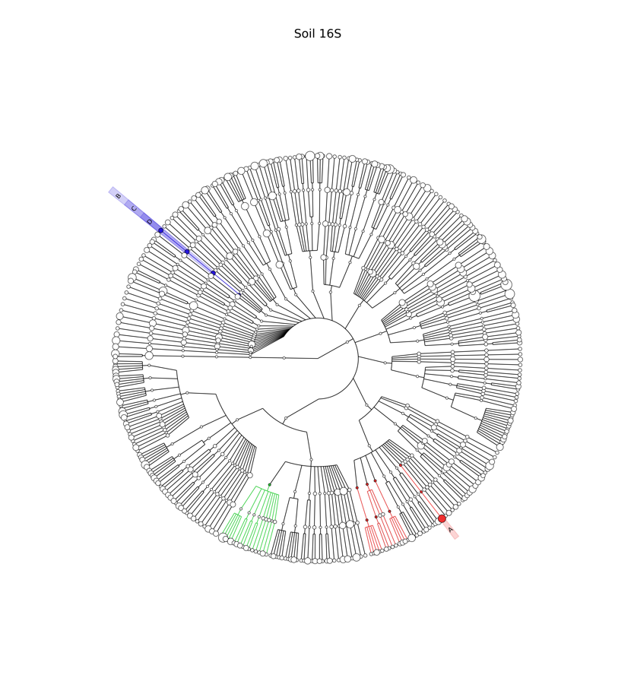
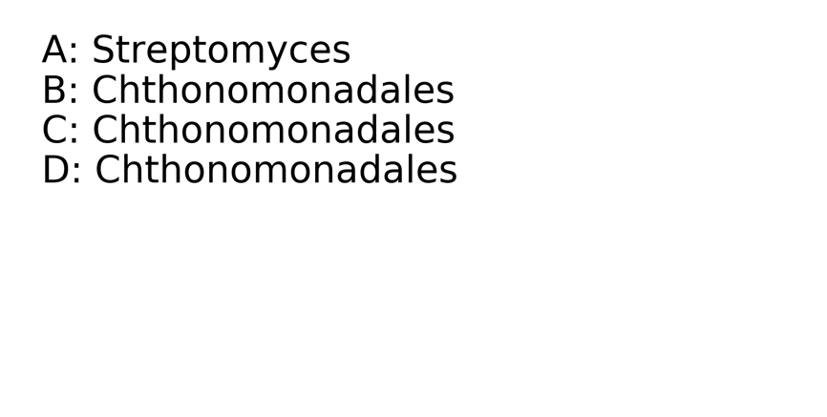

Supplementary Figure S1. Cladogram of Soil –bacteria
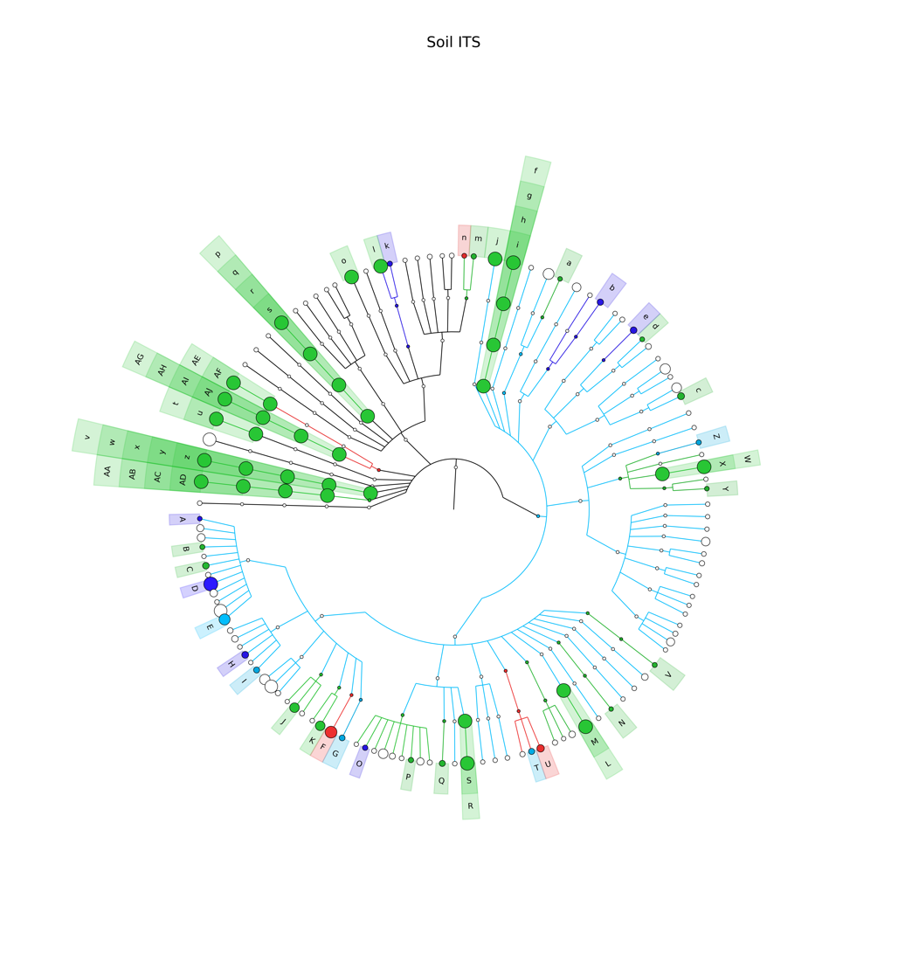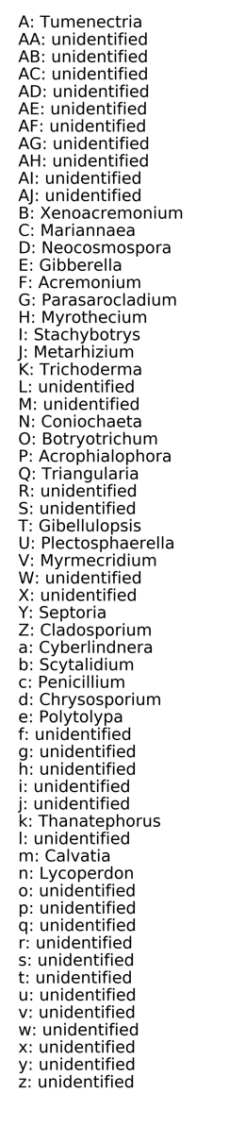
Supplementary Figure S2. Cladogram of Soil –Fungi

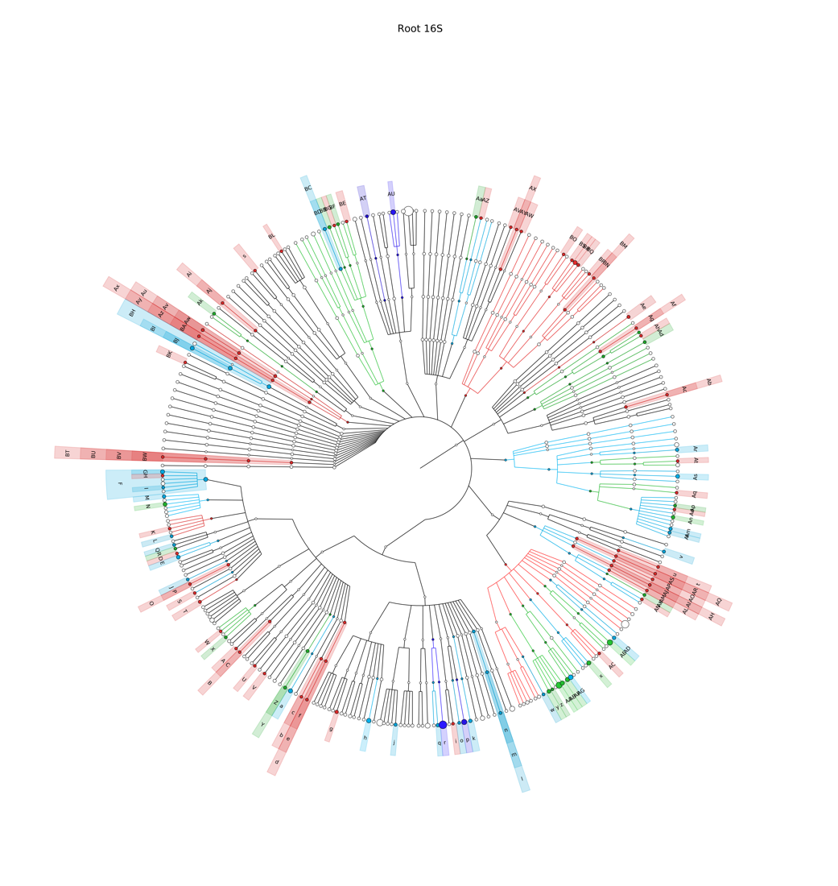
Supplementary Figure 3: Cladogram of Root and bacterial biome distribution.

