Supplement Hot and fresh: evidence of climate-related suboptimal conditions for seagrass in a large Gulf coast estuary
Marcus W Beck^{1,✉}, Kerry Flaherty-Walia¹, Sheila Scolaro¹, Maya C Burke¹, Bradley T Furman², David J Karlen³, Christopher Pratt³, Christopher J Anastasiou⁴, and Edward T Sherwood¹
¹ Tampa Bay Estuary Program, 263 13th Ave S., Suite 350, St. Petersburg, Florida 33701 USA
² Florida Fish and Wildlife Conservation Commission, Florida Fish and Wildlife Research Institute, 100 8th Avenue SE, St. Petersburg, FL 33701, USA
³ Environmental Protection Commission of Hillsborough County, 3629 Queen Palm Drive, Tampa, FL 33619, USA
⁴ Southwest Florida Water Management District, 7601 US Highway 301 North, Tampa, FL 33637, USA
✉ Correspondence: Marcus W Beck <mbeck@tbep.org>

Figures
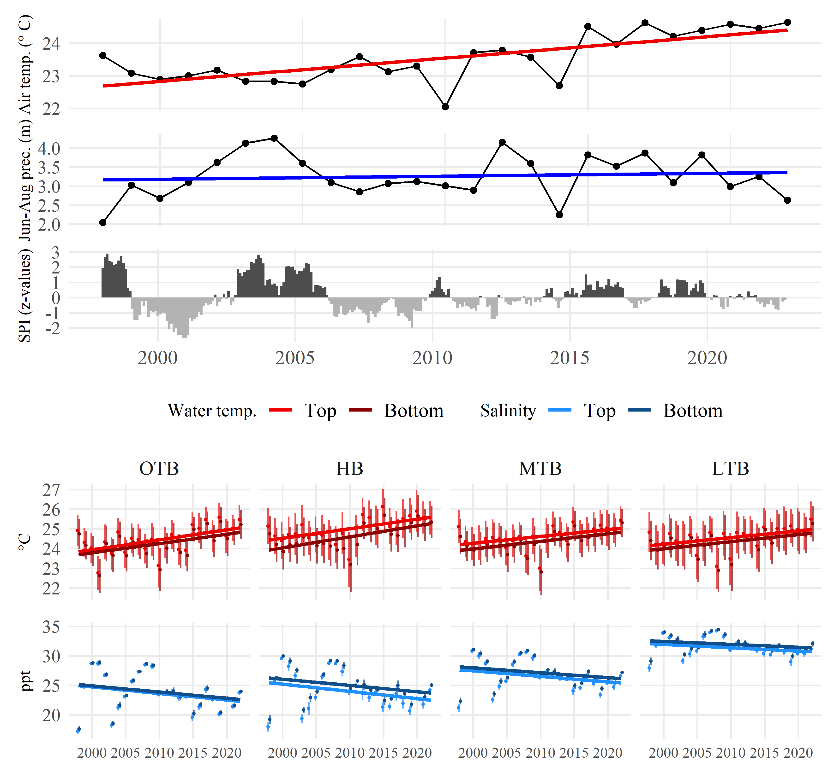
Fig. S1: Air temperature, precipitation (Jun-Aug), Standard Precipitation Index (SPI), water temperature, and salinity trends from 1998 to 2022. The color shades for water temperature and salinity indicate sampling location and values shown are the averages (95% confidence interval) across all Environmental Protection Commission (EPC) stations in each bay segment and sampling months for each year. OTB: Old Tampa Bay, HB: Hillsborough Bay, MTB: Middle Tampa Bay, LTB: Lower Tampa Bay.

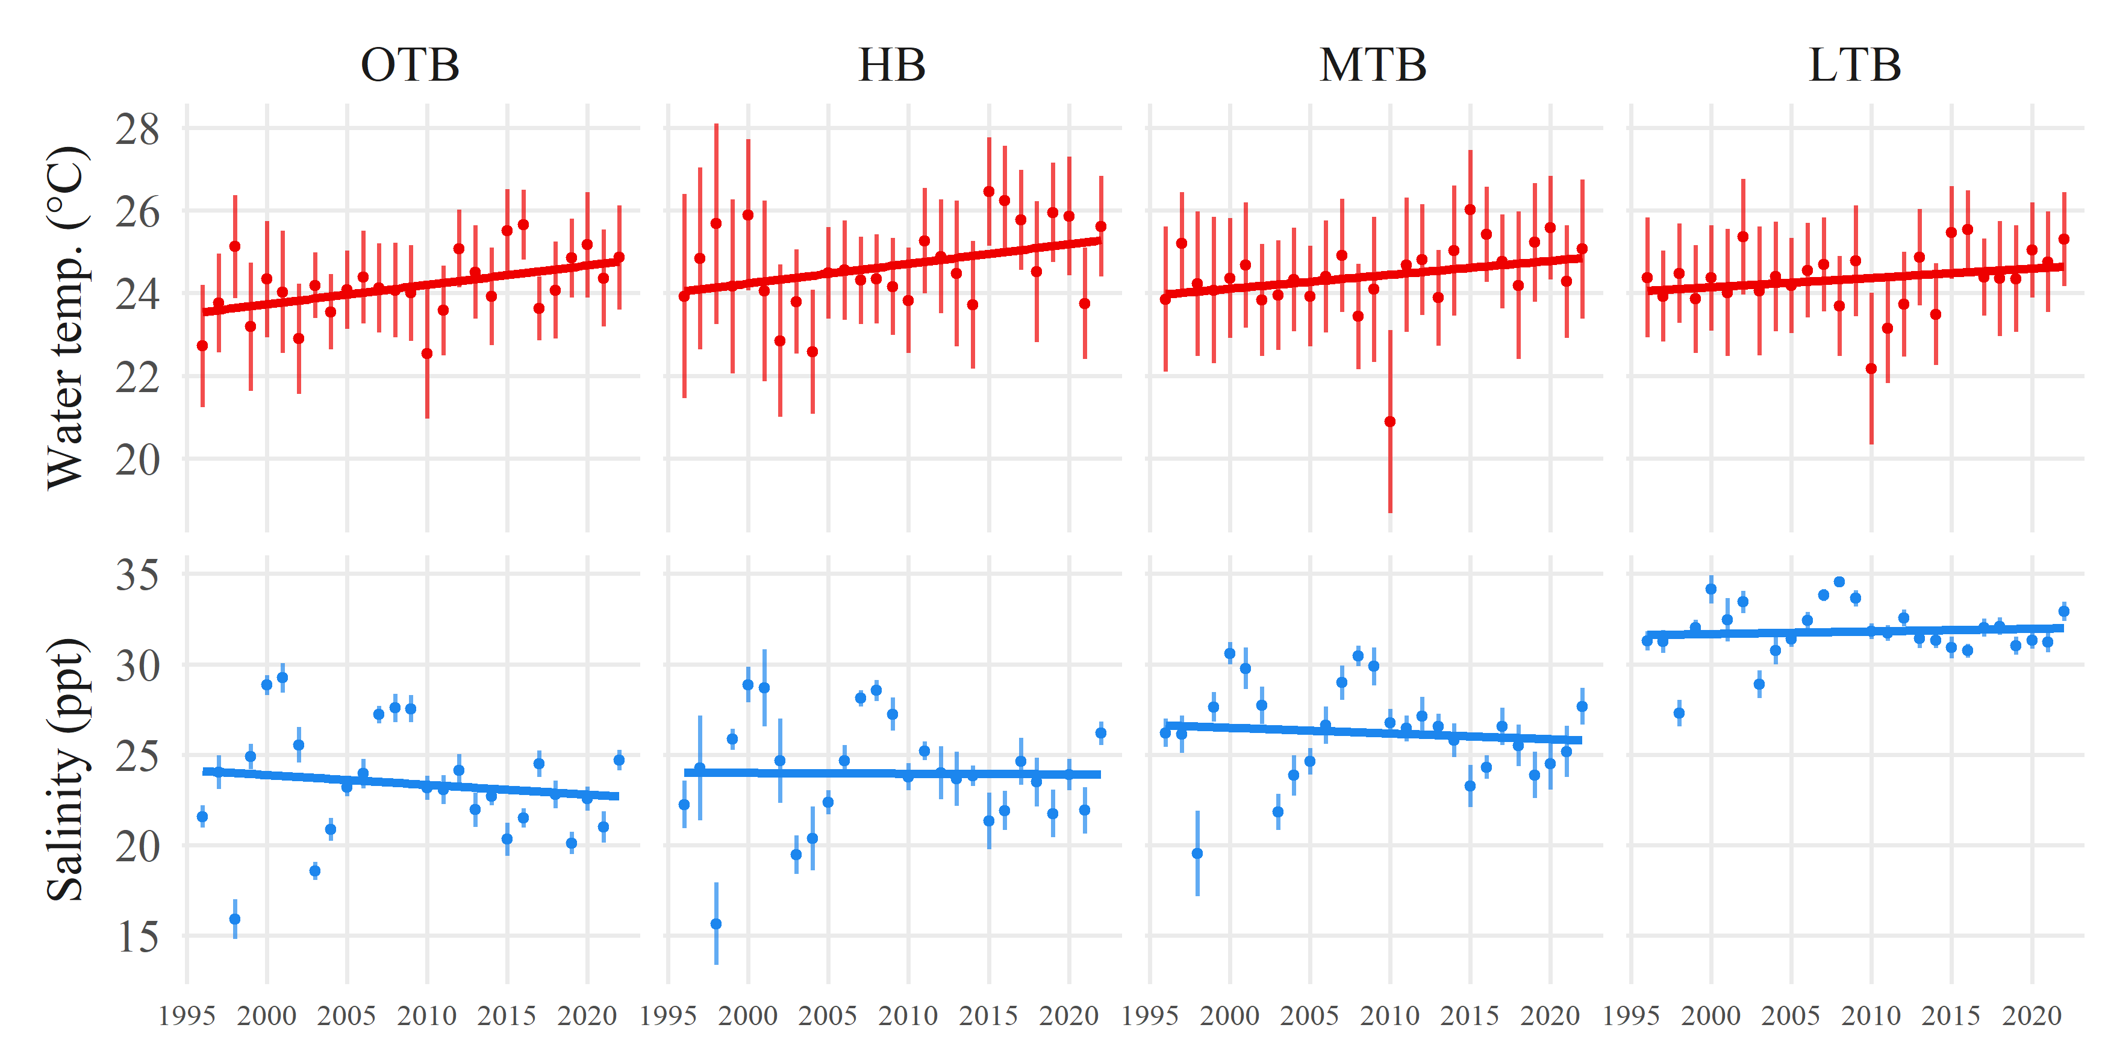
Fig. S2: Bottom water temperature and salinity trends from 1996 to 2021 for stations from the Fisheries Independent Monitoring program. Points show the average (95% confidence interval) across all stations in each bay segment and sampling months for each year. OTB: Old Tampa Bay, HB: Hillsborough Bay, MTB: Middle Tampa Bay, LTB: Lower Tampa Bay.

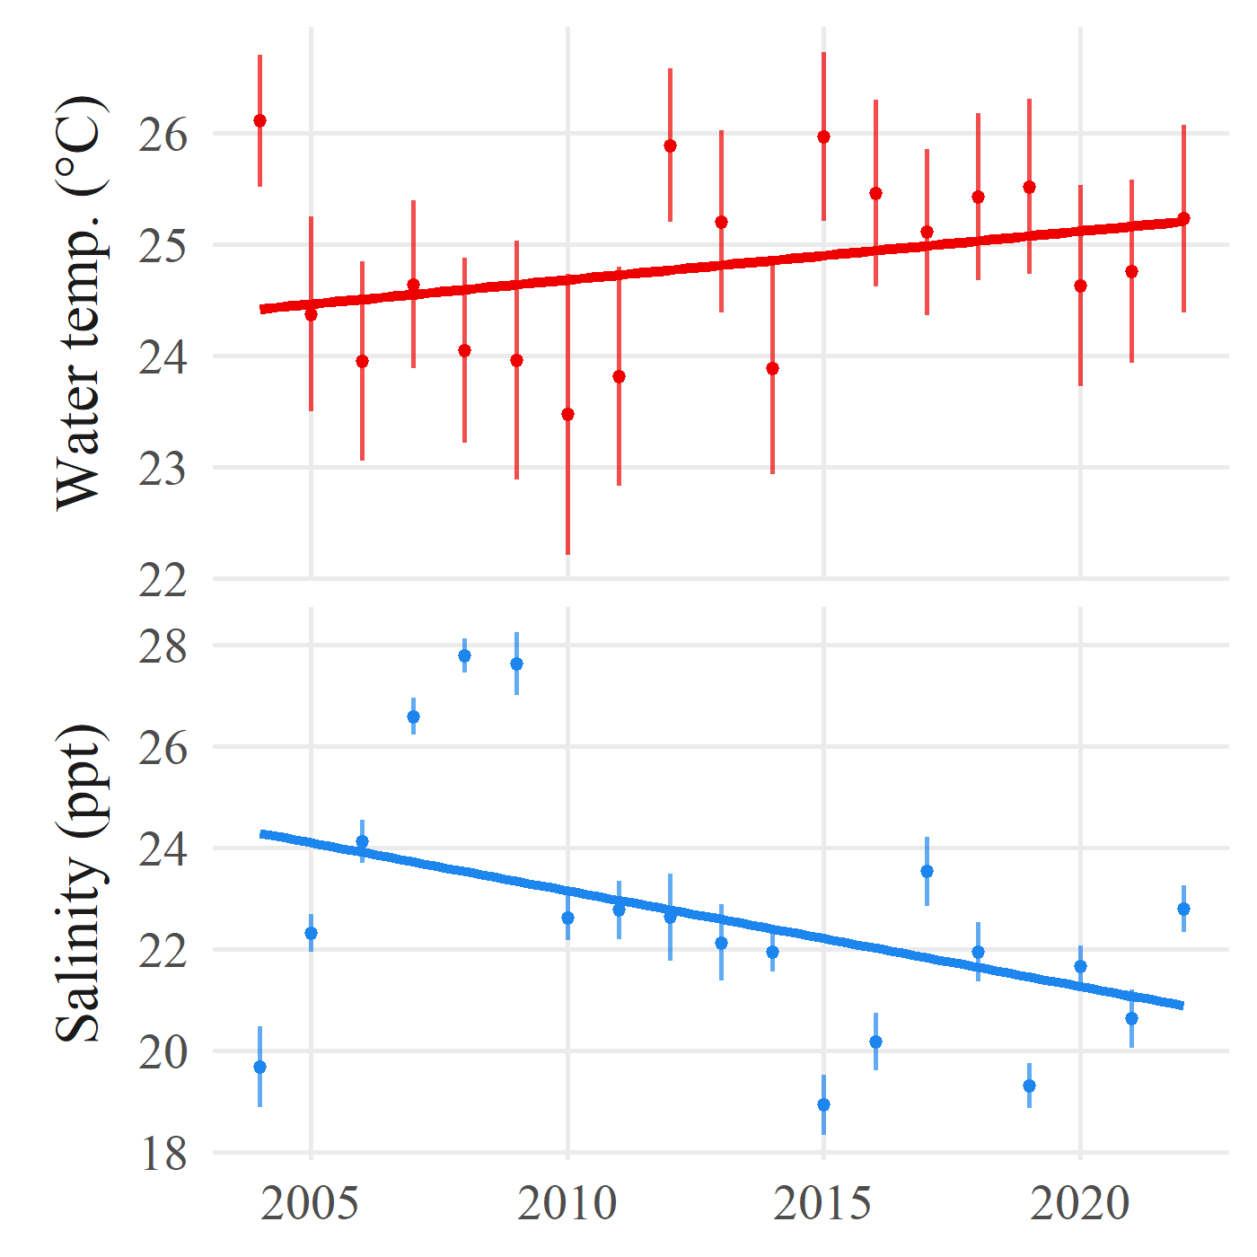
Fig. S3: Bottom water temperature and salinity trends from 2004 to 2022 for stations from the Pinellas County Department of Environmental Management in Old Tampa Bay. Points show the average (95% confidence interval) across all stations in each bay segment and sampling months for each year.

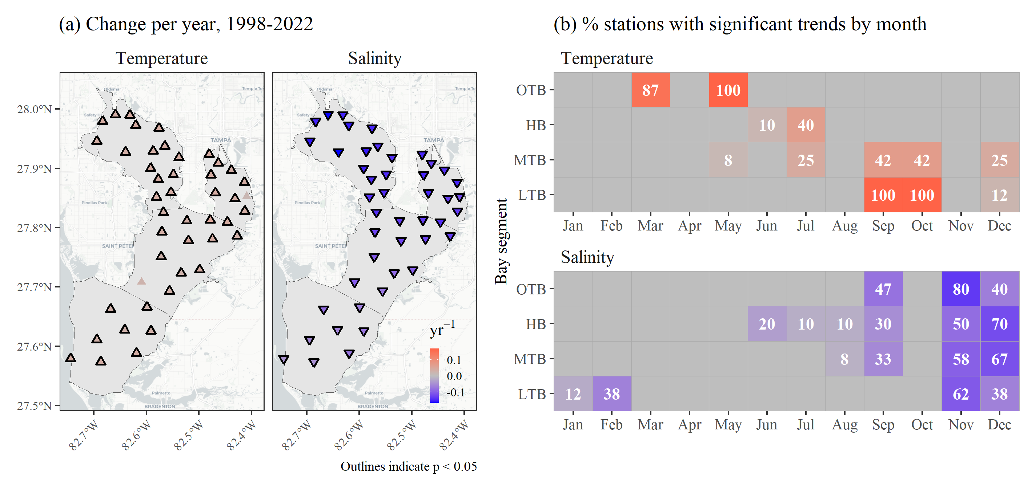
Fig. S4: Trends from 1998 to 2022 for temperature and salinity measurements at long-term monitoring stations in Tampa Bay. Results for seasonal Kendall tests by station and monitoring location (top or bottom of the water column) are shown in (a) with color and shape corresponding to the estimated annual slope as change per year (yr$​^{-1}$). Summarized seasonal trends by month are shown for (b) top and (c) bottom measurements as the percent of stations in each bay segment with significant increasing (temperature) or decreasing (salinity) trends. Bay segment outlines are shown in (a); OTB: Old Tampa Bay, HB: Hillsborough Bay, MTB: Middle Tampa Bay, LTB: Lower Tampa Bay.

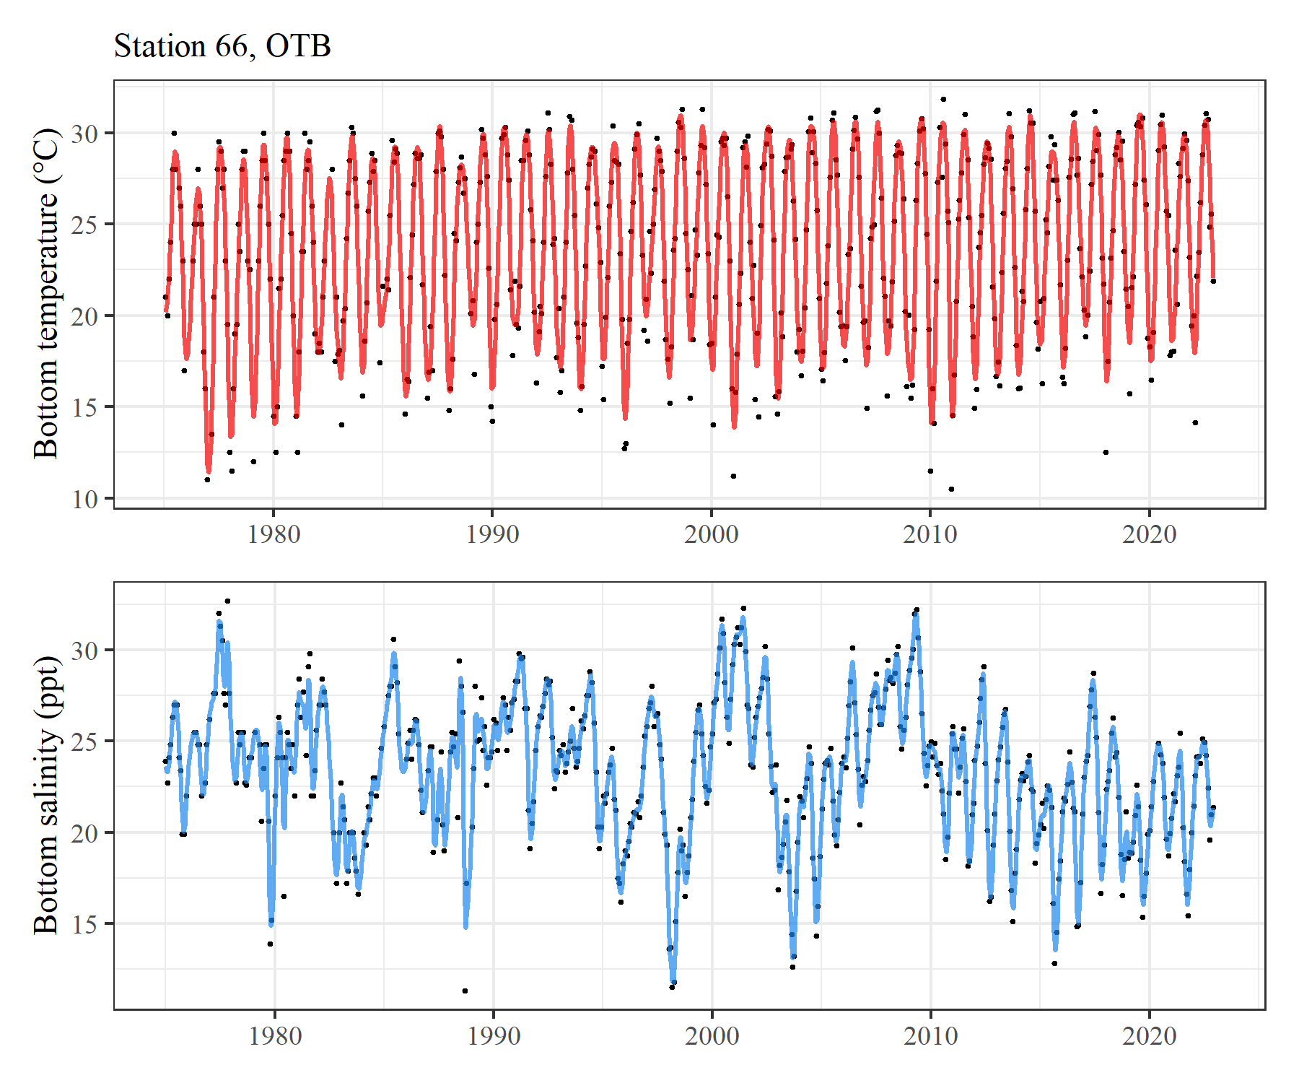
Fig. S5: Examples of Generalized Additive Models of bottom water temperature and salinity for station 66 in Old Tampa Bay. Models were fit using a continuous smoothing spline for decimal year. Monthly observations are shown as points and daily predictions from the models as lines.

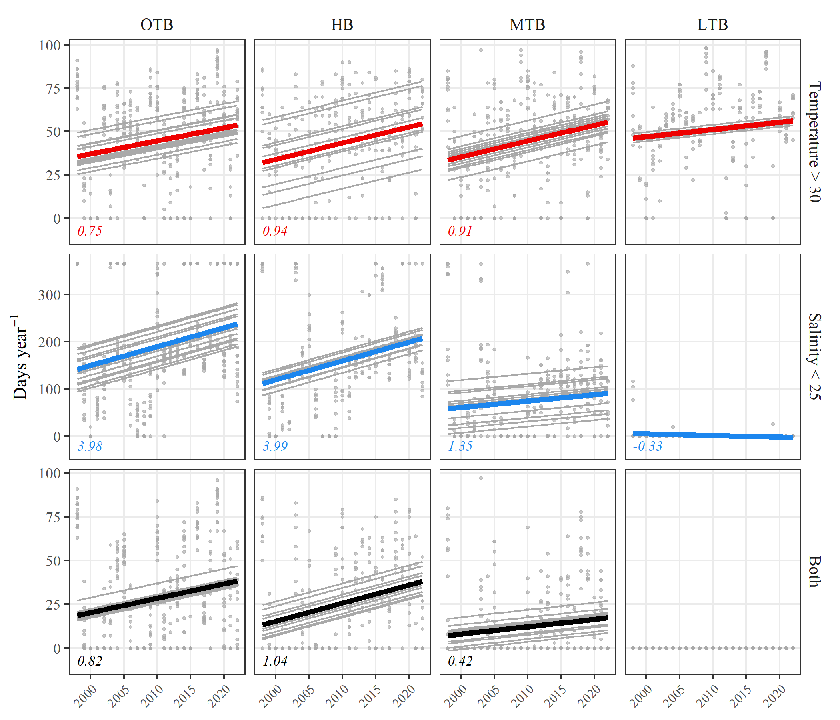
Fig. S6: Example of mixed effects models for the estimated number of days per year that temperature (red) or salinity (blue) were above or below thresholds of 30 $​^{∘}$C or 25 psu, respectively, from 1988 to 2022. The bottom row (black) shows the number of days when both temperature was above and salinity was below the thresholds. The models included station as a random effect for each bay segment, with grey lines indicating individual station trends, grey points as actual number of days, and thicker lines indicating the overall model fit. Slopes for significant models are shown in the bottom left of each facet. OTB: Old Tampa Bay, HB: Hillsborough Bay, MTB: Middle Tampa Bay, LTB: Lower Tampa Bay.

Tables
Table S1: Summary statistics for Generalized Additive Model fits to bottom water temperature data at all stations in Tampa Bay monitored by the Environmental Protection Commission of Hillsborough County. Models were fit on monthly data from 1975 to 2022 using decimal year as the single predictor. Fit statistics are Akaike Information Criterion (AIC), Generalized Cross-Validation (GCV) scores, and R-squared values of observed to predicted. OTB: Old Tampa Bay, HB: Hillsborough Bay, MTB: Middle Tampa Bay, LTB: Lower Tampa Bay.
Bay Segment | Station | Lon | Lat | AIC | GCV | R$​^{2}$
OTB | 36 | -82.553 | 27.856 | 2153 | 3.74 | 0.92
 | 38 | -82.577 | 27.882 | 2206 | 4.16 | 0.91
 | 40 | -82.587 | 27.929 | 2177 | 3.83 | 0.92
 | 41 | -82.565 | 27.937 | 2282 | 4.69 | 0.90
 | 46 | -82.659 | 27.990 | 2298 | 6.02 | 0.87
 | 47 | -82.620 | 27.973 | 2243 | 4.28 | 0.91
 | 50 | -82.538 | 27.919 | 2246 | 4.56 | 0.90
 | 51 | -82.549 | 27.890 | 2073 | 3.87 | 0.91
 | 60 | -82.632 | 27.990 | 1937 | 5.51 | 0.88
 | 63 | -82.576 | 27.968 | 2231 | 5.31 | 0.89
 | 64 | -82.683 | 27.979 | 1110 | 5.49 | 0.90
 | 65 | -82.694 | 27.946 | 2110 | 5.03 | 0.88
 | 66 | -82.640 | 27.928 | 2207 | 4.18 | 0.91
 | 67 | -82.592 | 27.900 | 2274 | 4.52 | 0.90
 | 68 | -82.581 | 27.852 | 2185 | 3.98 | 0.92
HB | 6 | -82.477 | 27.889 | 2348 | 4.85 | 0.89
 | 7 | -82.469 | 27.859 | 2275 | 4.30 | 0.90
 | 8 | -82.409 | 27.852 | 1288 | 4.49 | 0.90
 | 44 | -82.481 | 27.924 | 1520 | 5.46 | 0.88
 | 52 | -82.438 | 27.897 | 2241 | 4.13 | 0.91
 | 55 | -82.431 | 27.849 | 2260 | 4.20 | 0.91
 | 70 | -82.463 | 27.909 | 1545 | 4.23 | 0.90
 | 71 | -82.414 | 27.876 | 2379 | 5.06 | 0.88
 | 73 | -82.413 | 27.828 | 2318 | 5.05 | 0.89
 | 80 | -82.446 | 27.810 | 2229 | 4.15 | 0.91
MTB | 9 | -82.427 | 27.787 | 2503 | 6.22 | 0.85
 | 11 | -82.479 | 27.813 | 2217 | 4.53 | 0.90
 | 13 | -82.523 | 27.812 | 2032 | 3.09 | 0.94
 | 14 | -82.520 | 27.778 | 2193 | 3.74 | 0.92
 | 16 | -82.534 | 27.724 | 2074 | 3.39 | 0.94
 | 19 | -82.556 | 27.693 | 2039 | 3.25 | 0.94
 | 28 | -82.609 | 27.708 | 1989 | 3.25 | 0.94
 | 32 | -82.571 | 27.793 | 2015 | 3.07 | 0.94
 | 33 | -82.567 | 27.826 | 2091 | 3.43 | 0.93
 | 81 | -82.474 | 27.781 | 2204 | 3.85 | 0.91
 | 82 | -82.572 | 27.751 | 1958 | 3.17 | 0.94
 | 84 | -82.499 | 27.729 | 2080 | 4.45 | 0.90
LTB | 23 | -82.599 | 27.666 | 1978 | 3.04 | 0.95
 | 24 | -82.619 | 27.588 | 2380 | 5.19 | 0.89
 | 25 | -82.668 | 27.663 | 2188 | 4.37 | 0.91
 | 90 | -82.591 | 27.626 | 2109 | 3.49 | 0.93
 | 91 | -82.642 | 27.628 | 2019 | 3.18 | 0.94
 | 92 | -82.687 | 27.574 | 2065 | 3.35 | 0.94
 | 93 | -82.744 | 27.579 | 2038 | 3.29 | 0.94
 | 95 | -82.695 | 27.611 | 2042 | 3.29 | 0.94

Table S2: Summary statistics for Generalized Additive Model fits to bottom salinity data at all stations in Tampa Bay monitored by the Environmental Protection Commission of Hillsborough County. Models were fit on monthly data from 1975 to 2022 using decimal year as the single predictor. Fit statistics are Akaike Information Criterion (AIC), Generalized Cross-Validation (GCV) scores, and R-squared values of observed to predicted. OTB: Old Tampa Bay, HB: Hillsborough Bay, MTB: Middle Tampa Bay, LTB: Lower Tampa Bay.
Bay Segment | Station | Lon | Lat | AIC | GCV | R$​^{2}$
OTB | 36 | -82.553 | 27.856 | 1645 | 2.07 | 0.92
 | 38 | -82.577 | 27.882 | 1602 | 1.88 | 0.94
 | 40 | -82.587 | 27.929 | 1571 | 1.75 | 0.94
 | 41 | -82.565 | 27.937 | 1640 | 1.92 | 0.93
 | 46 | -82.659 | 27.990 | 1590 | 2.18 | 0.94
 | 47 | -82.620 | 27.973 | 1616 | 1.81 | 0.94
 | 50 | -82.538 | 27.919 | 1601 | 1.92 | 0.93
 | 51 | -82.549 | 27.890 | 1526 | 1.84 | 0.93
 | 60 | -82.632 | 27.990 | 1339 | 2.05 | 0.95
 | 63 | -82.576 | 27.968 | 1572 | 2.02 | 0.94
 | 64 | -82.683 | 27.979 | 1114 | 5.70 | 0.89
 | 65 | -82.694 | 27.946 | 1404 | 1.75 | 0.95
 | 66 | -82.640 | 27.928 | 1600 | 2.00 | 0.94
 | 67 | -82.592 | 27.900 | 1550 | 1.77 | 0.94
 | 68 | -82.581 | 27.852 | 1725 | 2.22 | 0.91
HB | 6 | -82.477 | 27.889 | 2091 | 4.36 | 0.86
 | 7 | -82.469 | 27.859 | 2088 | 4.03 | 0.85
 | 8 | -82.409 | 27.852 | 1446 | 6.74 | 0.82
 | 44 | -82.481 | 27.924 | 1482 | 6.68 | 0.89
 | 52 | -82.438 | 27.897 | 1809 | 2.66 | 0.89
 | 55 | -82.431 | 27.849 | 2026 | 3.33 | 0.82
 | 70 | -82.463 | 27.909 | 1567 | 5.01 | 0.87
 | 71 | -82.414 | 27.876 | 1980 | 3.54 | 0.87
 | 73 | -82.413 | 27.828 | 1895 | 3.35 | 0.87
 | 80 | -82.446 | 27.810 | 1847 | 2.89 | 0.88
MTB | 9 | -82.427 | 27.787 | 1778 | 2.50 | 0.89
 | 11 | -82.479 | 27.813 | 2344 | 5.31 | 0.68
 | 13 | -82.523 | 27.812 | 1702 | 2.34 | 0.90
 | 14 | -82.520 | 27.778 | 1750 | 2.25 | 0.88
 | 16 | -82.534 | 27.724 | 1553 | 2.60 | 0.90
 | 19 | -82.556 | 27.693 | 1954 | 2.83 | 0.79
 | 28 | -82.609 | 27.708 | 2031 | 3.61 | 0.82
 | 32 | -82.571 | 27.793 | 1789 | 2.49 | 0.87
 | 33 | -82.567 | 27.826 | 1630 | 2.06 | 0.92
 | 81 | -82.474 | 27.781 | 1920 | 2.93 | 0.85
 | 82 | -82.572 | 27.751 | 1409 | 2.31 | 0.94
 | 84 | -82.499 | 27.729 | 1568 | 2.68 | 0.90
LTB | 23 | -82.599 | 27.666 | 1792 | 2.43 | 0.82
 | 24 | -82.619 | 27.588 | 1885 | 2.85 | 0.81
 | 25 | -82.668 | 27.663 | 1898 | 2.75 | 0.78
 | 90 | -82.591 | 27.626 | 2010 | 2.91 | 0.75
 | 91 | -82.642 | 27.628 | 1933 | 2.75 | 0.73
 | 92 | -82.687 | 27.574 | 1859 | 2.25 | 0.73
 | 93 | -82.744 | 27.579 | 1839 | 2.04 | 0.66
 | 95 | -82.695 | 27.611 | 1757 | 1.94 | 0.74

Table S3: Summary of mixed-effects models evaluating increases in the number of days each year from 1975 to 2022 when temperature or salinity were above or below critical thresholds, respectively. The slope estimates in the “Both” column indicate trends in the number of days when both temperature and salinity were above or below critical thresholds. ** p < 0.005, * p < 0.05, - no model. OTB: Old Tampa Bay, HB: Hillsborough Bay, MTB: Middle Tampa Bay, LTB: Lower Tampa Bay.
 | Thresholds |  | Slopes
Bay Segment | Temperature | Salinity | Temperature | Salinity | Both
OTB
 | 29 | 15 | 1.47** | 0.07 | 0.02
 | 29 | 20 | 1.47** | 1.01** | 0.49**
 | 29 | 25 | 1.47** | 1.83** | 1.44**
 | 30 | 15 | 1.05** | 0.07 | -0.01
 | 30 | 20 | 1.05** | 1.01** | 0.15**
 | 30 | 25 | 1.05** | 1.83** | 0.81**
 | 31 | 15 | 0.13* | 0.07 | -0.01
 | 31 | 20 | 0.13* | 1.01** | -0.01
 | 31 | 25 | 0.13* | 1.83** | 0.08
HB
 | 29 | 15 | 1.15** | 0.05 | 0.04*
 | 29 | 20 | 1.15** | 0.37** | 0.43**
 | 29 | 25 | 1.15** | 0.8* | 1.13**
 | 30 | 15 | 0.99** | 0.05 | 0.02*
 | 30 | 20 | 0.99** | 0.37** | 0.21**
 | 30 | 25 | 0.99** | 0.8* | 0.76**
 | 31 | 15 | 0.18** | 0.05 | -
 | 31 | 20 | 0.18** | 0.37** | -
 | 31 | 25 | 0.18** | 0.8* | 0.09**
MTB
 | 29 | 15 | 1.33** | -0.01* | -
 | 29 | 20 | 1.33** | -0.01 | 0.05*
 | 29 | 25 | 1.33** | 0.53* | 0.71**
 | 30 | 15 | 1.06** | -0.01* | -
 | 30 | 20 | 1.06** | -0.01 | 0.01
 | 30 | 25 | 1.06** | 0.53* | 0.37**
 | 31 | 15 | 0.14** | -0.01* | -
 | 31 | 20 | 0.14** | -0.01 | -
 | 31 | 25 | 0.14** | 0.53* | 0.03*
LTB
 | 29 | 15 | 1.14** | 0 | -
 | 29 | 20 | 1.14** | -0.01* | -
 | 29 | 25 | 1.14** | -0.09* | 0
 | 30 | 15 | 0.97** | 0 | -
 | 30 | 20 | 0.97** | -0.01* | -
 | 30 | 25 | 0.97** | -0.09* | -
 | 31 | 15 | 0.23** | 0 | -
 | 31 | 20 | 0.23** | -0.01* | -
 | 31 | 25 | 0.23** | -0.09* | -

Table S4: Summary of mixed-effects models evaluating increases in the number of days each year from 1998 to 2022 when temperature or salinity were above or below critical thresholds, respectively. The slope estimates in the “Both” column indicate trends in the number of days when both temperature and salinity were above or below critical thresholds. ** p < 0.005, * p < 0.05, - no model. OTB: Old Tampa Bay, HB: Hillsborough Bay, MTB: Middle Tampa Bay, LTB: Lower Tampa Bay.
 | Thresholds |  | Slopes
Bay Segment | Temperature | Salinity | Temperature | Salinity | Both
OTB
 | 29 | 15 | 0.58** | -0.81** | -0.03
 | 29 | 20 | 0.58** | 0.69 | 0.37
 | 29 | 25 | 0.58** | 3.98** | 1.7**
 | 30 | 15 | 0.75** | -0.81** | -0.01
 | 30 | 20 | 0.75** | 0.69 | 0.1
 | 30 | 25 | 0.75** | 3.98** | 0.82**
 | 31 | 15 | 0.18 | -0.81** | -
 | 31 | 20 | 0.18 | 0.69 | 0.09
 | 31 | 25 | 0.18 | 3.98** | 0.13
HB
 | 29 | 15 | 0.68** | -0.43** | 0.09
 | 29 | 20 | 0.68** | -0.23 | 0.72**
 | 29 | 25 | 0.68** | 3.99** | 1.84**
 | 30 | 15 | 0.94** | -0.43** | 0.06
 | 30 | 20 | 0.94** | -0.23 | 0.41**
 | 30 | 25 | 0.94** | 3.99** | 1.04**
 | 31 | 15 | 0.29* | -0.43** | -
 | 31 | 20 | 0.29* | -0.23 | -
 | 31 | 25 | 0.29* | 3.99** | 0.07
MTB
 | 29 | 15 | 0.78** | - | -
 | 29 | 20 | 0.78** | -1** | -0.06
 | 29 | 25 | 0.78** | 1.35* | 0.83**
 | 30 | 15 | 0.91** | - | -
 | 30 | 20 | 0.91** | -1** | -0.01
 | 30 | 25 | 0.91** | 1.35* | 0.42*
 | 31 | 15 | -0.03 | - | -
 | 31 | 20 | -0.03 | -1** | -
 | 31 | 25 | -0.03 | 1.35* | -0.07
LTB
 | 29 | 15 | 0.83** | - | -
 | 29 | 20 | 0.83** | - | -
 | 29 | 25 | 0.83** | -0.33* | 0.02
 | 30 | 15 | 0.42 | - | -
 | 30 | 20 | 0.42 | - | -
 | 30 | 25 | 0.42 | -0.33* | -
 | 31 | 15 | 0.07 | - | -
 | 31 | 20 | 0.07 | - | -
 | 31 | 25 | 0.07 | -0.33* | -

Table S5: Number of days at the beginning and end of the period of record when temperature or salinity were above or below critical thresholds, respectively. Values are the estimated mean number of days (plus standard error) from 1975 to 2022. Columns for “Both” indicate the estimated number of days when both temperature and salinity were above or below critical thresholds. Note that not all models are significant (see table 3). - no model. OTB: Old Tampa Bay, HB: Hillsborough Bay, MTB: Middle Tampa Bay, LTB: Lower Tampa Bay.
 | Thresholds |  | Temperature |  | Salinity |  | Both
Bay Segment | Temperature | Salinity | Start | End | Start | End | Start | End
OTB
 | 29 | 15 | 37 (3.4) | 106 (3.3) | 3 (2.2) | 6 (2.2) | 0 (0.7) | 1 (0.7)
 | 29 | 20 | 37 (3.4) | 106 (3.3) | 21 (7.8) | 68 (7.7) | -1 (2.8) | 22 (2.8)
 | 29 | 25 | 37 (3.4) | 106 (3.3) | 130 (13) | 216 (13) | 4 (3.8) | 72 (3.7)
 | 30 | 15 | 7 (3.3) | 57 (3.2) | 3 (2.2) | 6 (2.2) | 1 (0.4) | 0 (0.4)
 | 30 | 20 | 7 (3.3) | 57 (3.2) | 21 (7.8) | 68 (7.7) | 1 (2.1) | 8 (2.1)
 | 30 | 25 | 7 (3.3) | 57 (3.2) | 130 (13) | 216 (13) | -1 (2.7) | 37 (2.7)
 | 31 | 15 | 2 (2.3) | 8 (2.3) | 3 (2.2) | 6 (2.2) | 0 (0.4) | 0 (0.4)
 | 31 | 20 | 2 (2.3) | 8 (2.3) | 21 (7.8) | 68 (7.7) | 2 (1.5) | 1 (1.5)
 | 31 | 25 | 2 (2.3) | 8 (2.3) | 130 (13) | 216 (13) | 2 (1.9) | 5 (1.9)
HB
 | 29 | 15 | 48 (3.9) | 103 (3.8) | 2 (1.8) | 4 (1.7) | 0 (0.7) | 2 (0.7)
 | 29 | 20 | 48 (3.9) | 103 (3.8) | 15 (5.3) | 33 (5.1) | -1 (2.5) | 19 (2.3)
 | 29 | 25 | 48 (3.9) | 103 (3.8) | 134 (12.2) | 171 (11.5) | 14 (3.6) | 67 (3.3)
 | 30 | 15 | 8 (4.9) | 55 (4.8) | 2 (1.8) | 4 (1.7) | 0 (0.3) | 1 (0.2)
 | 30 | 20 | 8 (4.9) | 55 (4.8) | 15 (5.3) | 33 (5.1) | -2 (1.2) | 8 (1.2)
 | 30 | 25 | 8 (4.9) | 55 (4.8) | 134 (12.2) | 171 (11.5) | -1 (2.9) | 35 (2.7)
 | 31 | 15 | -1 (1.4) | 8 (1.4) | 2 (1.8) | 4 (1.7) | - | -
 | 31 | 20 | -1 (1.4) | 8 (1.4) | 15 (5.3) | 33 (5.1) | - | -
 | 31 | 25 | -1 (1.4) | 8 (1.4) | 134 (12.2) | 171 (11.5) | -1 (0.7) | 4 (0.7)
MTB
 | 29 | 15 | 45 (2.6) | 107 (2.6) | 0 (0.1) | 0 (0.1) | - | -
 | 29 | 20 | 45 (2.6) | 107 (2.6) | 5 (1.6) | 5 (1.6) | 0 (0.6) | 2 (0.6)
 | 29 | 25 | 45 (2.6) | 107 (2.6) | 56 (11.8) | 81 (11.8) | 1 (3.2) | 34 (3.2)
 | 30 | 15 | 8 (3.1) | 58 (3.1) | 0 (0.1) | 0 (0.1) | - | -
 | 30 | 20 | 8 (3.1) | 58 (3.1) | 5 (1.6) | 5 (1.6) | 0 (0.3) | 1 (0.3)
 | 30 | 25 | 8 (3.1) | 58 (3.1) | 56 (11.8) | 81 (11.8) | -1 (1.7) | 16 (1.7)
 | 31 | 15 | 0 (0.9) | 6 (0.9) | 0 (0.1) | 0 (0.1) | - | -
 | 31 | 20 | 0 (0.9) | 6 (0.9) | 5 (1.6) | 5 (1.6) | - | -
 | 31 | 25 | 0 (0.9) | 6 (0.9) | 56 (11.8) | 81 (11.8) | 0 (0.5) | 2 (0.5)
LTB
 | 29 | 15 | 55 (3) | 109 (3) | 0 (0.1) | 0 (0.1) | - | -
 | 29 | 20 | 55 (3) | 109 (3) | 0 (0.1) | 0 (0.1) | - | -
 | 29 | 25 | 55 (3) | 109 (3) | 4 (1.2) | 0 (1.2) | 0 (0.2) | 0 (0.2)
 | 30 | 15 | 19 (3.4) | 64 (3.4) | 0 (0.1) | 0 (0.1) | - | -
 | 30 | 20 | 19 (3.4) | 64 (3.4) | 0 (0.1) | 0 (0.1) | - | -
 | 30 | 25 | 19 (3.4) | 64 (3.4) | 4 (1.2) | 0 (1.2) | - | -
 | 31 | 15 | -1 (1.5) | 10 (1.5) | 0 (0.1) | 0 (0.1) | - | -
 | 31 | 20 | -1 (1.5) | 10 (1.5) | 0 (0.1) | 0 (0.1) | - | -
 | 31 | 25 | -1 (1.5) | 10 (1.5) | 4 (1.2) | 0 (1.2) | - | -

Table S6: Number of days at the beginning and end of the period of record when temperature or salinity were above or below critical thresholds, respectively. Values are the estimated mean number of days (plus standard error) from 1998 to 2022. Columns for “Both” indicate the estimated number of days when both temperature and salinity were above or below critical thresholds. Note that not all models are significant (see table 4). - no model. OTB: Old Tampa Bay, HB: Hillsborough Bay, MTB: Middle Tampa Bay, LTB: Lower Tampa Bay.
 | Thresholds |  | Temperature |  | Salinity |  | Both
Bay Segment | Temperature | Salinity | Start | End | Start | End | Start | End
OTB
 | 29 | 15 | 81 (3.7) | 95 (3.7) | 17 (2.8) | -2 (2.8) | 2 (0.8) | 1 (0.8)
 | 29 | 20 | 81 (3.7) | 95 (3.7) | 49 (9.4) | 65 (9.4) | 13 (3.7) | 22 (3.7)
 | 29 | 25 | 81 (3.7) | 95 (3.7) | 142 (14.7) | 238 (14.7) | 34 (4.7) | 75 (4.7)
 | 30 | 15 | 36 (3.9) | 54 (3.9) | 17 (2.8) | -2 (2.8) | 0 (0.1) | 0 (0.1)
 | 30 | 20 | 36 (3.9) | 54 (3.9) | 49 (9.4) | 65 (9.4) | 5 (2.3) | 8 (2.3)
 | 30 | 25 | 36 (3.9) | 54 (3.9) | 142 (14.7) | 238 (14.7) | 19 (3.4) | 38 (3.4)
 | 31 | 15 | 4 (2.3) | 9 (2.3) | 17 (2.8) | -2 (2.8) | - | -
 | 31 | 20 | 4 (2.3) | 9 (2.3) | 49 (9.4) | 65 (9.4) | 0 (1.1) | 2 (1.1)
 | 31 | 25 | 4 (2.3) | 9 (2.3) | 142 (14.7) | 238 (14.7) | 3 (1.7) | 6 (1.7)
HB
 | 29 | 15 | 80 (3.8) | 97 (3.8) | 10 (2.6) | 0 (2.6) | 0 (1) | 2 (1)
 | 29 | 20 | 80 (3.8) | 97 (3.8) | 33 (6.7) | 27 (6.7) | 5 (3.6) | 23 (3.6)
 | 29 | 25 | 80 (3.8) | 97 (3.8) | 112 (15.2) | 207 (15.2) | 30 (4.7) | 74 (4.7)
 | 30 | 15 | 32 (6.1) | 55 (6.1) | 10 (2.6) | 0 (2.6) | 0 (0.4) | 1 (0.4)
 | 30 | 20 | 32 (6.1) | 55 (6.1) | 33 (6.7) | 27 (6.7) | 1 (1.9) | 11 (1.9)
 | 30 | 25 | 32 (6.1) | 55 (6.1) | 112 (15.2) | 207 (15.2) | 13 (4) | 38 (4)
 | 31 | 15 | 2 (2.1) | 9 (2.1) | 10 (2.6) | 0 (2.6) | - | -
 | 31 | 20 | 2 (2.1) | 9 (2.1) | 33 (6.7) | 27 (6.7) | - | -
 | 31 | 25 | 2 (2.1) | 9 (2.1) | 112 (15.2) | 207 (15.2) | 2 (1.1) | 3 (1.1)
MTB
 | 29 | 15 | 81 (2) | 99 (2) | - | - | - | -
 | 29 | 20 | 81 (2) | 99 (2) | 19 (2.6) | -5 (2.6) | 3 (1) | 1 (1)
 | 29 | 25 | 81 (2) | 99 (2) | 58 (13.6) | 91 (13.6) | 16 (4.7) | 36 (4.7)
 | 30 | 15 | 34 (3.5) | 55 (3.5) | - | - | - | -
 | 30 | 20 | 34 (3.5) | 55 (3.5) | 19 (2.6) | -5 (2.6) | 1 (0.5) | 0 (0.5)
 | 30 | 25 | 34 (3.5) | 55 (3.5) | 58 (13.6) | 91 (13.6) | 7 (2.8) | 17 (2.8)
 | 31 | 15 | 5 (1.5) | 5 (1.5) | - | - | - | -
 | 31 | 20 | 5 (1.5) | 5 (1.5) | 19 (2.6) | -5 (2.6) | - | -
 | 31 | 25 | 5 (1.5) | 5 (1.5) | 58 (13.6) | 91 (13.6) | 2 (0.9) | 1 (0.9)
LTB
 | 29 | 15 | 82 (2.1) | 102 (2.1) | - | - | - | -
 | 29 | 20 | 82 (2.1) | 102 (2.1) | - | - | - | -
 | 29 | 25 | 82 (2.1) | 102 (2.1) | 6 (1.7) | -2 (1.7) | 0 (0.3) | 0 (0.3)
 | 30 | 15 | 46 (3.6) | 56 (3.6) | - | - | - | -
 | 30 | 20 | 46 (3.6) | 56 (3.6) | - | - | - | -
 | 30 | 25 | 46 (3.6) | 56 (3.6) | 6 (1.7) | -2 (1.7) | - | -
 | 31 | 15 | 7 (2.4) | 9 (2.4) | - | - | - | -
 | 31 | 20 | 7 (2.4) | 9 (2.4) | - | - | - | -
 | 31 | 25 | 7 (2.4) | 9 (2.4) | 6 (1.7) | -2 (1.7) | - | -

