Novel Hing gum-based adsorbent with optimized synthesis parameters for cationic dye removal
Samiksha Gautam, Vijay Kumar*
Department of Physics, National Institute of Technology Srinagar, Jammu and Kashmir-190006, India
Corresponding author: vj.physics@gmail.com (V. Kumar)
Supplementary Data

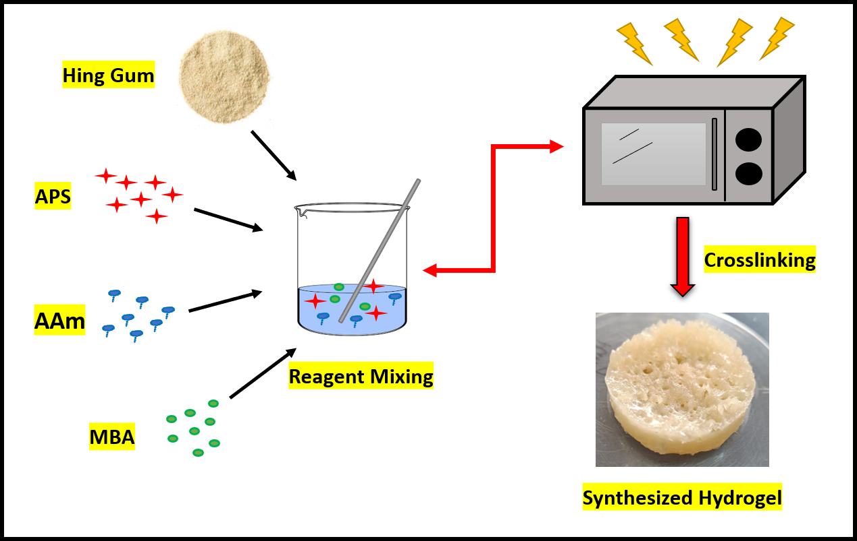
Figure S1: Schematic representation of the synthesis process of the HG-based hydrogel.

Figure S2(a): Plausible mechanism for the initiation of the synthesis of HG-cl-poly(AAm).
Figure S2(b): Plausible mechanism for the propagation of the synthesis of HG-cl-poly(AAm).
Figure S2(c): Plausible mechanism for the propagation of the synthesis of HG-cl-poly(AAm).
Figure S3: Possible interactions between MG dye and HG-g-poly(AAm).

Table S1: Experimental design with experimental values of %age swelling.
Std | Run | Factor 1 | Factor 2 | Factor 3 | Factor 4 | Factor 5 | Response
Std | Run | A: Initiator  10⁻² Mol/L | B: Monomer  10⁻¹ Mol/L | C: Crosslinker  10⁻² Mol/L | D: Solvent  mL | E: Time  sec | Swelling  %
12 | 1 | 3.03 | 8.67 | 3.99 | 8 | 80 | 582
3 | 2 | 2.35 | 4.32 | 3.99 | 8 | 60 | 491
15 | 3 | 2.35 | 6.49 | 4.98 | 10 | 70 | 658
7 | 4 | 1.68 | 4.32 | 3.99 | 12 | 80 | 648
1 | 5 | 3.03 | 8.67 | 5.98 | 8 | 60 | 614
6 | 6 | 1.68 | 4.32 | 5.98 | 12 | 60 | 652
14 | 7 | 2.35 | 6.49 | 4.98 | 10 | 70 | 605
13 | 8 | 2.35 | 6.49 | 4.98 | 10 | 70 | 655
5 | 9 | 3.03 | 8.67 | 3.99 | 12 | 80 | 785
2 | 10 | 1.68 | 8.67 | 3.99 | 8 | 80 | 577
8 | 11 | 3.03 | 4.32 | 5.98 | 12 | 60 | 557
4 | 12 | 3.03 | 4.32 | 5.98 | 8 | 80 | 476
11 | 13 | 1.68 | 4.32 | 5.98 | 8 | 60 | 542
9 | 14 | 1.68 | 8.67 | 5.98 | 12 | 80 | 780
10 | 15 | 1.68 | 8.67. | 3.99 | 12 | 60 | 788

Table S2: ANOVA table and model statistics for linear model.
Source | Sum of Squares | Degree of Freedom | Mean Square | F-value | p-value
Model | 1.322E+05 | 5 | 26439.22 | 67.85 | < 0.0001*
A-Initiator | 2795.04 | 1 | 2795.04 | 7.17 | 0.0253*
B-Monomer | 48133.33 | 1 | 48133.33 | 123.52 | < 0.0001*
D-Solvent | 55200.04 | 1 | 55200.04 | 141.65 | < 0.0001*
AB | 5017.04 | 1 | 5017.04 | 12.87 | 0.0059*
BD | 7526.04 | 1 | 7526.04 | 19.31 | 0.0017*
Lack of Fit | 1734.58 | 7 | 247.80 | 0.2796 | 0.9149#
Model Statistics
Standard Deviation | 19.74 | R² | 0.9752 | Standard Deviation | 19.74
Mean | 627.33 | Adjusted R² | 0.9598 | Mean | 627.33
C.V% | 3.15 | Predicted R² | 0.9306 | C.V% | 3.15
 |  | Adeq Precision | 25.1433
*Significant at p-value<0.05
# not significant at p-value<0.05

Table S3: Factorial design with %age swelling as response variable.
Std | Run | Factor 1 | Factor 2 | Factor 3 | Response
Std | Run | Initiator  10⁻² Mol/L | Monomer  10⁻¹ Mol/L | Solvent  mL | Swelling  %
2 | 1 | 3.03 | 6.49 | 10 | 652
10 | 2 | 3.60 | 8.65 | 13 | 681
14 | 3 | 2.19 | 8.65 | 18.0454 | 506
18 | 4 | 2.19 | 8.65 | 13 | 638
9 | 5 | 0.77 | 8.65 | 13 | 547
4 | 6 | 3.03 | 10.82 | 10 | 631
12 | 7 | 2.19 | 12.29 | 13 | 682
3 | 8 | 1.34 | 10.82 | 10 | 672
13 | 9 | 2.19 | 8.65 | 7.95462 | 642
6 | 10 | 3.03 | 6.49 | 16 | 425
15 | 11 | 2.19 | 8.65 | 13 | 635
1 | 12 | 1.34 | 6.49 | 10 | 611
5 | 13 | 1.34 | 6.49 | 16 | 314
16 | 14 | 2.19 | 8.65 | 13 | 701
8 | 15 | 3.03 | 10.82 | 16 | 712
11 | 16 | 2.19 | 5.01 | 13 | 397
17 | 17 | 2.19 | 0.8 | 13 | 624
7 | 18 | 1.34 | 10.82 | 16 | 629
20 | 19 | 2.19 | 8.65 | 13 | 760
19 | 20 | 2.19 | 8.65 | 13 | 721

Table S4: ANOVA analysis table and model statistics for fitted linear model.
Source | Sum of  Squares | Degree of Freedom | Mean  Square | F-value | p-value
Model | 2.355E+05 | 9 | 26161.24 | 14.93 | 0.0001*
A-Initiator | 12877.27 | 1 | 12877.27 | 7.35 | 0.0219*
B-Monomer | 92066.46 | 1 | 92066.46 | 52.56 | < 0.000*
D-Solvent | 37404.67 | 1 | 37404.67 | 21.35 | 0.0009*
AB | A-Initiator | 1 | 1512.50 | 0.8634 | 0.3747*
BD | 4704.50 | 1 | 4704.50 | 2.69 | 0.1323*
BC | 39480.50 | 1 | 39480.50 | 22.54 | 0.0008*
A² | 6095.42 | 1 | 6095.42 | 3.48 | 0.0917*
B² | 31707.01 | 1 | 31707.01 | 18.10 | 0.0017*
C² | 17360.66 | 1 | 17360.66 | 9.91 | 0.0104*
Lack of Fit | 3002.19 | 5 | 600.44 | 0.2068 | .9457#
Model Statistics
Standard Deviation | 41.85 |  | R² | 0.9308 | Standard Deviation
Mean | 608.70 |  | Adjusted R² | 0.8684 | Mean
C.V% | 6.88 |  | Predicted R² | 0.8251 | C.V%
 |  |  | Adeq  Precision | 14.0101
*Significant at p-value<0.05
# non-significant at p-value>0.1000

