Table 1. Relationship patterns in Centropogon australis, Gerres subfasciatus and Pelates sexlineatus individuals across physiological and behavioural performance (performance metric measured at 16°C vs performance metric measured at 20°C) with R² and p-values. Separate regressions were conducted in case order of temperature was significant. ‘Ascending’ indicates ascending order of temperatures (16°C 20°C) and ‘Descending’ indicates descending order of temperatures (20°C 16°C). Red indicates a significantly negative relationship; green indicates a significantly positive relationship and yellow indicates the lack of a significant relationship. For linear regressions, Pearson’s R² is reported, while for ordinal regressions, McFadden pseudo-R² is reported.

Species | Performance metrics  across individuals, 16°C vs 20°C
Species | Instantaneous growth rate | Change in total length | Bite rate | Burst speed | Aerobic scope | Shelter response | Boldness | Escape response
Centropogon australis  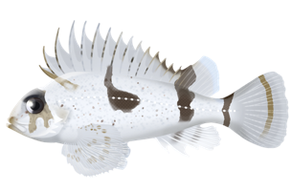  n = 20 | R² = 0.17  p = 0.12 | R² = 0.13  p = 0.13 | R² = 0.03  p = 0.50 | R² = 0.01  p = 0.66 | n/a | R² = 0.09  p = 0.20 | R² = 0.13  p = 0.006 | R² = 0.08  p = 0.27
Gerres subfasciatus  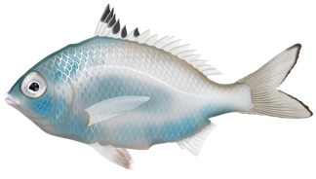  n = 37 | R² = 0.003  p = 0.75 | R² = 0.03  p = 0.32 | R² = 0.01  p = 0.52 | R² <0.01  p = 0.95 | R² = 0.14  p = 0.025 | R² = 0.03  p = 0.39 | R² = 0.03  p = 0.40 | R² = 0.03  p = 0.51
Pelates sexlineatus  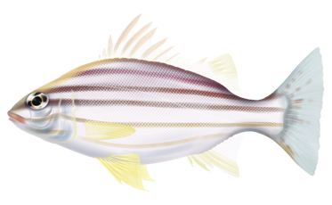  n = 34 | R² _{Ascending}= 0.01  p_{Ascending} = 0.79 | R² _{Ascending}= 0.06  p_{Ascending} = 0.32 | R² = 0.12  p = 0.047 | R² _{Ascending}= 0.01  p_{Ascending} = 0.57 | R² = 0.05  p = 0.20 | R² = 0.26  p < 0.001 | R² = 0.11  p = 0.037 | R² = 0.07  p = 0.26
 | R² _{Descending}= 0.11  p_{Descending} = 0.24 | R² _{Descending}= 0.03  p_{Descending} = 0.55 | R² = 0.12  p = 0.047 | R² _{Descending}= 0.06  p_{Descending} = 0.37

