Supplementary data

Title: Individual performance niches may buffer population responses to climate change in estuarine fishes

Authors
Clara Bellotto¹, Ashley M. Fowler^{1,2} David J. Booth¹,
1 Fish Ecology Lab, School of Life Sciences, University of Technology Sydney, Sydney, New South Wales, Australia
2 New South Wales Department of Primary Industries, Sydney Institute of Marine Science, Building 19, Chowder Bay Road, Mosman, New South Wales 2088, Australia

Correspondence: Clara Bellotto, School of Life Sciences, Building 4, Level 6, University of Technology Sydney, NSW 2007, Australia. Email: clara.bellotto@uts.edu.au

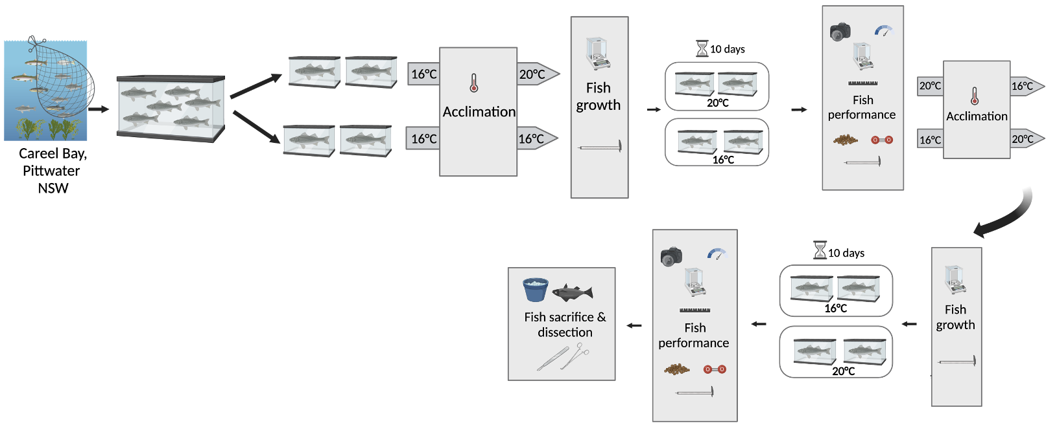
(A)

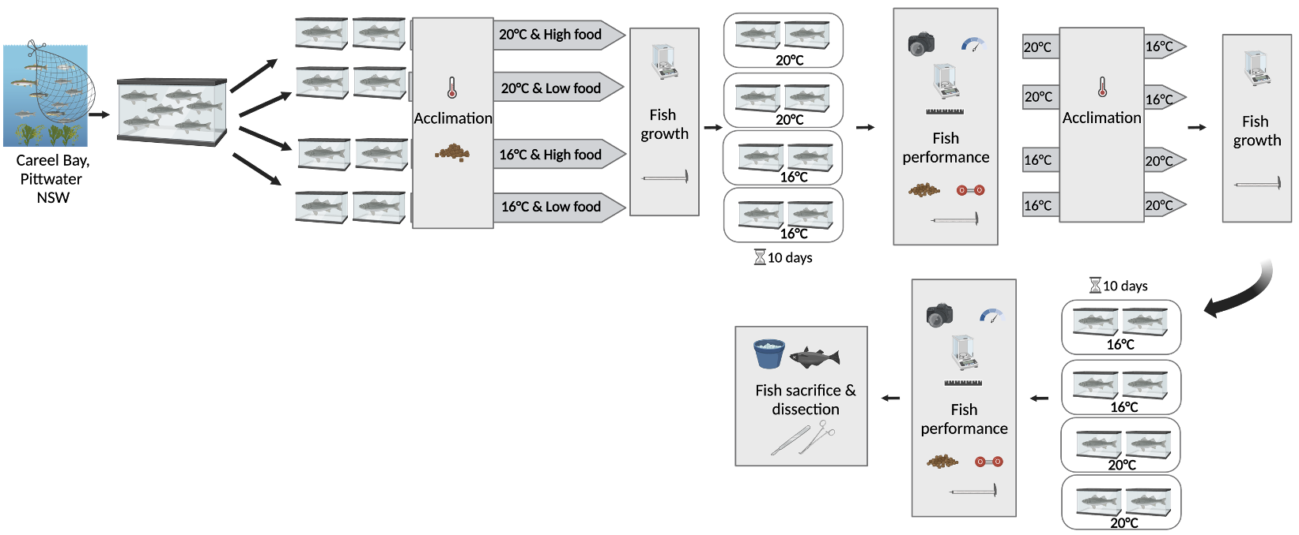
(B)

Figure S1. (A) Diagram of experimental design for the eastern fortescues, Centropogon australis (n = 20), with temperature (16°C vs 20°C) as factor. (B) Diagram of experimental design for the common silver biddy Gerres subfasciatus (n=37) and the eastern striped trumpeter, Pelates sexlineatus (n=34) with temperature (16°C vs 20°C) and food (low vs high food regime) as factors. A separate experiment was conducted for each species. Low food regimes were fed 0.5% fish weight in fish pellets, High food regimes were fed 1% fish weight in fish pellets. Created with BioRender (2023).

Table S1. ANOVA (F values, degrees of freedom, p-values) results for the effect of food regime and order of temperatures treatment across species.

Species | Performance metric | Factor | F | df | p-value
Centropogon australis | Instantaneous growth rate | Order of temperatures | 2.061 | 1,33 | 0.161
Centropogon australis | Change in total length | Order of temperatures | 3.414 | 1,35 | 0.074
Centropogon australis | Bite rate | Order of temperatures | 0.137 | 1,35 | 0.714
Centropogon australis | Burst speed | Order of temperatures | 0.048 | 1,32 | 0.828
Centropogon australis | Shelter response | Order of temperatures | 0.421 | 1,36 | 0.521
Centropogon australis | Boldness | Order of temperatures | 1.574 | 1,29 | 0.218
Centropogon australis | Escape response | Order of temperatures | 0.928 | 1,36 | 0.342
Gerres subfasciatus | Instantaneous growth rate | Food regime | 0.260 | 1,63 | 0.612
Gerres subfasciatus | Instantaneous growth rate | Order of temperatures | 2.674 | 1,63 | 0.107
Gerres subfasciatus | Change in total length | Food regime | 0.132 | 1,58 | 0.717
Gerres subfasciatus | Change in total length | Order of temperatures | 0.705 | 1,58 | 0.404
Gerres subfasciatus | Bite rate | Food regime | 0.631 | 1,66 | 0.430
Gerres subfasciatus | Bite rate | Order of temperatures | 2.128 | 1,66 | 0.149
Gerres subfasciatus | Burst speed | Food regime | 0.026 | 1,64 | 0.873
Gerres subfasciatus | Burst speed | Order of temperatures | 0.288 | 1,64 | 0.594
Gerres subfasciatus | Aerobic scope | Food regime | 0.009 | 1,64 | 0.926
Gerres subfasciatus | Aerobic scope | Order of temperatures | 0.667 | 1,64 | 0.417
Gerres subfasciatus | Shelter response | Food regime | 1.730 | 1,66 | 0.163
Gerres subfasciatus | Shelter response | Order of temperatures | 1.922 | 1,66 | 0.170
Gerres subfasciatus | Boldness | Food regime | 1.380 | 1,66 | 0.244
Gerres subfasciatus | Boldness | Order of temperatures | 0.451 | 1,66 | 0.504
Gerres subfasciatus | Escape response | Food regime | 0.004 | 1,66 | 0.949
Gerres subfasciatus | Escape response | Order of temperatures | 1.817 | 1,66 | 0.182
Pelates sexlineatus | Instantaneous growth rate | Food regime | 0.713 | 1,57 | 0.402
Pelates sexlineatus | Instantaneous growth rate | Order of temperatures | 12.533 | 1,57 | <0.001
Pelates sexlineatus | Change in total length | Food regime | 0.276 | 1,59 | 0.601
Pelates sexlineatus | Change in total length | Order of temperatures | 14.860 | 1,59 | <0.001
Pelates sexlineatus | Bite rate | Food regime | 1.073 | 1,60 | 0.304
Pelates sexlineatus | Bite rate | Order of temperatures | 0.074 | 1,60 | 0.786
Pelates sexlineatus | Burst speed | Food regime | 0.568 | 1,58 | 0.454
Pelates sexlineatus | Burst speed | Order of temperatures | 16.454 | 1,58 | <0.001
Pelates sexlineatus | Aerobic scope | Food regime | 0.035 | 1,59 | 0.851
Pelates sexlineatus | Aerobic scope | Order of temperatures | 0.409 | 1,59 | 0.525
Pelates sexlineatus | Shelter response | Food regime | 0.016 | 1,60 | 0.901
Pelates sexlineatus | Shelter response | Order of temperatures | 0.200 | 1,60 | 0.656
Pelates sexlineatus | Boldness | Food regime | 1.540 | 1,60 | 0.220
Pelates sexlineatus | Boldness | Order of temperatures | 0.341 | 1,60 | 0.561
Pelates sexlineatus | Escape response | Food regime | 0.501 | 1,60 | 0.482
Pelates sexlineatus | Escape response | Order of temperatures | 0.557 | 1,60 | 0.458

