Supplementary Materials
Enhancing Nutritional and Organoleptic Properties of Jerusalem Artichoke Tuber through Probiotic Fermentation
Kamil R. Bayazitov¹, Maksim S. Ivanov¹, Robert K. Gelazov¹, Subhrajit Barua¹, Filipp V. Lavrentev², Mariia А. Antsyperova¹, Aleksei А. Fedorov¹, Natalia V. Iakovchenko¹*
¹ITMO University, The Faculty of Biotechnologies (BioTech), St. Petersburg, Russian Federation
²ITMO University, Infochemistry Scientific Center, St. Petersburg, Russian Federation
*Corresponding author - nviakovchenko@itmo.ru
ORCID IDS:
Kamil R. Bayazitov - 0009-0007-8424-1053
Maksim S. Ivanov - 0009-0000-5754-5026
Robert K. Gelazov - 0009-0003-1110-2053
Subhrajit Barua - 0000-0003-3303-7742
Filipp V. Lavrentev - 0000-0003-3006-1325
Mariia A. Antsyperova - 0009-0004-0005-6597
Aleksei A. Fedorov - 0000-0003-3860-7708
Natalia V. Iakovchenko - 0000-0002-5188-5916

2 Materials and methods
2.1 Materials
The Jerusalem artichoke tubers were collected in October 2022 and were purchased from the local market in the Leningrad region. Commercial freeze-dried cultures and strains of Lactobacillus acidophilus H9, 57S, AT-41, 8 (National Research Center "Kurchatov Institute", Russia); Lactobacillus delbrueckii subsp. bulgaricus (Yo100, Micromilk s.r.l., Italy); Bifidobacterium bifidum (LYOBAC-D, ALCE, Italy); Bacillus coagulans MTCC 5856 (LactoSpore®); Bifidobacterium longum B379M (LLC Propionix, Russia); Propionibacterium freudenreichii subsp. shermani KM-186 (LLC Propionix, Russia); and Streptococcus thermophilus (Danisco TA 40 LYO 50 DCU, Denmark) were used.
2.2. Methods
2.2.1 Jerusalem artichoke dispersion production
A flowchart depicting the general manufacturing process of plant dispersions with different pretreatment methods is presented in Fig. 1.
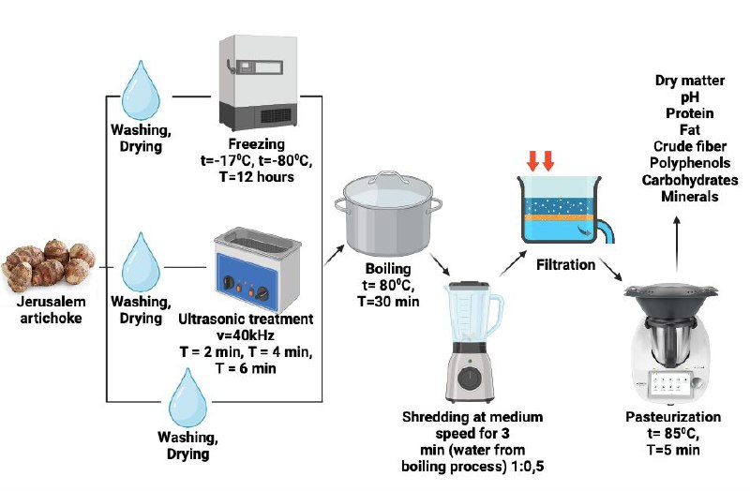
Fig. 1 The manufacturing process of Jerusalem artichoke milk
Tubers of Jerusalem artichoke (500 g), 35±3 mm in size were sorted out, weighed and washed under tap water, and dried. Control samples of Jerusalem artichoke dispersions were made from tubers without pretreatment. Freeze pretreatment for 12-13 h at -17°C (Biomedical Freezer DW-30L818BP, Haier, China) and -80°C (ANTECH ULT freezer, MDF-86U158, Antech Scientific Co., Ltd., China) of plant materials were done. For ultrasound pretreatment, SONOREX DIGIPLUS DL 510 H, frequency 35kHz, Bandelin electronic, Germany was used. The technology production was based on the procedure mentioned by Dimitrovski D. et. al. with some modifications [1].
After this step, the tubers were boiled for 20 minutes and crushed using an electrical blender KitchenAid K150 (USA) for 3 min at a ratio of water to tubers = 1:0.5 (v/w). The obtained slurry was filtered using a filter cloth made of polyethylene terephthalate (weight 140g/m²). The obtained liquid was heat treated using Thermomix® at a rate of 2 (7400xg approx.) and at a temperature of 85°C for 5 min to ensure system stability and microbiological safety.
2.2.2 Fermentation of Jerusalem artichoke tuber dispersions
The obtained plant bases were inoculated with different starter cultures (10⁷CFU/ml) and fermented until pH values of 4.6-4.8 at temperatures chosen individually for each starter culture (Table 1). The cell growth was observed by measuring the optical density at 600 nm (OD600) using a Shimadzu UV-1800 spectrophotometer (“Shimadzu Europa GmbH”, Germany) [2]. The resulting beverages were cooled to 5±1°C to stop further fermentation and were stored in a refrigerator for further analysis. Test samples were prepared with Jerusalem artichoke tubers taken at three different times and in three replications.
Table 1 Temperatures of sample fermentation for different starter cultures
Starter Culture | Temperature, ᵒC
L. acidophilus strains H9, 57S, AT-41, 8, B. bifidum, B. longum B379M | 37
L. delbrueckii subsp. bulgaricus, B. coagulans MTCC 5856, S. thermophilus | 45
P. freudenreichii subsp. shermanii KM-186 | 32

2.2.3 Analysis
The pH of the samples was measured using a pH meter, HANNA HI98127 (Hanna Instruments, Hungary). The total solid content was determined according to the method described by Liu and Chang [3]. The protein content of the samples was determined by the Kjeldahl method according to method 991.22 of [4]. Crude fiber content was estimated according to the procedure described in method No. 32-10 of [5]. Total fat content was determined gravimetrically using the method of Weibull-Stoldt by HydrolEx H-506 and FatExtractor E-500 Soxhlet (BuchiLabortechnik) [6]. The percentage of carbohydrate content was determined according to the method described by [7]. Total polyphenolic content was analyzed using the colorimetric method described by Rodríguez-Roque MJ et. al. using the Folin-Ciocalteu reagent [8]. Absorbance at 725 nm was measured using a UV-1800 spectrophotometer (Shimadzu, Japan). Concentrations were determined by comparing the absorbance of the trial samples with a calibration curve built using gallic acid (Sigma–Aldrich, Germany).
2.2.4 Mineral content
Mineralization of the Jerusalem artichoke dispersions was conducted using the Milestone Ethos Easy Microwave Sample Preparation System (Milestone, Italy). The mineral concentrations were measured using Atomic Emission Spectrometry with Microwave Plasma Emission method using a 4200 MP-AES system, Agilent. For the mineralization procedure, 4.0 g of a thoroughly homogenized sample was placed in an autoclave of a microwave decomposition system. Then, 8 ml of 70% HNO₃ and 2 ml of 30% H₂O₂ are added and kept at room temperature for at least 30 minutes. After exposure, the autoclave was hermetically sealed with a standard lid and mineralization was carried out according to the microwave system program. On completion of the mineralization, the autoclave was cooled down to room temperature. The contents of the autoclave were evaporated on an electric stove to a volume of not more than 5cm³, after which they were cooled down. The obtained mineral was quantitatively transferred into a volumetric flask with a capacity of 25cm³, the volume was adjusted to the mark with 1% HNO₃ solution. Sample preparation of each sample was performed in duplicate. Simultaneously with the analytical solutions, a blank sample solution was prepared. The obtained analytical solutions during the determination of K, Na, Ca, and P were additionally diluted with 1% HNO₃ solution 100 times. The analytical conditions for each element used for quantitation are shown in Table 2.
Table 2 Analytical conditions for determining elements
Element | The most sensitive wavelengths, nm
Iron | 234.349
Aluminium | 394.401
Barium | 614.171
Beryllium | 313.107
Boron | 249.772
Vanadium | 437.923
Potassium | 766.491
Calcium | 422.673
Cobalt | 340.512
Silicon | 251.611
Magnesium | 285.213
Manganese | 403.076
Copper | 324.754
Molybdenum | 379.825
Sodium | 589.592
Rubidium | 780.027
Strontium | 407.771
Phosphorus | 213.618
Chromium | 425.433
Zinc | 213.857
2.2.5 Organoleptic assessment
Quantitative descriptive analysis was used to describe the chosen key attributes of Jerusalem artichoke tuber dispersions and fermented beverages. The samples were presented in 100mL glass containers with lids. Descriptors were evaluated using a 7-point scale which is presented in Table 3. Sensory analysis was carried out by a panel of 21 trained panelists (50% of participants were women and 50% of participants were men aged between 23 to 65 years) and were between 22 and 65 years of age. The samples were tested in an air-conditioned room (20±1°C), with uniform lighting. During sample evaluation, the participants were asked to drink water or eat unsalted crackers to clean their mouths between every round of sample testing. Each sample was coded with a three-digit code. The sensory test panel was available for testing in three separate sessions in three rounds of repetitions during each session.
The sensory properties of fermented Jerusalem artichoke dispersion samples with different probiotic microorganisms were assessed by judges who were familiar with fermented plant-based products using the 10-point hybrid hedonic scale [9]. All the samples were evaluated by 38 panelists from the staff with an age range between 22 and 65. The hedonic scale starts from 0, which refers to extreme dislike, to 10, which refers to like extremely.
Table 3 Description of organoleptic indicators for the evaluation of samples
Attribute | Definition | Scale
Attribute | Definition | 1 | 7
Overall acceptability | Preference | The weakest | The strongest
Viscosity | The force required to move the spoon back and forth | Fluid | Thick
Wateriness | The state or condition of being watery or diluted. | Low | High
Homogeneity | Homogeneous is a mixture if there is no phase change between any two points in the mixture. No stratification, lumps, flakes | Low | High
Sour taste | Basic taste, perceived on the tongue, stimulated by organic acids | Not detected | Intensive
Bitter taste | Basic taste, perceived on the tongue, stimulated by substances such as quinine or caffeine | Not detected | Intensive
Sweet taste | Basic taste, perceived on the tongue, stimulated by sugars | Not detected | Intensive
Jerusalem artichoke flavor | The intensity of flavor of raw Jerusalem artichoke tubers | Not detected | Intensive
Pea flavour | The intensity of the flavor of green pea | Not detected | Intensive
Fungus/earthy flavor | The intensity of flavor of fungus, mushroom, or forest bed | Not detected | Intensive
Bitter aftertaste | The intensity of the bitter aftertaste after swallowing | Not detected | Intensive
Sweet aftertaste | The intensity of the sweet aftertaste after swallowing | Not detected | Intensive
Jerusalem artichoke aftertaste | The intensity of Jerusalem artichoke after taste after swallowing | Not detected | Intensive
Jerusalem artichoke aroma | The intensity of the aroma of raw Jerusalem artichoke tubers | Not detected | Intensive
Fungus/Earthy aroma | The intensity of fungus, mushroom, or forest bed | Not detected | Intensive
Putrid aroma | The intensity of the aroma of putrefaction | Not detected | Intensive

Total acidity (TA) values were measured by titration method using 0.1 M of NaOH in the presence of phenolphthalein as an indicator. The TA value was calculated using the following equation and expressed as a percentage of lactic acid [10].
$$TA (lactic acid,\%)=\frac{\left(\left(M NaOH\right)∙\left(mL NaOH\right)\right)∙90.08 }{mL of sample·10}$$
*90.08 g/mol is the lactic acid molecular weight.
The content of propionic acid was determined using the Prominence system (Shimadzu LC-20) according to the method described by Fernandez-Garcia et. al. with modifications [11]. Briefly, the samples of fermented Jerusalem artichoke tuber samples were mixed with 25 mL of 0.001 M H₂SO₄ and centrifuged at 10000rpm for 15 min. The obtained supernatants were filtered through 0.45μm pore-sized nylon filters and transferred to vials. The volume of the injected sample was 10 μL, flow rate of 1.0 mL·min⁻¹ at +25°C. The maximum acidification rate (Vmax) was determined as the ratio of change in pH over time, expressed in absolute values (pH unit/min), and was calculated using the equation according to Bezerra et al. [12].
$$V_{max}=\max\left(\frac{dpH}{dt}\right)$$

The antioxidant activities of Jerusalem artichoke dispersions before and after fermentation with different starter cultures were determined as follows: samples (10 mL) were centrifuged at 6500 rpm for 20 min at 4°C. The supernatants were used for further analysis. Free radical scavenging activity was determined following a modified method provided by Chan et. al. [13].
A total of 50 µL of each supernatant was mixed with 100 µL of 0.1 µg/mL ethanol DPPH (Sigma–Aldrich, Germany) solution. The mixture was incubated at room temperature in the dark for 30 minutes. Absorbance was measured at 517 nm and the inhibition of DPPH oxidation (%) was calculated as follows [14].
$$Inhibition \left(\%\right)=\left(\frac{A_{517}^{control}-A_{517}^{sample}}{A_{517}^{control}}\right)×100$$
2.2.7 Determination of the viability of probiotic bacteria
One milliliter of each fermented product was serially diluted 10 times (from 10⁻¹ to 10⁻¹⁰) in sterile 0.9% (w/v) sodium chloride solution. To determine probiotic bacterial cell counts in the samples, 1mL of the dilution was added to the dishes by deep pouring method using sterile MRS agar (for L. acidophilus, L. delbrueckii subsp. bulgaricus, B. coagulans, B. longum), M17 agar (for S. thermophilus) and incubated at 37°C for 48h. P. shermanii were cultured on sodium lactate agar and incubated at 30°C for 96 h. The number of each starter culture bacteria was expressed as a log of colony-forming units (log₁₀CFU/ml). The relationship between bacterial cell viability and time was calculated using the following equations [15].
$$Specific growth rate \left(μ_{G}\right)\left(h^{-1}\right)=\frac{ln X-ln X_{0}}{t-t_{0}}$$
where X – amount of growth after time (t) and X₀ – amount of growth at the beginning time (t₀).
$$Doubling time \left(t_{d}\right)=\frac{ln(2)}{μ_{G}}$$
$$Multiplication rate \left(MR\right)=\frac{1}{t_{d}}$$
2.2.8 Rheological measurements
The viscosity of the Jerusalem artichoke dispersion before and after fermentation was measured using a rotational rheometer Rheotest RN 4.1. (RHEOTEST Medingen GmbH, Germany) with a concentric cylinder geometry coupled with a circulating cooling bath at 4.0 ± 0.1°C. By the user manual of the rotational rheometer, the viscosity of the samples was measured at a constant shear rate of 1000 s⁻¹ for 60 s. With a decrease or increase in the shear rate in the actual measuring range of the device, no significant change in viscosity was detected.
2.2.9 Statistical analysis
All experiments were performed in triplicate (three batches). The data were expressed as mean ± standard deviation (SD). Comparisons between different samples were performed by the analysis of variance (ANOVA) and Tukey’s test (p < 0.05).
Supplementary Tables and Figures
Table S1 Quality characteristics of Jerusalem artichoke dispersions depending on pre-treatment methods
Sample of Jerusalem artichoke tuber dispersion | Control | US 2 min | US 4 min | US 6 min | -17°C | -80°C
pH | 6.16 ±0.04ª | 6.26 ±0.03ª | 6.27 ±0.03ª | 6.25 ±0.03ª | 6.22 ±0.04ª | 6.18 ±0.04ª
Dry matter, % | 6.91 ±0.11ª | 6.32±0.11ª | 6.42±0.13ª | 6.44 ±0.12ª | 5.83±0.11^{b} | 4.86 ±0.11^{c}
Protein, % | 0.66 ±0.02ª | 0.58 ±0.02^{b} | 0.43 ±0.01^{b} | 0.42 ±0.02^{b} | 0.42 ±0.03^{b} | 0.42 ±0.02^{b}
Fat, % | 0.02 ±0.01ª | 0.03 ±0.01ª | 0.03 ±0.01ª | 0.03 ±0.01ª | 0.02 ±0.01ª | 0.03 ±0.01ª
Crude fiber, % | Less 0.1 | Less 0.1 | Less 0.1 | Less 0.1 | Less 0.1 | Less 0.1
Polyphenols, mg (GAE)/100 g | 25.22 ±1.22^{b} | 24.35 ±1.11ª | 22.25 ±1.09ª | 22.47 ±1.17ª | 20.52 ±1.08ª | 16.58 ±0.96^{c}
Carbohydrates, % | 5.99 ±0.89ª | 5.38 ±0.78ª | 5.61 ±0.99ª | 5.65 ±0.78ª | 5.03 ±0.65ª | 4.08 ±0.52^{b}
Values in the same row having different superscripts differ significantly (p ≤ 0.05). The results were expressed as means ± standard deviation (SD). US – ultrasound

Table S2 Pretreatment influence on mineral content of plant-based dispersions
Element mg/1 kg | Sample of plant dispersion
Element mg/1 kg | Control | US 2 min | US 4 min | US 6 min | -17°C | -80°C
Fe* | 16.34±0.6ª | 12.56±0.5ª | 9.0265±0.4^{b} | 8.96±0.34^{b} | 15.22±0.65ª | 14.99±0.58ª
Al | 2.01±0.3ª | 2.39±0.36^{b} | 2.42±0.32^{b} | 2.47±0.31^{b} | 2.99±0.33^{c} | 2.21±0.3^{b}
Ba | 0.067±0.005ª | 0.069±0.005ª | 0.071±0.005ª | 0.071±0.005ª | 0.079±0.005ª | 0.074±0.005ª
B | Less 0.1 | Less 0.1 | Less 0.1 | Less 0.1 | Less 0.1 | Less 0.1
K | 1725±99ª | 1690±94ª | 1625±92ª | 1576±86ª | 1923±102^{b} | 1845±87^{b}
Ca | 66.3±4.2ª | 67.5±4.1ª | 69.2±4.2ª | 70.9±4.2ª | 89.2±4.2^{b} | 128.2±5.4^{c}
Si | 18.2±2.8^{b} | 23.3±2.9ª | 26.3±2.8ª | 27.7±2.8ª | 25.8±2.6ª | 29.1±2.9ª
Mg | 53.6±3.2ª | 52.5±3.2ª | 50.3±3.2ª | 48.5±3.2ª | 62.32±3.9^{b} | 68.55±3.5^{c}
Mn | 0.28±0.02ª | 0.31±0.02ª | 0.35±0.02ª | 0.37±0.02ª | 0.28±0.02ª | 0.35±0.02ª
Cu | 0.21±0.01ª | 0.18±0.01ª | 0.18±0.01ª | 0.18±0.01ª | 0.29±0.03^{b} | 0.23±0.02ª
Mo | Less 0.05 | Less 0.05 | Less 0.05 | Less 0.05 | Less 0.05 | Less 0.05
Na | 4.27±0.51ª | 4.86±0.52ª | 5.07±0.52ª | 5.21±0.54ª | 3.87±0.35^{b} | 3.57±0.35^{b}
Rb | 0.70±0.06ª | 0.66±0.05ª | 0.62±0.05ª | 0.62±0.05ª | 0.39±0.02^{b} | 0.28±0.02^{b}
Sr | 0.089±0.007ª | 0.092±0.007ª | 0.090±0.005ª | 0.090±0.005ª | 0.119±0.005^{b} | 0.093±0.005ª
P | 107±9ª | 103±7ª | 100±6ª | 97±5ª | 142±7^{b} | 167±8^{b}
Cr | 0.036±0.004^{b} | 0.081±0.004ª | 0.093±0.004ª | 0.095±0.004ª | 0.209±0.004^{c} | 0.056±0.004^{b}
Zn | 0.68±0.07^{b} | 0.87±0.07ª | 0.92±0.07ª | 0.94±0.07ª | 0.89±0.07ª | 0.65±0.07^{b}
Values in the same row having different superscripts differ significantly (p ≤ 0.05). The results were expressed as means ± standard deviation (SD). Be, Va, – less than 0.1 mg/kg. Co – less 0.2mg/kg. US – ultrasound.
* - µg/1 kg of plant dispersion

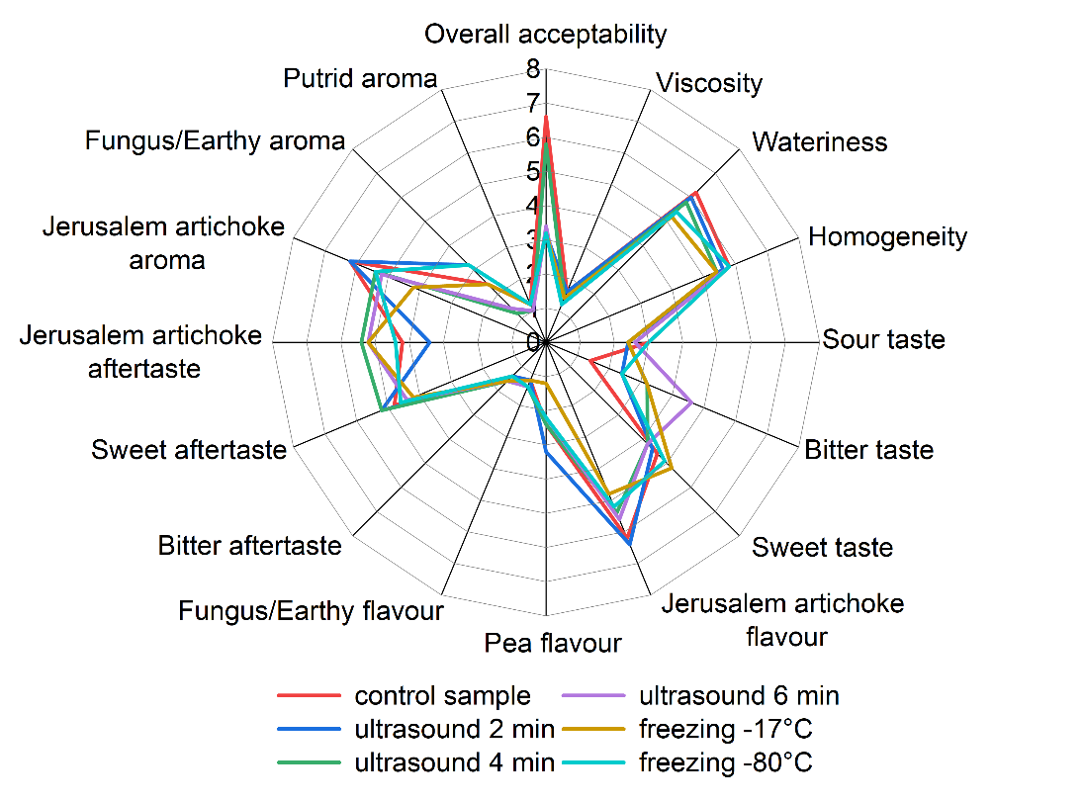
Fig. S1 Spider plot of sensory evaluation results of Jerusalem tuber dispersions depending on the pre-treatment method

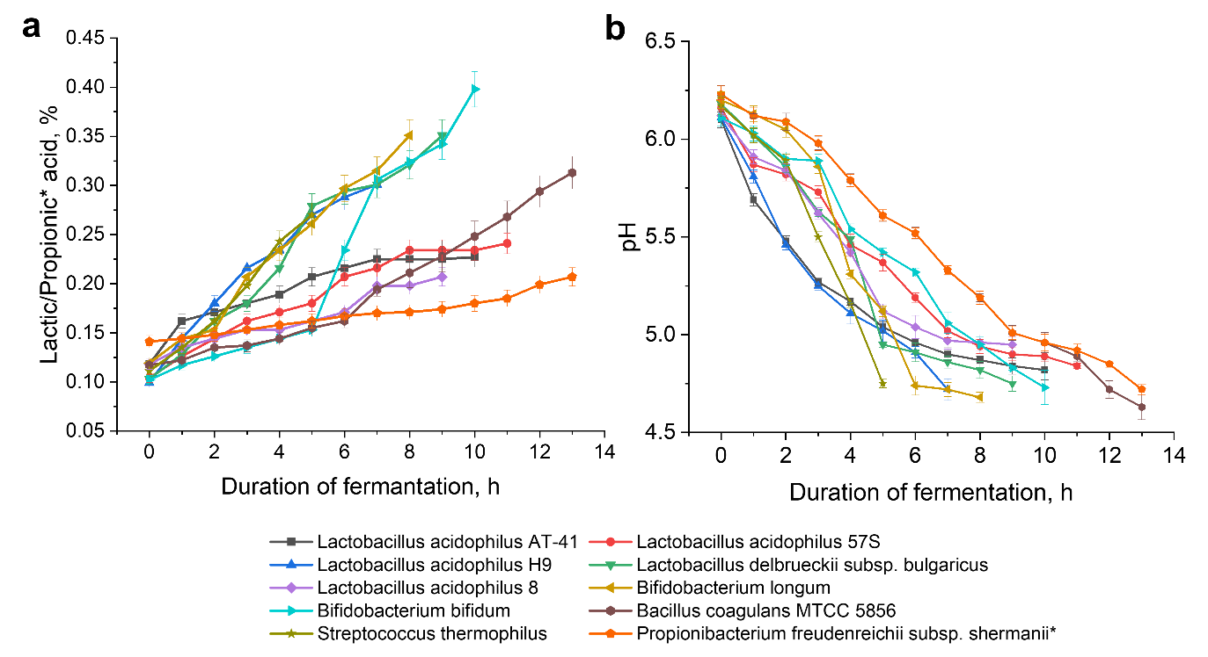
Fig. S2 (a) Changes in titratable acidity in Jerusalem artichoke dispersions over the fermentation period and (b) changes in pH values in Jerusalem artichoke dispersions over the fermentation period

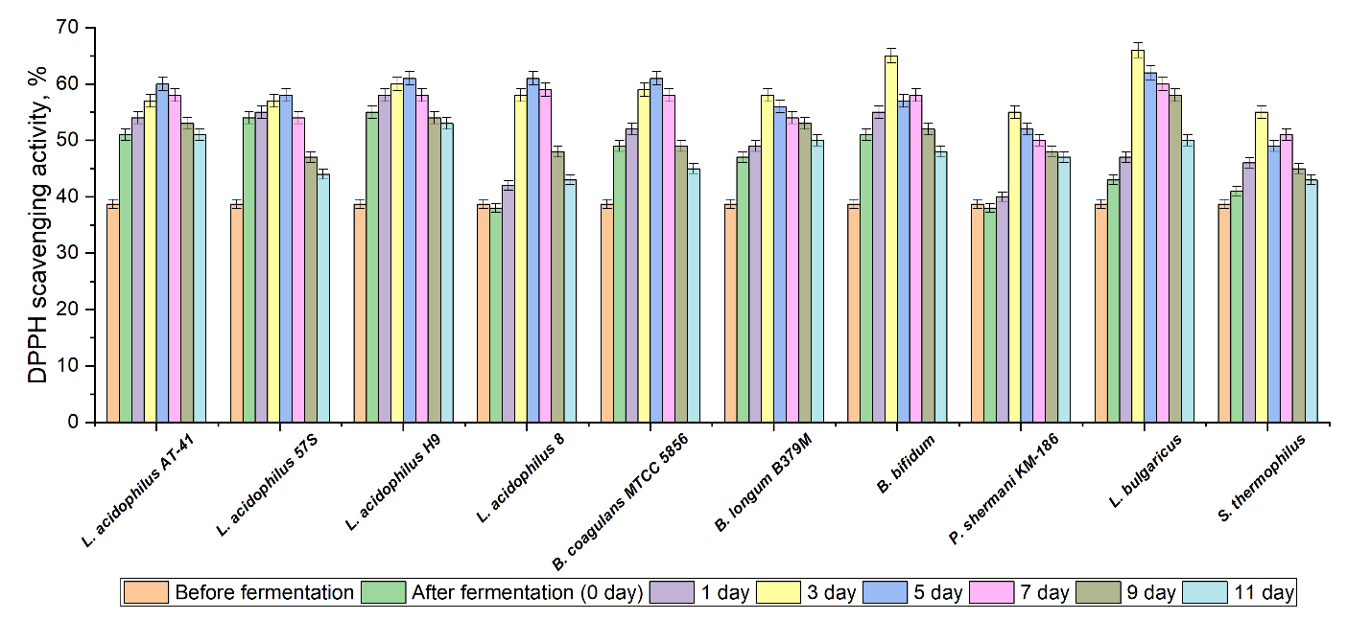
Fig. S3 The dynamic in antioxidant activity changes (% DPPH inhibition) of fermented samples when using different probiotic cultures during storage at 4◦C

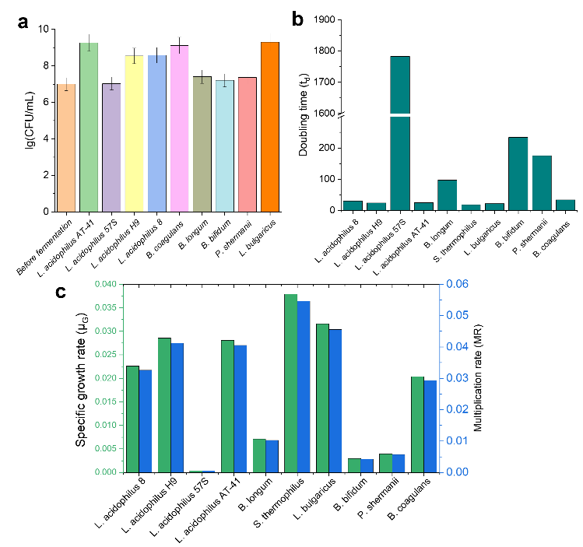
Fig. S4 (a) The viability of probiotic bacteria during the fermentation of Jerusalem artichoke dispersions. Growth kinetics of different strains in dispersions: (b) t_{d}=doubling time, (c) μ_{G} = Specific growth rate, and MR=multiplication rate
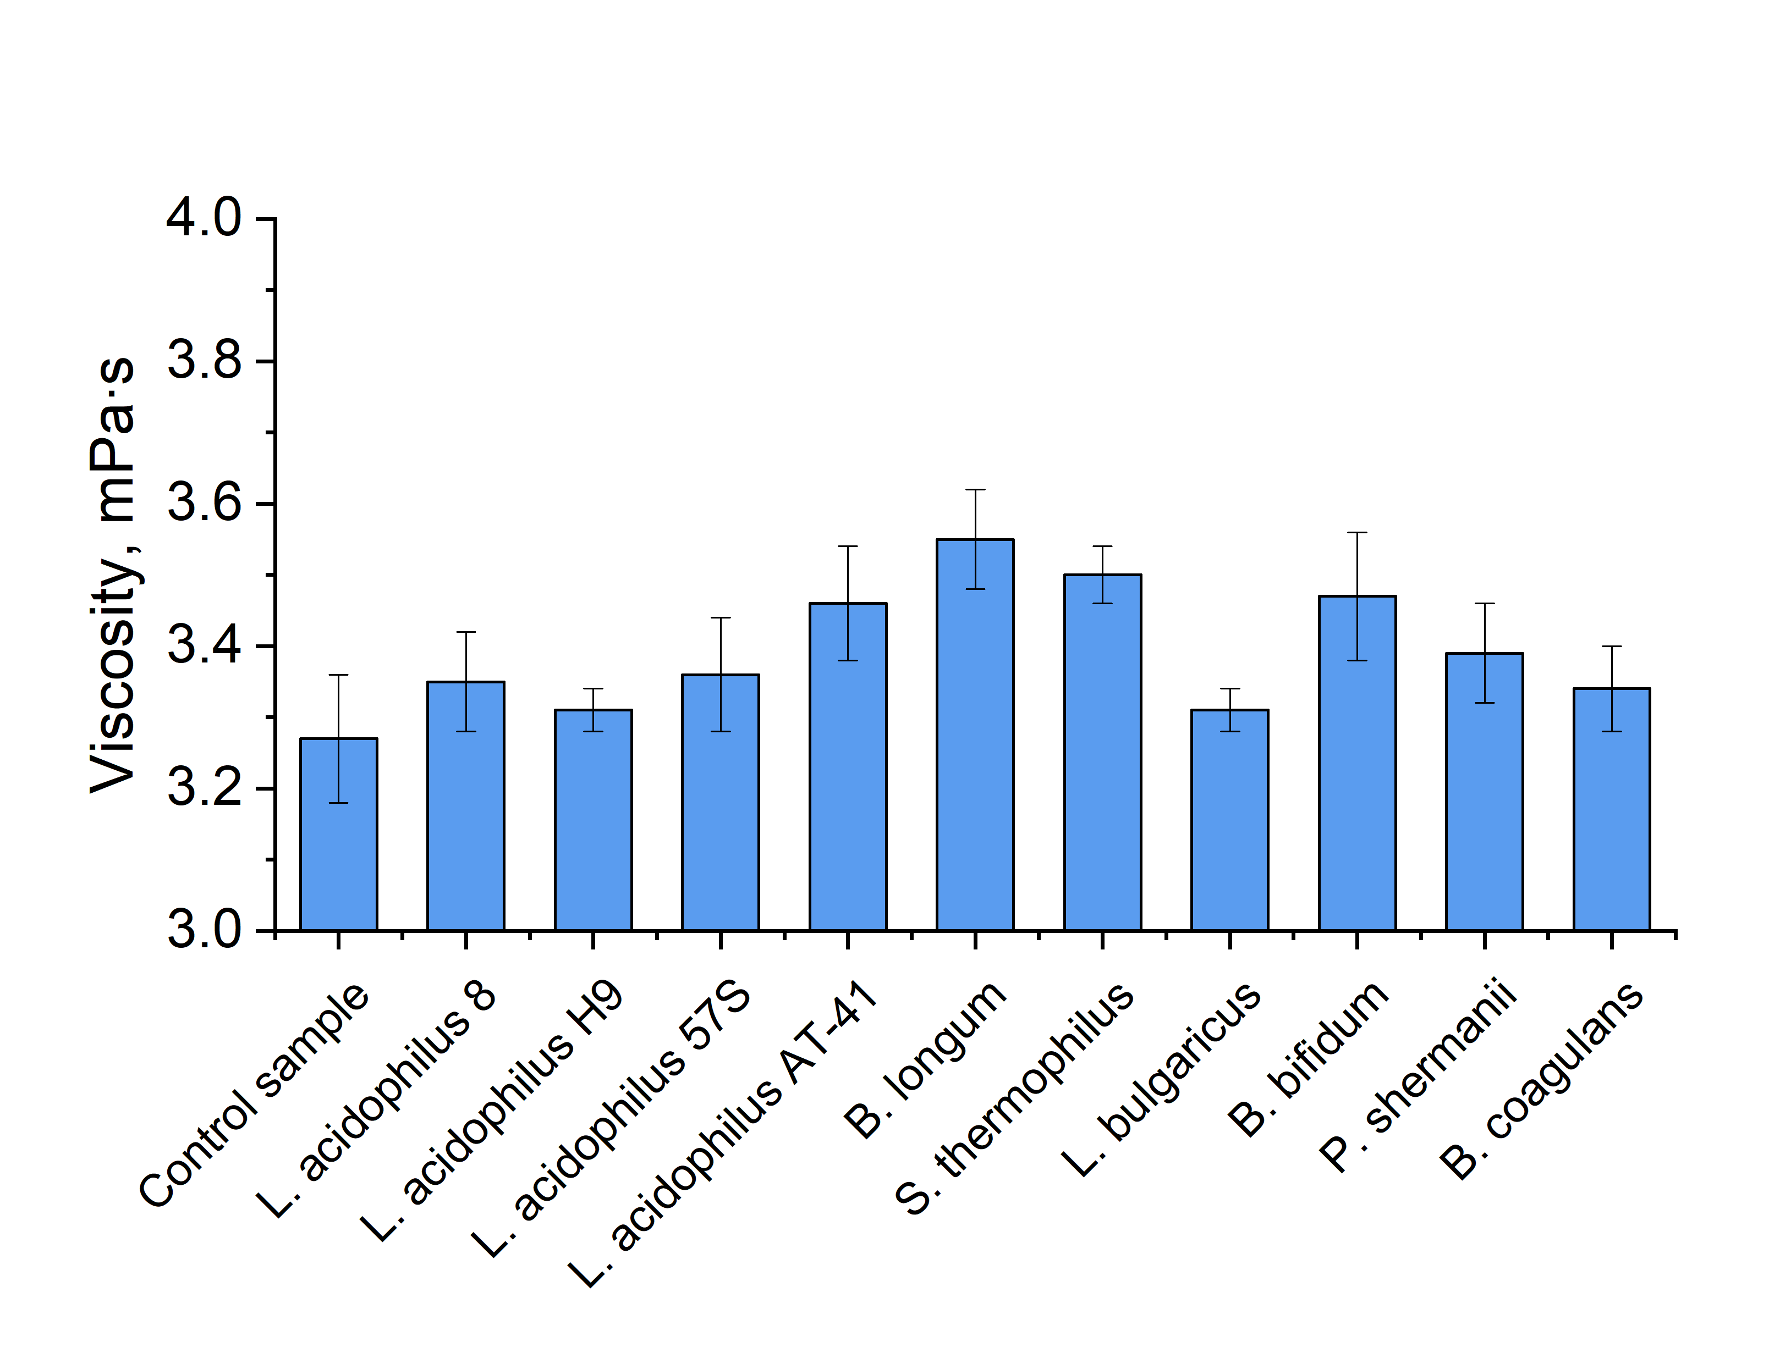
Fig. S5 Changes in viscosity values in Jerusalem artichoke tuber dispersions before and after fermentation depending on the starter culture. Control sample – Jerusalem artichoke dispersion before fermentation process
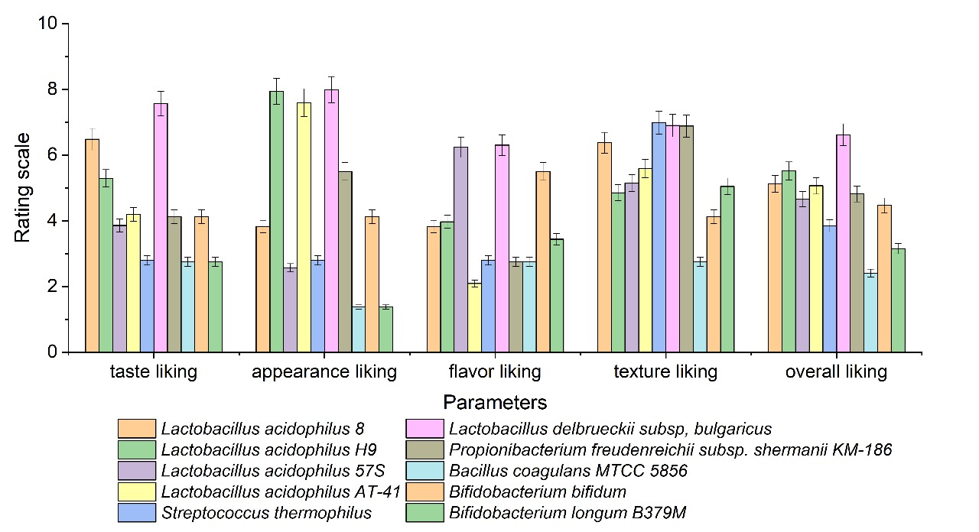
Fig. S6 Organoleptic characteristics of fermented Jerusalem artichoke dispersions
References
1. Dimitrovski, D., et al. (2016). Synbiotic functional drink from Jerusalem artichoke juice fermented by probiotic Lactobacillus plantarum PCS26. Journal of Food Science and Technology, 53(2), 766–774. https://doi.org/10.1007/s13197-015-2064-0
2. Choi, H. Y., et al. (2012). Direct lactic acid fermentation of Jerusalem artichoke tuber extract using Lactobacillus paracasei without acidic or enzymatic inulin hydrolysis. Bioresource Technology, 114, 745–747. https://doi.org/10.1016/j.biortech.2012.03.075
3. Liu, Z.-S., & Chang, S. K. C. (2013). Nutritional profile and physicochemical properties of commercial soymilk. Journal of Food Processing and Preservation, 37(6), 651–661. https://doi.org/10.1111/j.1745-4549.2012.00696.x
4. AOAC. (2005). Official methods of Analysis. 18th ed. Washington DC: Association of Officiating Analytical Chemists.
5. AACC. (2000). Approved Methods of the American Association of Cereal Chemists. 10th ed. St. Paul, MN.
6. ISO 8262-2. (2005). Milk products and milk-based foods — Determination of fat content by the Weibull-Berntrop gravimetric method (Reference method) — Part 2: Edible ices and ice-mixes. The International Organization for Standardization.
7. Goes, E. S. dos R., et al. (2016). Fresh pasta enrichment with protein concentrate of tilapia: nutritional and sensory characteristics. Food Science and Technology, 36, 76–82. https://doi.org/10.1590/1678-457X.0020
8. Rodríguez-Roque, M. J., et al. (2013). Soymilk phenolic compounds, isoflavones and antioxidant activity as affected by in vitro gastrointestinal digestion. Food Chemistry, 136, 206–212. https://doi.org/10.1016/j.foodchem.2012.07.115.
9. Clark, S., Costello, M., Drake, M., & Bodyfelt, F. (Eds.). (2009). The Sensory Evaluation of Dairy Products. Springer US. https://doi.org/10.1007/978-0-387-77408-4
10. Villanueva, N. D. M., Petenate, A. J., Da Silva, M. A. A. P. (2005). Performance of the hybrid hedonic scale as compared to the traditional hedonic, self-adjusting and ranking scales. Food Quality and Preference, 16, 691–703. https://doi.org/10.1016/j.foodqual.2005.03.013
11. Fawzi, N. Y., et al. (2022). The ability of probiotic lactic acid bacteria to ferment Egyptian broken rice milk and produce rice-based yogurt. Annals of Agricultural Sciences, 67(1), 107–118. https://doi.org/10.1016/j.aoas.2022.06.004
12. BEZERRA, M. F., SOUZA, D. F. S., & P CORREIA, R. T. (2012). Acidification kinetics, physicochemical properties and sensory attributes of yoghurts prepared from mixtures of goat and buffalo milks. In International Journal of Dairy Technology (Vol. 65, Issue 3, pp. 437–443). Wiley. https://doi.org/10.1111/j.1471-0307.2012.00845.x
13. Fernandez-Garcia, E., & McGregor, J. U. (1994). Determination of Organic Acids During the Fermentation and Cold Storage of Yogurt. Journal of Dairy Science, 77, 2934–2939. https://doi.org/10.3168/jds.S0022-0302(94)77234-9
14. Chan, E. W. C., Lim, Y. Y., & Omar, M. (2007). Antioxidant and antibacterial activity of leaves of Etlingera species (Zingiberaceae) in Peninsular Malaysia. Food Chemistry, 104, 1586–1593. https://doi.org/10.1016/j.foodchem.2007.03.023
15. Apostolidis, E., Kwon, Y.-I., & Shetty, K. (2007). Inhibitory potential of herb, fruit, and fungal-enriched cheese against key enzymes linked to type 2 diabetes and hypertension. Innovative Food Science & Emerging Technologies, 8, 46–54. https://doi.org/10.1016/j.ifset.2006.06.001

