Supplementary Figure 1
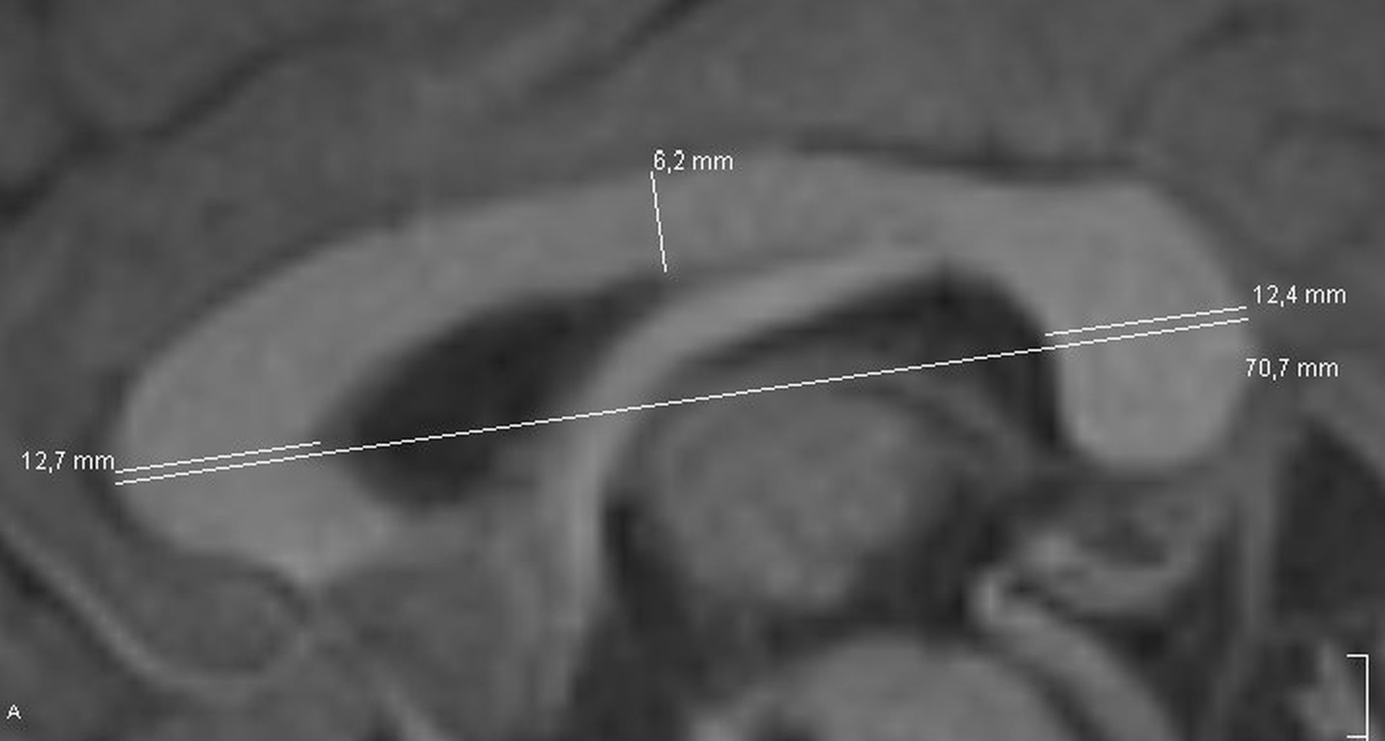
Example of the measurements to calculate CCI with diameters of the genu (12.7 mm), the splenium (12.4 mm), middle part of the corpus callosum (6.2 mm) and greatest anteroposterior diameter (70.7 mm).

