Table 2.
Description of the Python input function of the beginning algorithm code of user RGB data input and Kaggle output
Python # Ask the user for a unit of measurement
unit = input("Please enter concentration unit (eg. mg L-1): ")
Output to the Kaggle web environment (Kaggle) | 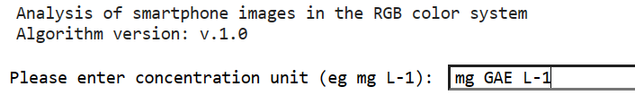
Python # Prompt the user for the value of I₀
I0 = int(input("Please enter the I0 value of the Comparison solution:"))
Kaggle | 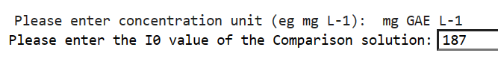
Python # Prompt the user to count the calibration solution point
n_points = int(input("Please enter the number of calibration solution points:"))
Kaggle
Python # Create an empty list for concentrations and RGB values
R = []
G = []
B = []
Python # Prompt the user for each concentration value, R, G and B values
for i in range(1, n_points+1):
concentration = float(input(f"Please enter the value of concentration {i} ({unit}):"))
concentrations.append(concentration)

r = int(input(f"Please enter the {concentration} {unit} R value:"))
g = int(input(f"Please enter the value of concentration {concentration} {unit} G value"))
b = int(input(f"Please enter the value of concentration {concentration} {unit} B value"))
R.append(r)
G.append(g)
B.append(b)
Kaggle | 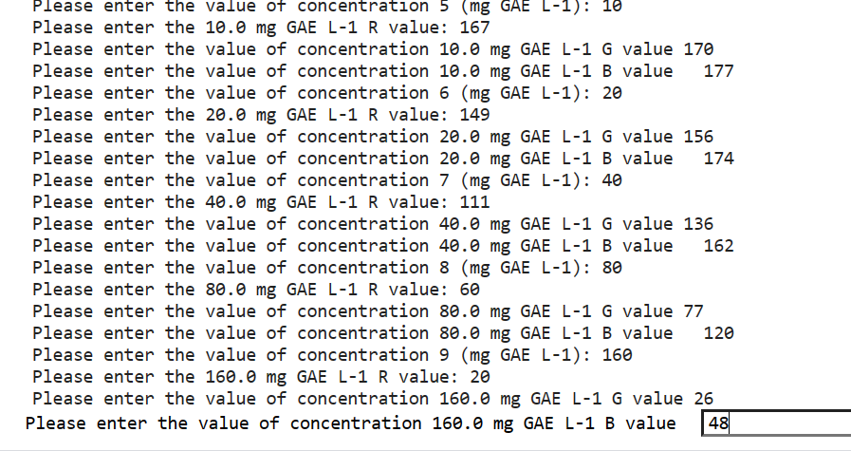
Python # Convert lists to NumPy arrays
concentrations = np.array(concentrations)
R = np.array(R)
G = np.array(G)
B = np.array(B)

Table 3.
A code fragment of the Python algorithm for calculating of absorbance with Kaggle output
Python # Calculation of absorption
A_R = -np.log(R / I0)
A_G = -np.log(G / I0)
A_B = -np.log(B / I0)

print(f"Concentration ({unit}): {concentrations}")
print(f"Absorption R {A_R}")
print(f"Absorption G {A_G}")
print(f"Absorption B {A_B}")
Python # Calculate combined channel absorbances (concentrations, A_R, A_G, A_B)

A_RGB = (A_R + A_G + A_B) / 3
A_RG = (A_R + A_G) / 2
A_RB = (A_R + A_B) / 2
A_GB = (A_G + A_B) / 2
Kaggle | 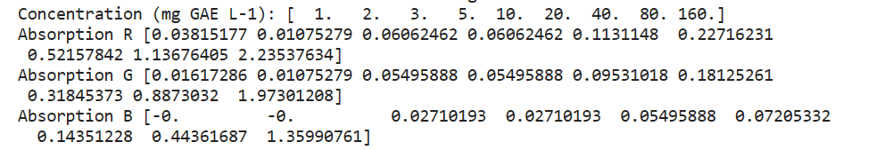

Table 4.
Linear regression calculations for each R, G, B and combined RGB, RG, RB and GB colour channels
Python # Linear regression calculations for each R, G, B and combined RGB, RG, RB and GB colour channels
def linear_regression(x, y):
slope, intercept, r_value, _, _ = linregress(x, y)
R2 = r_value**2
equation = f"y = {slope:.2f}x + {intercept:.4f}"
return slope, intercept, R2, equation

slope_R, intercept_R, R2_R, _ = linear_regression(concentrations, A_R)
slope_G, intercept_G, R2_G, _ = linear_regression(concentrations, A_G)
slope_B, intercept_B, R2_B, _ = linear_regression(concentrations, A_B)
slope_RGB, intercept_RGB, R2_RGB, _ = linear_regression(concentrations, A_RGB)
slope_RG, intercept_RG, R2_RG, _ = linear_regression(concentrations, A_RG)
slope_RB, intercept_RB, R2_RB, _ = linear_regression(concentrations, A_RB)
slope_GB, intercept_GB, R2_GB, _ = linear_regression(concentrations, A_GB)

Table 5.
A algorithm code fragment of calibration curves for R, G, B and combined RGB, RG, RB and GB colour system channels with Kaggle output
Python # Drawing calibration curves
def plot_calibration_curve(x, y, slope, intercept, R2, label, colour):
plt.scatter(x, y, colour=colour, label=f'{label} channel)
plt.plot(x, slope * x + intercept, colour=colour, linewidth=2)
plt.xlabel(f'Concentration ({unit})')
plt.ylabel('Absorption')
plt.legend()
plt.figure(figsize=(12, 8))
Python # Draw the calibration curve for each colour channel
plot_calibration_curve(concentrations, A_R, slope_R, intercept_R, R2_R, 'R', 'red')
plot_calibration_curve(concentrations, A_G, slope_G, intercept_G, R2_G, 'G', 'green')
plot_calibration_curve(concentrations, A_B, slope_B, intercept_B, R2_B, 'B', 'blue')
plot_calibration_curve(concentrations, A_RGB, slope_RGB, intercept_RGB, R2_RGB, 'RGB', 'purple')
plot_calibration_curve(concentrations, A_RG, slope_RG, intercept_RG, R2_RG, 'RG', 'orange')
plot_calibration_curve(concentrations, A_RB, slope_RB, intercept_RB, R2_RB, 'RB', 'cyan')
plot_calibration_curve(concentrations, A_GB, slope_GB, intercept_GB, R2_GB, 'GB', 'magenta')
Python # Set schedule name and display schedule
plt.title('Calibration curves for R, G, B, RGB, RG, RB and GB colour channels')
plt.show()
Kaggle | 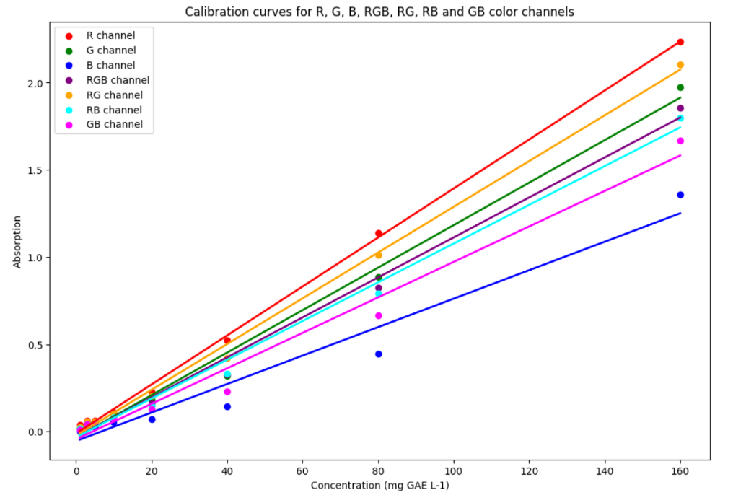

Table 6
Data structure created by Python algorithm code with R² values and equations with Kaggle output
Python # Create a data structure with R² values and equations
data = {
"Channel": ["R", "G", "B", "RGB", "RG", "RB", "GB"],
"R²": [R2_R, R2_G, R2_B, R2_RGB, R2_RG, R2_RB, R2_GB],
"Equation": [f"y = {slope_R:.4f}x + {intercept_R:.4f}",
f"y = {slope_G:.4f}x + {intercept_G:.4f}",
f"y = {slope_B:.4f}x + {intercept_B:.4f}",
f"y = {slope_RGB:.4f}x + {intercept_RGB:.4f}",
f"y = {slope_RG:.4f}x + {intercept_RG:.4f}",
f"y = {slope_RB:.4f}x + {intercept_RB:.4f}",
f"y = {slope_GB:.4f}x + {intercept_GB:.4f}"]
}
Python # Create a pandas DataFrame with R² values
R2_df = pd.DataFrame(data)
Python # Obtain the DataFrame
print(R2_df)
Kaggle | 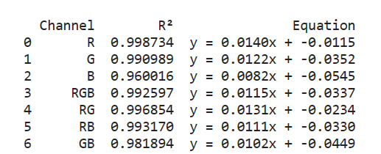

Table 7

A snippet of the code for the vegetable oil samples analysed by the Python algorithm for sample count, colour channel selection, and name retrieval with Kaggle output
Python # Prompt the user to enter the number of samples to be analysed
n_unknown_samples = int(input("Please enter the number of samples to analyse"))
Kaggle
Python # Choose which colour system channels to calculate the concentration
channels = input("Please select a channel to calculate concentration (R, G, B, RGB, RG, RB, GB):")
Kaggle
Python # Obtaining the names of the samples to be analysed
unknown_sample_names = []
for i in range(1, n_unknown_samples + 1):
sample_name = input(f"Please enter the name of the sample {i} to be analysed:")
unknown_sample_names.append(sample_name)
Kaggle | 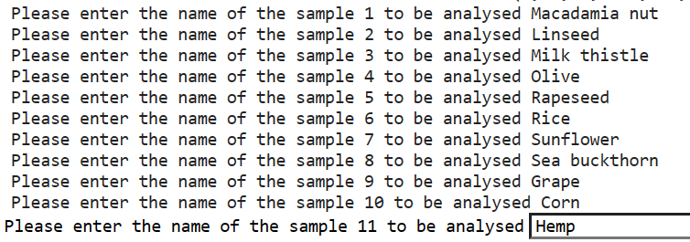

Table 8
Python algorithm code for calculating the concentration of the analysed sample with Kaggle output
Python # Obtaining the values of the analysed samples and calculating the concentration
unknown_concentrations = []
for i in range(n_unknown_samples):
if channels == "R":
r = int(input(f"Please enter the R value of the sample to be analysed {unknown_sample_names[i]}:"))
A = -np.log(r / I0)
concentration = (A - intercept_R) / slope_R
elif channels == "G":
g = int(input(f"Please enter the G value of the sample to be analysed {unknown_sample_names[i]}:"))
A = -np.log(g / I0)
concentration = (A - intercept_G) / slope_G
elif channels == "B":
b = int(input(f"Please enter the B value of the sample to be analysed {unknown_sample_names[i]}:"))
A = -np.log(b / I0)
concentration = (A - intercept_B) / slope_B
elif channels == "RGB":
r = int(input(f"Please enter the R value of the sample {unknown_sample_names[i]} to be analysed:"))
g = int(input(f"Please enter the G value of the sample {unknown_sample_names[i]} to be analysed:"))
b = int(input(f"Please enter the B value of the sample {unknown_sample_names[i]} to be analysed:"))
A = -np.log(np.mean([r, g, b]) / I0)
concentration = (A - intercept_RGB) / slope_RGB
elif channels == "RG":
r = int(input(f"Please enter the R value of the sample {unknown_sample_names[i]} to be analysed:"))
g = int(input(f"Please enter the G value of the sample {unknown_sample_names[i]} to be analysed:"))
A = -np.log(np.mean([r, g]) / I0)
concentration = (A - intercept_RG) / slope_RG
elif channels == "RB":
r = int(input(f"Please enter the R value of the sample {unknown_sample_names[i]} to be analysed:"))
b = int(input(f"Please enter the B value of the sample {unknown_sample_names[i]} to be analysed:"))
A = -np.log(np.mean([r, b]) / I0)
concentration = (A - intercept_RB) / slope_RB
elif channels == "GB":
g = int(input(f"Please enter the G value of the sample {unknown_sample_names[i]} to be analysed:"))
b = int(input(f"Please enter the B value of the sample {unknown_sample_names[i]} to be analysed:"))
A = -np.log(np.mean([g, b]) / I0)
concentration = (A - intercept_GB) / slope_GB
unknown_concentrations.append(concentration)
Kaggle | 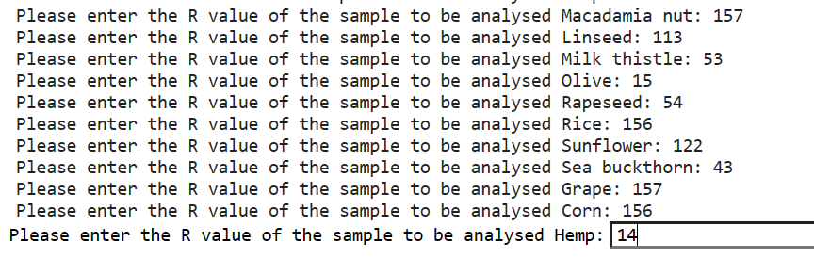
Table 9.
Python algorithm code for outputting analysed vegetable oil total phenol content data, inputting document name and saving data in Microsoft Excel format with Kaggle output
Python # Create a table with the results using pandas
results_df = pd.DataFrame({"Sample": unknown_sample_names, f"Concentration ({unit})": unknown_concentrations})
Python # Set the index of the DataFrame to start at 1
results_df.index = results_df.index + 1
Python #Output of the concentration of the analyte
print(f"\nConcentrations of samples to be analysed ({unit}):")
print(results_df)
Kaggle | 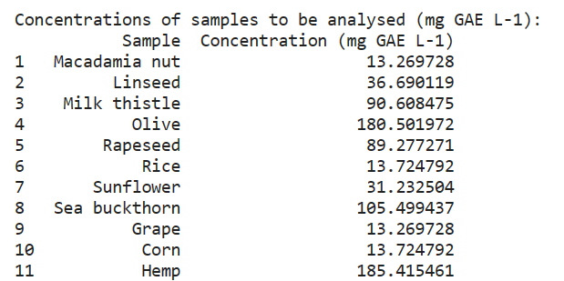
Python # Prompt the user for a document name
excel_file = input("Please enter a document name to save:") + '.xlsx'
Kaggle
Python # Adjust the column name to add the unit of measurement
results_df = results_df.rename(columns={"Concentration": f"Concentration({unit})"})
Python Save the obtained data in Microsoft Excel document format
with pd.ExcelWriter(excel_file, engine='openpyxl') as writer:
results_df.to_excel(writer, sheet_name='Results', index_label='No')
print(f"Results are saved in Microsoft Excel file '{excel_file}'.")
Kaggle

