Fish Active Packaging with ZnO/Fe-MMT nanoparticles

Kaveh Rahmanifarah*1, Mehdi Mahmoudian2, Somayeh Mahmoudi Eskandarabadi2
1Department of Pathobiology and Quality Control, Artemia and Aquaculture Research Institute, Urmia University, Urmia, Iran
2Nanotechnology Department, Faculty of Science, Urmia University, Urmia, Iran

Results and Discussion
SDS-page pattern
Many characteristics of meat tissue depend on myofibrillar proteins. Myosin is one of the most important proteins from the family of myofibrillar proteins. Myosin heavy chains (MHC) are very susceptible to hydrolysis and their size reduction is a measure of meat quality during the storage period. The changes in myosin size in the electrophoresis pattern of SDS-PAGE gel were investigated during the storage period, and the results are shown in Fig8 S1-S4. It was observed that MHC was 63 kD at the beginning of the experiment (Fig S1), and decreased to 48 kD on the third day (Fig S2), and remained almost unchanged until the ninth day (Fig S4). As seen in the patterns, all the samples in this test have shown a similar pattern.
Fig.8. Electrophoresis patterns of SDS-PAGE gels of myosin from rainbow trout fillets stored in 4℃.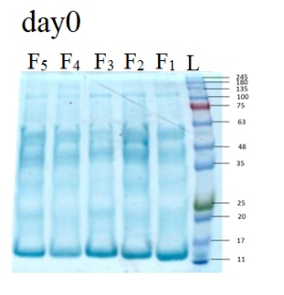
Fig S1. Electrophoresis patterns of SDS-PAGE gels of myosin from rainbow trout fillets stored in 4℃ in the day 0 of storage.
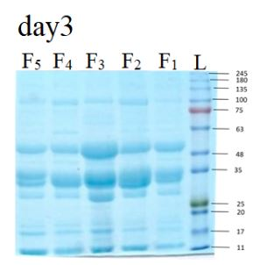
Fig S2. Electrophoresis patterns of SDS-PAGE gels of myosin from rainbow trout fillets stored in 4℃ in the day 3 of storage.
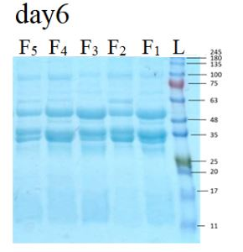
Fig S3. Electrophoresis patterns of SDS-PAGE gels of myosin from rainbow trout fillets stored in 4℃ in the day 6 of storage.

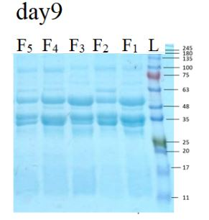
Fig S4. Electrophoresis patterns of SDS-PAGE gels of myosin from rainbow trout fillets stored in 4℃ in the day 9 of storage.

Corresponding author:
* Fatemeh Ahour
E-mail: Fatemeh.ahour@gmail.com, f.ahour@urmia.ac.ir; Fax: +98 44-32752746

EXPERIMENTAL
Materials and instruments
Deionized water was used to prepare the solutions. All chemicals consisting Graphite, acrylic acid, aniline, 2-bromopropinyl bromide (BPB, 97%), potassium ethyl xanthate, potassium permanganate, ammonium persulfate, diallyl dimethylammonium chloride, carbon disulphide and ethanol (synthetic grade), pyridine, N-methylpyrrolidone (NMP), N,N-dimethylformamide (DMF), acetone, chloroform, dichloromethane and diethyl ether, N,N'-Methylenebisacrylamide (MBA), azobisisobutyronitrile (AIBN), phosphoric acid, sulfuric acid, ammonium nitrate, hydrogen peroxide (30%), hydrochloric acid and potassium hydroxide) were purchased from Sigma-Aldrich. Sodium dihydrogen arsenate (NaH₂AsO₄), arsenic (III) trioxide (As₂O₃), nitrate salt of metals cations (Ag⁺, Cu²⁺, Co²⁺, Cd²⁺, Pb²⁺, Fe²⁺), tyrozin, acetaminophene, isoniazide and ascorbic acid and other analyts of anlytical grade were purchased from Sigma-Aldrich and used without further purification. Stock solutions of analytes (0.1 M) were prepared from the purchased chemicals as per the experimental requirements. Analytical solutions were prepared using deionized water. IR spectra were recorded by a Nicolet FT-IR NEXUS 670 spectrometer (Thermo Scientific, USA) and used to identify the presence of functional groups in the synthesized compounds. TESCAN MIRA III scanning electron microscope was used to record FE-SEM, EDAX and mapping images. pH was measured using a digital pH meter (HANNA 212). An ultrasonic bath (KODO model JAC1002) was used to clean the GCE surface and prepare homogeneous suspensions of modifiers.
Preparation of modified GO
For the synthesis of graphene oxide, the modified Hummer method was used. In this method, initially, graphite powder (5 g) was dispersed in a mixture of H₃PO₄ (12ml) and H₂SO₄ (100 ml) for 60 min. In the next step, ammonium nitrate (5 g) was added to the mixture. In continue, KMnO₄ (3 g) was added, and stirring was continued in a ice bath at 5°C for 2 h. Then the temperature was raised up to 98 °C, so that the process of oxidation and exfoliation can be done in the best way. Graphene oxide was stirred under these conditions for 1 hour and then distilled water was slowly added to the solution along with 20 ml of hydrogen peroxide (30%) to complete the oxidation process. Finally, The resulting sediment was washed several times with distilled water to neutralize its pH. The prepared sediment was separated by centrifugation at a speed of 5000 rpm and dried at 60 °C.
Functionalization of GO with acrilic acid
To create the acrylic acid functionality on the surface of graphene oxide, bromopropionyl bromide (BPB) was used as a linker to anchor the xanthate agent on the surface. For this purpose, graphene oxide (250 mg) was dispersed in pyridine (40 ml) and deoxygenated with a stream of nitrogen gas, and then BPB (3 ml) was added drop by drop to the reaction. The mixture was stirred for 3 hours at a temperature of 0°C and 48 hours at a temperature of 25°C until the reaction was complete and finally the sediment was washed three times with chloroform to separate unreacted BPB. The product (GO-BPB) was dried under vacuum at 50°C.
Potassium ethyl xanthate was used to create xanthate groups, which is the initiator of RAFT. This reagent was synthesized and used according to our previous report.⁴¹
GO-BPB (100 mg) and potassium ethyl xanthate (0.5 g) were mixed together and poured into a round-bottom flask and degassed after sealing. The mixture of dichromethane (8 ml) and pyridine (3 ml) was degassed in another vessel and added to the container containing the ingredients with a syringe. This mixture was stirred at room temperature for 48 hours and then diluted with dichloromethane (50 ml). The obtained sediment after centrifugation was dried at 50°C under vacuum.
Polymerization of acrylic acid on the surface of graphene oxide was done by reversiable addition fragmmentation chain transfer polymerization (RAFT) method. In this reaction, xanthate fixed on graphene oxide acts as an initiator. Graphene oxide with xanthate groups (50 mg) along with AIBN (3 mg) was dissolved in DMF (2 ml) and degassed. Acrylic acid (2 ml) was degassed in another container and injected into the container containing modified graphene oxide. The reaction was continued at 90°C for 48 hours and then the resulting black precipitate was washed several times with acetone and distilled water and dried at 50°C under vacuum.
Preparation of nanocamposite
Synthesis of polyaniline
To prepare polyaniline, two containers were needed. In a sealed container, aniline (0.5 ml) was mixed with 1M hydrochloric acid solution (50 ml). In the second vessel, an oxidizing solution was prepared by combining ammonium persulfate (1.55 g) with 1 M hydrochloric acid (50 ml). The solutions of both containers were placed in an ice water bath until the temperature reach to 0 °C. The first container was degassed using nitrogen, and then the solution prepared in the second container was added drop by drop to the first one over a period of 1 hour and the resulting precipitate was filtered, washed with a mixture of water and ethanol and finally stirred in an ammonia solution (1M) for 48 hours. The prepared green color sediment confirms the formation of polyaniline doped with ammonia, the resulting sediment was centrifuged, separated and dried at 40 °C.
Synthesis of AA-GO doped PDDA-PA nanocomposite
The method used to prepare the nanocomposite applied on the electrode surface has been reported in previous studies.⁴¹ Diallyl dimethylammonium chloride (0.5 g) was poured into a solution of AA-GO containing 1mg/ml. Then, ammonium persulfate was added to the above solution 5 wt%. After the complete dissolution of the initiator in this solution, the cross-linking agent (MBA) was added to the solution 30 wt% of the monomer. This solution was thoroughly stirred until a clear solution was prepared. In the next step, 0.003 g of polyaniline was added to the above solution. An ultrasonic probe was used to disperse this solution completely. Finally, this mixture was used to modify the electrode surface.
Preparation of nanocomposite modified electrode
In this research, casting method was used to modify the electrode surface. For this purpose, 0.5 μl of the nanocomposite solution prepared in the previous step was dropped on the surface of the electrode using a sampler and dried at 40 °C for 24 hours. The prepared electrode was used in quantitative arsenic detection experiments.
RESULTS AND DISCUSSION
Preliminary experiments
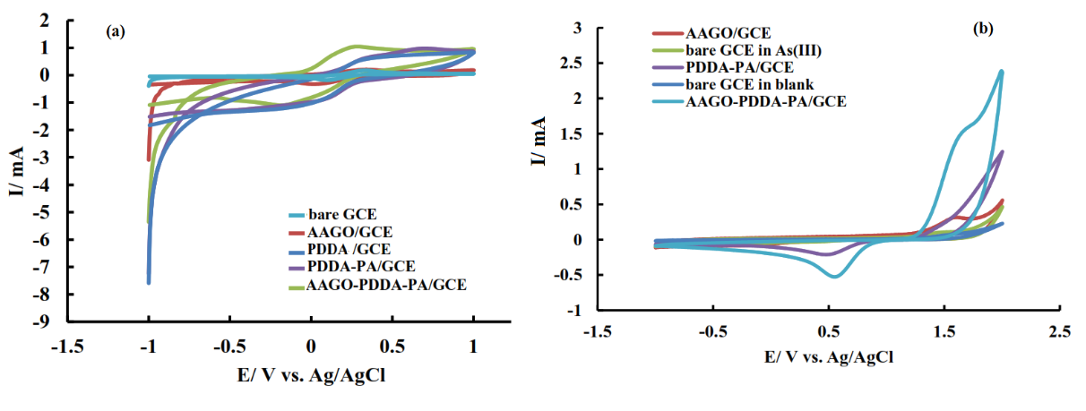 Figure S1. CV experiments of bare and modified electrodes in (a) 5 mM ferri-ferro containing 0.5 M NaCl; (b) in 10 mM arsenite solution. scan rate: 50 mV s⁻¹.

Concentration effect and detection limit
Table S1. Measurement results of As in rice powder and water samples
Sample | AsO₄³⁻added (μM) | AsO₄³⁻ found (nM) | Recovery (%) | RSD (%) [a]
rice powder | 0 | 0 |  | 1.9
rice powder | 2 | 2.09 | 104 | 2.8
rice powder | 5 | 4.93 | 98.6 | 3.3
Tap water | 0  3  6 | 0  3.11  6.19 | 103.6  103.2 | 1.8  2.1  2.6

