Supplemental Figure 1. Expression of key genes in CHOL from TCGA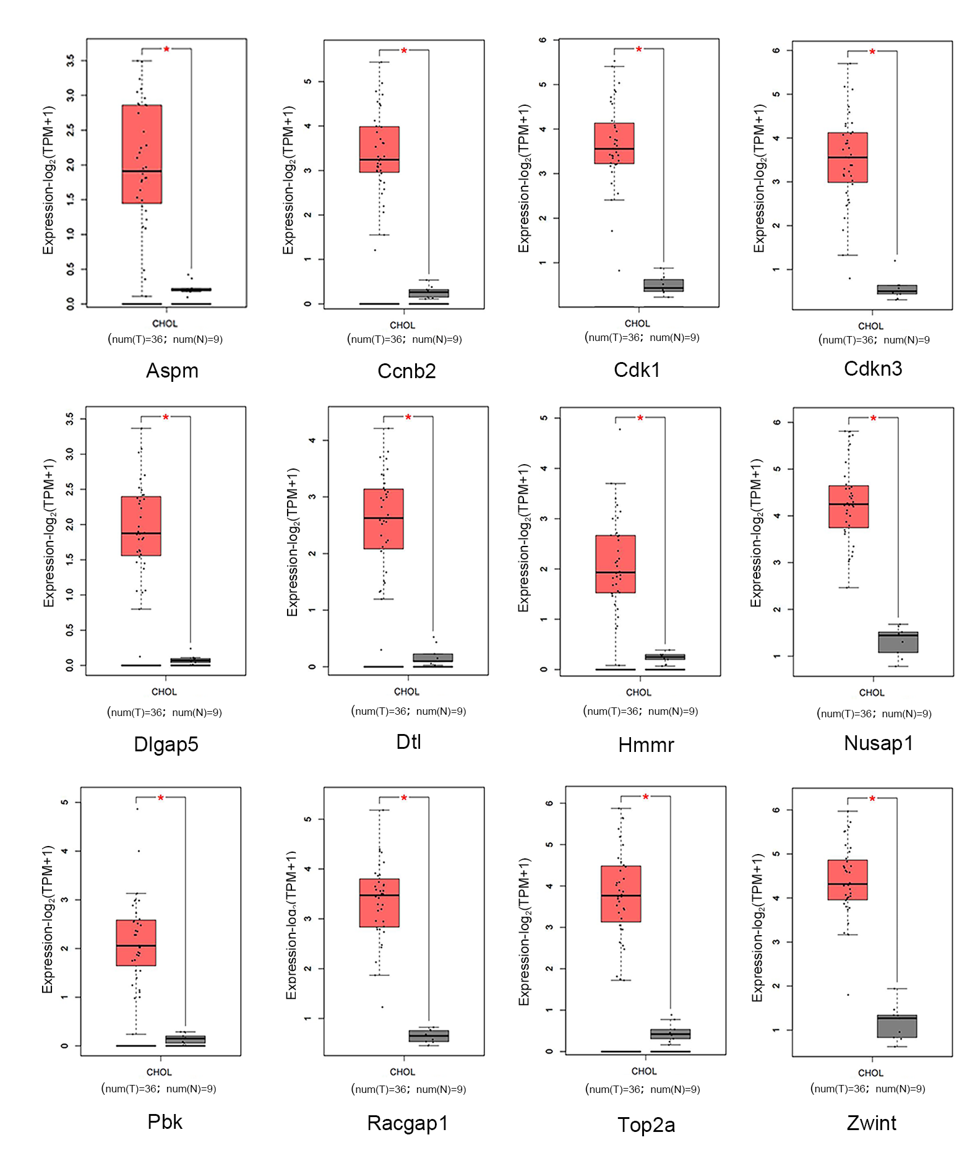
mRNA expression analysis of Aspm, Ccnb2, Cdk1, Cdkn3, Dlgap5, Dtl, Hmmr, Nusap1, Pbk, Racgap1, Top2a, Zwint in CHOL from TCGA. Red represents tumor tissue, and gray represents normal tissue. *P<0.01.

Supplemental Figure 2. Expression of CDK1 and DLGAP5
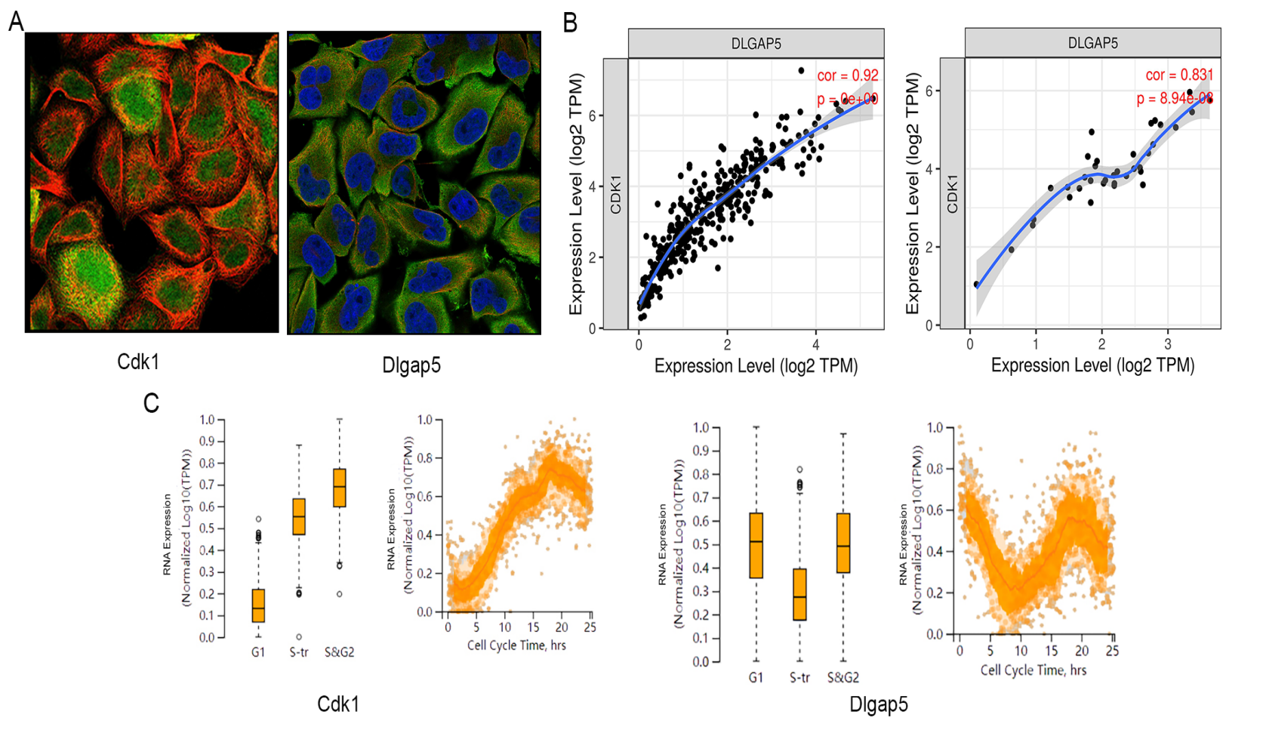
(A) Immunofluorescence staining of CDK1 and DLGAP5 in liver cancer. Nuclei, blue; microtubules, red; target protein, green. (B) Relative expression of CDK1 and DLGAP5 in LICH and CHOL. (C) RNA expression of CDK1 and DLGAP5 in different time of cell cycle.

