AZINE BASED OLIGOESTERIC CHEMOSENSORS FOR Cu²⁺ ION DETECTION: SYNTHESIS, STRUCTURAL CHARACTERIZATION, AND THEORETICAL INVESTIGATIONS

Subramani Manigandan¹³, Athianna Muthusamy^{1*}, Siddeswaran Anand^{3*}

¹PG and Research Department of Chemistry, Sri Ramakrishna Mission Vidyalaya College of Arts and Science, Coimbatore-641 020, Tamil Nadu, India, ,
²Department of Chemical Engineering, Chonnam National University, 77 Yongbongro, Buk-gu, Gwangju 61186, South Korea,
3 Department of Chemistry, K.S.R. College of Engineering, KSR Kalvinagar, Tiruchengode 637215, Tamilnadu,India

*Corresponding Authors:
Siddeswaran Anand: Email:dnanapoly@gmail.com
Athianna Muthusamy: E-mail: muthusrkv@gmail.com
Supplementary images
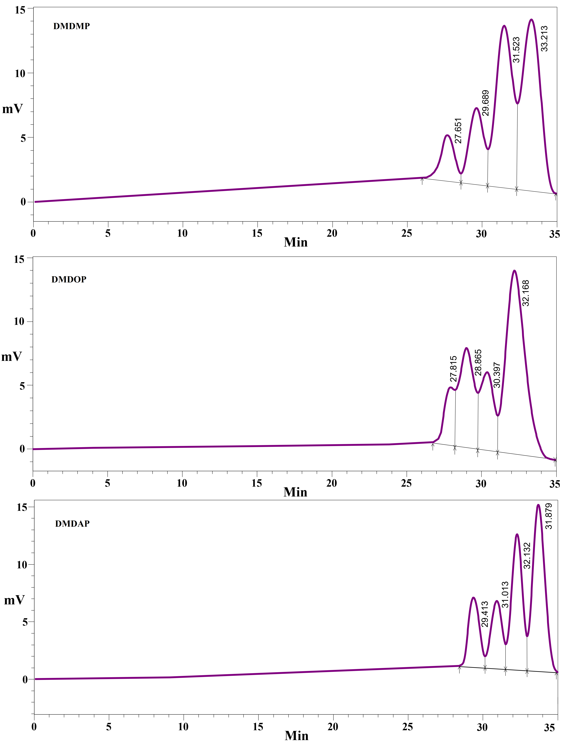

SF.1. GPC chromatogram of oligoesters
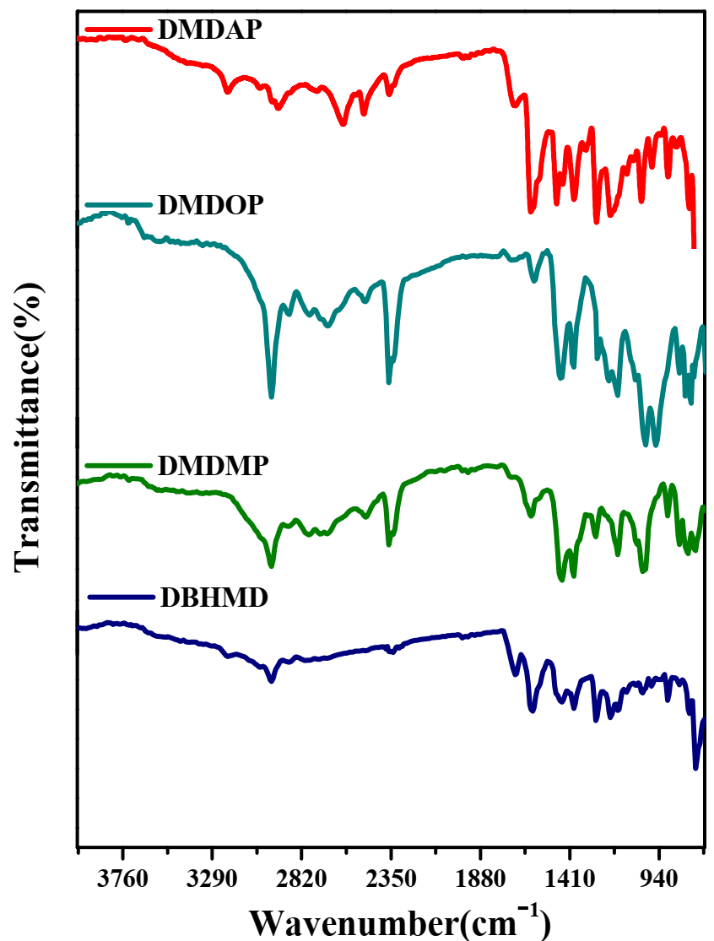
SF.2. FT–IR spectra of monomer and oligoesters

SF.3. ¹H and ¹³C–NMR spectra of DBHMD
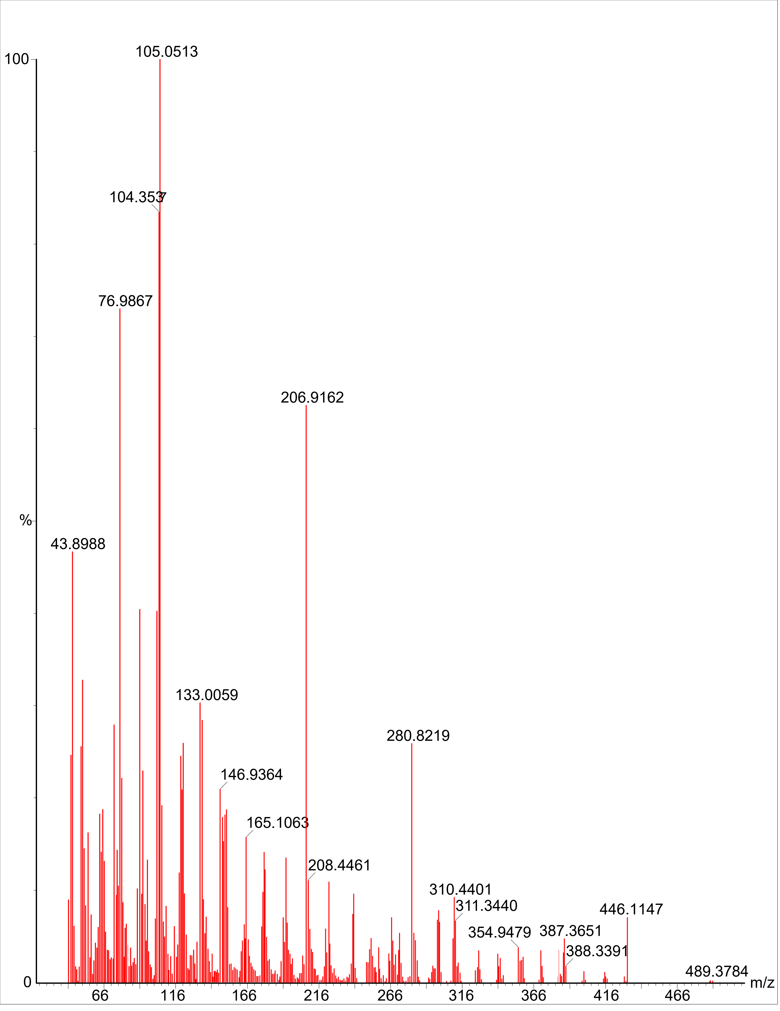
SF.4. Mass spectrum of DBHMD
SF.5. ¹H and ¹³C–NMR spectra of oligoesters
SF.6. ³¹P–NMR spectra of DMDMP and DMDOP

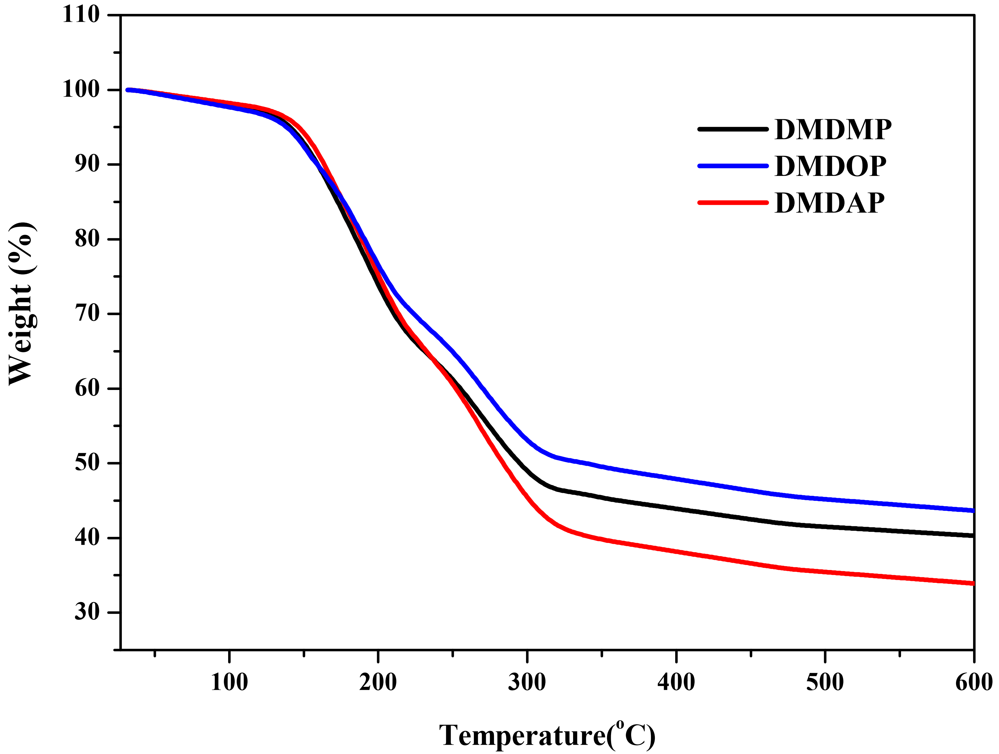
SF.7. TGA traces of oligoesters
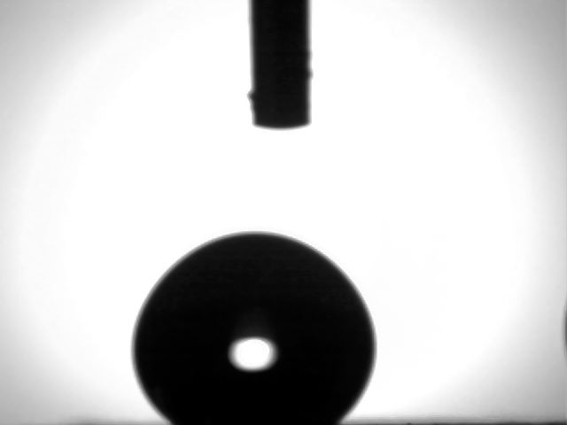
SF.8. The static contact angle's droplet
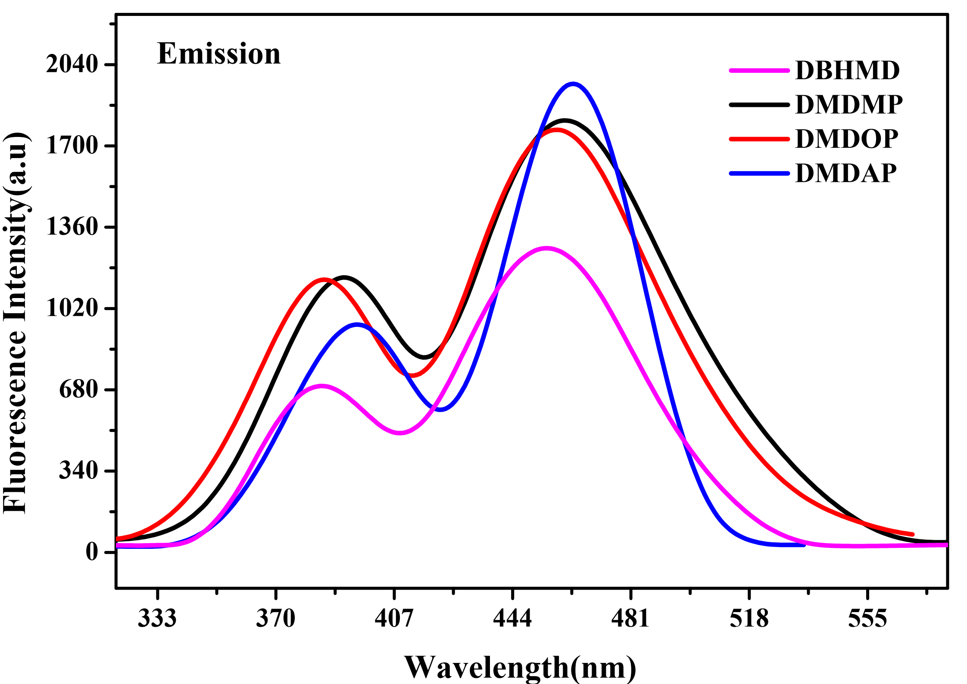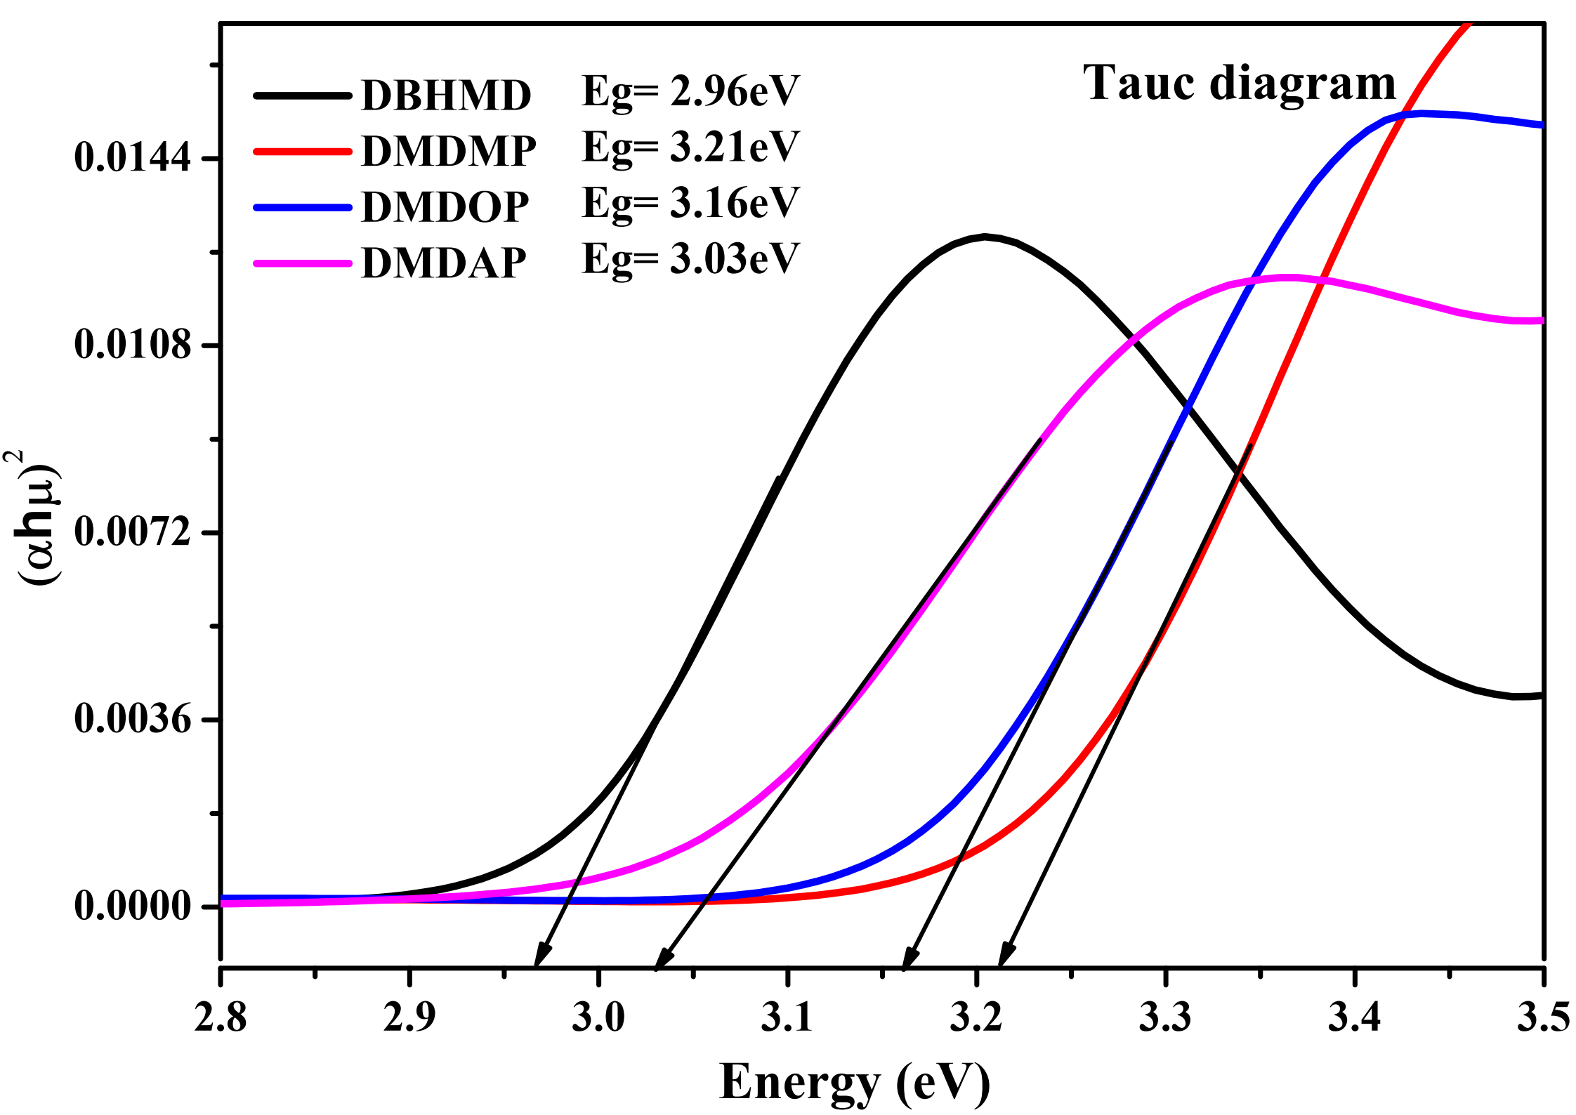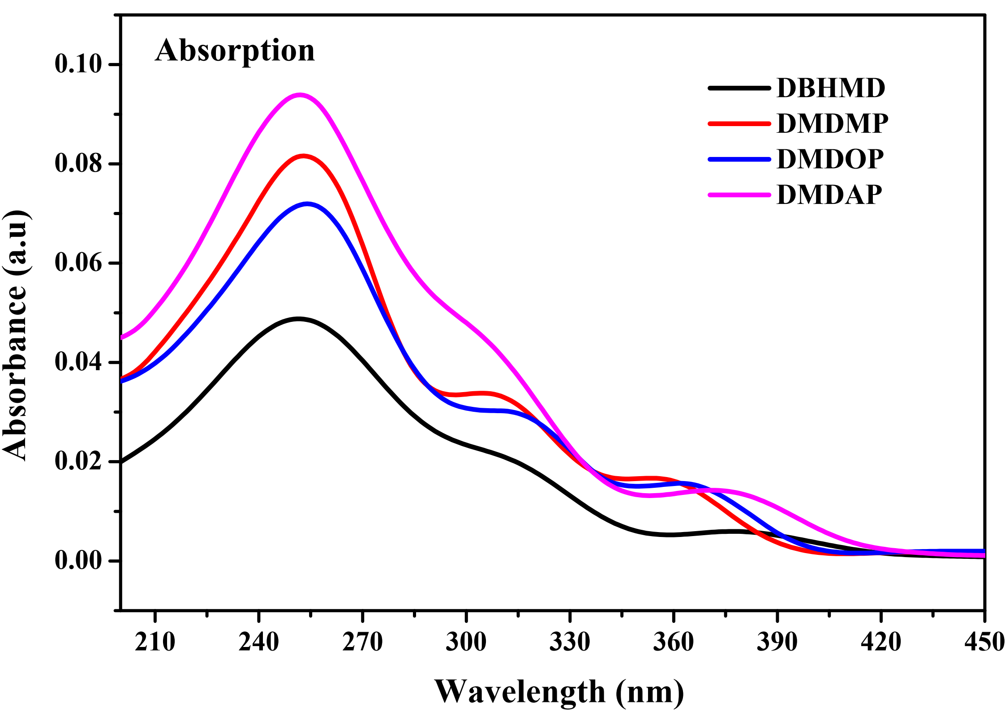
SF.9. Absorption, emission and Tauc energy gap spectra
of monomer and oligoesters

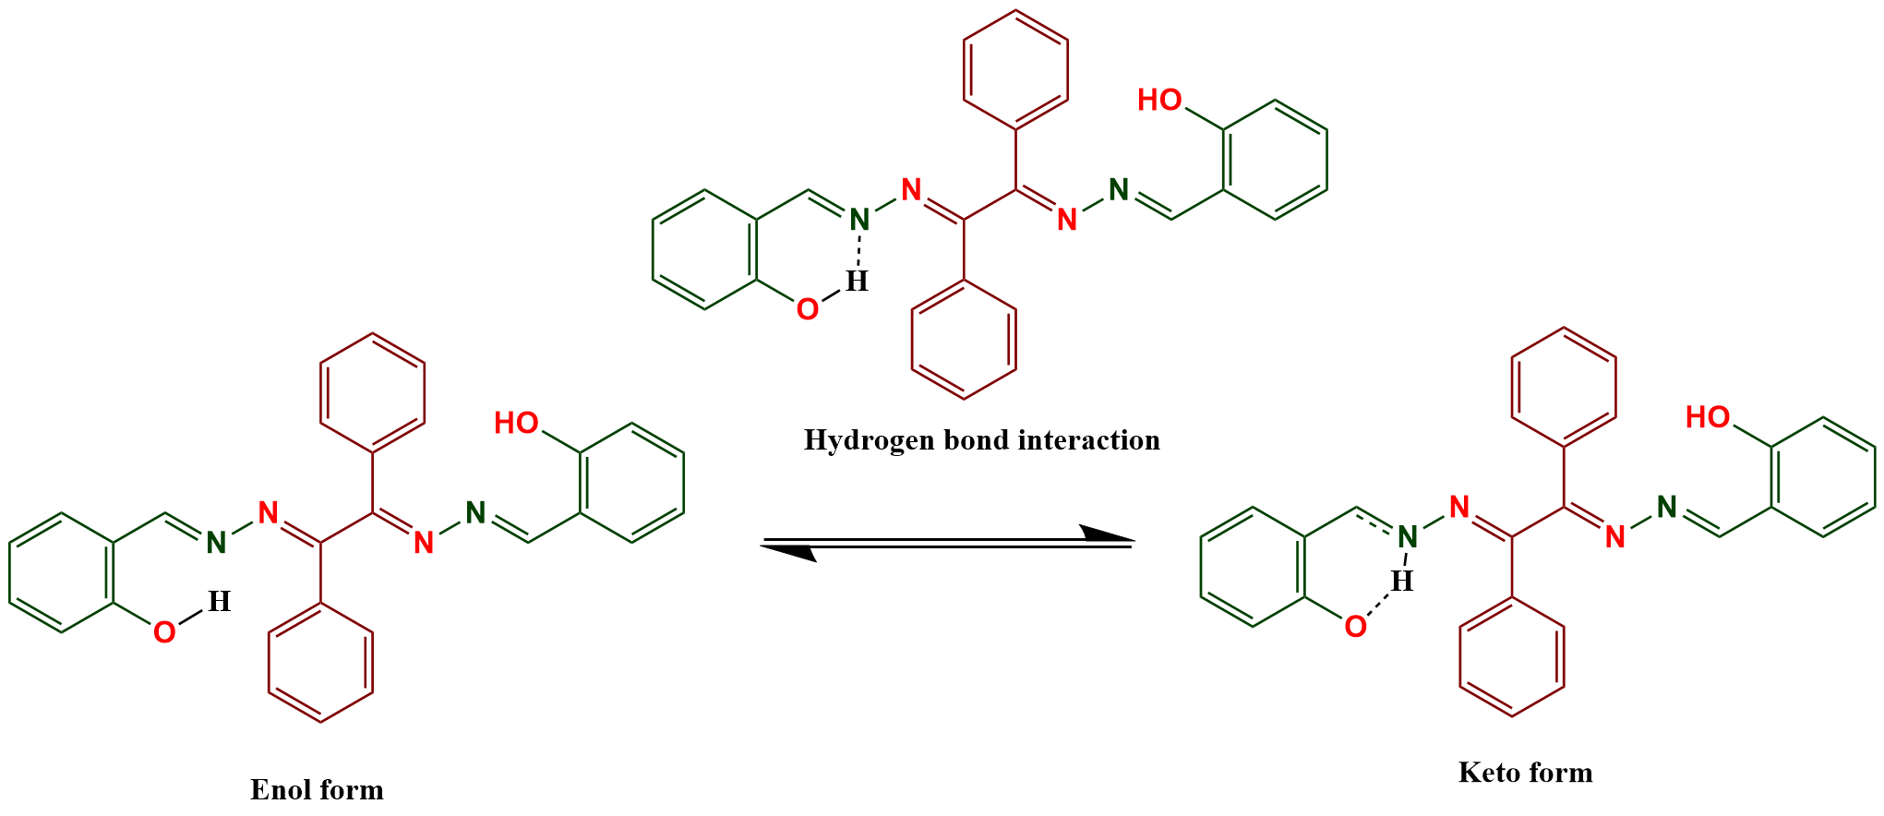
SF.10. Keto enol tautomerism of compound DBHMD
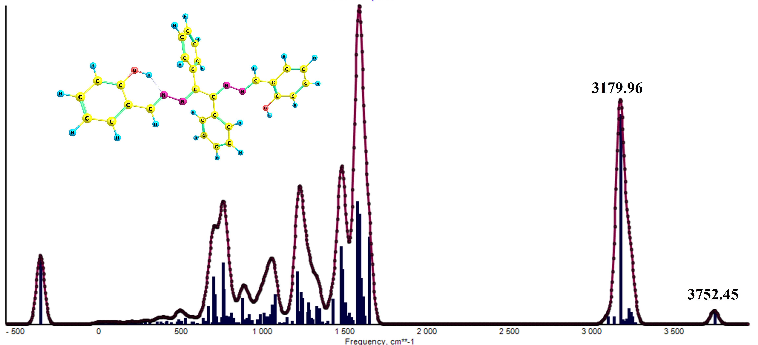
SF.11. FT-IR Spectrum of DBHMD
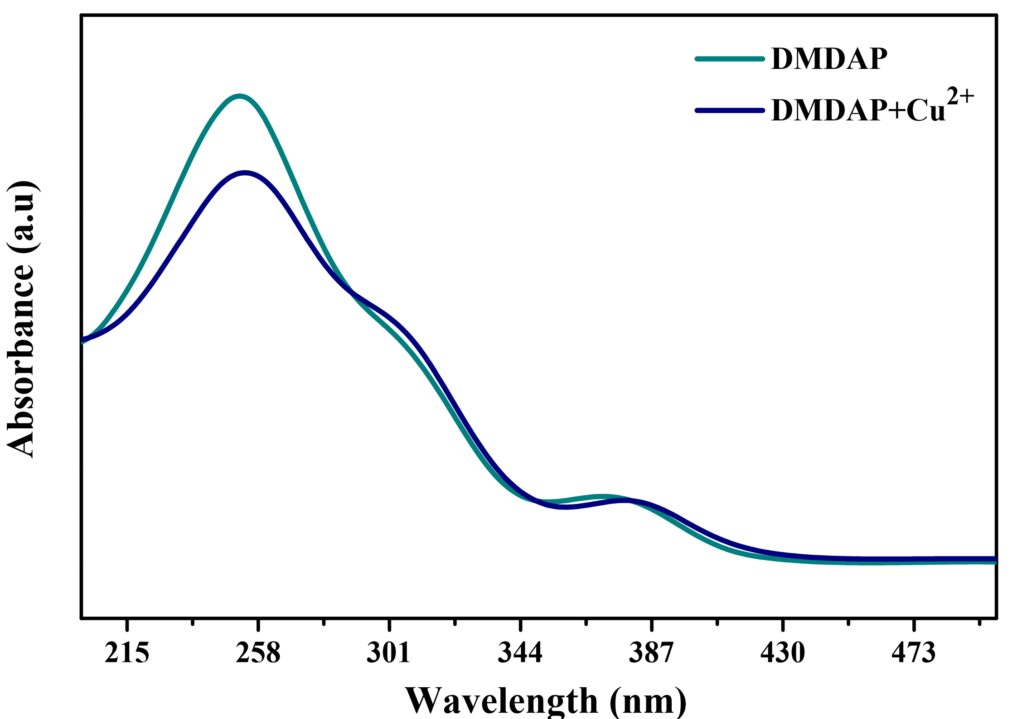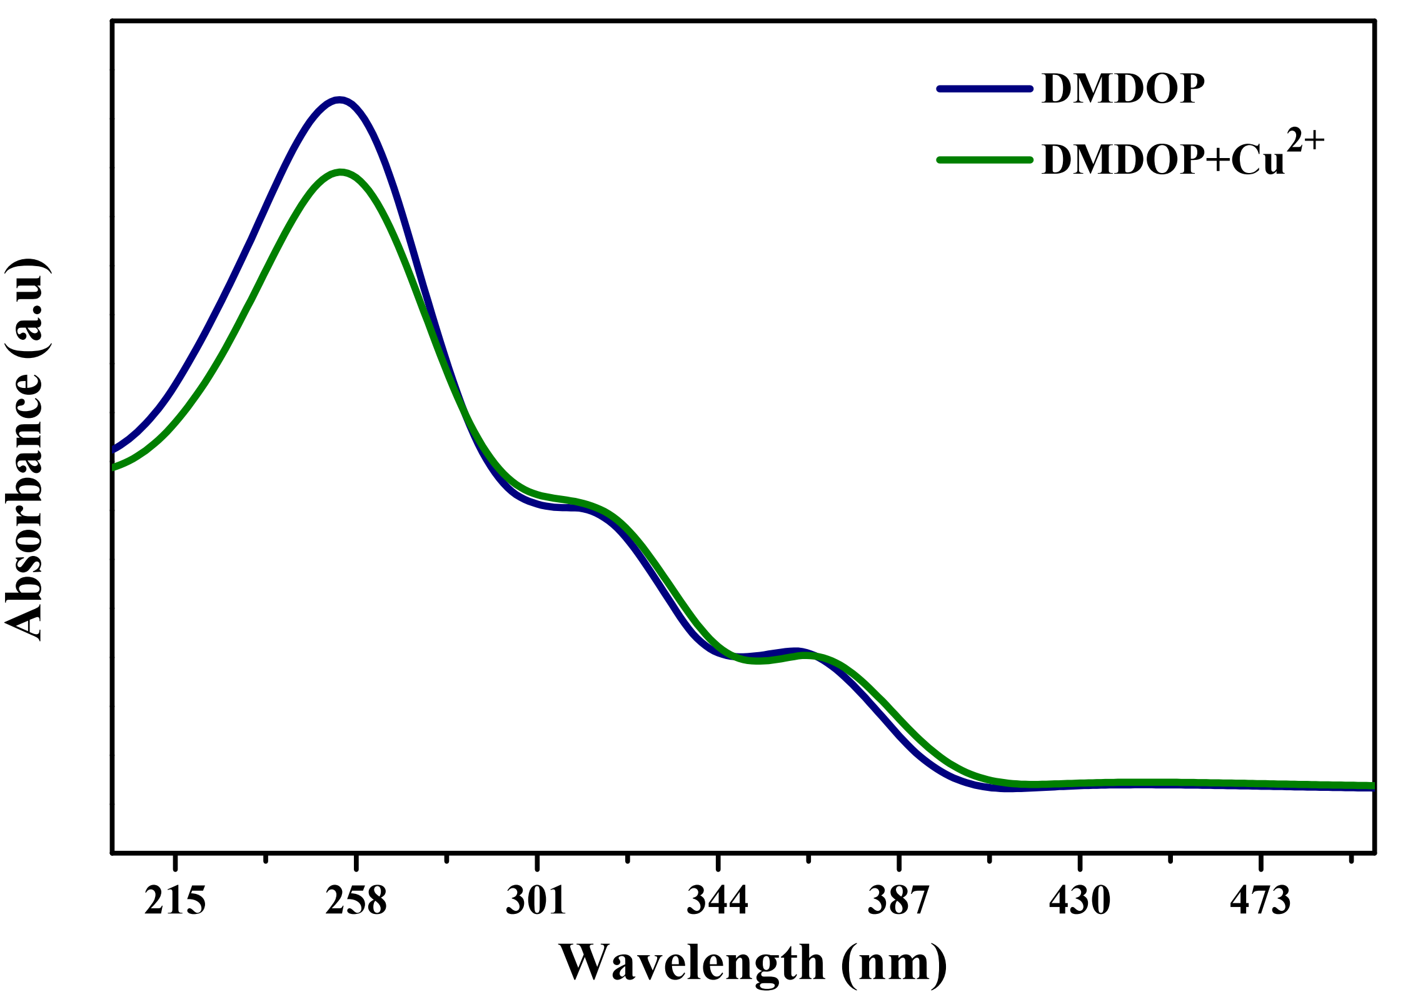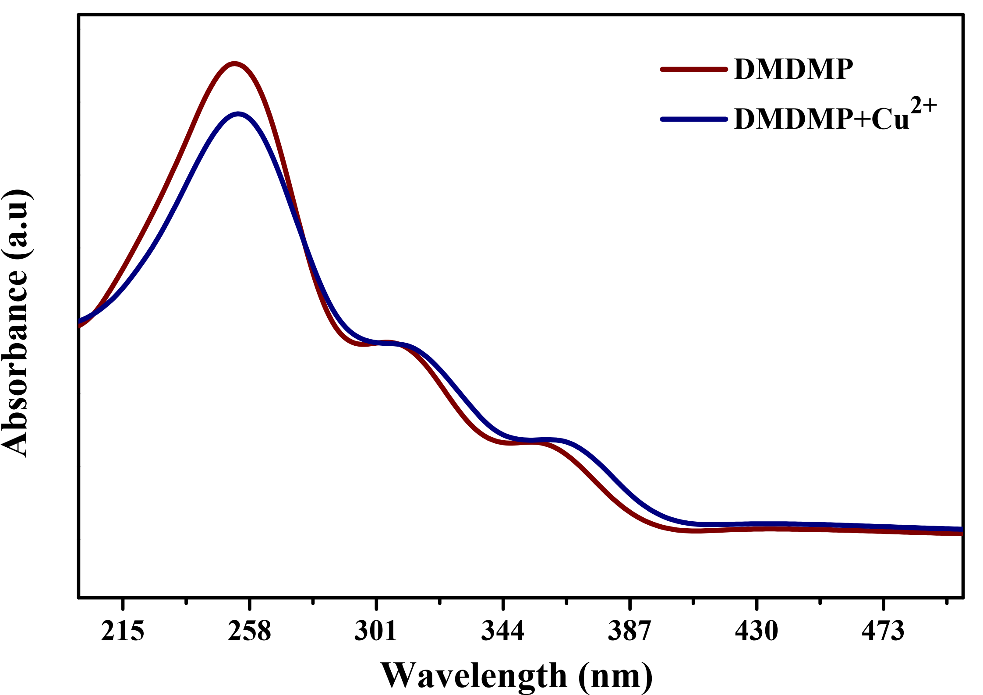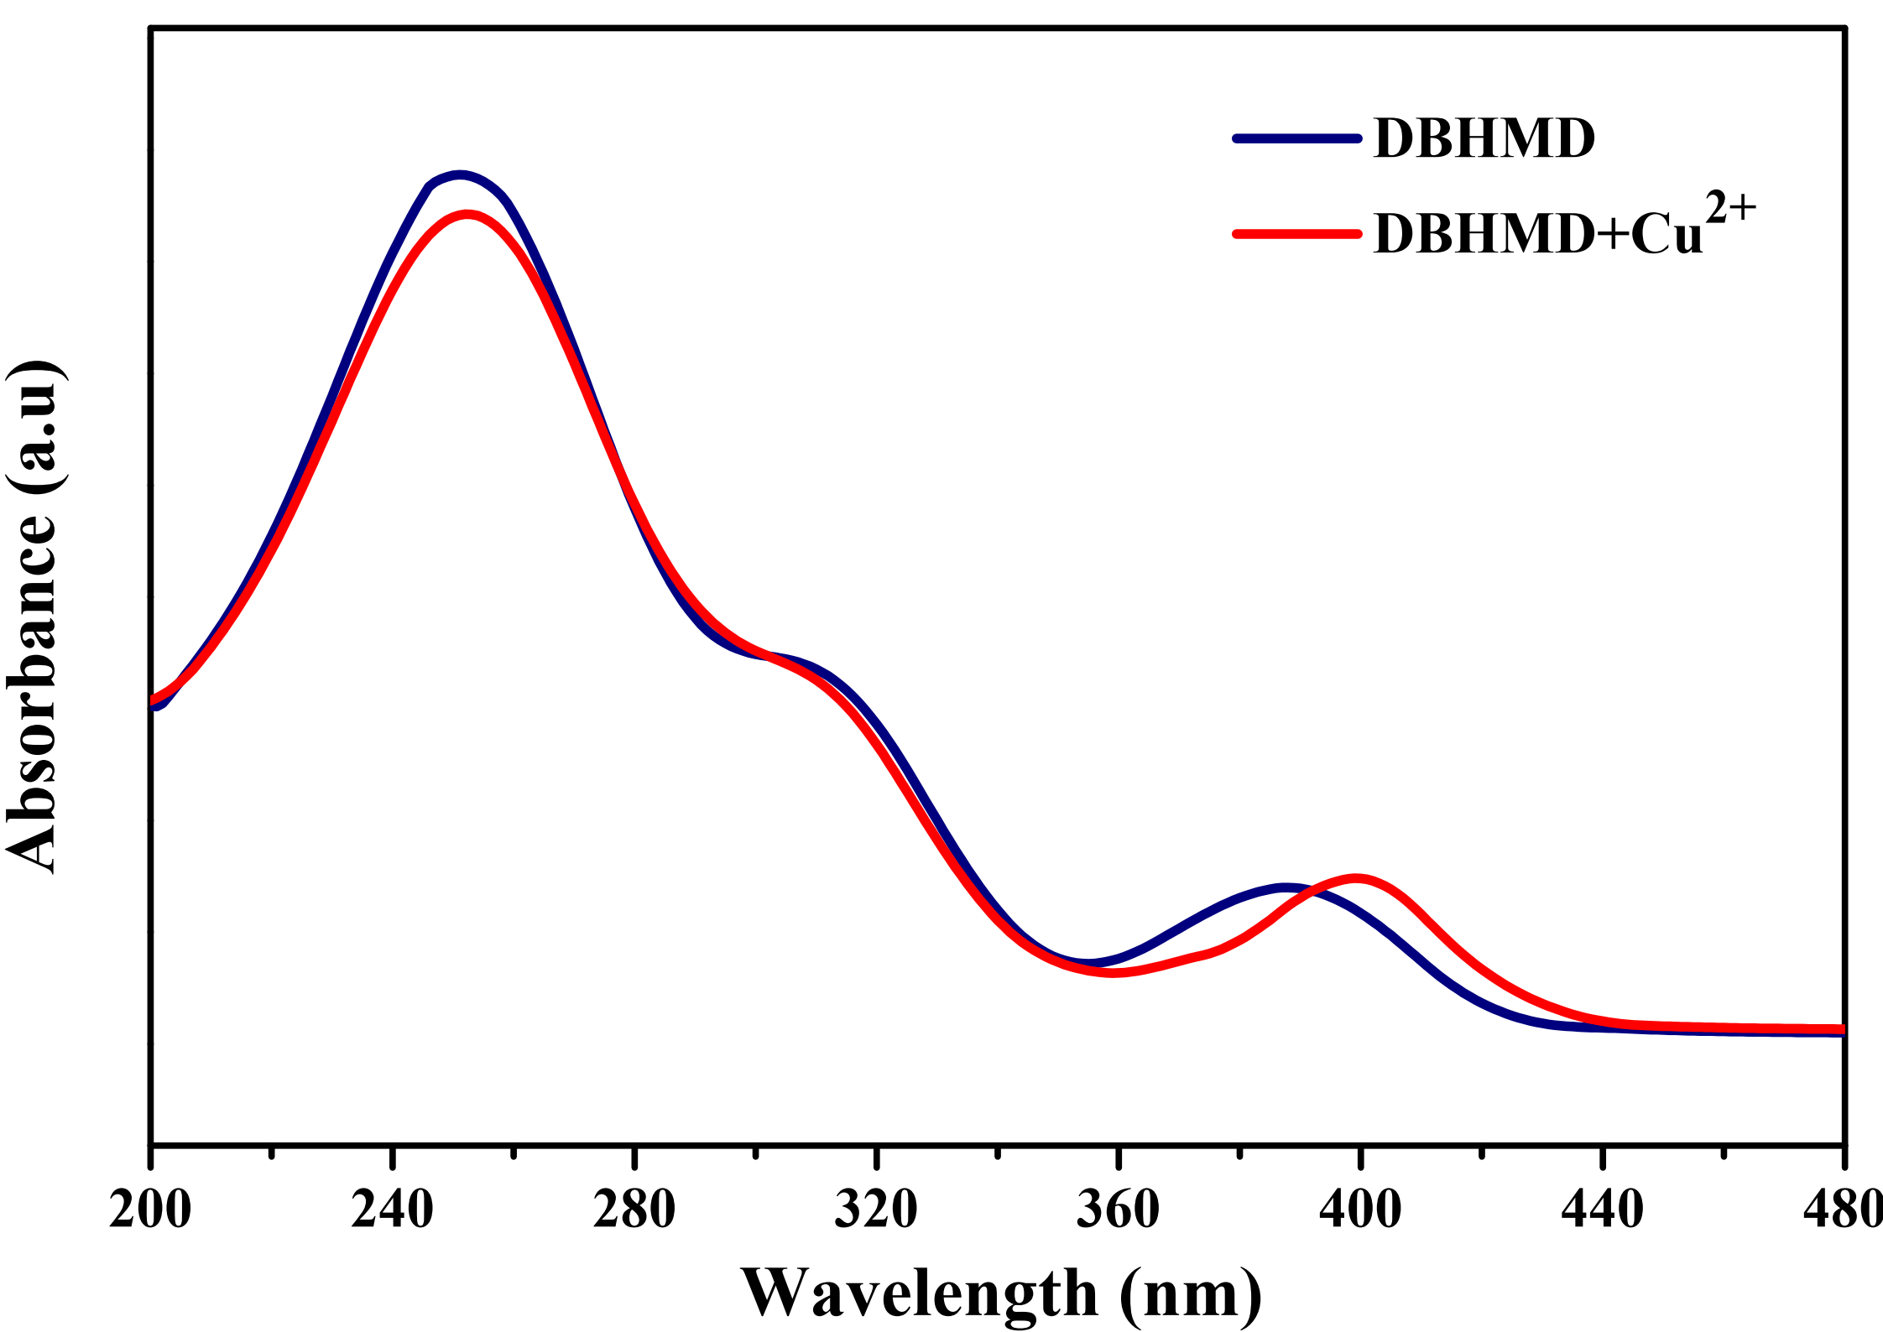
SF.12. Absorption shift of monomer and oligoesters with Cu²⁺ ion
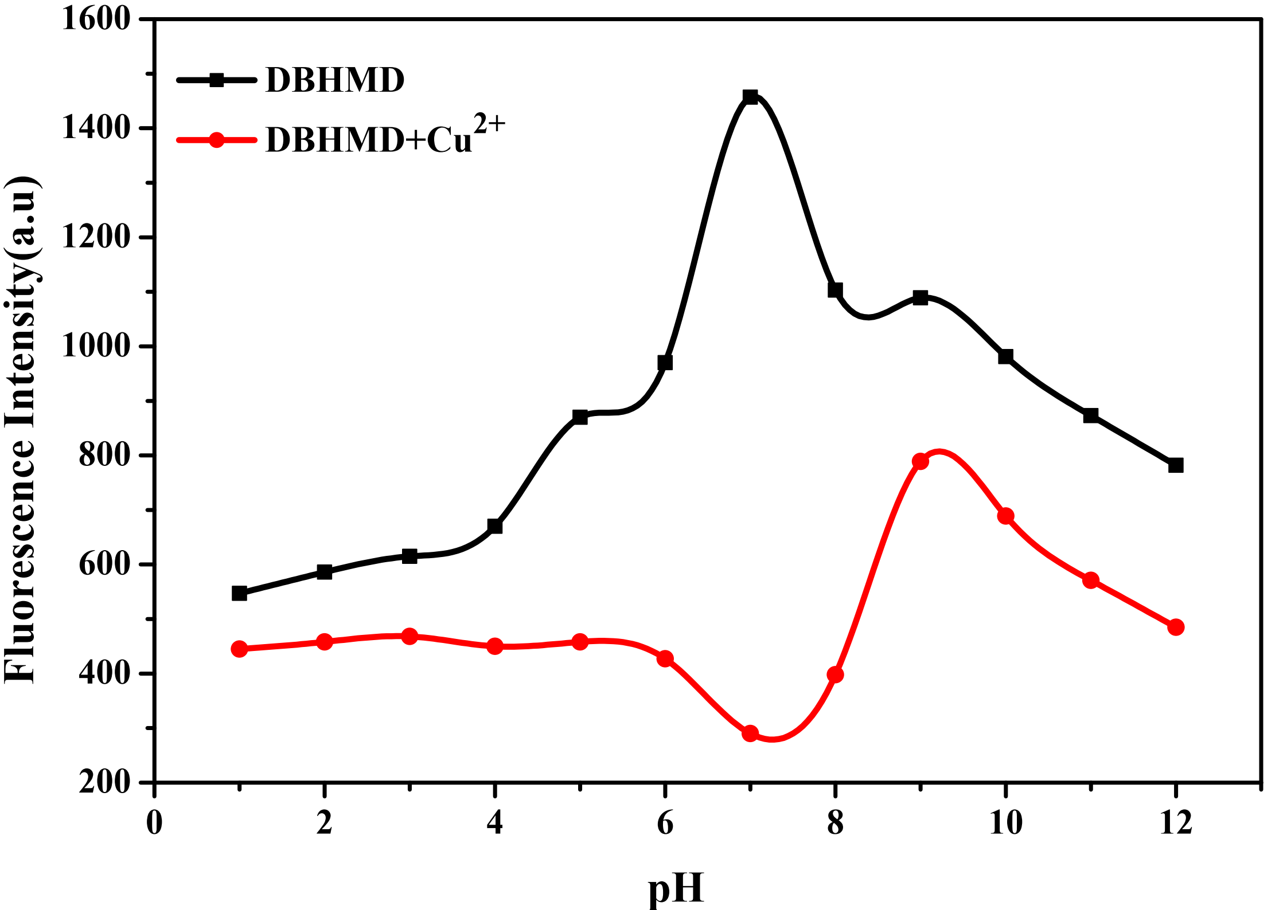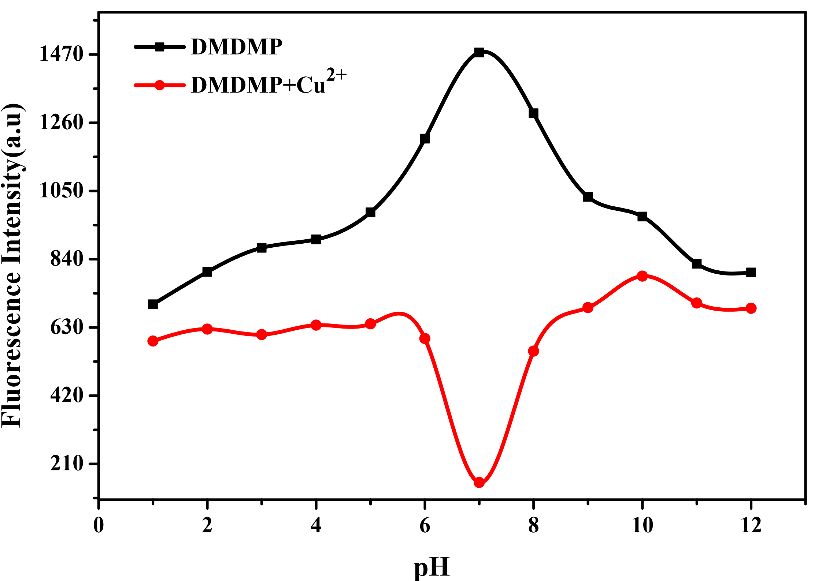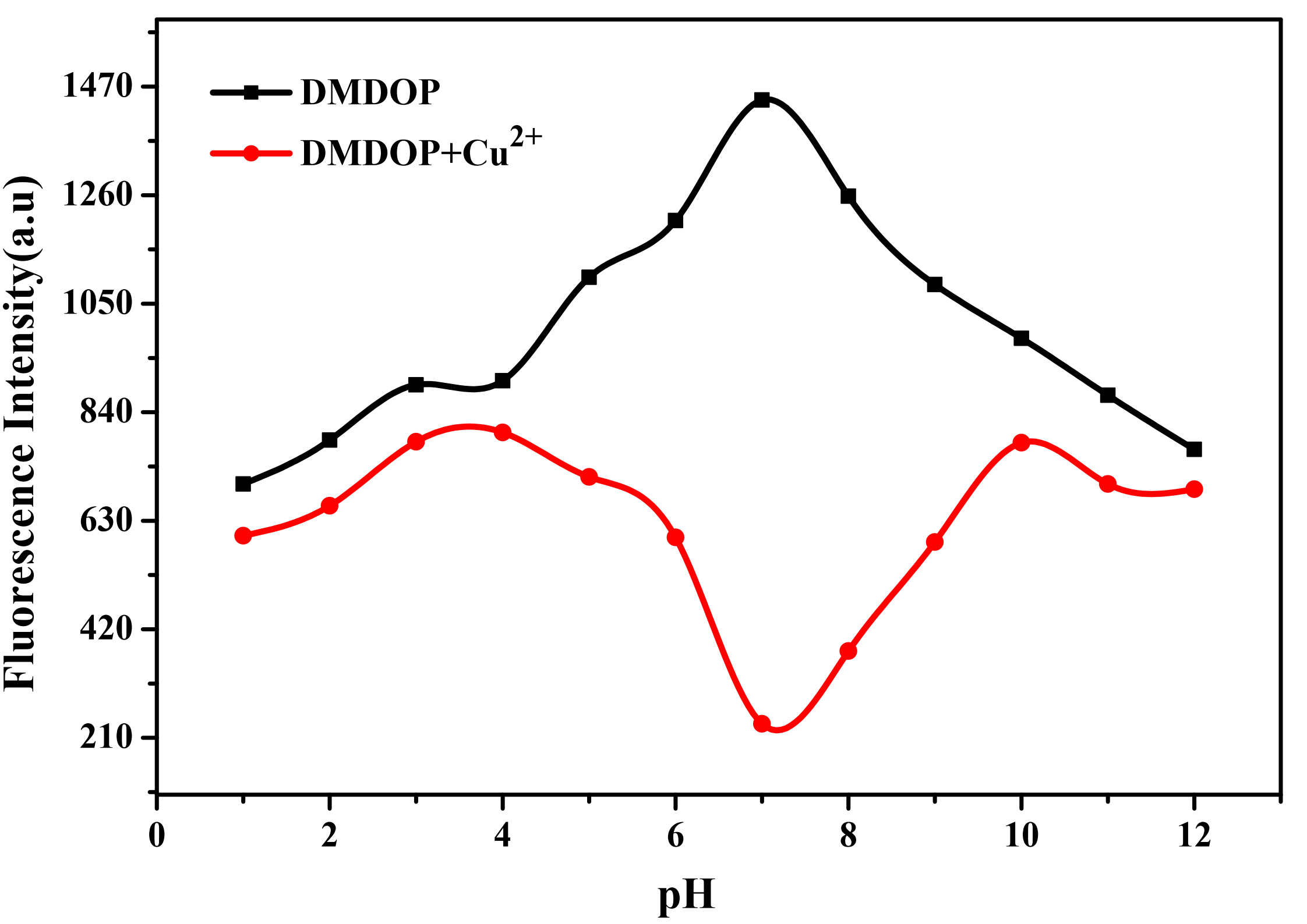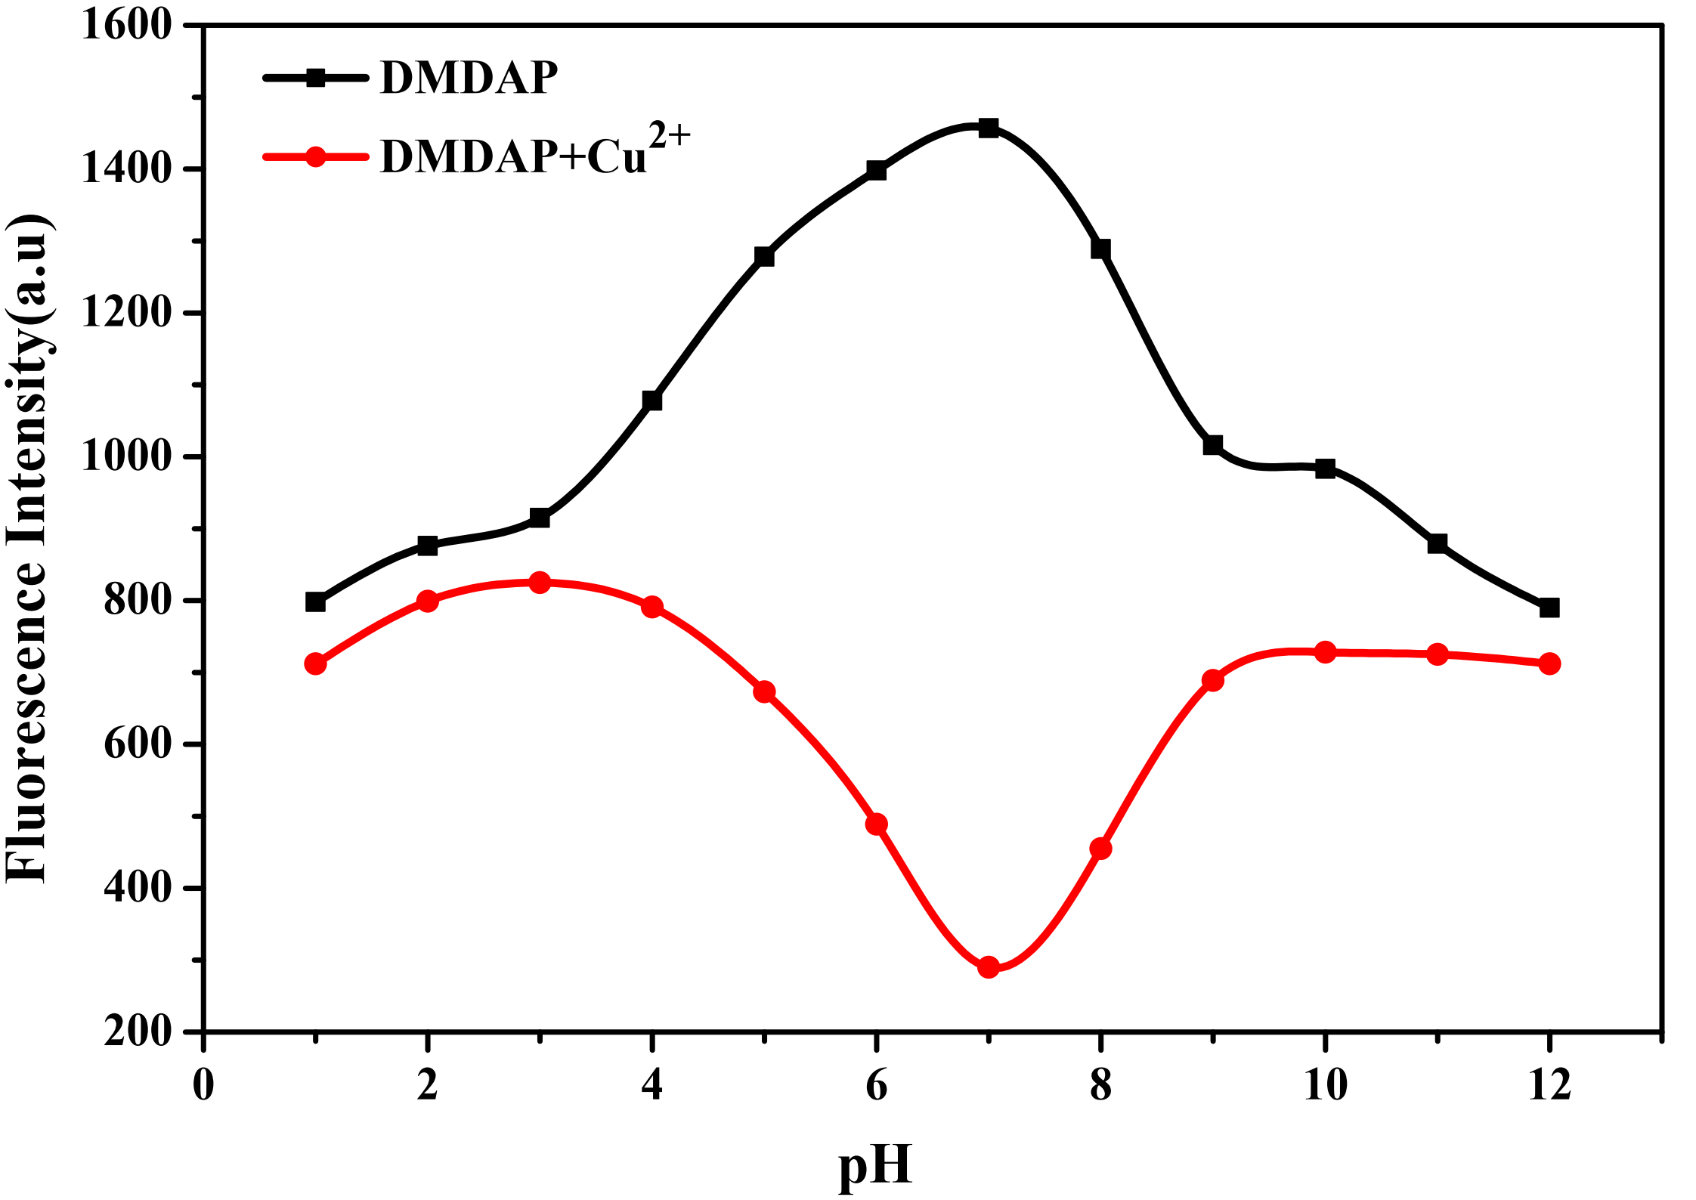
SF.13. Effect of pH on monomer and oligoesters
SF.14. Optimized structure of monomer and dimer of oligoesters
SF.15. Molecular orbital diagram of fluorophores

SF.16. Molecular orbital diagram of quencher, Cu²⁺(Cu(OH)₂)

SF.17. MEP of monomer and dimer of oligoesters
SF.18. Contour map of monomer and dimer of oligoesters
SF.19. Fluorescence cell imaging studies of THP–1 cancer
cell treated with DMDMP
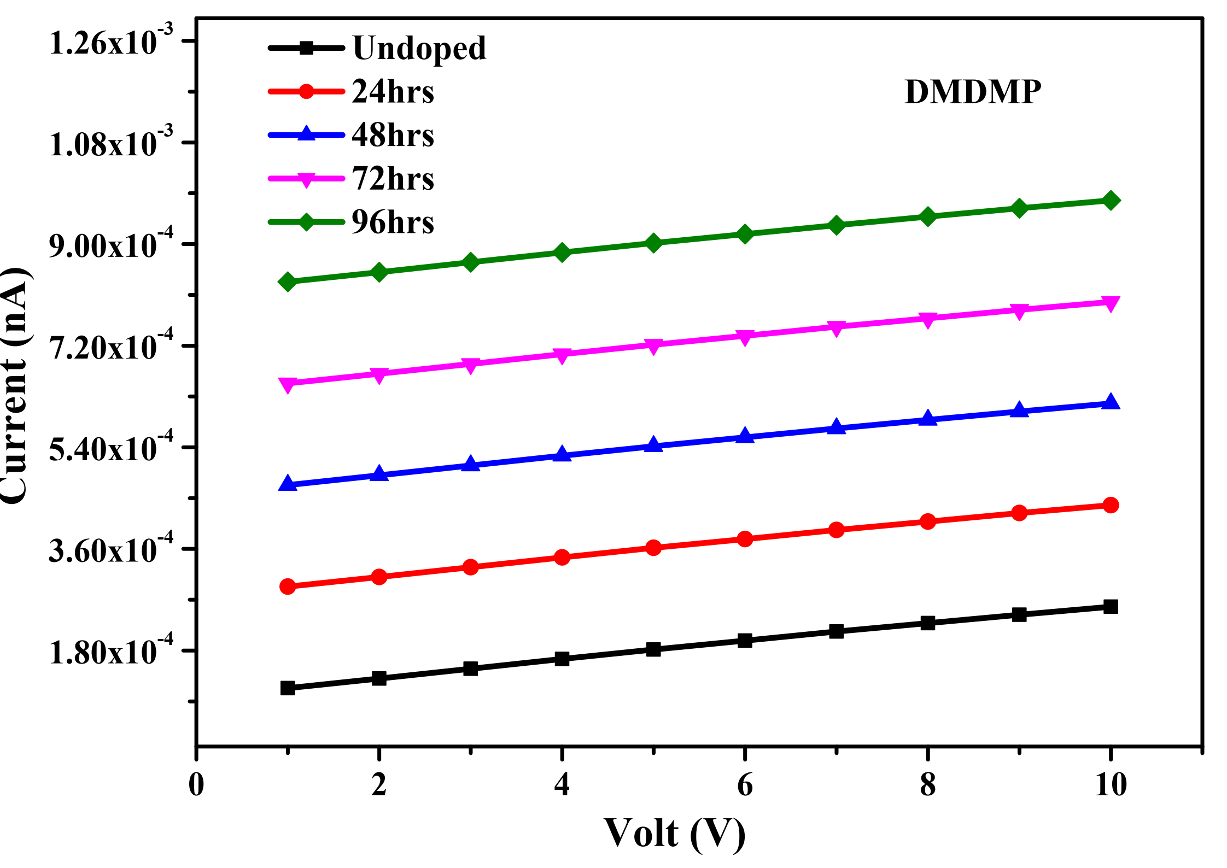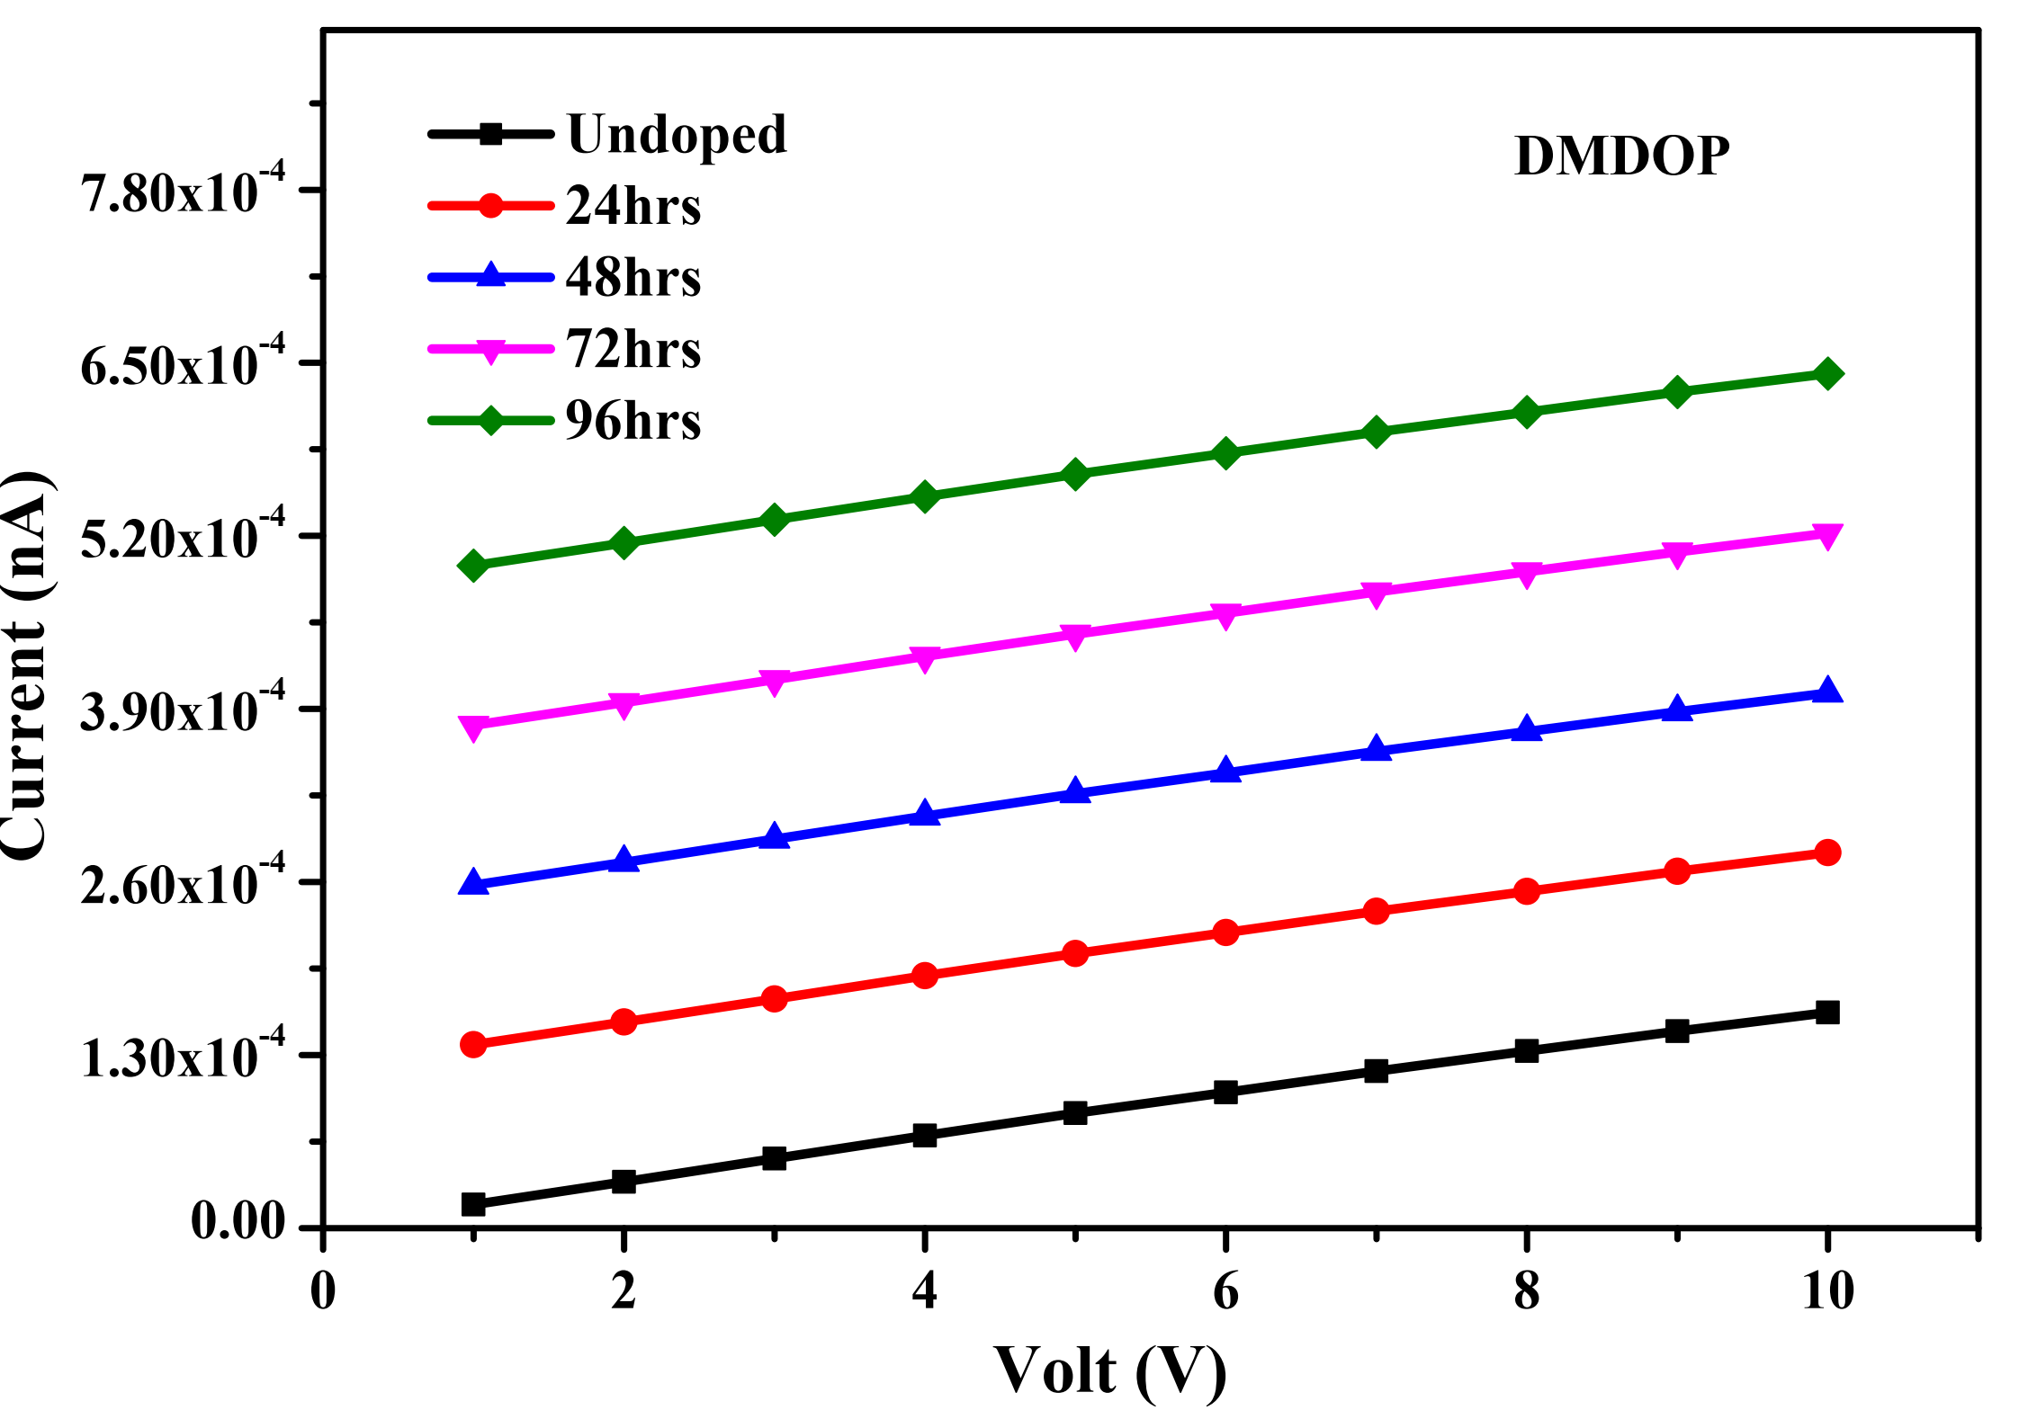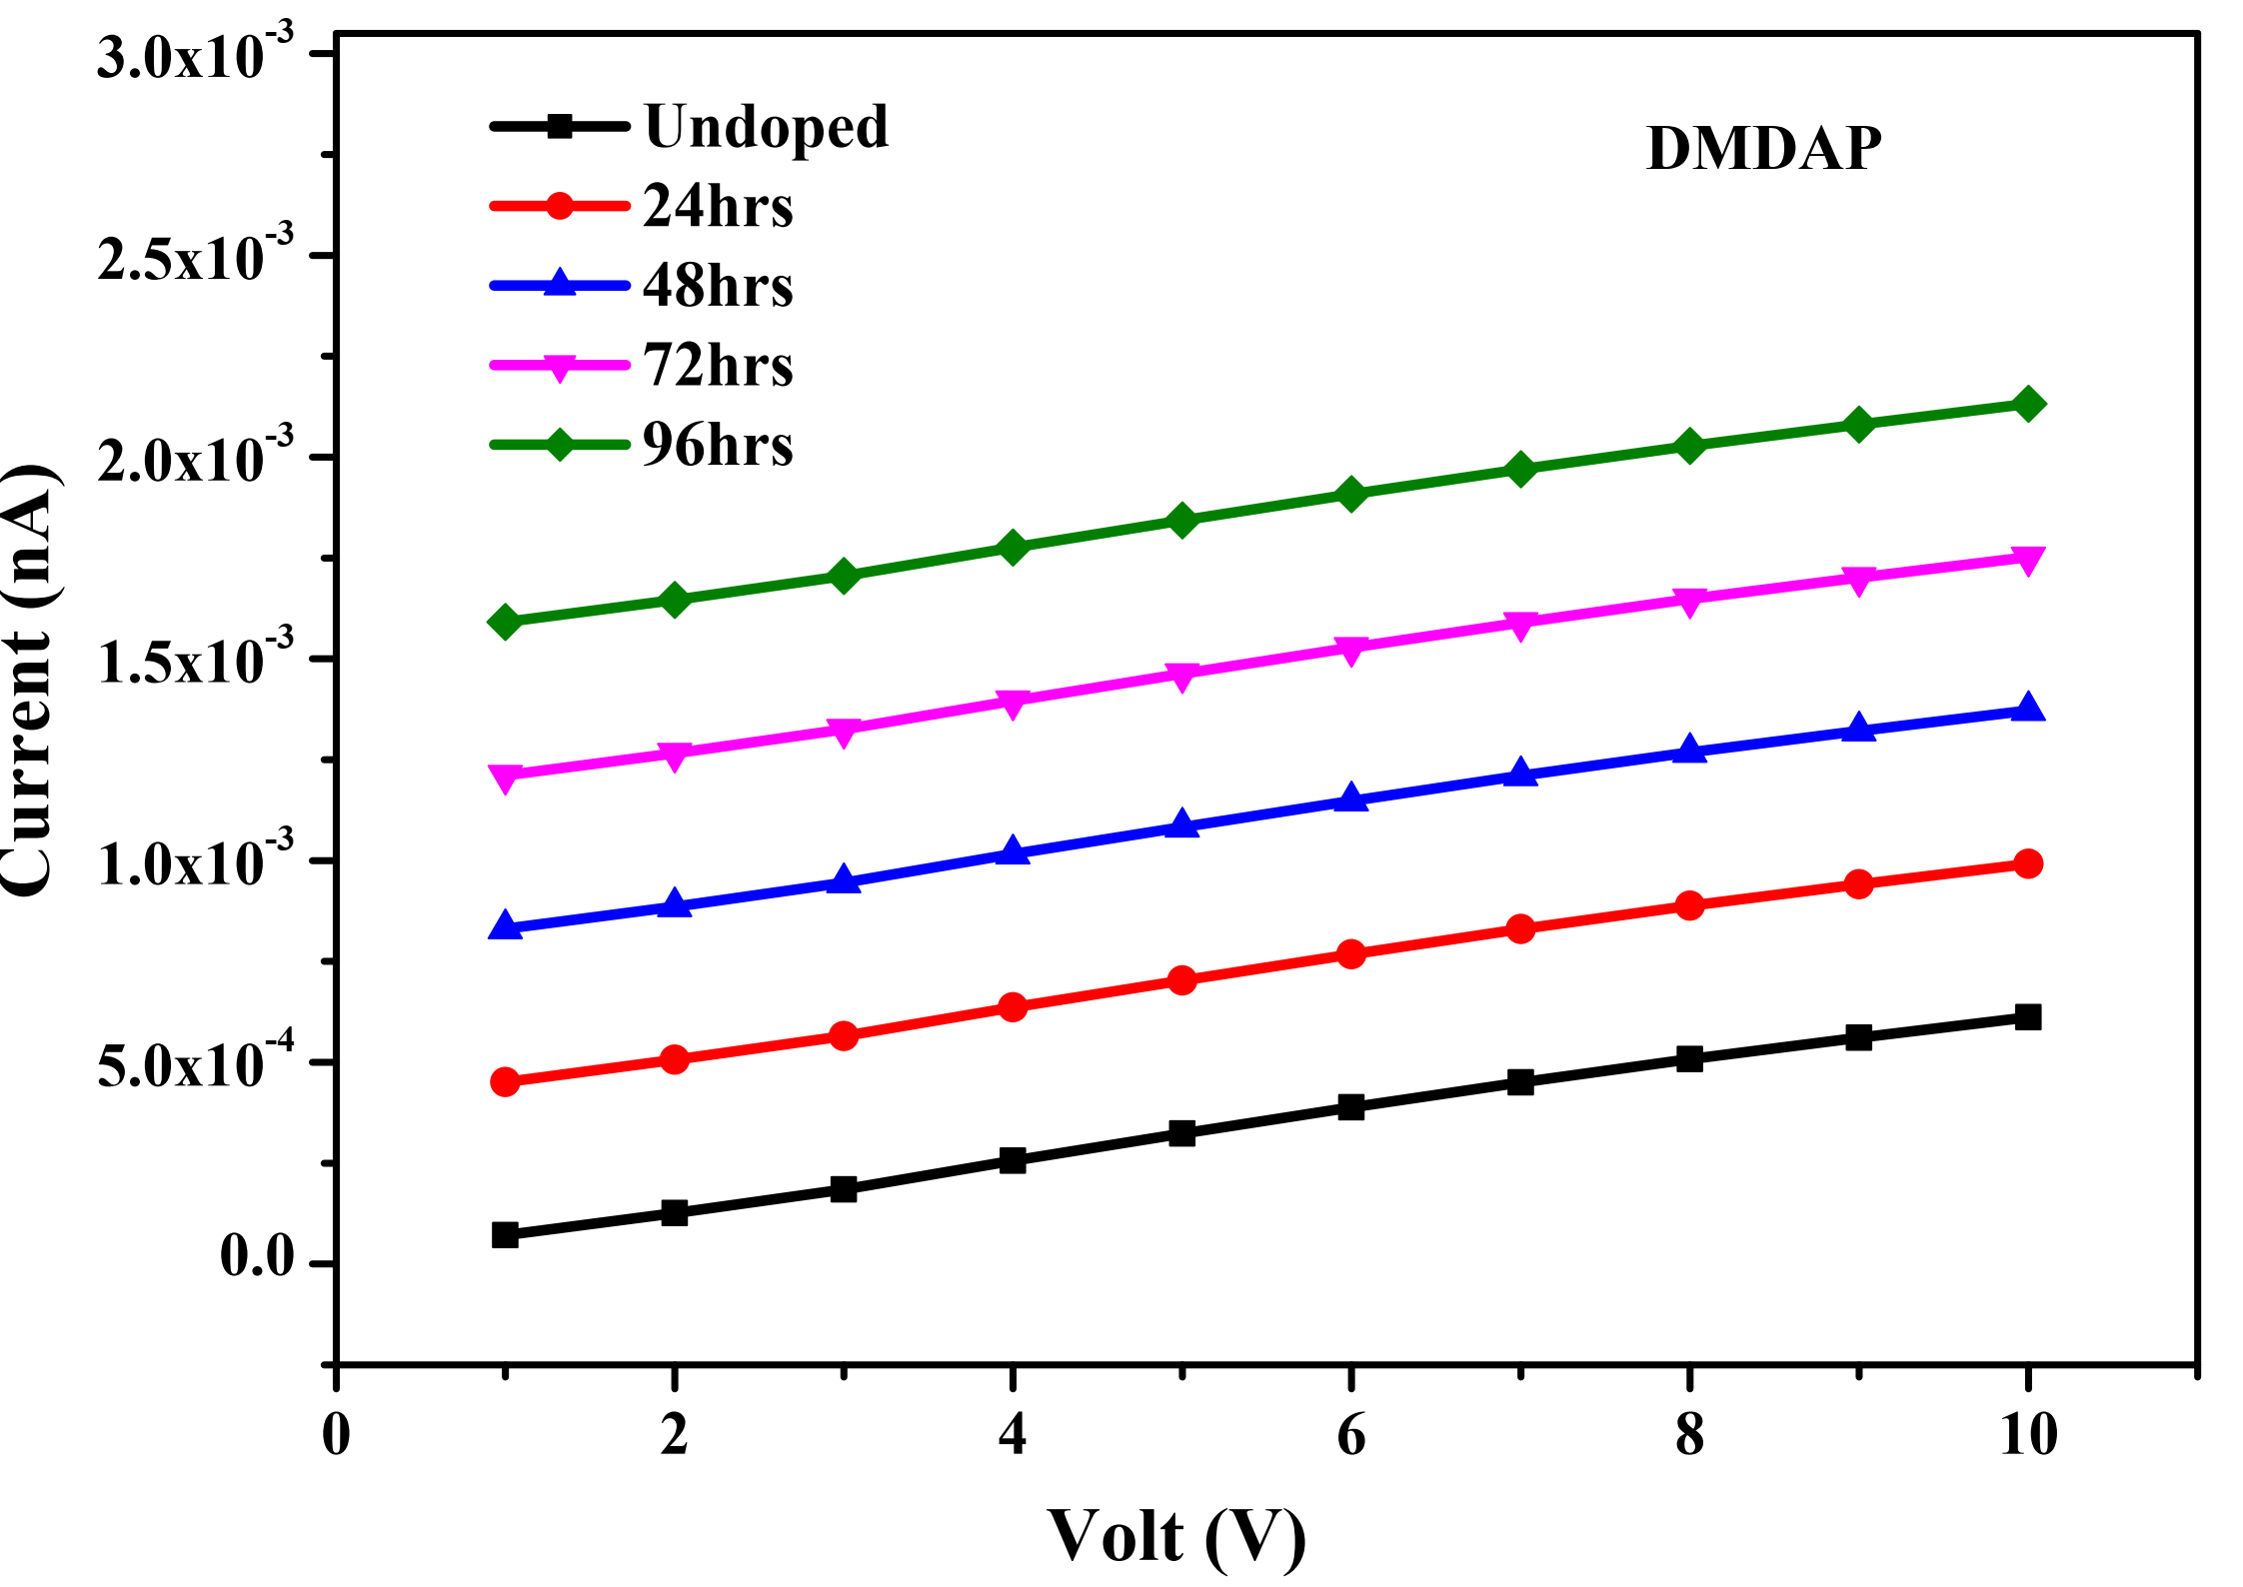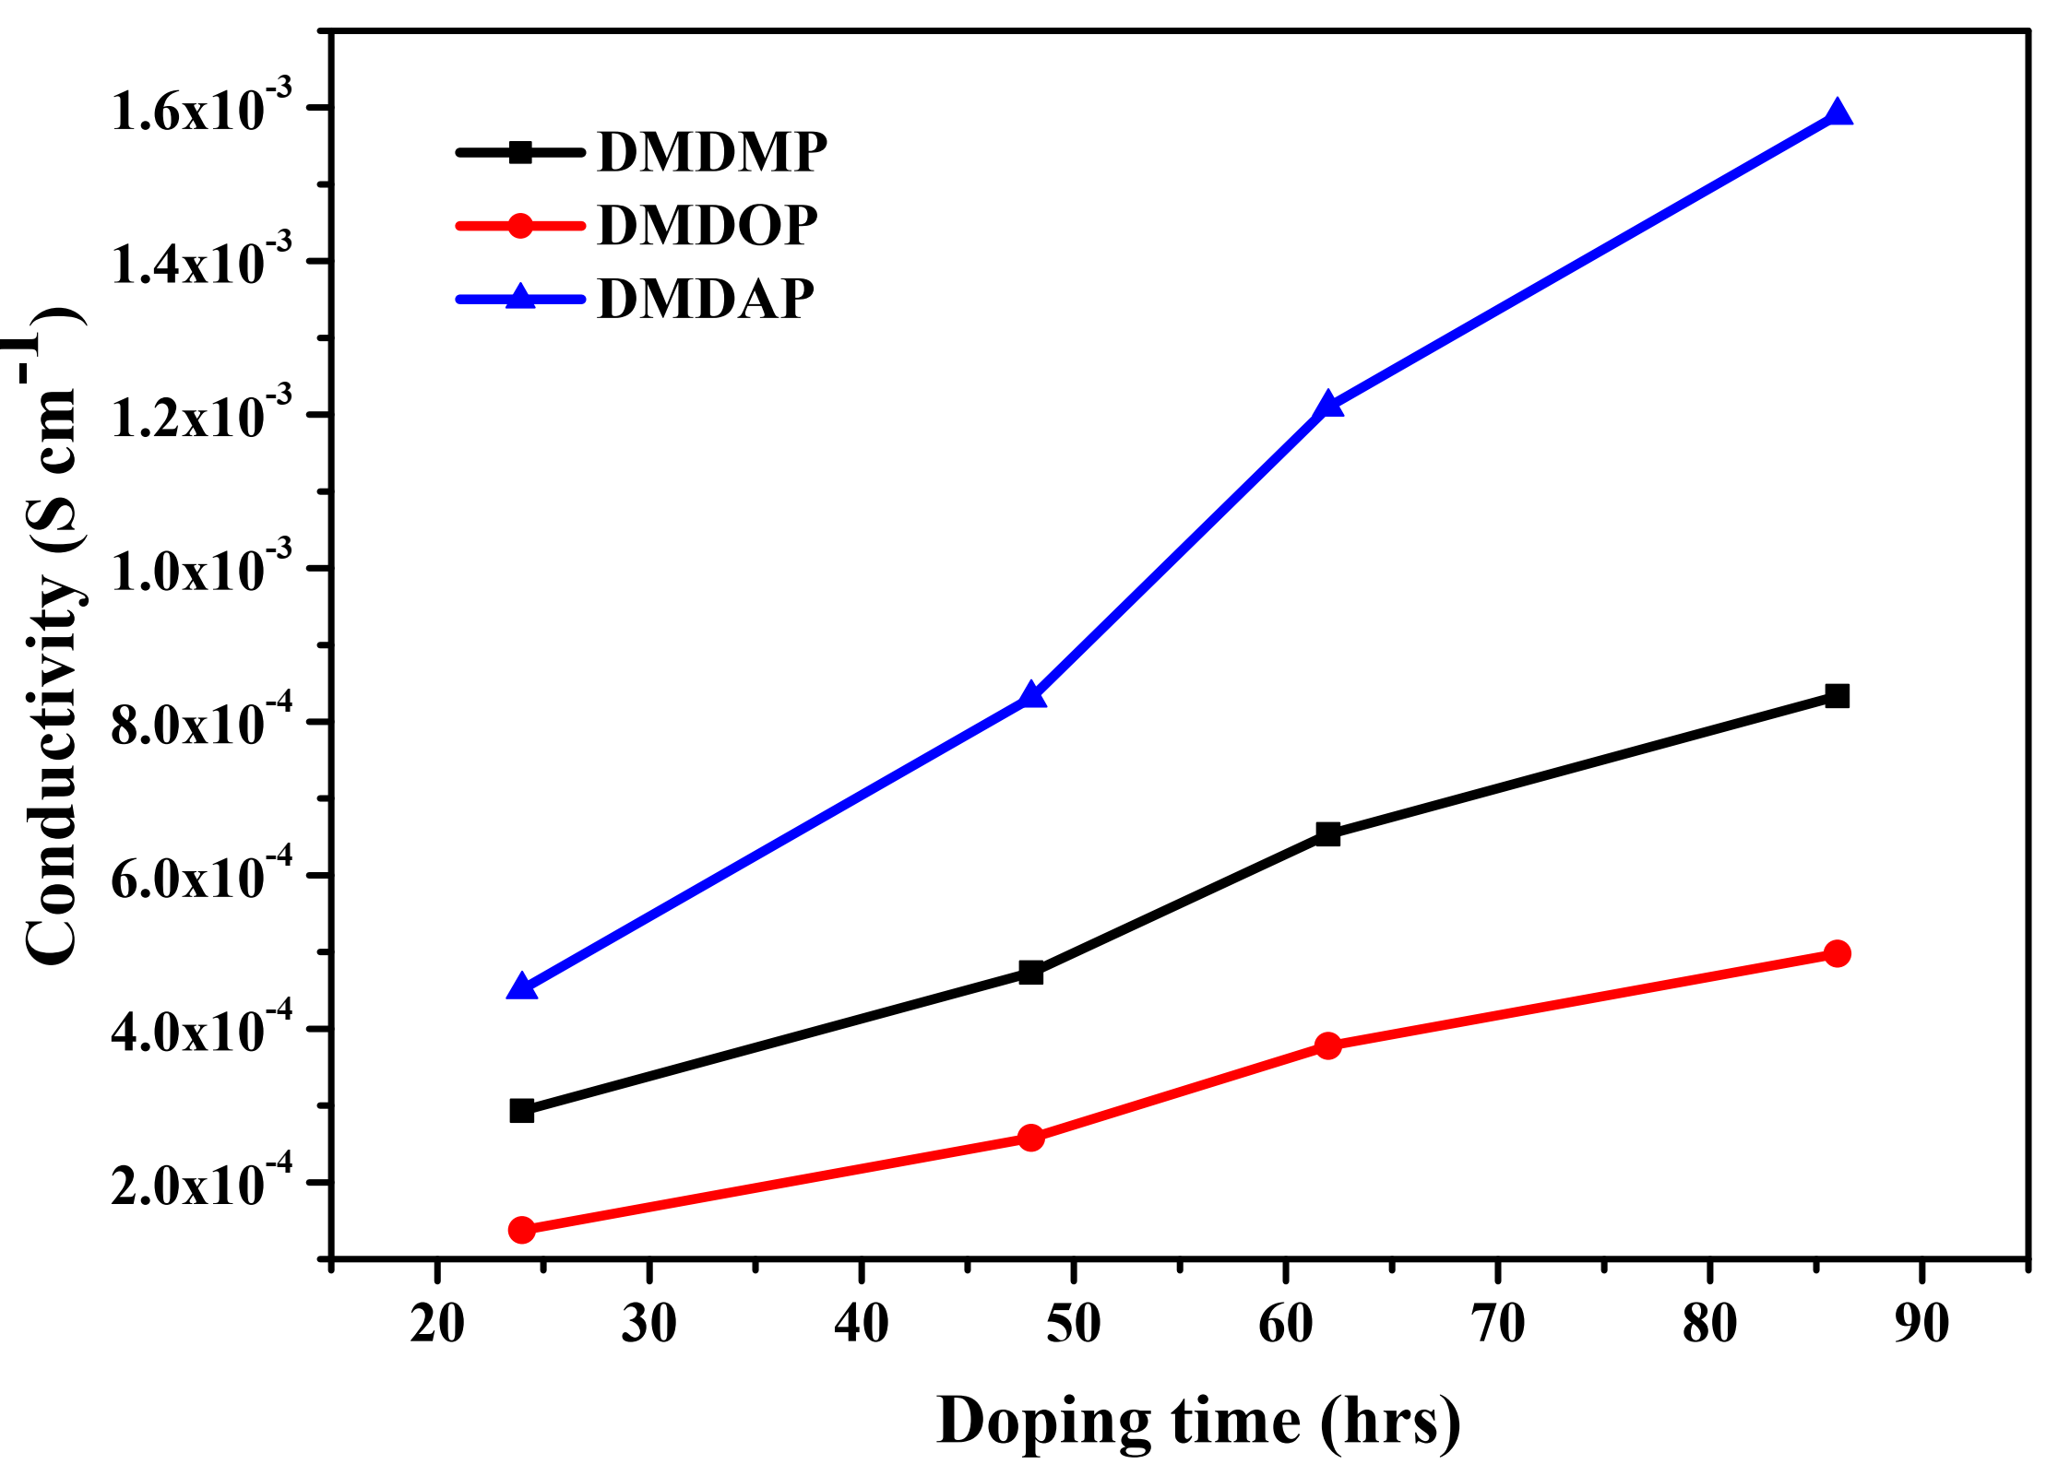
SF.20. Electrical conductivity of oligoesters vs I₂contact time
SF.21. Possible coordination of I₂with oligoesters
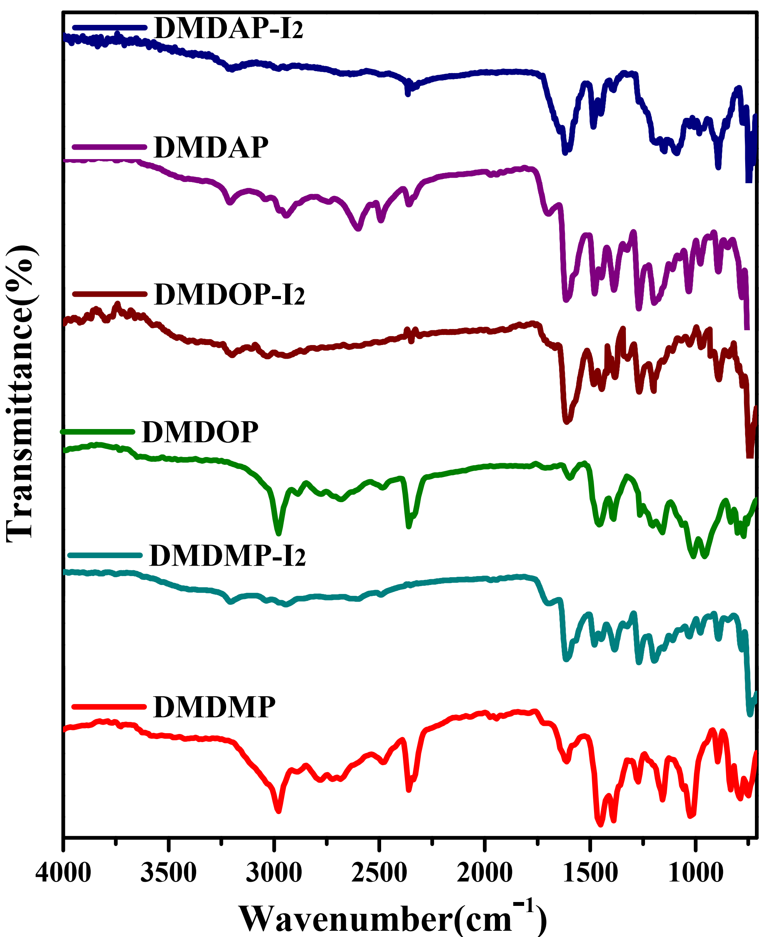
SF.22. FT–IR spectra of I₂ doped and undoped oligoesters
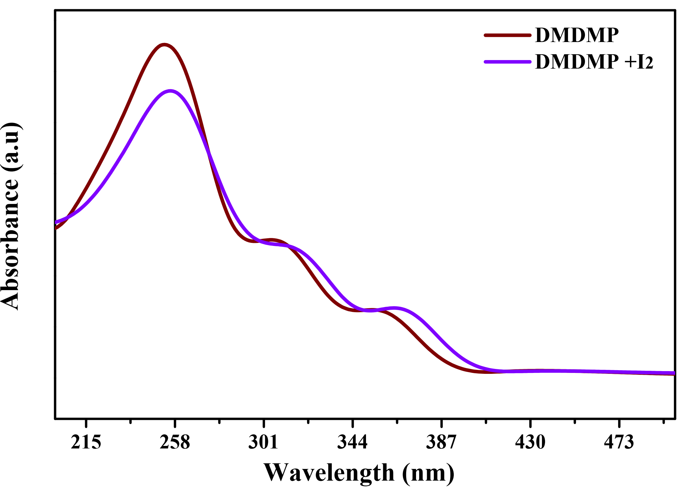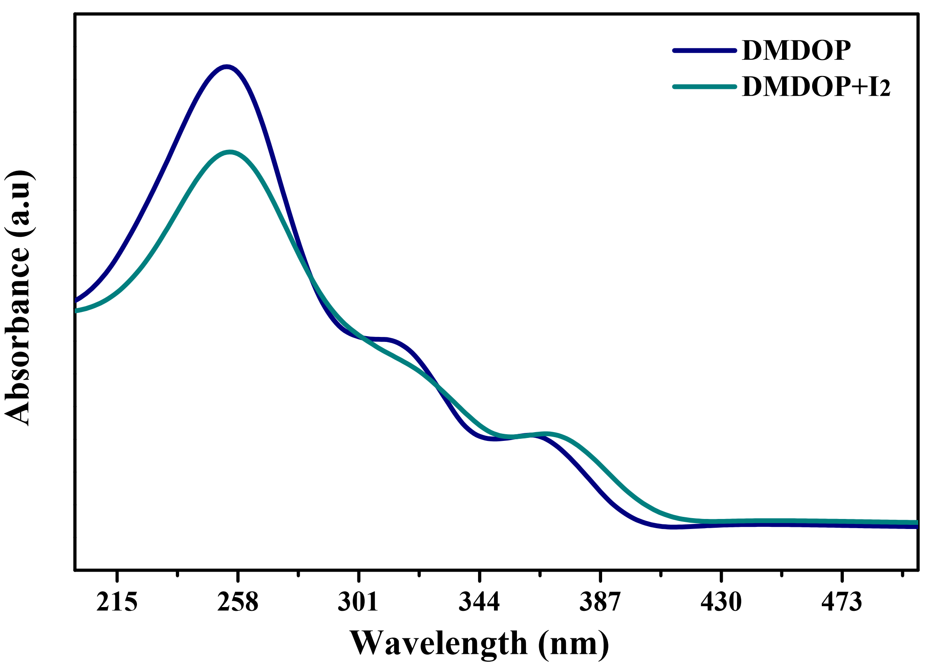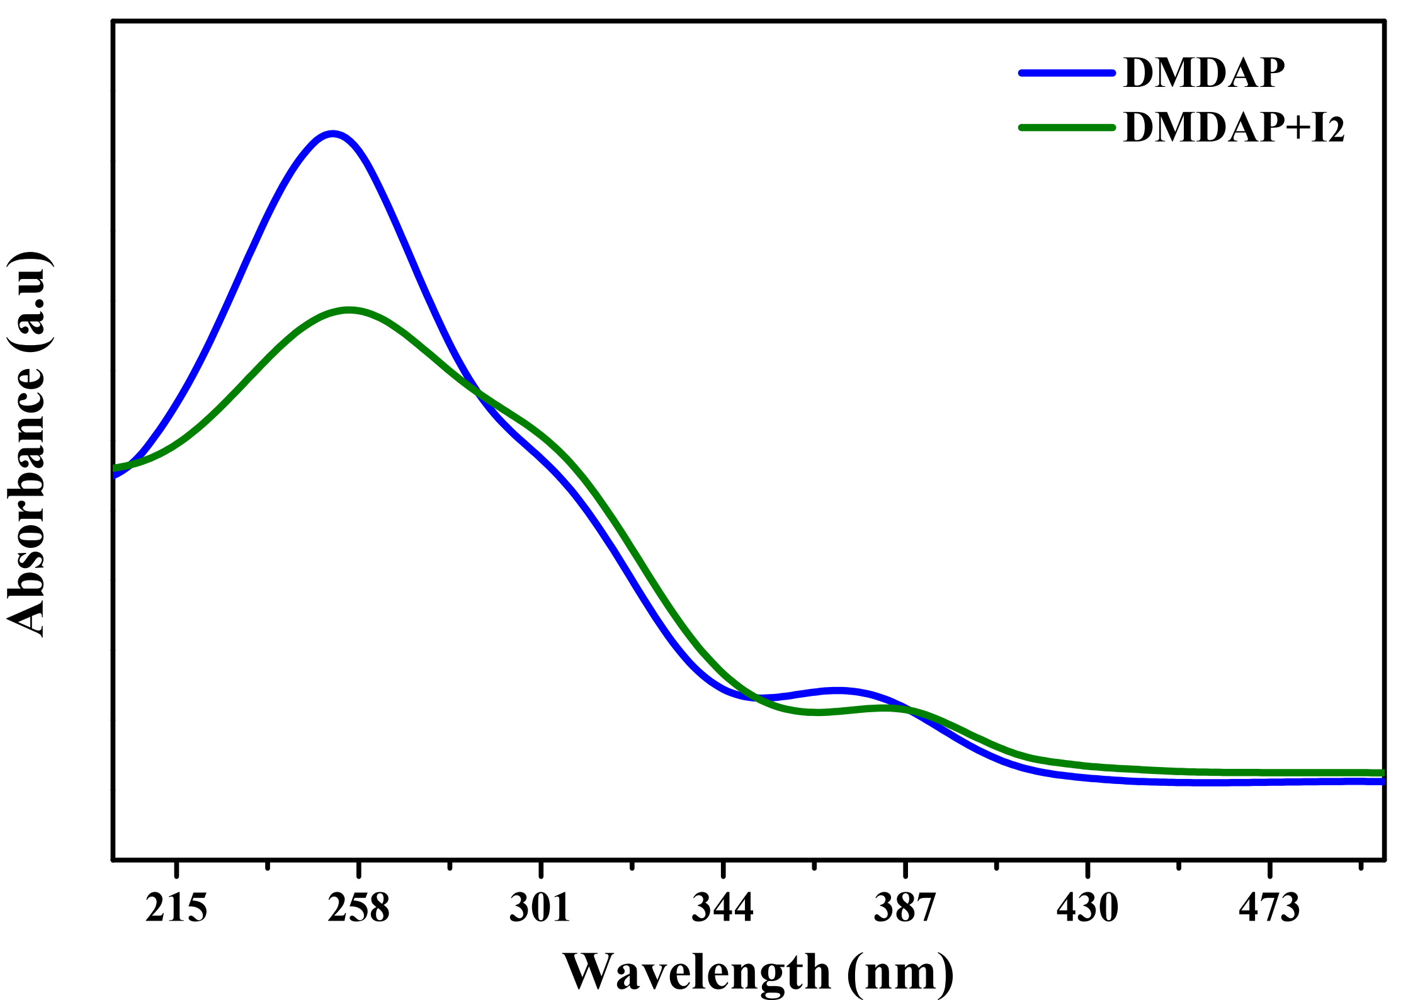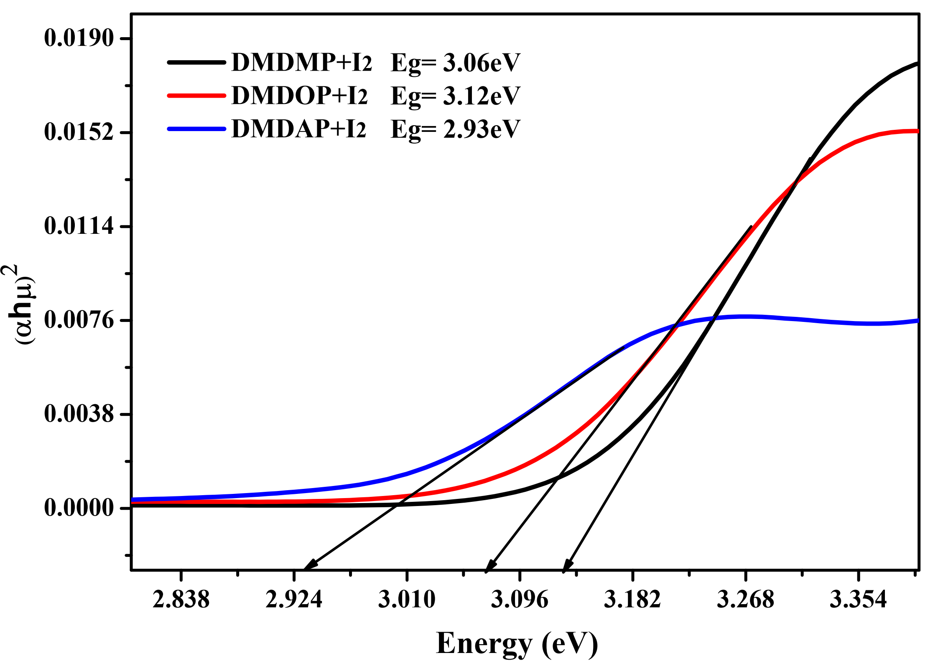
SF.23. UV–Vis spectra of I₂ doped oligoesters
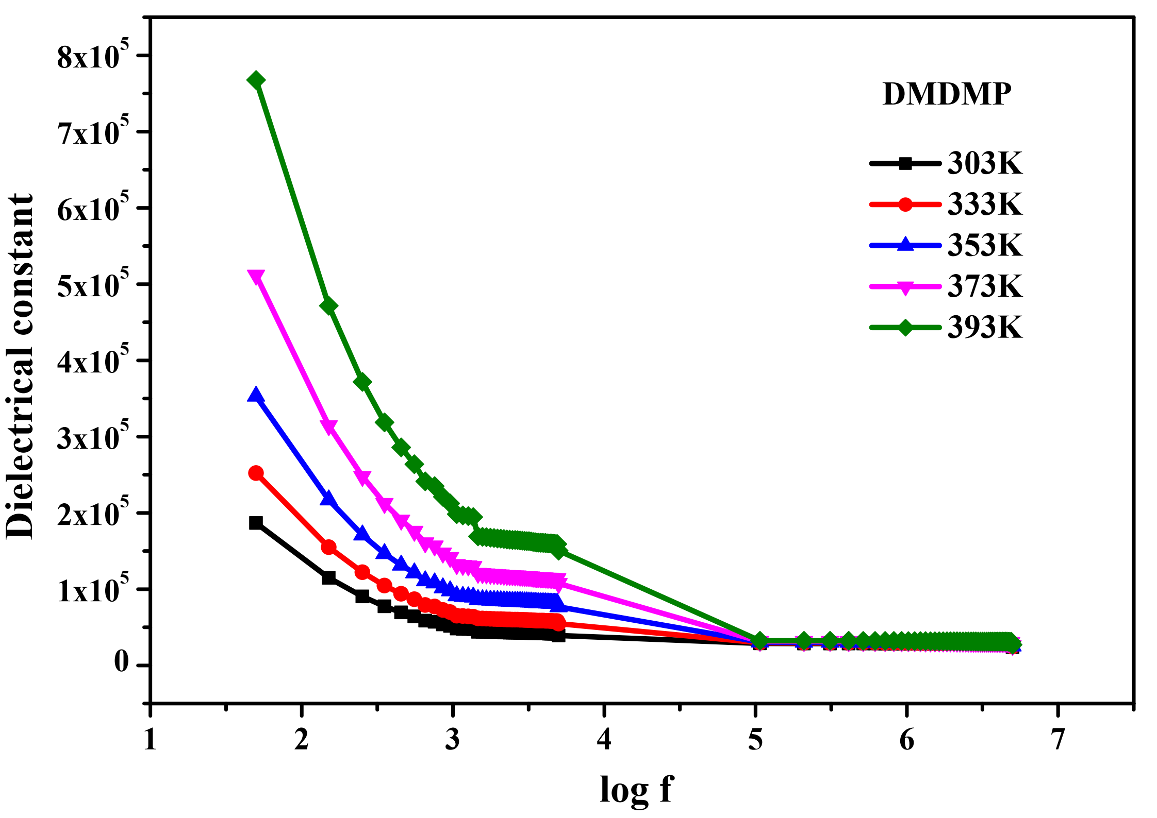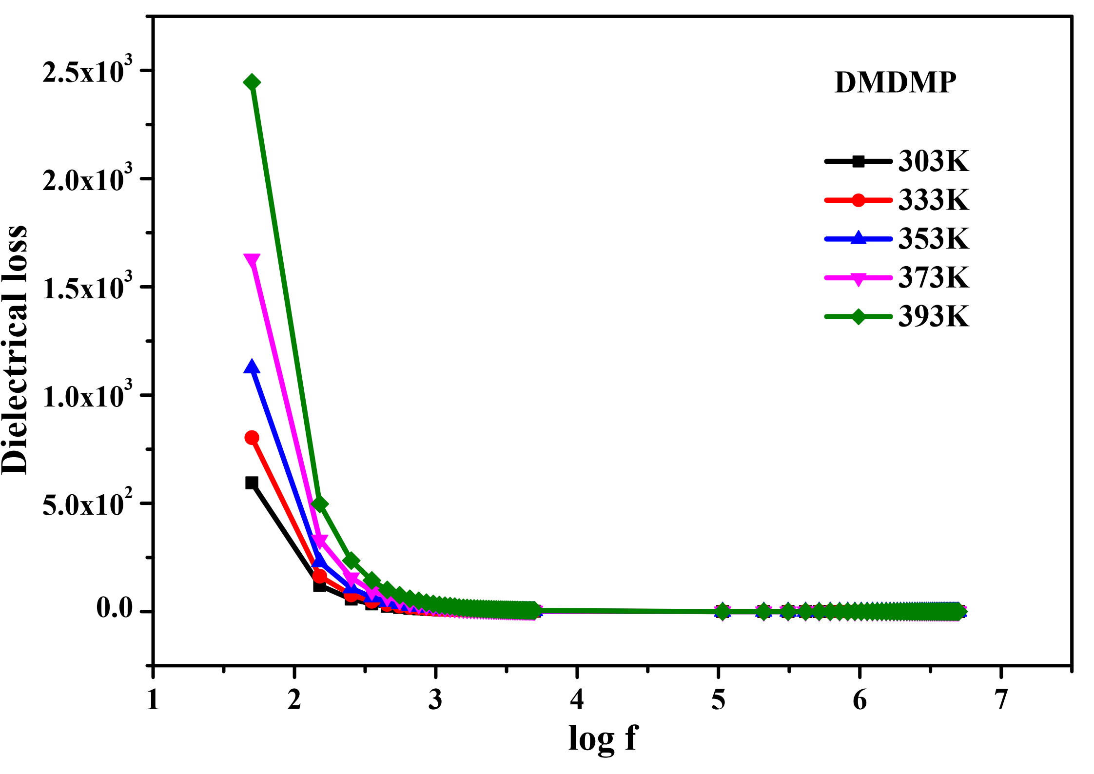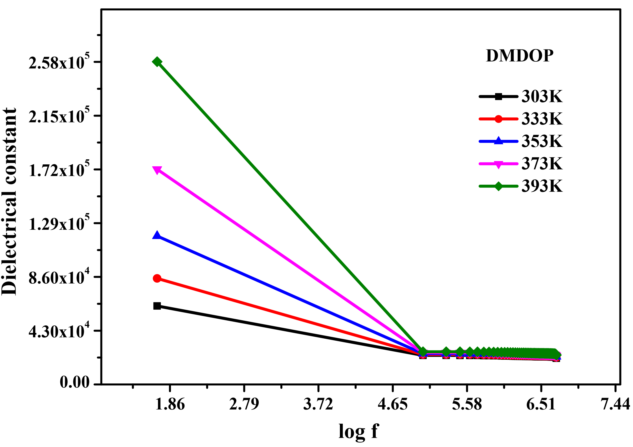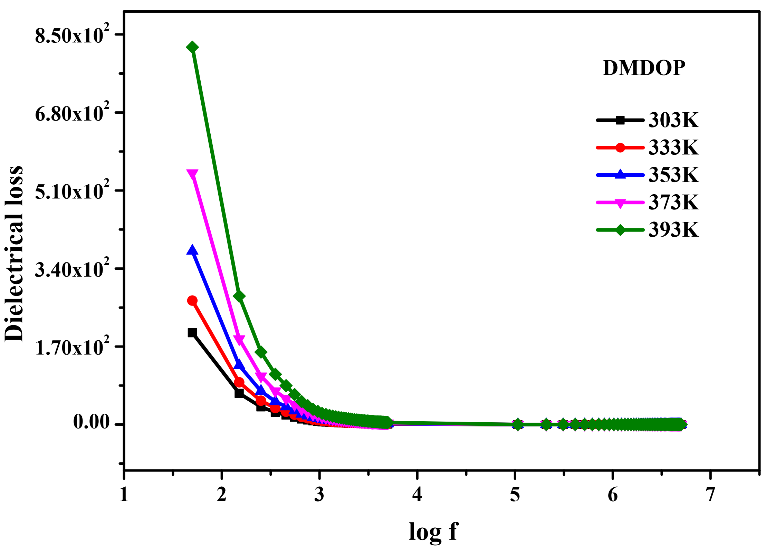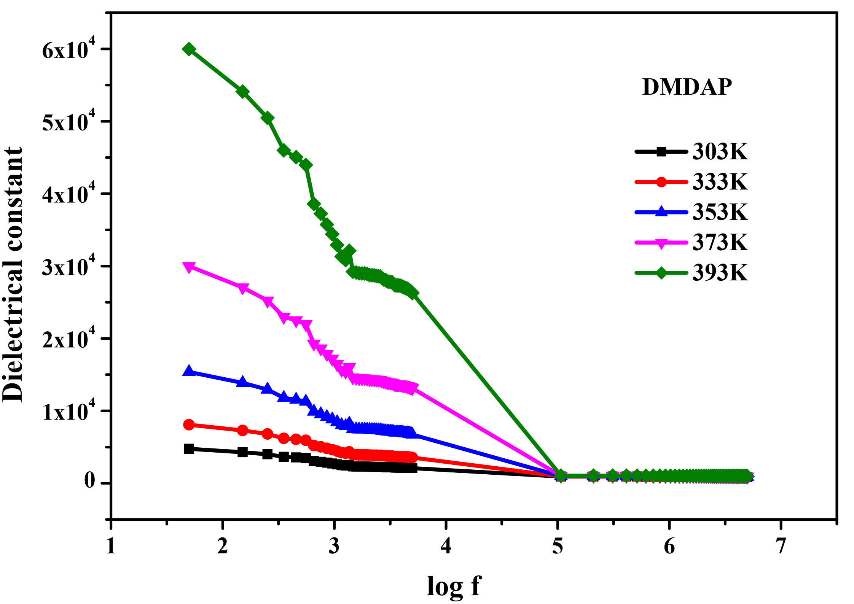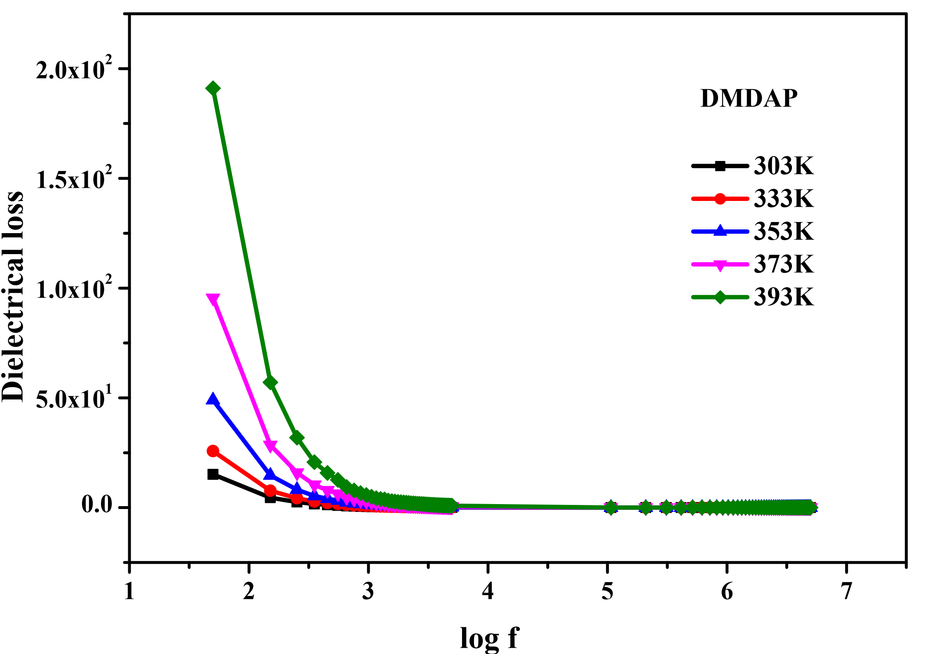
SF.24. Dielectric constant (a, c, e) and dielectric loss (b, d, f) of oligoesters
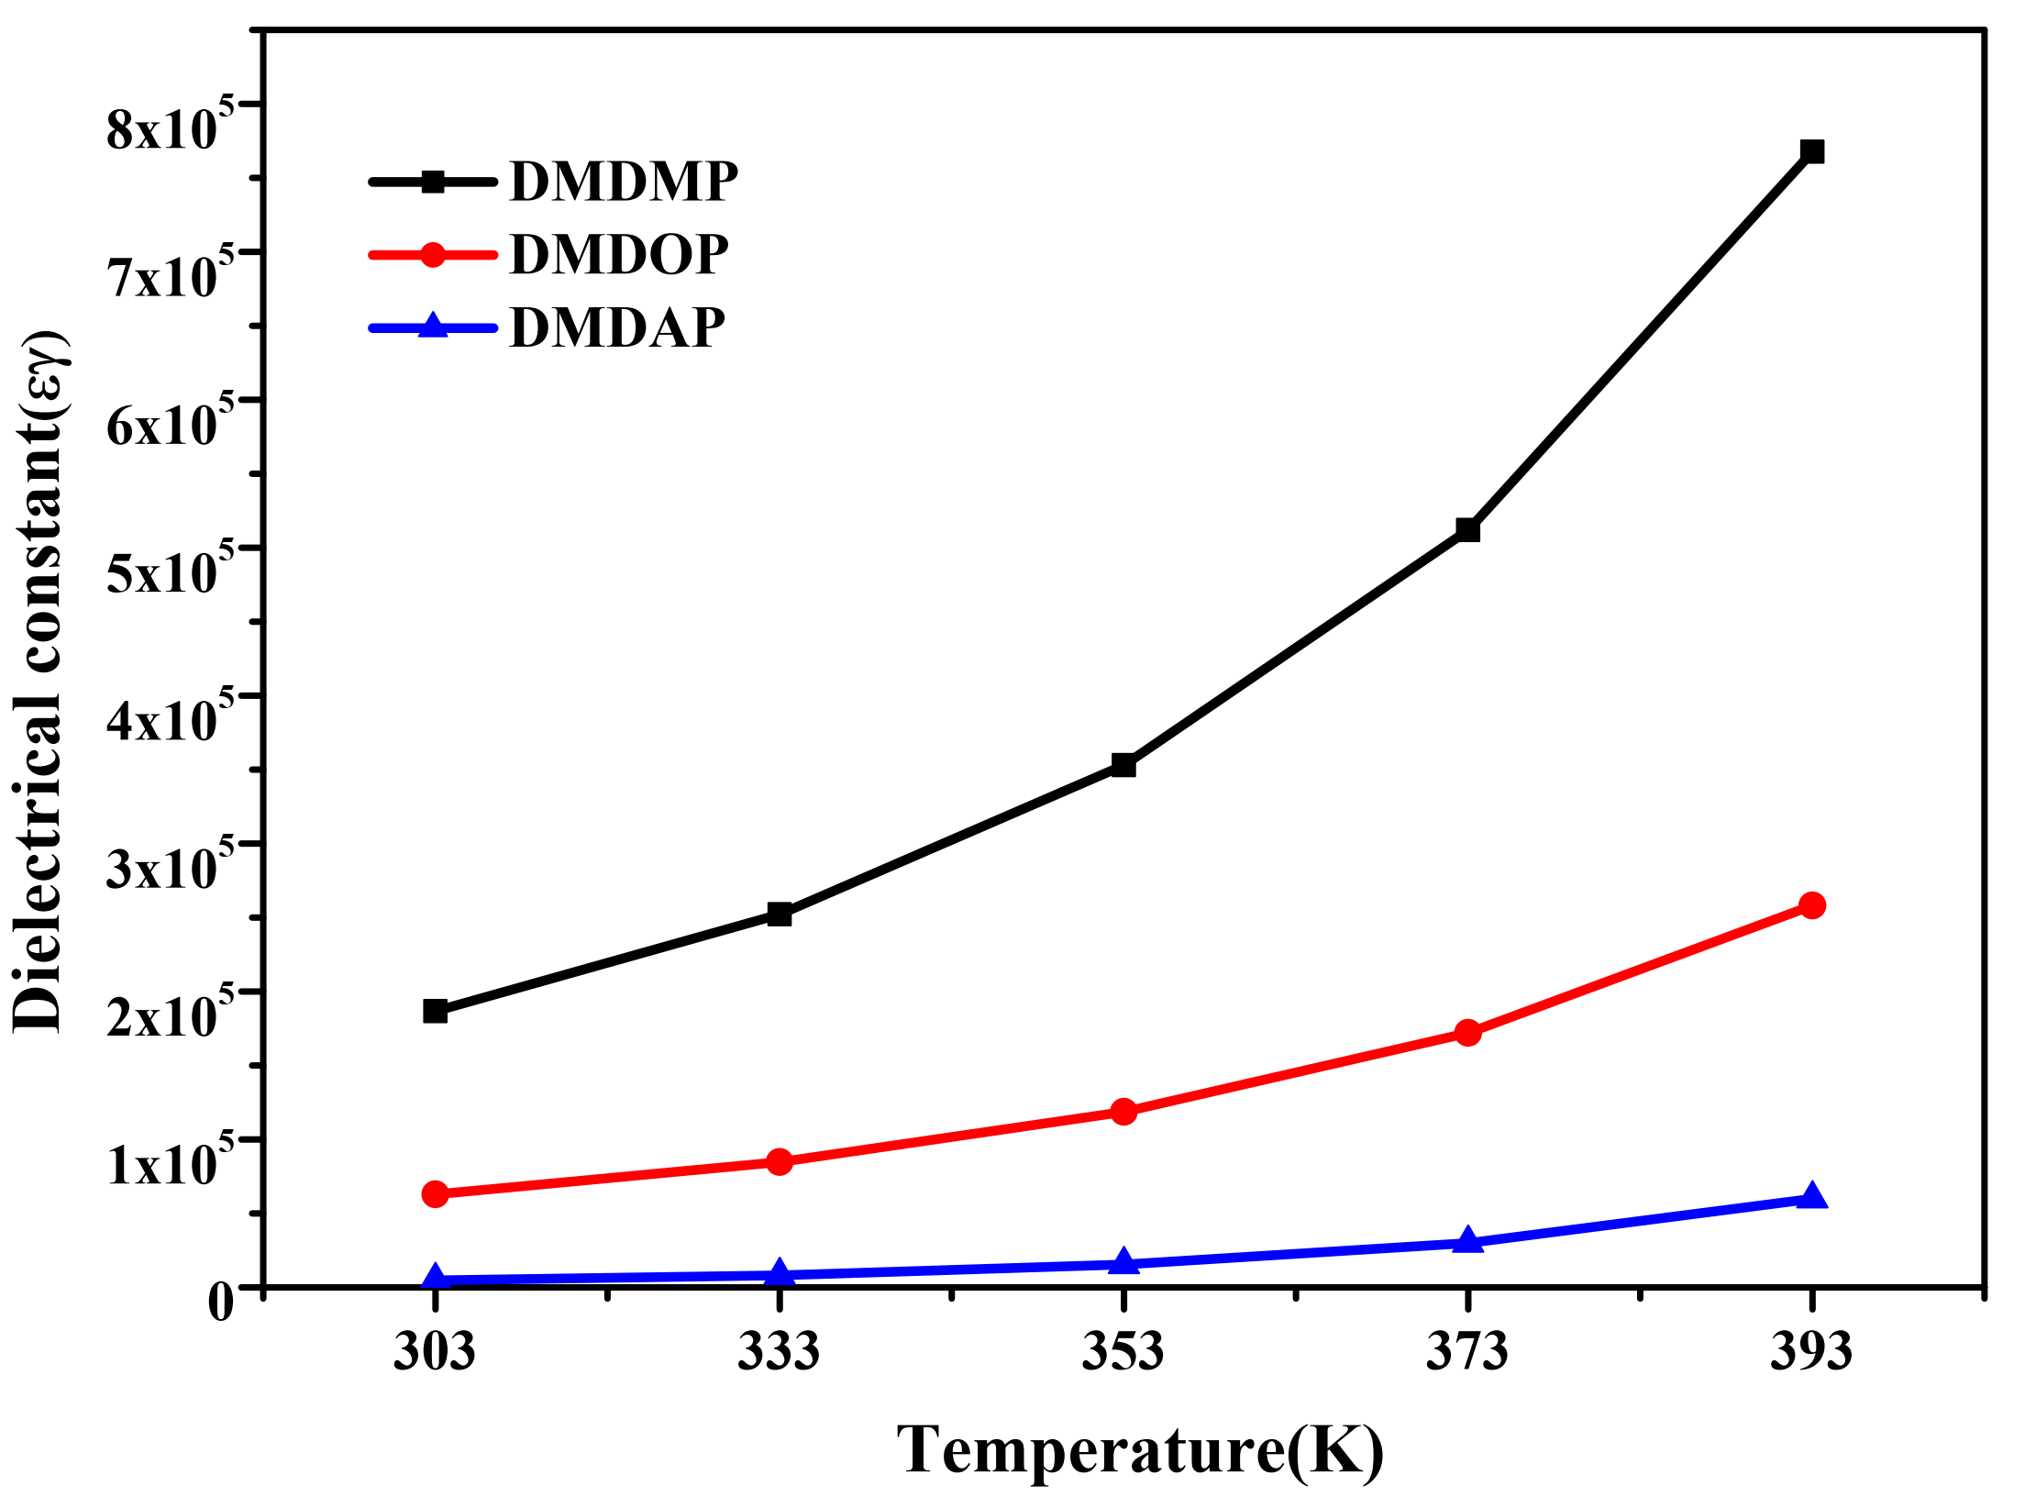
SF.25. Dielectric constant of oligoesters with temperature at 50Hz

SF.26. Real(Z′) and imaginary(Z′′) part of oligoesters

