Comparison of natural abundance and enriched 15-N methods to quantify nitrogen fertilizer recovery in maize under field conditions

Sarita Manandhar^{1,4*}, Cristina Martinez⁵, Neal Menzies³, Ram C. Dalal¹ and Michael Bell^{1,2}

¹ School of Agriculture and Food Sustainabilty, The University of Queensland, St Lucia, Australia
² Centre for Crop Science, Queensland Alliance for Agriculture and Food Innovation (QAAFI), The University of Queensland, Australia
³ Griffith University, Brisbane, Australia
⁴ Nepal Agricultural Research Council, Kathmandu, Nepal
⁵ Grains Research and Development Corporation (GRDC)
* Corresponding author (e-mail): s.manandhar@uqconnect.edu.au

Submitted to: Plant and Soil

Filename: Manandhar et al NAvsEN

Last modified: November 3, 2023

ORCID ID and e-mail address:
Sarita Manandhar ^{ID} 0000-0002-6353-3539 | E-mail: s.manandhar@uqconnect.edu.au
Michael Bell^{ID} 0000-0002-3957-2685 | E-mail: m.bell4@uq.edu.au
Ram C. Dalal^{ID} 0000-0003-2381-9601 | E-mail: r.dalal@uq.edu.au
Neal W. Menzies^{ID} 0000-0003-0207-070X | E-mail: n.menzies@uq.edu.au

Supplementary figures
Use of sigma plot to prepare graphs and figures
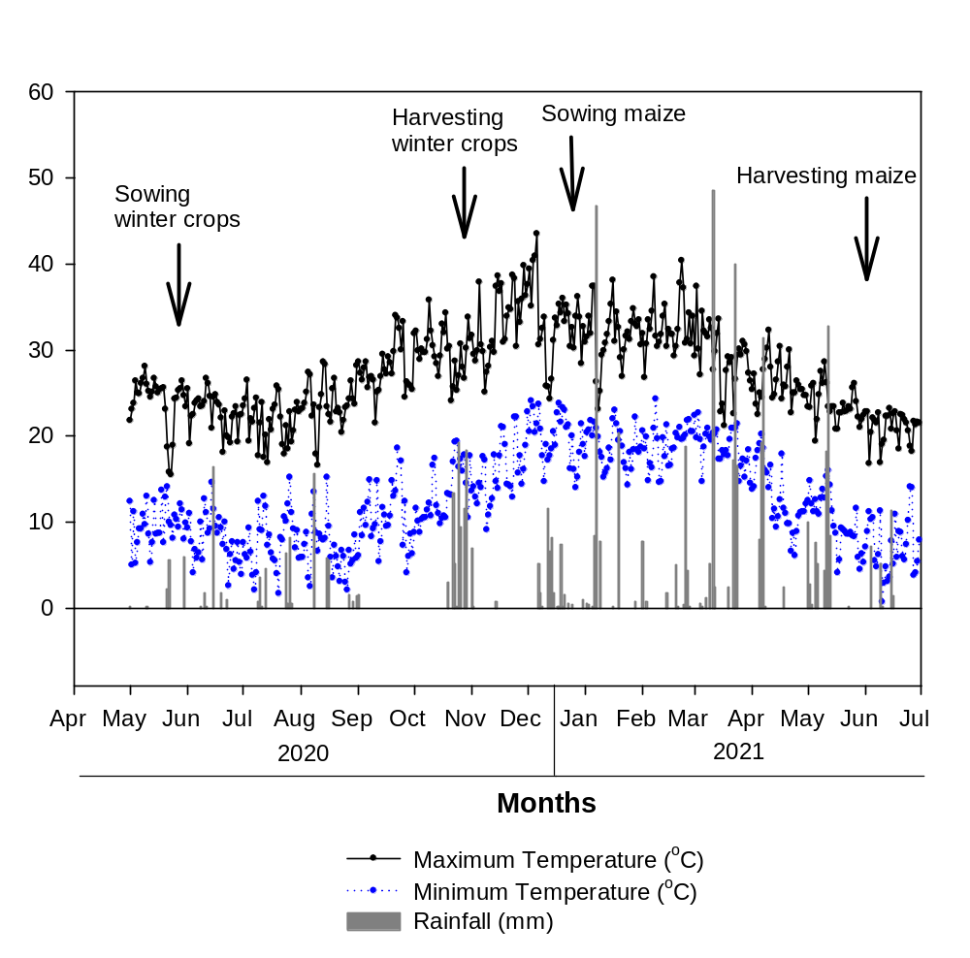
Fig. S1 Weather (temperature, rainfall/irrigation) during the experimental period

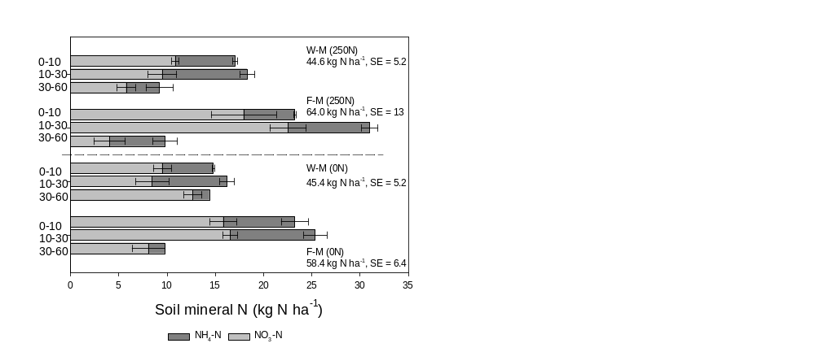
Fig. S2 Pre-sowing soil NH₄-N and NO₃-N in Experiment 3 (2021). M = maize, F = faba bean, W = wheat, 0N = 0 kg N ha⁻¹, 250N = 250 kg N ha⁻¹, SE = standard error

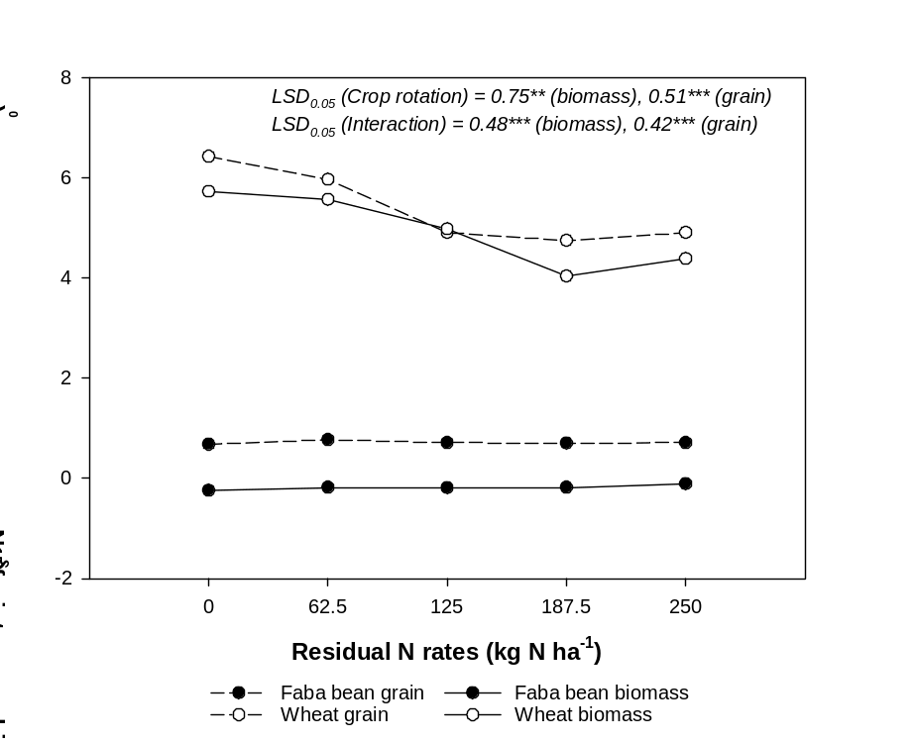
Fig. S3 Effect of residual fertilizer N rates on δ¹⁵N of winter crop (faba bean and wheat) biomass or grain. * significant at p≤0.05, **significant at p≤0.01, ***significant at p≤0.001
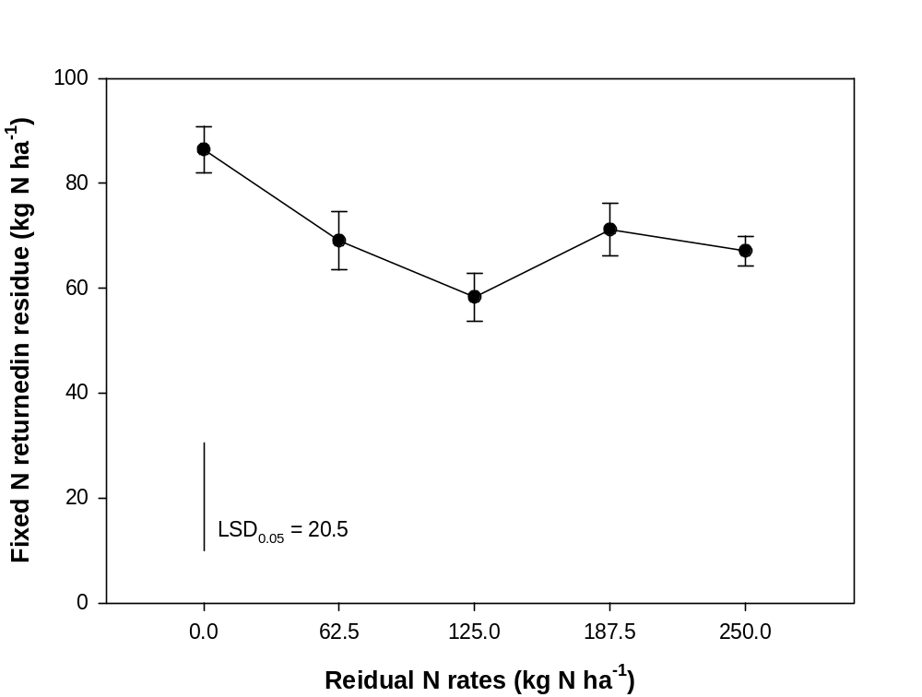

Fig. S4 Effect of residual fertilizer N rates on fixed N returned in faba bean residues

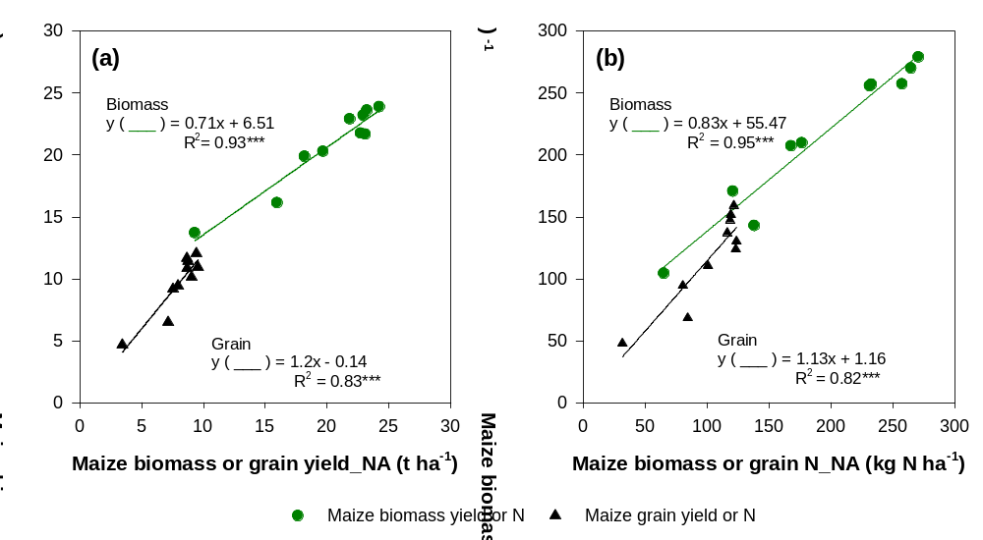Fig. S5 Effect of plot size and harvesting method on (a) maize (biomass or grain) yield and (b) crop N uptake derived using the NA and EN sampling strategies. ***significant at p≤0.001

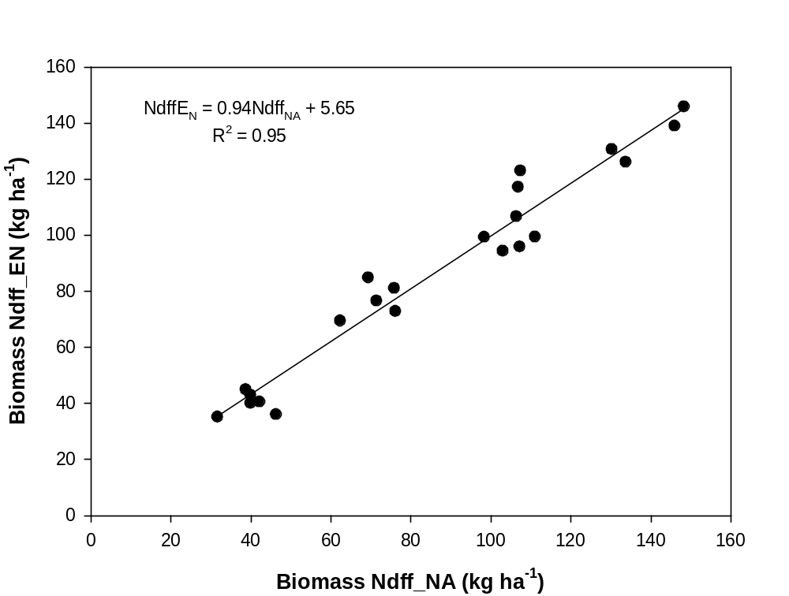
Fig. S6 The similarity in the mass of fertilizer N accumulated in crop biomass determined using the NA and EN methods, with their associated differences in sampling times and harvested areas.

Table S1 Key soil physical and chemical properties of the study site
Soil property | 0-10 | 10-30 | 30-60 | 60-90
pH (1:5 water) | 8.3 | 8.3 | 8.4 | 8.5
EC (ds/m) | 0.1 | 0.2 | 0.3 | 0.3
Cl (mg/kg) | <20 | <20 | 46 | 122
P-Colwell (mg/kg) | 130 | 73 | 67 | 55
PBI (colwell) | 166 | 173 | 182 | 176
TOC (%) | 1.8 | 1.6 | 1.5 | 1.3
TN (%) | 0.15 | 0.11 | 0.09 | 0.07
CEC (cmol/kg) | 50 | 49 | 49 | 49
Coarse sand (%) | 3.4 | 3.6 | 3.5 | 4.3
Fine sand (%) | 12.2 | 20 | 13.8 | 13.1
Silt (%) | 26.8 | 25.1 | 23.4 | 21.6
Clay (%) | 59.2 | 59.2 | 62.9 | 61.2
Field capacity (%) | 44 | 45.6 | 47.5 | 48.3
Wilting point (%) | 31.2 | 32.6 | 31.1 | 31.7

