Supplement Materials

- Supplementary Discussions
- Supplementary Figures
- Supplementary Tables
- Supplementary References

Supplementary Discussions
- Emissions-based “fair-share” metrics and “impact-integrated” metrics
In the Main Text, we focus on assessing cross-border, monetized climate change impacts attributable to national greenhouse gas emissions, thereby linking both the causes and consequences of climate change. This perspective differs from the widely studied emissions-based “fair-share” approaches ¹⁻⁵, which primarily quantify how much each country has contributed to global cumulative emissions. Typical representations of such fair-share metrics include the “equal per capita” principle ⁶ and the “planetary boundary” principle ², both of which derive national indicators by combining national population data with global carbon budget, and national responsibility is borne by countries whose emissions exceed their allocated fair shares.

We estimate global net climate change impacts at US$43.7 trillion using “impact-integrated” metrics. This figure is lower than the US$192 trillion reported by Fanning and Hickel ¹. Their estimate is based on the planetary boundary principle for allocating fair emissions shares, which assessed emissions responsibility between 1960 and 2050 and simply assumed US$547 per tonne of CO₂ to price cumulative emissions overshooting the 1.5°C fair share for each country in 2050. Below, we provide a detailed comparison of different metrics for measuring cross-country climate inequalities.

- Fair-share metrics: equal per capita and planetary boundary principles
Under the equal per capita principle, following the approach by Matthews et al. ⁶, each country’s fair share of the global carbon budget is in proportion to its population, ensuring equal per capita access to the atmospheric commons. Countries that exceed their allocated fair shares are considered to have overshot emissions, while those staying within fair shares are recognized for undershoot emissions (Equation 1). Aggregating the overshoot emissions across all countries (or the absolute values of undershoot emissions) yields the total global excess emissions (Equation 2). Each country’s historical emissions responsibility is then expressed as the ratio of its overshoot emissions to the total global excess emissions (Equation 3).

${Over\left(under\right)shootEm}_{i}= \sum_{t=base}^{end}{\left[{Em}_{t,i}-{Em}_{t,global}*(\frac{{Pop}_{t,i}}{{Pop}_{t,global}})\right]}$ (1)
$GlobalEm= \sum_{i=1}^{n1}{{OvreshootEm}_{i}}=-\sum_{i=1}^{n2}{{UndershootEm}_{i}}$ (2)
${NationalShare}_{i}= {Over\left(under\right)shootEm}_{i}/GlobalEm$ (3)

In these equations, the parameter i represents a specific country or region, and t denotes time, typically referring to the years within the study period. Em_{t,i} refers to the emissions from country i during year t, and Pop_{t,i} represents its population. OvershootEm_{i} is the excess emissions of country i, calculated as the cumulative difference between actual emissions and the fair share over the target period. GlobalEm is the total global excess emissions, and NationalShare_{i} refers to the share of global over(under)shoot emissions attributable to country i.

To extend the assessment from emissions inequality to impact inequality, we apply the same equal per capita principle to measure national responsibilities for climate change impacts. Specifically, we first calculate the difference between a country’s realized climate change impacts (IMPACT_{t,i​}) attributable to its observed emissions, and the counterfactual impacts it would cause if its emissions had aligned with its equal per capita share of the global carbon budget (IMPACT _{t,i​}^{budget}) (Equation 4). We then aggregate all excess impacts (IMPACT _{t,i​}^{excess}) to obtain the total global net climate change impacts (Equation 5). Each country’s share (IMPACTshare_{i}) is determined as the ratio of its excess impact to this global total (Equation 6).

${IMPACT}_{i}^{excess}= \sum_{t=base}^{end}{({IMPACT}_{i,t}-{IMPACT}_{i,t}^{budget})}$ (4)
$GlobalIMPACT= \sum_{i=1}^{n1}{{IMPACT}_{i}^{excess}}$ (5)
${IMPACTshare}_{i}= {IMPACT}_{i}^{excess}/GlobalIMPACT$ (6)

We further quantify national responsibilities based on the concept of planetary boundaries following the approach by Hickel et.al ^{1,2}, focusing on the 350ppm CO₂ concentration limit and the more ambitious 1.5°C target. The 350ppm boundary ², which was crossed in 1988, suggests a safe operational space for humanity. Similarly, the 1.5°C target sets a limit on global temperature rise in the Paris Agreement, deemed necessary to avoid the most extreme impacts of climate change ¹.

Under the planetary boundary principle, the global carbon budget consistent with the 350ppm CO₂ concentration or 1.5°C target is distributed among countries based on their population size. Countries exceeding their allocated fair share are considered to have overshot, while those staying within the limit are recognized for their adherence. The analysis uses cumulative historical emissions data from 1950 to 2022 to determine whether countries have exceeded or remained within their fair share. In the 350ppm scenario ², the timespan from 1950 to 1988 is associated with a global carbon budget of 519 Gt CO₂, while the 1.5 °C scenario, also starting in 1950, applies a budget of 1865 Gt CO₂, consistent with the estimates of Fanning and Hickel ¹. In the following equation (7), FairShare_{i} represents the fair share emissions of country i, GlobalCarbonBudget is the total carbon budget for either the 350ppm or 1.5°C target with 1950 as the start year, and Population_{i} is the average population of country i from 1950 to 2022, and GlobalPopulation is the average global population. The Over(under)shoot emissions for each country is determined by comparing its cumulative historical emissions to the allocated fair share (Equation 8). Where Emissions_{t,i} is the emissions of country i in year t.

${FairShare}_{i}=\frac{GlobalCarbonBudget}{GlobalPopulation}×{Population}_{i}$ (7)
${Over\left(under\right)shootEmissions}_{i}= \sum_{t=base}^{end}{{Emissions}_{t,i}-}{FairShare}_{i}$ (8)

According to this principle, all climate change impacts (US$90.3 trillion) are attributed to countries that have exceeded their allocated fair share carbon budget. The 350ppm limit, which was breached in 1988, represents a stricter global emissions constraint, with more countries exceeding their fair share budgets than the 1.5°C target. As countries continue to accumulate emissions, particularly high-emitting nations, it is possible that all countries will eventually exceed their emissions budgets. In such cases, the fairness and applicability of the method in terms of funding allocation would need to be reassessed. The results also emphasize that high-emitting nations, such as the USA and the EU, have greatly exceeded their fair share under both 350ppm and 1.5°C target.

Supplementary Table 1. National fair shares and emission overshoot or undershoot relative to the 350ppm and 1.5°C planetary carbon budgets.
 | 350ppm fair share |  | 1.5 °C fair share
 | Overshoot or undershoot emissions (Gt CO₂) | Proportion of total overshoots or undershoots | Overshoot or undershoot emissions (Gt CO₂) | Proportion of total overshoots or undershoots
World total | 965.8 |  | -380.0
Total overshoots | 1070.3 | 100.0% | 523.6 | 100.0%
Total undershoots | -104.5 | 100.0% | -903.6 | 100.0%
USA | 311.9 | 29.1% | 245.6 | 46.9%
EU27 | 189.4 | 17.7% | 81.8 | 15.6%
OECD (excl. EU and USA) | 172.6 | 16.1% | 78.7 | 15.0%
Russia-GCC | 127.3 | 11.9% | 84.2 | 16.1%
Other overshooters | 118.5 | 11.1% | 33.3 | 6.4%
China | 150.7 | 14.1% | -128.9 | 14.3%
India | -29.5 | 28.3% | -256.1 | 28.3%
LDCs | -46.7 | 44.7% | -188.5 | 20.9%
AFR and SIS (excl. LDCs) | -12.2 | 11.7% | -88.5 | 9.8%
Other undershooters | -16.0 | 15.3% | -241.6 | 26.7%

- Extension of fair-share metrics to impact-integrated assessment
This section extends the traditional emissions based fair-share approach by integrating information on how countries are differentially affected by climate change to construct the impact-integrated assessment framework. To enable a direct comparison between the fair-share and impact-integrated metrics, we apply the GIVE model to estimate global net climate change impacts and national responsibilities under both metrics.

- Planetary boundary principle: This approach allocates all climate change impacts resulting from historical emissions exclusively to countries that have exceeded their fair share of the global carbon budget aligned with the 1.5°C target. Under this principle, total global net climate change impacts – equivalent to the full climate impacts caused by cumulative global emissions from 1950 to 2022 – amount to approximately US$90.3 trillion (Supplementary Figure 1a).

- Equal per capita principle: This approach attributes climate change impacts only to excess emissions beyond what would have been permissible if emissions had been equally distributed on a per capita basis historically. Consequently, it produces a lower global estimate of US$37.3 trillion.

- Impact-integrated assessment: This metric combines information on excess emissions with the distribution of climate change impacts across countries, yielding an intermediate estimate of global net climate change impacts of US$43.7 trillion.

While national shares differ in magnitude across the three frameworks, the overall ranking of major contributors remains broadly consistent, with OECD countries and Russia holding the largest shares under all approaches (Supplementary Figure 1b). The differences in share levels arise from how each framework defines responsibility, such as through carbon budget overshoot, per capita excess, or experienced climate change impacts. These approaches reflect different fairness metrics in attributing national responsibility for climate change.

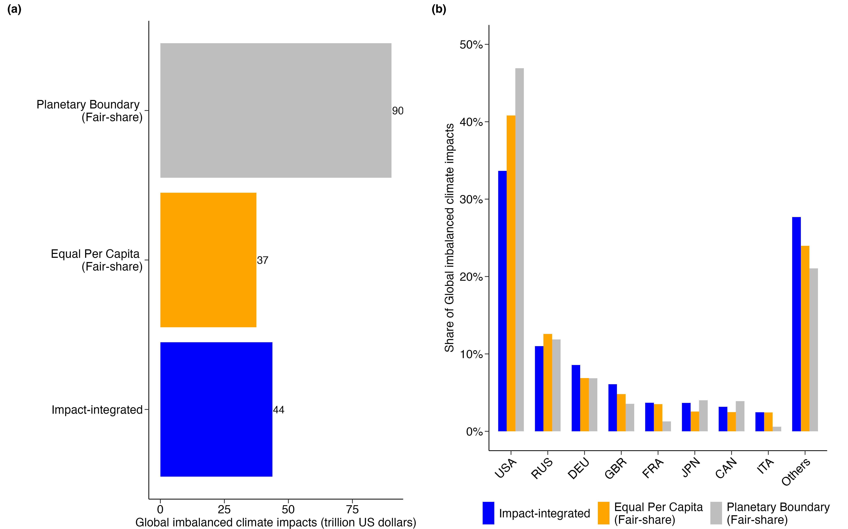
Supplementary Figure 1. Comparison of global net climate change impacts and national shares calculated under the impact-integrated principle, planetary boundary principle, and equal per capita principle. (a), Global net climate change impacts. (b), Comparison of the main contributors’ shares for climate change impacts under each principle.

- Comparative analysis of climate change impact assessment models: growth vs. level effects
One of the core debates in the assessment of climate change impacts is whether the persistence of climate change impacts over time should be taken into account. Some models incorporate the concept that early climate change impacts can influence future economic baselines, leading to an accumulation of impacts – a phenomenon known as the “growth effect” ^{7,8}. This typically results in substantially higher estimates of climate change impacts and the social cost of greenhouse gases (SC-GHGs) ^{9,10}. In contrast, other models, such as the GIVE model, assume that climate change impacts do not persist into future years, characterizing them as the “level effect”, where damages occur in a given year but do not compound over time.

We conducted a comparative analysis of the GIVE model and two alternative models that capture the growth effect: the Burke–Hsiang–Miguel (BHM) model ⁷ and the Dell–Jones–Olken (DJO) model ⁸. The main difference between BHM and DJO lies in the specification of their damage functions. The BHM model employs a quadratic function to describe the temperature-growth relationship, establishing an optimal temperature for all countries. The DJO model employs a linear damage function, distinguishing between poor and rich countries by assigning different coefficients to each.

Equations (9-15) provide a framework for evaluating the economic impacts of climate change by comparing observed temperature changes to those in counterfactual no-climate-change scenarios. Equation (9) defines the adjusted growth rate (𝑔̃) as the observed growth rate (g) minus the differential impacts of regional temperature under no-climate-change versus with-climate-change conditions. The term $f\left(T_{r,t}^{NoClimateChange}\right)-f\left(T_{r,t}^{WithClimateChange}\right)$ quantifies the change in economic growth attributable to temperature deviations induced by climate change. Equation (10) introduces ΔT, which captures the difference between the regional temperature under climate change and the baseline no-climate-change temperature. This temperature deviation serves as a key input for understanding how changes in regional climate conditions disrupt economic growth trajectories. Equation (11) then aggregates these impacts over time, with the cumulative difference between the logarithmic economic outputs (ln(𝑦) and 𝑙𝑛(𝑦̃)), representing the total economic damages caused by climate change.

$\tilde{g_{t,r}}=g_{t,r}- [f\left(T_{r,t}^{NoClimateChange}\right)-f\left(T_{r,t}^{WithClimateChange}\right)]$ (9)
${∆T}_{r,t}= {T_{r,t}^{WithClimateChange}- T}_{r,t}^{NoClimateChange}$ (10)
$\ln{{(y}_{r,t})}- \ln{(\tilde{y_{r,t})}}=\sum_{i=1}^{t}{[f\left(T_{r,i}^{NoClimateChange}\right)-f\left(T_{r,i}^{WithClimateChange}\right)]}$ (11)

In the BHM model, the relationship between temperature and economic growth is expressed as a quadratic function. Specifically, the Equation (12) captures how regional temperature (T_{r,t}) affects economic output over time. This quadratic form indicates that the impact of temperature on economic growth may either increase or decrease depending on the degree of temperature deviation from an optimal level, which is defined as -β₁/(2*β₂). In our BHM model, we use a lag-5 specification, meaning that a 5-year lag is applied in the econometric estimation to determine the parameters β₁ and β₂, which helps capture the long-term effects of climate change. The compounded impact of temperature changes (ΔT_{r,t}) over time is further described in the BHM model using Equation (13). The BHM model evaluates climate damages not only based on temperature changes but also the time span (t), indicating that the cumulative effects of temperature rise compound over time.

$f_{BHM}\left(T_{r,t}\right)= β_{1}*T_{r,t}+β_{2}*{T_{r,t}}^{2}$ (12)
$\ln{y_{r,t}^{BHM}}- \ln{\tilde{y_{r,t}^{BHM}}}=t*(\frac{β_{1}}{2}*{∆T}_{r,t}+β_{2}*T_{0}*{∆T}_{r,t}+\frac{β_{2}}{3}*{{∆T}_{r,t}}^{2})$ (13)

The DJO model adopts a simpler linear functional form to describe the relationship between temperature and economic growth. In Equation (14), the impact of temperature on economic output is directly proportional to the temperature level, with α representing the sensitivity coefficient. The DJO model distinguishes between “poor” and “rich” countries by assigning different α values (0.01041 for poor countries and 0.00191 for rich countries), thus capturing varying vulnerabilities to temperature changes. The threshold dividing these two groups is set at a per capita GDP of $2,269 (in 2005 USD), which corresponds to the median global GDP per capita in 1980. In Equation (15), the compounded growth effect is simplified, illustrating how economic output deteriorates over time with the temperature rises, with the degree of climate damages being proportional to the time step (t) and the magnitude of temperature increases (ΔT).

$f_{DJO}\left(T_{r,t}\right)= α*T_{r,t}$ (14)
$\ln{y_{r,t}^{DJO}}- \ln{\tilde{y_{r,t}^{DJO}}}=t*(\frac{α}{2}*{∆T}_{r,t})$ (15)

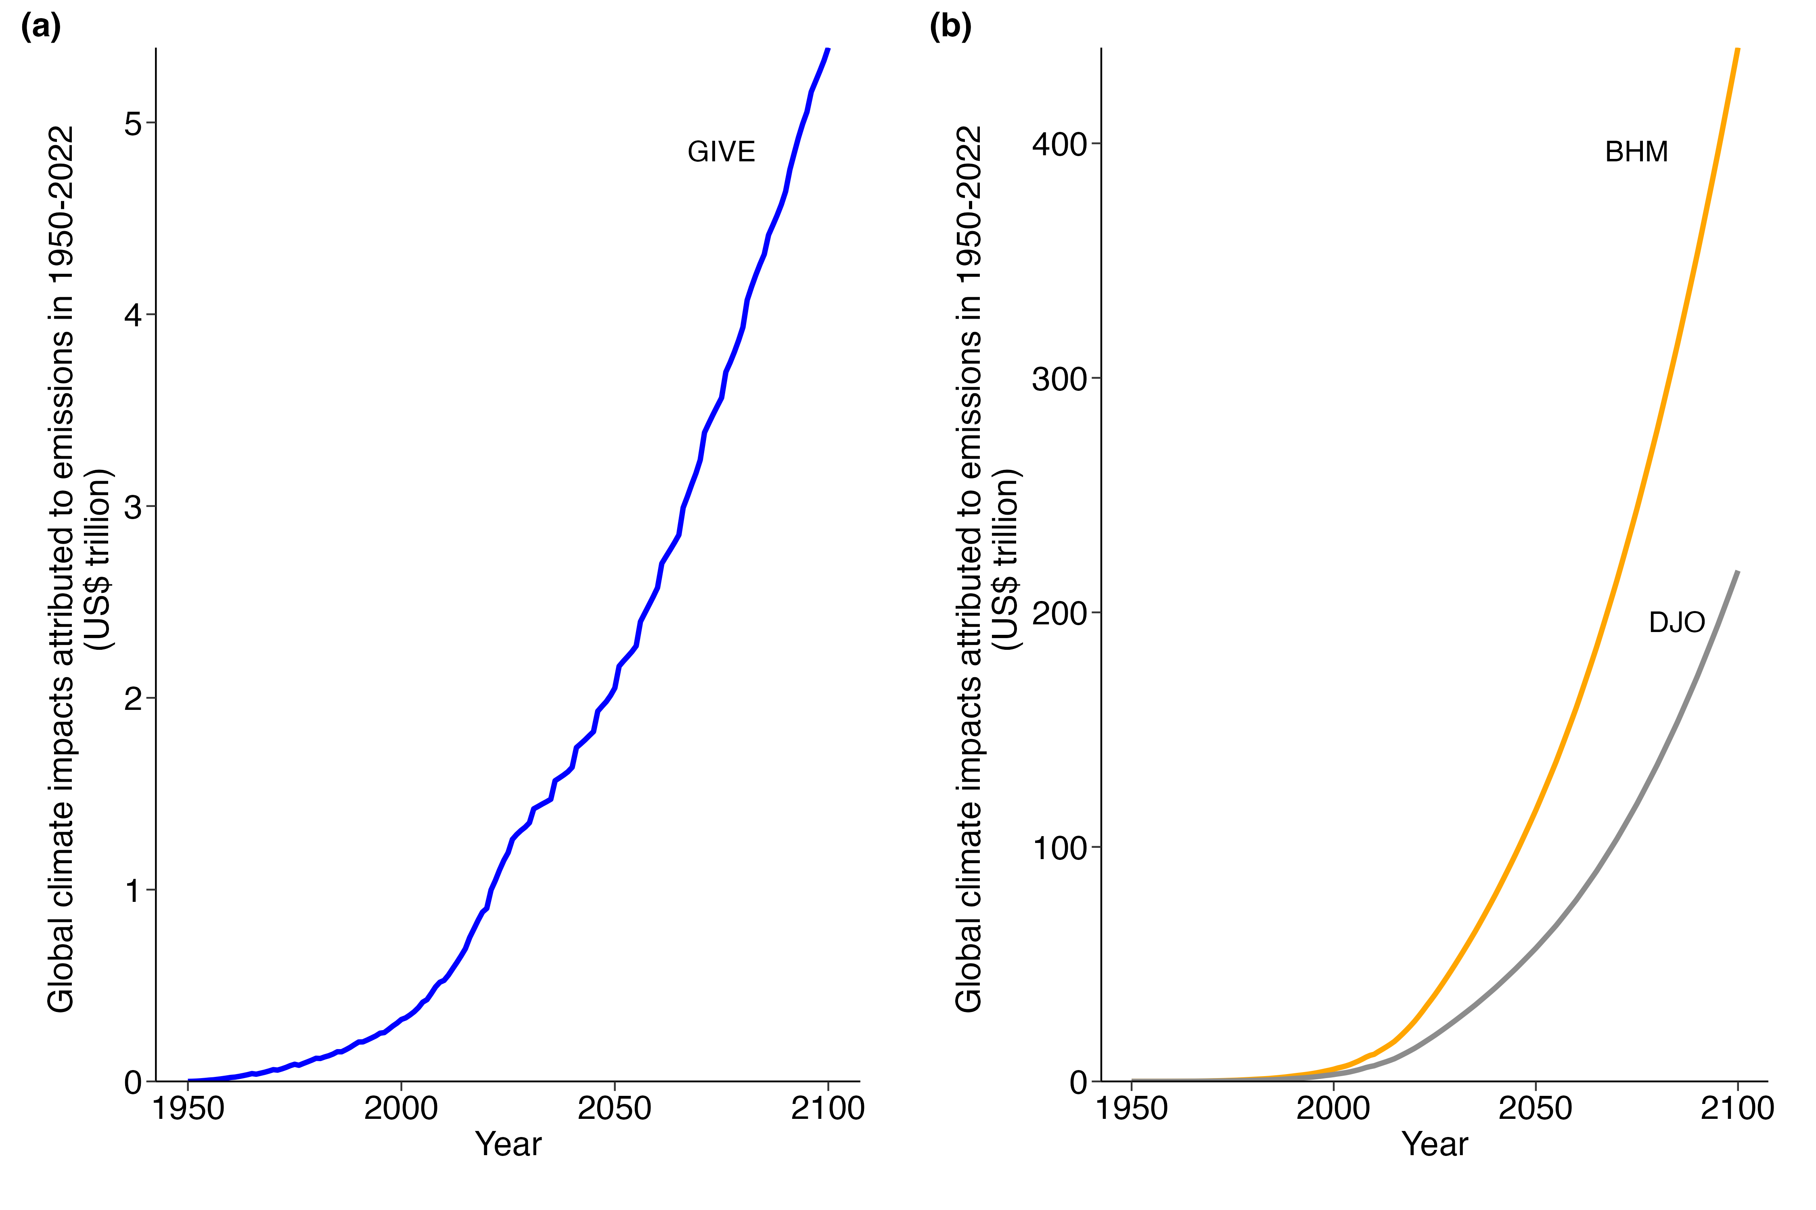
Supplementary Figure 2. Projected annual global climate change impacts attributed to historical emissions from 1950 to 2022 by different climate change impact assessment models: the GIVE model (a) and the BHM and DJO models (b). The BHM and DJO models consider the persistence of climate change impacts, while the GIVE model assumes zero persistence of climate change impacts.

To better understand the differences in projected climate change impacts across models, we performed a comparative analysis based on global historical emissions between 1950 and 2022. The results demonstrate large disparities among models. The BHM and DJO models, which account for the persistence of climate change impacts, project a rapid escalation of climate change impacts over time, especially toward the end of the century. These models predict substantially higher levels of impacts than the GIVE model, which assumes zero persistence and thus produces more conservative estimates (Supplementary Figure 2). The divergence among these models becomes particularly pronounced in the later years.

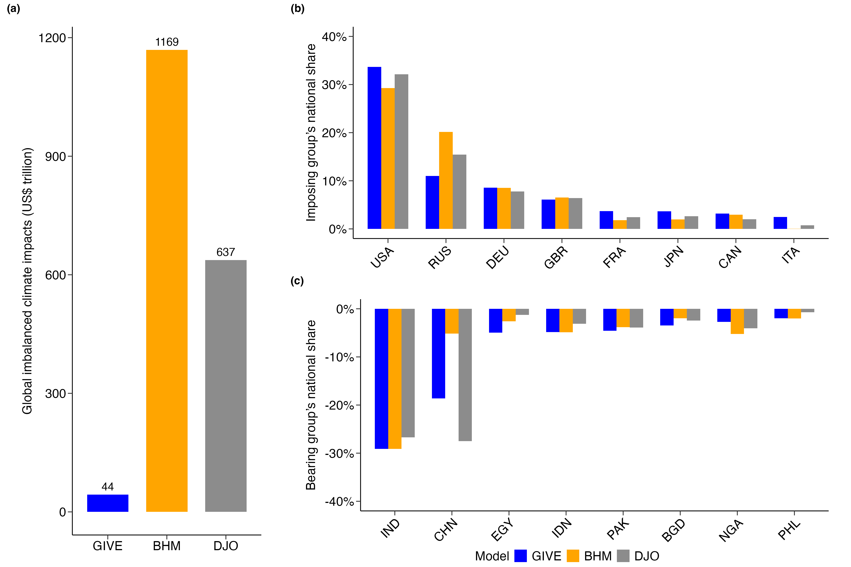
Supplementary Figure 3. Comparison of global net climate change impacts estimates (in trillion USD) under three different models: GIVE, BHM, and DJO. (a), Total global net climate change impacts caused by historical emissions from 1950 to 2022. (b), Bearing group: national shares of countries suffering the largest net climate change impacts. (c), Imposing group: national shares of countries responsible for the largest net climate change impacts.

The growth effect substantially increases the estimated global net climate change impacts (Supplementary Figure 3a). The BHM and DJO models estimate these net impacts to be US$1170 and US$637 trillion, respectively, which are much higher than the US$43.7 trillion estimated by the GIVE model. Despite the wide differences in aggregate estimates, the relative distribution of national shares remains broadly consistent across models. Countries such as the USA, Russia, and Germany consistently account for the largest shares of imposed climate change impacts, while countries including India appear prominently in the bearing group as among the most severely affected (Supplementary Figure 3b, c).

In the Main Text, we chose to use the GIVE model to evaluate climate change impacts rather than the BHM or DJO models primarily because the persistence of climate change impacts – central to models incorporating growth effects – remains a matter of debate. Recent critiques, such as those by Newell et al. ¹¹, have highlighted the substantial uncertainty and poor out-of-sample performance of models that assume growth effects, raising doubts about their predictive reliability. Meanwhile, the large GDP reductions identified in Burke et al. may also reflect macroeconomic factors rather than climate effects alone ¹². The GIVE model, which focuses on level effects rather than growth effects, provides a more conservative and less contentious estimate, serving as a robust and widely accepted basis for assessing climate change impacts.

- Attribution of climate change impacts to national greenhouse gas emissions
The method we propose for attributing climate change impacts in one country to the emissions of another country is derived from the calculation of SC-GHGs. SC-GHGs is defined as the aggregate climate change impacts across different regions globally caused by a marginal change in GHG emissions. To calculate the SC-GHGs for a target year, a pulse of emissions is added to the baseline emissions pathway for that year, and the subsequent changes in climate change impacts across various regions are computed. Previous studies have shown that the SC-GHGs results differ by no more than 1% when tested with changes in target year emissions of 1 Gt, 10 Gt, and 100 Gt ¹³. Since most countries’ historical emissions are below 100 Gt, removing each country’s emissions from the global total can be considered a marginal change, allowing for the calculation of the corresponding climate change impacts attributable to that country’s emissions.

According to the GIVE model, under the default scenario, global climate change impacts increase from under US$500 billion in 2000 to over US$15,000 billion by 2100 (Supplementary Figure 4a). The counterfactual scenario, assuming zero historical emissions from 1950 to 2022, shows lower global climate change impacts compared to the default scenario. Comparing the default and counterfactual scenarios isolates the portion of climate change impacts attributable to historical emissions. Because the GIVE model reports climate impacts at the country level, this comparison can yield a bilateral matrix of impacts, quantifying for each emitting country the climate change impacts its historical emissions cause in every other country.

When modeling national contributions to climate change impacts, each country’s marginal contribution is calculated ceteris paribus. If the dynamics of emissions impacts are non-linear, a ton of emissions will have greater effect in a world already burdened by substantial anthropogenic emissions. This may introduce potential bias: the aggregate of all nations’ marginal contributions to climate change impacts could exceed the global total climate change impacts. We assessed this potential bias using the GIVE model. Each country’s contribution to climate change impacts is stacked in Supplementary Figure 4b, showing how different nations have historically contributed to climate change impacts, with the black line showing the total global effect by removing all countries’ historical emissions. The comparison reveals that while slight discrepancies emerge due to the non-linear effects of emissions, the aggregate of individual contributions aligns closely with the total. To quantify this bias, we assessed the discounted global climate change impacts. When summing the marginal contributions from individual countries, the total amounts to US$90.8 trillion, while removing all historical emissions yields a global impact total of US$90.3 trillion, resulting in a small difference of approximately 0.5% (Supplementary Figure 4c), proving the robustness of the results despite the non-linear effects of emissions.

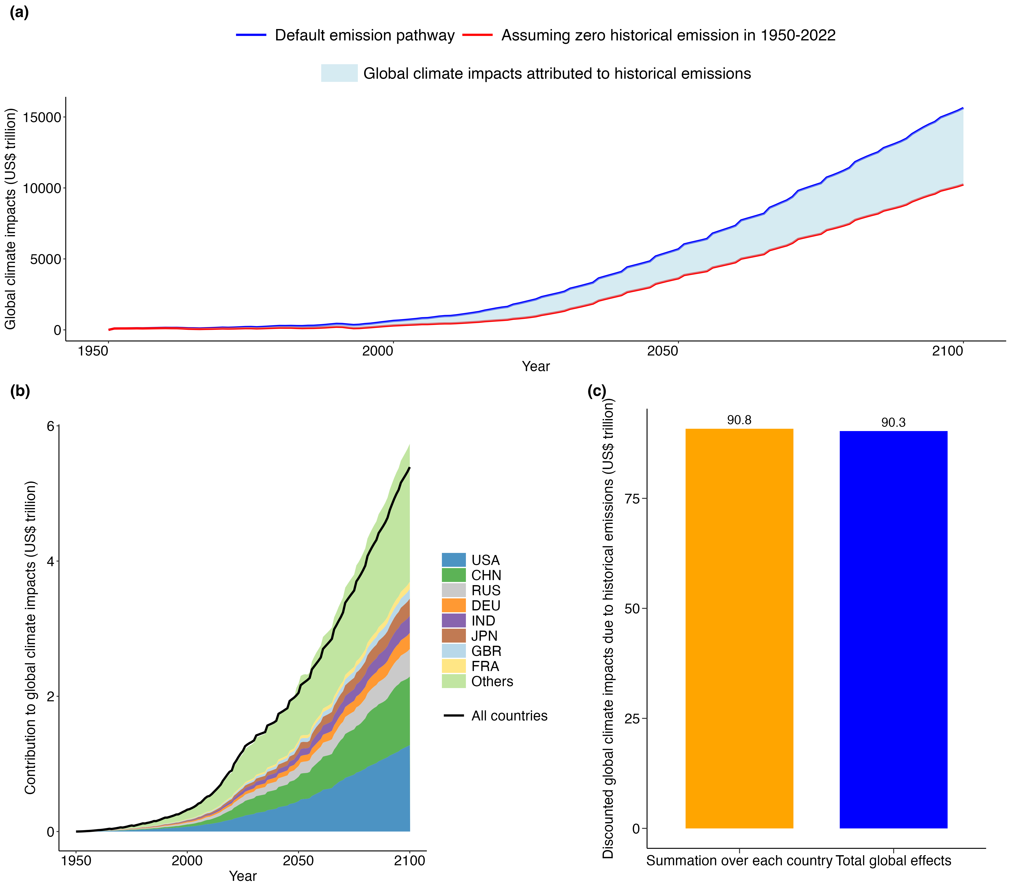
Supplementary Figure 4. Assessment of global climate change impacts attributable to individual countries’ historical emissions. (a), Global climate change impacts over time by the GIVE model under the default scenario and the counterfactual scenario assuming zero historical emissions from 1950 to 2022. The differences between the two scenarios (default and counterfactual) are shown in the blue shadow area. (b), Cumulative contributions of individual countries’ historical emissions to global climate change impacts, represented as a stacked bar chart. Each color represents a different country, and the black line indicates the total impacts when all countries' historical emissions are removed. (c), Comparison between the discounted total climate change impacts by aggregating over each country (left bar) and by considering the total impacts with all historical emissions removed (right bar).

Supplementary Figures
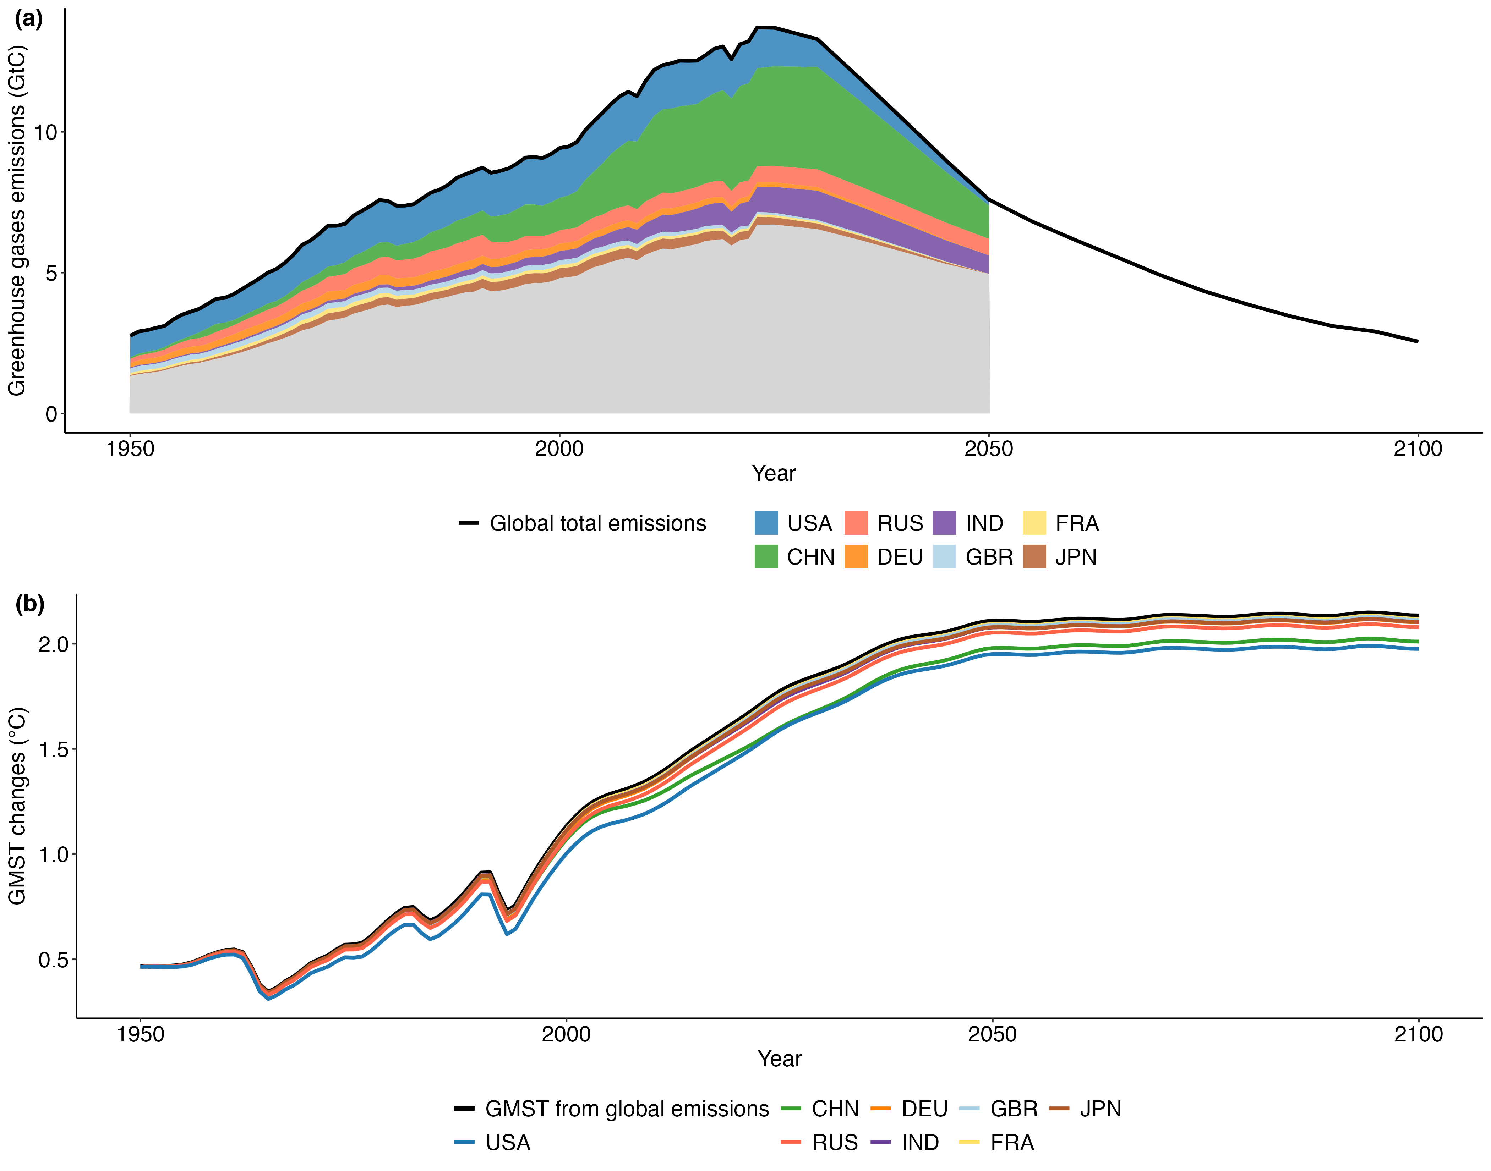
Supplementary Figure 5. Global greenhouse gas emissions and main emitters’ contributions to global mean surface temperature (GMST) changes. (a), Global greenhouse gas emissions from 1950 to 2100 under the default scenario (black line). The stacked colored areas depict the contributions of major emitting countries, including the USA, China, Russia, India, Germany, the UK, Japan, and France. This covers both historical emissions and future committed emissions up to 2050, including CO₂, CH₄, and N₂O emissions from fossil fuel consumption. (b), GMST changes relative to the 1850-1900 baseline. The black line represents the GMST changes caused by the cumulative emissions of all countries. The colored lines for each major emitting country indicate the GMST changes after removing the respective country’s historical emissions.
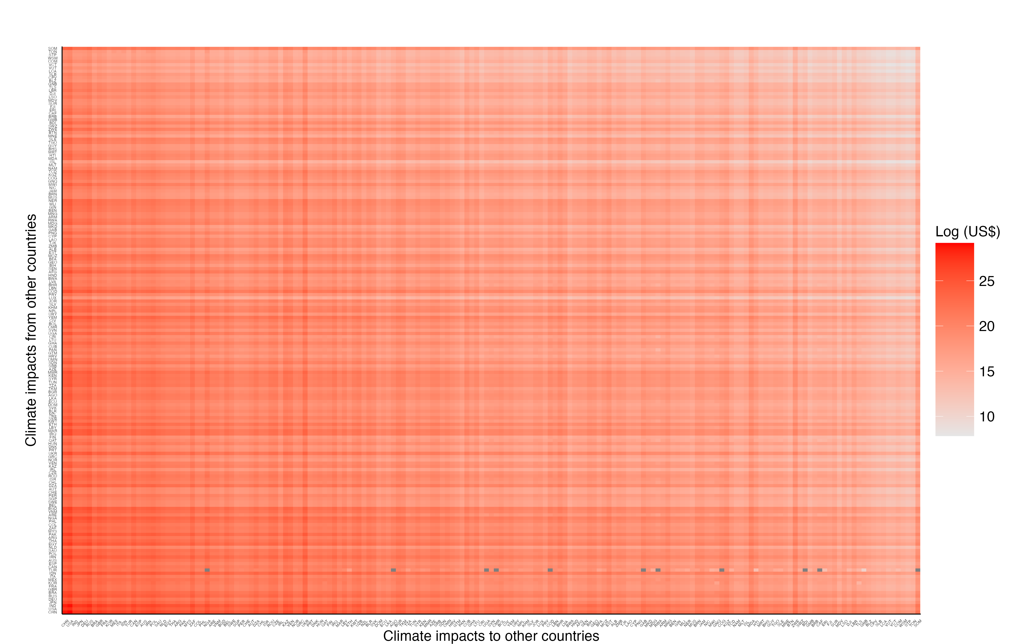
Supplementary Figure 6. Inter-country matrix of climate change impacts attributable to historical emissions. This matrix visualizes the climate change impacts caused by the country on the horizontal axis upon the country on the vertical axis. The intensity of the impact is represented by the color gradient, with darker shades indicating greater impacts. Countries along the horizontal axis are arranged by their GDP scale in 2022, from smallest to largest, while the countries on the vertical axis follow the same order from bottom to top. In some cases, certain countries may experience net benefits from climate change, as indicated in gray shading.

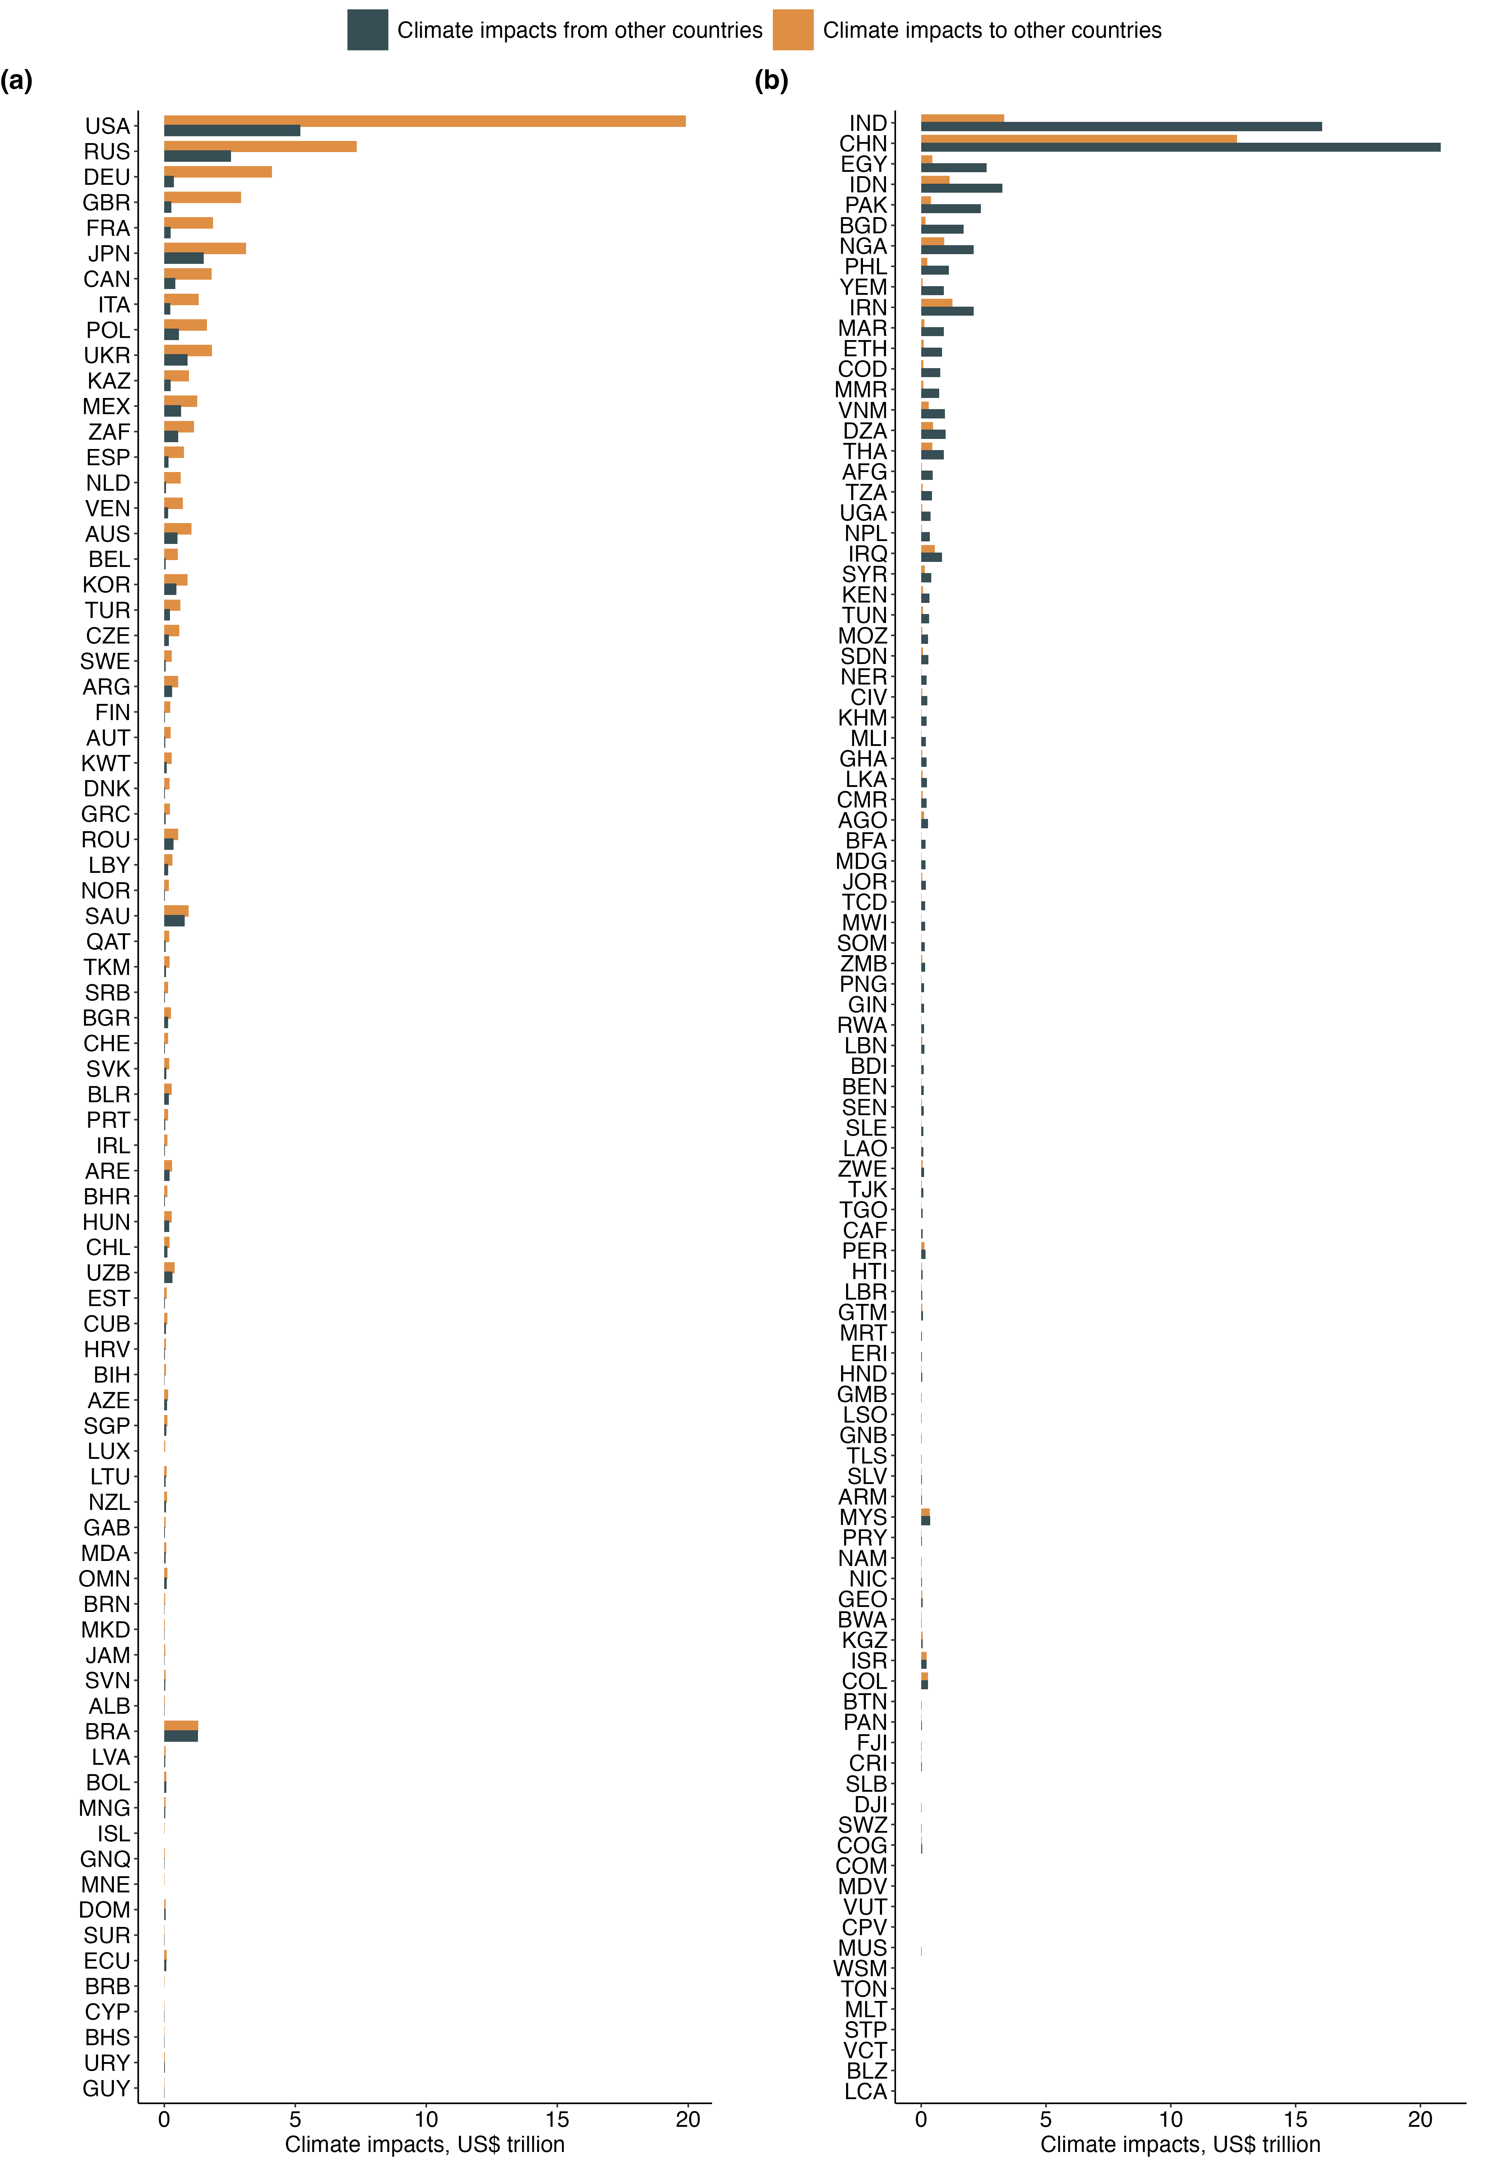
Supplementary Figure 7. Climate change impacts attributed to historical emissions. (a), Countries in the “imposing group” that cause net climate change impacts. (b), Countries in the “bearing group” that bear net climate change impacts.

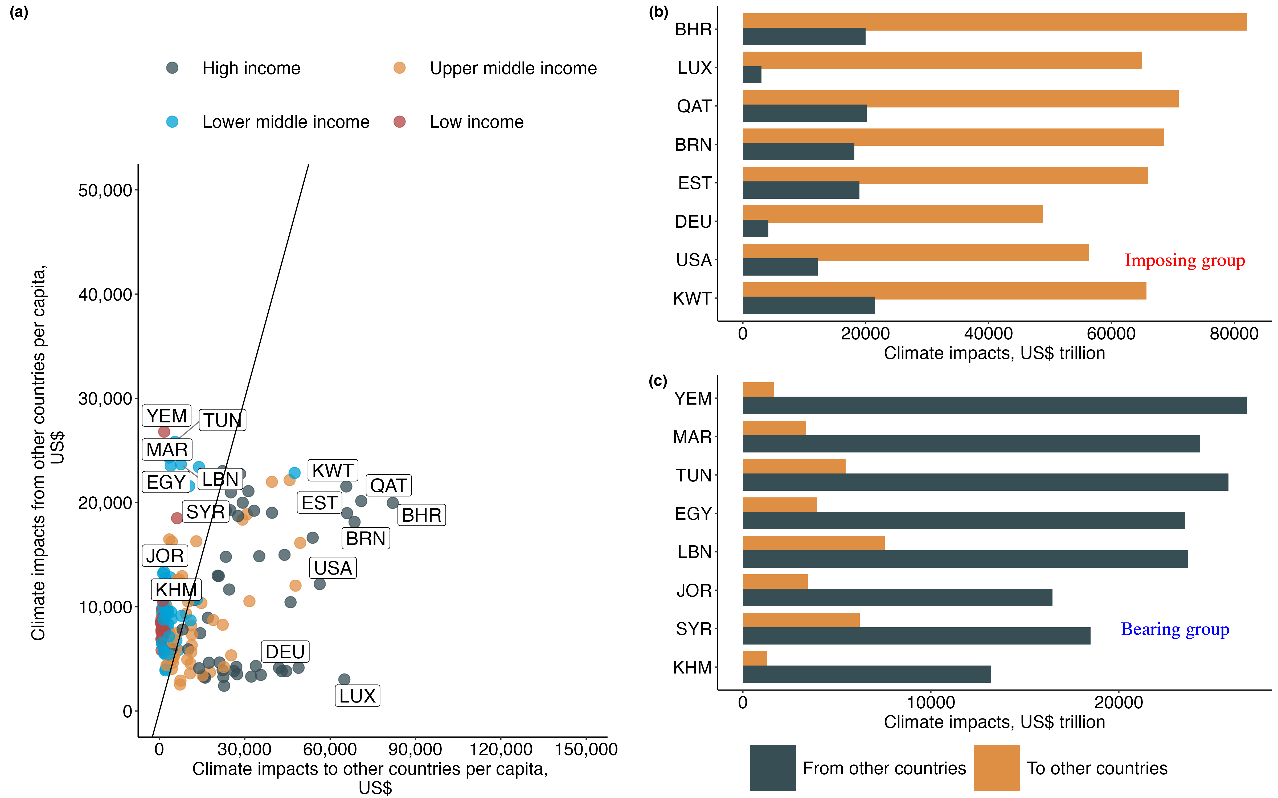
Supplementary Figure 8. Dfference between climate change impacts per capita to and from other countries. (a), Comparison of climate change impacts per capita based on historical emissions. The countries below the diagonal line belong to the “imposing group”, while the countries above the diagonal line belong to the “bearing group”. (b-c), Countries with the highest net positive (b) and net negative (c) climate change impacts per capita. Country income classifications are based on the World Bank (Supplementary Table 2).

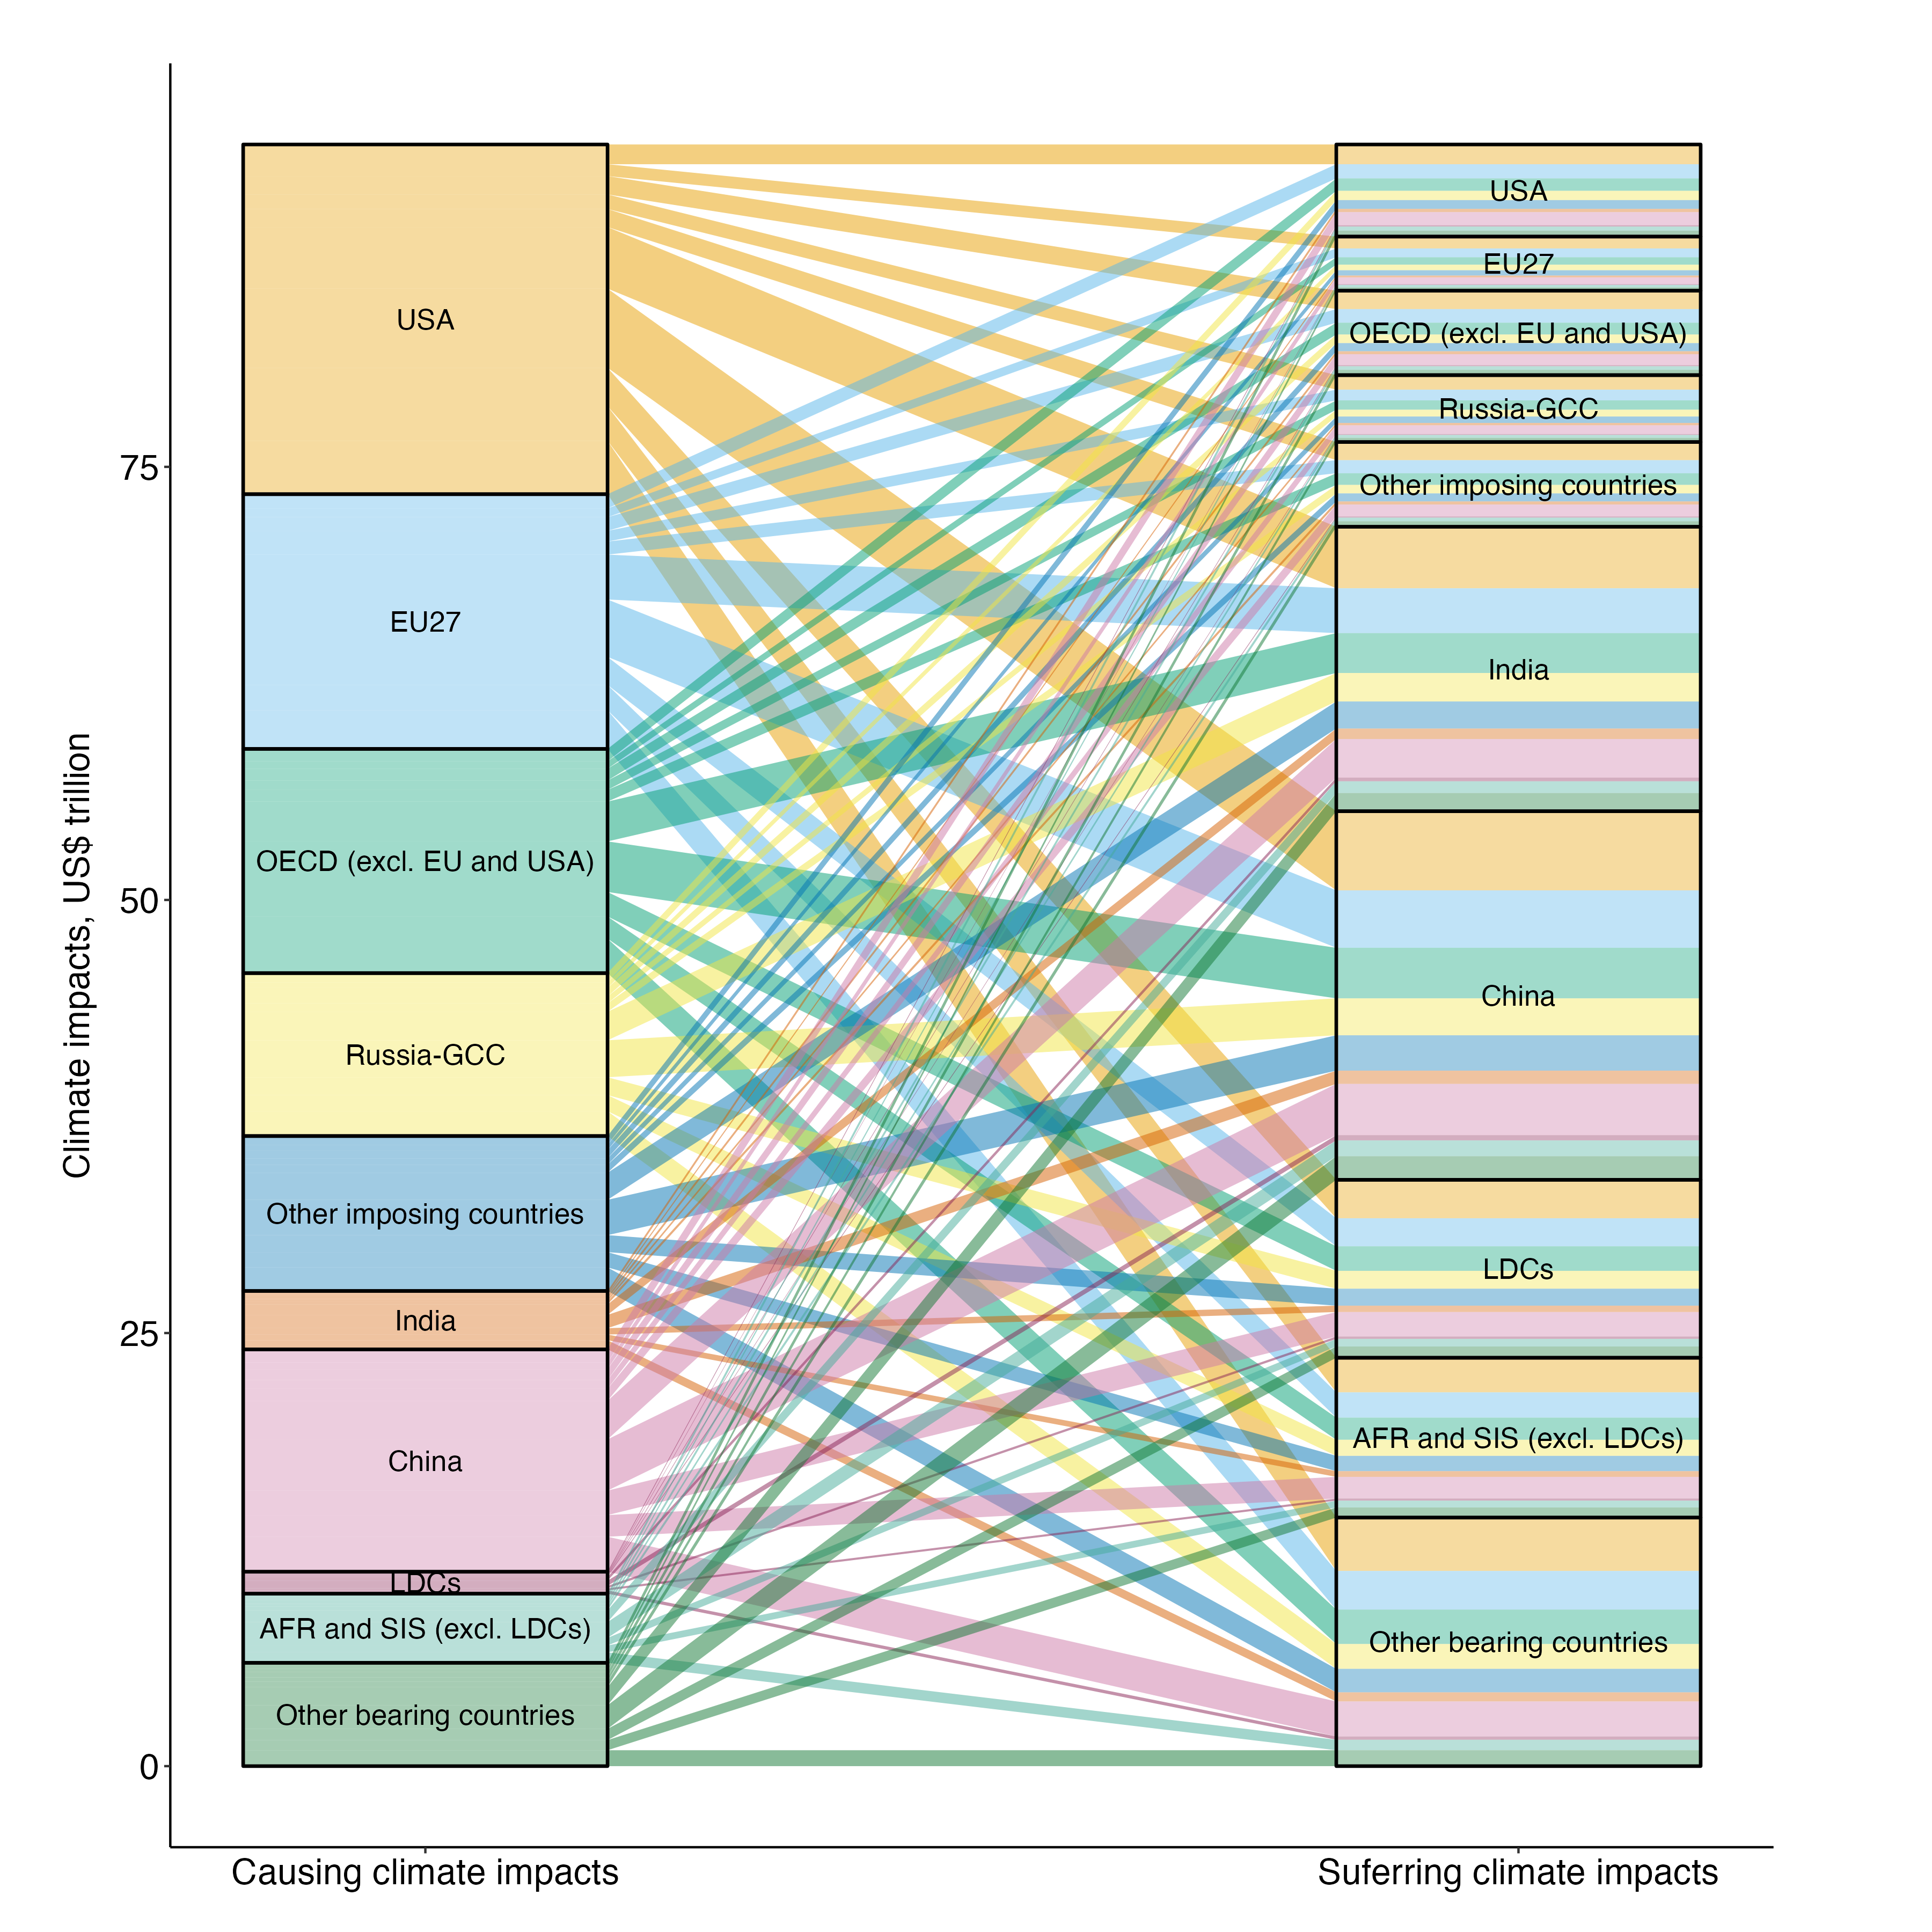
Supplementary Figure 9. Sankey diagram of global climate change impact flows due to historical emissions. Each stream in the diagram represents the flow of climate change impacts from the left to the right, with the width proportional to the magnitude of the impact transferred. The “imposing group” includes USA: United States of America; EU27: the 27 European Union countries; OECD (excl. EU and USA): OECD countries outside the EU and USA; Russia-GCC: Russia and the Gulf Cooperation Council countries (Saudi Arabia, Kuwait, the United Arab Emirates, Qatar, Bahrain, and Oman); Other imposing countries: all remaining countries causing net impacts. The “bearing group” includes India; China; LDCs: least developed countries; AFR and SIS (excl. LDCs): African countries and small island states excluding the LDCs; Other bearing countries: all remaining countries experiencing net impacts. The color coding corresponds to the source country groups.
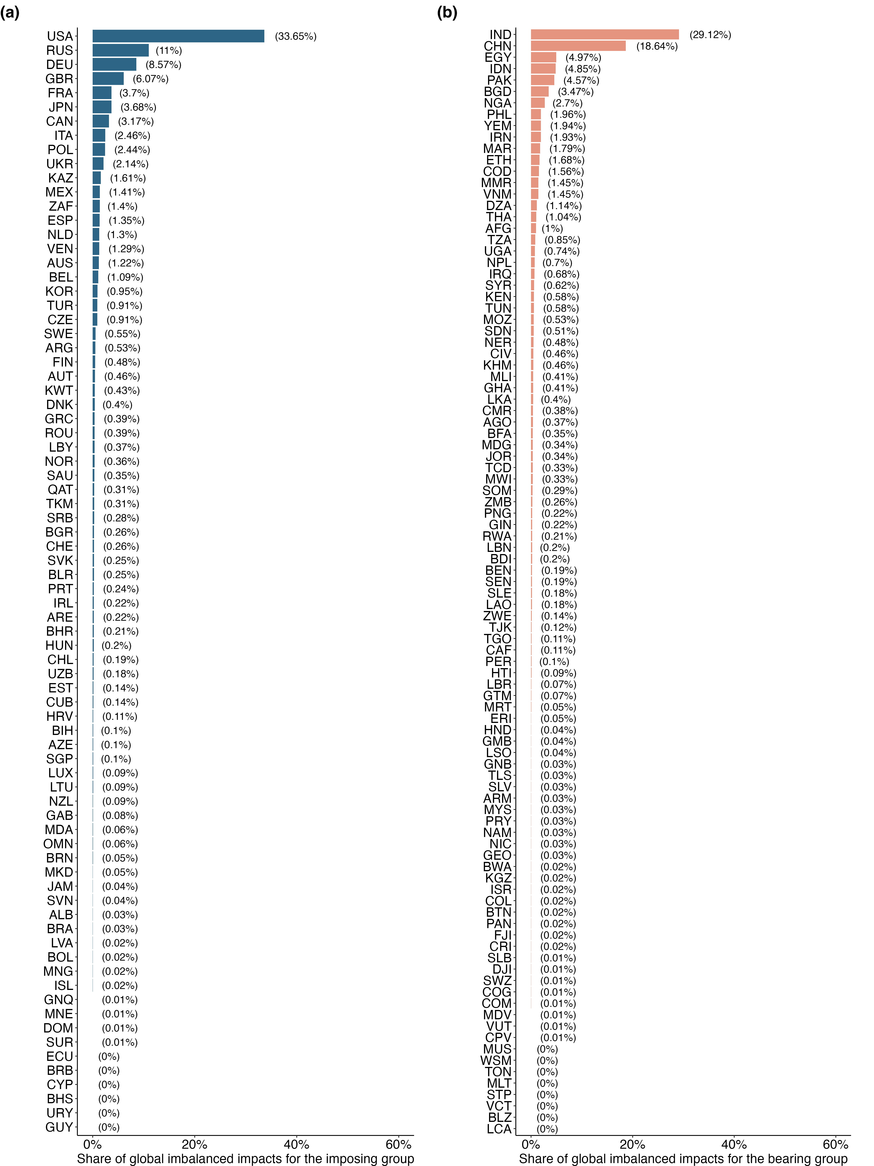
Supplementary Figure 10. National shares for global net climate change impacts. (a), National shares for countries in the “imposing group”. (b), National shares for countries in the “bearing group”.

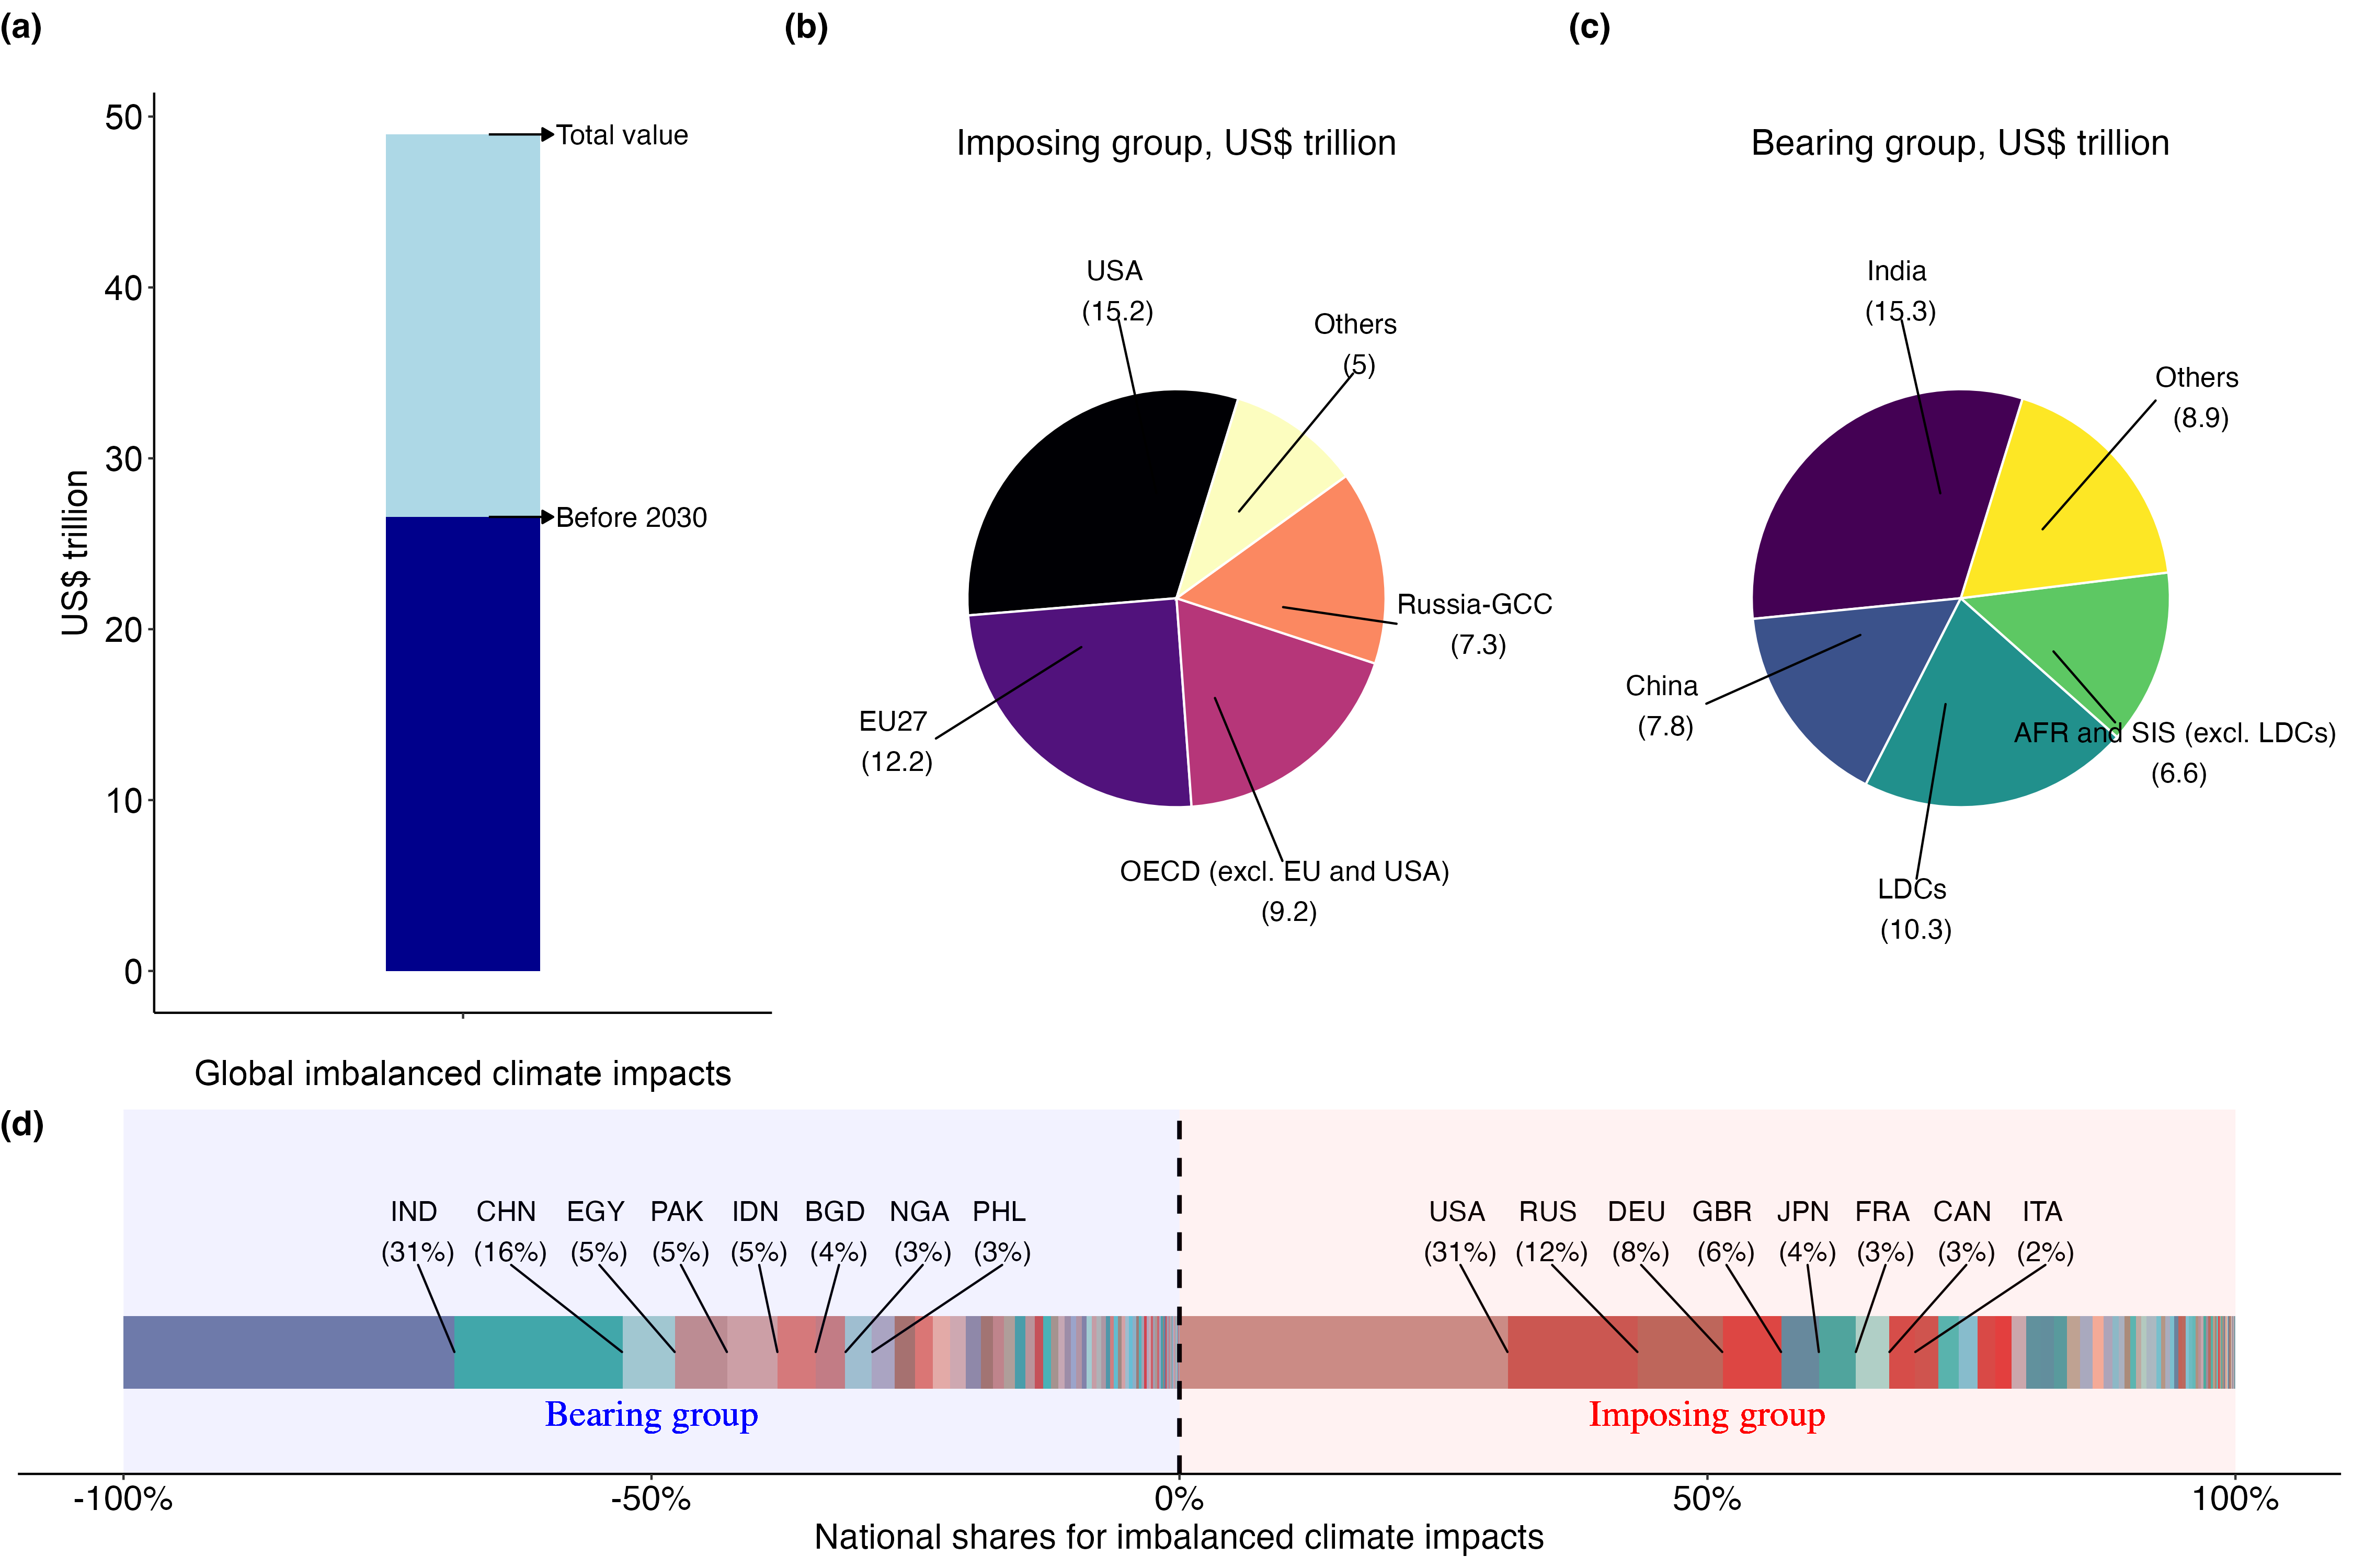
Supplementary Figure 11. Global net climate change impacts and national shares from both historical and pledged emissions. (a), Projected global net climate change impacts, with breakdowns for the pre-2030 period. (b), Net climate change impacts attributed to nations in the imposing group (USA: United States of America; EU27: the 27 European Union countries; OECD (excl. EU, USA): OECD states outside the EU and USA; Russia-GCC: Russia plus Gulf Cooperation Council countries (Saudi Arabia, Kuwait, the United Arab Emirates, Qatar, Bahrain, and Oman); Others: all remaining imposing countries based on their historical and pledged emissions. (c), Net climate change impacts borne by nations in the bearing group (India; China; LDCs: least developed countries; AFR and SIS (excl. LDCs): African countries and small island states excluding LDCs; Others: all remaining bearing-group countries. (d), National shares for net climate change impacts, with positive values representing contributions from the imposing group and negative values representing impacts borne by the bearing group. Major countries with the largest shares are labeled.
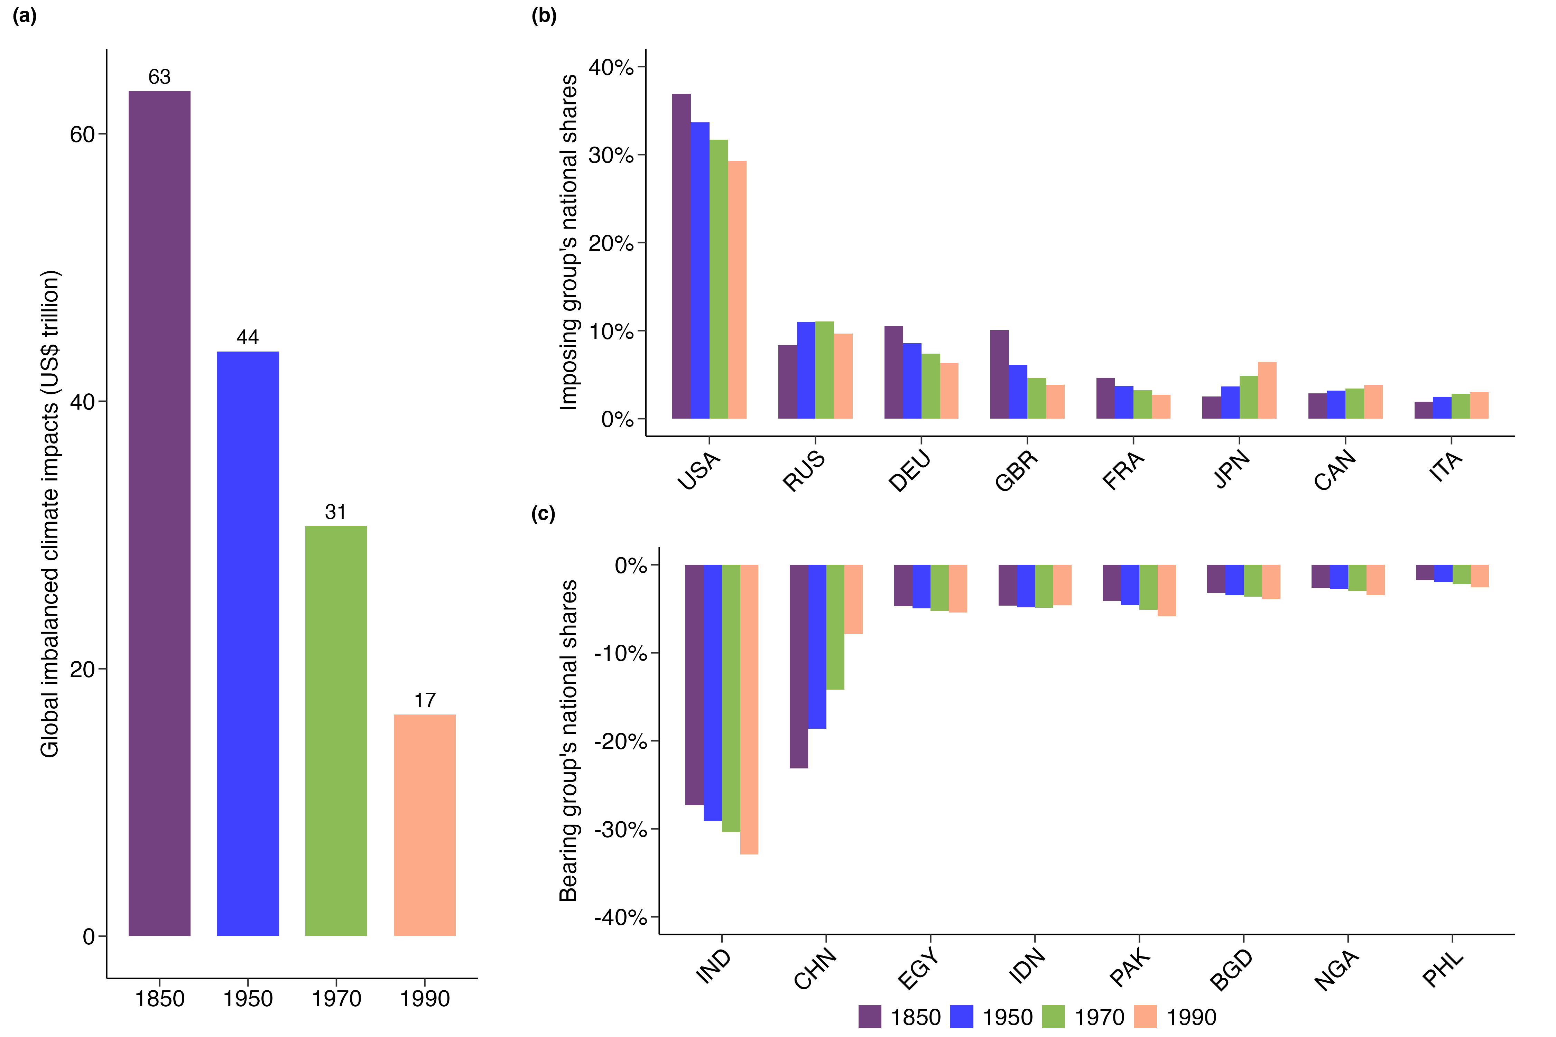
Supplementary Figure 12. Sensitivity analysis of global net climate change impacts (a) and national shares (b-c) with varying starting years (1850, 1950, 1970, and 1990).

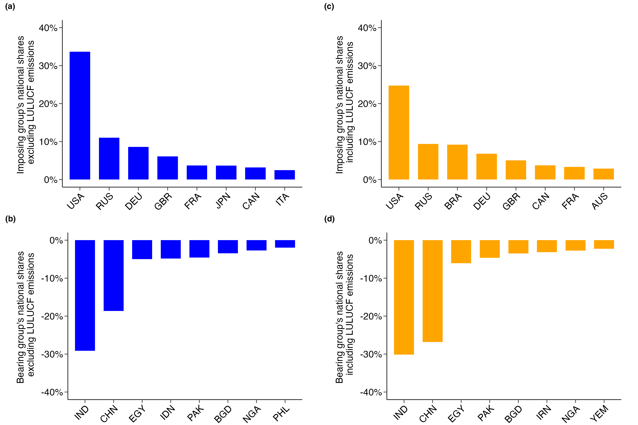
Supplementary Figure 13. Comparative analysis of national shares with and without LULUCF emissions. (a-b), National shares excluding LULUCF emissions. (c-d), National shares including LULUCF emissions.

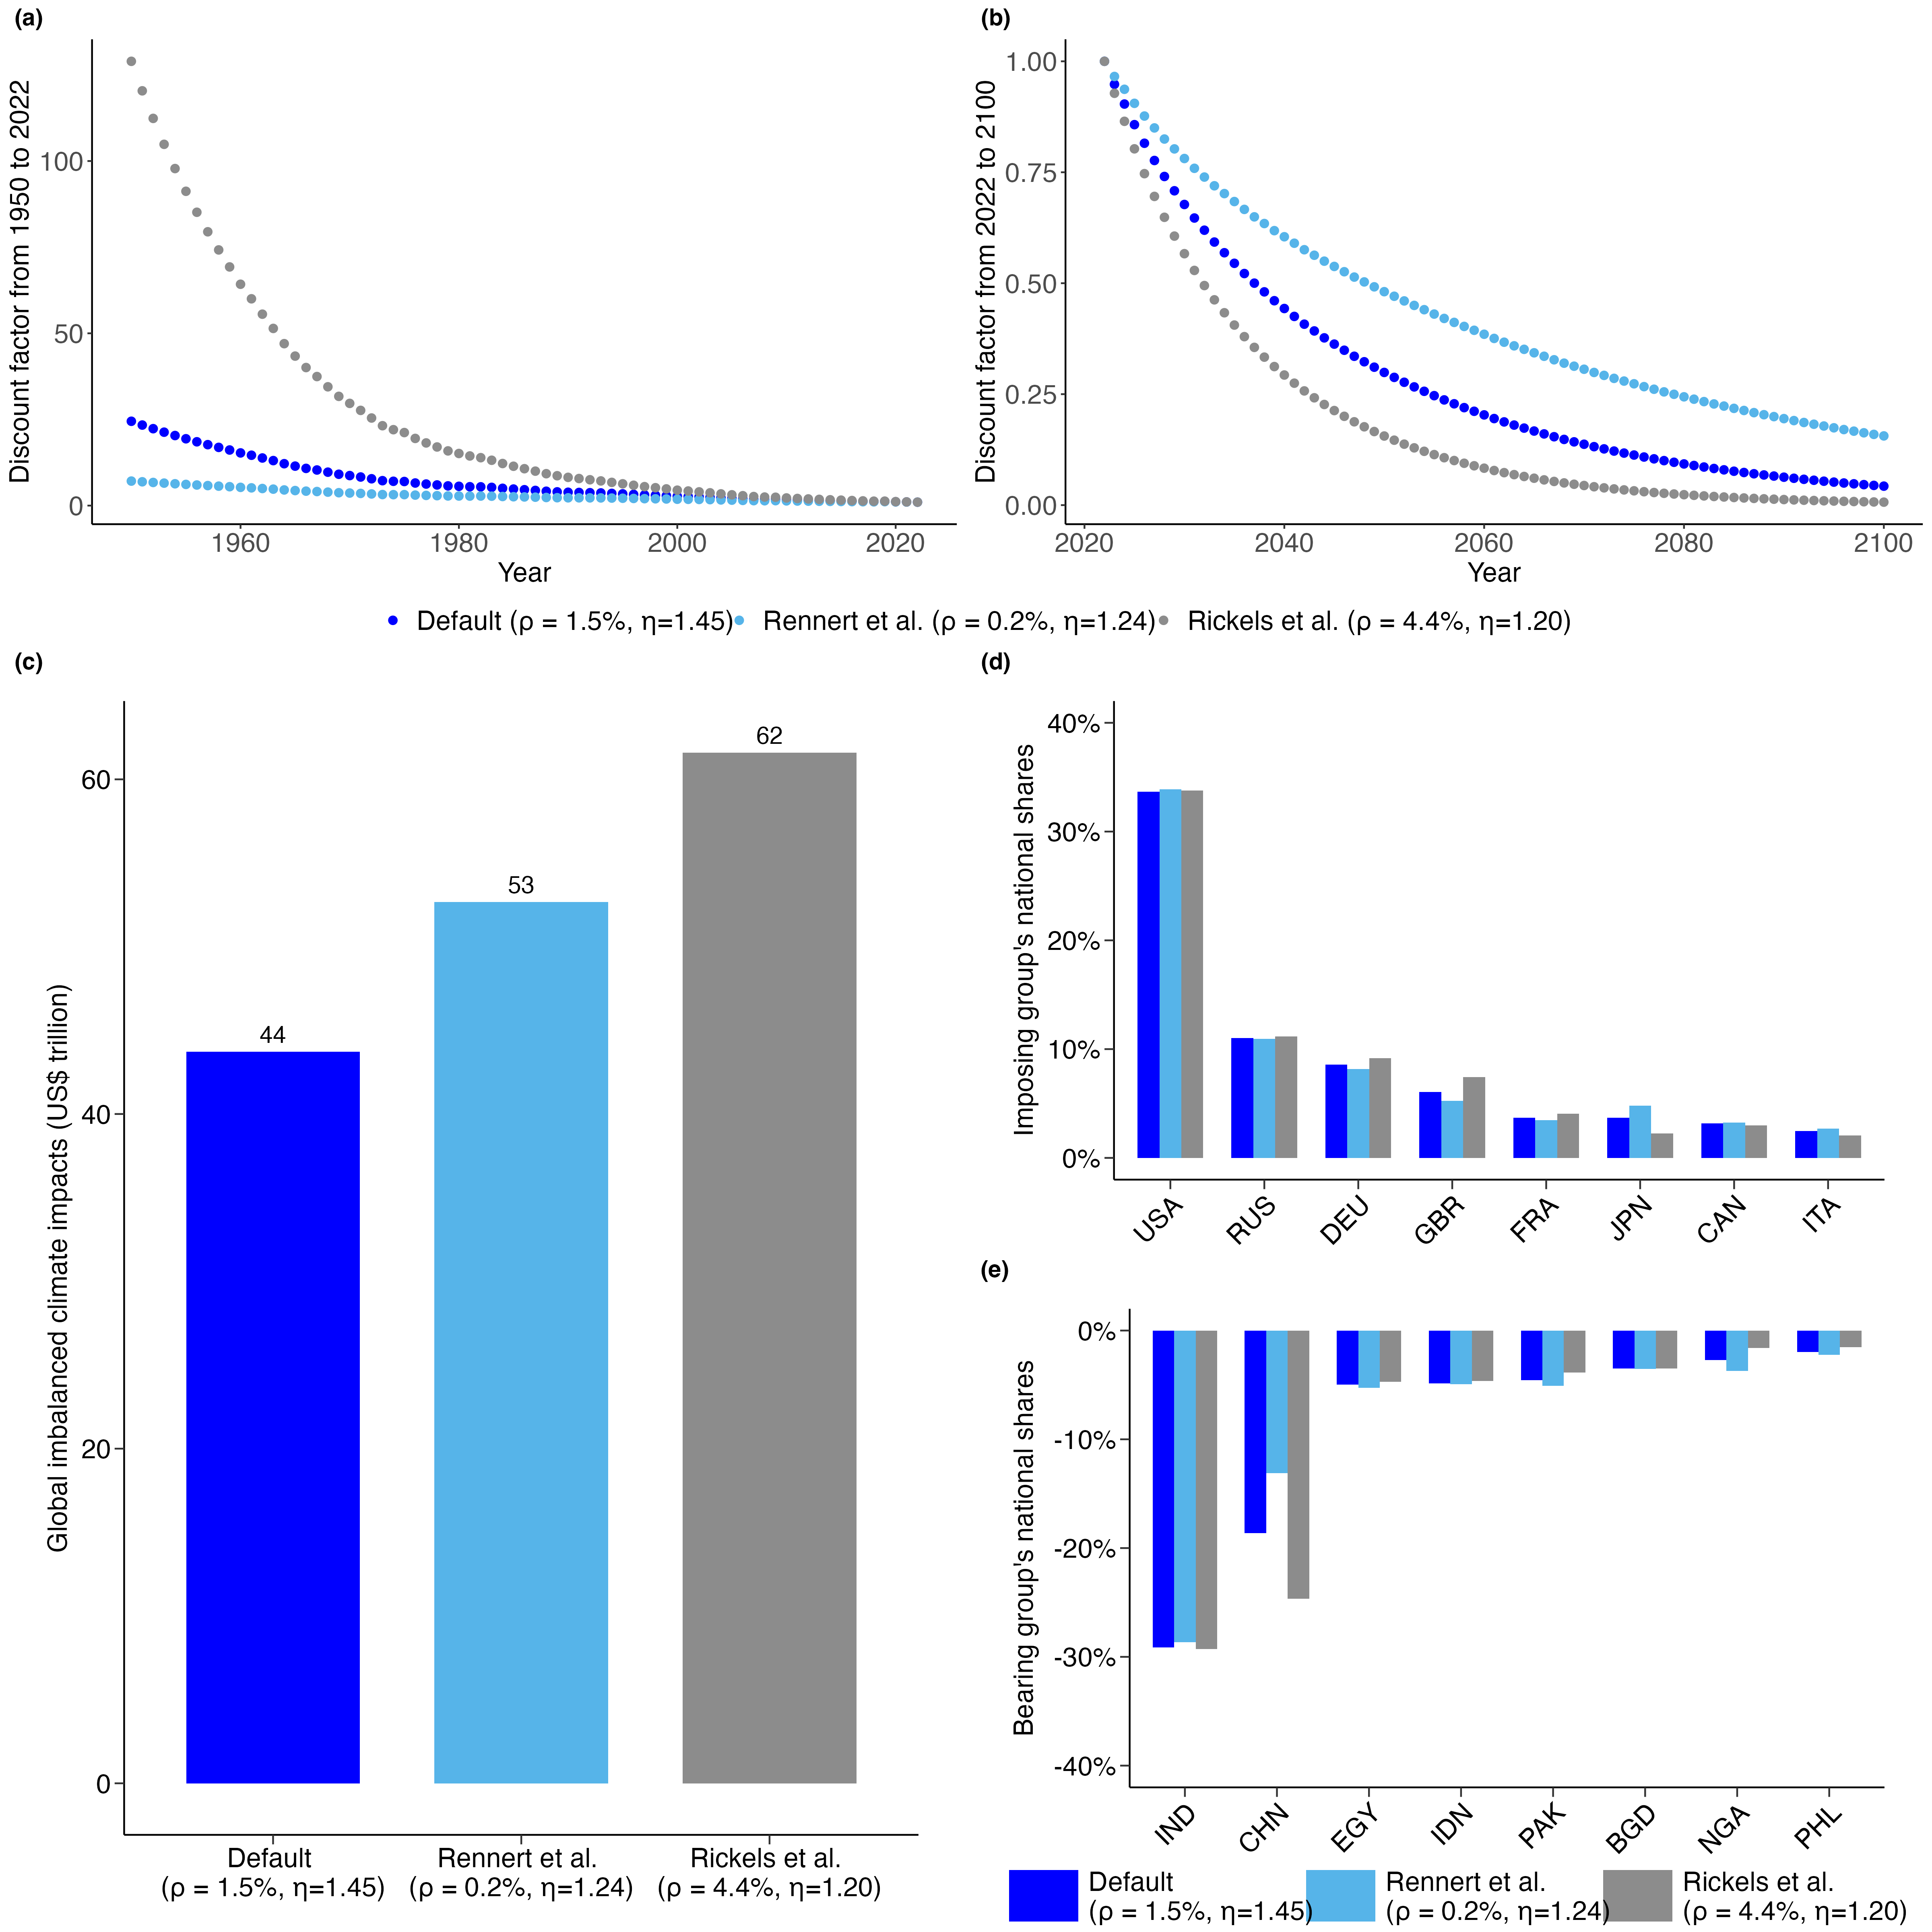
Supplementary Figure 14. Impact of different discounting methods on global net climate change impacts and national shares. (a-b), Discount factors applied from 1950 to 2022 (a) and from 2022 to 2100 (b) under three different discounting methods: Default (ρ = 1.5%, η = 1.45), Rennert et al. (ρ = 0.2%, η = 1.24), and Rickels et al. (ρ = 4.4%, η = 1.20). The discount factor is set to 1 in the base year (2022). (c), Global net climate change impacts (in trillion US dollars) under these three discounting methods. (d-e) National shares of global net climate change impacts by country, highlighting the shares of major imposing countries (d) and bearing countries (e) under the three discounting methods.

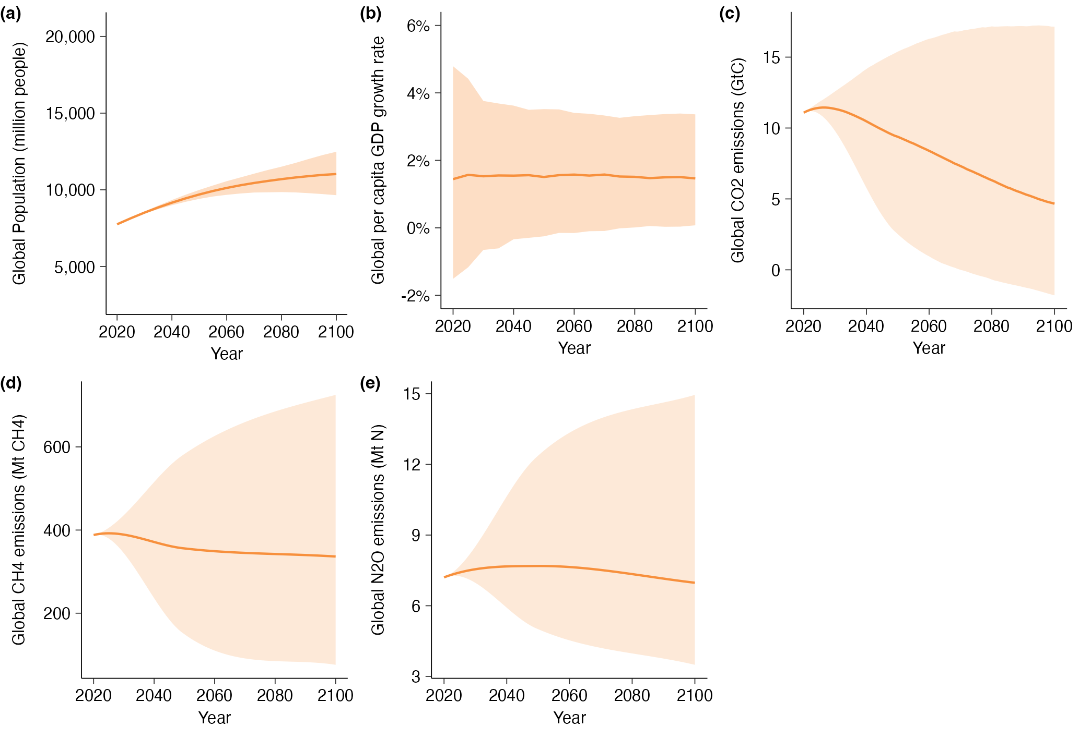
Supplementary Figure 15. Key socioeconomic and emissions parameters under the REF-SPs probabilistic scenario. (a), Global population (b), Global per capita GDP growth rate (c), Global CO₂ emissions (d), Global CH₄ emissions (e), Global N₂O emissions. The shaded areas represent the 5th to 95th percentile range, reflecting the uncertainty in the projections, while the solid orange line indicates the median estimate for each parameter across the REF-SPs probabilistic scenario.

Supplementary Tables
Supplementary Table 2. Countries and their classifications in this study. Country income classifications are from the World Bank, and the list of least developed countries is from the United Nations’ standard.
Classification |  | Country
High-income countries | OECD countries | Australia; Austria; Belgium; Canada; Denmark; Finland; France; Germany; Greece; Iceland; Ireland; Italy; Japan; Luxembourg; Netherlands; New Zealand; Norway; Portugal; Spain; Sweden; Switzerland; United Kingdom; United States
High-income countries | Other countries | Bahrain; Bahamas; Barbados; Brunei Darussalam; Chile; Cyprus; Czech Republic; Estonia; Croatia; Hungary; Israel; South Korea; Kuwait; Lithuania; Latvia; Malta; Oman; Panama; Poland; Qatar; Romania; Saudi Arabia; Singapore; Slovakia; Slovenia; United Arab Emirates; Uruguay
Upper-middle income countries |  | Albania; Argentina; Armenia; Azerbaijan; Bulgaria; Bosnia and Herzegovina; Belarus; Belize; Brazil; Botswana; China; Colombia; Costa Rica; Cuba; Dominican Republic; Ecuador; Fiji; Gabon; Georgia; Equatorial Guinea; Guatemala; Guyana; Iraq; Jamaica; Jordan; Kazakhstan; Libya; Saint Lucia; Moldova; Maldives; Mexico; North Macedonia; Montenegro; Mauritius; Malaysia; Namibia; Peru; Paraguay; Russia; Serbia; Suriname; Thailand; Turkmenistan; Tonga; Turkey; Saint Vincent and the Grenadines; Venezuela; South Africa
Lower-middle income countries | Least developed countries | Angola; Benin; Bangladesh; Bhutan; Comoros; Djibouti; Haiti; Cambodia; Laos; Lesotho; Myanmar; Mauritania; Nepal; Senegal; Solomon Islands; Sao Tome and Principe; Timor-Leste; Tanzania
Lower-middle income countries | Other countries | Bolivia; Cote d'Ivoire; Cameroon; Congo; Cape Verde; Algeria; Egypt; Ghana; Honduras; Indonesia; India; Iran; Kenya; Kyrgyzstan; Lebanon; Sri Lanka; Morocco; Mongolia; Nigeria; Nicaragua; Pakistan; Philippines; Papua New; Guinea; El Salvador; Swaziland; Tajikistan; Tunisia; Ukraine; Uzbekistan; Vietnam; Vanuatu; Samoa; Zimbabwe
Low-income countries | Least developed countries | Afghanistan; Burundi; Burkina Faso; Central African Republic; Democratic Republic of the Congo; Eritrea; Ethiopia; Guinea; Gambia; Guinea-Bissau; Liberia; Madagascar; Mali; Mozambique; Malawi; Niger; Rwanda; Sudan; Sierra Leone; Somalia; Syria; Chad; Togo; Uganda; Yemen; Zambia
Low-income countries | Other countries | Syria

Supplementary References
1 Fanning, A. L. & Hickel, J. Compensation for atmospheric appropriation. Nat. Sustainability 6, 1077-1086 (2023). https://doi.org/10.1038/s41893-023-01130-8
2 Hickel, J. Quantifying national responsibility for climate breakdown: an equality-based attribution approach for carbon dioxide emissions in excess of the planetary boundary. The Lancet Planetary Health 4, e399-e404 (2020).
3 Botzen, W. J. W., Gowdy, J. M. & Van Den Bergh, J. C. J. M. Cumulative CO2 emissions: shifting international responsibilities for climate debt. Clim. Policy 8, 569-576 (2008).
4 Xu, X., Wang, Q., Ran, C. & Mu, M. Is burden responsibility more effective? A value-added method for tracing worldwide carbon emissions. Ecol. Econ. 181, 106889 (2021).
5 Fuglestvedt, J. S. & Kallbekken, S. Fair shares? Nat. Clim. Change 6, 19-20 (2016). https://doi.org/10.1038/nclimate2791
6 Matthews, H. D. Quantifying historical carbon and climate debts among nations. Nat. Clim. Change 6, 60-64 (2016). https://doi.org/10.1038/nclimate2774
7 Burke, M., Davis, W. M. & Diffenbaugh, N. S. Large potential reduction in economic damages under UN mitigation targets. Nature 557, 549-553 (2018). https://doi.org/10.1038/s41586-018-0071-9
8 Dell, M., Jones, B. F. & Olken, B. A. Temperature Shocks and Economic Growth: Evidence from the Last Half Century. American Economic Journal: Macroeconomics 4, 66-95 (2012). https://doi.org/10.1257/mac.4.3.66
9 Wang, T. & Teng, F. Damage function uncertainty increases the social cost of methane and nitrous oxide. Nat. Clim. Change 13, 1258-1265 (2023). https://doi.org/https://doi.org/10.1038/s41558-023-01803-4
10 Ricke, K., Drouet, L., Caldeira, K. & Tavoni, M. Country-level social cost of carbon. Nat. Clim. Change 8, 895-900 (2018). https://doi.org/10.1038/s41558-018-0282-y
11 Newell, R. G., Prest, B. C. & Sexton, S. E. The GDP-Temperature relationship: Implications for climate change damages. J. Environ. Econ. Manage. 108, 102445 (2021). https://doi.org/https://doi.org/10.1016/j.jeem.2021.102445
12 Rosen, R. A. Temperature impact on GDP growth is overestimated. Proc. Natl. Acad. Sci. USA 116, 16170-16170 (2019). https://doi.org/10.1073/pnas.1908081116
13 Hope, C. The social cost of CO2 from the PAGE09 model. Economics discussion paper (2011).

