Construing the resilience to osmotic stress using endophytic fungus in maize (Zea mays L.)
Roopashree, B.¹ Rajendra Prasad, S.¹ and M. K. Prasanna Kumar²*
¹Department of Seed Science and Technology, University of Agricultural Sciences, Gandhi Krishi Vignana Kendra (GKVK), Bengaluru, India. Email: roopagowda152@gmail.com , prasadsr1959@gmail.com
^{2*}Department of Plant Pathology, University of Agricultural Sciences, Gandhi Krishi Vignana Kendra, Bangalore, India. Email: babu_prasanna@rediffmail.com

* Address correspondence to:
M. K. Prasanna Kumar*, Department of Plant Pathology, University of Agricultural Sciences, Bangalore, India. babu_prasanna@rediffmail.com, https://orcid.org/0000-0002-5115-411X

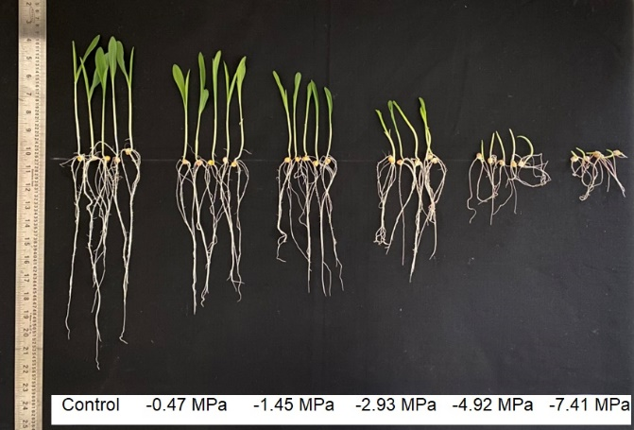
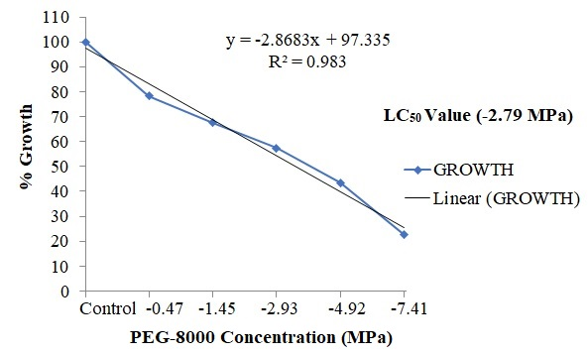
(A)
(B)

Figure S1: (A) & (B) Seedling growth of maize (MAH 14-5) on different concentrations of PEG-8000.

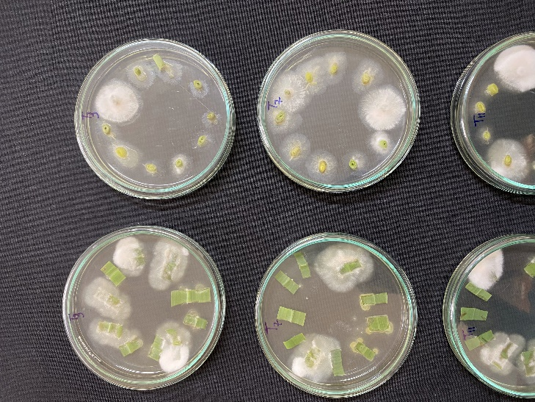 | 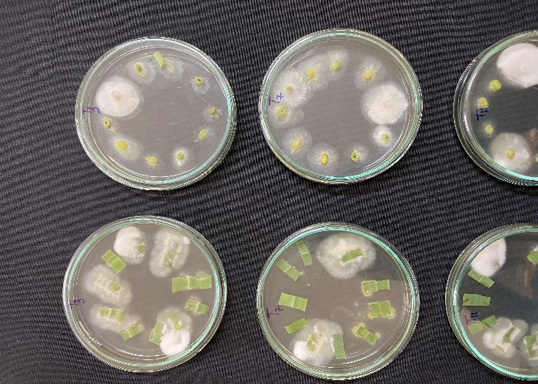
LEAF | SHOOT

Figure S2: Confirmation of strain K23-FE colonization from maize tissue segments
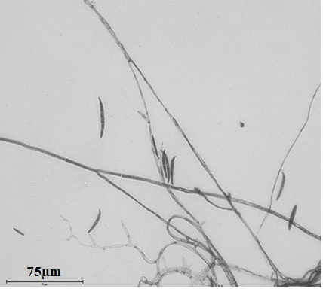

Figure S3: Microscopic characterization of strain K23-FE obtained from maize tissue segments

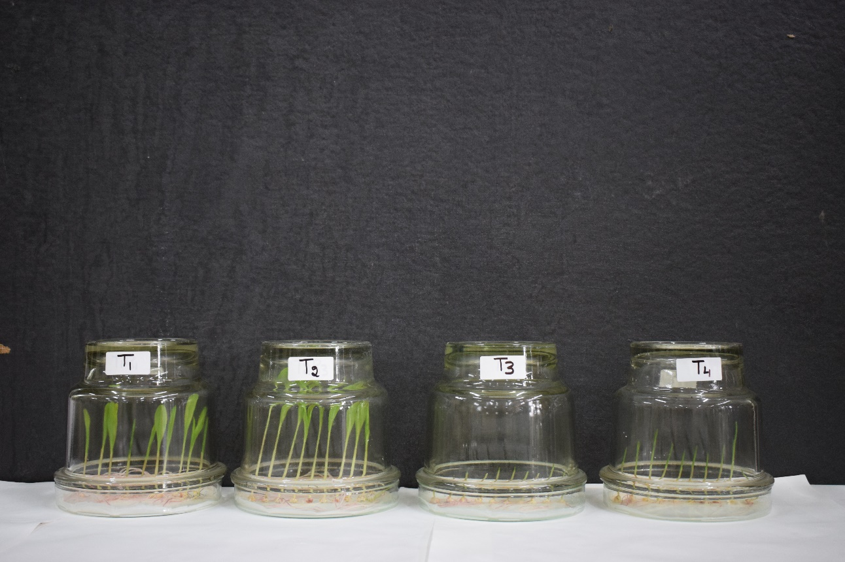
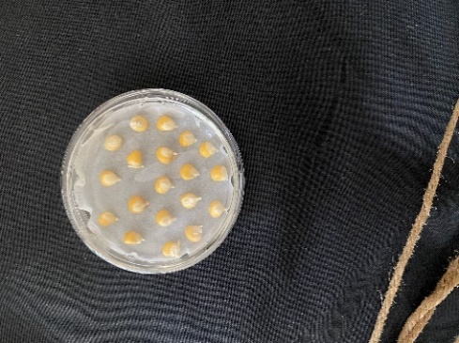
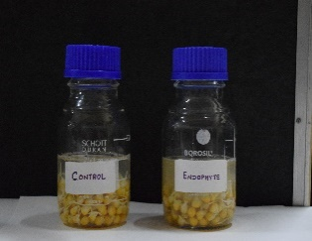
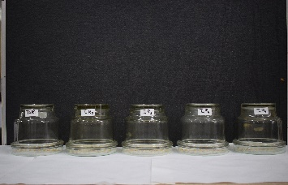
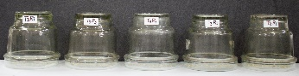
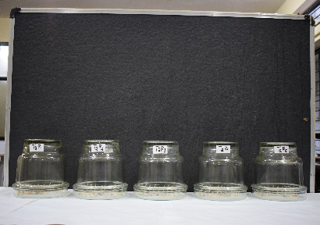
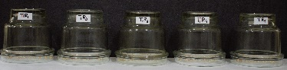
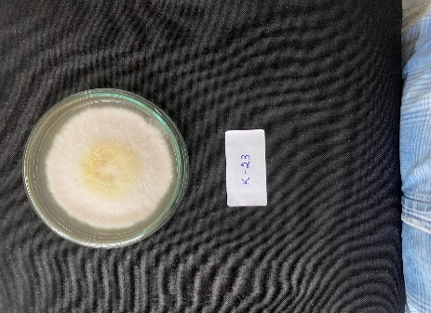
(a)
(b)
(c)
(d)
Experiment Setup
Pre-germinated seeds
Endophytic strain K23-FE culture
Endophytic strain K23-FE suspension
7days old seedlings

Figure S4: Endophytic strain K23-FE treatment and Phenotype of maize seedlings grown in a sterile condition. (a) control, (b) endophyte treatment, (c) osmotic stress and (d) osmotic stress + endophyte treatment.

(A)
(B)
Figure S5: Volcano plot for differentially expressed genes, (A) Endophytic strain K23-FE vs Control and (B) PEG-8000 + Endophytic strain K23-FE vs PEG-8000. The x-axis shows the log₂ fold change in gene expression between different treatments, and the y-axis shows the statistical significance of the differences. Significantly up and downregulated genes are highlighted in green and red colors, respectively. Genes did not express differently between the treatment and control groups in grey.
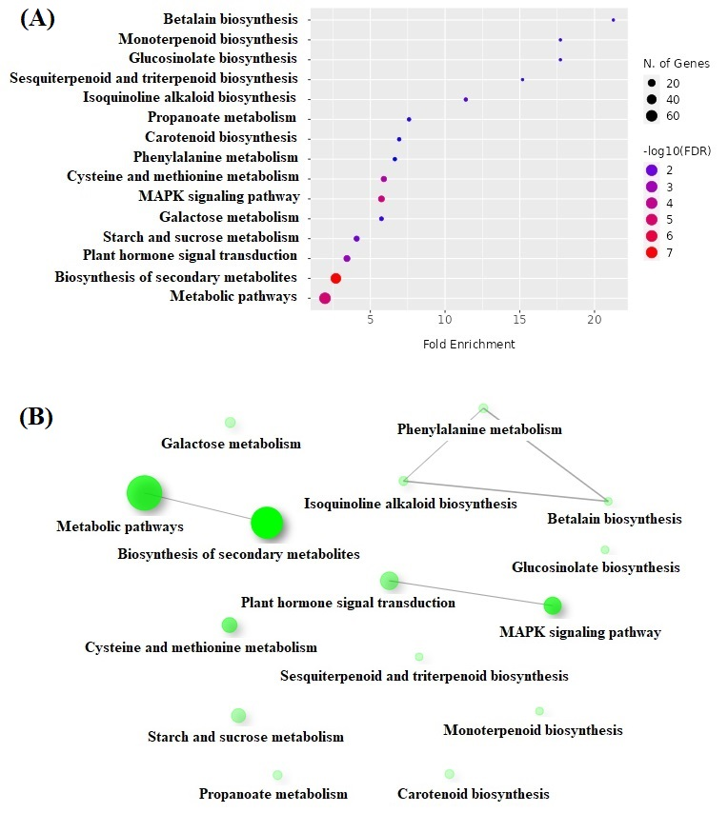

Figure S6: KEGG analysis showing enriched molecular pathways after endophyte inoculation in maize seedlings under unstressed conditions (A) Bubble plot analysis and (B) Networks of the pathways associated at a p-value cut-off (FDR) of 0.05, and edge cut-off of 0.3. Two pathways(nodes) are connected if they share 20% or more genes. The thickness of edges denotes more overlapped genes. The node size represents the number of genes involved in a particular function, and the intensity of the color represents the significance of the interaction).

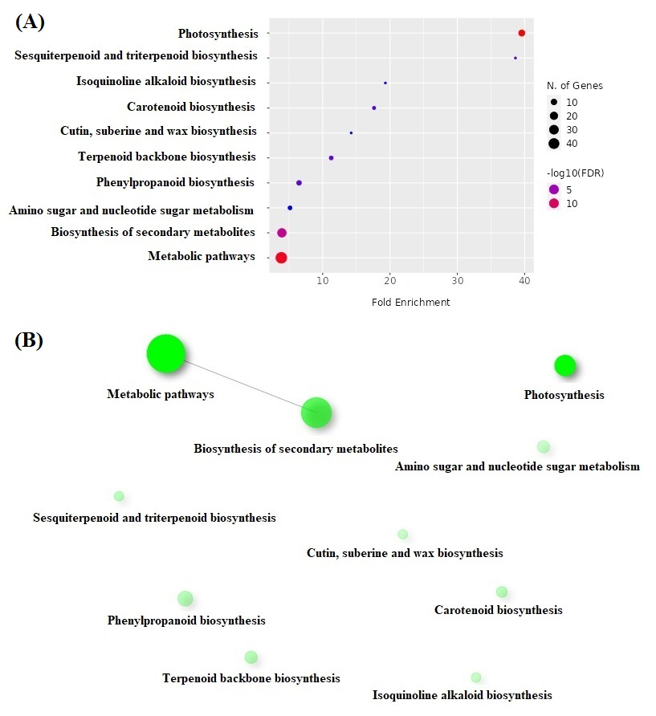

Figure S7: KEGG analysis showing enriched molecular pathways after endophyte inoculation in maize seedlings under PEG-8000 induced osmotic stress conditions (A) Bubble plot analysis and (B) Networks of the pathways associated at a p-value cut-off (FDR) of 0.05, and edge cut-off of 0.3. Two pathways(nodes) are connected if they share 20% or more genes. The thickness of edges denotes more overlapped genes. The node size represents the number of genes involved in a particular function, and the intensity of the color represents the significance of the interaction).

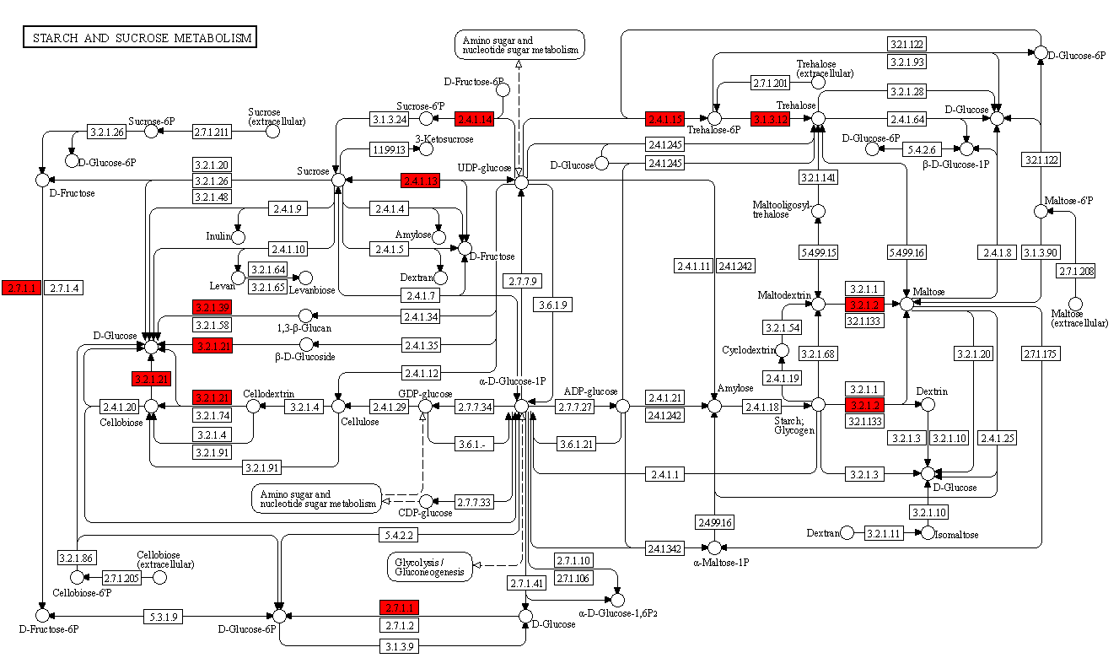

Figure S8: Pathways in starch and sucrose metabolism of endophyte inoculated maize seedlings under unstressed conditions from KEGG with query genes highlighted in red.

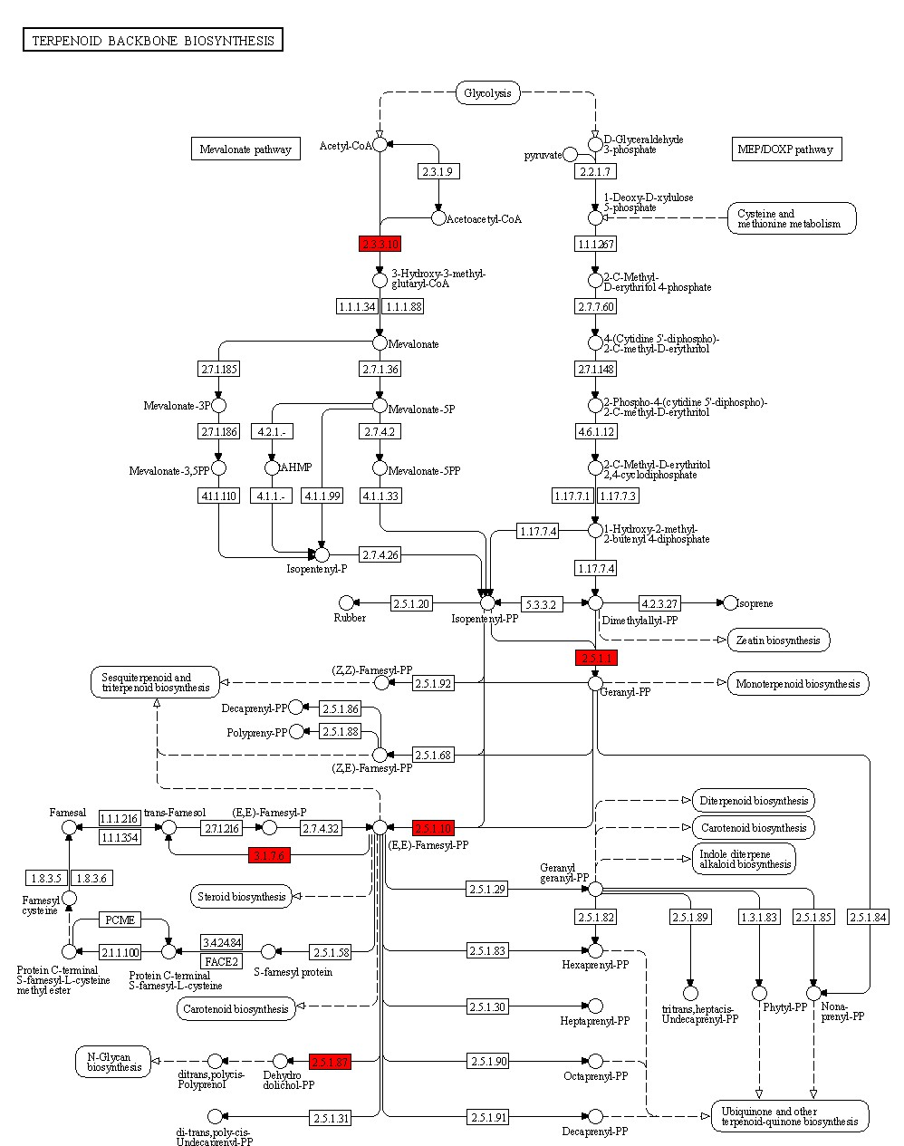
Figure S9: Pathways in terpenoid biosynthesis of endophyte inoculated maize seedlings under PEG-8000 induced osmotic stress conditions from KEGG with query genes highlighted in red.

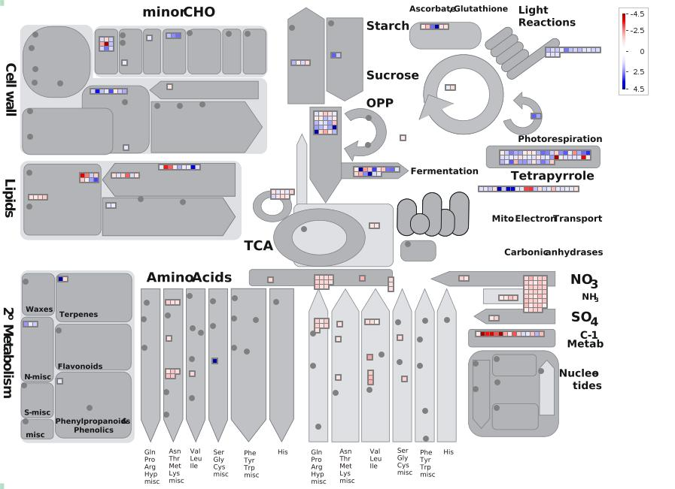
Figure S10: MapMan overview of differentially expressed transcripts involved in different metabolic processes under unstress condition in endophytic strain K23-FE treatment. The images were obtained using MapMan software showing different functional categories that passed the cutoff (less than 0.05 Q value and greater than 2-fold change) for differential expression. Red stands for downregulation, and blue stands for upregulation.

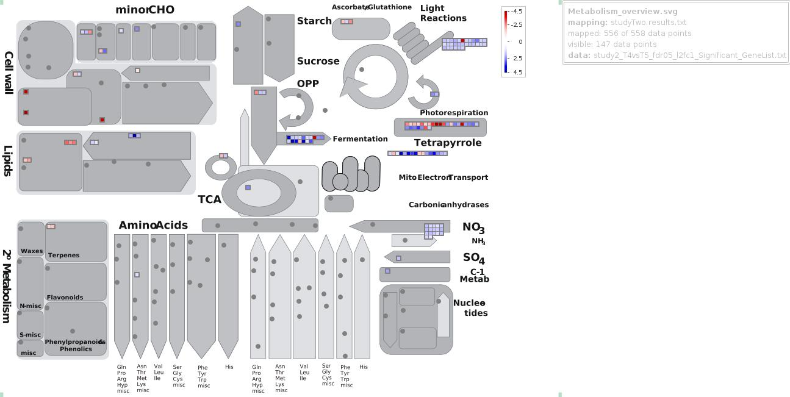

Figure S11: MapMan overview of differentially expressed transcripts involved in different metabolic processes under PEG-8000 induced osmotic stress condition in endophytic strain K23-FE treatment. The images were obtained using MapMan software, showing different functional categories that passed the cutoff (less than 0.05 Q value and greater than 2-fold change) for differential expression. Red stands for downregulation, and blue stands for upregulation.

Table S1: Details of the analysis of phytohormones by LC-MS/MS [HPLC 1260 (Agilent Technologies)-QTRAP6500 (SCIEX)] in negative ionization mode

Q1 | Q3 | RT (min) | Compound | Internal std | RF | DP | CE
136.93 | 93.00 | 5.9 | SA | D4-SA | 1.0 | -20 | -24
263.00 | 153.20 | 6.4 | ABA | D6-ABA | 1.0 | -20 | -22
140.93 | 97.00 | 5.9 | D4-SA |  |  | -20 | -24
269.00 | 159.20 | 6.4 | D6-ABA |  |  | -20 | -22
345.0 | 143.0 | 4.8 | GA3 | D4-SA | 7.6 | -20 | -36
173.85 | 129.9 | 6.0 | IAA | D5-IAA |  | -20 | -14
178.85 | 134.9 | 6.0 | D5-IAA-135 |  |  | -20 | -14
178.85 | 133.9 | 6.0 | D5-IAA-134 |  |  | -20 | -14
178.85 | 132.9 | 6.0 | D5-IAA-133 |  |  | -20 | -14
Note: CE: collision energy, DP: declustering potential; RT: retention time, RF: radio frequency, Q1/Q3: first and third quadrupoles (mass filters)

