Supplementary information
Patchiness of plankton ecosystem structure due to nutrient mixing along the shelf edge in the North Sea
Axelle Cordier^{1*}, Jørgen Bendtsen², Niels Daugbjerg³, Nikolaj From¹, Sigrún Huld Jónasdóttir⁴, Erik Askov Mousing⁵, Jens Tang Christensen⁶, Teresa Silva⁷, Katherine Richardson¹
¹ Globe Institute, Section for Biodiversity, University of Copenhagen, Universitetsparken 15, 2100 Copenhagen Ø, Denmark.
² Globe Institute, Section for Geobiology, University of Copenhagen, Øster Voldgade 5-7, 1350 Copenhagen K, Denmark.
³ Marine Biological Section, Department of Biology, University of Copenhagen, Universitetsparken 4, 2100 Copenhagen Ø, Denmark.
⁴ National Institute of Aquatic Resources, Technical University of Denmark, DK-2800 Kgs. Lyngby, Denmark
⁵ Institute of Marine Research, 5817 Bergen, Norway
⁶ Department of Biology, Aarhus University, Ole Worms Allé 1, DK-8000 Aarhus C, Denmark
⁷ Marine Pelagic Division, Marine and Freshwater Research Institute, Fornubudin 5, 220 Hafnafjordur, Iceland
*email: axelle.cordier@sund.ku.dk

Supplementary methods
Zooplankton identification. Zooimage¹ package in R uses machine learning algorithms to analyse plankton samples automatically after a taxonomist supervised creation of an image library. Raw scanned images were processed using ImageJ through the zooimage plugin “Scanner_Gray16”. Sub-images called vignettes were produced, representing every animal or particle detected by the plugin (Fig. 2) and respective parameters indicating, for example, the Equivalent Circular Diameter (ECD), area, perimeter, Feret’s diameter, or the density.
A defined number of groups were created to build a classifier. Theoretically, the more classes there are, the more precise the taxonomic classification. However, given the large diversity of zooplankton, a reasonable trade-off between taxonomy and resolution is usually needed to reduce the error². The chosen taxa were Appendicularia, Chaetognatha, Copepoda, Gelatinous, Crustacea, Echinodermata and Mollusca. Copepoda were divided into Calanus (lateral and dorsal view), Pseudocalanus, Temora and Oithona. Mollusca in Gastropoda and Bivalvia. Crustaceans in Cladocera (Podon and Evadne), Euphausiidae, Ostracoda, and Cnidaria in two types of unidentified jellies. To build the training set, 10 representative samples (different depths and transects) were randomly chosen to be classified manually. Vignettes were grouped per class through the Xnview software (version 2.30). The final training set had 24 groups with 15-205 vignettes in each (1505 in total).
The classifier was assessed by the calculation of a 10-fold cross-validation between the manual and automated classifications (Fig. S1). At this stage, the group Polychaeta was removed from the training set because of a high class error rate (62%). Additional tests were completed through an analysis of the precision and recall F-score ratios, and a manual validation of the classifier. The final classifier had a global error of 7.2% (F = 0.91) and the highest error rates per class were 32% and 26% for a group of gelatinous organisms and Pseudocalanus respectively.
Table S1 Stations selected for zooplankton sampling. Coordinates and sampling information of zooplankton samples.
Transect | Station | Latitude (°N) | Longitude (°E) | Bottom depth (m) | Replicates | Start depth (m) | Stop depth (m)
1 | 11 | 57.83 | 8.25 | 516 | 3 | 16 | 0
1 | 11 | 57.83 | 8.25 | 516 | 2 | 50 | 16
1 | 11 | 57.83 | 8.25 | 516 | 3 | 200 | 50
1 | 11 | 57.83 | 8.25 | 516 | 3 | 300 | 200
1 | 11 | 57.83 | 8.25 | 516 | 3 | 500 | 300
2 | 24 | 57.21 | 7.75 | 54 | 3 | 24 | 0
2 | 24 | 57.21 | 7.75 | 54 | 3 | 46 | 24
2 | 35 | 57.48 | 7.76 | 163 | 3 | 16 | 0
2 | 35 | 57.48 | 7.76 | 163 | 3 | 50 | 16
2 | 35 | 57.48 | 7.76 | 163 | 3 | 150 | 50
2 | 42 | 57.13 | 7.75 | 40 | 3 | 16 | 0
2 | 42 | 57.13 | 7.75 | 40 | 3 | 36 | 16
2 | 62 | 57.30 | 7.76 | 57 | 6 | 16 | 0
2 | 62 | 57.30 | 7.76 | 57 | 5 | 30 | 16
2 | 62 | 57.30 | 7.76 | 57 | 5 | 50 | 30
3 | 49 | 57.54 | 7.27 | 245 | 2 | 50 | 0
3 | 49 | 57.54 | 7.27 | 245 | 2 | 170 | 50
3 | 49 | 57.54 | 7.27 | 245 | 2 | 238 | 170
4 | 55 | 57.54 | 6.77 | 172 | 3 | 16 | 0
4 | 55 | 57.54 | 6.77 | 172 | 3 | 60 | 16
4 | 55 | 57.54 | 6.77 | 172 | 3 | 170 | 60
4 | 80 | 57.53 | 6.77 | 172 | 3 | 16 | 0
4 | 80 | 57.53 | 6.77 | 172 | 3 | 50 | 16
4 | 80 | 57.53 | 6.77 | 172 | 2 | 140 | 50
4 | 108 | 56.65 | 6.78 | 41 | 3 | 16 | 0
4 | 108 | 56.65 | 6.78 | 41 | 3 | 30 | 16
4 | 122 | 57.56 | 6.78 | 174 | 3 | 16 | 0
4 | 122 | 57.56 | 6.78 | 174 | 3 | 40 | 16
4 | 122 | 57.56 | 6.78 | 174 | 3 | 100 | 40
4 | 122 | 57.56 | 6.78 | 174 | 3 | 120 | 100
4 | 122 | 57.56 | 6.78 | 174 | 3 | 150 | 120
4 | 128 | 57.32 | 7.29 | 80 | 3 | 16 | 0
4 | 128 | 57.32 | 7.29 | 80 | 3 | 50 | 16
4 | 128 | 57.32 | 7.29 | 80 | 3 | 70 | 50
4 | 130 | 57.32 | 6.77 | 83 | 3 | 10 | 0
4 | 130 | 57.32 | 6.77 | 83 | 3 | 30 | 10
4 | 130 | 57.32 | 6.77 | 83 | 3 | 40 | 30
4 | 130 | 57.32 | 6.77 | 83 | 3 | 75 | 40
5 | 88 | 57.60 | 6.28 | 154 | 3 | 16 | 0
5 | 88 | 57.60 | 6.28 | 154 | 3 | 40 | 16
5 | 88 | 57.60 | 6.28 | 154 | 3 | 90 | 40
5 | 88 | 57.60 | 6.28 | 154 | 3 | 140 | 90
5 | 97 | 56.88 | 6.28 | 50 | 3 | 16 | 0
5 | 97 | 56.88 | 6.28 | 50 | 3 | 30 | 16
5 | 97 | 56.88 | 6.28 | 50 | 3 | 40 | 30
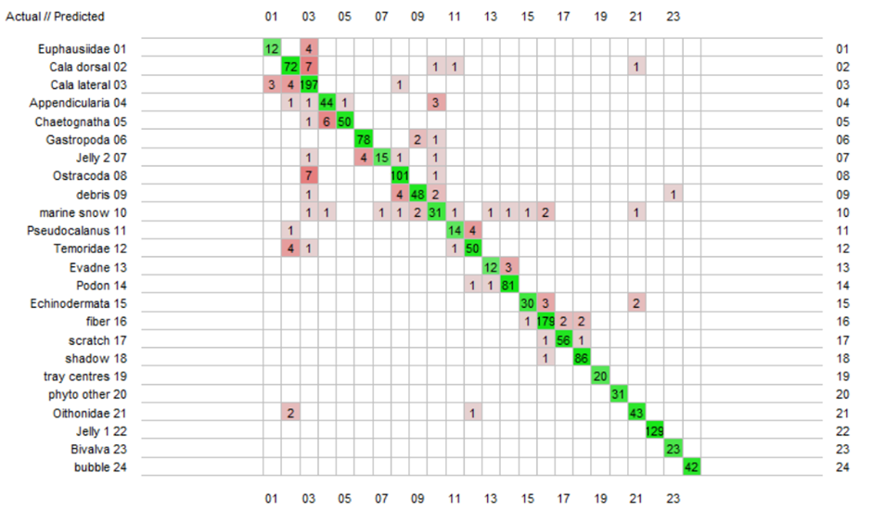
Figure S1 Zooplankton classifier assessment. Confusion matrix of the final classifier tested with the random forest algorithm. Rows are groups classified in the training set and columns are groups classified by the classifier. The green diagonal represents the number of vignettes the programme correctly classified. Boxes coloured in red are the wrongly classified organisms (light to darker red represents low to higher proportions).

Supplementary results
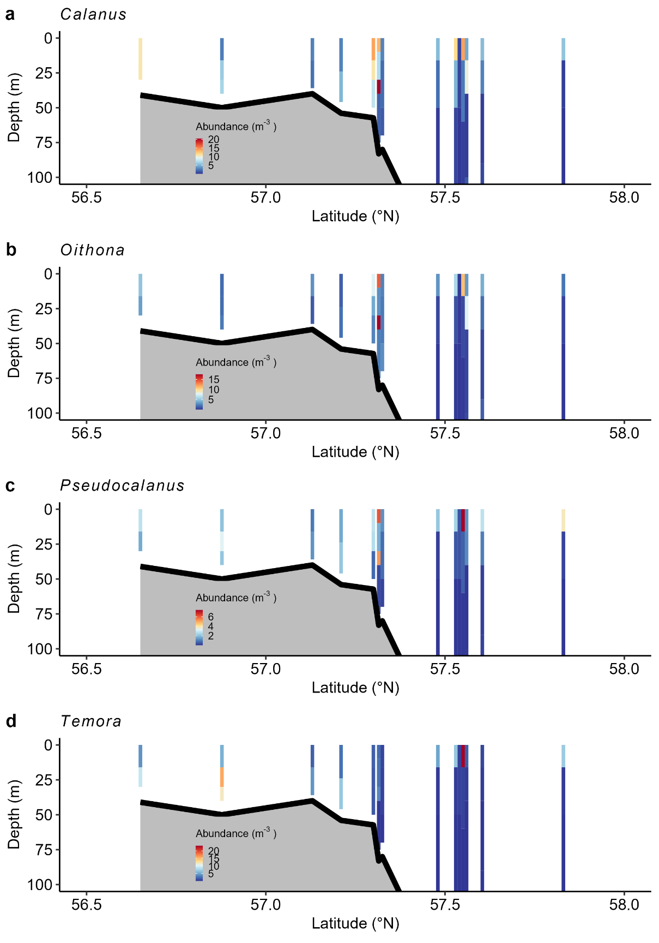
Figure S2 Distribution of copepod species. Mean abundance (number m⁻³) of Calanus, Oithona, Pseudocalanus and Temora (all sizes considered) over all transect. The black line represents the bottom depth at the station sampled.
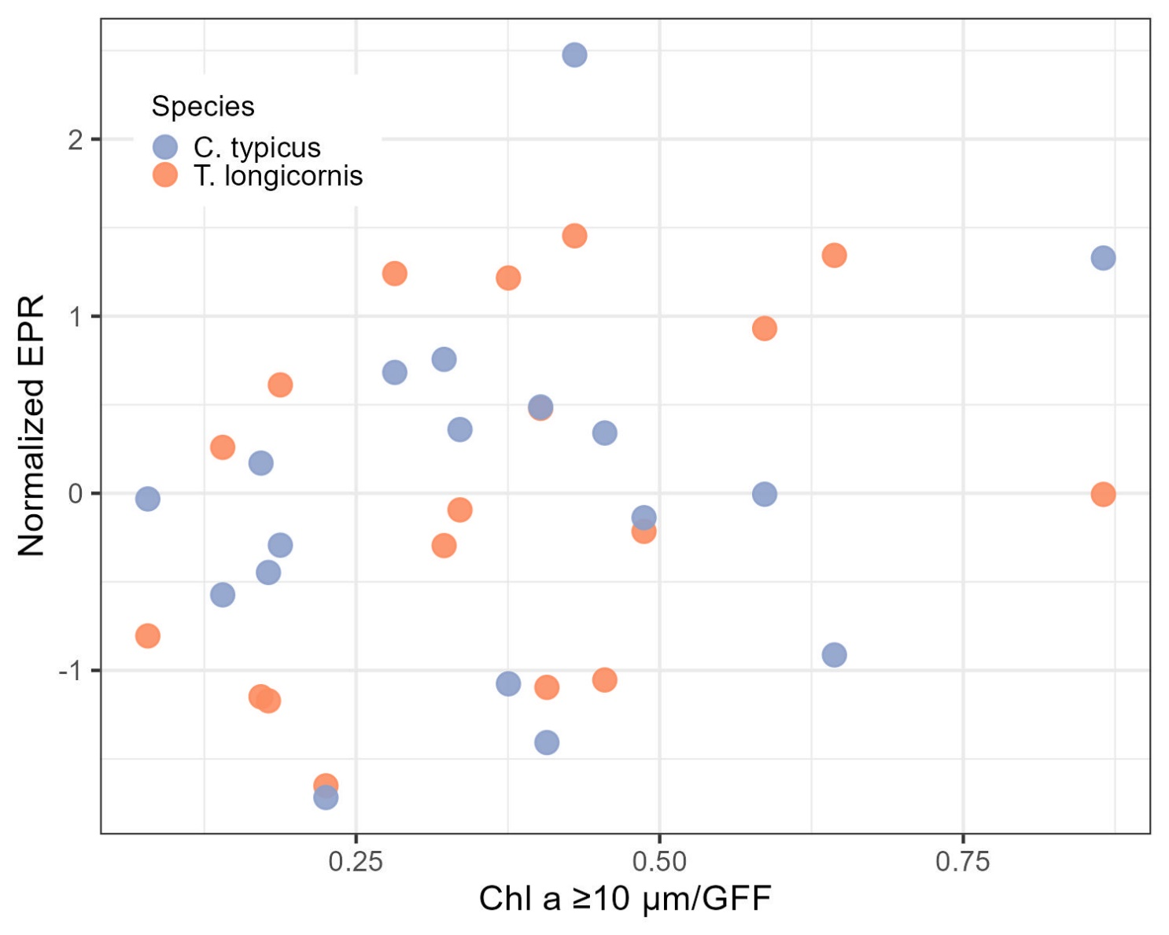
Figure S3 EPR and chlorophyll a ≥ 10 μm/GFF. Normalised (Z-score) EPR (eggs female⁻¹ day⁻¹) for two copepod species (C. typicus and T. longicornis) against mean chlorophyll a ≥ 10 μm/GFF in the water column.

References
1. Philippe, G. & Kevin, D. Supervised classification of images, applied to plankton samples using R and Zooimage. Data Mining Applications with R. 331–365; https://doi.org/10.1016/B978-0-12-411511-8.00013-X (2014).
2. Gislason, A. & Silva, T. Comparison between automated analysis of zooplankton using ZooImage and traditional methodology. J. Plankton Res. 31, 1505–1516; https://doi.org/10.1093/plankt/fbp094 (2009).

