Supplementary Information for

Modeling the 2024 Noto Peninsula earthquake tsunami: implications for tsunami sources in the eastern margin of the Japan Sea

Hidetoshi Masuda¹, Daisuke Sugawara²*, An-Chi Cheng³, Anawat Suppasri²,
Yoshinori Shigihara⁴, Shuichi Kure⁵ and Fumihiko Imamura²

¹ Department of Earth Science, Graduate School of Science, Tohoku University, 6-3 Aramaki Aza Aoba, Sendai, Miyagi 980-8578, Japan
² International Research Institute of Disaster Science, Tohoku University, 468-1 Aramaki Aza Aoba, Sendai, Miyagi 980-8572, Japan
³ Civil and Environmental Engineering, Graduate School of Engineering, Tohoku University, 6-6-06 Aramaki Aza Aoba, Sendai, Miyagi 980-8579, Japan
⁴ Department of Civil and Environmental Engineering, National Defense Academy, 1-10-20 Hashirimizu, Yokosuka, Kanagawa 239-8686, Japan
⁵ Department of Environmental and Civil Engineering, Faculty of Engineering, Toyama Prefectural University, 5180 Kurokawa, Imizu, 939-0398 Toyama, Japan

*Corresponding author: sugawara@irides.tohoku.ac.jp

Contents of this file
Figs. S1–S5
Table S1
References

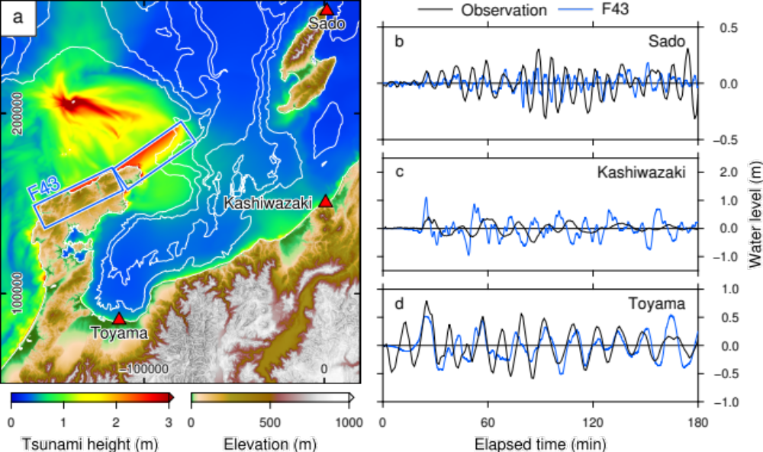
Fig. S1. Simulated regional tsunami height and time history of water levels at selected tide stations by Case #1. (a) Maximum tsunami height with locations of the F43 fault. Annotations along the vertical and horizontal axes in panel (a) indicate the northing and easting (unit: m) from the reference point (36°0′N, 138°30′E), respectively. White lines indicate isobaths with 500 m intervals. (b–d) Comparison of the time series of the observed and computed water levels at three tide stations (b: Sado, c: Kashiwazaki, d: Toyama).

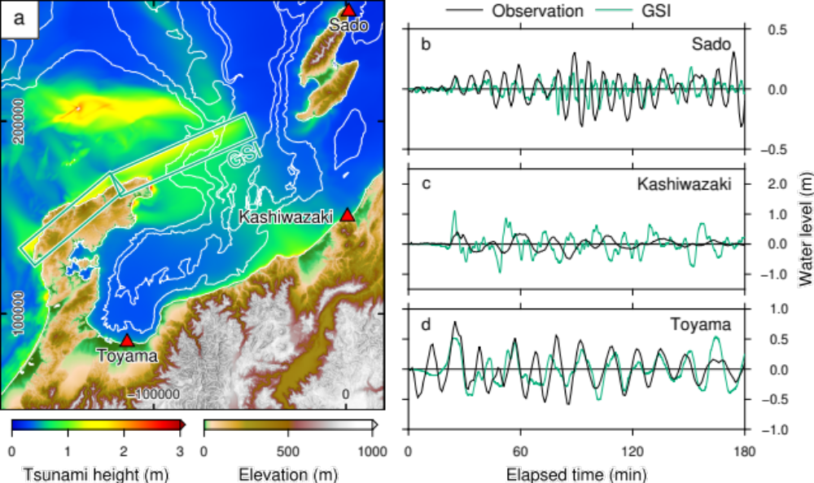
Fig. S2. Simulated regional tsunami height and time history of water levels at selected tide stations by Case #3. (a) Maximum tsunami height with locations of the fault determined by GSI (2024a). Annotations along the vertical and horizontal axes in panel (a) indicate the northing and easting (unit: m) from the reference point (36°0′N, 138°30′E), respectively. White lines indicate isobaths with 500 m intervals. (b–d) Comparison of the time series of the observed and computed water levels at three tide stations (b: Sado, c: Kashiwazaki, d: Toyama).

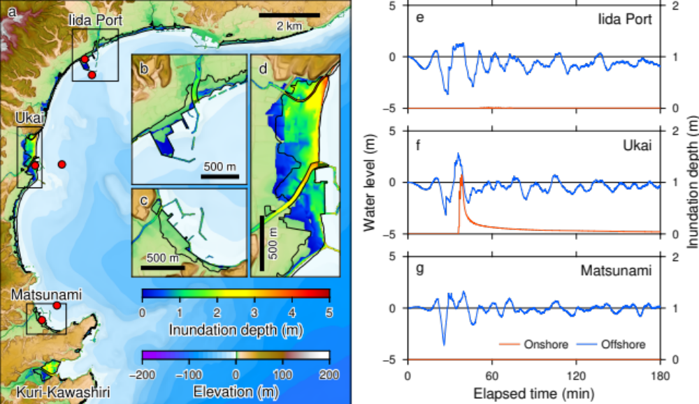
Fig. S3. Simulated tsunami inundation of the Iida Bay coast and time history of water levels by Case #2. (a) Distribution of the simulated inundation depth. The black solid line indicates the inundation area estimated from the aerial photo (GSI, 2024b). Red circles represent the locations of the virtual tsunami stations. (b–d) Enlarged view of the inundation depths in three selected areas (Iida Port, Ukai, and Matsunami). (e–g) Time series of the water levels at offshore (blue line) and inundation depths at onshore (red line) stations.
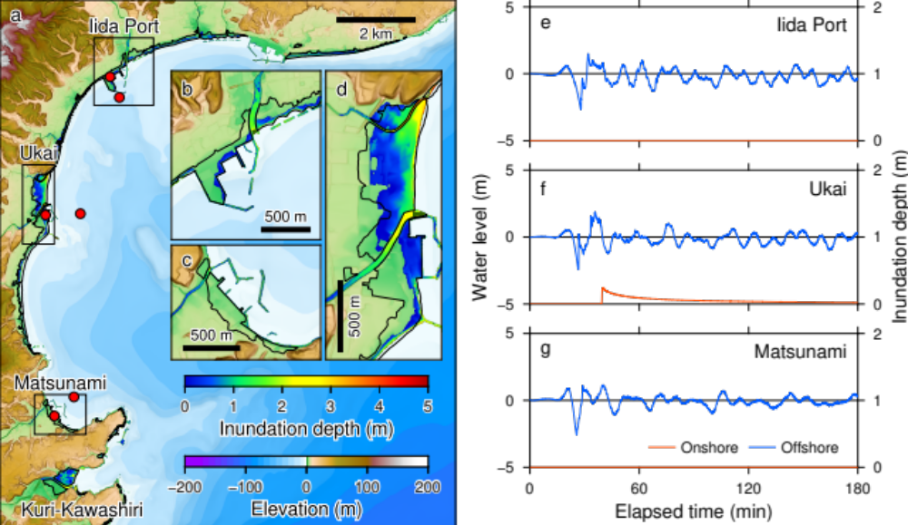
Fig. S4. Simulated tsunami inundation of the Iida Bay coast and time history of water levels by Case #3. (a) Distribution of the simulated inundation depth. The black solid line indicates the inundation area estimated from the aerial photo (GSI, 2024b). Red circles represent the locations of the virtual tsunami stations. (b–d) Enlarged view of the inundation depths in three selected areas (Iida Port, Ukai, and Matsunami). (e–g) Time series of the water levels at offshore (blue line) and inundation depths at onshore (red line) stations.
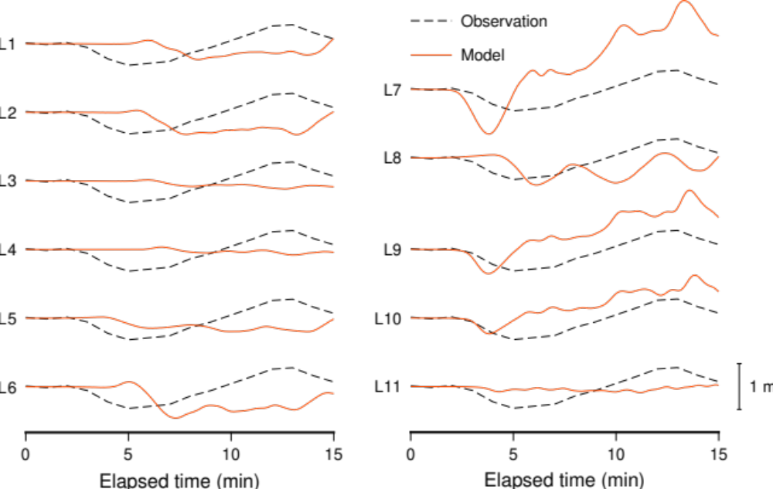
Fig. S5. Simulated time series of the water levels at the Toyama tide station using landslide-mimicking normal faults. Locations of the faults are shown in Fig. 4.

Table S1. Parameters of landslide-mimicking normal faults.
ID | Longitude  (°E) | Latitude  (°N) | Depth (km) | Length (km) | Width (km) | Strike (°) | Dip (°) | Rake (°) | Slip (m)
L1 | 137.399569 | 36.8812264 | 0.001 | 5 | 5 | 194 | 11 | 270 | 100
L2 | 137.384684 | 36.8296395 | 0.001 | 5 | 5 | 224 | 11 | 270 | 100
L3 | 137.081447 | 36.8114022 | 0.001 | 5 | 3 | 318 | 7 | 270 | 100
L4 | 137.042208 | 36.8486702 | 0.001 | 5 | 3 | 359 | 7 | 270 | 100
L5 | 137.173872 | 36.7848925 | 0.001 | 5 | 3 | 286 | 7 | 270 | 100
L6 | 137.361136 | 36.8065215 | 0.001 | 5 | 5 | 221 | 11 | 270 | 100
L7 | 137.246713 | 36.7939426 | 0.001 | 5 | 5 | 259 | 11 | 270 | 100
L8 | 137.321442 | 36.771766 | 0.001 | 5 | 5 | 280 | 11 | 270 | 100
L9 | 137.244094 | 36.8055053 | 0.001 | 5 | 3.65 | 259 | 11 | 270 | 100
L10 | 137.24251 | 36.8121122 | 0.001 | 5 | 2.9 | 259 | 11 | 270 | 100
L11 | 137.252737 | 36.8000645 | 0.001 | 6 | 2 | 350 | 6 | 270 | 100

References
Geospatial Information Authority of Japan (GSI) (2024a) Preliminary earthquake fault model of the 2024 Noto Peninsula earthquake (as of January 2, 2024). https://www.gsi.go.jp/common/000253939.pdf Accessed 18 Jan 2024. (in Japanese, translated title)
Geospatial Authority of Japan (GSJ) (2024b) Inundation area of the 2024 Noto Peninsula earthquake tsunami inferred from aerial photographs. https://www.gsi.go.jp/BOUSAI/20240101_noto_earthquake.html#7 Accessed 18 Jan 2024. (in Japanese, translated title)
Ministry of Land, Infrastructure, Transport and Tourism (MLIT) (2014) Final Report of Research and Examination Meeting on the Large-Scale Earthquake in the Japan Sea. https://www.mlit.go.jp/river/shinngikai_blog/daikibojishinchousa/ Accessed 18 Jan 2024. (in Japanese, translated title)

