Controlled Synthesized of Ternary Cu-Co-Ni-S Sulfides Nanoporous Network Structure on Carbon Fiber Paper: A Superior Catalytic Electrode for Highly-Sensitive Glucose Sensing
Yuanyuan Li¹, Yi Duan¹, Jiangtao Lin¹, Jinghan Liao¹, Chao Xu², Fangqin Xue^{2,*}, Yourong Duan^{1,*}
¹State Key Laboratory of Systems Medicine for Cancer, Shanghai Cancer Institute, Renji Hospital, School of Medicine, Shanghai Jiao Tong University, Shanghai 200032, China.
²Department of Gastrointestinal Surgery, Shengli Clinical Medical College of Fujian Medical University, Fujian Provincial Hospital, No. 134 Dongjie, Fuzhou, China.
*Corresponding authors:
Correspondence to Yourong Duan (E-mail: yrduan@shsci.org) and Fangqin Xue (E-mail: xuefangqingsl@sina.com)

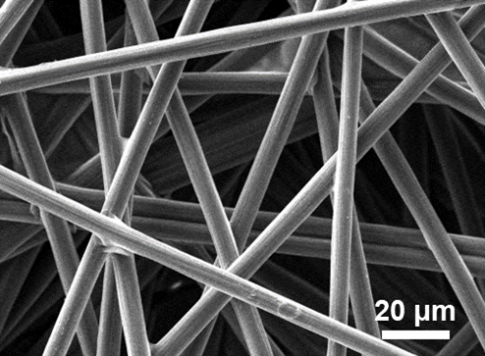
Fig. S1 SEM image of bare CP.

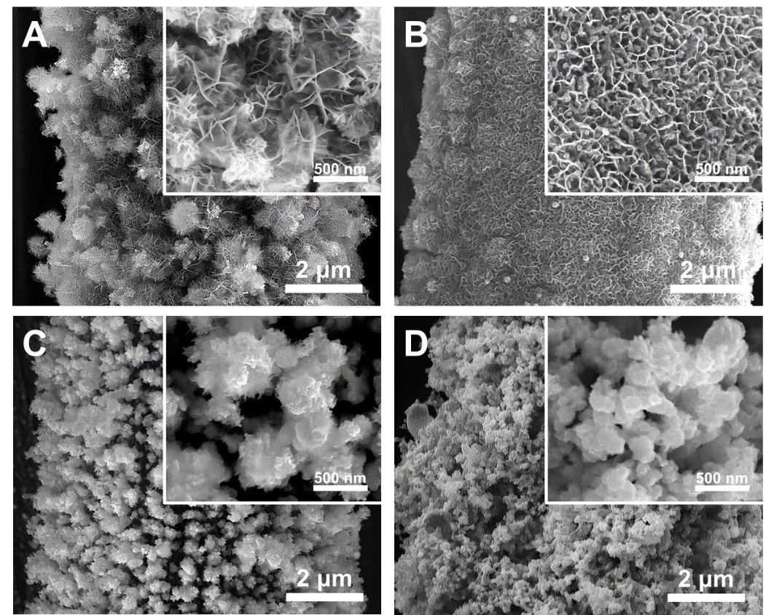
Fig. S2. SEM of Cu-Co-Ni-S/CP at different concentrations of CuCl₂·2H₂O solutions: (A) 0.5 mM; (B) 1 mM; (C) 2 mM; (D) 3 mM.
Fig. S3. CVs of CP electrodes measured in the applied potential range from 0.00 V to +0.10 V at various scan rates.

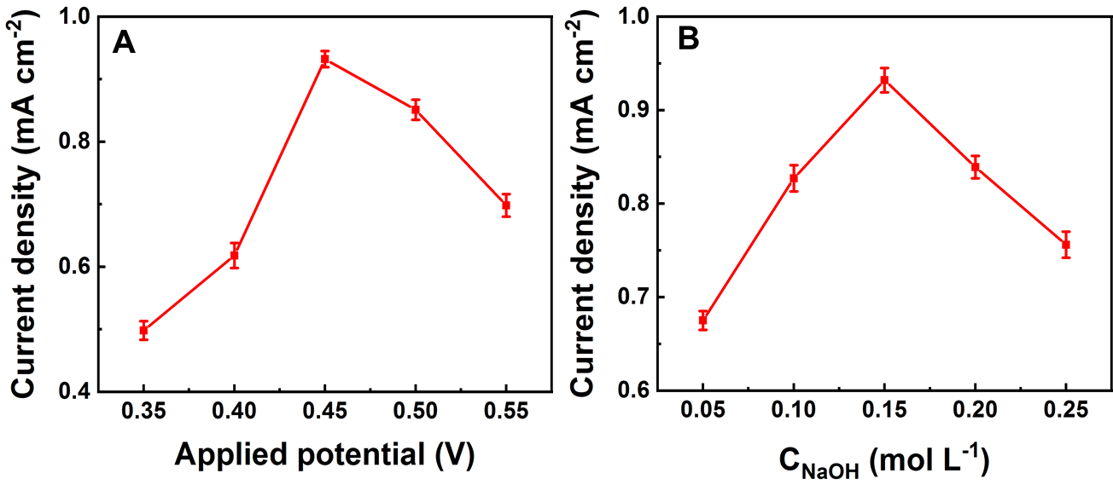
Fig. S4. Effects of experimental conditions on the current density response of 0.1 mM glucose. (A) Applied potential; (B) NaOH concentration.

Fig. S5. The reusability test of Cu-Co-Ni-S/C electrode.

