Supplementary Material
Identification and map-based cloning a new gene TaSP1 related to spike shape by EMS-induced wheat mutant
Lin Zhang², Huidan Zhou¹, Xian Fu², Niuniu Zhou², Mengjie Liu², Shenglong Bai², Xinpeng Zhao², Ruiru Cheng^{1*}, Suoping Li^{1*}, Dale Zhang^{1*}
1 State Key Laboratory of Crop Stress Adaptation and Improvement, College of Agricultural Sciences, Henan University, Kaifeng 475001, Henan, China.
2 School of Life Sciences, Henan University, Kaifeng 475001, China.
* Corresponding authors: Ruiru Cheng, Dale Zhang, Suoping Li
E-mail: chengruiru@henu.edu.cn, zhangdale@henu.edu.cn, lisuoping@henu.edu.cn.

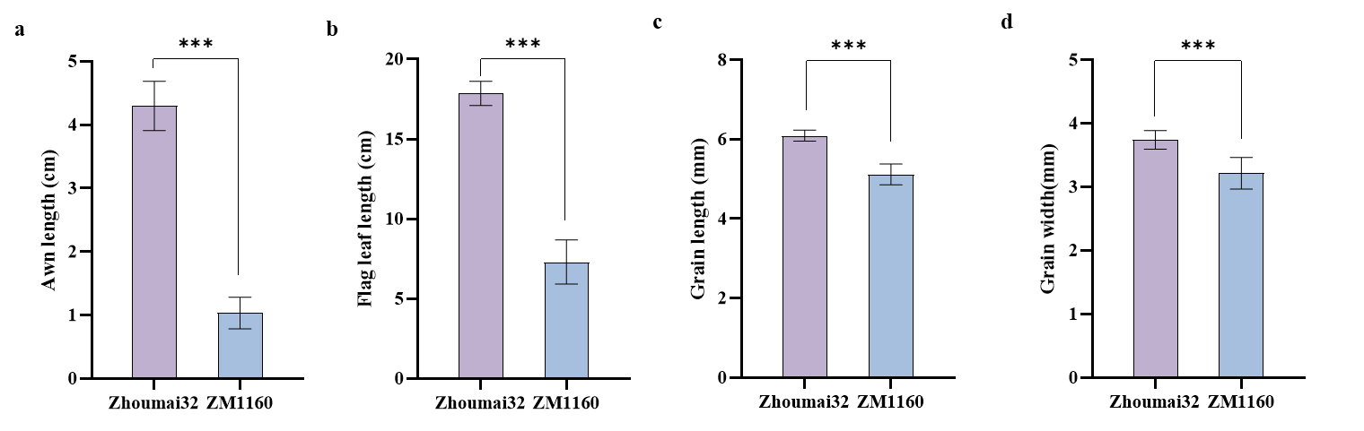
Supplementary Fig. 1 Phenotypic characterization of the mutant. Awn length (a), flag leaf length (b), grain length (c), and grain width (d) of Zhoumai32 and ZM1160. *** indicates significant differences at P = 0.001.
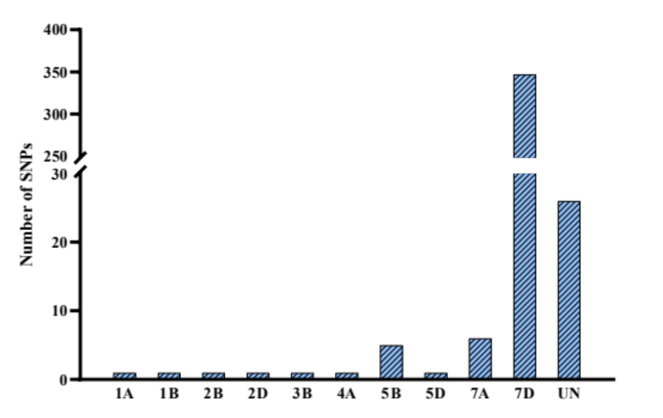
Supplementary Fig. 2 Distribution and numbers of the SNPs between the BSA pools based on wheat 660K SNP array.
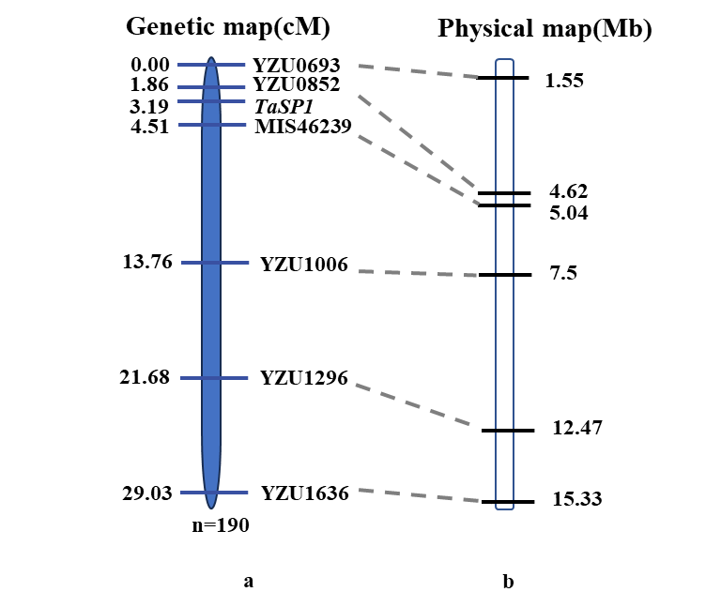
Supplementary Fig. 3 Genetic (a) and physical (b) maps of the TaSP1 region on chromosome 7D. The genetic map was constructed based on 190 F₂ plants, derived from F₁ hybrids which were produced by crossing Bainong207 with ZM1160. The marker physical position to the right was determined through mapping the markers to the CS IWGSC v1.0 sequence.
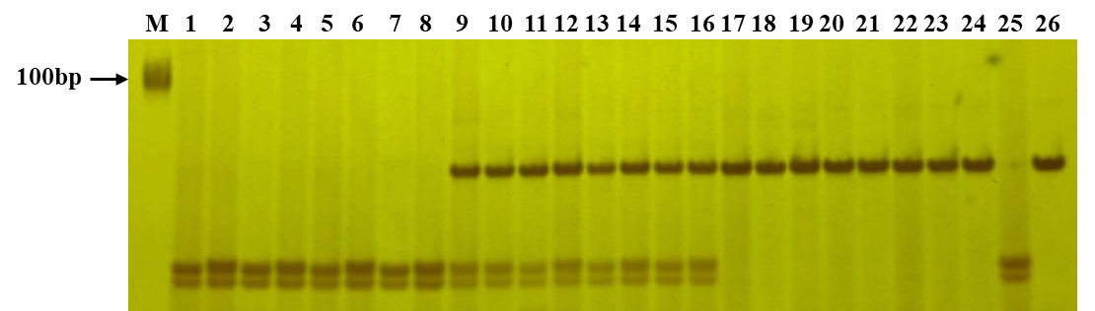
Supplementary Fig. 4 Banding pattern after Hha Ⅰ digestion of the PCR products from amplification of F₂ plants and parental lines with marker MIS48109, based on the SNP present in TaSP1. M, DNA marker DL2000; 1-8, homozygous wild type F₂ plants; 9-16, heterozygous wild type F₂ plants; 17-24, F₂ plants showing homozygous for the ZM1160 phenotype; 25, Bainong207; 26, ZM1160.
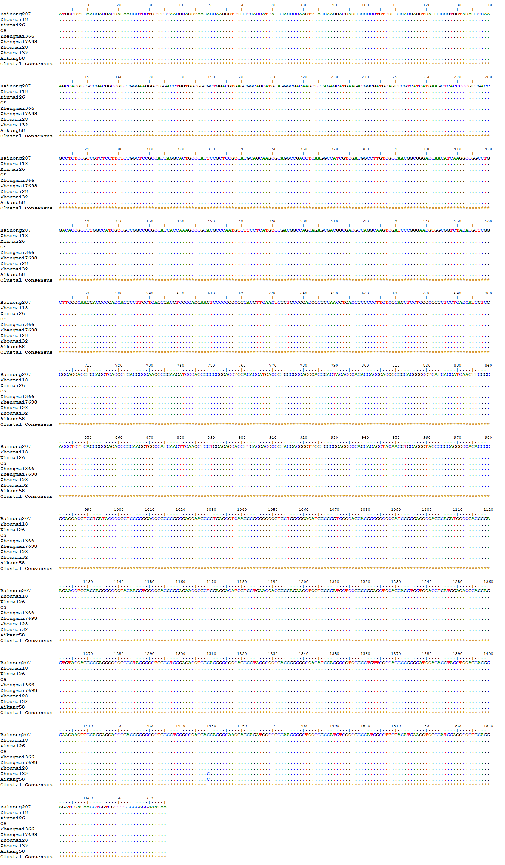
Supplementary Fig. 5 Multiple alignments of the gene TraesCS7D02G010200 full-length ORF sequences of wheat varieties Aikang58, Zhoumai18, Zhoumai28, Zhengmai7698, Zhengmai366, Xinmai26, CS, Zhoumai32, and Bainong207. The mutant nucleotide was highlighted with a red box. The dots showed the same nucleotide sequence as Bainong.

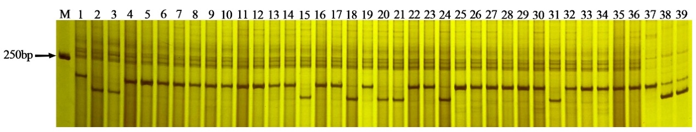
Supplementary Fig. 6 Banding pattern after Sal Ⅰ digestion of the PCR products from amplification of some wheat cultivars with TaSP1 gene-specific marker G010200P2. M, DNA marker DL2000; 1, Fengdecunmai29; 2, Huaxia588;3, Huaxia599; 4, Huaxia999; 5, Huamai99; 6, Shunmai13; 7, Shanmai33; 8, Nongda2011; 9, Tianmin198; 10, Weilong169; 11, Xinmai9389; 12, Xinmai55; 13, Xinmai57; 14, Xinmai58; 15, Xinmai60; 16, Xinong100; 17, Xinong172; 18, Zhoumai22; 19, Zhoumai28; 20, Zhoumai36; 21, Zhongyu1686; 22, Zhengmai113; 23, Zhengmai163; 24, Zhengmai817; 25, Shannonghan; 26, LS4628; 27, Dai4366; 28, Xinong511; 29, Taishan6426; 30, Yutianmai119; 31, Jimai44; 32, Jimai106; 33, Luyan1403; 34, Caizhi0173; 35, Zhengmai9170; 36, Zhengmai1860; 37, Bainong207; 38, Zhoumai32; 39, Aimai24.

