Supplemental Figures/Tables and Legends

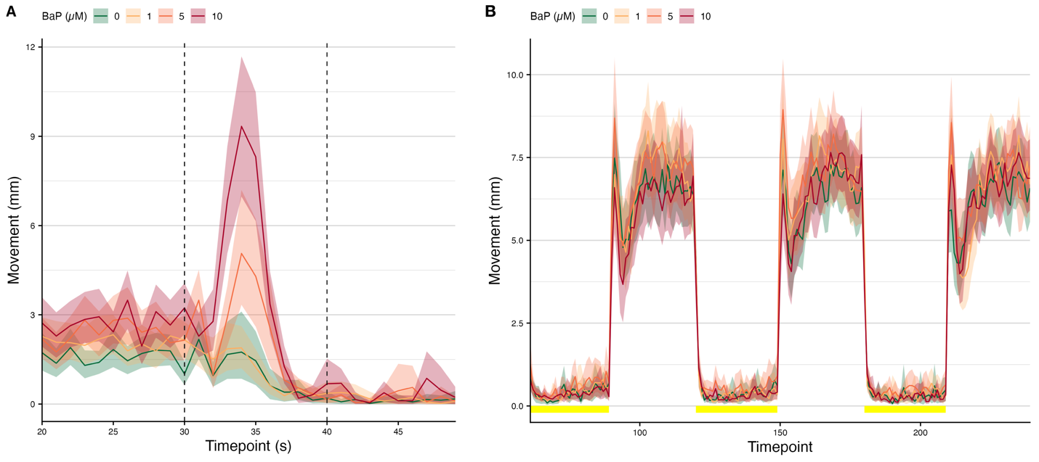Supplemental Figure 1: BaP dosage effect on behavior metrics (A) EPR movement data. Colored lines indicate the mean movement (mm) for zebrafish embryos for each BaP exposure level (in µM). The shaded ribbons indicate 95% C.I.s for the movement means. The black dotted lines indicate the window of time on which later statistical analyses are based. (B) Colored lines indicate the mean movement (mm) for zebrafish embryos for each BaP exposure level (in μM). The shaded ribbons indicate 95% C.I.s for the movement means. The yellow segments near the x-axis indicate which time points fall within light cycles (the rest of the time points are in dark cycles).

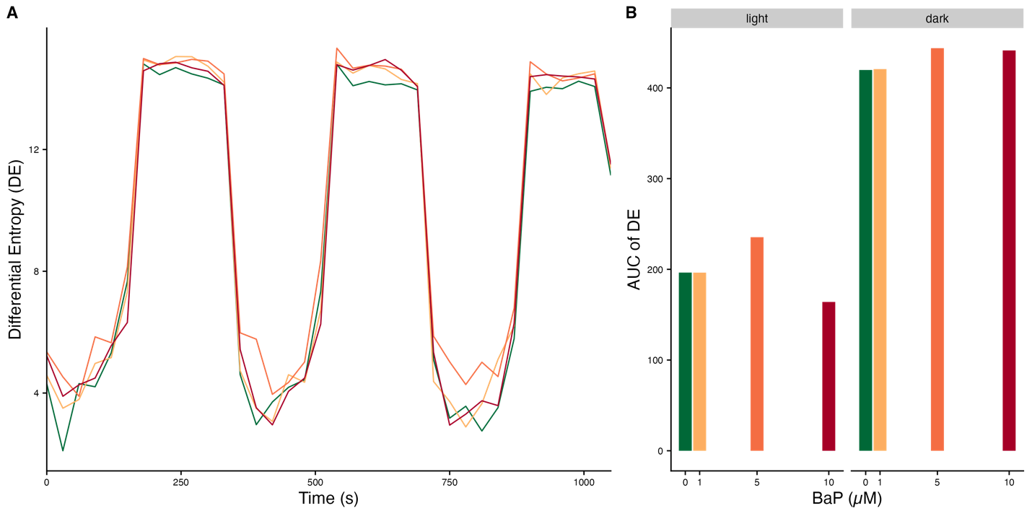Supplemental Figure 2: Plots of the differential entropy (DE) calculated per BaP exposure per 96-well plate per LPR cycle (dark vs light). (A) DE over time for the LPR assay. (B) AUCs of the DE plots in panel A by light and dark cycles.

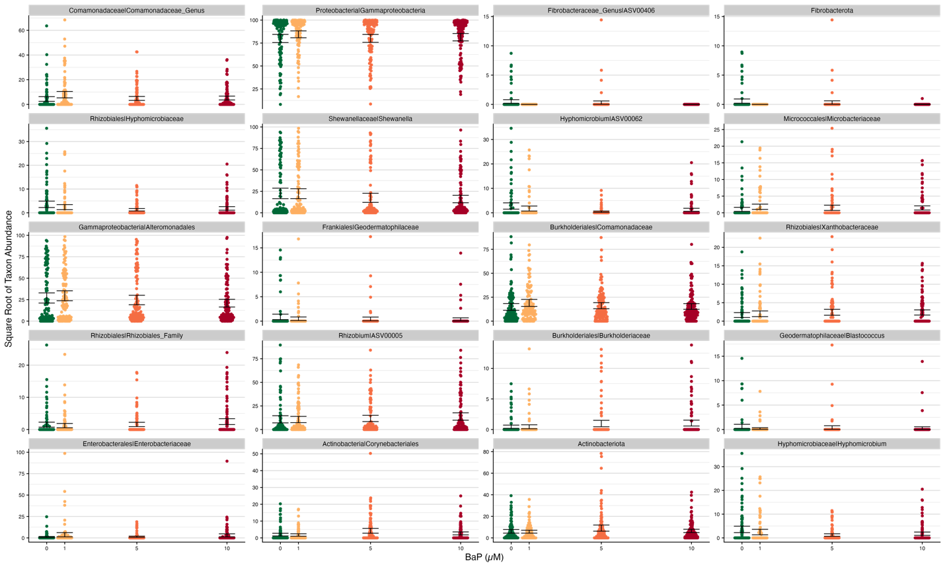Supplemental Figure 3: Plots of the square root of abundances by BaP exposure for the top 20 significantly most important taxa for the random forest model (classification) predicting BaP exposure from taxon abundances.

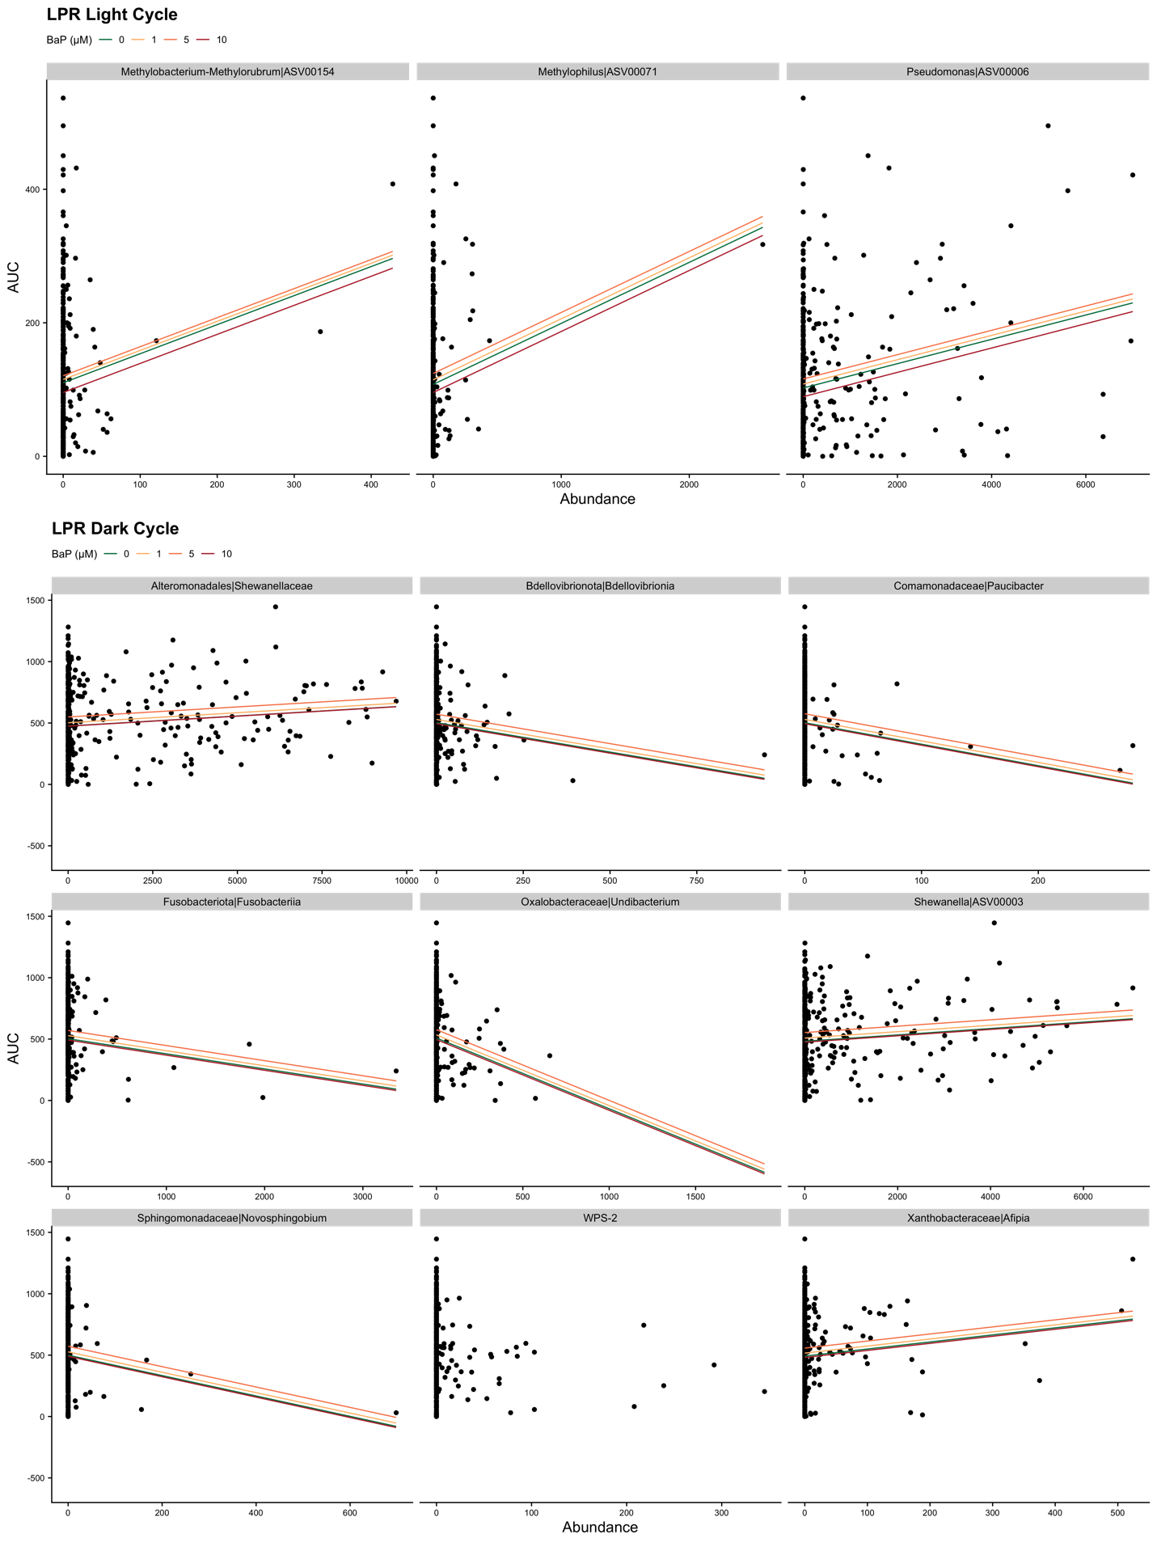Supplemental Figure 4: Scatter plots of the relationship between individual taxon abundances and LPR light and dark cycle AUCs. In this figure, only statistically significant associations (p < 0.05) with no abundance-by-BaP interactions are shown. Lines represent estimated relationships from gaussian generalized linear models. Light cycle associated taxa are shown on the top row and dark cycle associated taxa are show in the three rows below. The colored lines represent each concentration of BaP in µM.
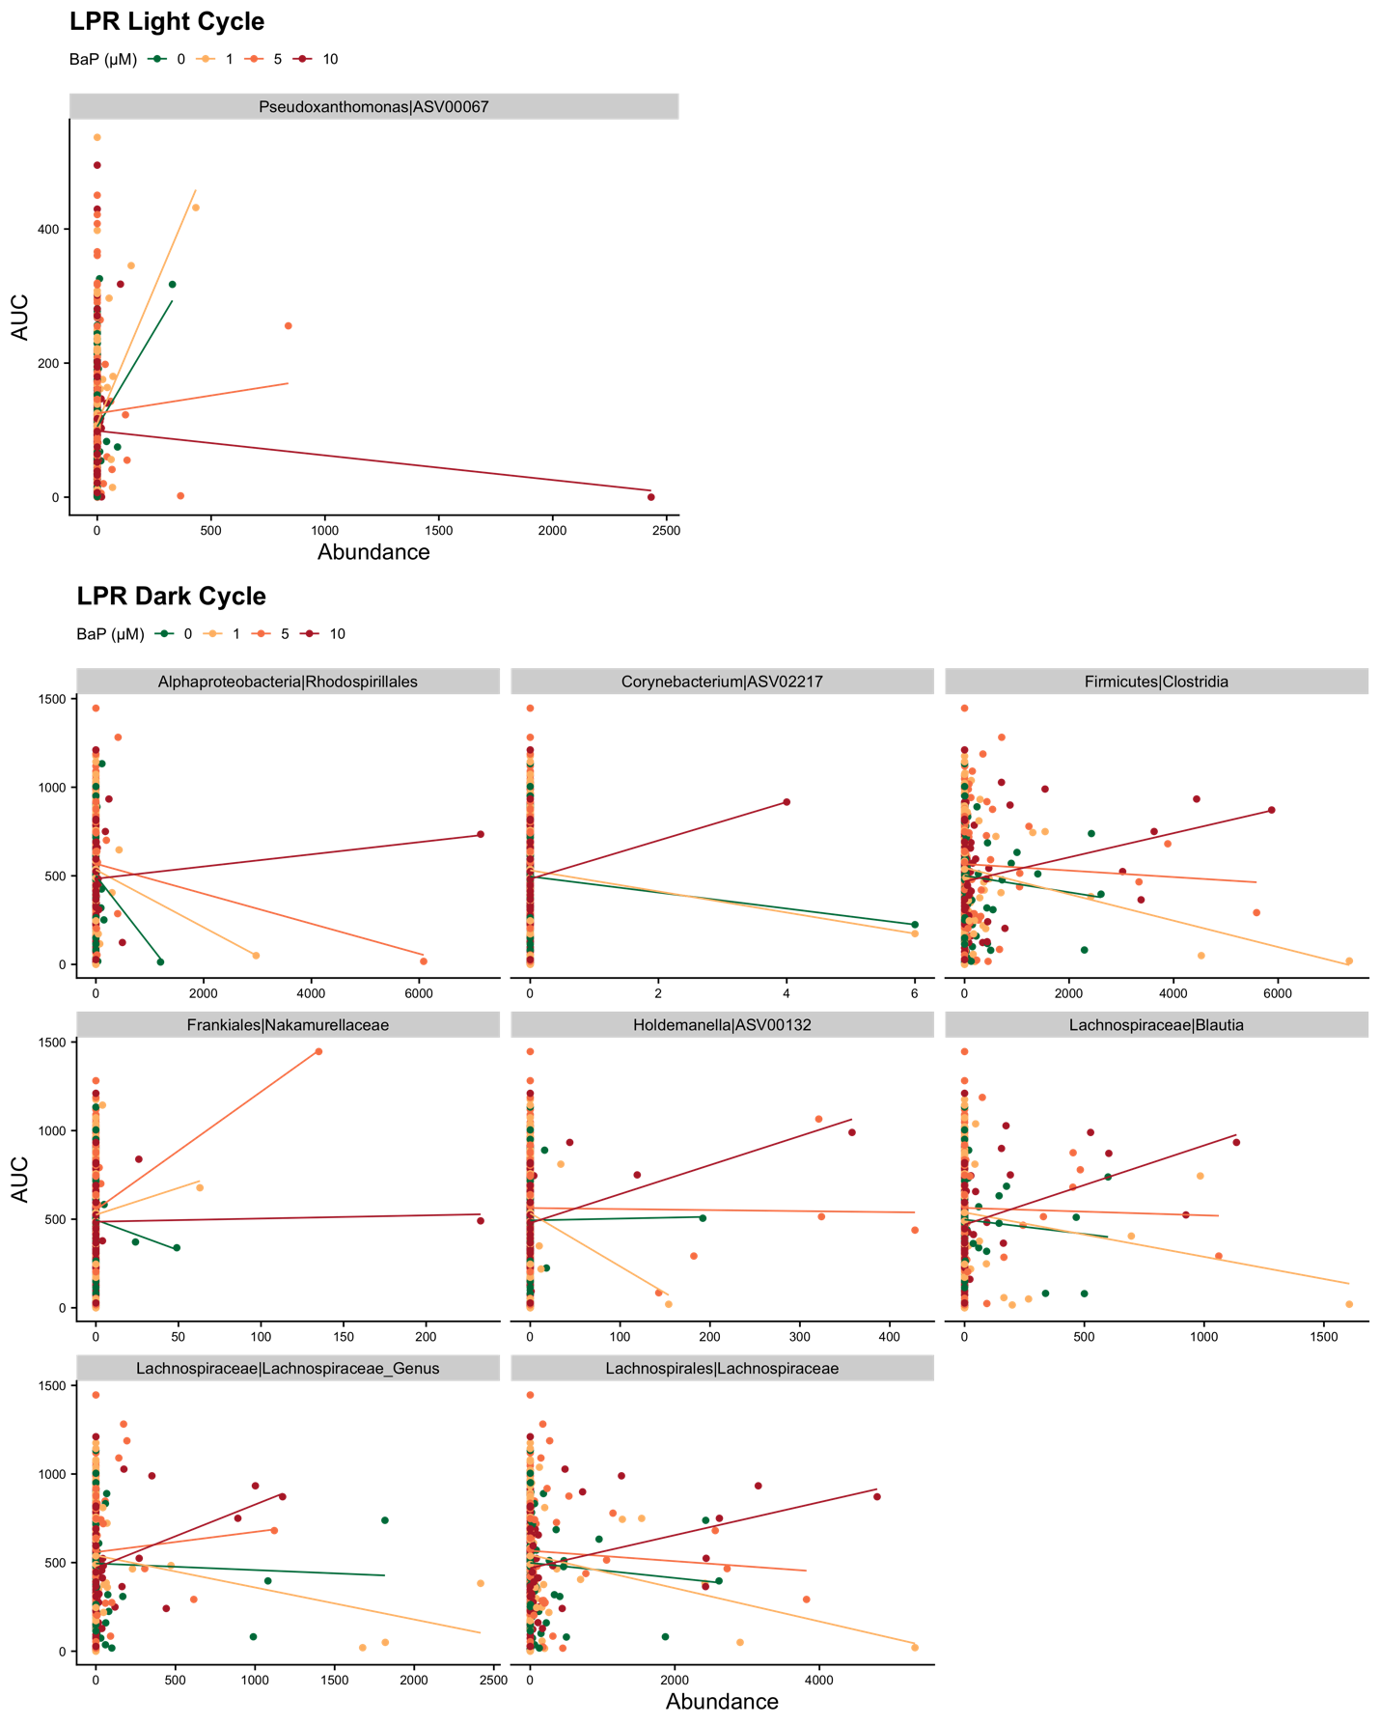Supplemental Figure 5: Scatter plots of the relationship between individual taxon abundances and LPR light and dark cycle AUCs. In this figure, only statistically significant associations (p < 0.05) with abundance-by-BaP interactions are shown. Lines represent estimated relationships from gaussian generalized linear models. Points and lines are colored by BaP exposure level. Light cycle associated taxa are shown on the top row and dark cycle associated taxa are show in the three rows below.

Supplemental Table 1: Linear regression model testing the association between BaP exposure and EPR AUC values (embryonic activity).
Term | Estimate | Std.error | Statistic | P.value | Sig
(Intercept) | 10.55 | 3.35 | 3.15 | 0.002 | *
BaP 1µM | 1.34 | 4.72 | 0.28 | 0.776
BaP 5µM | 14.16 | 4.68 | 3.02 | 0.003 | *
BaP 10µM | 26.54 | 4.63 | 5.73 | 0 | *

Supplemental Table 2: Linear regression models testing the association between BaP exposure and LPR AUC values (larval activity) by light and dark cycles.
Model | Cycle | Effect | Group | Term | Estimate | Std.error | Df | Statistic | P.value | Sig
1st order | light | fixed |  | (Intercept) | 118.45 | 10.98 | 399 | 10.79 | 0 | *
 |  |  |  | BaP µM | -1.39 | 1.43 | 399 | -0.97 | 0.333
1st order | light | ran_pars | SARL_plateID | sd_(Intercept) | 21.3
 |  |  |  | cor_BaP_uM.(Intercept) | -0.36
 |  |  |  | sd_BaP_uM | 2.05
1st order | light | ran_pars | Residual | sd_Observation | 92.96
2nd order | light | fixed |  | (Intercept) | 110.39 | 11.46 | 398 | 9.63 | 0 | *
 |  |  |  | BaP µM | 7.75 | 4.74 | 398 | 1.64 | 0.102
 |  |  |  | BaP µM^2 | -0.91 | 0.45 | 398 | -2.02 | 0.044 | *
2nd order | light | ran_pars | SARL_plateID | sd_(Intercept) | 20.64
 |  |  |  | cor_BaP_uM.(Intercept) | -0.3
 |  |  |  | sd_BaP_uM | 2.03
2nd order | light | ran_pars | Residual | sd_Observation | 92.61
1st order | dark | fixed |  | (Intercept) | 525.63 | 25.87 | 399 | 20.32 | 0 | *
 |  |  |  | BaP µM | -1.64 | 3.72 | 399 | -0.44 | 0.66
1st order | dark | ran_pars | SARL_plateID | sd_(Intercept) | 39.47
 |  |  |  | cor_BaP_uM.(Intercept) | 0.55
 |  |  |  | sd_BaP_uM | 3
1st order | dark | ran_pars | Residual | sd_Observation | 281.09
2nd order | dark | fixed |  | (Intercept) | 499.26 | 28.25 | 398 | 17.67 | 0 | *
 |  |  |  | BaP µM | 28.28 | 14.15 | 398 | 2 | 0.046 | *
 |  |  |  | BaP µM^2 | -2.96 | 1.35 | 398 | -2.19 | 0.029 | *
2nd order | dark | ran_pars | SARL_plateID | sd_(Intercept) | 38.6
 |  |  |  | cor_BaP_uM.(Intercept) | 0.57
 |  |  |  | sd_BaP_uM | 3.34
2nd order | dark | ran_pars | Residual | sd_Observation | 279.72

Supplemental Table 3: Linear regression models testing the association between BaP exposure and larval microbiome alpha-diversity metrics.

Alpha.metric | Effect | Group | Term | Estimate | Std.error | Df | Statistic | P.value | Sig
Chao1 | fixed |  | (Intercept) | 30.39 | 1.84 | 407 | 16.5 | 0 | *
Chao1 | fixed |  | BaP µM | 0.86 | 0.37 | 407 | 2.33 | 0.02 | *
Chao1 | ran_pars | SARL_plateID | sd_(Intercept) | 1.87
Chao1 | ran_pars | SARL_plateID | cor_BaP_uM.(Intercept) | -0.91
Chao1 | ran_pars | SARL_plateID | sd_BaP_uM | 0.55
Chao1 | ran_pars | Residual | sd_Observation | 23.55
Shannon | fixed |  | (Intercept) | 1.64 | 0.11 | 407 | 14.72 | 0 | *
Shannon | fixed |  | BaP µM | 0.02 | 0.01 | 407 | 1.45 | 0.147
Shannon | ran_pars | SARL_plateID | sd_(Intercept) | 0.23
Shannon | ran_pars | SARL_plateID | cor_BaP_uM.(Intercept) | -0.93
Shannon | ran_pars | SARL_plateID | sd_BaP_uM | 0.01
Shannon | ran_pars | Residual | sd_Observation | 0.81
Simpson | fixed |  | (Intercept) | 0.62 | 0.04 | 407 | 14.85 | 0 | *
Simpson | fixed |  | BaP µM | 0 | 0 | 407 | 0.72 | 0.47
Simpson | ran_pars | SARL_plateID | sd_(Intercept) | 0.09
Simpson | ran_pars | SARL_plateID | cor_BaP_uM.(Intercept) | -0.91
Simpson | ran_pars | SARL_plateID | sd_BaP_uM | 0
Simpson | ran_pars | Residual | sd_Observation | 0.22
Phylogenetic | fixed |  | (Intercept) | 6.52 | 0.24 | 407 | 26.71 | 0 | *
Phylogenetic | fixed |  | BaP µM | 0.09 | 0.04 | 407 | 2.2 | 0.028 | *
Phylogenetic | ran_pars | SARL_plateID | sd_(Intercept) | 0.01
Phylogenetic | ran_pars | SARL_plateID | cor_BaP_uM.(Intercept) | -0.08
Phylogenetic | ran_pars | SARL_plateID | sd_BaP_uM | 0
Phylogenetic | ran_pars | Residual | sd_Observation | 3.43
Observed | fixed |  | (Intercept) | 29.88 | 1.76 | 407 | 16.97 | 0 | *
Observed | fixed |  | BaP µM | 0.84 | 0.35 | 407 | 2.38 | 0.018 | *
Observed | ran_pars | SARL_plateID | sd_(Intercept) | 1.49
Observed | ran_pars | SARL_plateID | cor_BaP_uM.(Intercept) | -0.89
Observed | ran_pars | SARL_plateID | sd_BaP_uM | 0.49
Observed | ran_pars | Residual | sd_Observation | 23.22

Supplemental Table 4: PERMANOVA models testing the association between BaP exposure and larval microbiome beta-diversity metrics.
Beta.metric | Term | Df | SumOfSqs | Statistic | P.value | Sig
Bray-Curtis | BaP_uM | 1 | 0.63 | 1.42 | 0.114
Bray-Curtis | Residual | 411 | 181.76
Canberra | BaP_uM | 1 | 0.5 | 1.1 | 0.093
Canberra | Residual | 411 | 189.26
Sørensen | BaP_uM | 1 | 0.39 | 1.1 | 0.213
Sørensen | Residual | 411 | 143.41
Weighted UniFrac | BaP_uM | 1 | 0.02 | 1.06 | 0.356
Weighted UniFrac | Residual | 411 | 8.55
Half-weighted UniFrac | BaP_uM | 1 | 0.12 | 1.34 | 0.122
Half-weighted UniFrac | Residual | 411 | 36.61
Unweighted UniFrac | BaP_uM | 1 | 0.44 | 1.35 | 0.015 | *
Unweighted UniFrac | Residual | 411 | 135.78

Supplemental Table 5: Linear regression models testing the associations between LPR AUCs (larval activity) and BaP exposure, microbiome diversity.
Alpha.metric | Cycle | Effect | Group | Term | Estimate | Std.error | Df | Statistic | P.value | Sig
Chao1 | light | fixed |  | (Intercept) | 110.53 | 10.62 | 398 | 10.41 | 0 | *
 |  |  |  | BaP | 7.73 | 4.68 | 398 | 1.65 | 0.099
 |  |  |  | BaP^2 | -0.91 | 0.45 | 398 | -2.02 | 0.044 | *
Chao1 | light | ran_pars | SARL_plateID | sd_(Intercept) | 17.59
Chao1 | light | ran_pars | Residual | sd_Observation | 92.67
Chao1 | dark | fixed |  | (Intercept) | 499.63 | 29.09 | 398 | 17.18 | 0 | *
 |  |  |  | BaP | 27.94 | 14.11 | 398 | 1.98 | 0.048 | *
 |  |  |  | BaP^2 | -2.93 | 1.35 | 398 | -2.17 | 0.031 | *
Chao1 | dark | ran_pars | SARL_plateID | sd_(Intercept) | 41.82
Chao1 | dark | ran_pars | Residual | sd_Observation | 279.27
Shannon | light | fixed |  | (Intercept) | 110.53 | 10.62 | 398 | 10.41 | 0 | *
 |  |  |  | BaP | 7.73 | 4.68 | 398 | 1.65 | 0.099
 |  |  |  | BaP^2 | -0.91 | 0.45 | 398 | -2.02 | 0.044 | *
Shannon | light | ran_pars | SARL_plateID | sd_(Intercept) | 17.59
Shannon | light | ran_pars | Residual | sd_Observation | 92.67
Shannon | dark | fixed |  | (Intercept) | 557.43 | 46.09 | 396 | 12.09 | 0 | *
 |  |  |  | BaP | 30.01 | 14.12 | 396 | 2.13 | 0.034 | *
 |  |  |  | BaP^2 | -4.52 | 1.55 | 396 | -2.92 | 0.004 | *
 |  |  |  | Shannon | -36.48 | 22.65 | 396 | -1.61 | 0.108
 |  |  |  | BaP^2:Shannon | 0.81 | 0.39 | 396 | 2.08 | 0.038 | *
Shannon | dark | ran_pars | SARL_plateID | sd_(Intercept) | 40.51
Shannon | dark | ran_pars | Residual | sd_Observation | 277.81
Simpson | light | fixed |  | (Intercept) | 110.53 | 10.62 | 398 | 10.41 | 0 | *
 |  |  |  | BaP | 7.73 | 4.68 | 398 | 1.65 | 0.099
 |  |  |  | BaP^2 | -0.91 | 0.45 | 398 | -2.02 | 0.044 | *
Simpson | light | ran_pars | SARL_plateID | sd_(Intercept) | 17.59
Simpson | light | ran_pars | Residual | sd_Observation | 92.67
Simpson | dark | fixed |  | (Intercept) | 499.63 | 29.09 | 398 | 17.18 | 0 | *
 |  |  |  | BaP | 27.94 | 14.11 | 398 | 1.98 | 0.048 | *
 |  |  |  | BaP^2 | -2.93 | 1.35 | 398 | -2.17 | 0.031 | *
Simpson | dark | ran_pars | SARL_plateID | sd_(Intercept) | 41.82
Simpson | dark | ran_pars | Residual | sd_Observation | 279.27
Phylogenetic | light | fixed |  | (Intercept) | 110.53 | 10.62 | 398 | 10.41 | 0 | *
 |  |  |  | BaP | 7.73 | 4.68 | 398 | 1.65 | 0.099
 |  |  |  | BaP^2 | -0.91 | 0.45 | 398 | -2.02 | 0.044 | *
Phylogenetic | light | ran_pars | SARL_plateID | sd_(Intercept) | 17.59
Phylogenetic | light | ran_pars | Residual | sd_Observation | 92.67
Phylogenetic | dark | fixed |  | (Intercept) | 499.63 | 29.09 | 398 | 17.18 | 0 | *
 |  |  |  | BaP | 27.94 | 14.11 | 398 | 1.98 | 0.048 | *
 |  |  |  | BaP^2 | -2.93 | 1.35 | 398 | -2.17 | 0.031 | *
Phylogenetic | dark | ran_pars | SARL_plateID | sd_(Intercept) | 41.82
Phylogenetic | dark | ran_pars | Residual | sd_Observation | 279.27
Observed | light | fixed |  | (Intercept) | 110.53 | 10.62 | 398 | 10.41 | 0 | *
 |  |  |  | BaP | 7.73 | 4.68 | 398 | 1.65 | 0.099
 |  |  |  | BaP^2 | -0.91 | 0.45 | 398 | -2.02 | 0.044 | *
Observed | light | ran_pars | SARL_plateID | sd_(Intercept) | 17.59
Observed | light | ran_pars | Residual | sd_Observation | 92.67
Observed | dark | fixed |  | (Intercept) | 499.63 | 29.09 | 398 | 17.18 | 0 | *
 |  |  |  | BaP | 27.94 | 14.11 | 398 | 1.98 | 0.048 | *
 |  |  |  | BaP^2 | -2.93 | 1.35 | 398 | -2.17 | 0.031 | *
Observed | dark | ran_pars | SARL_plateID | sd_(Intercept) | 41.82
Observed | dark | ran_pars | Residual | sd_Observation | 279.27

Supplemental Table 6: PERMANOVA models testing the association between beta-diversity scores and BaP exposure, LPR AUC scores.
Beta.metric | Cycle | Term | Df | SumOfSqs | Statistic | P.value | Sig
Bray-Curtis | light | BaP_uM | 1 | 0.63 | 1.429 | 0
Bray-Curtis | light | LPR.light.auc | 1 | 0.89 | 2.021 | 0 | *
Bray-Curtis | light | Residual | 402 | 176.91
Canberra | light | LPR.light.auc | 1 | 0.56 | 1.228 | 0 | *
Canberra | light | Residual | 403 | 185.47
Canberra | dark | LPR.dark.auc | 1 | 0.54 | 1.178 | 0 | *
Canberra | dark | Residual | 403 | 185.49
Sørensen | light | LPR.light.auc | 1 | 0.61 | 1.753 | 0 | *
Sørensen | light | Residual | 403 | 140.31
Sørensen | dark | LPR.dark.auc | 1 | 0.56 | 1.602 | 0 | *
Sørensen | dark | Residual | 403 | 140.37
Weighted UniFrac | dark | BaP_uM | 1 | 0.02 | 1.129 | 0
Weighted UniFrac | dark | LPR.dark.auc | 1 | 0.03 | 1.351 | 0
Weighted UniFrac | dark | BaP_uM:LPR.dark.auc | 1 | 0.04 | 1.849 | 0
Weighted UniFrac | dark | Residual | 401 | 8.3
Half-weighted UniFrac | light | LPR.light.auc | 1 | 0.12 | 1.357 | 0
Half-weighted UniFrac | light | Residual | 403 | 35.77
Half-weighted UniFrac | dark | BaP_uM | 1 | 0.13 | 1.414 | 0
Half-weighted UniFrac | dark | LPR.dark.auc | 1 | 0.13 | 1.417 | 0
Half-weighted UniFrac | dark | BaP_uM:LPR.dark.auc | 1 | 0.14 | 1.596 | 0
Half-weighted UniFrac | dark | Residual | 401 | 35.49
Unweighted UniFrac | light | BaP_uM | 1 | 0.45 | 1.363 | 0 | *
Unweighted UniFrac | light | LPR.light.auc | 1 | 0.4 | 1.225 | 0
Unweighted UniFrac | light | Residual | 402 | 132.85
Unweighted UniFrac | dark | BaP_uM | 1 | 0.45 | 1.364 | 0 | *
Unweighted UniFrac | dark | LPR.dark.auc | 1 | 0.43 | 1.311 | 0 | *
Unweighted UniFrac | dark | BaP_uM:LPR.dark.auc | 1 | 0.39 | 1.196 | 0
Unweighted UniFrac | dark | Residual | 401 | 132.43

Supplemental Table 7: Linear mixed-effects regression models predicting LPR AUC values from individual taxon abundances and BaP exposure. Interactions terms between taxon abundance and BaP exposure were only included if that term significantly improved the model.
Taxon | Cycle | Effect | Group | Term | Estimate | Std.error | Df | Statistic | P.value | Sig | Mod.pval
ASV00006 | light | fixed |  | (Intercept) | 102.32 | 7.95 | 399 | 12.87 | 0 | * | 0
 |  |  |  | BaP | 6.71 | 4.65 | 399 | 1.44 | 0.15 |  | 0
 |  |  |  | BaP^2 | -0.8 | 0.44 | 399 | -1.8 | 0.072 |  | 0
 |  |  |  | ASV00006 | 0.02 | 0 | 399 | 4.29 | 0 | * | 0
ASV00006 | light | ran_pars | SARL_plateID | sd_(Intercept) | 1.64 |  |  |  |  |  | 0
 |  |  |  | cor_BaP_uM.(Intercept) | -0.54 |  |  |  |  |  | 0
 |  |  |  | sd_BaP | 1.22 |  |  |  |  |  | 0
ASV00006 | light | ran_pars | Residual | sd_Observation | 92.02 |  |  |  |  |  | 0
ASV00071 | light | fixed |  | (Intercept) | 107.73 | 9.97 | 399 | 10.81 | 0 | * | 0.008
 |  |  |  | BaP | 7.75 | 4.69 | 399 | 1.65 | 0.099 |  | 0.008
 |  |  |  | BaP^2 | -0.9 | 0.45 | 399 | -2.01 | 0.045 | * | 0.008
 |  |  |  | ASV00071 | 0.09 | 0.03 | 399 | 2.66 | 0.008 | * | 0.008
ASV00071 | light | ran_pars | SARL_plateID | sd_(Intercept) | 15.04 |  |  |  |  |  | 0.008
 |  |  |  | cor_BaP_uM.(Intercept) | -0.26 |  |  |  |  |  | 0.008
 |  |  |  | sd_BaP | 1.59 |  |  |  |  |  | 0.008
ASV00071 | light | ran_pars | Residual | sd_Observation | 92.05 |  |  |  |  |  | 0.008
ASV00067 | light | fixed |  | (Intercept) | 108.61 | 9.51 | 398 | 11.42 | 0 | * | 0.003
 |  |  |  | BaP | 5.81 | 4.68 | 398 | 1.24 | 0.215 |  | 0.003
 |  |  |  | BaP^2 | -0.68 | 0.45 | 398 | -1.53 | 0.127 |  | 0.003
 |  |  |  | ASV00067 | 0.31 | 0.1 | 398 | 2.92 | 0.004 | * | 0.003
 |  |  |  | BaP^2:ASV00067 | 0 | 0 | 398 | -3 | 0.003 | * | 0.003
ASV00067 | light | ran_pars | SARL_plateID | sd_(Intercept) | 13.32 |  |  |  |  |  | 0.003
 |  |  |  | cor_BaP_uM.(Intercept) | -0.15 |  |  |  |  |  | 0.003
 |  |  |  | sd_BaP | 1.43 |  |  |  |  |  | 0.003
ASV00067 | light | ran_pars | Residual | sd_Observation | 91.93 |  |  |  |  |  | 0.003
ASV00154 | light | fixed |  | (Intercept) | 110.18 | 10.54 | 399 | 10.45 | 0 | * | 0.007
 |  |  |  | BaP | 5.65 | 4.67 | 399 | 1.21 | 0.227 |  | 0.007
 |  |  |  | BaP^2 | -0.71 | 0.45 | 399 | -1.6 | 0.111 |  | 0.007
 |  |  |  | ASV00154 | 0.44 | 0.16 | 399 | 2.69 | 0.007 | * | 0.007
ASV00154 | light | ran_pars | SARL_plateID | sd_(Intercept) | 17.41 |  |  |  |  |  | 0.007
 |  |  |  | cor_BaP_uM.(Intercept) | -0.25 |  |  |  |  |  | 0.007
 |  |  |  | sd_BaP | 1.26 |  |  |  |  |  | 0.007
ASV00154 | light | ran_pars | Residual | sd_Observation | 91.95 |  |  |  |  |  | 0.007
p__Bdellovibrionota.c__Bdellovibrionia | dark | fixed |  | (Intercept) | 503.32 | 28.04 | 397 | 17.95 | 0 | * | 0.046
 |  |  |  | BaP | 28.39 | 14.12 | 397 | 2.01 | 0.045 | * | 0.046
 |  |  |  | BaP^2 | -2.93 | 1.35 | 397 | -2.17 | 0.03 | * | 0.046
 |  |  |  | p__Bdellovibrionotac__Bdellovibrionia | -0.48 | 0.24 | 397 | -2 | 0.046 | * | 0.046
p__Bdellovibrionota.c__Bdellovibrionia | dark | ran_pars | SARL_plateID | sd_(Intercept) | 37.33 |  |  |  |  |  | 0.046
 |  |  |  | cor_BaP_uM.(Intercept) | 0.06 |  |  |  |  |  | 0.046
 |  |  |  | sd_BaP | 3.59 |  |  |  |  |  | 0.046
p__Bdellovibrionota.c__Bdellovibrionia | dark | ran_pars | Residual | sd_Observation | 277.57 |  |  |  |  |  | 0.046
p__WPS-2 | dark | fixed |  | (Intercept) | 503.53 | 27.17 | 397 | 18.53 | 0 | * | 0.04
 |  |  |  | BaP | 28.06 | 14.12 | 397 | 1.99 | 0.048 | * | 0.04
 |  |  |  | BaP^2 | -2.89 | 1.35 | 397 | -2.14 | 0.033 | * | 0.04
 |  |  |  | p__WPS2 | -0.89 | 0.43 | 397 | -2.05 | 0.041 | * | 0.04
p__WPS-2 | dark | ran_pars | SARL_plateID | sd_(Intercept) | 33.24 |  |  |  |  |  | 0.04
 |  |  |  | cor_BaP_uM.(Intercept) | 0.19 |  |  |  |  |  | 0.04
 |  |  |  | sd_BaP | 3.46 |  |  |  |  |  | 0.04
p__WPS-2 | dark | ran_pars | Residual | sd_Observation | 277.68 |  |  |  |  |  | 0.04
p__Proteobacteria.c__Gammaproteobacteria.o__Alteromonadales.f__Shewanellaceae | dark | fixed |  | (Intercept) | 475.49 | 31.52 | 397 | 15.08 | 0 | * | 0.014
 |  |  |  | BaP | 29.68 | 14.04 | 397 | 2.11 | 0.035 | * | 0.014
 |  |  |  | BaP^2 | -2.98 | 1.34 | 397 | -2.22 | 0.027 | * | 0.014
 |  |  |  | p__Proteobacteriac__Gammaproteobacteriao__Alteromonadalesf__Shewanellaceae | 0.02 | 0.01 | 397 | 2.5 | 0.013 | * | 0.014
 | dark | ran_pars | SARL_plateID | sd_(Intercept) | 45.98 |  |  |  |  |  | 0.014
 |  |  |  | cor_BaP_uM.(Intercept) | -0.06 |  |  |  |  |  | 0.014
 |  |  |  | sd_BaP | 1.86 |  |  |  |  |  | 0.014
 | dark | ran_pars | Residual | sd_Observation | 276.77 |  |  |  |  |  | 0.014
ASV00003 | dark | fixed |  | (Intercept) | 482.11 | 29.57 | 397 | 16.31 | 0 | * | 0.024
 |  |  |  | BaP | 29.18 | 14.07 | 397 | 2.07 | 0.039 | * | 0.024
 |  |  |  | BaP^2 | -2.99 | 1.35 | 397 | -2.22 | 0.027 | * | 0.024
 |  |  |  | ASV00003 | 0.03 | 0.01 | 397 | 2.27 | 0.024 | * | 0.024
ASV00003 | dark | ran_pars | SARL_plateID | sd_(Intercept) | 40.04 |  |  |  |  |  | 0.024
 |  |  |  | cor_BaP_uM.(Intercept) | 0 |  |  |  |  |  | 0.024
 |  |  |  | sd_BaP | 2.2 |  |  |  |  |  | 0.024
ASV00003 | dark | ran_pars | Residual | sd_Observation | 277.38 |  |  |  |  |  | 0.024
p__Proteobacteria.c__Alphaproteobacteria.o__Rhizobiales.f__Xanthobacteraceae.g__Afipia | dark | fixed |  | (Intercept) | 492.11 | 26.51 | 397 | 18.56 | 0 | * | 0.035
 |  |  |  | BaP | 27.15 | 14.15 | 397 | 1.92 | 0.056 |  | 0.035
 |  |  |  | BaP^2 | -2.83 | 1.35 | 397 | -2.1 | 0.037 | * | 0.035
 |  |  |  | p__Proteobacteriac__Alphaproteobacteriao__Rhizobialesf__Xanthobacteraceaeg__Afipia | 0.58 | 0.27 | 397 | 2.11 | 0.035 | * | 0.035
 | dark | ran_pars | SARL_plateID | sd_(Intercept) | 29.5 |  |  |  |  |  | 0.035
 |  |  |  | cor_BaP_uM.(Intercept) | 0.36 |  |  |  |  |  | 0.035
 |  |  |  | sd_BaP | 3.97 |  |  |  |  |  | 0.035
 | dark | ran_pars | Residual | sd_Observation | 277.56 |  |  |  |  |  | 0.035
p__Proteobacteria.c__Alphaproteobacteria.o__Rhodospirillales | dark | fixed |  | (Intercept) | 502.48 | 28.59 | 396 | 17.57 | 0 | * | 0.005
 |  |  |  | BaP | 30.79 | 14.07 | 396 | 2.19 | 0.029 | * | 0.005
 |  |  |  | BaP^2 | -3.27 | 1.34 | 396 | -2.44 | 0.015 | * | 0.005
 |  |  |  | p__Proteobacteriac__Alphaproteobacteriao__Rhodospirillales | -0.16 | 0.05 | 396 | -3.13 | 0.002 | * | 0.005
 |  |  |  | BaP^2:p__Proteobacteriac__Alphaproteobacteriao__Rhodospirillales | 0 | 0 | 396 | 2.85 | 0.005 | * | 0.005
p__Proteobacteria.c__Alphaproteobacteria.o__Rhodospirillales | dark | ran_pars | SARL_plateID | sd_(Intercept) | 40.53 |  |  |  |  |  | 0.005
 |  |  |  | cor_BaP_uM.(Intercept) | 0.04 |  |  |  |  |  | 0.005
 |  |  |  | sd_BaP | 4.23 |  |  |  |  |  | 0.005
p__Proteobacteria.c__Alphaproteobacteria.o__Rhodospirillales | dark | ran_pars | Residual | sd_Observation | 275.22 |  |  |  |  |  | 0.005
p__Firmicutes.c__Clostridia.o__Lachnospirales.f__Lachnospiraceae.g__Lachnospiraceae_Genus | dark | fixed |  | (Intercept) | 505.82 | 27.4 | 396 | 18.46 | 0 | * | 0.005
 |  |  |  | BaP | 27.87 | 14.06 | 396 | 1.98 | 0.048 | * | 0.005
 |  |  |  | BaP^2 | -3.15 | 1.35 | 396 | -2.34 | 0.02 | * | 0.005
 |  |  |  | p__Firmicutesc__Clostridiao__Lachnospiralesf__Lachnospiraceaeg__Lachnospiraceae_Genus | -0.12 | 0.07 | 396 | -1.8 | 0.073 |  | 0.005
 |  |  |  | BaP^2:p__Firmicutesc__Clostridiao__Lachnospiralesf__Lachnospiraceaeg__Lachnospiraceae_Genus | 0 | 0 | 396 | 2.82 | 0.005 | * | 0.005
 | dark | ran_pars | SARL_plateID | sd_(Intercept) | 33.65 |  |  |  |  |  | 0.005
 |  |  |  | cor_BaP_uM.(Intercept) | 0.09 |  |  |  |  |  | 0.005
 |  |  |  | sd_BaP | 2.82 |  |  |  |  |  | 0.005
 | dark | ran_pars | Residual | sd_Observation | 276.49 |  |  |  |  |  | 0.005
p__Proteobacteria.c__Gammaproteobacteria.o__Burkholderiales.f__Comamonadaceae.g__Paucibacter | dark | fixed |  | (Intercept) | 502.38 | 28.18 | 397 | 17.83 | 0 | * | 0.005
 |  |  |  | BaP | 30.02 | 14.06 | 397 | 2.13 | 0.033 | * | 0.005
 |  |  |  | BaP^2 | -3.09 | 1.34 | 397 | -2.3 | 0.022 | * | 0.005
 |  |  |  | p__Proteobacteriac__Gammaproteobacteriao__Burkholderialesf__Comamonadaceaeg__Paucibacter | -1.75 | 0.62 | 397 | -2.81 | 0.005 | * | 0.005
 | dark | ran_pars | SARL_plateID | sd_(Intercept) | 38.67 |  |  |  |  |  | 0.005
 |  |  |  | cor_BaP_uM.(Intercept) | 0.21 |  |  |  |  |  | 0.005
 |  |  |  | sd_BaP | 3.61 |  |  |  |  |  | 0.005
 | dark | ran_pars | Residual | sd_Observation | 276.07 |  |  |  |  |  | 0.005
p__Firmicutes.c__Clostridia | dark | fixed |  | (Intercept) | 509.77 | 27.31 | 396 | 18.67 | 0 | * | 0.002
 |  |  |  | BaP | 29.39 | 14.04 | 396 | 2.09 | 0.037 | * | 0.002
 |  |  |  | BaP^2 | -3.36 | 1.35 | 396 | -2.49 | 0.013 | * | 0.002
 |  |  |  | p__Firmicutesc__Clostridia | -0.06 | 0.02 | 396 | -2.47 | 0.014 | * | 0.002
 |  |  |  | BaP^2:p__Firmicutesc__Clostridia | 0 | 0 | 396 | 3.12 | 0.002 | * | 0.002
p__Firmicutes.c__Clostridia | dark | ran_pars | SARL_plateID | sd_(Intercept) | 33.05 |  |  |  |  |  | 0.002
 |  |  |  | cor_BaP_uM.(Intercept) | 0.03 |  |  |  |  |  | 0.002
 |  |  |  | sd_BaP | 2.87 |  |  |  |  |  | 0.002
p__Firmicutes.c__Clostridia | dark | ran_pars | Residual | sd_Observation | 276 |  |  |  |  |  | 0.002
p__Proteobacteria.c__Gammaproteobacteria.o__Burkholderiales.f__Oxalobacteraceae.g__Undibacterium | dark | fixed |  | (Intercept) | 508.58 | 27.66 | 397 | 18.39 | 0 | * | 0.004
 |  |  |  | BaP | 28.52 | 14.05 | 397 | 2.03 | 0.043 | * | 0.004
 |  |  |  | BaP^2 | -2.98 | 1.34 | 397 | -2.22 | 0.027 | * | 0.004
 |  |  |  | p__Proteobacteriac__Gammaproteobacteriao__Burkholderialesf__Oxalobacteraceaeg__Undibacterium | -0.58 | 0.2 | 397 | -2.9 | 0.004 | * | 0.004
 | dark | ran_pars | SARL_plateID | sd_(Intercept) | 35.6 |  |  |  |  |  | 0.004
 |  |  |  | cor_BaP_uM.(Intercept) | 0.2 |  |  |  |  |  | 0.004
 |  |  |  | sd_BaP | 3.73 |  |  |  |  |  | 0.004
 | dark | ran_pars | Residual | sd_Observation | 276.03 |  |  |  |  |  | 0.004
p__Firmicutes.c__Clostridia.o__Lachnospirales.f__Lachnospiraceae.g__Blautia | dark | fixed |  | (Intercept) | 505.85 | 27.81 | 396 | 18.19 | 0 | * | 0.003
 |  |  |  | BaP | 28.4 | 14.01 | 396 | 2.03 | 0.043 | * | 0.003
 |  |  |  | BaP^2 | -3.21 | 1.35 | 396 | -2.38 | 0.018 | * | 0.003
 |  |  |  | p__Firmicutesc__Clostridiao__Lachnospiralesf__Lachnospiraceaeg__Blautia | -0.21 | 0.12 | 396 | -1.78 | 0.075 |  | 0.003
 |  |  |  | BaP^2:p__Firmicutesc__Clostridiao__Lachnospiralesf__Lachnospiraceaeg__Blautia | 0.01 | 0 | 396 | 3.02 | 0.003 | * | 0.003
 | dark | ran_pars | SARL_plateID | sd_(Intercept) | 35.73 |  |  |  |  |  | 0.003
 |  |  |  | cor_BaP_uM.(Intercept) | 0.01 |  |  |  |  |  | 0.003
 |  |  |  | sd_BaP | 1.12 |  |  |  |  |  | 0.003
 | dark | ran_pars | Residual | sd_Observation | 276.45 |  |  |  |  |  | 0.003
p__Fusobacteriota.c__Fusobacteriia | dark | fixed |  | (Intercept) | 502.81 | 27.49 | 397 | 18.29 | 0 | * | 0.043
 |  |  |  | BaP | 28.02 | 14.12 | 397 | 1.98 | 0.048 | * | 0.043
 |  |  |  | BaP^2 | -2.91 | 1.35 | 397 | -2.16 | 0.031 | * | 0.043
 |  |  |  | p__Fusobacteriotac__Fusobacteriia | -0.12 | 0.06 | 397 | -2.02 | 0.045 | * | 0.043
p__Fusobacteriota.c__Fusobacteriia | dark | ran_pars | SARL_plateID | sd_(Intercept) | 34.96 |  |  |  |  |  | 0.043
 |  |  |  | cor_BaP_uM.(Intercept) | 0.26 |  |  |  |  |  | 0.043
 |  |  |  | sd_BaP | 3.62 |  |  |  |  |  | 0.043
p__Fusobacteriota.c__Fusobacteriia | dark | ran_pars | Residual | sd_Observation | 277.53 |  |  |  |  |  | 0.043
p__Firmicutes.c__Clostridia.o__Lachnospirales.f__Lachnospiraceae | dark | fixed |  | (Intercept) | 509.04 | 27.43 | 396 | 18.56 | 0 | * | 0.002
 |  |  |  | BaP | 28.88 | 14.03 | 396 | 2.06 | 0.04 | * | 0.002
 |  |  |  | BaP^2 | -3.28 | 1.35 | 396 | -2.44 | 0.015 | * | 0.002
 |  |  |  | p__Firmicutesc__Clostridiao__Lachnospiralesf__Lachnospiraceae | -0.07 | 0.03 | 396 | -2.29 | 0.023 | * | 0.002
 |  |  |  | BaP^2:p__Firmicutesc__Clostridiao__Lachnospiralesf__Lachnospiraceae | 0 | 0 | 396 | 3.05 | 0.002 | * | 0.002
 | dark | ran_pars | SARL_plateID | sd_(Intercept) | 33.55 |  |  |  |  |  | 0.002
 |  |  |  | cor_BaP_uM.(Intercept) | 0.01 |  |  |  |  |  | 0.002
 |  |  |  | sd_BaP | 2.51 |  |  |  |  |  | 0.002
 | dark | ran_pars | Residual | sd_Observation | 276.26 |  |  |  |  |  | 0.002
ASV02217 | dark | fixed |  | (Intercept) | 502.78 | 28.05 | 396 | 17.92 | 0 | * | 0.039
 |  |  |  | BaP | 27.56 | 14.12 | 396 | 1.95 | 0.052 |  | 0.039
 |  |  |  | BaP^2 | -2.97 | 1.35 | 396 | -2.2 | 0.029 | * | 0.039
 |  |  |  | ASV02217 | -54.54 | 33.31 | 396 | -1.64 | 0.102 |  | 0.039
 |  |  |  | BaP^2:ASV02217 | 1.61 | 0.78 | 396 | 2.06 | 0.04 | * | 0.039
ASV02217 | dark | ran_pars | SARL_plateID | sd_(Intercept) | 37.28 |  |  |  |  |  | 0.039
 |  |  |  | cor_BaP_uM.(Intercept) | 0.17 |  |  |  |  |  | 0.039
 |  |  |  | sd_BaP | 3.16 |  |  |  |  |  | 0.039
ASV02217 | dark | ran_pars | Residual | sd_Observation | 277.28 |  |  |  |  |  | 0.039
p__Actinobacteriota.c__Actinobacteria.o__Frankiales.f__Nakamurellaceae | dark | fixed |  | (Intercept) | 495.59 | 29.08 | 396 | 17.04 | 0 | * | 0.033
 |  |  |  | BaP | 27.09 | 14.06 | 396 | 1.93 | 0.055 |  | 0.033
 |  |  |  | BaP^2 | -2.81 | 1.35 | 396 | -2.09 | 0.037 | * | 0.033
 |  |  |  | p__Actinobacteriotac__Actinobacteriao__Frankialesf__Nakamurellaceae | 5.66 | 2.16 | 396 | 2.63 | 0.009 | * | 0.033
 |  |  |  | BaP^2:p__Actinobacteriotac__Actinobacteriao__Frankialesf__Nakamurellaceae | -0.06 | 0.03 | 396 | -2.14 | 0.033 | * | 0.033
 | dark | ran_pars | SARL_plateID | sd_(Intercept) | 42.11 |  |  |  |  |  | 0.033
 |  |  |  | cor_BaP_uM.(Intercept) | 0.02 |  |  |  |  |  | 0.033
 |  |  |  | sd_BaP | 2.68 |  |  |  |  |  | 0.033
 | dark | ran_pars | Residual | sd_Observation | 276.49 |  |  |  |  |  | 0.033
ASV00132 | dark | fixed |  | (Intercept) | 500.28 | 27.99 | 396 | 17.88 | 0 | * | 0.037
 |  |  |  | BaP | 28.83 | 14.21 | 396 | 2.03 | 0.043 | * | 0.037
 |  |  |  | BaP^2 | -3.1 | 1.36 | 396 | -2.28 | 0.023 | * | 0.037
 |  |  |  | ASV00132 | -0.63 | 0.55 | 396 | -1.15 | 0.25 |  | 0.037
 |  |  |  | BaP^2:ASV00132 | 0.02 | 0.01 | 396 | 2.1 | 0.036 | * | 0.037
ASV00132 | dark | ran_pars | SARL_plateID | sd_(Intercept) | 37.29 |  |  |  |  |  | 0.037
 |  |  |  | cor_BaP_uM.(Intercept) | 0.02 |  |  |  |  |  | 0.037
 |  |  |  | sd_BaP | 2.43 |  |  |  |  |  | 0.037
ASV00132 | dark | ran_pars | Residual | sd_Observation | 277.56 |  |  |  |  |  | 0.037
p__Proteobacteria.c__Alphaproteobacteria.o__Sphingomonadales.f__Sphingomonadaceae.g__Novosphingobium | dark | fixed |  | (Intercept) | 499.69 | 27.2 | 397 | 18.37 | 0 | * | 0.019
 |  |  |  | BaP | 30.08 | 14.12 | 397 | 2.13 | 0.034 | * | 0.019
 |  |  |  | BaP^2 | -3.1 | 1.35 | 397 | -2.3 | 0.022 | * | 0.019
 |  |  |  | p__Proteobacteriac__Alphaproteobacteriao__Sphingomonadalesf__Sphingomonadaceaeg__Novosphingobium | -0.83 | 0.36 | 397 | -2.33 | 0.02 | * | 0.019
 | dark | ran_pars | SARL_plateID | sd_(Intercept) | 34 |  |  |  |  |  | 0.019
 |  |  |  | cor_BaP_uM.(Intercept) | 0.24 |  |  |  |  |  | 0.019
 |  |  |  | sd_BaP | 3.62 |  |  |  |  |  | 0.019
 | dark | ran_pars | Residual | sd_Observation | 277.13 |  |  |  |  |  | 0.019

Supplemental Table 8: Linear regression models testing the association between BaP exposure, microbiome treatment and LPR AUC values (larval activity) by light and dark cycles.
Model | Cycle | Term | Estimate | Std.error | Statistic | P.value | Sig
1st order | light | (Intercept) | 120.37 | 14.92 | 8.07 | 0 | *
1st order | light | BaP µM | 4.98 | 3.22 | 1.55 | 0.122
1st order | light | CVZ | 22.83 | 20.78 | 1.1 | 0.272
1st order | light | GF | 168.51 | 20.77 | 8.11 | 0 | *
1st order | light | BaP µM:CVZ | -5.23 | 4.12 | -1.27 | 0.204
1st order | light | BaP µM:GF | -7.25 | 4.13 | -1.76 | 0.079
2nd order | light | (Intercept) | 102.98 | 14.39 | 7.16 | 0 | *
2nd order | light | BaP µM | 20.48 | 6.02 | 3.4 | 0.001 | *
2nd order | light | BaP µM^2 | -1.45 | 0.67 | -2.16 | 0.031 | *
2nd order | light | CVZ | 25.98 | 18.21 | 1.43 | 0.154
2nd order | light | GF | 167.01 | 18.13 | 9.21 | 0 | *
2nd order | light | BaP µM^2:CVZ | -0.71 | 0.41 | -1.73 | 0.084
2nd order | light | BaP µM^2:GF | -0.85 | 0.41 | -2.07 | 0.039 | *
1st order | dark | (Intercept) | 361.76 | 24.22 | 14.94 | 0 | *
1st order | dark | BaP µM | 5.59 | 5.24 | 1.07 | 0.286
1st order | dark | CVZ | -103.86 | 33.79 | -3.07 | 0.002 | *
1st order | dark | GF | 52.89 | 33.77 | 1.57 | 0.118
1st order | dark | BaP µM:CVZ | -1.17 | 6.7 | -0.18 | 0.861
1st order | dark | BaP µM:GF | -3.81 | 6.72 | -0.57 | 0.571
2nd order | dark | (Intercept) | 337.13 | 23.43 | 14.39 | 0 | *
2nd order | dark | BaP µM | 33.82 | 9.83 | 3.44 | 0.001 | *
2nd order | dark | BaP µM^2 | -2.96 | 1.1 | -2.7 | 0.007 | *
2nd order | dark | CVZ | -100.69 | 29.7 | -3.39 | 0.001 | *
2nd order | dark | GF | 47.8 | 29.58 | 1.62 | 0.106
2nd order | dark | BaP µM^2:CVZ | -0.06 | 0.67 | -0.09 | 0.932
2nd order | dark | BaP µM^2:GF | -0.17 | 0.67 | -0.26 | 0.795

