TARGETING SOLUBLE AMYLOID-BETA OLIGOMERS WITH A NOVEL NANOBODY
Justin R. Haynes ^{1,2}, Clayton A. Whitmore ^{1,2} William J. Behof ^{1,2}, Charlotte A. Landman^{1,2}, Henry H. Ong³, Andrew P. Feld⁶, Isabelle C. Suero⁶, Celeste B. Greer⁴, John C. Gore^{1,2,4,7,8,9}, Printha Wijesinghe⁵, Joanne A. Matsubara⁵, Brian E. Wadzinski* ^{6,8,9}, Benjamin W. Spiller* ^{6, 9,11}, and Wellington Pham* ^{1,2,4,7,8,9,10,12}

Figure S1. Original Coomassie staining data. Lanes: 1, ladder; 2, SAβO batch 1 (loaded at 50 μg/mL); 3, SAβO batch 2; 4, SAβO batch 3 (sample was stored at -20°C for multiple years); 5, SAβO batch 4 (loaded at 0.45 μg/μL); 6, SAβO batch 5 (loaded at 1/1000th); 7, SAβO batch 6 (loaded at 0.1 μg/μL); 8, SAβO batch 7; 9, SAβO batch 8; 10, SAβO batch 9.
Lanes 1, 2, and 3 in Fig. 2A were cropped from lanes 3,4 and 6 of this original data, respectively.

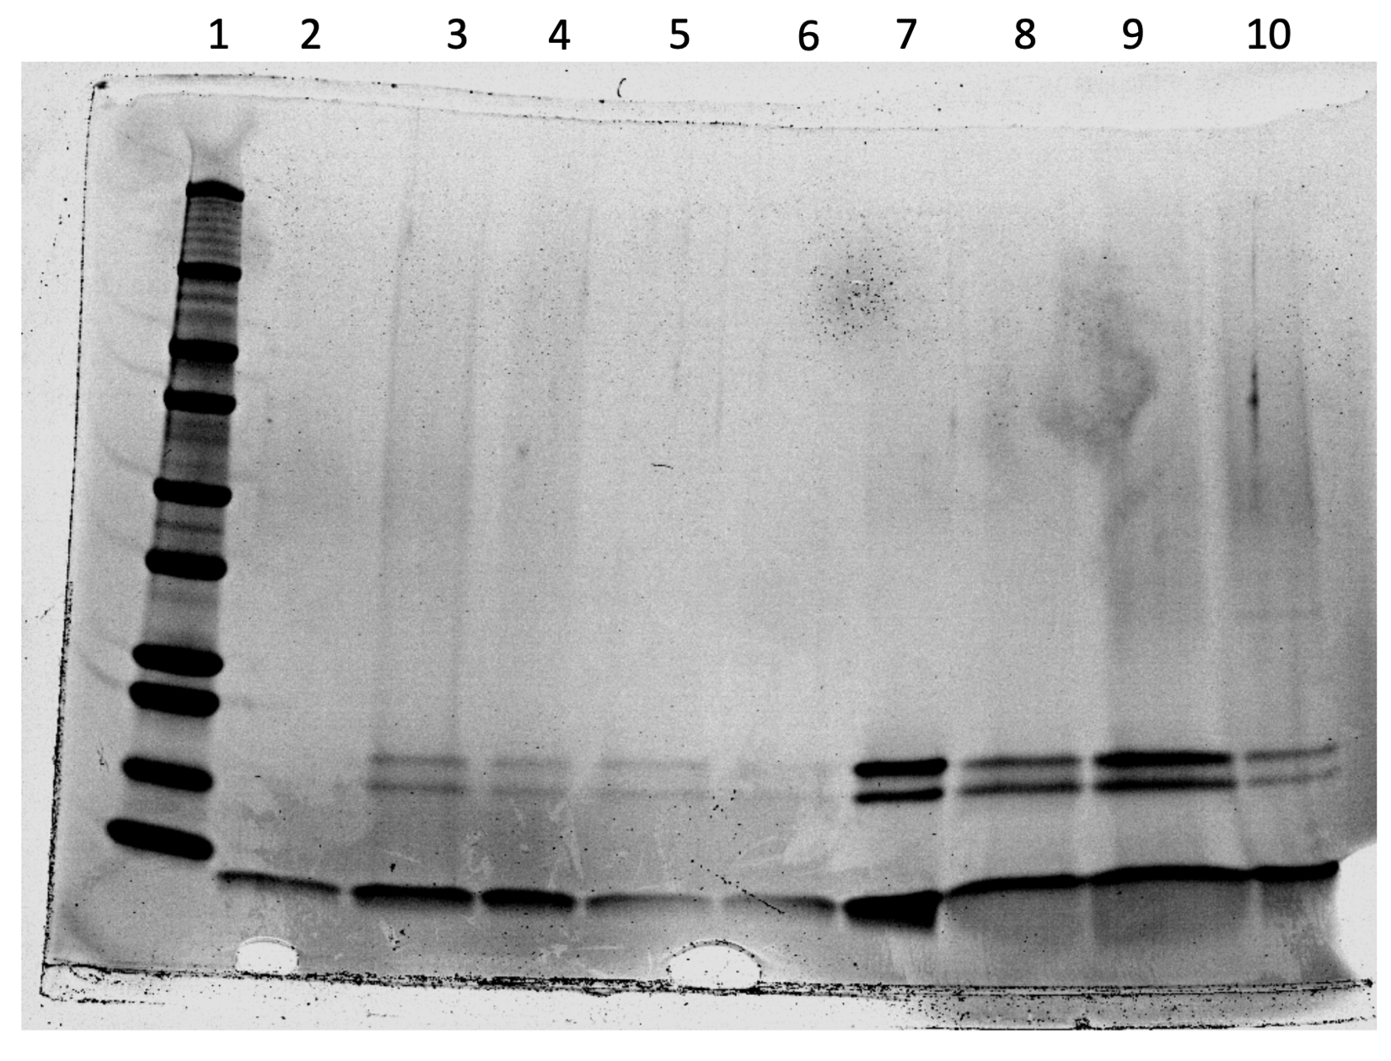

Figure S2. Original Western analysis to confirm the production of low molecular weight SAβO and some higher molecular species. Lanes: 1, ladder; 2, Formic acid extracted amyloid-beta plaques/fibrils from 5XFAD brain lysate; 3, SAβO batch 1; 4, SAβO batch 2; 5, SAβO batch 3; 6, SAβO batch 4; 7, SAβO batch 5; 8, SAβO batch 6; 9, SAβO batch 7; 10, SAβO batch 8; 11, SAβO batch 9; 12, we don't have a record of this lane.
Lanes 1, 2, and 3 of the Western blot in Fig. 2B were cropped from lanes 4, 5, and 7 of this original data, respectively.

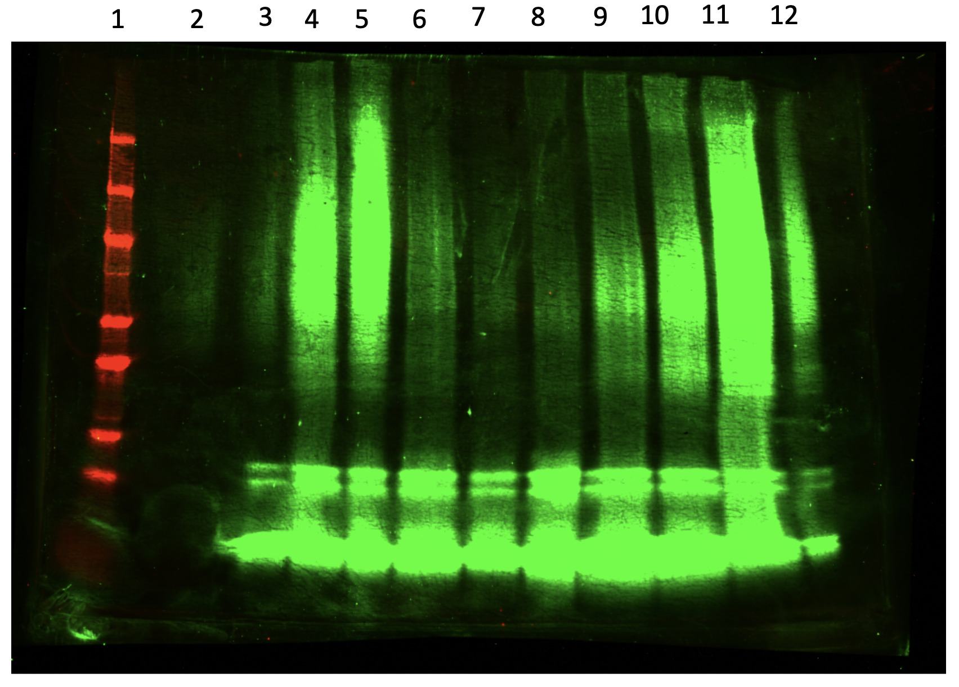

Figure S3. (A) Representative ELISA result from nanobody supernatants; (B) A total of 4 96 well plates worth of clones were picked from two different nanobody libraries. Six clones were both identified multiple times and positive in multiple assays. These six clones were expressed and purified from 1L bacterial cultures. A portion of each purified nanobody was biotinylated with 20-fold molar excess of NHS-Biotin (Pierce) and 8 point, 5-fold, binding titrations were done for each clone using Streptavidin-HRP or anti-HA-HRP (Thermo Fisher).

Figure S4. Western blot data showing successful FAM dye labeling of E3 nanobody, uncropped image. Lanes are, from left to right: Precision Plus Protein Kaleidoscope Standard Ladder (Bio-Rad), E3 nanobody, FAM-labeled E3 nanobody. This blot was probed with anti-HA 800 to detect nanobody signal and imaged for AF647 and DyLight 800 on a Bio-Rad ChemiDoc MP imaging system. Visible ladder bands (solid red bands) represent, from top to bottom: 250, 150, 100, 50, 20, and 15 kD, respectively.

Figure S5. Labeled panel of dot blots to screen E3 nanobody specificity for different Abeta species. The top blot was stained with 6E10, a commercially available Abeta antibody; the middle blot received E3 nanobody as an antibody; the bottom blot served as both an assay control to demonstrate that the secondary anti-VHH antibody could detect E3 as an antigen as well as a negative control for all other samples. Blots were imaged together on a Bio-Rad ChemiDoc MP imaging system set to detect AF488.

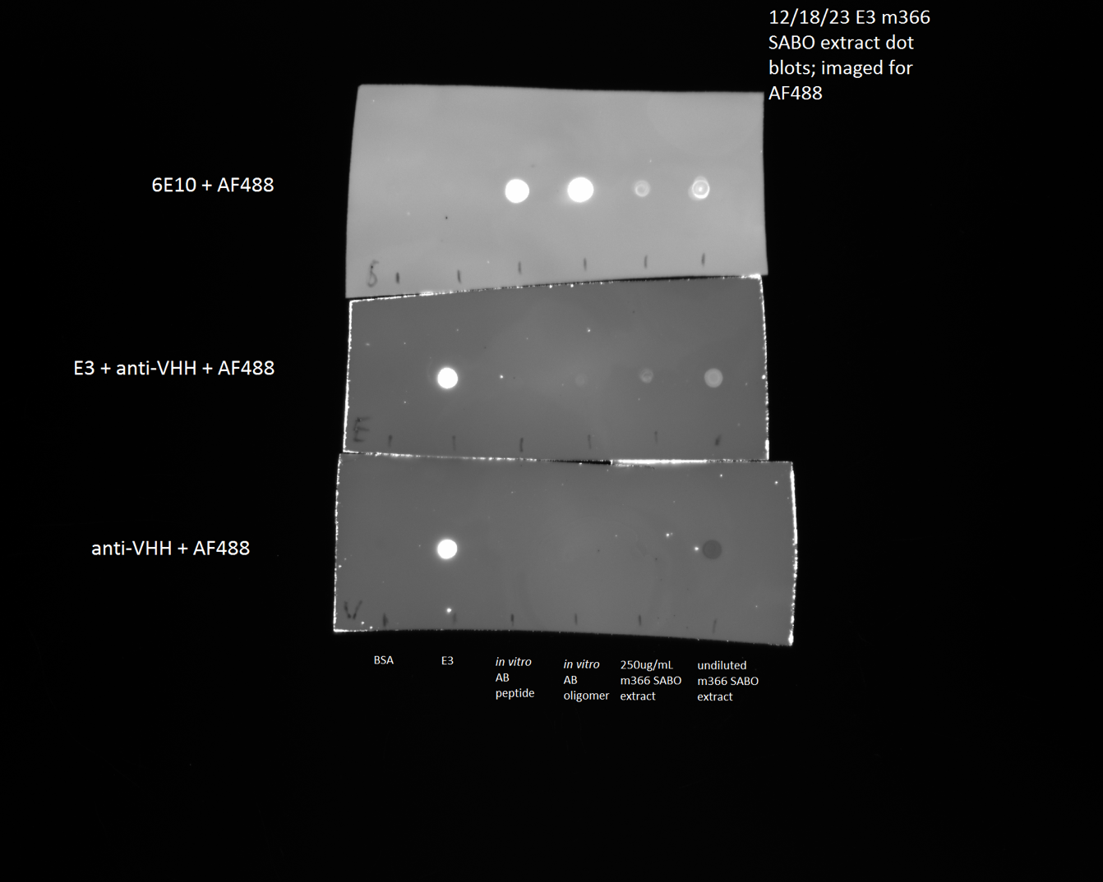

Figure S6. AlphaFold suggests potential binding modes. A. A single AlphaFold model of nanobody E3. Complementary Determining Regions (CDRs) are colored green for CDR1, yellow for CDR2, and orange for CDR3. The unusual orientation of CDR3 (relatively flat and jutting away from the nanobody) was present in all 20 models (B) but was associated with relatively low confidence values (C). Panel C shows a color ramp from low to high confidence based on AlphaFold’s estimates, suggesting low confidence in the CDR3 orientation. Panels C and D show E3 positioned next to a structure of a human amyloid-β(1–42) fibril (pdb 5OQV from ⁶²). The inter strand spacing of the beta-solenoid structure of the fibril is such that the CDRs of E3 could easily contact multiple Aβ peptides.

