Supplementary Materials
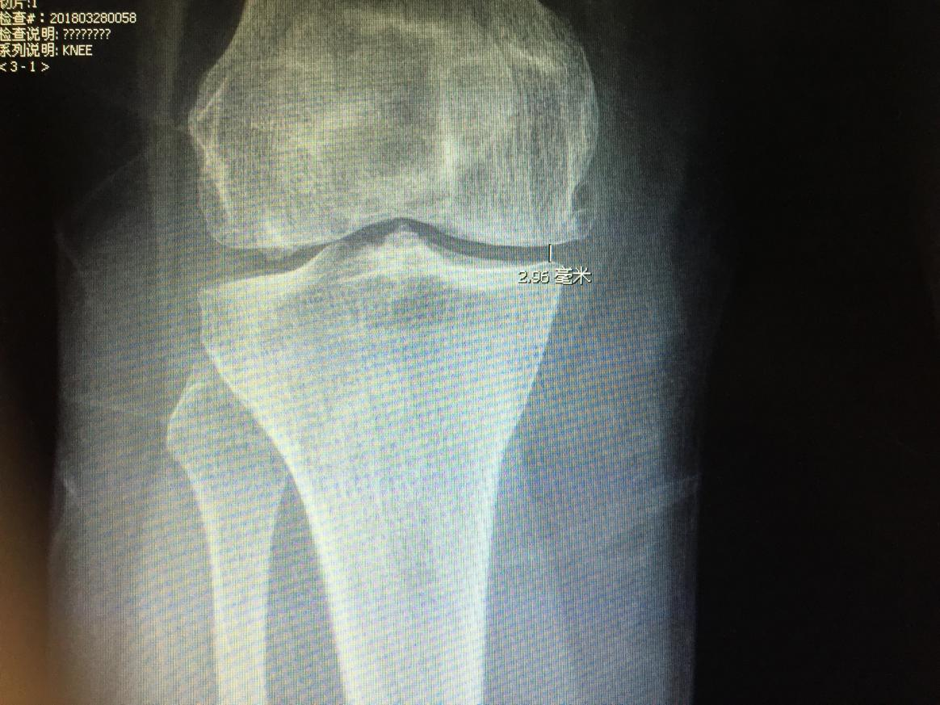
Material 1 Preoperative minimal joint space width(pre-mJSW)illustrated in X-rays
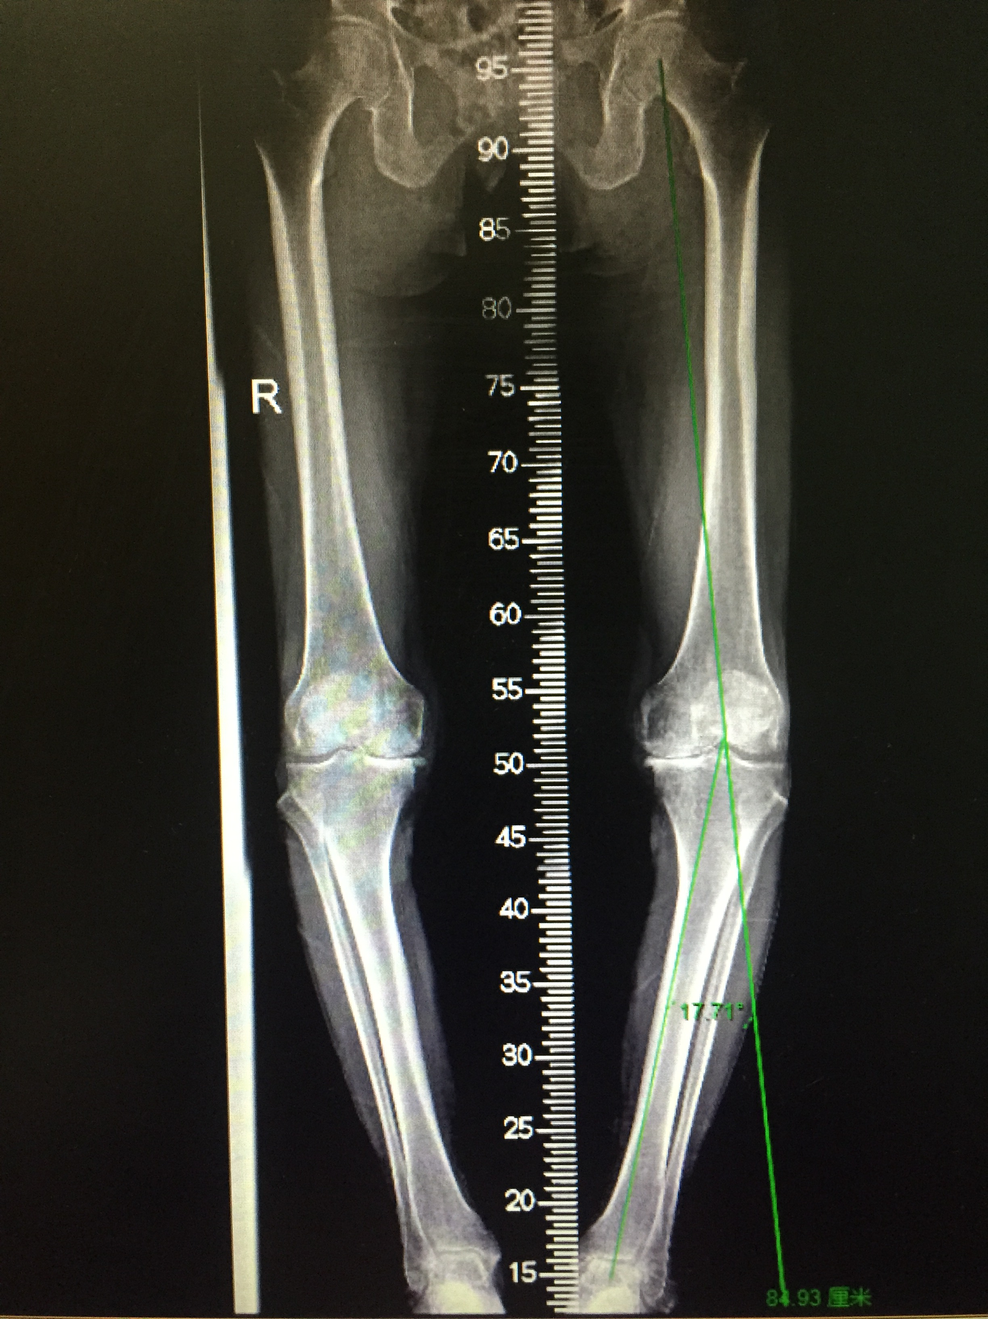
Material 2 Preoperative alignment measurement(varus angle of knee)illustrated in X-rays

