Supplementary data.
Appendix 1
Seven different methodologies were tested, optimizing the volume and flow rate of the perfusion of the detergents, as shown in Table A1. Method a and b were performed without heparinization and in a bioreactor with 21cm height and 11.8cm diameter. For the aforementioned methods, a bioreactor with 30cm H and 25.4cm of diameter was used.
Table A1.
Method | ddH₂O ml/min | ddH₂O  ml/min | Triton 1X ml/min | Triton 1X ml/min | SDS 1% ml/min | SDS 1% ml/min | Number of cycles | Total time of perfusion
a | 10 |  | 15 | 10 | 15 |  | 22 | 14 days
b | 10 |  | 25 | 5 | 10 |  | 14 | 8 days
c | 20 |  | 25 | 5 | 10 | 20 | 6 | 133 hours
d | 60 |  | 30 | 10 | 15 | 20 | 1 | 27 hours
e | 20 |  | 20 | 8 | 15 | 20 | 5 | 111 hours
f | 30 |  | 20 | 5 | 20 | 25 | 4 | 89 hours
g | 10 | 25 | 25 | 10 | 25 |  | 2 | 45 hours

During the first trials, a small bioreactor with a diameter of 11.8cm was used (Fig.A1A and Fig.A2A). Yorkshire adult pig kidneys have an average length of 12cm, entailing that the organ’s poles were oppressed by the bioreactor walls, constraining the perfusion of the detergents into the organ. For that reason, the decellularization in methods a and b was unsuccessful even though the process was carried out for several days. Since the decellularization process involves the use of detergents is not recommended to submit the tissues to the perfusion of these substances for an extended period of time because it could negatively impact the properties of the organ, weakening of the extracellular matrix and losing essential proteins like growth factors. In method b we detected that just the inferior pole was being decellularized and sections of the superior pole remained with the presence of cells and blood. After dissecting the organ, we noticed the presence of clots which were formed prior to the perfusion of water, preventing the flow of detergents to that section of the kidney. To enhance the decellularization methodology a home-made bioreactor with a bigger diameter of 25.4 cm was used in a way that the organ was only in direct contact with a petri dish of 15mm in one of its sides. The organ was flipped every cycle to avoid deformations. In method c (Fig.A1C) the big bioreactor was used in addition to a second step of SDS at a higher flow rate but having in total the same time of exposure to the matrix since we noticed that during the SDS cycle is where the biggest macroscopic changes occurred and where the turbidity of the perfusate was higher. This ionic detergent improves cell removal, but an excess amount could denature the protein structures of the ECM, the reason why we combined it with Triton IX. Using a big bioreactor, we could see a significant improvement in the decellularization having only the presence of cells in the superior pole. However, the number of cycles was still elevated, which is the reason why we stopped the experiment and proceeded to increase the flow rates. Increasing the flow rate of ddH₂O to 60ml/min resulted in the rupture of the kidney cortex. We noticed that the organ increased its size and was not draining correctly, generating that the inflow rate was higher than the outflow, fissuring the extracellular matrix being unable to be used for recellularization. Therefore, the experiment was terminated (Fig.A1D). Reducing the flow rates as stated in method D after 5 cycles, the organ was almost wholly decellularized by the exception of a red section on the center of the kidney (Fig.A1E). Further optimization was made for methods f and g obtaining in both cases a decellularized organ (Fig.A1F and Fig.A2).
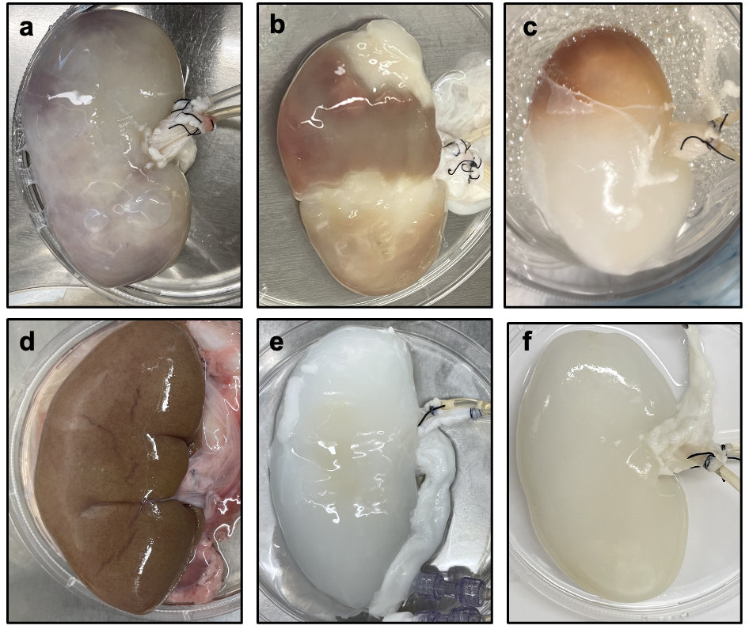
Figure A1. Decellularization of pig kidneys. (a) Unsuccessful decellularization of a pig kidney using a bioreactor with XX diameter for 14 days. (b) Non-fully decellularized pig kidney suspecting the presence of clots in the inferior pole. (c) Improvement of decellularization method using heparin perfusion before the harvesting. (d) Rupture kidney in the cortex probably due to a high perfusion flow. (e) Ineffective decellularization with the presence of a red section in the center of the kidney. (f) Successful decellularization.

Appendix 2
Table A2. Sequence of pig primers for RT-PCR
Gene | Forward | Reverse
CD31 | 5′-CAGTGAAATCCGGAAAGCTGA-3′ | 5′-TCTCAGAATGCGGTGTCTCC-3′
CD14 | 5′-TTCGCAGAAGTGTAGCGAAC-3′ | 5′-TCTGTCCTCACTCTTTGGCA-3′
CDH1 | 5′-ACGTTTGCCCTCAAATTCCC-3′ | 5′-TTGCTAACACCTTTTGGGGC-3′
AQP1 | 5′-CATCATTGCCCAGTGTGTGG-3′ | 5′-CATCATTGCCCAGTGTGTGG-3′
AQP2 | 5′-CTACACTGGCTGCTCCATGA-3′ | 5′-ACGGGAAGAGGACGTAGTTG-3′
AQP4 | 5′-ACGGACTGATGTCACTGGTT-3′ | 5′-ATCGGGCAGGGTTCATACTG-3′
Podocin | 5′-TGTGAGTGGCTTCTTGTCCT-3′ | 5′-AGGAAGCAGATGTCCCAGTC-3′
Vimentin | 5′-GGAGCGCAAGATAGGTTTGG-3′ | 5′-CCAAGTTGGTTGGATATTTGATGG-3′
GAPDH | 5′-GAGTGAACGGATTTGGCCG-3′ | 5′-GGAGGTCAATGAAGGGGTCA-3′

