Supplementary Figure 1
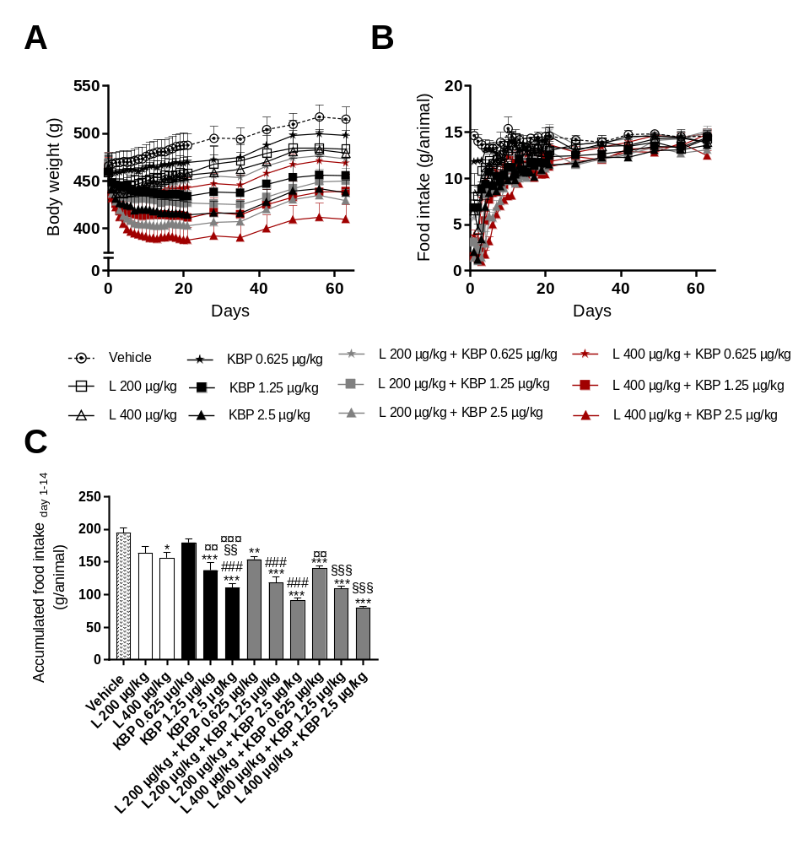
Supplementary figure 1. Body weight (A) and food intake (B) during the study. Accumulated food intake for the initial 14 (C). N=8-10 rats per group. Statistical analysis between groups in C were performed as a one-way ANOVA followed by Tukey’s post-hoc test with the following annotations: *P < 0.05, **P < 0.01, ***P < 0.001 vs. vehicle, ###P < 0.001 vs. liraglutide (200 µg/kg), §§P < 0.01 vs. liraglutide (400 µg/kg), ¤¤ P < 0.01, ¤¤¤ P < 0.001 vs. KBP-089 (0.625 µg/kg). All data are means ± SEM.

