Supplementary Figure 2
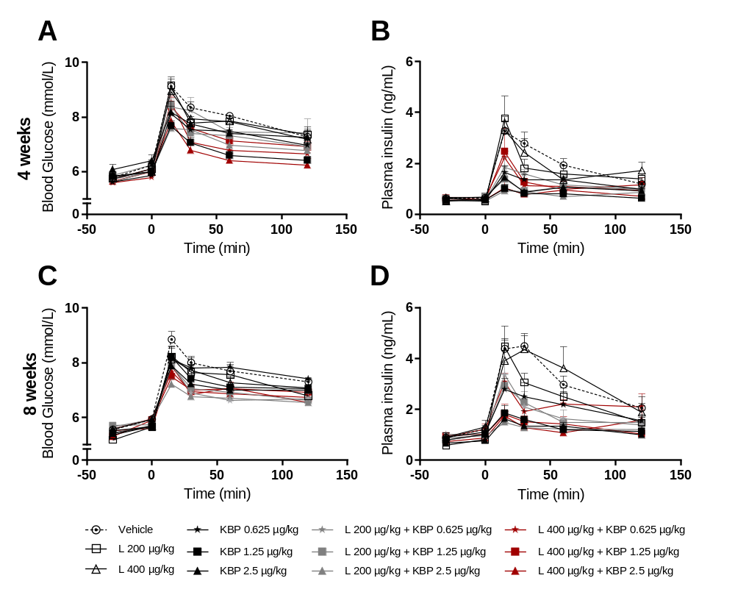
Supplementary figure 2. Blood glucose (A and C) and plasma insulin (B and D) during oral glucose tolerance test (OGTT) after 4 and 8 weeks, respectively. n=8-10 rats per group. All data are means ± SEM.

