Supplementary Figure 3
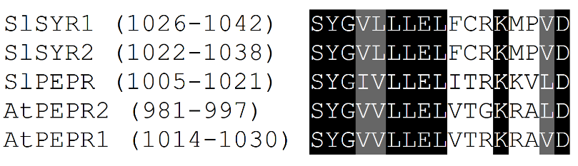
MSA of putative GC center of systemin receptors SlSYR1 and SlSYR2, SlPEPR, and Arabidopsis PEPRs AtPEPR1 and AtPEPR2. This MSA provides evidence that residues corresponding with the GC center in SYR and PEPR sequences are conserved. The positions of the residues depicted are shown in parentheses after each sequence name. Identical (matching) residues at each position are highlighted in black, and residues which are chemically similar are highlighted in gray (V/I/L). This MSA is a subset of the MSA supplied in Supplementary File 2 with gaps removed at all-gap positions.

